Name | Student Number | Date | Lecturer’s Name | Your score
Tomas Balog | 2433608 | 27/06/2025 | Ellie | To be filled by the marker  ___/40
You will have 75 minutes to complete this assessment. It is divided into three sections: note-taking, paraphrasing and writing a paragraph.
---------------------------------------------------------------------------------------------------------------------
1. Take diagrammatic notes from the passage below using the space provided:

As a student you've got a lot on your plate - academic work, social life, work commitments, career plans, relationships and finances - sometimes stress can get in the way of this juggling act. When you recognise that you have become overwhelmed with stress, adopt a few strategies to help you manage your triggers more effectively. Those strategies could include exercising; you simply need to get your heart racing, for example by going for a brisk walk or a bike ride. Another suggestion is to try mindfulness, a relaxation technique originating in Buddhism. It is used by clinicians to improve patients' physical and mental health as it can significantly lower stress levels. Thirdly, why not speak to your friends and family - they know you best and care about you the most. What's more, studies suggest that socialising with a friend just once a week can reduce your stress levels and improve your mood as much as therapy or counselling. Simple time management techniques can also help you to feel more relaxed and focused. Try creating a written schedule, breaking your tasks down into manageable chunks, planning accordingly and allocating yourself time every day to relax or socialise. Finally, an obvious but often overlooked solution: get enough sleep, as no one functions at 100% when they're tired.
Adapted from: https://www.prospects.ac.uk/applying-for-university/university-life/5-ways-to-manage-student-stress

Space for your notes (max 12 marks):
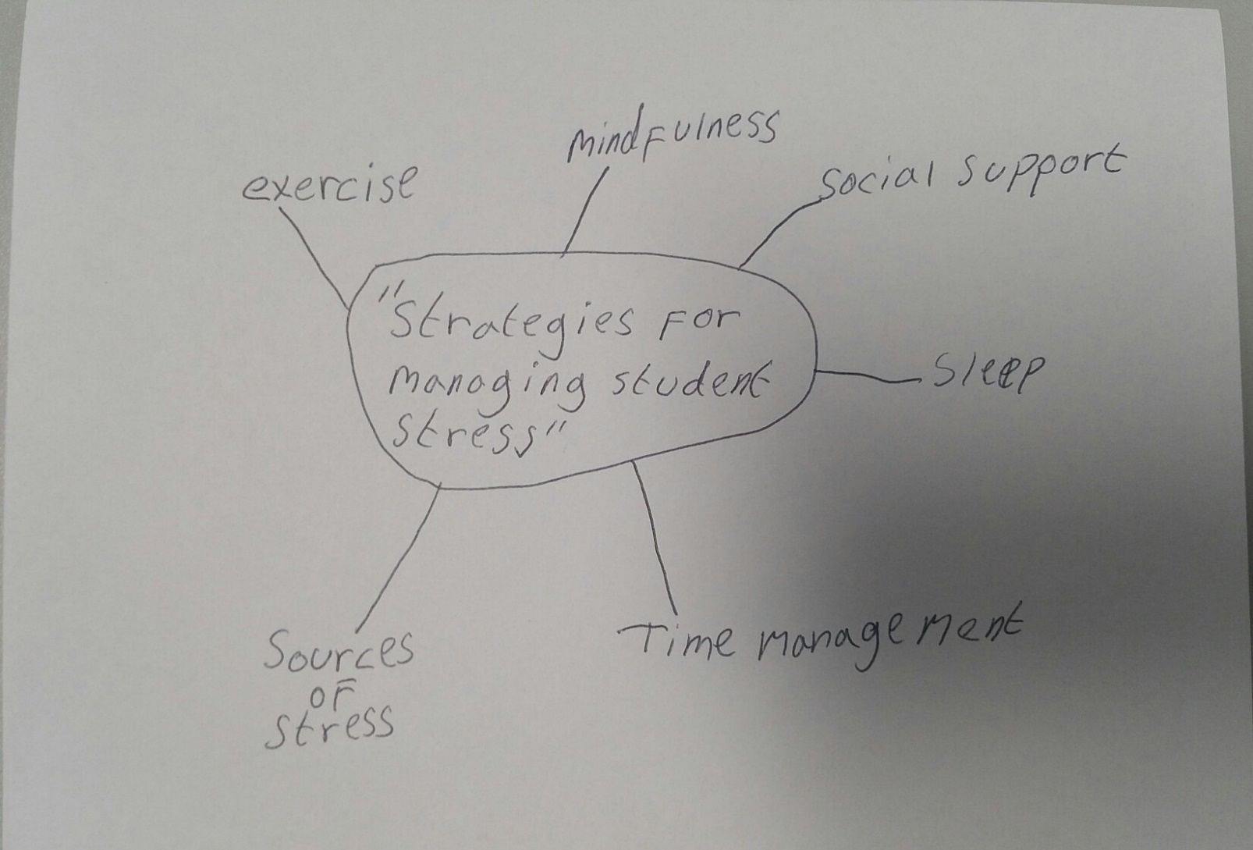

2. Paraphrase the following sentences (max 3 marks for each, max 12 marks in total):

a) Good time management techniques can help you feel more relaxed and focused.

By developing strong time management skills, you can create a more organized daily routine that not only helps you stay on top of your responsibilities, but also promotes a greater sense of calm, reduces stress, and allows you to concentrate more fully on the tasks that matter most.
b) Speaking to your friends and family can significantly lower stress levels.
Talking to friends and family can ease your stress by offering comfort, support, and a sense of connection, helping you feel less alone during tough times.
c) University life offers numerous opportunities for personal growth and development.
University life is a time filled with opportunities to discover your interests, grow as a person, and build important skills that will benefit you long after graduation.
d) Attending lectures regularly is crucial for understanding course material.

Showing up to lectures consistently helps you stay on track with the course, making it easier to grasp key concepts and connect ideas as they’re taught.

3. Write a well-structured paragraph (8 sentences) on the following topic:

Strategies for managing a student budget and reducing costs while at university.

Your paragraph must be written in full sentences (no bullet points) and in an academic style.

(max 16 marks in total)

Managing a student budget effectively is essential for maintaining financial stability throughout university life. One important strategy is to create a detailed monthly budget that tracks income and expenses, helping students identify areas where they can cut unnecessary spending. Prioritising essential costs such as rent, food, and academic supplies ensures that core needs are met first. Students can also save money by cooking meals at home rather than eating out, which significantly reduces food expenses. Making use of student discounts for transport, entertainment, and shopping can further lower overall costs. Additionally, purchasing second-hand textbooks or borrowing them from the university library can be more economical than buying new ones. Finding part-time work or applying for scholarships and grants can also provide extra financial support. By implementing these strategies, students can reduce financial stress and focus more fully on their academic and personal development.

