
HTML & CSS Web development
ACCA4023

26 March 2026
DEyby alexis osorio guevara
LECTURER: Sadhana Jha

Contents
Introduction 2
Requirements 3
Purpose: 3
Subject matter 3
Intended audience 3
Implementation 4
Screenshots of the Webpages 4
Validation 6
HTML Validation 6
CSS Validation 7
Evaluation 8
Part A 8
Website usability- 8
Website accessibility: 9
Search engine optimisation 9
Part B 9
Usefulness (Usability and Utility) 9
Search Engine Optimisation (SEO) 9
Part C 9
References: 11
Appendix 12

Introduction
In the following report we will review the information about the website that was created what was the goal and aspects about the information that is disclosed or the goal of the website which is preserved and share folklore, stories and unite people through a topic they are interested to make a community and also to understand how a website is built from scratch the different process that we need to follow to make sure the website follow different standards to be accessible for everyone and easy to access and easy to locate in the internet by making the website more visible in the search.

Requirements

Purpose:
This website was created to continue local traditions and share a bit of the culture of the different countries in Latin America, including a topic which is still really popular in different age groups, which is Mystery/ Horror, because it’s well known that a lot of stories are getting forgotten because a small minority knows them, and it’s important to help people to get interested in good reading habits, and including stories within American folklore with help to preserve part of history from different ethnic groups, because a lot of stories are really similar not only in Latin America, but in the whole world, and by doing this website will help people to connect with other that went trough different or similar situation or memories from early years when their parents were talking about old stories that their parents told them or heard about with family or friends

Subject matter
The website was created and designed to catch people’s attention by using dark colours, trying to give some ideas that the reading is taking place in a mysterious place trying to make the user feel that is in mysterious place also the cursor is changing shape in the door was designed to try to make the user feel that is getting to a different place just by one click entering in a room to read a story and the other door for the use to tell a story to be share with the audience by doing this the user is feeling that it’s been invited to be part of the community creating inclusion.

Intended audience
The website was designed for people interested in reading and learning about different experiences from other people, also to catch the curiosity of people who want to explore a different type of genre that is inspired by other people's experiences that could be accessed by anyone interested in the topic, which could lead to create different type of reading experience.

Implementation

Screenshots of the Webpages

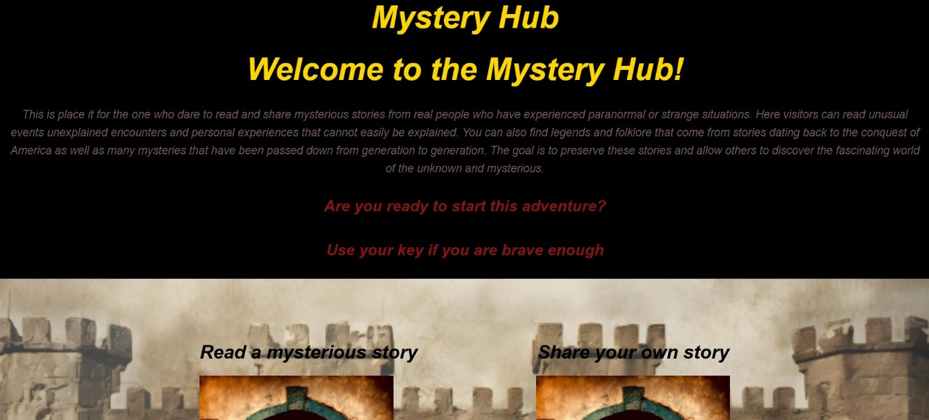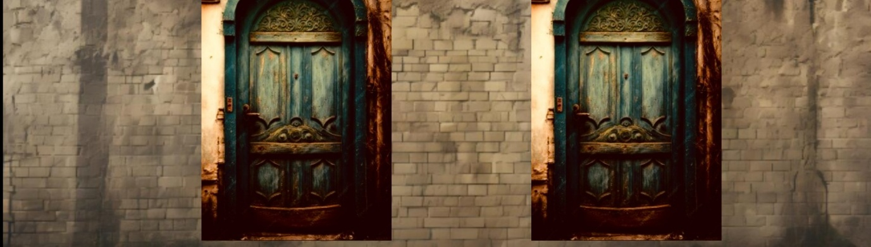
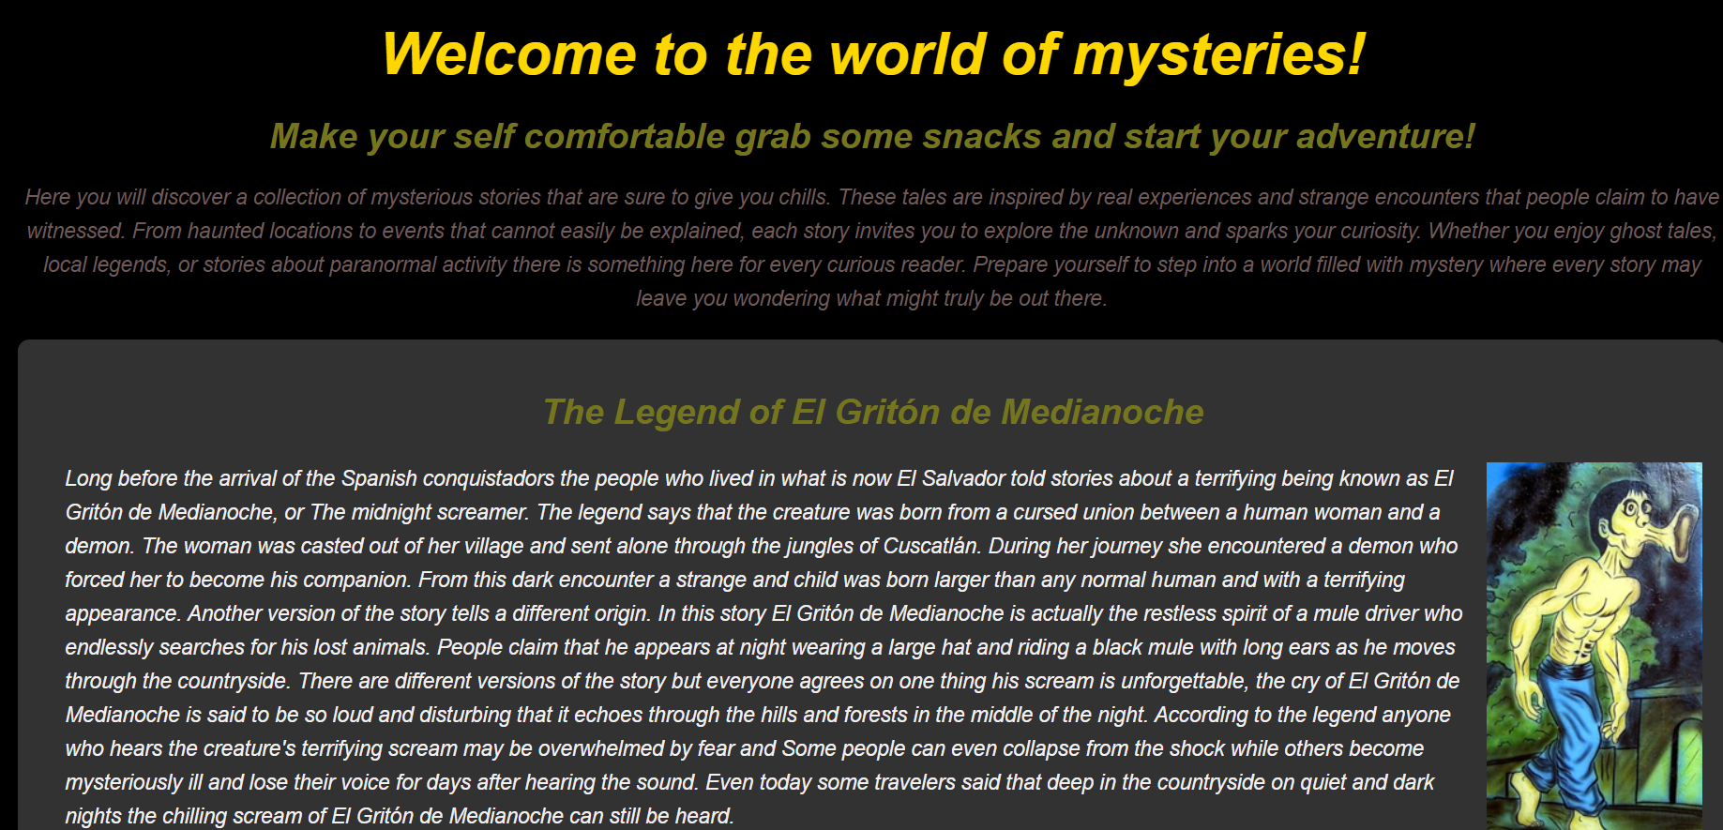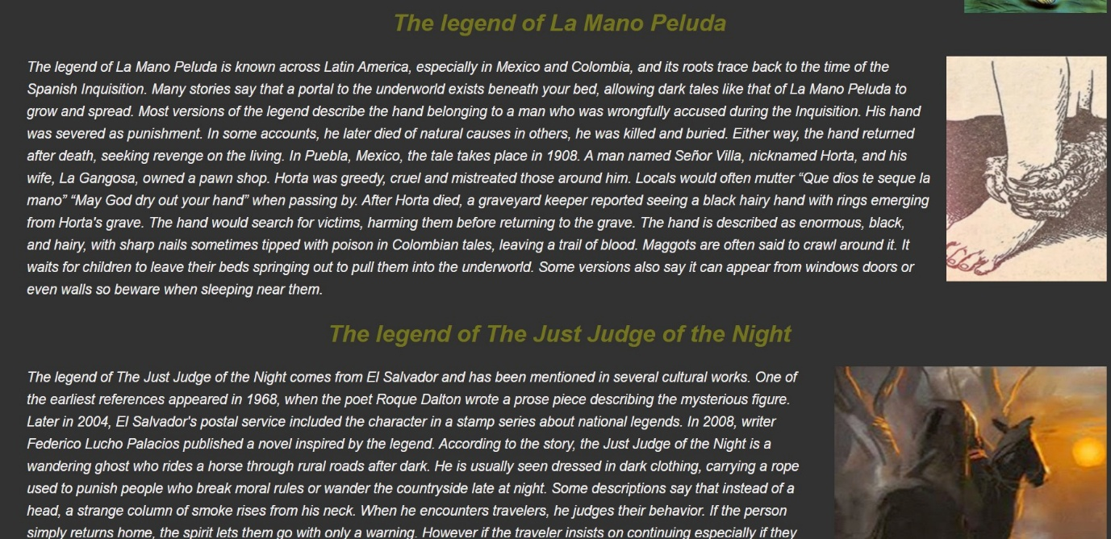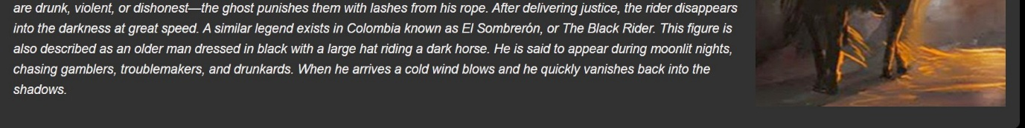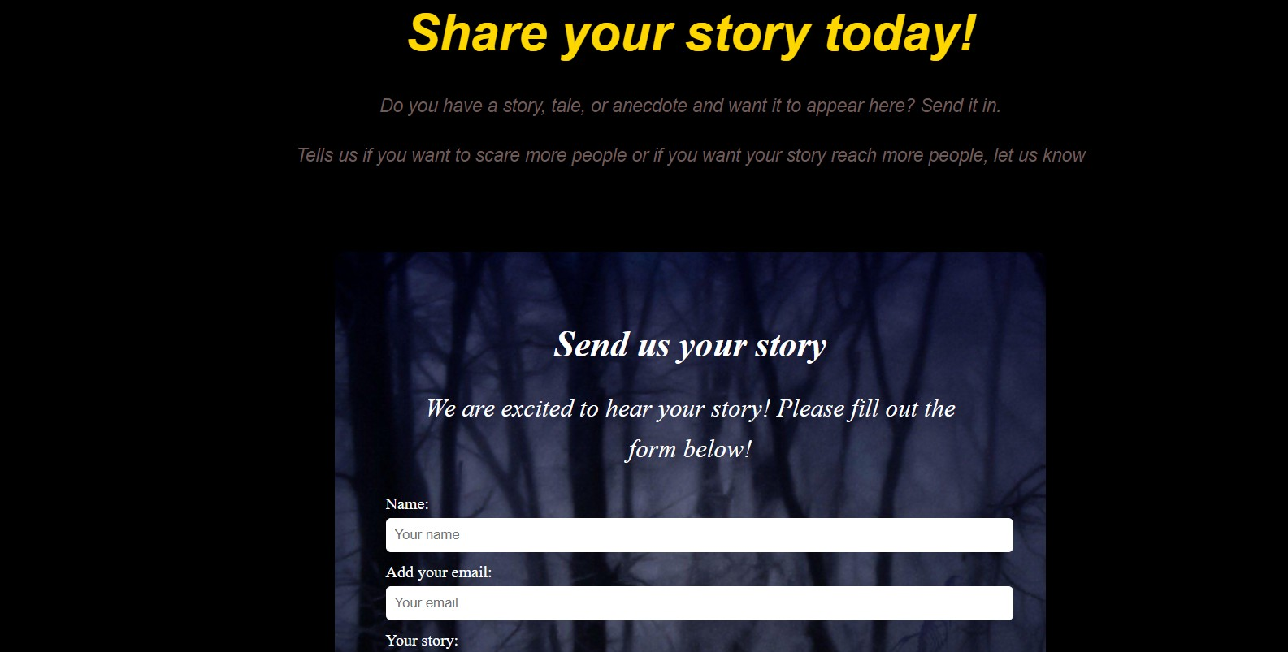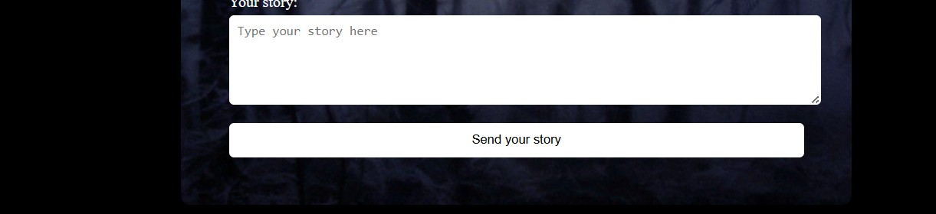

Validation

HTML Validation
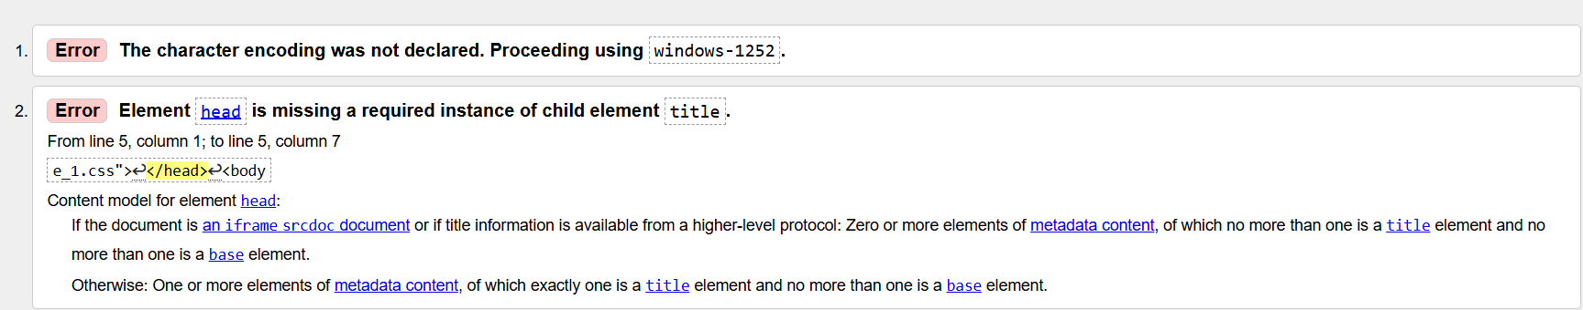
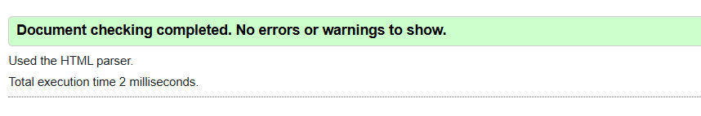
The web page was not declared originally and was not added to the head of the file.
The error was corrected by adding the head to the file, adding the title, and changing the word from META to meta.

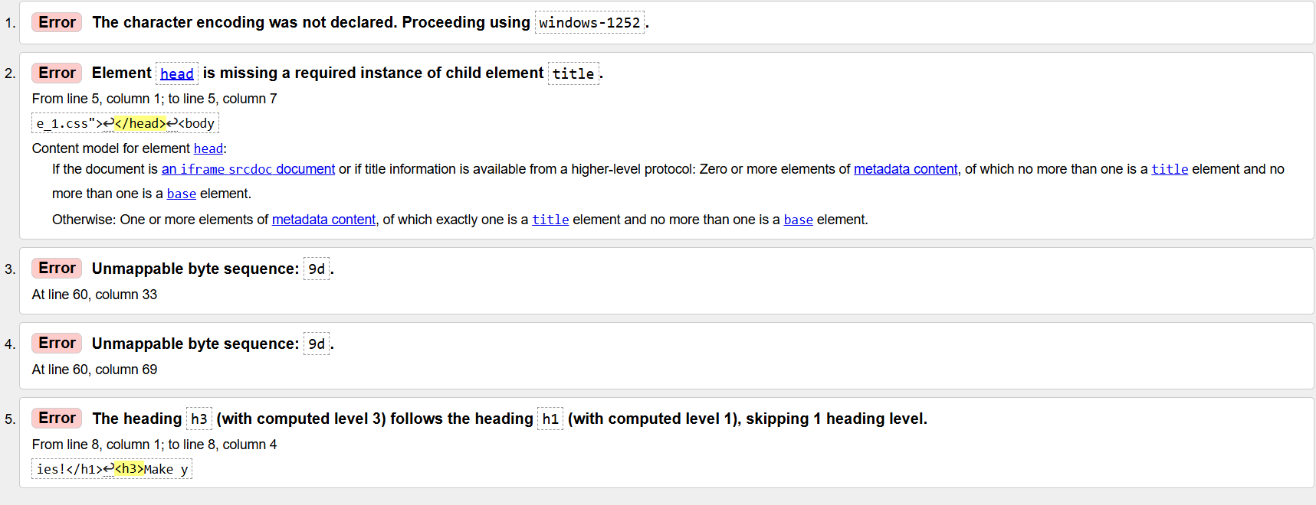

The webpage was not declared originally and was not added to the head of the file.
The error was corrected by adding the head in the file, and also the title and changing the word from META to meta.

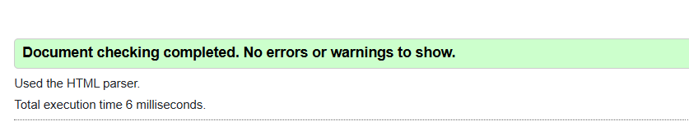
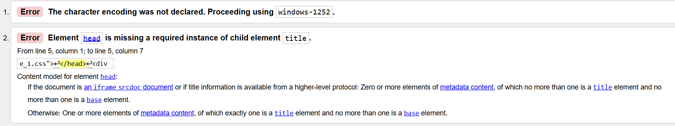
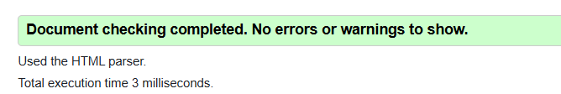

CSS Validation
In this section, include the screenshot of the validation of your CSS page
If you have any error in the validation, describe how you corrected that error and re-validate your home page and put the new screenshot here
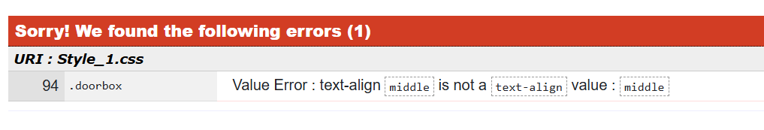

The error that was showing in the CSS page was fixed by adding the correct value, since an invalid value was entered.

Evaluation

Part A

Website usability-
Website usability refers to how easy it is for people to use the website. It focuses on how people navigate it, find information, and complete tasks without any inconvenience. A website built following those guidelines helps users to understand how the website works very quickly. This involves how much effort the user puts to navigate in the website.
It’s very important for the developers to follow this because decrease user efforts. This could be reading information, finding a story, or navigating between pages. If users can do this quickly and without needing help, then the website is considered usable. Good usability also means users do not need extra instructions or external help to understand how the website works.
Web usability also involves testing. Designers get real users interacting with the website to see how it works well and what causes problems. This helps improve and modify the website and make it easy to use and move within the content. It also includes making sure the website is easy to learn and efficient to use. Website usability is very important because it makes the website more effective and enjoyable for users. If a website is difficult to use, people will likely leave and not return. However, if it is simple and clear, users are more likely to stay longer. [1]

Website accessibility:
The Web Accessibility Guidelines are international rules to create websites in a easier way to use for everyone, including people with vision, hearing, mobility, or thinking difficulties. For example, people who are blind or partially sighted, color blind, deaf, hard of hearing. Governments requires services to meet WCAG level AA, so if you’re making a website you need need to follow these guidelines
Users should be able to see or hear the content in a way that works for them. Like adding alt text for images, captions for videos, using clear colors, and making sure content works with screen readers or when text is enlarged. Operable means that users can actually use the site, even if they only have a keyboard or use voice commands. 2]

Search engine optimisation
SEO refers to making the website more visible for people and making it easier to be found on the internet. It's basically how people can access the website; it also refers to information that needs to be related to the website, so users can go to the website by being prioritised in the search. SEO employs algorithms to determine the order in which the website will be found. It’s really important to reach different markets, conect customer with the business and improve user traffic. [3]
Part B

Usefulness (Usability and Utility)
The website was created trying to make it really usable, so users can access it, navigate, and the information will be displayed right after the users enter the pages, because the type of website which was selected is basically to read information, so it was intended to be as short as possible, not to show a lot of options to the users.

Search Engine Optimisation (SEO)
The website was created with some keywords that people normally use to find information related to the topic, which the website was intended by making this it’s going to be more visible for the audience and easy to locate for users.

Part C (Provide the comparison of two Live Websites)

Area | Website 1 | Website 2
Weblink of the Website | Amazon.co.uk: Low Prices in Electronics, Books, Sports Equipment & more | Spotify - Web Player: Music for everyone
Usability | This website is designed to see all the options in one go, depending on what the user wants to do. | This website is really straightforward and well-organised to perform any actions needed for the user because all the information is disclosed in the main page.
Accessibility | This website is well designed by implement feature like Alexa that can placed order or perform different activities like play video and music | Spotify is now implementing a virtual assistant to look for content by voice or writing
SEO | This website can be found in any type of search if you are looking to buy something, there is always links that sends you through amazon main page. | Spotify has a good implementation because if you know the name of a song, but you remember part of the lyrics, and you look for it on Google, it tells you the name and a link to go to their website
Mobile Friendliness | This website can be used in the same way as in computer, making it mobile-friendly. | The mobile option of Spotify is good as the web option it got some limitation in account management but besides that it can be use as good as in pc.
Conclusion | Amazon is well structured, easy to use and user-friendly to navigate inside the website and taking consideration for people with disabilities. | Spotify is well organized and really easy to access and used in different devices even sharing connectivity at the same time, you can control using different devices as long as you are connected in the same account without the need to use the device you started listening to.

References:
[1] Alex. Mika"Ramotion. What is Website Usability 25/03/2025. [Online]. Available: URL Website Usability: Definition, Principles and Methods | Ramotion Agency
[2] "GOV.UK." Title of website. Accessed: Month day, year. [Online]. Available: https://www.gov.uk/service-manual/helping-people-to-use-your-service/understanding-wcag
[3] Sarah Berry"TWhat is SEO?" What is SEO [Online]. Available: URLhttps://www.seo.com/basics/glossary/seo/

Appendix
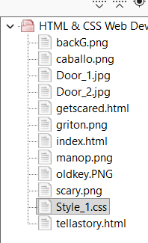
Index/ Mystery Hub first page

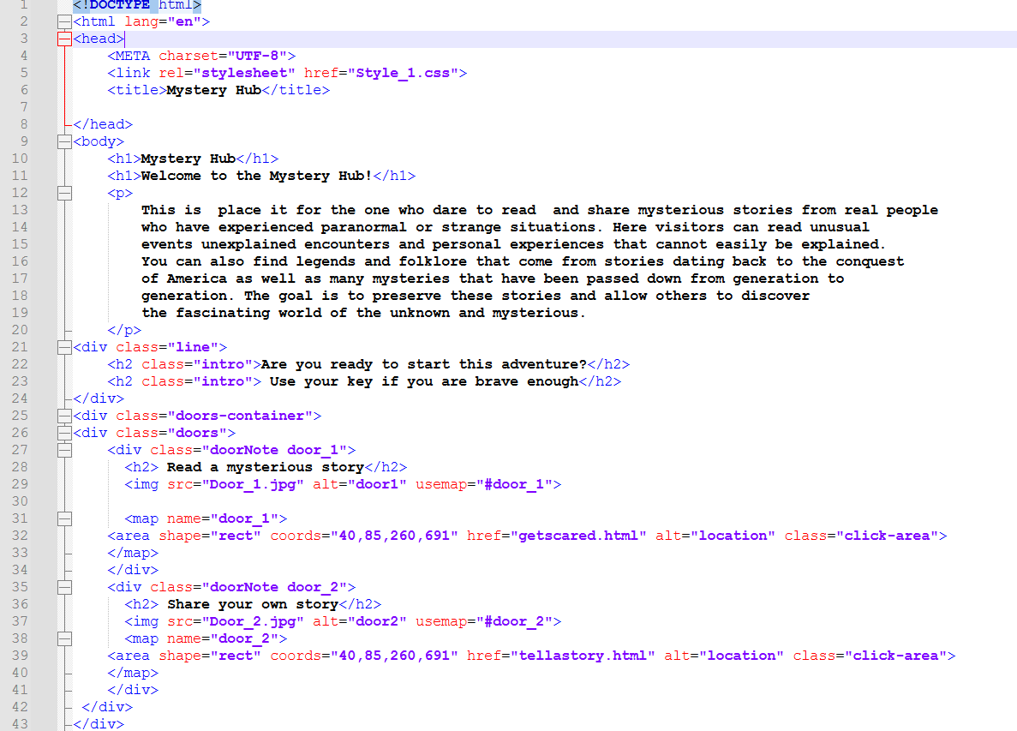
Get scared/ second page

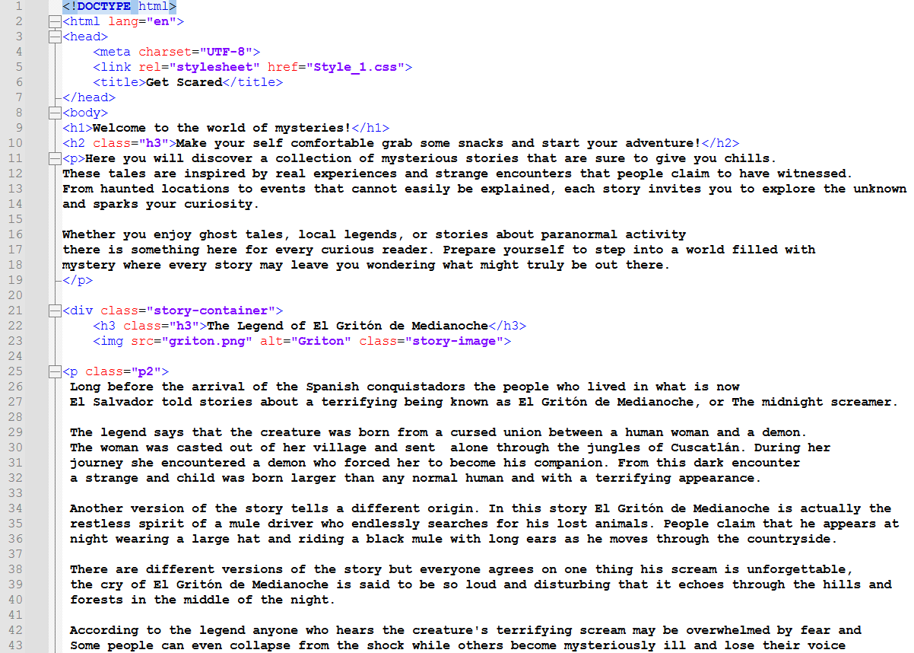
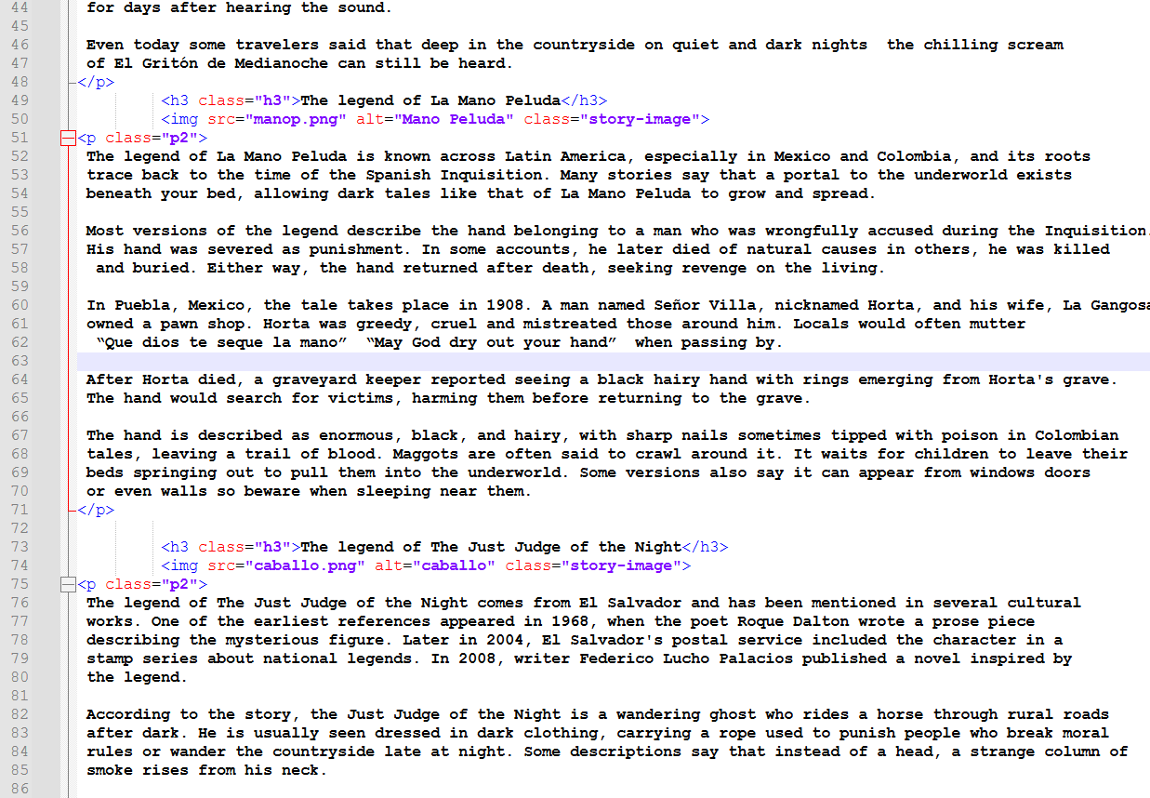
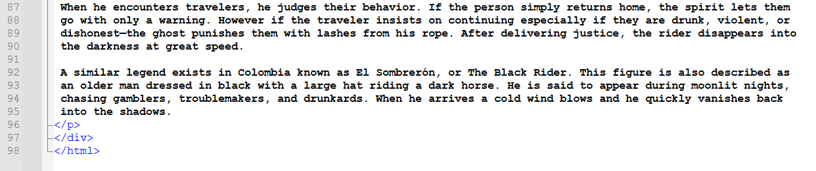
Tell a story/Third page
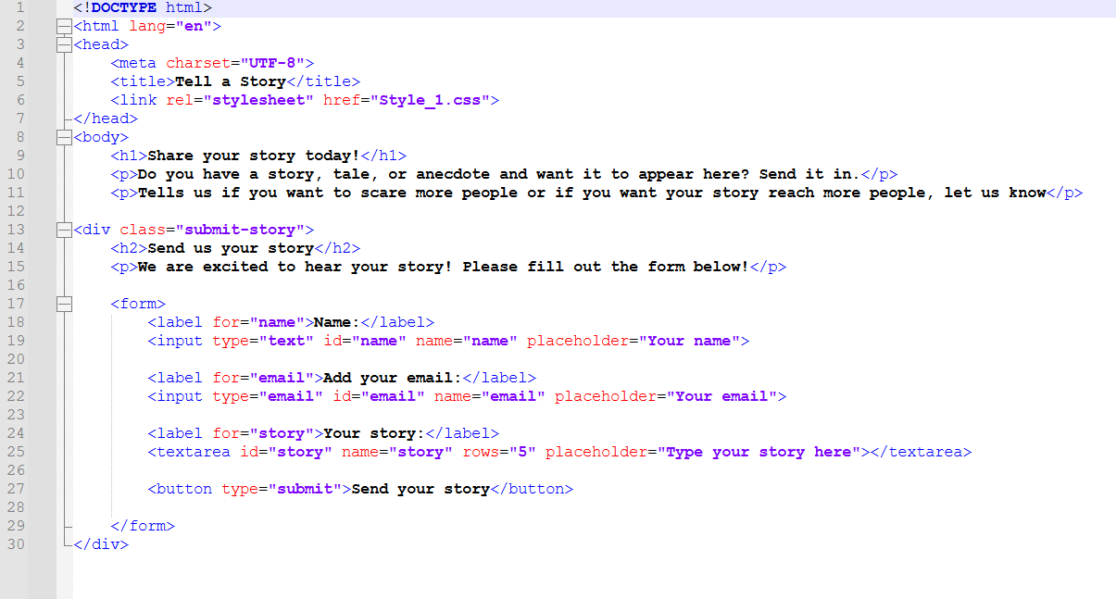

CSS page


