Physics (ACDB4007) – Dynamic Stress-Strain Investigation.
By Jesamy Kellow (2030428)
L4 OME Apprenticeship

I declare this report is the product of my own work and is not being submitted for any other degree etc.

Abstract
This report investigates into the stress-strain values for a projectile hitting a plate in order to predict the failure mode of the plate, whether it is tensile or shear stress. The velocity of the projectile is increased to investigate into a possible change in the plate’s failure mode.

Contents

1. Abstract 1
2. Contents 2
3. Table of figures 2
4. Introduction 3
5. Simulation programme used – abacus 3
6. Component properties – dimensions and materials 3
6.1. Projectile Properties 3
6.1.1. Materials 3
6.1.2. Dimensions 3
6.2. Plate Properties 4
6.2.1. Materials 4
6.2.2. Dimensions 4
6.3. Why the properties were chosen 4
7. Investigation into the change in velocity of the Projectile 5
8. Results 5
8.1. Velocity of 500ms-1 5
8.2. Velocity of 1500ms-1 6
8.3. Velocity of 2000ms-1 8
8.4. Velocity of 2500ms-1 10
8.5. Velocity of 3000ms-1 12
8.6. Comparison of results 13
9. Analysis and Evaluation of results 14
10. Conclusion and further testing 15
References 15

Table of figures

Figure No. | Description | Page number
Figure 1  Figure 2  Figure 3  Figure 4  Figure 5  Figure 6  Figure 7  Figure 8  Figure 9  Figure 10  Figure 11  Figure 12  Figure 13  Figure 14  Figure 15  Figure 16  Figure 17  Figure 18  Figure 19  Figure 20  Figure 21  Figure 22  Figure 23  Figure 24  Figure 25  Figure 26  Figure 27  Figure 28  Figure 29  Figure 30  Figure 31  Figure 32  Figure 33 | ‘Edit Material’ selection screen for density  ‘Edit Material’ selection screen for elastic  Dimensions of the projectile in Abacus.  ‘Edit Material’ section for Plastic  ‘Edit Material’ section for Elastic  ‘Edit Material’ section for Density  ‘Edit Material’ section for Damage evolution  Velocity 500ms⁻¹ – frame 1  Velocity 500ms⁻¹ – frame 15 Tensile stress  Velocity 500ms⁻¹ – frame 15 Shear stress  Velocity 500ms⁻¹ – Velocity-Time graph  Velocity 1500ms⁻¹ – frame 1  Velocity 1500ms⁻¹ – frame 10 Tensile stress  Velocity 1500ms⁻¹ – frame 10 Shear stress  Velocity 1500ms⁻¹ – frame 40  Velocity 1500ms⁻¹ – Velocity-Time graph  Velocity 2000ms⁻¹ – frame 1  Velocity 2000ms⁻¹ – frame 6 Tensile stress  Velocity 2000ms⁻¹ – frame 6 Shear stress  Velocity 2000ms⁻¹ – frame 25  Velocity 2000ms⁻¹ – Velocity-Time graph  Velocity 2500ms⁻¹ – frame 1  Velocity 2500ms⁻¹ – frame 5 Tensile stress  Velocity 2500ms⁻¹ – frame 5 Shear stress  Velocity 2500ms⁻¹ – frame 19  Velocity 2500ms⁻¹ – Velocity-Time graph  Velocity 3000ms⁻¹ – frame 1  Velocity 3000ms⁻¹ – frame 4 Tensile stress  Velocity 3000ms⁻¹ – frame 4 Shear stress  Velocity 3000ms⁻¹ – frame 15  Velocity 3000ms⁻¹ – Velocity-Time graph  Graph of velocity comparison to time increments  Graph of velocity comparison to stress values | 4  4  5  5  5  6  6  7  7  7  8  8  8  9  9  9  10  10  10  11  11  11  12  12  12  13  13  13  14  14  14  15  15

Introduction
The aim of this report is to investigate into the dynamic stress and strain of materials. To investigate this, a variable must be chosen in order to measure this, the variable chosen is velocity. Once measured, the results will be analysed. This is an Ordnance, Munitions and Explosives (OME) focussed report, so a projectile going into a plate has been chosen as the two mediums being used. This is going to be completed through simulation and designed on a computer aided design (CAD) software rather than being completed practically.

Simulation programme used – abacus
The specialised design simulation software used for this experiment is Abacus CAE. On Abacus, it is possible to “quickly and efficiently create, edit, monitor, diagnose, and visualize advanced Abaqus analyses” [1] and because of its ability of visualisation, the software has been chosen for use on this experiment.

Component properties – dimensions and materials

Projectile Properties

Materials
The projectile was made out of Iron 7860 (steel) for this example. To replicate steel, some properties have been inputted into the ‘Edit Material’ section in Abacus. As can be seen in figure [1], the density inputted is 7860 kg/m³ which is the density of the steel chosen. Another aspect inputted into the ‘Edit Material’ section can be seen in figure [2]. Under the Elastic material behaviour, the Young’s modulus of 210 GPa and Poisson’s ratio of 0.3 for steel.
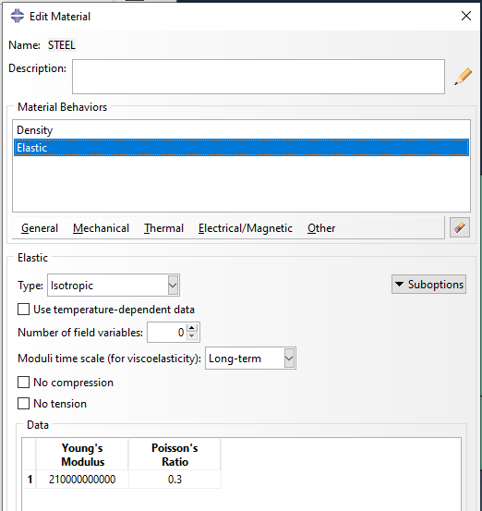
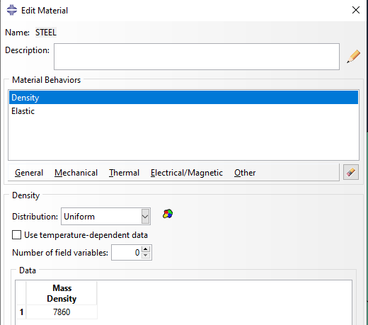
Figure [1] – ‘Edit Material’ selection screen for density Figure [2] – ‘Edit Material’ selection screen for elastic

Dimensions
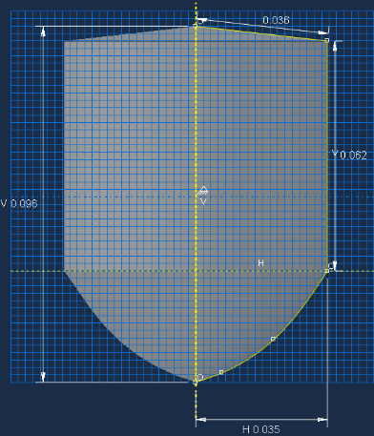
The diameter of the projectile is 0.07m and the length of the projectile is 0.096m. All of the other dimensions can be seen in figure [3].

Figure [3] – dimensions of the projectile in Abacus.

Plate Properties

Materials
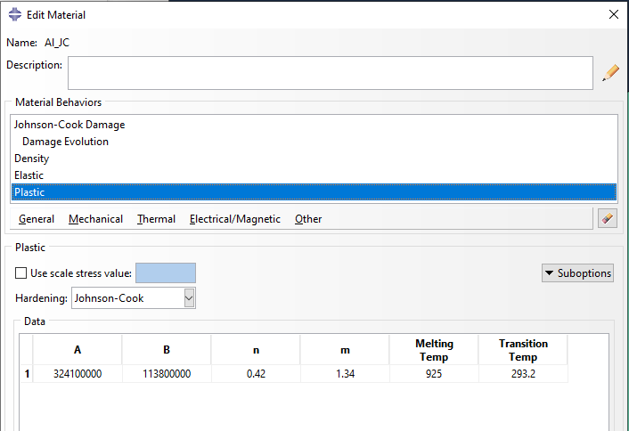
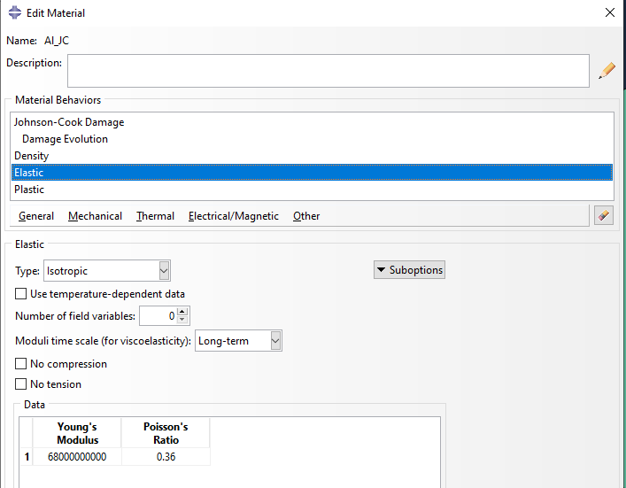
The material chosen for the plate was Aluminium and more specifically Johnson cook aluminium. To replicate aluminium, some properties were put into the ‘Edit Material’ section of Abacus as with the projectile. The first was added from the plastic section as seen in figure [4] and it was the Johnson-Cook values. The next is from the Elastic section and it is Young’s Modulus of 68 GPa and Poisson’s ratio of 0.36, as shown in figure [5].
Figure [4] – ‘Edit Material’ section for Plastic Figure [5] – ‘Edit Material’ section for Elastic

The next section is from density which can be seen in figure [6] below, and this is just adding in the mass density of aluminium which is 2699 kg/m³. And the final properties added are from the Damage evolution section as shown in figure [7], where damage values and melting and transition temperatures have been added.
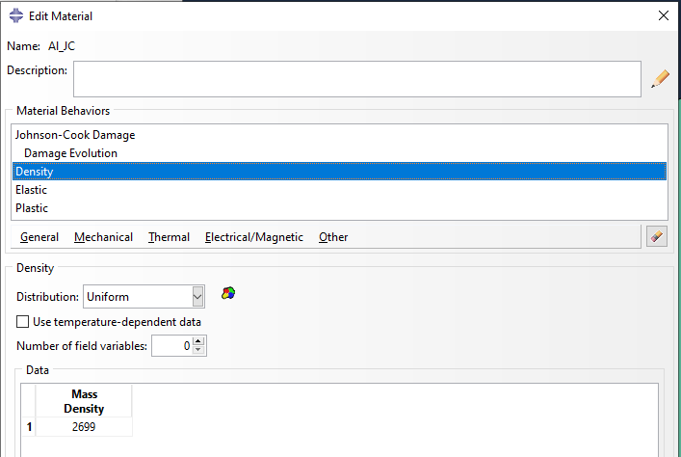
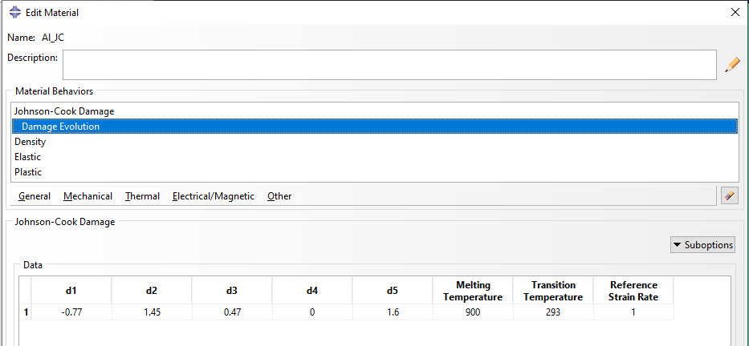
Figure [6] – ‘Edit Material’ section for Density Figure [7] – ‘Edit Material’ section for Damage evolution

Dimensions
The dimensions for the aluminium plate which is being hit by the projectile were 0.3m length, 0.3m width and 0.035m depth.

Why the properties were chosen
The Johnson-Cook properties were chosen for the plate model because they work effectively in dynamic scenarios. These types of models are used widely to predict mechanical properties of materials. It predicts the deformation behaviour of the material over a wide range of strain rates and temperatures. The disadvantage of using this model is that a large amount of experimental data is required for developing the data [2]. However, the numbers have been found using the Lesuer et al. model [3] and not tested by the experimentalist of this report.
The Johnson-Cook values were not used for the steel projectile as this then also deforms the projectile. It was decided that the model would be easier to analyse and see by removing these values and only using density and elastic material behaviour values.
The dimensions were chosen as they display the stress strain values clearly for both the projectile and the plate. The plate has been made to the chosen size so that it can withstand a higher level of stress pointed in the centre by the projectile.

Investigation into the change in velocity of the Projectile
The property chosen to be investigated in this report is velocity. The velocities of the projectile have been measured at between 500ms⁻¹ and 3000ms⁻¹ (not including 100ms⁻¹) with increasing increments of 500 ms⁻¹. For each velocity, the frame and time increment are measured at the first frame, the point of the tip of the projectile aligning with the back surface of the plate, the back of the projectile being aligned with the back surface of the plate and a graph of the velocity change over time. Also, the tensile stress and shear stress are measured against each other to determine the possible failure mode of the plate, conical cracking (caused by shear stress) or star cracking (caused by tensile stress).

Results
For each of the tested velocities, there has been multiple pieces of data taken. For each one which the projectile penetrated the plate, the first frame is taken to show the initial impact, then the frame which shows the tip of the projectile being aligned with the back side of the plate, both shear stress and tensile stress, then the time frame which the back of the projectile is aligned with the back side of the plate and finally the velocity-time graph to compare the velocities over time.
For the velocity where the projectile bounces off the plate, the time frame where the projectile stops moving before bouncing off, with both shear and tensile stresses, the first frame to show initial contact and the velocity-time graph are the data being used.

Velocity of 500ms⁻¹
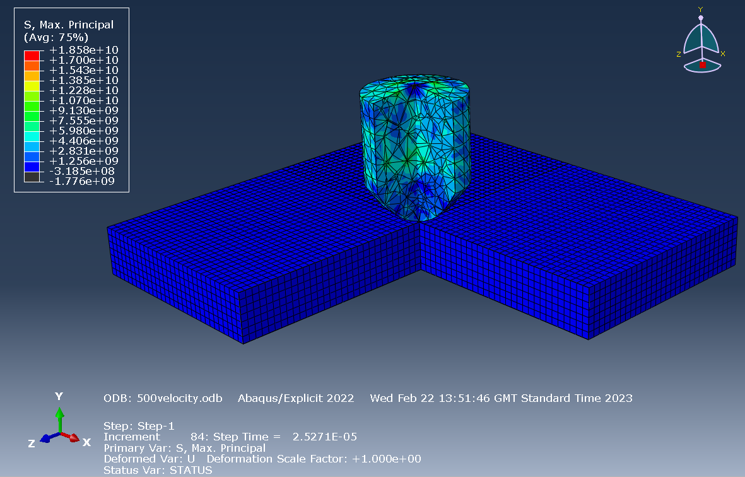 | Velocity 500ms⁻¹ – Figure [8] – shows frame 1 of the experiment at the time increment of 84
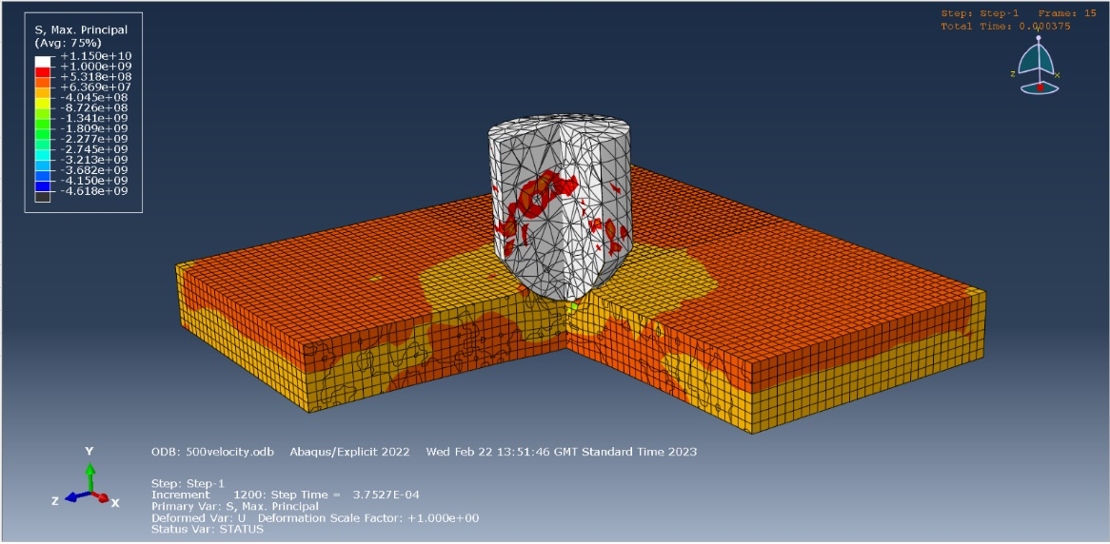 | Velocity 500ms⁻¹ – figure [9] shows frame 15 of the experiment at the time increment of 1200 – this is the point where the projectile stops before bouncing off of the plate. The colouring signifies tensile stress with highs of -1.341e+09.
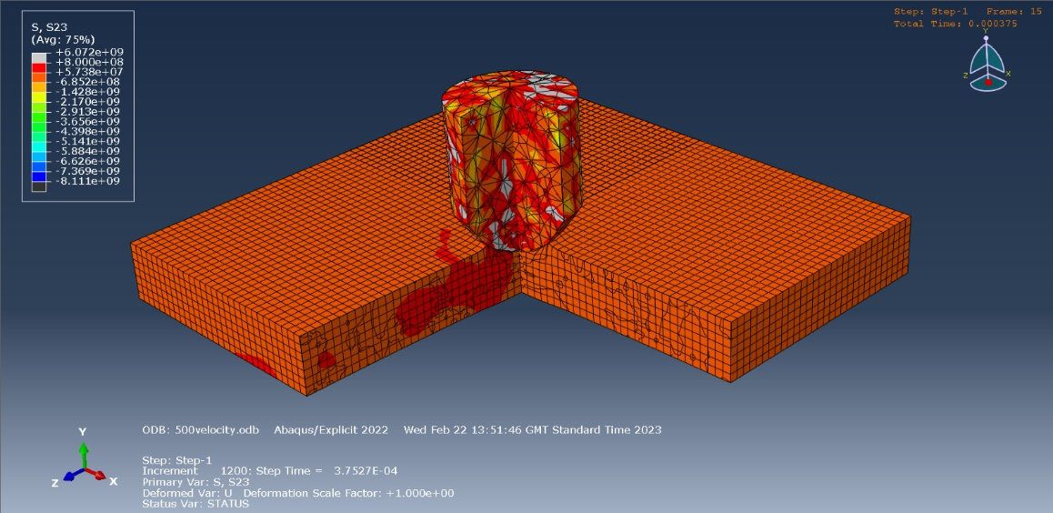 | Velocity 500ms⁻¹ - figure [10] - shows the same as above but the colouring signifies shear stress. Shear stress has highs of -6.852e+08.
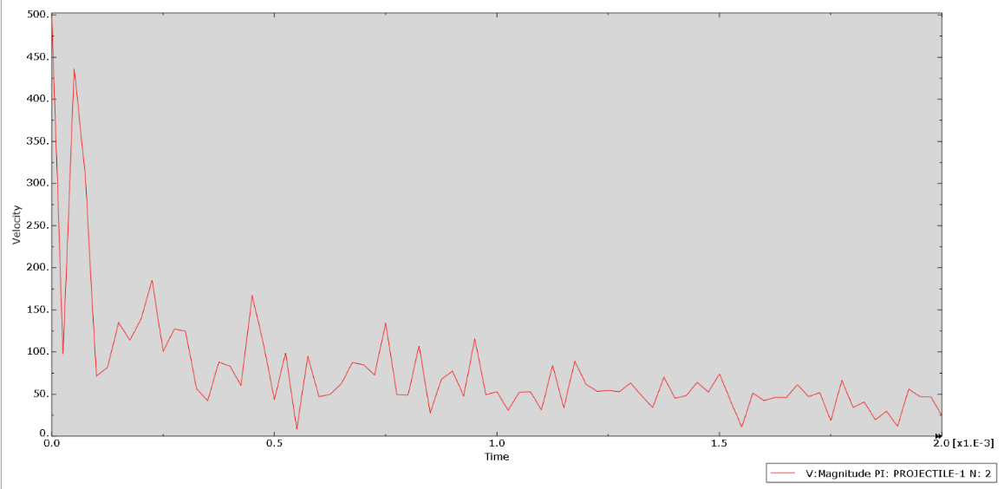 | Figure [11] – shows a velocity- time graph at the projectile with a starting velocity of 500ms⁻¹.

Velocity of 1500ms⁻¹
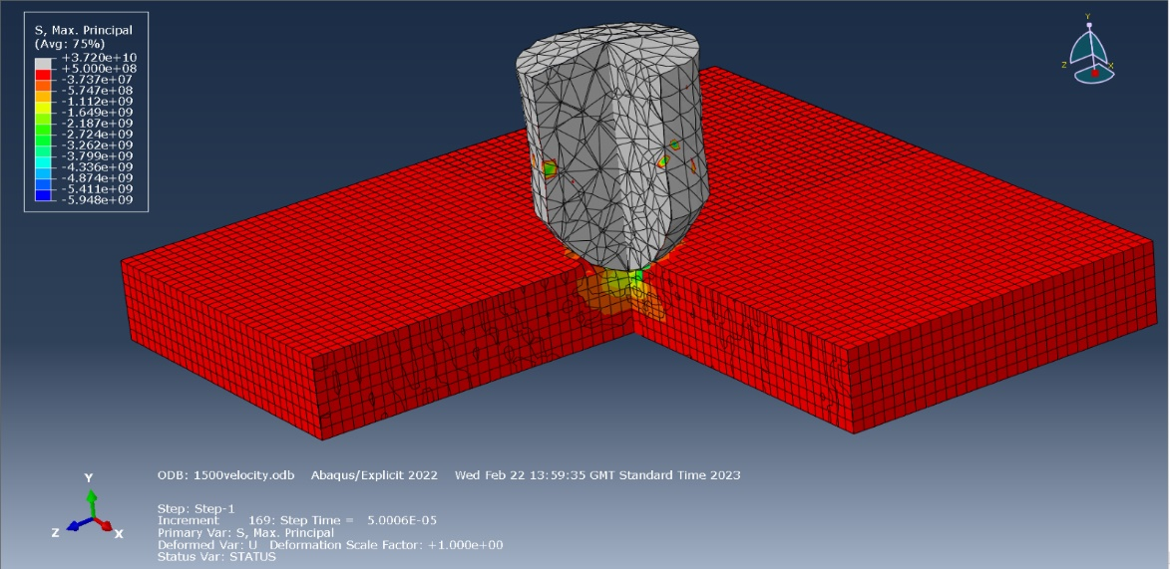 | Velocity 1500ms⁻¹ – Figure [12] – shows frame 1 of the experiment at the time increment of 88
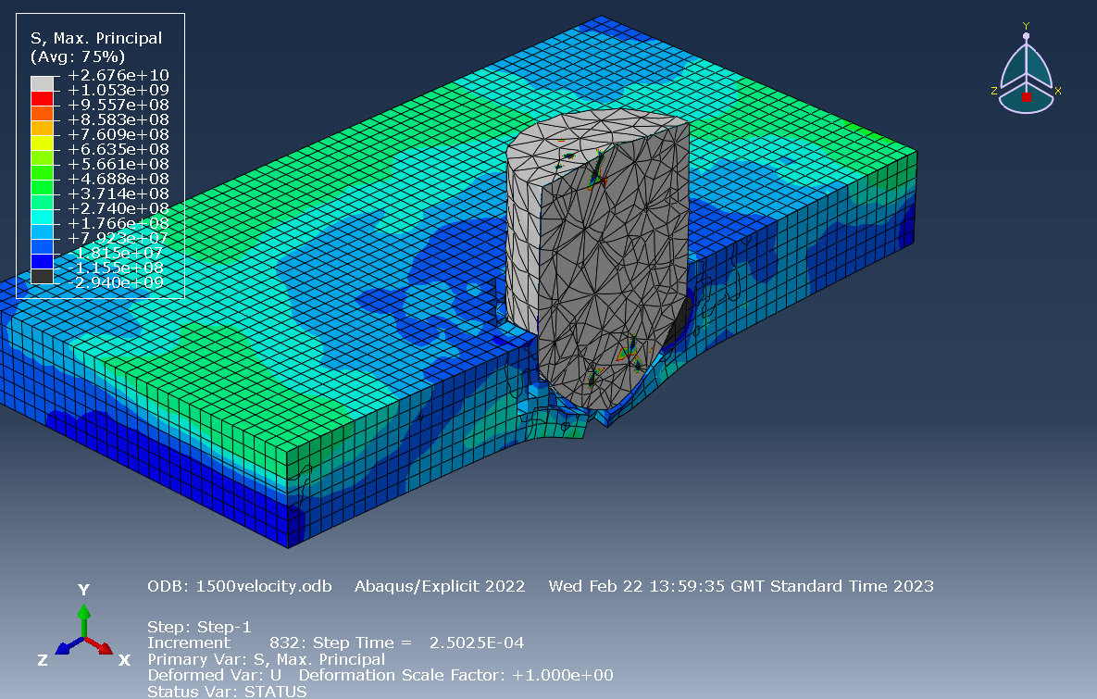 | Velocity 1500ms⁻¹ – figure [13] - shows frame 10 of the experiment at the time increment of 832 – this is the point where the projectile’s tip is aligned with the back surface of the plate. The colouring signifies tensile stress with highs of +7.923e+07.
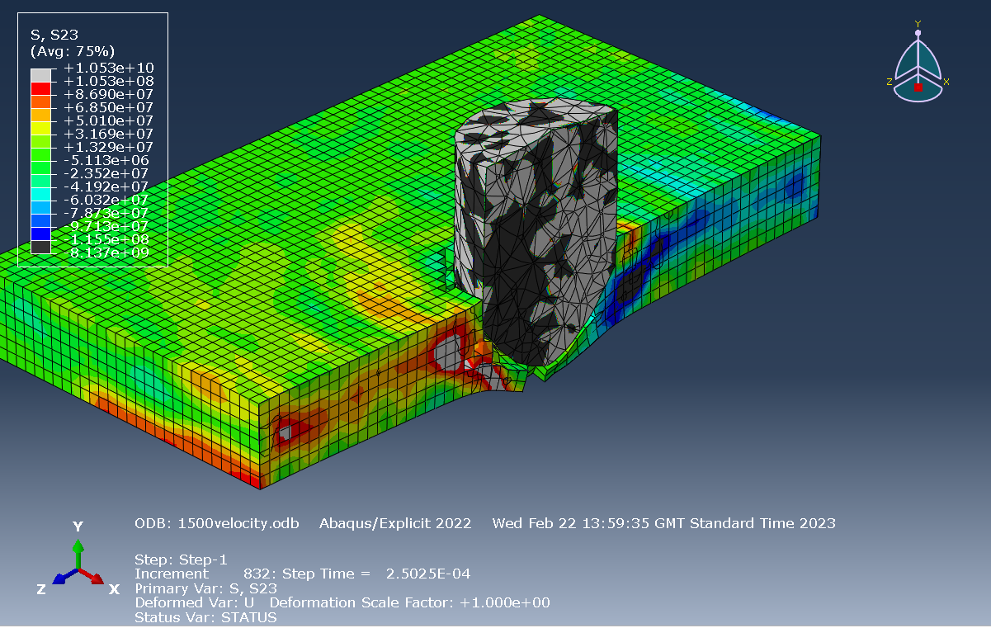 | Velocity 1500ms⁻¹ – figure [14] – same as above however this colouring is showing shear stress. In this case the stress is showing highs of -5.113e+06.
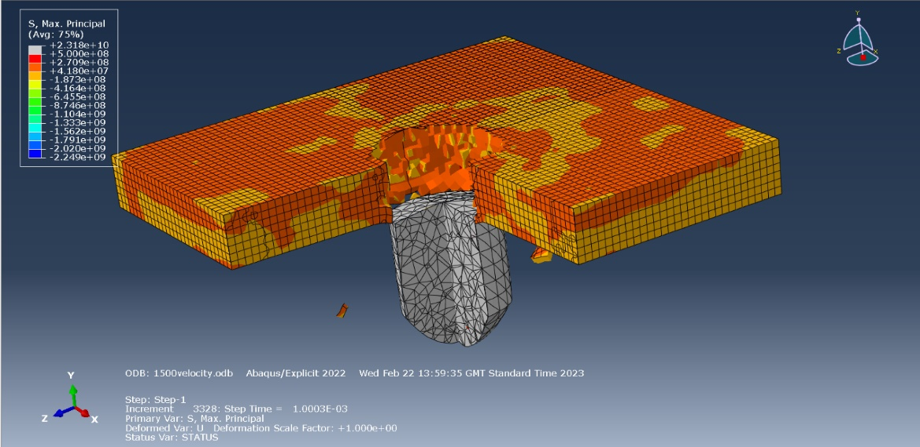 | Velocity 1500ms⁻¹ – figure [15] -shows frame 40 of the experiment at the time increment of 3328 – this is the point where the back side of the projectile is aligned with the back side of the plate. The colouring signifies tensile stress.
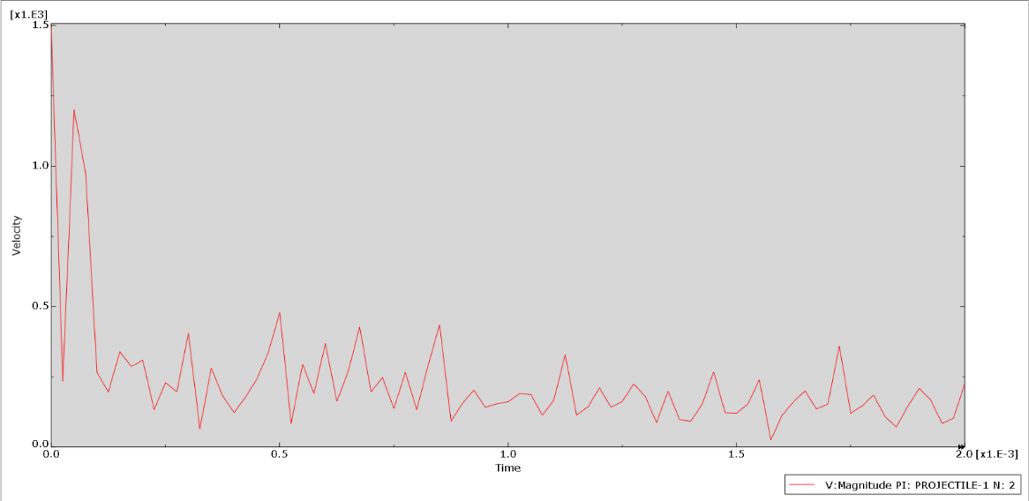 | Figure [16] – shows a velocity- time graph at the projectile with a starting velocity of 1500ms⁻¹.

Velocity of 2000ms⁻¹
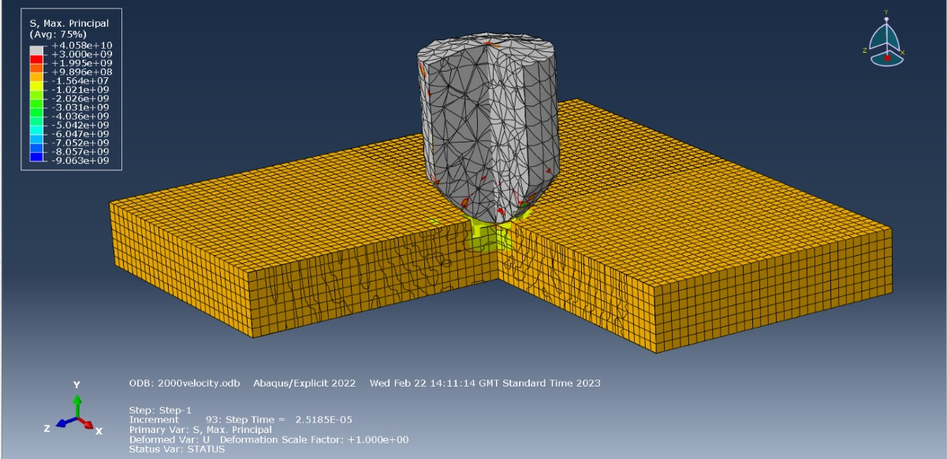 | Velocity 2000ms⁻¹ – Figure [17] – shows frame 1 of the experiment at the time increment of 93
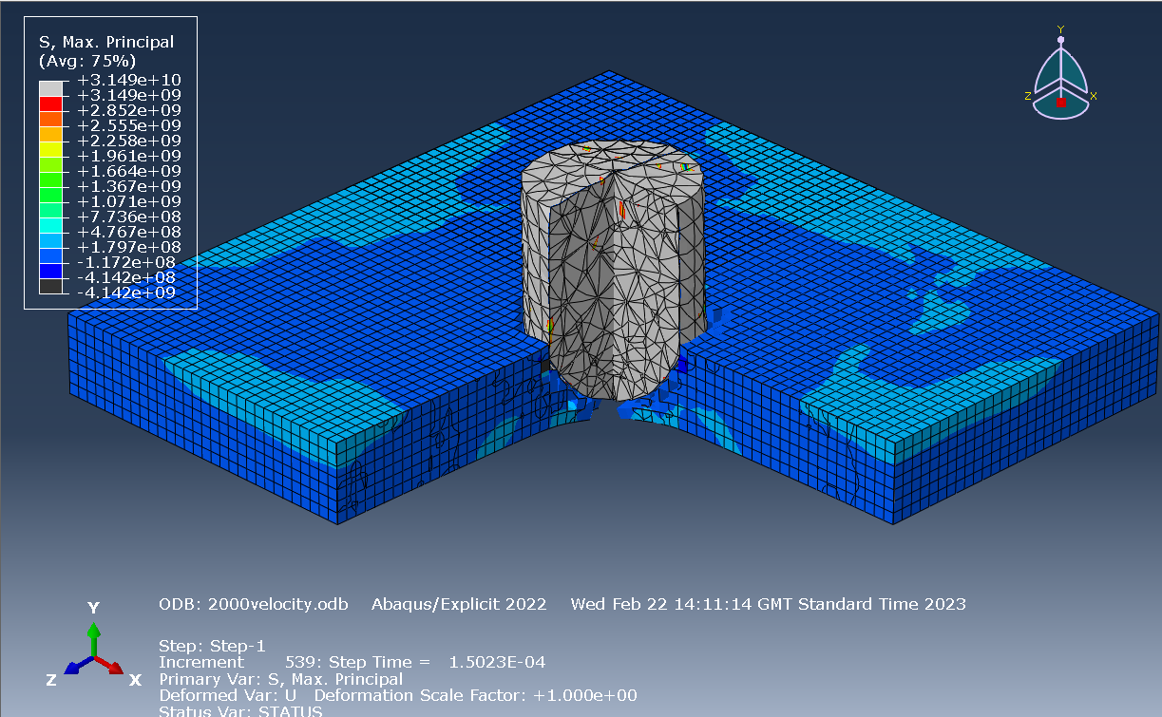 | Velocity 2000ms⁻¹ – figure [18] - shows frame 6 of the experiment at the time increment of 539 – this is the point where the projectile’s tip is aligned with the back surface of the plate. The colouring signifies tensile stress with highs of +1.797e+08.
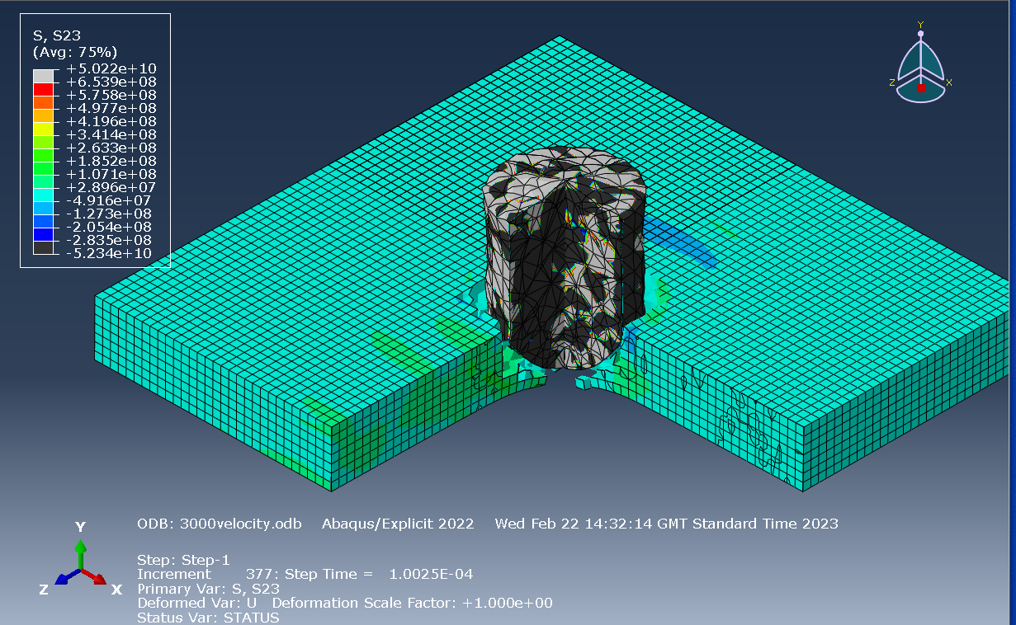 | Figure [19] – same as above however this colouring is showing shear stress. In this case the stress is showing highs of -4.916e+07.
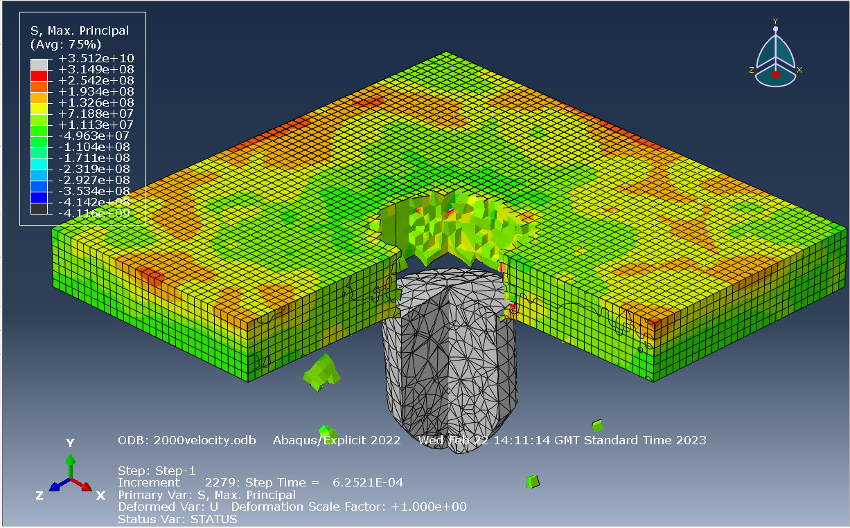 | Velocity 2000ms⁻¹ – figure [20] -shows frame 25 of the experiment at the time increment of 2279 – this is the point where the back side of the projectile is aligned with the back side of the plate. The colouring signifies tensile stress.
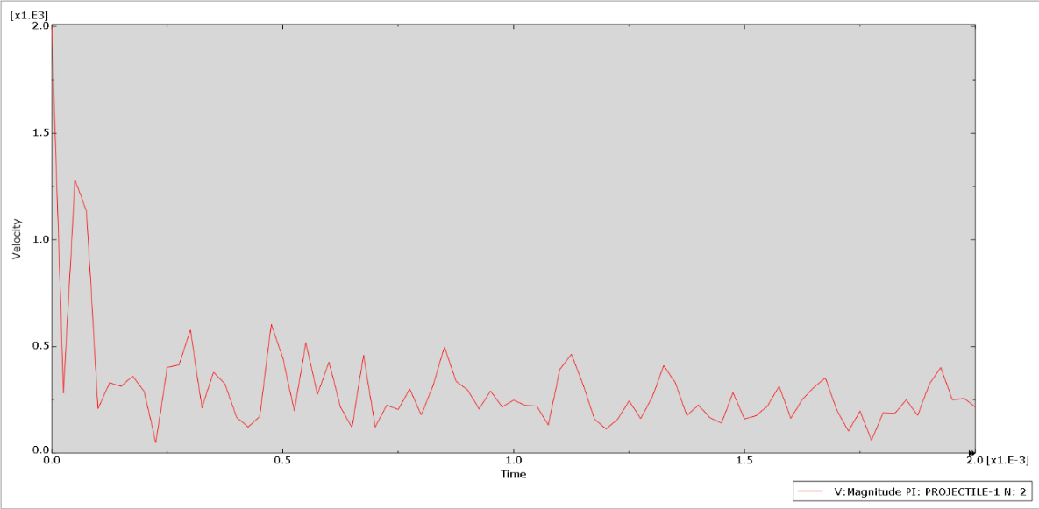 | Figure [21] – shows a velocity- time graph at the projectile with a starting velocity of 2000ms⁻¹.

Velocity of 2500ms⁻¹
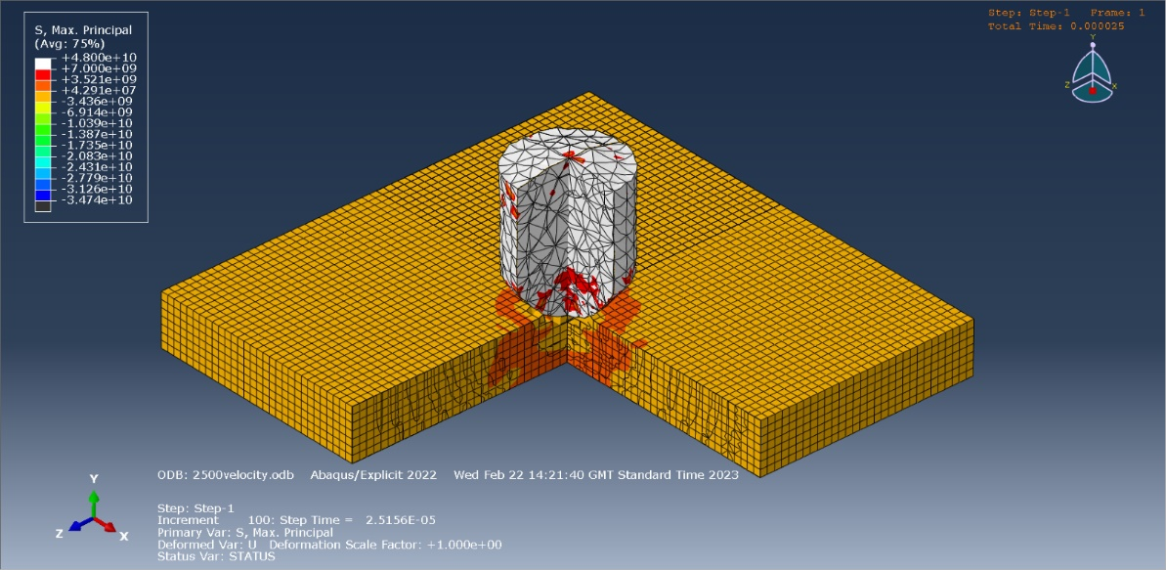 | Velocity 2500ms⁻¹ – Figure [22] – shows frame 1 of the experiment at the time increment of 100
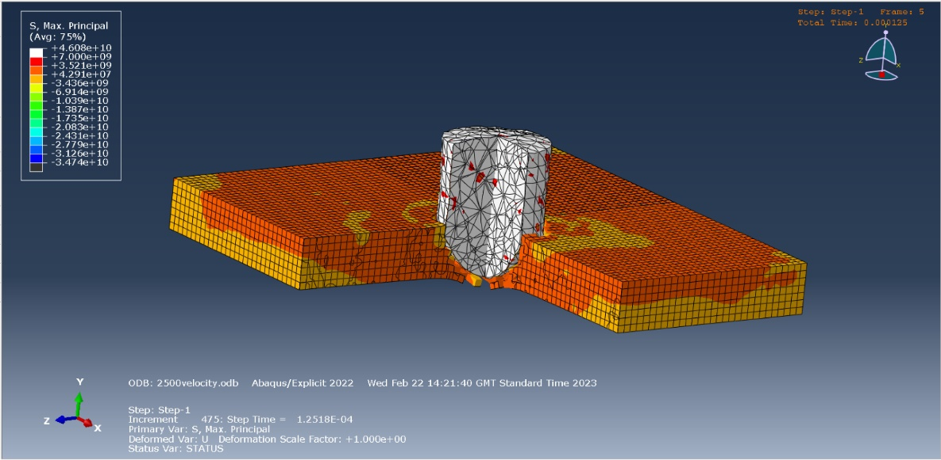 | Velocity 2500ms⁻¹ – figure [23] - shows frame 5 of the experiment at the time increment of 475 – this is the point where the projectile’s tip is aligned with the back surface of the plate. The colouring signifies tensile stress with highs of +4.291e+07.
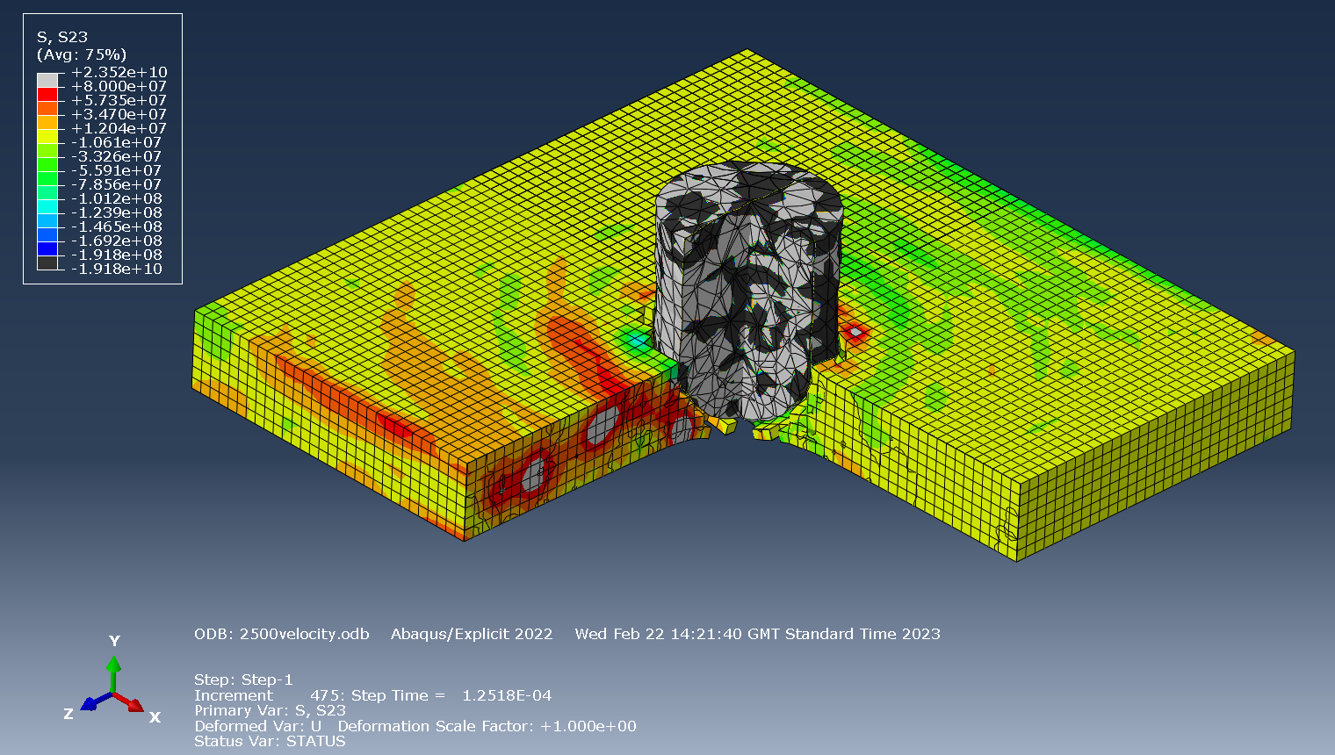 | Figure [24] – same as above however this colouring is showing shear stress. In this case the stress is showing highs of -1.012e+08.
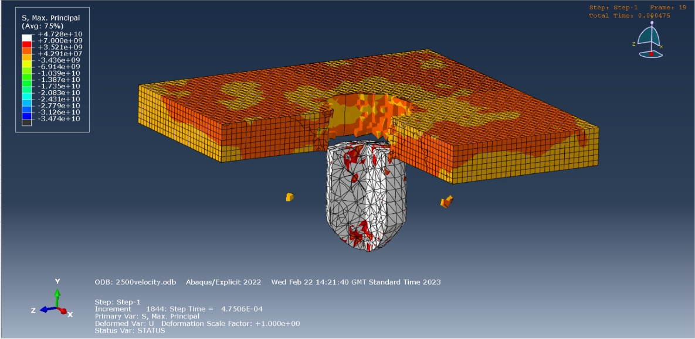 | Velocity 2500ms⁻¹ - figure [25] -shows frame 19 of the experiment at the time increment of 1844 – this is the point where the back side of the projectile is aligned with the back side of the plate. The colouring signifies tensile stress.
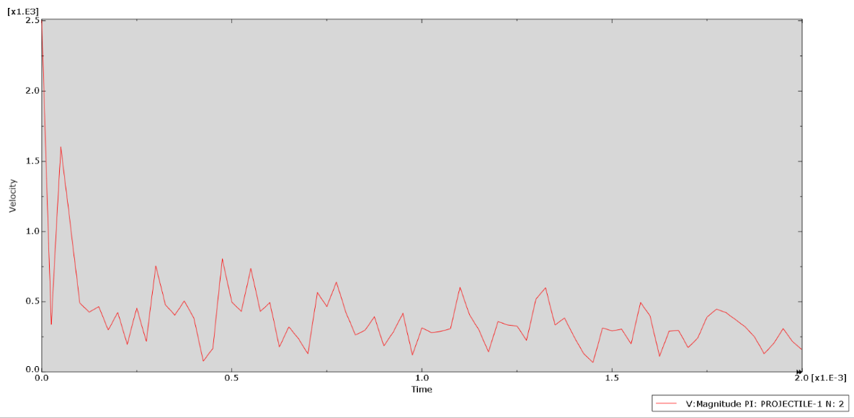 | Figure [26] – shows a velocity- time graph at the projectile with a starting velocity of 2500ms⁻¹.

Velocity of 3000ms⁻¹
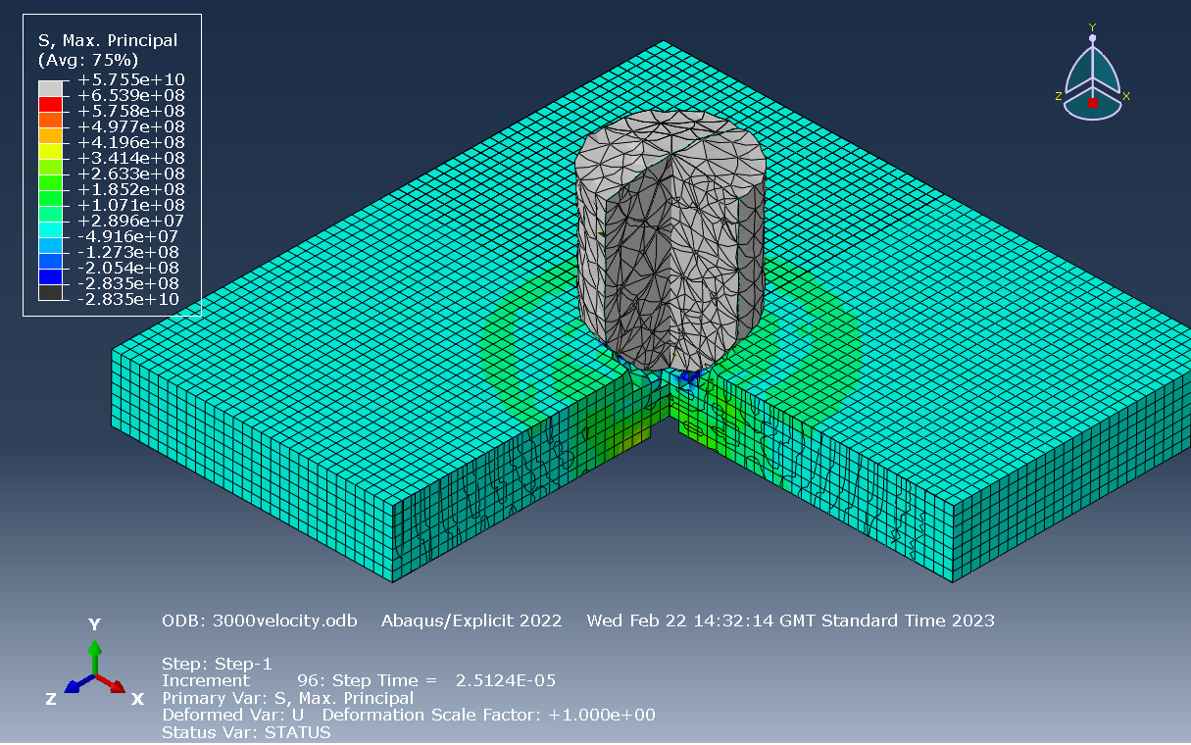 | Velocity 3000ms⁻¹ – Figure [27] – shows frame 1 of the experiment at the time increment of 96
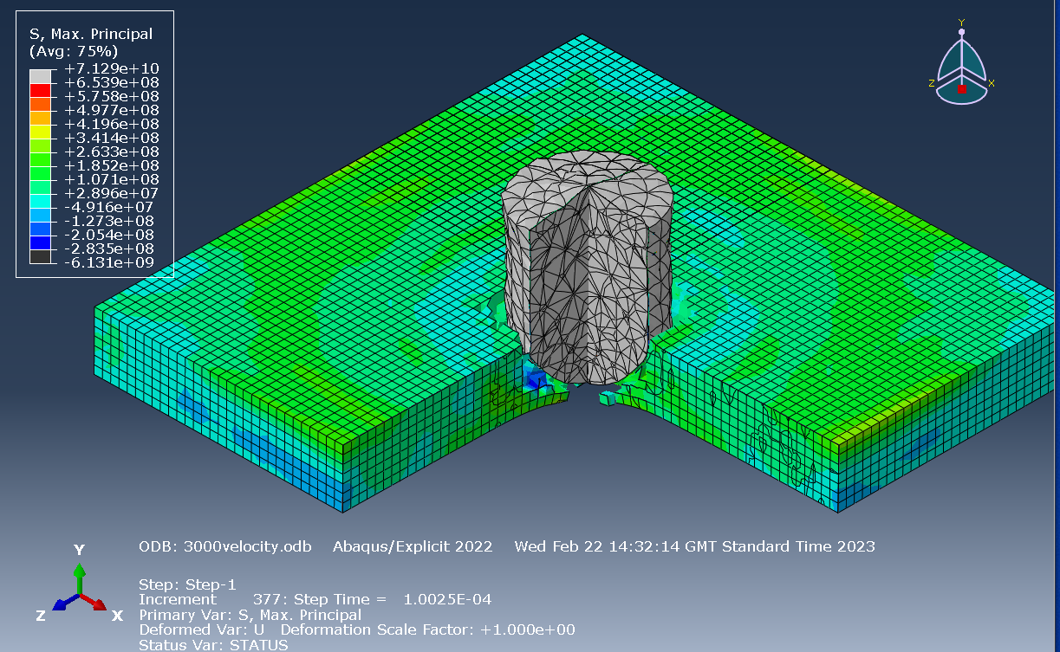 | Velocity 3000ms⁻¹ – figure [28] - shows frame 4 of the experiment at the time increment of 377 – this is the point where the projectile’s tip is aligned with the back surface of the plate. The colouring signifies tensile stress with highs of -2.054e+08.
 | Figure [29] – same as above however this colouring is showing shear stress. In this case the stress is showing highs of 2.896e+07.
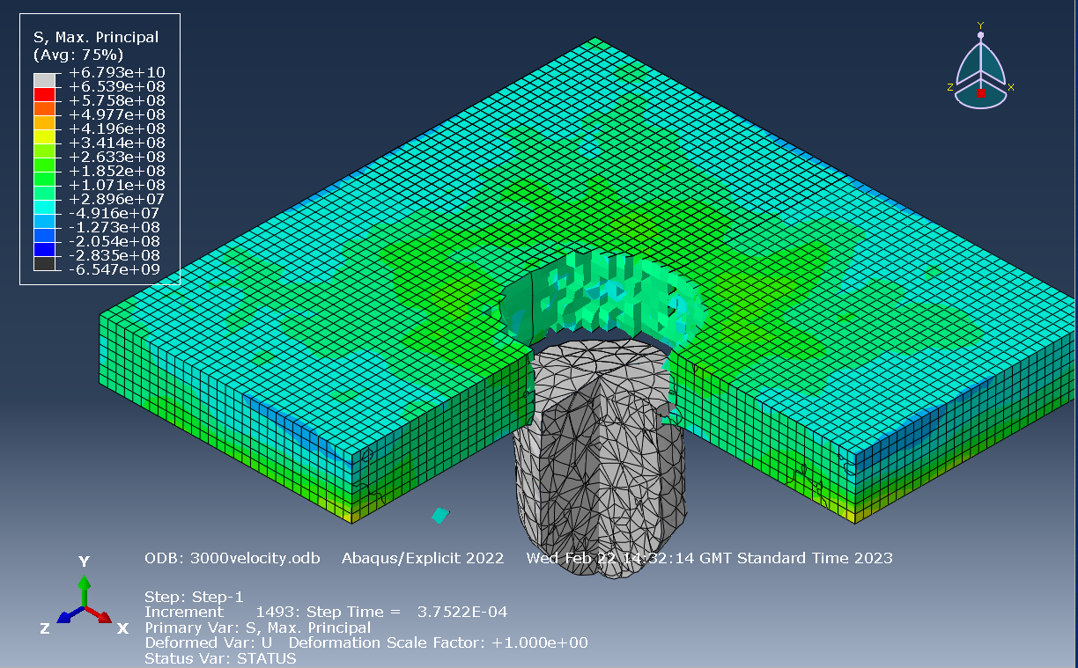 | Velocity 3000ms⁻¹ - figure [30] -shows frame 15 of the experiment at the time increment of 1493 – this is the point where the back side of the projectile is aligned with the back side of the plate. The colouring signifies tensile stress.
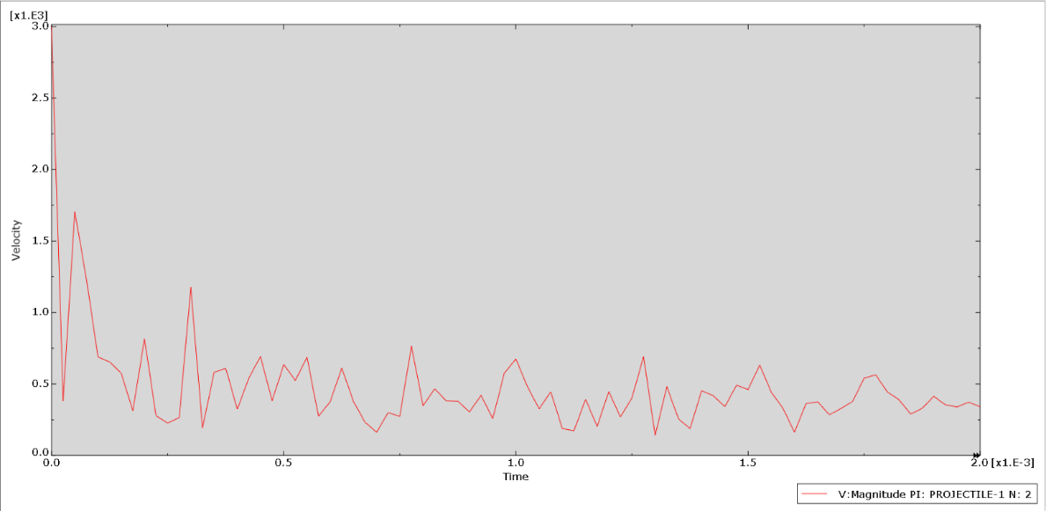 | Figure [31] – shows a velocity- time graph at the projectile with a starting velocity of 3000ms⁻¹.

Comparison of results
Below is the data all put together in a couple of graphs to show haw the information from each velocity is compared. Specifically, in figure [32], the velocity is compared to the time increments where the projectile either stops before it bounces back off the plate or its tip reaches the back surface of the plate and when the back end of the projectile aligns with the back side of the plate. In figure [33], the velocity has been compared to stress values of shear and tensile stress. This gives an indication of whether the plate’s failure is due to shear or tensile stresses.

Figure [32] – graph of velocity comparison to time increments

Figure [33] – graph of velocity comparison to stress values

Analysis and Evaluation of results
From the first graph in figure [32], a clear trend is shown which proves a suspected hypothesis that the time increment decreases then the velocity increases, which is likely due to the penetration of the projectile being quicker through the plate at higher speeds. Although this doesn’t provide stress-strain data, as this report is investigating, this does however show that the projectile and plate are behaving as expected as the time increment decreases when the velocity increases. The exception to this is at 500ms⁻¹ where the projectile bounced off the plate, so the data is different to the rest.
Using the second graph in figure [33], at all the velocities except 2500ms⁻¹ there is a higher tensile stress value which suggests the failure of the material is due to tensile stress. For the exception, this indicates there is a higher chance of the plate failing due to shear stress. This is also backed up by the screenshots as there is clear high and low stress areas at opposite sides showing the possibility of shear stress failure, opposed to the more cylindrical stress shapes from the screenshots showing the possibility of tensile stress failures.
The Time increment graphs in figures [11,16,21,26 ,31] show a node’s movement throughout the experiment. When the velocity increases, the noise and movement of the node on the graphs also increases. In general, the graphs have the same pattern, start high at the velocity values, velocity drops right down when the plate is hit and then the velocity increases as it passes through/ bounces off the plate.
The data is reliable as the Abacus software is accurate and trustworthy for this type of experiment however there are possibilities of issues with the inputs and the data provided. The projectile didn’t use Johnson-Cook values for its material so it is assuming the projectile wouldn’t break or bend during testing, which is not true. Also, the data is shown in frames so there is missing data in between the frames which could have provided valuable data in this report. With calculating the stress values, it was difficult to measure which value to use and which time frame to use as the stress colours changed and multiple values cold have been chosen, this provides doubts in the data received.

Conclusion and further testing
In conclusion, further testing would be required to better this model and reduce doubt on the data. To improve the Abacus model, the Johnson-Cook values could be added for the projectile to show damage, also using other software to compare results of experiment and finally the use of real-life testing could be used to test out the theories with the possibility of gauges or probes as a diagnostic option.

References

[1] | 3DS Simulia, “ABAQUS/CAE - COMPLETE SOLUTION FOR ABAQUS FINITE ELEMENT MODELING, VISUALIZATION, AND PROCESS AUTOMATION,” [Online]. Available: https://www.3ds.com/products-services/simulia/products/abaqus/abaquscae/. [Accessed 02 05 2023].
[2] | C. Rodean, L.-D. Beju, G. Rusu and M. Popp, “The Usage of the Johnson-Cook Constitutive Model in the Finite Element Analysis of the Caulking Process,” MATEC Web of Conferences, Sibiu, Romania, 2019.
[3] | S. Akram, S. Jaffrey, M. Khan, M. Fahad, A. Mubashar and L. Ali, “Numerical and experimental investigation of Johnson–Cook material models for aluminum (Al 6061-T6) alloy using orthogonal machining approach,” Advances in Mechanical Engineering, vol. 10, p. 6, 2018.

