Student: Constantin Bogdan Rusu(2014305)
Lecturer: Tristan Hawkins

BA INTERNATIONAL HOTEL MANAGEMENT - FINANCIAL MANAGEMENT FOR THE HOTEL INDUSTRY
Report Case Study: Urban Heights Hotel

Executive summary
This case study focuses on analysing the financial performance of the Urban Heights hotel, a hospitality provider that offers accommodation, restaurant services, bar services, and event facilities located in an urban area. Considering that in the last three years, the organisation has suffered a decline in income, occupancy rates, and customer satisfaction, its owner is concerned. Therefore, the owner seeks to determine whether a turnaround plan can save the business. The case study employs risk management tactics to identify the financial risks faced by the Urban Heights hotel, evaluate their severity, and find solutions to mitigate them.
The analysis found that there is a concerning trend of declining profitability for the Urban Heights Hotel. Market and operational risks are the primary reasons for the decrease in profitability.
To address the above risks, the company can diversify its revenue streams or increase the efficiency of the existing revenue streams. Additionally, it could improve pricing strategies, revenue management, or cost control measures. Furthermore, the hotel must diminish operational inefficiencies, such as poor inventory management, ineffective maintenance and housekeeping practices, or inadequate staffing levels. Moreover, it can implement sustainable practices to increase brand equity and attract environmentally conscious travellers.

Table of Contents
Executive summary 1
Introduction 3
The Urban Heights Hotel's financial performance 3
Financial Analysis Ratios 7
Primary factors contributing to the decrease in profitability 9
Strategy 11
Conclusion 11
References 11

Figure 1. Income Statement data illustration 4
Figure 2. Assets 5
Figure 3. Liabilities 6
Figure 4. Equity 6
Figure 5. 2023 like-for-like hospitality sales versus inflation 10

Table 1. Current Ratio 7
Table 2. Debt to Equity Ratio 8
Table 3. Return on Equity 8

Introduction
This case study focuses on analysing the financial performance of the Urban Heights hotel, a hospitality provider that offers accommodation, restaurant services, bar services, and event facilities located in an urban area. Considering that in the last three years, the organisation has suffered a decline in income, occupancy rates, and customer satisfaction, its owner is concerned. Therefore, the owner seeks to determine whether a turnaround plan can save the business.
The case study will employ risk management tactics to identify the financial risks faced by the Urban Heights hotel, evaluate their severity, and find solutions to mitigate them. The goals of the evaluation include the evaluation of the trends and patterns in the firm's financial performance in the last three reporting periods, focusing on revenue, expenses, profitability, liquidity, and solvency; the identification of the main causes of the decreasing profitability based on macroeconomic factors and the challenges in the current economy; and the proposal of a turnaround strategy to consolidate the organisation's financial health and reestablish its reputation.
According to Lancaster and Goff (2023), financial risk management is essential for protecting the company's finances and mitigating potential losses. An effective financial risk management approach is impacted by factors such as robust cash flow, diversification, and proficient financial management. Effective financial risk management results in reduced expenses, enhanced decision-making, and increased income (Lancaster and Goff, 2023). Therefore, it is crucial to comprehend financial risks and consistently and effectively manage them.

The Urban Heights Hotel's financial performance
According to CFI Education Inc. (2024a), the process of financial risk management includes five steps:
- the identification of the risk;
- the assessment and quantification of the risk;
- the implementation of a strategy to manage it;
- and the monitoring strategy’s effectiveness.
A financial risk can be defined as an event or occurrence that is negatively impacting the financial performance of an organisation (CFI Education Inc., 2024a).
The procedure begins with the identification of the risk, which is a critical first step. During this stage, it is essential to take into account any and all potential occurrences or events that have the potential to have a detrimental effect on the financial situation (CFI Education Inc., 2024a). The various risks that could arise can be stated in a list, and they are typically classified according to the different categories of financial hazards.
In the case of the Urban Heights hotel, among the most suitable tools that can be utilised to assist in the identification of financial hazards are:
- Conducting an analysis of the current state of the finances.
- Utilising previous instances of financial strain as a point of reference.
- Utilising financial risk checklists that have been predetermined.
For this assessment, the most appropriate approach is to conduct an analysis of the current state of the Urban Heights hotel's finances.
The following figure illustrates the data regarding the revenue, operating expenses, and net income of the Urban Heights Hotel over the last three reporting periods.
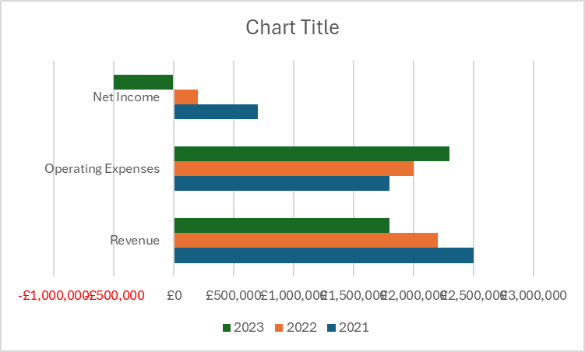
Figure 1. Income Statement data illustration
This illustration provides a breakdown of the revenue, operating expenses, and net income for each year, allowing for an immediate analysis of the financial performance.

The revenue has decreased over the analysed period. The calculations of the change in revenue indicate a decline in revenue of 12% from 2021 to 2022, a further decline of 18.18% from 2022 to 2023, a decrease in revenue of £300,000 from 2021 to 2022, and a decrease in revenue of £700,000 from 2021 to 2023. ​

The calculations of the change in operating expenses indicate an increase in operating expenses of 11.11% from 2021 to 2022, a further increase of 15% from 2022 to 2023, an increase in operating expenses of £200,000 from 2021 to 2022, and an increase in operating expenses of £500,000 from 2021 to 2023. ​
The change in net income is calculated as follows: ​
- A decline of 71.43% from 2021 to 2022.
- A further decline of 350% from 2022 to 2023. ​
- A decrease of £500,000 from 2021 to 2022. ​
- A decrease of £1,200,000 from 2021 to 2023. ​
As a result, there is a concerning trend of declining profitability for the Urban Heights Hotel. The decline in net income can be attributed to factors such as a decrease in revenue and an increase in operating expenses. These changes resulted in a significant decrease in net income over the three-year period. Hence, it is crucial for the hotel to address the underlying issues causing this decline and implement a turnaround strategy to improve its financial health and restore profitability. ​
The following figure illustrates the data regarding the company’s assets.
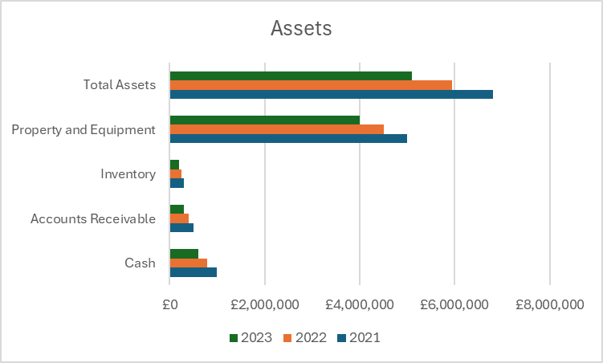
Figure 2. Assets
The analysis of the provided data shows the following insights related to total assets:
- A decrease of 7.8% from 2021 to 2022.
- A further decrease of 8.3% from 2022 to 2023.
- A decrease of £350,000 from 2021 to 2022. ​
- A decrease of £420,000 from 2021 to 2023.
The following figure illustrates the data regarding the company’s liabilities.
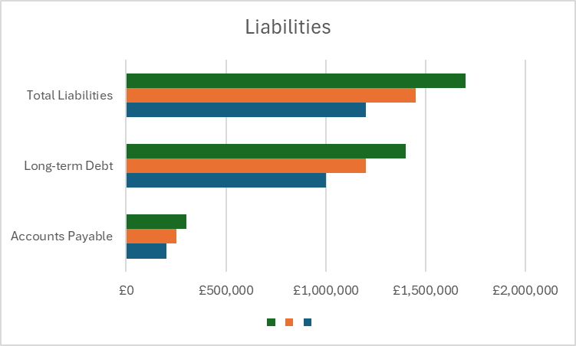
Figure 3. Liabilities
The analysis of the data provided on liabilities shows the following:
- A slight increase of 0.6% from 2021 to 2022.
- A further increase of 0.9% from 2022 to 2023. ​
- An increase of £20,000 from 2021 to 2022. ​
- An increase of £50,000 from 2021 to 2023.

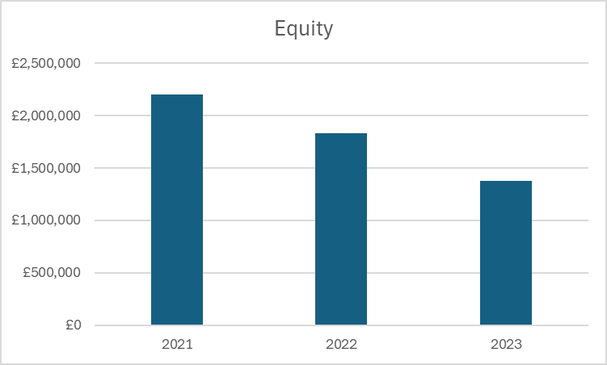
Figure 4. Equity
The analysis of the change in equity reveals the following:
- A decrease of 16.8% from 2021 to 2022.
- A further decrease of 24.6% from 2022 to 2023.
- A decrease of £370,000 from 2021 to 2022. ​
- A decrease of £820,000 from 2021 to 2023.
As a result of the information contained in the balance sheet, the organisation's worth of assets, liabilities, and shareholder equity for the particular period under consideration was presented (Wood and Robinson, 2004). This indicates that the balance sheet has demonstrated not only what the company owns and owes but also the sum of money that shareholders have invested (Fernando, 2024).

Financial Analysis Ratios

Current Ratio
The current ratio is calculated by dividing the total current assets by the total current liabilities. It is an indicator of an enterprise's capacity to fulfill its short-term obligations with its short-term assets (Semczuk, 2024).

 | 2021 | 2022 | 2023
Current Ratio | £450,000 / £250,000 = 1.8 | £300,000 / £270,000 = 1.11 | £180,000 / £300,000 = 0.6
Table 1. Current Ratio
In 2021, the current ratio is 1.8, indicating that the hotel has £1.80 of current assets for every £1 of current liabilities. This implies that the organisation maintains an adequate liquidity position.
The current ratio decreases to 1.11 in 2022, suggesting that the hotel's capacity to satisfy its short-term liabilities with its short-term assets has diminished. This could be cause for concern, as it implies a potential liquidity issue.
The current ratio will further decrease to 0.6 in 2023, which suggests a substantial decrease in the hotel's capacity to fulfil its short-term obligations. This is a concerning indicator, as it implies the possibility of a liquidity crisis.
The company's financial health has deteriorated over the past three years, as evidenced by the analysis of the current ratio, which indicates a substantial decrease in liquidity.

Quick Ratio
In contrast to the current ratio, the quick ratio is a more stringent indicator of a company's liquidity. The term "current assets" does not include inventory, as it is not readily convertible into currency in the short term (Girardin, 2023).
Since the inventory value is not disclosed on the balance sheet, the quick ratio cannot be computed. The absence of this information restricts our capacity to evaluate the company's liquidity position through the quick ratio.

Debt-to-equity ratio

The debt-to-equity ratio is computed by dividing the total debt by the total equity (Wall Street Prep, 2024). Using the information from the Balance Sheet table for the years 2021, 2022, and 2023, we can calculate the debt-to-equity ratio for each year.

 | 2021 | 2022 | 2023
Debt-to-equity ratio | 0.54 | 0.53 | 0.5
Table 2. Debt-to-equity ratio
In 2021, the debt-to-equity ratio will be 0.54, demonstrating a moderate level of debt relative to equity. The next year, it remains relatively stable at 0.53, while in 2023, it decreases to 0.5, indicating a lower level of debt comparative to equity. Overall, the enterprise has maintained a relatively stable level of debt relative to equity over the three-year period. However, in 2023, the company will show improvement by reducing its debt and strengthening its equity position. This suggests a lower financial risk and a healthier balance sheet.

Return on Equity
Return on equity (ROE) is a percentage that represents the annual return of a company (net income) divided by the value of its total shareholders' equity (CFI Education Inc., 2024b).
To calculate ROE for each year, we need to divide the net income by the equity and multiply by 100 to express it as a percentage.
 | 2021 | 2022 | 2023
ROE | (£700,000 / £2,200,000) * 100 ​= 31.82% | (£200,000 / £1,830,000) * 100 = 10.93% | (£-500,000 / £1,380,000) * 100 = -36.23%
Table 3. Return on Equity
The analysis of the calculation shows a decline in ROE over the three-year period, with a significant drop in 2023 resulting in a negative ROE. This indicates a decrease in profitability and efficiency in utilising equity, raising concerns about the hotel's financial performance and its capability to produce returns for its shareholders. Further investigation and strategic measures may be necessary to improve the company's financial health and restore profitability.

Primary factors contributing to the decrease in profitability
The purpose of the second section of the case study is to determine the primary factors that led to the decrease in profitability, taking into account the present state of the economy as well as the events that have occurred in the actual world. Consequently, its objective is to examine the market risks that are linked to fluctuations in market conditions that can have an impact on a hotel's profitability and revenue, as well as the operational risks.
According to Research and Markets (2024), over the past few years, the UK hotel industry has exhibited remarkable resilience in the face of significant economic challenges. The depreciation of the pound sterling following the Brexit referendum increased the accessibility of the country to international tourists, thereby increasing occupancy rates throughout the country. At the same time, domestic tourism experienced an increase, as a greater number of British residents opted for staycations due to the increased relative cost of overseas travel due to the weaker currency. This consistent performance of the hotel industry in the pre-pandemic landscape was a result of the collective impact of these factors.
The analysis by Research and Markets (2024) highlighted the significant negative impact of the COVID-19 pandemic on the hospitality sector. The tourism and hospitality sectors were severely impacted by stringent travel restrictions and subsequent lockdowns, which led to a significant decrease in industry revenue. In spite of these challenges, recent data indicates that the UK hotel industry is on the brink of a robust recovery trajectory. Revenue is expected to increase by an estimated 14.7% in 2022–23, indicating a robust rebound from the pandemic era (Research and Markets, 2024).
According to RSM UK (2024), the inflationary pressure has also negatively impacted the industry. After Russia’s invasion of Ukraine, the global economy has faced higher inflation due to shortages in supplying energy and food (European Council, 2024).
RSM UK (2024) emphasises that the tourism sector faced a persistent struggle with inflation during the year 2023. With only a few instances of like-for-like sales surpassing the consumer price index, a significant increase in revenue was unattainable for all except the top-performing businesses. Instead, companies prioritised maintaining positive cash flow.
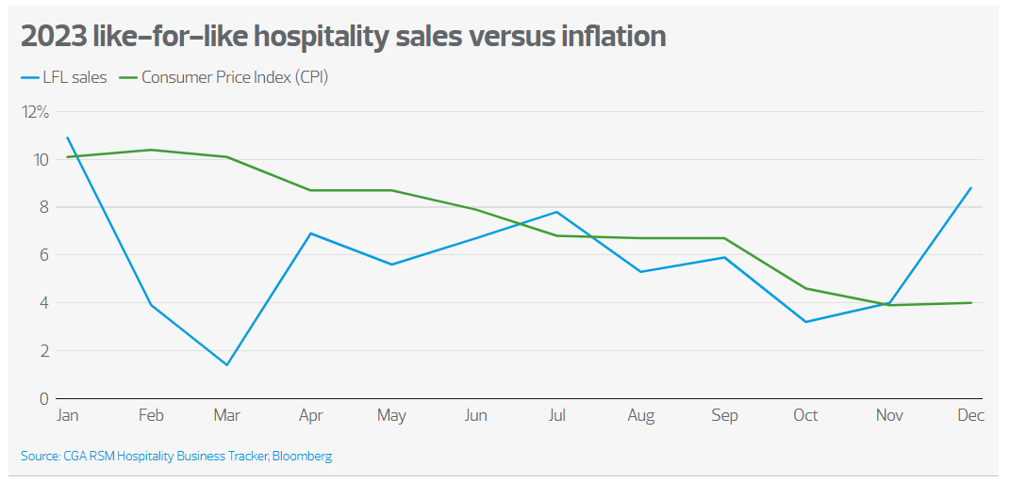
Figure 5. 2023 like-for-like hospitality sales versus inflation
Source: RSM UK, 2024
The decline in revenue, occupancy rates, and customer satisfaction may indicate potential operational risks that the hotel is facing. The decrease in customer satisfaction could be an operational risk, indicating issues with service quality, staff training, or the overall customer experience. Moreover, the decline in occupancy rates suggests challenges in attracting and retaining guests, which could be due to increased competition, ineffective marketing strategies, or a decline in the hotel's reputation.

Strategy
To address the above risks, the company can diversify its revenue streams or increase the efficiency of the existing revenue streams. Additionally, it could improve pricing strategies, revenue management, or cost control measures. Furthermore, the hotel must diminish operational inefficiencies, such as poor inventory management, ineffective maintenance and housekeeping practices, or inadequate staffing levels. Moreover, it can implement sustainable practices to increase brand equity and attract environmentally conscious travellers.

Conclusion
This case study examined the financial performance of the Urban Heights hotel, investigated the primary factors that contributed to the decrease in profitability, and recommended strategies to boost revenues.

References
CFI Education Inc. (2024a) Financial Risk Management Process. Available at: https://corporatefinanceinstitute.com/resources/career-map/sell-side/risk-management/financial-risk-management-process/#:~:text=The%20financial%20risk%20process%20includes,implemented%20to%20manage%20the%20risk. (Accessed: 7 May 2024)
CFI Education Inc. (2024b) Return on Equity (ROE). Available at: https://corporatefinanceinstitute.com/resources/accounting/what-is-return-on-equity-roe/ (Accessed: 20 May 2024)
European Council (2024) Impact of Russia's invasion of Ukraine on the markets: EU response. Available at: https://www.consilium.europa.eu/en/policies/eu-response-ukraine-invasion/impact-of-russia-s-invasion-of-ukraine-on-the-markets-eu-response/#:~:text=people%20and%20goods-,Energy%20prices%20and%20security%20of%20supply,the%20security%20of%20energy%20supply. (Accessed: 27 May 2024)
Fernando, J. (2024) Balance Sheet: Explanation, Components, and Examples. Available at: https://www.investopedia.com/terms/b/balancesheet.asp (Accessed: 10 May 2024)
Girardin, M. (2023) What Is the Quick Ratio? Definition and Formula. Available at: https://www.theforage.com/blog/skills/quick-ratio#:~:text=The%20quick%20ratio%20typically%20excludes,time%20to%20convert%20to%20cash. (Accessed: 15 May 2024)
Lancaster, A., and Goff, S. (2023) Financial Risk Management Fundamentals. Available at: https://www.auditboard.com/blog/financial-risk-management/ (Accessed: 3 May 2024)
Research and Markets (2024) UK Hotel Industry Shows Resilience with Projected Growth Despite Pandemic Challenges. Available at: https://finance.yahoo.com/news/uk-hotel-industry-shows-resilience-234500262.html (Accessed: 27 May 2024)
RSM UK (2024) Leisure and hospitality industry outlook. Available at: https://www.rsmuk.com/insights/consumer-markets-outlook-2024/leisure-and-hospitality (Accessed: 27 May 2024)
Semczuk, N. (2024) Current ratio: What it is and how to calculate it. Available at: https://www.bankrate.com/investing/current-ratio/#:~:text=The%20current%20ratio%20shows%20a,be%20paid%20within%20one%20year. (Accessed: 15 May 2024)
Wall Street Prep (2024) Debt to Equity Ratio (D/E). Available at: https://www.wallstreetprep.com/knowledge/debt-to-equity-ratio/ (Accessed: 20 May 2024)
Wood, F., and Robinson, S. (2004) Book-keeping and Accounts. 6th edn. Harlow: Pearson Education Limited.

