Reflective review on Employability skills (report)

Student name: Agnieszka Janina Wilkosz
Student ID number: 2115098
Programme: Certificate in Higher Education Skills for the Workplace
Module: Academic and Employability Skills
Module code: BMSW 4001
Lecturer name: Terkimbi Atonde

Table of Contents

- Introduction………………………………………3
- Academic skills………………………….………4
- Time management ………………………………...5
- Taking notes ………………………………………..7
- Finding information………………………………..9

- Feedback from teacher…….…………………..9
- Feedback from presentation…..………………10
- Personal development plan……………………11
- Conclusion…………………………………...…...11
- Reference List…………………………...…….…12

Introduction

In this report, I will focus on three things.
Firstly, my academic skills and how learning about them has helped me change my habits. In the second part, I will describe the reflections on the section will focus on the input from the teacher's Report 1 and the final presentation and feedback that I received from my group and my Personal Develop Plan.
In the 21st century, in constant economic and technological development, it is essential to have specific skills. First, I should start from the beginning, what exactly "skill" means. "Skill To be skilled is to be able to perform a learned activity well and at will. A skill is a learned ability rather than an outcome achieved through luck or chance" (Cottrell, 2019).
"Today, because of rapid economic and social change, schools have to prepare students for jobs that have not yet been created, technologies that have not yet been invented, and problems that we don't yet know will arise." (Eccles,2014)
In this report, I will focus on academic skills. What are learning skills? The term study skills here refers to the skills, habits, understandings and attitudes that enable successful studies. (Cottrell, 2019).

1 ACADEMIC SKILLS

Academic capabilities are a set of study routines, forms of learning and time management that enable students to understand and learn what they explain in schools (wiseGEEK, n.d.).

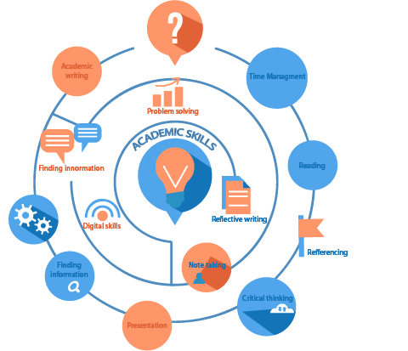

One study showed that time management, taking notes, and reading skills are critical skills during studies. Students with better grades used their learning skills. Also, girls use these methods better than boys. (MASOOD, 2012)
During the classes, I had all academic skills. I will focus on the three most important for me.

  - Time management
Time management while studying is essential. Time flies whether you like it or not. There is nothing worse than feeling wasted time. Time cannot be undone and is the only resource that cannot be recovered. According to Collins Dictionary (2020), time management is "the examination of how time is used and the ability to rank the important assignments with the aim to be efficient in the work". I am a student, but I also work full time. It is hard for me to reconcile my studies, work and private life. I had to plan the work to meet all deadlines and create an action plan. I included time thieves such as social media, friends, family, etc.
This semester I had four assessments to write. I had to plan when I would be doing my job because I could not leave everything until the last minute. I used my entire vacation to attend classes, so it was not possible to take a few days off before the deadline. I learned a lot from preparing a presentation about Donna.
She is a perfect example because she did everything students should not have done. From writing her assessment, everything was more important than writing her assessment. Donna was not an assertive person. She did not make a plan, was unprepared and disorganized.
Time management is an essential skill for me. I always planned everything, even going on vacation. That allows me to feel comfortable and avoid stressful situations like not being able to find the time to complete a task.
During the presentation preparation, I learned a lot about the 4D strategy.

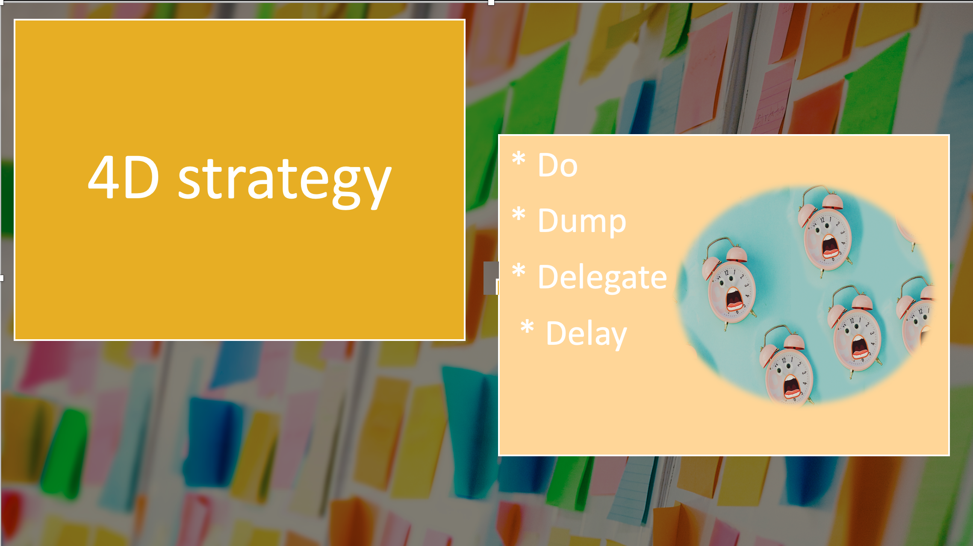

Collection and analysis - I gather tasks on the list and sort them from the most urgent to the least important.
Planning time - I recommended planning about 60% of the time and spending the rest on unplanned matters.
Setting priorities - I divide my plans and activities according to the scheme:
• Important and urgent matters
• Important and non-urgent matters
• Unimportant and urgent matters
• Unimportant and non-urgent matters
Controlling - I try monitoring activities and the progress.
Dosing energy according to the amount of work - I try not to waste your most productive hours of the day on secondary and tertiary matters.
Distractions Avoid distractions - it's hard to concentrate by Internet and social networking sites. Incoming messages and notifications often disturb the work. How can this be done? The answer is simple, silencing the phone or turning off the Internet.
For time management to work correctly in my life, I need to be assertive and learn to say no. I should avoid looking for excuses. The sooner I start, the sooner I will finish. Time management made me feel confident. I felt less stressed. I plan what to do at the end of each day or week. For example, if I need to shop, let's make a list of the things I need to buy to avoid wasting time walking around the store. If I have an enormous task, I divide it into parts so that what I must do does not scare me. I also estimate when I will start performing the job and finishing it. For example, I knew I had to finish the first report by November 26th because I would need feedback from the teacher. When planning my time, I consider that something unprecedented may happen. I try to identify what distracts me the most and takes the most time. I am delighted by the phone and the messages I receive because I stop writing now and then to check who I got the message.
A good solution is to turn off the phone for writing, but I am not assertive enough on this topic yet. So, I also propose to find a place where can focus and a time in which we think best. for me the best time to write is at night. (Cook,2011). My advantages of good time management:

- carrying out the same tasks but with less effort,
- better organization of my work,
- better results at work,
- less stress,
- greater job satisfaction,
- greater motivation,
- less pressure,
- fewer mistakes made during the implementation of tasks,
- faster achievement of professional and private goals.

1.2 Taking notes

No matter how good the student's memory is, taking notes is an essential part of the study.
If you do not save any information, after 20 minutes, you will forget 42% of the information, after 1 hour 56% and after a week you will remember only 25%.
There are many ways to take notes. Three main methods:

- Mind map

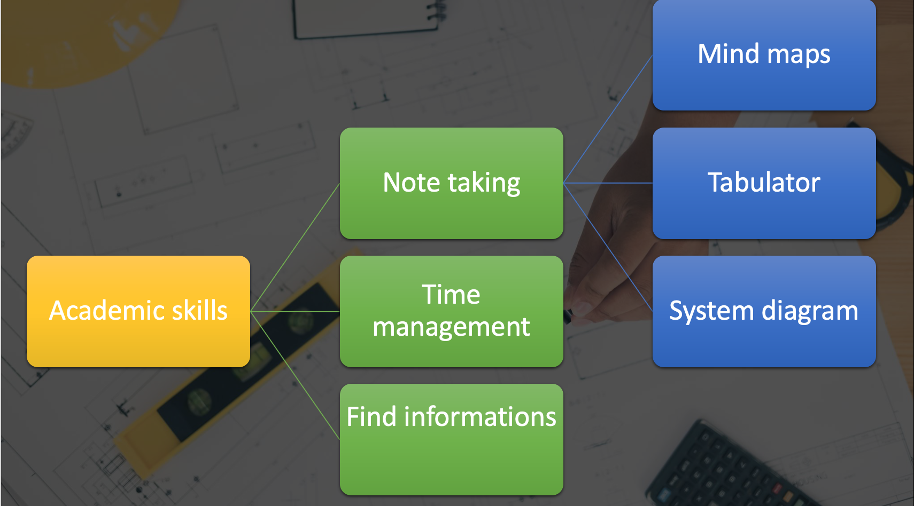

- System diagram

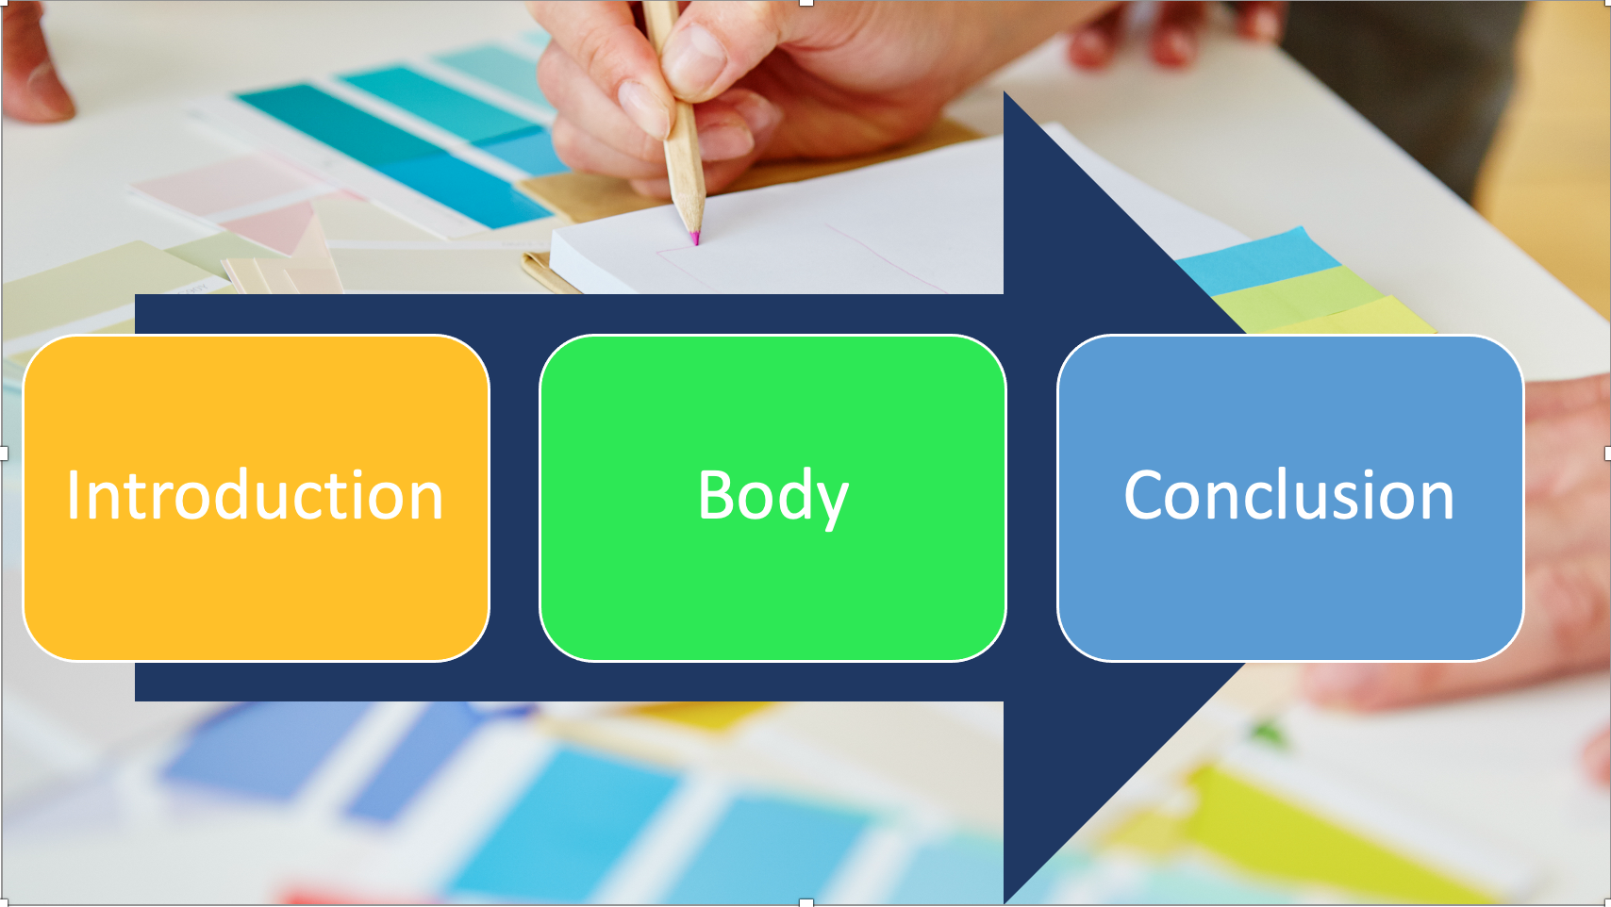

- Tabular note taking

 | PRO’S | CON’S
1ST INFORMACION
2ND INFORMATION

Taking notes is helpful for me because it has shown me how to figure out which information is most important. Therefore, it allows me to focus on essential things. That is, I do not waste my time looking for information. For example, during class, I used mind mapping in my notebook to note down essential information while listening. It is an excellent tool for me, which helped me when writing assessments because the most important information was written down, which allowed me not to forget important things.
Good notes should include the date page number and the title. It should also be short and written in your own words. I write phrases, not whole sentences. I underline the keyword to make it easier to find information later. (Pritchard,2008)

1.3 Finding information

To get a good mark on my assessments, I used information from reliable sources. When writing my works, I used mainly libraries and google scholar. The meeting at which the lady working in the library explained how to use online resources was very helpful. It made it easier for me to find the information because, with the help of search, it was enough to enter the word key to display the information. When writing the first report, I had a problem finding up-to-date information, so it took many hours to find the right books or articles. I should not rely on unreliable internet sites because never know if the information is accurate. In searching for information, the keyword is the most important. I spent many hours looking for information when writing my first report. Still, to this, I have learned how to find valuable information, and I hope to increase this skill with every written academic paper.

- Feedback from teacher

“Feedback is one of the most powerful influences on learning and achievement, but this impact can be either positive or negative.” (Timperley,2007)
Feedback is not advice, evaluation, or approval. That is the information intended to show how to achieve the best effect. It shows the recipient what he did well in his work and what he still must work on or what needs to be changed.
After writing the first report, I got feedback from my teacher about my work.
The picture below shows what my teacher wrote about the first report.

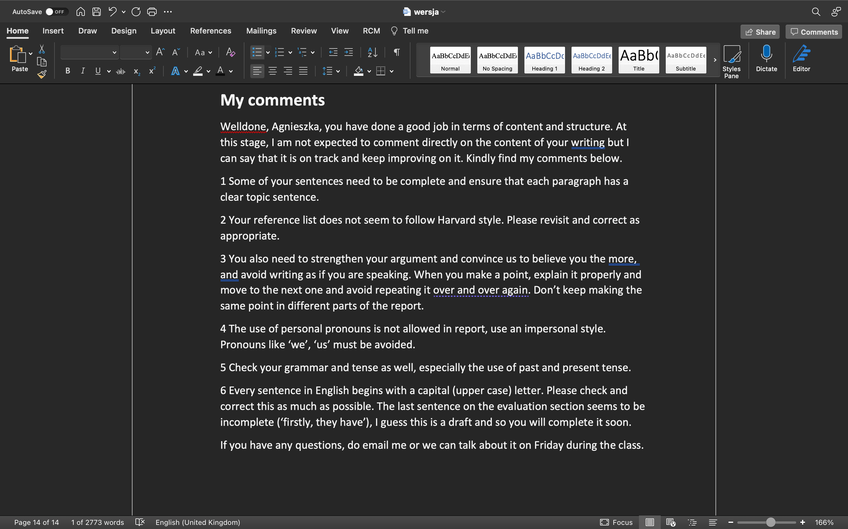

When I started writing my first report, I made a draft and consulted it with my teacher. It was then that I got the first feedback. That allowed me to ensure that I included information I needed in my work. After that, it was straightforward for me to write because I did not have to think about to write when because I had already created a detailed plan and thanks to the teacher's hint, I knew that the idea was the right way.
After writing the entire report, I sent it to the teacher. I was eagerly awaiting his feedback as I took a long time to write.
The feedback turned out not to be so bad. Thanks to what my teacher wrote to me, I was able to pay attention to things that I could have better noted in this report. I checked the grammar and references, and I did not see these errors before reading the description. For example, I did not notice that not all sentences start with a capital letter. Thanks to the fact that the teacher drew my attention to these things, I corrected them.
This feedback was constructive for me and motivated me. Thanks to my teacher he included both positive and negative aspects in his message. He showed me that I did not waste time writing this report. After reading the feedback, I immediately corrected what my teacher mentioned. Thanks to this, I hope that my grade from the first report will be better.

- Feedback from presentation

At one of the classes, I had to prepare a presentation in groups. Together with my team, we made presentations about Donna and her time management problems. We presented in front of all classmates and as well as the teacher during the classes. In the end, everyone received feedback from colleagues and the teacher. We also had a chance to provide feedback on colleagues' presentations. In my opinion, it was an exciting and inspiring experience.
Together with my group, we were assessed by a colleague in 2 criteria—delivery and relevance of the topic. The average score for the delivery was 22.8 points out of 30 and the importance of the topic was 27 points out of 30. In comments, we received positive information about the slides and presented knowledge and information. We should work on slowing down the pace of speech, more confidence, and eye contact. Each presentation requires practice. The more times we could present in front of an audience, the more confidence we have. this has taught me in experience, first, that do not slide create presentations, but my speech. Thanks to this, I will stress less during the presentation because I now know what caused the most significant problem and what I must work on. Thanks to the feedback from a teacher who has more knowledge about the presentation than my colleagues and me, I found out that my group's slides were excellent, but we should practice more to make each subsequent presentation better.

- Personal development plan

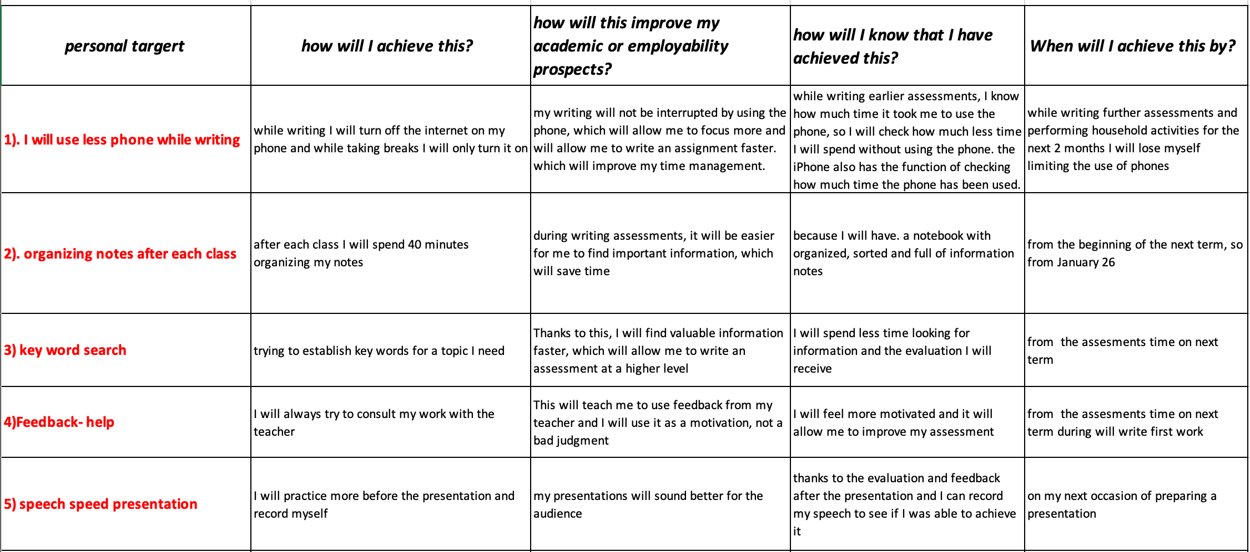

Conclusion

According to the skills definition, it is "the capability to practice the owned knowledges in practice" (Merriam-webster, n.d.). Therefore, you need to use all your skills to succeed in higher education. During our studies, we, as students, learn and improve these behavioural elements.
After writing this report, I can confidently say that skills are related to each other, and if one does not work correctly in my life, I will have a problem with another one. If I don’t manage my workload, my notes will not be any good. It will be hard for me to find helpful information for writing a thesis, which will make my writing time longer and the quality of my work low. Thanks to the feedback I received, I was able to improve my work, and in the future, I know what to pay attention. The feedback was very motivating for me. At the end of my work, I set my development plan, implementing it in the next term. This report made me realize that to achieve good results, I have to work on all my academic skills because I am a human being, and I have learned all my life and only thanks to learning I will be able to achieve perfection.

References

- Cook, S. (2011) Essential time management and organisation a pocket guide. 1st edition. Ely, Cambridgeshire: IT Governance Pub.
- Cottrell, S 2019, The Study Skills Handbook, Bloomsbury Publishing Plc, London. Available from: ProQuest Ebook Central. [18 November 2021].
- FAZAL, S., HUSSAIN, S., MAJOKA, M.I. and MASOOD, S., 2012. The Role of Study Skills in Academic Achievement of Students: A Closer Focus on Gender. Pakistan Journal of Psychological Research, 27(1), pp. 37-51.
- Hattie, J. and Timperley, H. (2007) ‘The Power of Feedback’, Review of Educational Research, 77(1), pp. 81–112. doi: 10.3102/003465430298487.
- Merriam-webster (n.d.). Definition of SKILL. [online] Available at: https://www.merriam-webster.com/dictionary/skill
- Pritchard, A. (2008) Studying and learning at university vital skills for success in your degree. Los Angeles, CA: Sage Publications.
- Suto, I. and Eccles, H., 2014. The Cambridge approach to 21st Century skills: definitions, development and dilemmas for assessment. In IAEA conference, Singapore.
- wiseGEEK. (n.d.). What are Academic Skills. [online] Available at: https://www.wisegeek.com/what-are-academic-skills.htm

