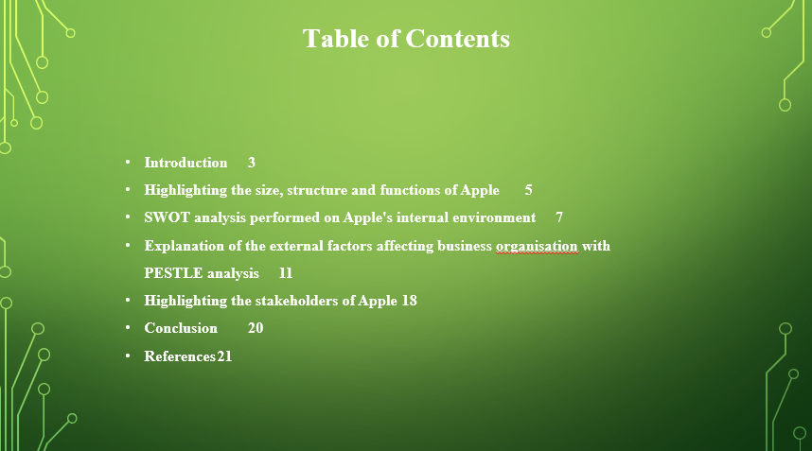

Introduction

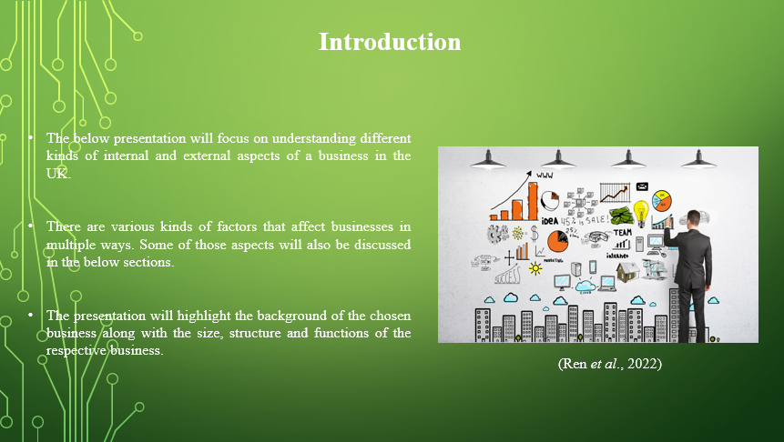
The below presentation will focus on understanding different kinds of internal and external aspects of a business in the UK. There are various kinds of factors that affect businesses in multiple ways. Some of those aspects will also be discussed in the below sections. The presentation will highlight the background of the chosen business along with the size, structure and functions of the respective business. Moreover, there will be various frameworks that will be used to analyse the internal as well as external business environment. Ultimately, the stakeholders of the respective business will also be highlighted in the below presentation.

Overview of Apple

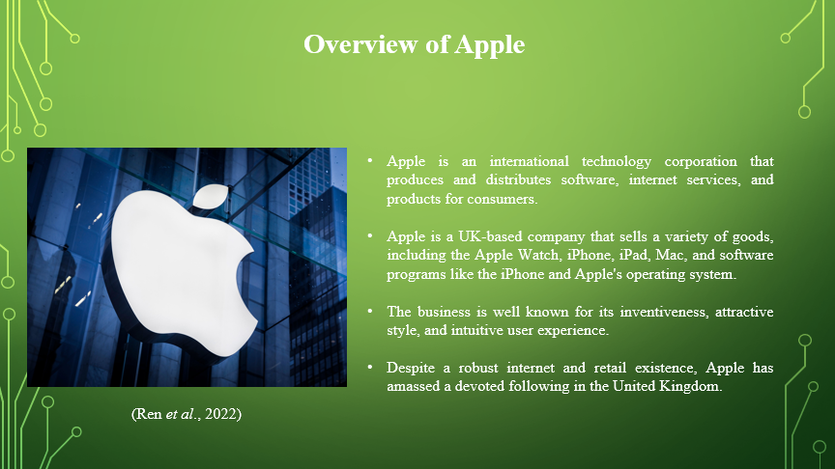
Apple is an international technology corporation that produces and distributes software, internet services, and products for consumers. Apple is a UK-based company that sells a variety of goods, including the Apple Watch, iPhone, iPad, Mac, and software programs like the iPhone and Apple's operating system. The business is well known for its inventiveness, attractive style, and intuitive user experience. Despite a robust internet and retail existence, Apple has amassed a devoted following in the United Kingdom. Apple offers products to improve the client experience generally such as Apple TV+, iCloud, and Apple Music. In general, Apple is a well-known participant in the technological advances sector, renowned for its innovative products and offerings in the United Kingdom industry (Manzoor et al., 2023).

Highlighting the size, structure and functions of Apple

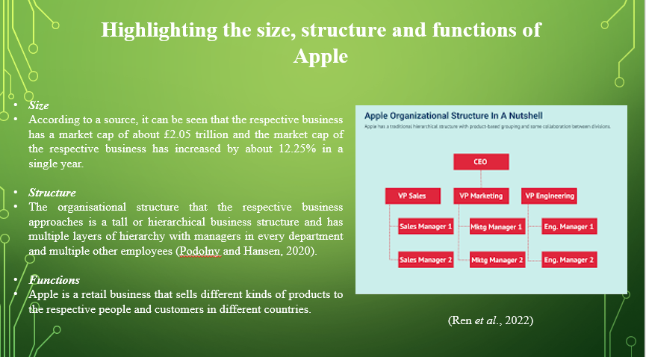
Apple is a renowned business firm that is famous for the electronic devices that they sell to premium customer segments in multiple countries.
Size
According to a source, it can be seen that the respective business has a market cap of about £2.05 trillion and the market cap of the respective business has increased by about 12.25% in a single year. This data has been generated as per the records till the 5th of March in the current year which is 2024 (Companiesmarketcap, 2024).
Structure
The organisational structure that the respective business approaches is a tall or hierarchical business structure and has multiple layers of hierarchy with managers in every department and multiple other employees (Podolny and Hansen, 2020).
Functions
Apple is a retail business that sells different kinds of products to the respective people and customers in different countries. It is mainly indulged in designing, manufacturing and selling a variety of electronic products (Podolny and Hansen, 2020).

SWOT analysis performed on Apple's internal environment

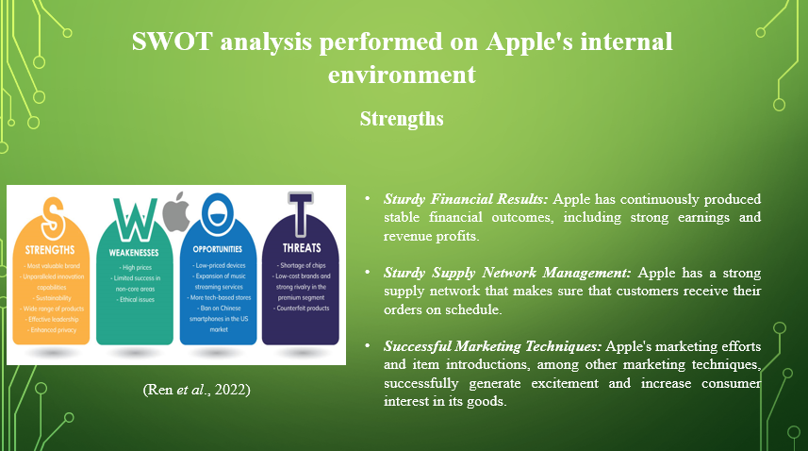
Apple has issues including exorbitant costs & a reliance on the iPhone, even with its inventive items and significant brand recognition. It should make investments in research and enter new markets in order to maintain its standing.
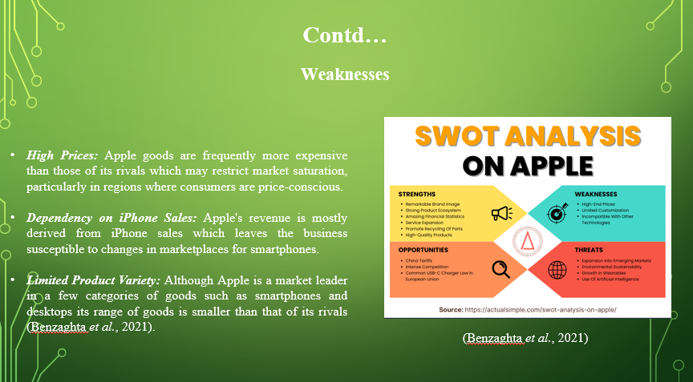
Strength | Weakness
1. Sturdy Financial Results: Apple has continuously produced stable financial outcomes, including strong earnings and revenue profits. A strong basis for future expansion and development is provided by this fiscal stability (Puyt et al., 2023).  2. Sturdy Supply Network Management: Apple has a strong supply network that makes sure that customers receive their orders on schedule. The organisation's superiority is bolstered by its effective supply network.  3. Successful Marketing Techniques: Apple's marketing efforts and item introductions, among other marketing techniques, successfully generate excitement and increase consumer interest in its goods. | 1. High Prices: Apple goods are frequently more expensive than those of its rivals which may restrict market saturation, particularly in regions where consumers are price-conscious.  2. Dependency on iPhone Sales: Apple's revenue is mostly derived from iPhone sales which leaves the business susceptible to changes in marketplaces for smartphones.  3. Limited Product Variety: Although Apple is a market leader in a few categories of goods such as smartphones and desktops its range of goods is smaller than that of its rivals (Benzaghta et al., 2021).
Opportunities | Threats
1. Growth in new markets: Considering thefast-increasing use of smartphones in these countries, Apple gets the chance to increase its market share in these areas.  2. Put an emphasis on service income: In order to lessen its reliance on product revenues, Apple can increase the income from its offerings such as Apple Music, iCloud, and Apple TV+ memberships (Viviana and Victor, 2022).  3. Efforts for Global Environmental Sustainability: Apple may profit from the increasing demand from consumers for items that are beneficial to the environment by making investments in economically friendly creation and manufacturing techniques. | 1. Legal Challenges: Modifications to laws pertaining to property rights, competition, or confidentiality of data may present difficulties for Apple's commercial activities.  2. Disruptions to the Supply Chain: Apple's manufacturing and supply chain may be affected by labour disputes in important industrial countries, emergencies, or international crises.  3. Quick Technical Progress: Due to the speed at which technology is developing, there's a chance that Apple products will become outmoded or supplanted by newer models.
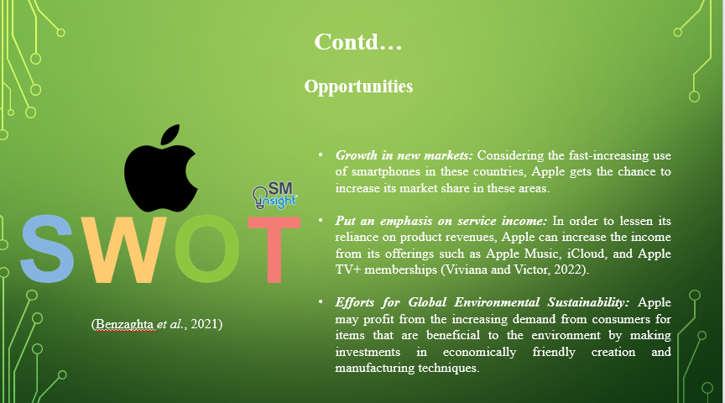
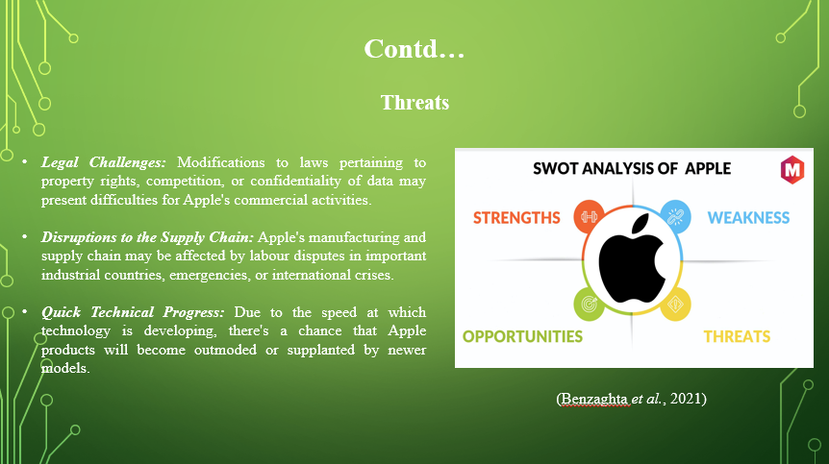

Explanation of the external factors affecting business organisation with PESTLE analysis

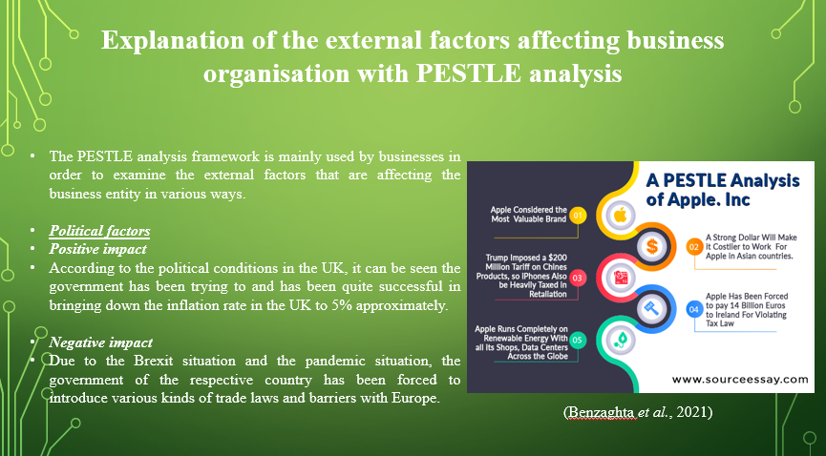
The PESTLE analysis framework is mainly used by businesses in order to examine the external factors that are affecting the business entity in various ways. It mainly has 6 different external factors that impact the business operations and its activities in the market. Those factors will be discussed in the below sections in detail with respect to the chosen business firm, Apple.
Political factors
Positive impact
According to the political conditions in the UK, it can be seen the government has been trying to and has been quite successful in bringing down the inflation rate in the UK to 5% approximately. This has allowed the respective business to gain back some of their sales and income, however, they have to pay a significant amount of interest on their sales of every product (Graham and O’Rourke, 2021).
Negative impact
Due to the Brexit situation and the pandemic situation, the government of the respective country has been forced to introduce various kinds of trade laws and barriers with Europe. This might have impacted the import and export business of the respective entity to a specific extent. This is because they have to trade with higher taxes and other extra expenses to run their business in those countries (Graham and O’Rourke, 2021).
Economic factors

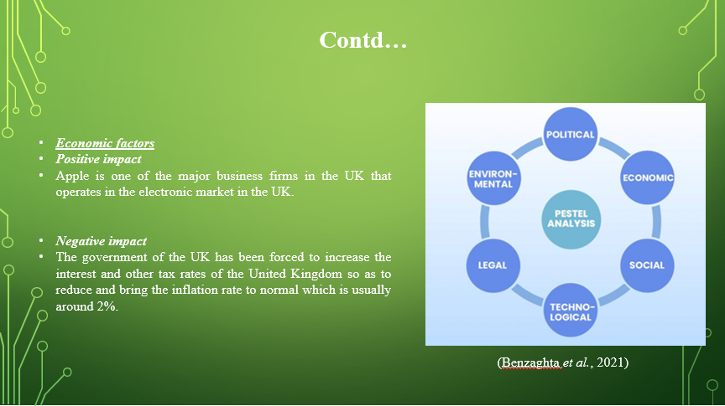
Positive impact
Apple is one of the major business firms in the UK that operates in the electronic market in the UK. Along with that, the annual future growth rate in the UK in terms of the electronic market can be seen to be rising significantly which can be a beneficial factor for the respective business in the UK (Iriarte et al., 2021).
Negative impact
The government of the UK has been forced to increase the interest and other tax rates of the United Kingdom so as to reduce and bring the inflation rate to normal which is usually around 2%. Therefore, as the company has to pay more to the government taxes, they are currently facing some challenges in the pricing of their products which has automatically increased and is impacting their overall sales (Iriarte et al., 2021).
Social factors

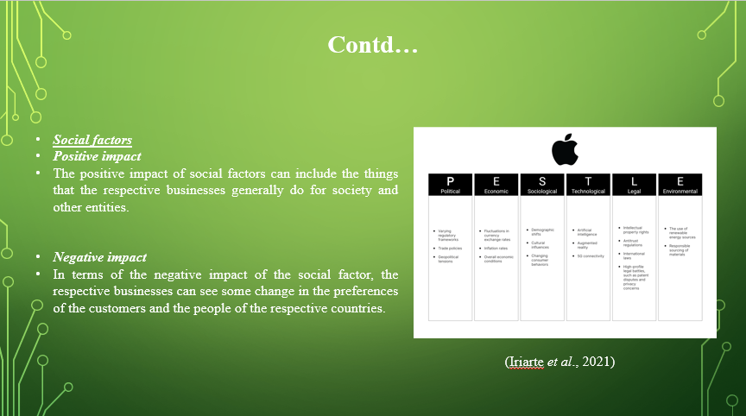
Positive impact
The positive impact of social factors can include the things that the respective businesses generally do for society and other entities. Apple can be seen donating millions of funds to nonprofit business organisations through the grants available for them. Moreover, their CSR policies include promoting gender equality, women empowerment and also promotion towards education for unprivileged children (Cot et al., 2021).
Negative impact
In terms of the negative impact of the social factor, the respective businesses can see some change in the preferences of the customers and the people of the respective countries. Other than that, the respective demands of the specific people are also increasing and decreasing depending on various aspects. This might have a significant impact on the operations of the respective business (Cot et al., 2021).
Technological factors

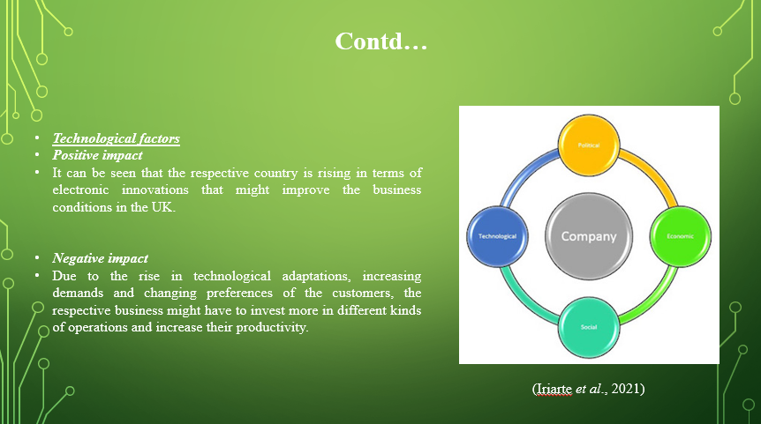
Positive impact
It can be seen that the respective country is rising in terms of electronic innovations that might improve the business conditions in the UK. According to some sources, it can also be seen that the respective market can grow significantly and reach about £26.03 billion at the end of the year 2024. Therefore, it can be considered a positive impact on the respective business industry (Guiné et al., 2021).
Negative impact
Due to the rise in technological adaptations, increasing demands and changing preferences of the customers, the respective business might have to invest more in different kinds of operations and increase their productivity. This can impact the overall revenue of the respective business entity due to the extra investment (Guiné et al., 2021).
Environmental factors

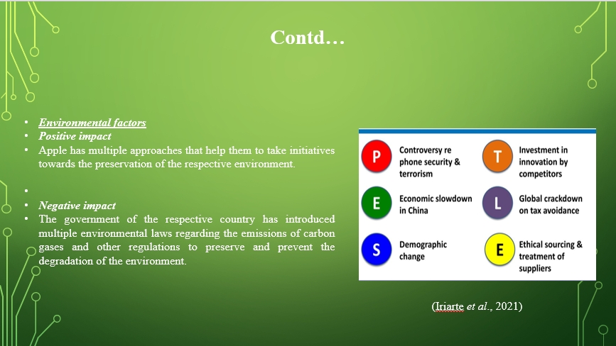
Positive impact
Apple has multiple approaches that help them to take initiatives towards the preservation of the respective environment. They are already investing in nature-based projects and reducing emissions in various operations (Iriarte et al., 2021).
Negative impact
The government of the respective country has introduced multiple environmental laws regarding the emissions of carbon gases and other regulations to preserve and prevent the degradation of the environment. Avoiding or failing to maintain and operate according to the regulations can impact the respective businesses in the UK to face strict actions from the government (Iriarte et al., 2021).
Legal factors
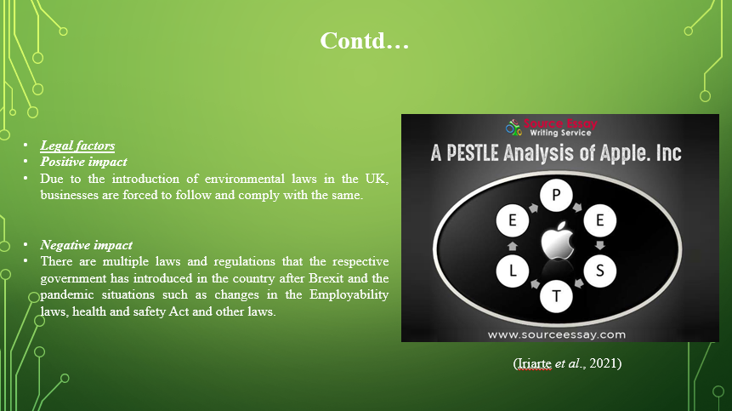
Positive impact
Due to the introduction of environmental laws in the UK, businesses are forced to follow and comply with the same. Along with that, the people of the UK also prefer businesses that are approaching to save the environment and prevent it from degradation while making decisions to buy their desired products. Therefore, complying with the respective environmental regulations can help them attract more customers from every segment and increase their sales in the market (Shuttleworth, 2021).
Negative impact
There are multiple laws and regulations that the respective government has introduced in the country after Brexit and the pandemic situations such as changes in the Employability laws, health and safety Act and other laws. Due to this reason, the respective business might face issues in complying with all the same, which might affect their business activities and operations (Shuttleworth, 2021).

Highlighting the stakeholders of Apple

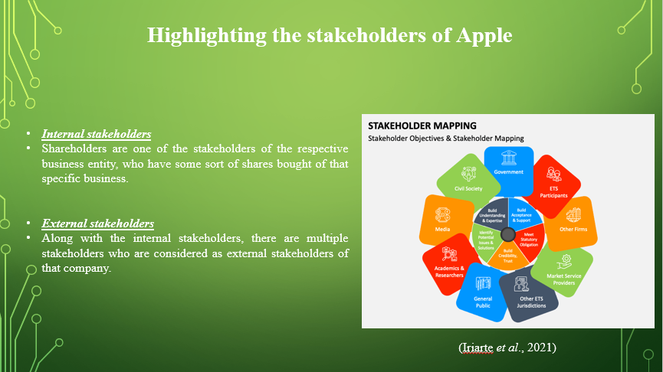
There are various kinds of stakeholders of the respective business entities in the UK and other parts of the world. Some of those stakeholders of Apple will be highlighted in the below sections.
Internal stakeholders
There are multiple internal stakeholders of the respective business entity among which, some of the specific internal stakeholders will be highlighted in the below sections.
Shareholders
Shareholders are one of the stakeholders of the respective business entity, who have some sort of shares bought of that specific business. They require the financial information of the respective business in order to determine whether they want to buy more shares or sell the existing shares of that company (Lu et al., 2023).
Employees
Employees of the respective business are those who are working for the specific company and helping to generate specific revenue over the years. They can also decide whether want to continue working in that particular company by analysing the financial conditions of the respective business (Lu et al., 2023).
External stakeholders
Along with the internal stakeholders, there are multiple stakeholders who are considered as external stakeholders of that company. Some of those external stakeholders will be highlighted in the below sections.
Customers
Customers are those people who are buying or purchasing different kinds of products from that particular business. They can determine whether the company is making enough profits and revenue to sustain its business in the market or not. This might help them to decide whether they want to continue purchasing their desired products or shift to other similar businesses (Ren et al., 2022).
Suppliers
Suppliers are those individuals who have made any contract with the respective business entity regarding the raw materials and resources required for them to manufacture their electronic devices. They would also need to understand the financial conditions so as to decide whether they want to continue their contracts with Apple or not (Ren et al., 2022).

Conclusion

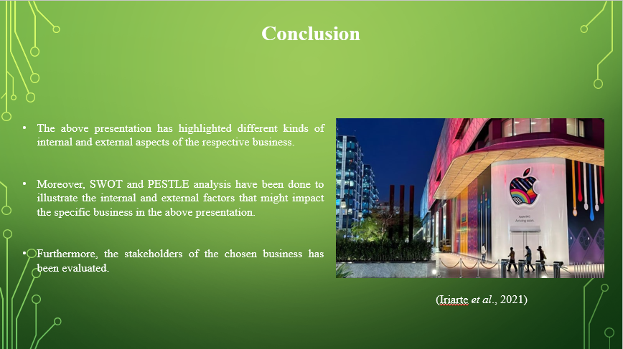
The above presentation has highlighted different kinds of internal and external aspects of the respective business. The overview of the respective business has been included in the below section. In addition to that, the size, functions and structure of the respective business has been illustrated which is a hierarchical structure. Moreover, SWOT and PESTLE analysis have been done to illustrate the internal and external factors that might impact the specific business in the above presentation. Furthermore, the stakeholders of the chosen business has been evaluated.

References

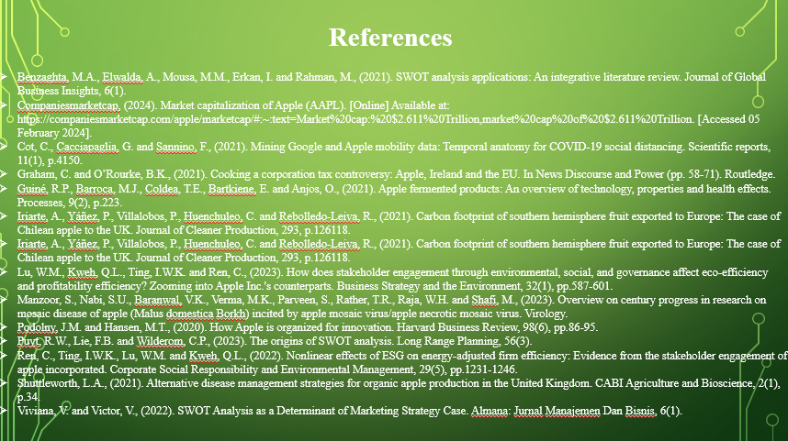
Benzaghta, M.A., Elwalda, A., Mousa, M.M., Erkan, I. and Rahman, M., (2021). SWOT analysis applications: An integrative literature review. Journal of Global Business Insights, 6(1).
Companiesmarketcap, (2024). Market capitalization of Apple (AAPL). [Online] Available at: https://companiesmarketcap.com/apple/marketcap/#:~:text=Market%20cap:%20$2.611%20Trillion,market%20cap%20of%20$2.611%20Trillion. [Accessed 05 February 2024].
Cot, C., Cacciapaglia, G. and Sannino, F., (2021). Mining Google and Apple mobility data: Temporal anatomy for COVID-19 social distancing. Scientific reports, 11(1), p.4150.
Graham, C. and O’Rourke, B.K., (2021). Cooking a corporation tax controversy: Apple, Ireland and the EU. In News Discourse and Power (pp. 58-71). Routledge.
Guiné, R.P., Barroca, M.J., Coldea, T.E., Bartkiene, E. and Anjos, O., (2021). Apple fermented products: An overview of technology, properties and health effects. Processes, 9(2), p.223.
Iriarte, A., Yáñez, P., Villalobos, P., Huenchuleo, C. and Rebolledo-Leiva, R., (2021). Carbon footprint of southern hemisphere fruit exported to Europe: The case of Chilean apple to the UK. Journal of Cleaner Production, 293, p.126118.
Iriarte, A., Yáñez, P., Villalobos, P., Huenchuleo, C. and Rebolledo-Leiva, R., (2021). Carbon footprint of southern hemisphere fruit exported to Europe: The case of Chilean apple to the UK. Journal of Cleaner Production, 293, p.126118.
Lu, W.M., Kweh, Q.L., Ting, I.W.K. and Ren, C., (2023). How does stakeholder engagement through environmental, social, and governance affect eco‐efficiency and profitability efficiency? Zooming into Apple Inc.'s counterparts. Business Strategy and the Environment, 32(1), pp.587-601.
Manzoor, S., Nabi, S.U., Baranwal, V.K., Verma, M.K., Parveen, S., Rather, T.R., Raja, W.H. and Shafi, M., (2023). Overview on century progress in research on mosaic disease of apple (Malus domestica Borkh) incited by apple mosaic virus/apple necrotic mosaic virus. Virology.
Podolny, J.M. and Hansen, M.T., (2020). How Apple is organized for innovation. Harvard Business Review, 98(6), pp.86-95.
Puyt, R.W., Lie, F.B. and Wilderom, C.P., (2023). The origins of SWOT analysis. Long Range Planning, 56(3).
Ren, C., Ting, I.W.K., Lu, W.M. and Kweh, Q.L., (2022). Nonlinear effects of ESG on energy‐adjusted firm efficiency: Evidence from the stakeholder engagement of apple incorporated. Corporate Social Responsibility and Environmental Management, 29(5), pp.1231-1246.
Shuttleworth, L.A., (2021). Alternative disease management strategies for organic apple production in the United Kingdom. CABI Agriculture and Bioscience, 2(1), p.34.
Viviana, V. and Victor, V., (2022). SWOT Analysis as a Determinant of Marketing Strategy Case. Almana: Jurnal Manajemen Dan Bisnis, 6(1).

