HPHI5907. –
Heritage and Archaeology of Conflict

Katie L Pullen-O’Brien

How battlefield archaeology contributes positively to bereavement, commemoration, and reconciliation.

Archaeologists can gain valuable insights from battlefield archaeology by integrating archaeological expertise with battlefield/combat experience. As historians, we consider this information to be precious. Although battlefield archaeology is a relatively recent discipline, it has contributed significantly to our understanding of the past. It was first introduced in the United Kingdom in the 1990s. This essay will discuss how battlefield archaeology contributes positively to bereavement, commemoration, and reconciliation. In this essay, you will find that my examples will be based on the First and Second World Wars.

In an article titled "Battlefield and Conflict Archaeology," the renowned American archaeologist Douglas D. Scott defines battlefield archaeology as a specialised field within archaeology that focuses on the study and archaeological investigation of conflict and conflict-related sites. It combines archaeological techniques with historical research to investigate and interpret the material remains of past conflicts. The term 'the archaeology of battle' is sometimes used as a more accurate description of the area.

Considering this, battlefield archaeology's primary goal is to assist archaeologists and historians in acquiring a comprehensive understanding of historical events, technological tactics and strategies of warfare and conflict, even the social, cultural, and spanning various historical periods. Their efforts significantly contribute to our understanding of military history, human experiences in conflict, the preservation of associated military sites, and the impact on bereavement, commemoration, and reconciliation.

Significant outcomes result from battlefield archaeology's contributions, and here in the UK, there are plenty of battlefields where archaeologists continue to grow their knowledge. Three crucial results of Battlefield archaeology can positively contribute to bereavement, commemoration, and reconciliation by establishing a tangible and historical link to the past. Battlefield archaeology plays a crucial role in helping us understand and honour the experiences of those who fought and died in conflicts. By uncovering artifacts and remains, it allows us to acknowledge the sacrifices made by all parties involved and aids in the healing process for grieving people. Additionally, it helps bring to light lesser-known aspects of conflicts, promoting a more comprehensive and inclusive understanding of history and contributing to reconciliation efforts.

Bereavement

Conflict inevitably results in significant loss of life and can have varying impacts on individuals. Battlefield archaeology plays a crucial role in helping families find closure by discovering and identifying the remains of soldiers who perished in battle. For many of these families, living with uncertainty about the fate of their loved ones has been a long-standing challenge.

An integral aspect of battlefield archaeology involves excavation. The discovery of human remains, along with associated artefacts and personal effects, including dog tags and uniforms, is poignant and offers crucial opportunities for individual identification. Unearthing these personal artefacts can be intensely emotional for families. They provide a link to the soldier and enable them to envision the person as they were in life rather than just as a name or a photograph. These artefacts can be treasured as heirlooms, offering solace and ongoing connection.

While excavating First World War battlefields, archaeologists have discovered personal letters and items such as engraved watches. When these artefacts are returned to the families of the deceased, they become cherished remembrances that help preserve the memory of the lost loved one. Many families find receiving personal items of their deceased loved ones to be an essential part of the grieving process, offering comfort and insight into their relative's life. Additionally, for some families, not knowing the details surrounding a loved one's death can be distressing. Battlefield archaeology can provide valuable information about how their loved ones died during a specific battle or a more extensive military operation. This understanding can help families understand their loss and facilitate healing.

Fortunately, forensic techniques have proven invaluable for modern excavations and are consistently being developed. DNA analysis has become widely used, enabling the accurate identification of remains, even many years after the conflict. For example, in the battlefields of the First and Second World Wars, many unidentified soldiers were buried in mass graves or left where they fell. It is important to note that the discovery of individuals and artefacts will undergo thorough analysis. The findings can provide closure for families, allowing them to finally lay their ancestors to rest and grieve with a better understanding of their loved ones' circumstances of death.

The repatriation of remains is a crucial part of battlefield archaeology and is especially significant in the grieving process. After identification, the remains can be returned to their home country and laid to rest according to cultural and familial customs. This process allows families to honour their loved ones through a respectful burial, and I will explore this further in the essay.

Commemoration
Battlefield archaeology is known as the archaeology of remembering. Lawrence Binyon's "For the Fallen" comes to mind when contemplating conflict, loss, and remembering the fallen.

"They shall grow not old, as we that are left grow old:
Age shall not weary them, nor the years condemn.
At the going down of the sun and in the morning
We will remember them."

This sentiment resonates in battlefield archaeology, where thousands of soldiers remain uncovered. Every year on and around Remembrance Day serves as a poignant reminder that we will continue honouring and remembering them by singing "For the Fallen."

Battlefield archaeology is crucial in honouring historical conflicts by uncovering and preserving artefacts and sites. This critical work ensures that the sacrifices of those who fought are not forgotten and that the locations where they fell are protected. According to the Commonwealth War Graves Commission, over 150 human remains are discovered yearly worldwide due to disturbances in their resting places.

Artefacts found during archaeological excavations, such as weapons, uniforms, and personal items, are powerful reminders of historical events. These objects are essential for museums and historical exhibitions, providing physical evidence to substantiate historical occurrences. These artefacts play a crucial role in educating historians and others about the realities of war and the experiences of individuals who lived through it. Museums worldwide, such as the Imperial War Museum, utilise these artefacts to develop captivating and informative exhibits that honour the lives and sacrifices of soldiers. Battlefield archaeology is vital for educating the public and deepening our comprehension of historical conflicts and their impact on humanity. As adults, we are responsible for educating and providing the knowledge that will enable future generations to comprehend from a young age the significance of remembering and honouring the individuals who made the ultimate sacrifice for us or found themselves in unfortunate circumstances. Luckily, during their time in school, most young people in Great Britain are taught about the significance of commemorating historical events and the importance of understanding and honouring these occasions for the future.

Commemoration plays a significant role in facilitating the bereavement process. By unearthing and showcasing various artefacts, soldiers' individual experiences can be illuminated, thereby providing a more comprehensive and personalised understanding of conflicts. The Commonwealth War Graves Commission helped make this possible. They look after one. seven million casualties of war and over twenty-three thousand war memorials and war cemeteries with locations all over the globe. In certain regions, cemeteries are situated in remote areas, such as small villages or fields, while others are integrated within or near larger cities.

The Commonwealth War Graves Commission recovery team has been active in Europe since the end of the First World War. They collaborate with other organisations to facilitate the commemoration of fallen soldiers. Utilising battlefield archaeology, they ensure that the fallen are laid to rest and honoured with dignity. The team oversees crafting a headstone or plaque in the soldier's name. Even without successful identification, the soldier will be reburied in a Commonwealth War Graves Commission cemetery near the discovery site. It is truly remarkable how battlefield archaeology has enabled the initial steps in uncovering information about their lives and deaths, bringing the comforting knowledge that they now rest in a place of peace.

During a recent trip to France, my wife and I had the opportunity to witness firsthand the layout and maintenance of these cemeteries and experience the solemn atmosphere among the fallen. I captured four images for documentation purposes during this trip. The photos were taken at Villers Hill British Cemetery and Marœuil British Cemetery 11, showcasing the resting places of two of my wife's relatives.

Two of the images highlight the distinct features of these cemeteries. Villers Hill British Cemetery and Marœuil British Cemetery are comparatively small, with fewer than six hundred graves, in contrast to the eleven thousand five hundred and fifty-seven burials at Etaples Military Cemetery.
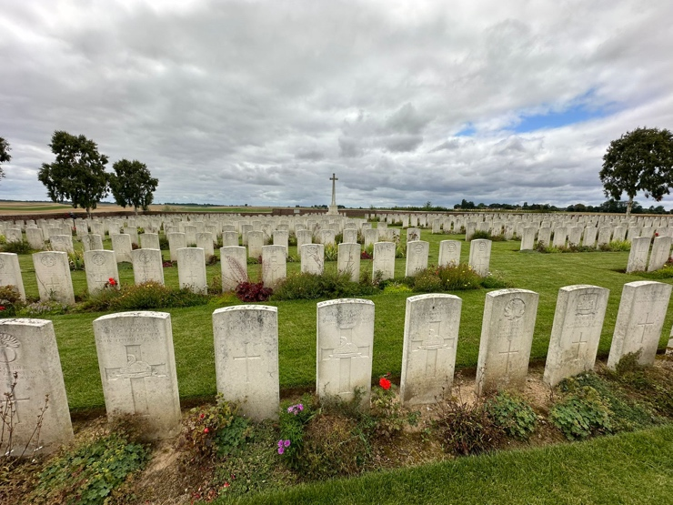
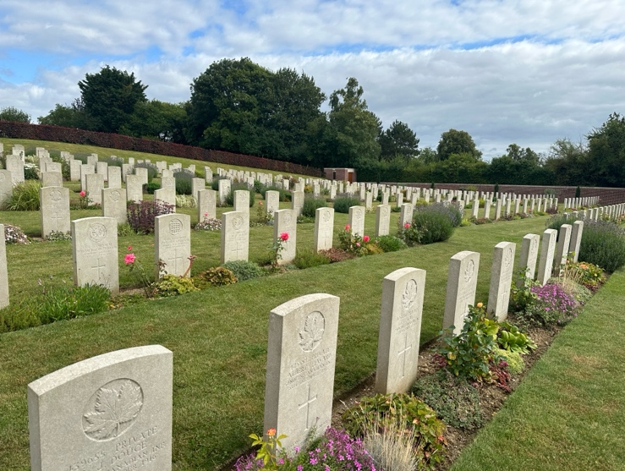
IMAGE 1 (Left) - Commonwealth War Graves Commission, Maroeuil British Cemetery, France. 571 Identified Casualties.

IMAGE 2 (Right) - Commonwealth War Graves Commission, Villers Hill British Cemetery, France. 386 Casualties.
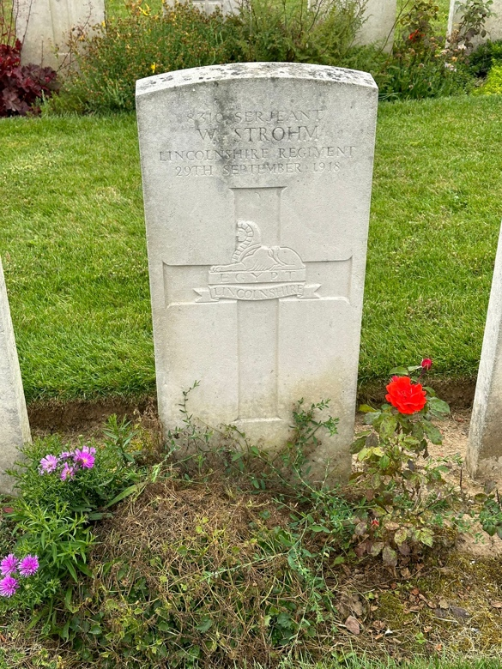
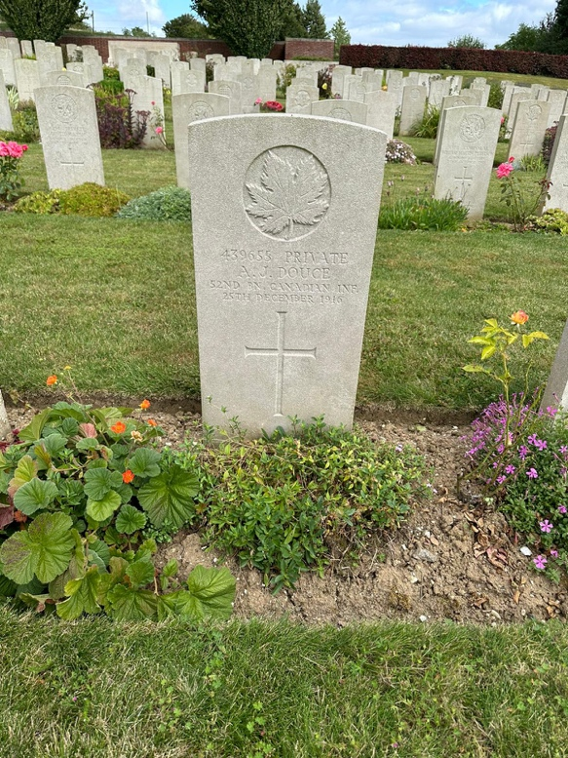
You can see from the images to the right and left that it is clear how distinct yet similar the individual graves are. Each one details the soldier and their regiment and features a cross or other relevant religious symbol. I was taken aback to discover that both cemeteries also accommodated a small number of German soldiers, all of whom were commemorated in a very similar way. Likely, these soldiers died nearby, potentially at a field hospital, hence the number of individuals at the cemeteries.

IMAGE 3 (Left) – Private A.J Douce. Commonwealth War Graves Commission, Maroeuil British Cemetery, France.
IMAGE 4 (Right) – Sergeant W.Strohm Commonwealth War Graves Commission, Maroeuil British Cemetery, France.

The work of the Commonwealth War Graves Commission is genuinely remarkable. My wife and I witnessed the dedicated groundskeepers toiling diligently. They paused their work out of respect while we paid our respects, a gesture that deeply moved me. I expressed my gratitude to them in my limited French. After years of searching, finally locating a family member and being able to visit their resting place in person is an incredibly emotional experience.

The Commonwealth War Graves Commission still adheres to burial protocols that originated during the Great War. These protocols dictate that casualties found together are buried in joint or collective graves, with their headstones placed so that they touch, thereby maintaining the integrity of the established burial practices. The Commonwealth War Graves Commission will conduct research into soldiers laid to rest with the inscription 'Known Unto God' on their graves who are otherwise known as unknown soldiers.

The Joint Casualty and Compassionate Centre Commemorations Team, also known as the MOD War Detectives, is a unit in the United Kingdom that is part of the Ministry of Defence. The Commemorations Team at the Joint Casualty and Compassionate Centre is dedicated to identifying individuals by conducting thorough military and historical records research. This includes confirming the identity of casualties whenever possible, examining military and personal items found with an individual, and carrying out genealogical research to locate the families of casualties. Additionally, with modern techniques, such as DNA analysis, whenever necessary, DNA testing will be arranged to enhance the likelihood of matching remains to living relatives.

The Commemorations Team at the Joint Casualty and Compassionate Centre collaborates with the host nation, the Commonwealth War Graves Commission (CWGC), and the armed forces. Most importantly, they arrange military funerals, rededication, or repatriation services and host receptions after burials or rededication services. We also maintain close communication with the families of fallen individuals. The team will research an individual to see whether they had commemorations for their service/ actions.

The work of the Commemorations Team at the Joint Casualty and Compassionate Centre must be rewarding for all involved. Most importantly, it provides reassurance and facilitates the closure process for the relatives. However, it could also be disheartening if they conduct DNA testing and the results come back negative or inconclusive. This could be distressing for the relatives hoping for closure.

Reconciliation

Battlefield archaeology plays a significant role in fostering reconciliation between former rivals. By unveiling a shared past, battlefield archaeology can offer impartial evidence for seeking justice and establish neutral discussion forums to counter denial attempts. In this way, battlefield archaeology aids in healing historical rifts and promotes mutual understanding.

The discoveries in battlefield archaeology demonstrate that soldiers on opposing sides of conflicts faced similar challenges and shared everyday experiences, fostering a sense of shared humanity essential for reconciliation. Excavations of battlefields from conflicts like the First and Second World Wars reveal the interconnected fates of soldiers from various nations, highlighting their sacrifice and courage. Additionally, battlefield sites, memorials, and cemeteries can serve as neutral spaces where individuals from both sides of a conflict can gather to reflect and engage in discussion. In Germany, students aged 16 years and older visit commemorative sites related to the Second World War as part of their education, aiming to gain an understanding of the historical errors made by Nazi Germany. The scholarly journal Protecting a Bloodstained History: Battlefield Conservation in Scotland highlights instances of former enemies of the Second World War engaging in commemorative gatherings on battlefields where both sides experienced the loss of friends and comrades.

In addition, forty-seven registered battlefields throughout the United Kingdom are part of Historic England’s Register of Historic Battlefields. The Register of Historic Battlefields was established in 1995 to protect the legacy of its historical significance and the importance of the contents of historical relics that lay on or under the grounds for future generations. Battlefields can help with bereavement, commemoration, and, most importantly, education; however, they are at significant risk of development and heritage crime.

Preserving battlefield sites is of the utmost importance to prevent forgetting historical lessons. These sites serve as vital educational resources, providing valuable insights into the consequences of conflict and highlighting the crucial significance of peace for future generations.

The Challenges of Battlefield Archaeology:

Battlefield sites such as the trenches, fox holes from the First and Second World Wars or other affluent historical conflict areas pose unique and challenging issues. A significant challenge facing archaeology is artefact theft by amateur treasure/relic hunters. These individuals pose a persistent threat that jeopardises the integrity of archaeological sites especially if human remains are involved.. I have watched multiple videos on the internet showing amateur detectorists leaving sites in appalling states, dangerous for others by not filling holes or reporting ordinances to the authorities and treating human remains with limited to no respect. It is worth noting that the issue persists even within protected battlefield areas, owing to the inherent challenges of effectively monitoring and safeguarding these sites.

Battlefield sites are usually large and can cover areas where battles last for days or weeks. This makes excavation and survey efforts challenging as they require significant personnel, time, and resources to cover the vast ground adequately. The study of battlefield sites presents unique challenges for archaeological and historical research. Uncovering artefacts and understanding the events in these locations require meticulous planning and collaborative efforts.

When conducting excavations at sites with mass casualties, such as mass graves, archaeologists are at risk of inadvertently mixing individuals in the graves. Furthermore, there is a potential of losing bone fragments that were separated during the conflict, which is necessary for reconstruction. It is crucial to have trained osteologists on-site or collaborate with archaeologists who understand and have training in osteology. When excavating mass graves, the absence of osteologists can compromise the integrity of individual skeletons, resulting in the loss of vital information such as age, sex, general health, and previous injuries. The expertise of osteologists is crucial in effectively differentiating and separating everyone's bones.

Conclusion:

Battlefield archaeology is a crucial tool in bereavement, commemoration, and reconciliation, providing a means to remember, honour, and understand the past on both personal and collective levels. In terms of bereavement, it offers closure and facilitates the remembrance of loved ones lost in war through the discovery of personal artefacts. Regarding commemoration, it uncovers and preserves historical evidence, provides context for memorials, and engages the public through education, ensuring meaningful remembrance of historical conflicts. Additionally, battlefield archaeology aids in reconciliation by uncovering shared histories, providing objective evidence to clarify historical events, and creating neutral spaces for discussion. This ultimately develops a mutual understanding and promotes a culture of peace.

The field of battlefield archaeology presents various challenges, especially when significant discoveries are likely. Effective collaboration between authorities and governing bodies is imperative to deter heritage crime and the destruction of battlefields and excavation sites.

These contributions prove crucial in uncovering our hidden past, enabling historians to understand conflicts better and educate future generations.

Bibliography
Banks, Ian & Pollard, Tony, Protecting a Bloodstained History: Battlefield Conservation in Scotland, Journal of Conflict Archaeology,
6.2 (2011) 124-145 <https://www.jstor.org/stable/48601729> [accessed 11 August 2024]

Cambridge University Press & Assessment, Osteologist (2024) <https://dictionary.cambridge.org/dictionary/english/osteologist>
[accessed 10 August 2024]

Commonwealth War Graves Commission (2024) <https://www.cwgc.org/our-work/> [accessed 10 July 2024]

Commonwealth War Graves Commission, Are Casualties From The World Wars Still Found? (2024)
<https://www.cwgc.org/find-records/commemorations/finding-and-rebuying-our-war-dead/> [accessed 10 July 2024]

Commonwealth War Graves Commission, Caring For Our Sites (2024) <https://www.cwgc.org/our-work/caring-for-our-sites/>
[accessed 10 July 2024]

Commonwealth War Graves Commission, Commemorating The Commonwealth Casualties Of Both World Wars (2024)
<https://www.cwgc.org/find-records/commemorations/finding-and-rebuying-our-war-dead//> [accessed 10 July 2024]

Commonwealth War Graves Commission, Etaples Military Cemetery (2024)
<https://www.cwgc.org/visit-us/find-cemeteries-memorials/cemetery-details/56500/etaples-military-cemetery/> [accessed 11 August 2024]

Commonwealth War Graves Commission, Villers Hill British Cemetery, Villers-Guislain (2024)
<https://www.cwgc.org/visit-us/find-cemeteries-memorials/cemetery-details/24100/villers-hill-british-cemetery-villers-guislain/> [accessed 11 August 2024]

Drexler, Carl, Why Conflict Archaeology Matters (2013)
<https://cgdrexler.wordpress.com/2013/10/10/why-conflict-archaeology-matters/> [accessed 10 August 2024]

GOV.UK, MOD War Detectives – the Joint Casualty and Compassionate Centre Commemorations team - what we do (2022)
<https://www.gov.uk/guidance/mod-war-detectives-the-joint-casualty-and-compassionate-centre-commemorations-team-what-we-do> [accessed 07 August 24]

Historic England: What Are Registered Battlefields? (2024)
<https://historicengland.org.uk/listing/what-i/s-designation/registered-battlefields/> [accessed 05 August 24]

Imperial War Museum (2024) <https://www.iwm.org.uk> [accessed 10 July 2024]

Perring, Dominic & van der Linde, Sjoerd, 'The Politics and Practice of Archaeology in Conflict', Conservation and Management of
Archaeological Sites, 11.3-4, (2013) 197-213 <https://www.tandfonline.com/doi/pdf/10.1179/175355210X12747818485321> [accessed 10 August 2024]

Pullen-O'Brien, Celine, Private Collection of Images

Scott, Douglas D., ‘Battlefield and Conflict Archaeology’, Anthropology (2024)
<https://oxfordre.com/anthropology/display/10.1093/acrefore/9780190854584.001.0001/acrefore-9780190854584-e-642> [accessed 10 July 2024]

Stallworthy, Jon, The New Oxford Book of War Poetry, (Oxford: Oxford University Press, 2014), p.232

Sutherland, Tim, Battlefield Archaeology - a Guide to the Archaeology of Conflict (2005)
<http://www.bajr.org/BAJRGuides/8.%20Battlefield%20Archaeology%20%20A%20Guide%20to%20the%20Archaeology%20of%20Conflict/BAJRBattleGuide.pdf> [accessed 09 August 2024]

Tarlow, Sarah, ‘An Archaeology of Remembering: Death, Bereavement and the First World War’, Cambridge Archaeological
Journal, 7.1 (1997) 105-121
<https://www.cambridge.org/core/journals/cambridge-archaeological-journal/article/an-archaeology-of-remembering-death-bereavement-and-the-first-world-war/4591D2CC5E9B955823E5918D4634D48E> [accessed 10 July 2024]
The Society for Historical Archaeology, J. C. Harrington Medal in Historical Archaeology (2024)
<https://sha.org/wp-content/uploads/2016/10/49-2-01-award-Harrington.pdf> [accessed 10 July 2024]

Tim Sutherland, Battlefield Archaeology - a Guide to the Archaeology of Conflict (2005) <http://www.bajr.org/BAJRGuides/8.%20Battlefield%20Archaeology%20%20A%20Guide%20to%20the%20Archaeology%20of%20Conflict/BAJRBattleGuide.pdf> [accessed 09 August 2024].
Douglas D. Scott, ‘Battlefield and Conflict Archaeology’, Anthropology (2024) <https://oxfordre.com/anthropology/display/10.1093/acrefore/9780190854584.001.0001/acrefore-9780190854584-e-642> [accessed 10 July 2024].
The Society for Historical Archaeology, J. C. Harrington Medal in Historical Archaeology (2024) <https://sha.org/wp-content/uploads/2016/10/49-2-01-award-Harrington.pdf> [accessed 10 July 2024].
Scott, 2024.
Sutherland, Battlefield Archaeology - a Guide to the Archaeology of Conflict, p.28
Sarah Tarlow, ‘An Archaeology of Remembering: Death, Bereavement and the First World War’, Cambridge Archaeological Journal, 7.1 (1997) 105-121 <https://www.cambridge.org/core/journals/cambridge-archaeological-journal/article/an-archaeology-of-remembering-death-bereavement-and-the-first-world-war/4591D2CC5E9B955823E5918D4634D48E> [accessed 10 July 2024]
Jon Stallworthy, The New Oxford Book of War Poetry, (Oxford: Oxford University Press, 2014), p.232
Carl Drexler, Why Conflict Archaeology Matters (2013) <https://cgdrexler.wordpress.com/2013/10/10/why-conflict-archaeology-matters/> [accessed 10 August 2024].
Commonwealth War Graves Commission, Commemorating The Commonwealth Casualties Of Both World Wars (2024) <https://www.cwgc.org/find-records/commemorations/finding-and-rebuying-our-war-dead//> [accessed 10 July 2024].
Imperial War Museum (2024) <https://www.iwm.org.uk> [accessed 10 July 2024].
Commonwealth War Graves Commission (2024) <https://www.cwgc.org/our-work/> [accessed 10 July 2024].
Commonwealth War Graves Commission, Caring For Our Sites (2024) <https://www.cwgc.org/our-work/caring-for-our-sites/> [accessed 10 July 2024].
Commonwealth War Graves Commission, Villers Hill British Cemetery, Villers-Guislain (2024) <https://www.cwgc.org/visit-us/find-cemeteries-memorials/cemetery-details/24100/villers-hill-british-cemetery-villers-guislain/> [accessed 11 August 2024].
Commonwealth War Graves Commission, Etaples Military Cemetery (2024) <https://www.cwgc.org/visit-us/find-cemeteries-memorials/cemetery-details/56500/etaples-military-cemetery/> [accessed 11 August 2024].
Celine Pullen-O'Brien, Private Collection of Images
Celine Pullen-O'Brien, Private Collection of Images
Celine Pullen-O'Brien, Private Collection of Images
Celine Pullen-O'Brien, Private Collection of Images
Commonwealth War Graves Commission, Are Casualties From The World Wars Still Found? (2024) <https://www.cwgc.org/find-records/commemorations/finding-and-rebuying-our-war-dead/> [accessed 10 July 2024].
GOV.UK, MOD War Detectives – the Joint Casualty and Compassionate Centre Commemorations team - what we do (2022) <https://www.gov.uk/guidance/mod-war-detectives-the-joint-casualty-and-compassionate-centre-commemorations-team-what-we-do> [accessed 07 August 24].
Dominic Perring & Sjoerd van der Linde, 'The Politics and Practice of Archaeology in Conflict', Conservation and Management of Archaeological Sites, 11.3-4, (2013) 197-213 <https://www.tandfonline.com/doi/pdf/10.1179/175355210X12747818485321> [accessed 10 August 2024].
Ian Banks & Tony Pollard, ‘Protecting a Bloodstained History: Battlefield Conservation in Scotland’, Journal of Conflict Archaeology, 6.2 (2011) 124-145, (p.132) <https://www.jstor.org/stable/48601729> [accessed 11 August 2024].)
Historic England What Are Registered Battlefields? (2024) <https://historicengland.org.uk/listing/what-i/s-designation/registered-battlefields/> [accessed 05 August 24].
Banks & Pollard, ‘Protecting a Bloodstained History: Battlefield Conservation in Scotland’, p.133.
Banks & Pollard, ‘Protecting a Bloodstained History: Battlefield Conservation in Scotland’, p.133.
Cambridge University Press & Assessment, Osteologist (2024) <https://dictionary.cambridge.org/dictionary/english/osteologist> [accessed 10 August 2024].
Sutherland, Battlefield Archaeology - a Guide to the Archaeology of Conflict, p.31.

