TITLE PAGE : Health And Social Care Portfolio

Name: Nadia Bi

Student Number: 2434187

Module Code : LCHS4009

Title: Development Portfolio

Lecturer’s Name: Olubukola Adegbite

Assignment Title: Career Portfolio for Health and Social Care

DATE: 27 March 2026

TASK 1: PROFESSIONAL CV
Nadia Bi
Birmingham
Mobile: 07474 891345
Email: nadia786xx@icloud.com
Personal Profile A compassionate and motivated individual seeking a Care Assistant role within health and social care. I am committed to supporting individuals with dignity, respect, and empathy. I have strong communication skills, remain calm in challenging situations, and work well as part of a team. Currently studying Health and Social Care Level 4, I am eager to develop my skills and progress within the care sector.
Key Skills • Empathy and compassion • Effective communication • Teamwork and collaboration • Time management and organisation • Adaptability and willingness to learn • Attention to detail • Patient, calm, and professional approach
Employment and Experience
Stay-at-Home Parent | 2010 – 2025 • Managed daily routines, appointments, and schedules • Supported children’s education, homework, and activities • Developed strong organisational, multitasking, and caregiving skills • Maintained a safe, clean, and healthy home environment
Asda – Marketing and Promotion | 2007 – 2010 • Promoted world foods and Asda brand products • Delivered high standards of customer service • Trained and supported new staff members • Maintained up-to-date product knowledge
Education and Training
St David’s University | 2025 – Present Health and Social Care Level 4
University College Birmingham | 2022 – 2023 BTEC Level 2 Childcare
Foundry Primary School | 2022 Level 2 Mental Health First Aid Training
Sure Start | 2014 Level 1 Award in Caring for Children Maths Level 2
Summerfield Community Centre | 2013 English Level 2
Birmingham Adult Education | 2013 Maths Level 1
Lordswood Girls School | 2002 GCSEs: Maths, English, Science, Healthcare, Childcare, Textiles
Interests and Hobbies • Volunteering within the community • Learning about health and wellbeing • Supporting family and social activities
References Available on request

Job Title: Care Assistant Employer: Birmingham Community Care Services Location: Birmingham Job Type: Full-time / Part-time
Job Description: Birmingham Community Care Services is seeking compassionate and reliable Care Assistants to support adults in residential and community settings. Duties include assisting with personal care, supporting daily living activities, promoting independence, maintaining accurate records, and working as part of a multidisciplinary team. No prior experience is required as full training will be provided. Applicants should demonstrate empathy, good communication skills, and a willingness to learn.

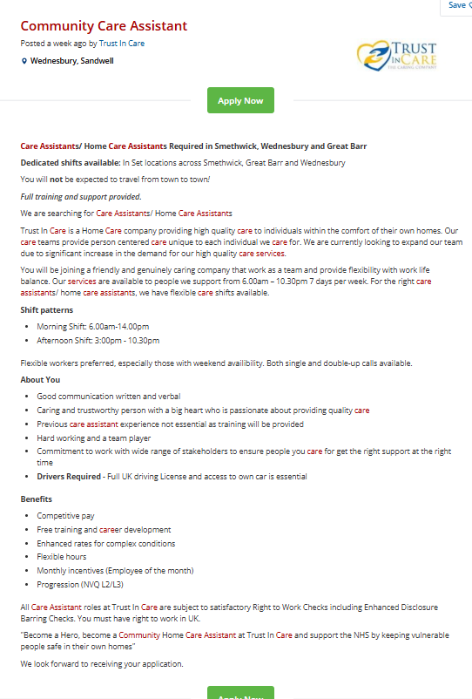

TASK 2: PERSONAL STATEMENT
I am applying for the position of Care Assistant within the health and social care sector as I am highly motivated to pursue a professional career dedicated to supporting individuals with diverse needs. My long-term career aim is to develop my knowledge, skills, and practical experience within care settings while contributing positively to the wellbeing, dignity, and independence of service users. I am particularly committed to person-centred care and to upholding the professional values and standards required within health and social care practice.
I am currently undertaking a Level 4 qualification in Health and Social Care, which has provided me with a strong theoretical foundation relevant to the Care Assistant role. Through my studies, I have developed knowledge in key areas such as safeguarding, equality and diversity, communication in care environments, and the promotion of health and wellbeing. This academic learning has enhanced my understanding of professional responsibilities, ethical practice, and the importance of delivering safe, effective, and individualised care. In addition, I hold Level 2 Mental Health training and First Aid certification, enabling me to respond appropriately to individuals experiencing emotional distress or medical emergencies.
My experience as a stay-at-home parent has enabled me to develop a wide range of transferable skills that are directly applicable to health and social care practice. These include managing daily routines, coordinating appointments, providing emotional support, and promoting physical and emotional wellbeing. This role required a high level of patience, organisation, adaptability, and resilience. It also strengthened my ability to observe changes in behaviour or wellbeing and to respond in a calm, supportive, and responsible manner.
Previously, my employment with Asda in a marketing and promotion role allowed me to develop effective communication, teamwork, and customer service skills. I was responsible for promoting products, training staff, and maintaining professional standards. These experiences have strengthened my confidence in working collaboratively, communicating clearly, and maintaining professionalism, all of which are essential competencies within health and social care settings.
My personal strengths include empathy, reliability, and a strong commitment to continuous professional development. I am able to remain calm under pressure and approach challenging situations with patience and professionalism. I am eager to learn, receptive to feedback, and motivated to progress within the care sector. I believe these qualities, combined with my education and experience, would enable me to make a valuable contribution to an organisation by delivering high-quality, compassionate care to service users.

TASK 3: SWOT ANALYSIS AND PERSONAL DEVELOPMENT PLAN
A) SWOT ANALYSIS
Strengths:
• Compassionate and patient nature
• Strong communication and interpersonal skills
• Relevant education in health and social care
Weaknesses:
• Limited formal care work experience
• Developing confidence in clinical settings
Opportunities:
• Ongoing Level 5 qualification
• Training and progression opportunities in care sector
Threats:
- Competitive job market
- Emotional demands of care work
- balancing personal life

Personal Development Plan (PDP)
Goal | Action Plan | Timescale | Review Method
Gain practical care experience | Apply for a Care Assistant role in a health and social care setting.  Attend all mandatory training such as safeguarding, manual handling, and infection control.  Learn from experienced staff and develop practical care skills. | 0–6 months | Feedback from supervisor or manager. Reflect on experiences and identify areas for improvement.
Improve communication and record-keeping skills | Attend communication training courses.  Practice accurate and clear record-keeping when supporting service users.  Use reflective practice to evaluate communication with colleagues and service users. | 6–18 months | Performance appraisals with supervisor and personal self-reflection.
Progress to a senior care role | Complete further health and social care qualifications.  Gain additional experience and take on more responsibilities within the workplace  . Develop leadership and teamwork skills. | 18–24 months | Career development reviews with manager and evaluation of readiness for promotion.

TASK 4: GIBBS REFLECTIVE MODEL
This reflection applies Gibbs’ Reflective Cycle (1988) to critically evaluate my performance in the LCHS4009 Component 1 presentation assessment. The aim of this reflection is to analyse my experience, identify strengths and areas for development, and establish strategies for improving future academic and professional presentations.
Description:
The assessment required the delivery of an individual presentation on a topic relevant to communication skill in health. The presentation was supported by prepared slides and delivered within a specified time limit to my lecturer and peers. Following the presentation, verbal feedback was provided by my lecturer.
Feelings:
Prior to the presentation, I experienced feelings of anxiety and low confidence, particularly regarding public speaking. During the presentation, although I remained nervous, I gradually became more comfortable as I progressed through the content. After completing the assessment, I felt relieved but also reflective, recognising that while my knowledge was strong, my confidence affected my delivery. The feedback provided by my lecturer was not good has I expected she did reassure me which helped to reduce my self-doubt.
Evaluation:
One positive aspect of my presentation was the clear structure and relevance of the content. My lecturer commented positively on my understanding of the topic and the level of preparation demonstrated. However, it was noted that my voice was quiet at times and that I relied heavily on my slides, which limited audience engagement. These factors reduced the overall effectiveness of my presentation delivery.

Analysis:
Effective communication is a fundamental skill within health and social care, as professionals are required to share information clearly with colleagues, service users, and other professionals. Although my academic knowledge was evident, my lack of confidence impacted my verbal communication and presentation skills. This may be attributed to limited experience with formal presentations. Developing confidence and communication skills is therefore essential not only for academic success but also for my future professional role within the care sector.
Conclusion:
This presentation was a valuable learning opportunity that highlighted both my strengths and areas for improvement. While my research and subject knowledge were strong, greater confidence, improved voice projection, and reduced reliance on slides are necessary to enhance my presentation skills. Reflecting on this experience has allowed me to view the assessment as a constructive step in my personal and professional development.
Action Plan:
To improve future presentations, I plan to practise delivering presentations aloud during preparation and rehearse in front of peers or family members to build confidence. I will actively participate in class discussions to strengthen my verbal communication skills. Additionally, I will seek and apply feedback from lecturers to monitor my progress. Through consistent practice and reflection, I aim to improve my presentation skills and confidence, which will support both my academic development and future professional practice in health and social care.

#REFERENCE LIST
Gibbs, G. (1988) Learning by Doing: A Guide to Teaching and Learning Methods. Oxford: Oxford Polytechnic. (Accessed 10 March 2026)
Health and Care Professions Council (2023) Standards of conduct, performance and ethics. London: HCPC. (Accessed 11 March 2026)
Skills for Care (2023) Care Certificate Standards. Leeds: Skills for Care. (Accessed 9 March 2026)
Department of Health and Social Care (2022) Care and support statutory guidance. London: DHSC. (Accessed 29 April 2026)
NHS Jobs (no date) NHS Jobs. Available at: https://www.jobs.nhs.uk (Accessed: 27 March 2026).
Abraham Maslow (1943) ‘A theory of human motivation’, Psychological Review, 50(4), pp. 370–396. (Accessed 14 March 2026)
Donald Schön (1983) The Reflective Practitioner: How Professionals Think in Action. New York: Basic Books. (Accessed 14 March 2026)
Denise Boyd and Helen Bee (2020) Lifespan Development. 8th edn. Harlow: Pearson. (Accessed 24 April 2026)

