

Fire and Rehire Report

Janeth Catherine Mosquera Restrepo
Student Number:1908748

Module:
Managing People
LCMB7011

Lecturer:
Piyumika Kithulgoda Gamage

12/05//2023

TABLE OF CONTENTS
INTRODUCTION 3
EMPLOYMENT LAW - 4
Employment Contract 6
Wrongful Dismissal 8
Unfair Dismissal 8
IMPACT OF CONTRACTUAL CHANGES ON EMPLOYMENT ENGAGEMENT 9
METHODS 9
LITERATURE REVIEW 9
FINDINGS 11
Primary Research 11
Secondary Research 11
DISCUSSION 12
CONCLUSION AND LIMITATION 13
EMPLOYMENT RELATIONSHIPS 13
CONCLUSION 17
RECOMMENDATIONS 18
REFERENCES 20
APPENDICES 24
A.Fire And Rehire Cases UK 24
B Interview Questions 27
Answers from HR Manager at a university in London 27
Answers from HR Manager in a Cleaning Company 27

INTRODUCTION

The business environment is one of the most critical factors for an organisation. The factors that affect a company are different, and the strategies to solve them differ in every industry. One of those strategies is cost reduction to increase profits. Reductions affect the functional level of the organisation, such as finance, marketing, and human resources. Also, the production and R&D. According to Wiles (2022), cost reduction is necessary for a VUCA environment as the one business is living now, with high inflation, disruption in operations and lack of talent on the market. He also pointed out that cutting costs to reduce personnel is a mistake because new skills are needed after the pandemic to complete a job. However, companies seek to use their strategies to make significant changes that affect employees’ stability and benefits.

Strategies are a tool to help companies be competitive and sustainable in time. Nevertheless, some strategies affect employees’ contracts and their engagement. Since the covid-19 in the UK business environment, companies have been using the practice of “fire and rehired” as a tool to reduce costs. However, ACAS (2022) affirmed that it could be only used as the last resource for a company to survive. Also, it should have a particular condition before executing it.

Moreover, CIPD (2022) commented that fire and rehire is a legal practice in the UK, which causes controversy between employees, Trade Unions, and employers. They also define fire and rehire as a practice by the employer changing the employee contract conditions, in which the formerly lost benefits. In other words, fire and rehire are the dismissal of an employee and re-engaging with new employment terms. This article will review the practice of fire and rehire in the UK labour market, focusing on British Gas company. In which, the not agreement left the company to use the SOSR (fire and rehire) dismissal (Chance and Lau, 2021).

The article will explain and analyse the legal implication of changing contractual terms in other organisations—also the impact on well-being and employee engagement affected by this approach. Finally, we will evaluate the importance of the HRM framework and employment relations.

EMPLOYMENT LAW -

The workplace has become an environment that affects not only the employee but the employer and, most importantly, the factors that influence their behaviour. According to Businesses, creating policies to protect the workplace environment is necessary to create a safe, productive, and collaborative place for employees and employers to serve customers’ needs. Barling (2023), in her book ‘Brake New Workplace’, conclude that the workplace environment should be secure (physically and mentally) for employees to give their best effort to increase performance. She also pointed out that employers should create and implement that environment with minor changes. Safe workplace started creating and following employment laws. However, many other topics cover employment law, as seen in Figure 1, and this section will focus on contracts and dismissal.

Figure 1 Employment Law and Common Law
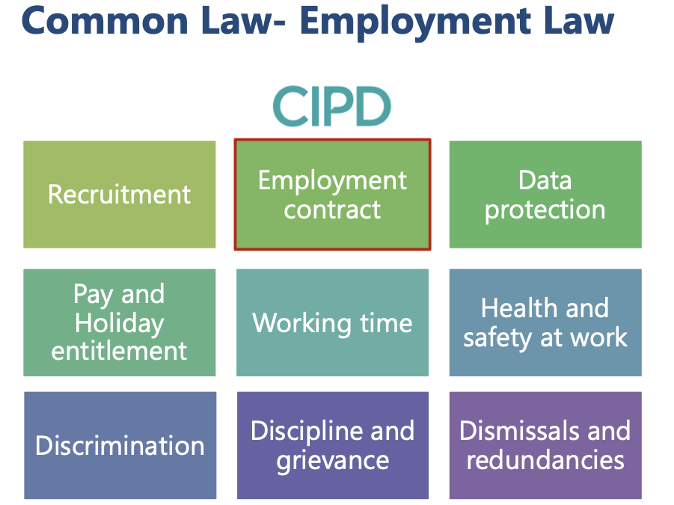

In the UK, employment and labour law has become synonymous with regulations and policies between employees and employers (Freedland, 2020). Also, it includes civil and criminal disputes where the rights of employees have been violated (Lewis and Sargeant, 2019, p,2). Laws emerge from parliament legislation, and the court system is the one that deals with cases of injustice. The civil court system deals with employment cases. Figure 2 show the court system. In the figure, the first point of contact is the employment tribunal, then the employment appeal tribunal, the appeal court and finally, the supreme court.

However, all the steps are not necessarily in a dispute, only when the plaintiff (a person who feels wrongly abused by another and takes legal action) is not satisfied with the results. Moreover, employment law helps the part that the rights have been breached, so, one time could be the employee, others could be the employer (Aylott, 2022, p. 29). The government has been trying to make precise regulations for employers to be fair with employees in a changing business environment.

Figure 2. Court System.

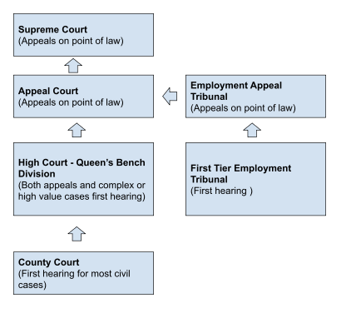
Source: Aylott, 2021, p.19.

Figure 3. Written Statement
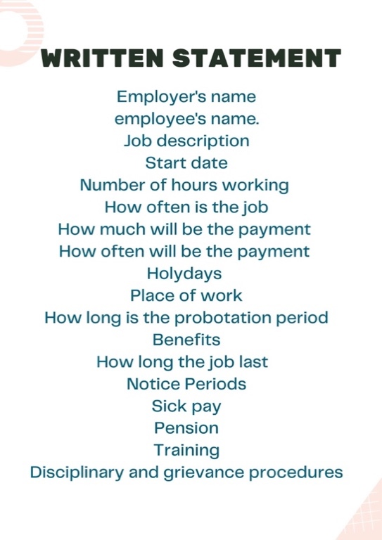
Source: (ACAS, 2022)

Employment Contract

One of the regulations the government is trying to force is specifying employment contracts. An employment contract is an agreement between an employee and an employer, and this contract is subject to rights and responsibilities for both parties. Also, it can be oral or written, with specific duties and conditions and must be stipulated in terms of that contract. There is also the written statement, see figure 3, with details such as the employer’s name, employee name, job title and starting date (ACAS, 2023). Moreover, the contract can contain policies, clauses, and a code of conduct. The terms differ between positions and companies to be fair and related to the employee’s task. There are express, implied, and statutory terms (see figure 4 that illustrate the employment terms). However, even with those regulations, a contract can be terminated by the employer or employee in which the due conditions should be in the contract to avoid lengthy and costly legal procedures and employee unfair or wrongful dismissals.

Figure 4 Employment Terms.
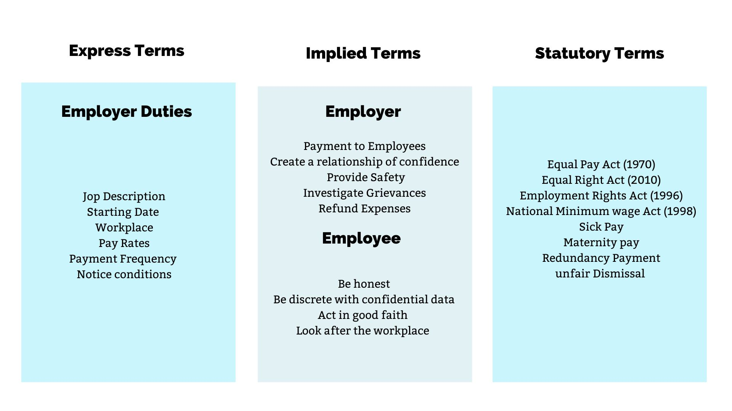
Source: GOV, UK, 2022.

Contracts usually terminate because of a breach of the contract for part of the employee not accomplishing the task established or because their employer did not comply with the necessary legal terms in the contract. To avoid this, both parties must know their rights, obligations, and duties. However, there are times that these terms must be altered by any of the parties (employee or employer), but all should agree to the updated terms (GOV, UK. 2023). There should be an explanation of the latest changes. Employers and employees can agree to the new changes, which must be amended in the written statement to avoid conflicts in the future. Despite these procedures, some terms could be more beneficial to the employees, starting a negotiation period for both parties to get the best solution. Sometimes even with negotiation, there is no agreement, as in the case of British Gas, where they offered new terms(long hours and lower pay) to their engineers, resulting in a dispute for various months, ending with a 500 worker dismissed through negotiation with their GMB(Gas Workers and General Labourers) union, the new terms were modified and giving better benefits to the engineers in the new contracts(GMB, 2021). Thus, contract agreement affects the quality of employment offer to the employee so is important for both parties to agree and be aware of the terms and conditions.

As the case of British Gas and their engineers can be deducted that changes in the contract should be worked together and that the law should be help meditating in these cases. ACAS (Advisory, Conciliation and Arbitrary Service) is a non-departmental organisation that works to improve the relationships between employers and employees. Employers should be careful when changing contracts to avoid employees’ stressful situations, legal claims about unappropriated dismissals, strikes and discrimination.

Wrongful Dismissal

When a disagreement occurs between the parties, a dismissal can occur. According to ACAS (2022), wrongful dismissal is when the employer infringes the contract terms with the employee. For example, a Spanish teacher was compensated for a contract breach and unfair dismissal (Cholteeva, 2023). In this case, the teacher was dismissed because he did not sign the new contract with new unfavourable terms, such as unpaid overtime and only a one per cent raise despite at 10% rise promised. Wrongful dismissal can be seen as well around the world, as the case. This case was a fire and rehire, however the teacher was not interested in the new contract because of the worst conditions. Another case where a man was dismissed as his position was not necessary, this case stated by Ismail (2018) shows a breach of the contract where the company did not want to continue working with him but declared that his position was no longer available. However, he was the only one dismissed, and another person was doing their job. According to the case study, unfair and wrongful dismissals are common in Malaysia due to poor knowledge of the law and sometimes employers' unfairness towards certain employees. Given the above information, employment laws are there to protect employees, but employers have the power to terminate their contracts, sometimes breaching their agreement.

Unfair Dismissal

Similarly, unfair dismissal is one of the reasons that employees claim before tribunal cases, see figure 2 about court system. Unfair dismissal is a breach of statutory rights; also, it needs to be done by an employee of a company, meaning being a continuous employee for two years (Acas, 2022). To illustrate this, an office manager was granted compensation and unfair dismissal by the employment tribunal in Manchester. The case was about misconduct on the part of the manager by not ordering stock, according to the company; however, it was proven that the manager took the best decision according to her knowledge due to a lack of communication between their top managers (Sriganthan, 2023). An unfair dismissal can be seen in many other parts, as in Mauritius, where the law has not explained the word ‘dismissal’ and states that employers have the right to dismiss an employee according to misconduct, lousy performance, and redundancy Beebeejaun (2018). Also, in this paper, the author stated that Mauritius law tries to protect employees facing unfair dismissal; however, they are guidelines that are subjective to employers' interpretation. It can be concluded that governments try to protect employees by creating laws and guidelines that employers and employees could misinterpret. To avoid that, it is essential to be aware of the new law.

Employment law is vital to society, particularly in creating a secure business environment for employers and employees. Awareness of their rights, obligations and duties is primordial to have a balanced work environment. In the UK, even though the employee thinks he has been treated unfairly, they can consult within the company or ACAS and find advice to conciliate or make a claim.

In the appendix there some case of fire and rehire in the UK. Where the new terms and conditions will affect the wellbeing, work balance and statuary terms of the employees.

IMPACT OF CONTRACTUAL CHANGES ON EMPLOYMENT ENGAGEMENT

This review aims to interpret the literature and data about employee engagement and its influence in situations where the contract change occurred, specifically in fire and rehires.

METHODS

The library was used to find relevant research papers on the topic. That was used as secondary research, and because lack of journal articles, the researcher conducted a semi-formal interview with two HR managers in a university and a cleaning company. The interview is in Appendix B. The questions were the following:

1. What is fire and rehire? What do you think about it?
2. What must an employer consider before doing a 'fire and rehire'?
3. In your opinion, how can contractual change impact employees in a fire and rehire process?

LITERATURE REVIEW

The review explores the published literature concerning employee engagement during 'fire and rehire' and in various contexts, as fire and rehire are an organisational and psychological change.

All studies agree that the work environment is linked to employee engagement and its effects. According to Bailey (2022), employee engagement can be defined as a series of actions between an organisation and the employee to benefit both.
Teo et al. (2020) found that toxic environments (long hours, lack of adequate equipment, too much work) affect employees emotionally, psychologically, and physically. Also, Saleem et al. (2020) identify that workplace violence (physical or verbal, such as threats, disrespect, shouting, assaults, and intimidation) is a factor that increases absenteeism, job dissatisfaction and health problems. In addition, psychological drivers (positive and negative such as rewards and punishment) in the workplace from leaders affect employees' responses, manifested as burnout, lack of engagement and stress (Lee et al., 2022). In contrast, Lim et al. (2023) studied the circumstances that made employees behave negatively and reduced the morale towards the company. However, in a more specific view, the business side, a contract breach could incur dissatisfaction, underperformance, lack of trust, inequality, conflicts, and lack of cooperation (Gillani et al., 2021).

The other studies suggest practices to improve the engagement of employees. Oluwatayo and Adetoro (2020) found that employees like the flexibility to choose their benefits and workplace. Also, they stated that feedback, resources, and relationships with bosses increase the engagement of employees. Moreover, Amah (2018) highlights that employees with voice and support in the organisation tend to have a special relationship with the boss but are subject to their behaviour. For their part, Lalatendu et al. (2018) identify a relationship between employee engagement and trust; when the leader is trusted, high levels of psychological engagement (creativity, positivism, happiness) are present and according to Fiaz and Fahim (2023) considered negative experiences as a motivator to keep a positive attitude and improve the work environment through mindfulness and interaction with colleagues.

FINDINGS

Primary Research

The interview answers were critically analysed, and the results were similar. HR Manager's answer to question number one about the meaning of fire and rehire was standard. Part b of the question about their opinion both think fire and rehire are controversial and employers and employees are right to defend their terms and conditions. Also, if a company needs to do it, they should follow the proper procedures.

Question two concerns what an employer needs to consider before firing and rehiring; both are unsure because they need never face that situation. They have general knowledge about the topic and experience from friends. Both agree on following the guidelines, such as consultation and communication and, if there is no agreement, do not give unfavourable terms and conditions to employees. However, both agree that dismissal will occur even if the employee has not agreed because the company need to adjust their cost, starting with modifying the contract.

Question three concerns their opinion on the impact of contractual changes on employees during a fire and rehire. Both agreed on many factors affecting the employee, such as disengagement, lack of productivity and distrust. The Manager from the university adds well-being; the Manager from the Cleaning company thinks lack of respect and overall performance is affected.

Secondary Research

Comparing their previous research findings, they appear correlated with the literature about the relationship between work environment (health& safety, job design and work-life balance) and employee engagement. Every study research shows that there is not only one factor that affects employee engagement but various and some related to HR practices. There was some typical funding as leadership styles and behaviours affecting engagement (Lalatendu et al., 2018; Amah, 2018; Lee et al., 2022). It indicates that leaders are vital to promoting an organisation's mission and values and creating a culture that engages through positive, honest, and transparent experiences even in the more tough times. The lack of leadership attitude and compassion towards employees in distressful situations is a factor that affects employees (Amah, 2018; Teo et al., 2020; Saleem et al., 2020). Thus, there are many studies on employee engagement and the relationship between work environment; it might be assumed that the work environment is affected by any organisational change such as fire and rehire.

DISCUSSION

After analysing primary and secondary research, it shows that
only a leader with experience and a human centre can create the proper procedures to deal with changes that affect all. In the case of British Gas, the employees were in a stressful situation, and their psychological needs were neglected, creating distrust, dissatisfaction and uncooperating towards resolving the organisational change together. For example, Miles Hobson, a British Gas engineer, was feeling bullied because of how the company was dealing with the employees, and worst because the emotional attachment and commitment were destroyed (Espiner, 2021). Thus, this shows many implications under challenging situations such as fire and rehiring.

Leadership is one of the drivers of employee engagement, and in a fire and rehire situation, it is not only necessary the outcome but how the process is conducted. Not all solutions are adequate for all companies (Taylor, 2017). According to the Gallup employment engagement model (2023), when employee needs are satisfied, there is an environment of trust, respect, and commitment to the workplace. The model consists of four levels: basic, Individual, teamwork and growth. The overall focus is on employees knowing their responsibilities, having the resources adequate to do them, being recognised and encouraged from all around them, and participating in activities and decisions. See the figure illustrating the four levels of employee engagement.

Figure 5 Employee Engagement Model
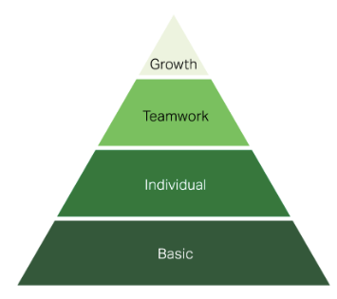
Source: Gallup, 2023.

CONCLUSION AND LIMITATION

There are essential differences between the approach taken by organisations and HR. According to the data of the studies, the creation of policies, training, and employee-centric techniques create an environment of respect. However, this needed to be demonstrated, not only as a suggestion. There were some limitations in the research as some surveys were analysed, and the scope of the secondary and primary data was small, only on a specific region, brief period, and particular context (Fiaz and Fahim, 2023; Gilliani et al., 2022; Oluwatayo and Adetoro, 2020). However, the research can be concluded with some highlights as there is a relation between employee engagement and contractual changes, as in the case of fire and rehire, where salary rate change and overtime are not paid affect not only the employees dismissed by the ones that accept the recent changes. So, the responsibility of managers and organisations is to create a safe environment with support and care to decrease the effect on the company's performance.

EMPLOYMENT RELATIONSHIPS

Relations evolve according to the environment and personal traits. Employees and organisations create relationships from the first contact which others. In other words, employee relations are the contact between employees and companies or its manager, increasing engagement and trust (CIPD,2022). As with any good relationship, the benefits are more significant than a conflicted relationship. According to Crail and Watts (2023), the relationship should be focused on communication leading to positive relationships. However, employees are unwilling to express their voices in a crisis, and the relationship starts falling (Lee, 2020). So, employees and employers should work together to create relations where expression and honesty can lead and keep the relationship healthy.
Every employee is different in their way of expressing their point of view. So, every relationship is different, and organisations show this difference in the employment contract and the policies and procedures (CIPD, 2023). The contract and handbook stipulate conditions about dismissal, discipline, sickness, DEI, and holidays. In contrast, a psychological contract is defined by Topa et al. (2022) as the expectations produced by the company or employees of mutual understanding and collaboration. This contract is the most fragile to break and more difficult to fix due to the anger and frustration a person might express. Hence, breaking the contract (physical and psychological) affect the interaction with others and could lead to legal action.
Legal actions can be made individually or collectively, depending on the relations. Unions, employees, or employers make collective relations to voice what is not working with employers. In other words, collective bargains and consultations help negotiate the terms and conditions (ILO, 2022). usually, employees seek help from unions in redundancies, dismissals and health and safety-related matters. According to Acas (2022), conciliation helps if there is a disagreement between the parties (employees and employers). Collective relations are changing with the adoption of modern technology, and the power has diminished over the years, affecting relationships.
As seen before, employee relations are essential to creating a positive environment. However, it is important to highlight that individual and collective relationships are made to strengthen the relationship with managers and others as unions. Besides, the relationship with unions could be seen as a falter with their intervention by strikes affecting other people. So, even though unions are allowed by UK law, there is a controversial relationship. Also, relations strengthen or weaken an employee's performance, increase co-workers shared tasks, and the organisation is seen as a big family, with fewer conflicts and overall motivation to be part of the company.
Analysing the workforce is indispensable finding the suitable model a company can apply to increase productivity in managing its people. According to Gerguri (2023), Hard HRM systems focus on the results a company can get by managing the workforce with an authoritarian style and less investment. For example, some companies do not invest in employee programs because they see them as a liability. However, they do not think minimum wages and top-down management decrease motivation and increase turnover. However, this approach is helpful when micromanaging and budget constraints are necessary. Even so, managers must know what and how to apply where the context determined it or needs more control. Due to the company's control, they try to be cost-efficient and understanding to the overall process to be profitable.
In contrast, a soft HR approach uses less control and is more people centric. Employees are essential assets that must be supported through engagement programs, motivation, and feedback (Gerguri, 2023). For example, there are companies where the participation of employees is validated through activities as consultation of new objectives for the organisation. Also, where learning is primordial to continuously improving skills and personal development, according to Bai et al. (2019), informal recognition through positive gossip from supervisors and managers enhances confidence. However, negative gossip increases employee self-awareness of their performance and motivates them to change. This approach increases morale and executes an onboarding process that helps new talent adjust quickly and efficiently into the organisation. Employees are ambassadors of the company because they are proud and attached to its culture, creating indirect publicity. Hence, as with the other approach, only can be used when staff is at the centre of the strategy or program. Thus, soft approaches help human resources value employees and cooperate with them to make them as competitive as the market requires.
Even though each approach has many advantages in its one, they lack its benefits. Hard HRM approaches strength is the cost-effective procedure and soft HRM strength is people focus. Instead, soft HRM approach incurs in expensive costs, investing in people and their needs. Learning and development programs need inversion and talent and must be rewarded and paid well. The two approaches can work in the same company; for example, for the learning and development department, a gentle approach is valid because tolerance, respect and progress are the drivers that motivate employees to search for personal growth and get the job done in a structured way. The same company could use a hard HRM approach to undertake a project that requires collaboration, and time is a constraint.
Human resources have a great responsibility when working with individuals and unions. Working with unions can be unattractive for new generations that find memberships unvaluable just to be represented. However, Heckscher (2018) states that in modern time, there are no more abuse or unsafety, but there are other concerns related to employee rights and diversity. In the case of fire and rehire, employees should work with unions to dimmish the damage caused by their actions, such as a national rail strike. Another advantage is that if the company is trying to change the contract of 200 or more employees is better to discuss it with a representative that knows contractual and employment law to avoid misguidance. HR individual relation could be affected if there is not effective communication, and the company do not support staff during that demanding situation as 'fire and rehire'.
Fire and rehire is a process that only should be done when their no other way for the company to survive. Hard approaches will tend to press employees into the new contractual changes, favouring the company and its restructuring. According to Lou et al. (2022), there are two types of authoritarian styles dominance and discipline. He states dominance is detriment leadership where employees are threatened, bullied, and devaluated. In contrast, discipline tends to achieve its goals through monitoring and controlling but creates a perception of value in employees motivating them to accomplish their tasks. However, they should remember that threatening and not following the consultation notice could incur in unfair dismissal even though employees could feel afraid, discouraged, and disengaged because they have experienced it while working with them. HR should focus on support through the channel where communication goes transparent and lead to productivity.
Human resources communications are essential during the process of fire and rehire to avoid misunderstanding and follow the legal terms. Soft HRM approaches being people-centric will be in favour of employees. The approach will not justify the fire and rehire process, but if it is fair, it will be accepted through negotiation and financial incentives. Human resources still provide support, through other channels, to engage and motivate employees. According to Sahoo and Sahoo (2019), the quality of relations between employees and organisations in conflicts will determine how trust and sustainability will be in the future. Also, the support network will keep the expected productivity levels. However, Lyiola and Rjoub (2020) stated that leadership is vital to obtain a climate of trust and support. They also highlight that collaboration is essential, even with an authoritarian leader that will enforce the solutions. In summary, soft HRM approaches will make the process of fire and rehiring compassionately for both parts and overall employees. Also, they will think about future employees and how the relationship can be supported and valued to avoid disengagement, frustration, and demotivation.
In summary, employee and employer relations are vital to a company's process independent of the HRM strategies. External factor affects the organisation and makes planning strategies necessary to be competitive in the market. So, aligning the HRM strategies with business strategies is ideal for achieving high performance and engagement, and involvement of employees. HR work with unions, managers and individuals are the beginning of relationships that could co-create new policies, new procedures and new terms and conditions in a contract. All of this might be the way of doing things in the future.

CONCLUSION

Fire and rehire is a tactic rarely used in stable economic markets. In this article, the author presented findings about the legal implications surrounding fire and rehire or dismissal and re-engagement. Also, the importance of relationships, even during that process, is to keep the well-being of re-engaged and old employees. During the process, the most affected the employee in numerous ways, but UK law justified this procedure to avoid an increase in unemployment. The government has made some guidelines that employers should follow to avoid unfair dismissal and costly legal actions.
However, the unstable economy affects companies, and they use fire and rehire as a tactic to reduce costs and keep getting profits. The uncertainty of the business market signals that more companies will use this tactic not as a last resource but as one strategy to survive, and others will get higher profits. Being ethical is necessary of a company, but changing the contract terms into less favourable ones for employees is losing the essence of being a company. Companies are responsible for profits but for the environment and society, but acting unethical affects the factors that made them in the first place getting profits.

RECOMMENDATIONS

Organisations are networks of systems connected, being agile and productive. In theory, that is what one firm should be. While many organisations have management, leadership and performance gaps, others grow and shine. However, what is that made them special? Their people, the products, the image, and culture could be anything or everything. It is difficult because companies are independent of a community but have inside a mini society with their rules, culture, and ambitions. So, it is society's responsibility to help companies become the best for themselves, their environment, and their people.
According to the findings in this report, the researcher will give some suggestions on the topic for all people concerned.
- Government should not only put a code but be more tactical and put high finance fine when the code has not been followed. It will send the signal that it must be done first in a state of financial trouble, near cessing the activities, second, following a process of consultation and negotiation between the parties, and finally, being honest and compassionate during the process.
- Employers must be honest with employees and discuss the situation with the employees. Give participation to employees to propose solutions to the distressful time the company is passing. Listening to them will make them feel important and be part of a big family.
- Employees should listen and have a voice while giving ideas that could lead to solutions.
- The code should be a legal obligation for employers. It should be liable to fines and imprisonment if it fails to comply.
- HR should play an essential role in this tactic. But not only during the process but before and after. HR oversees the management of personnel and their well-being. So, it is indispensable that support such as workshops explaining the reason to changes the terms and conditions and how all will benefit from it.
- HR should plan how to attract and retain talent because no one wants to be in an unstable environment. A company doing a fire and rehire tactic is in a severe economic condition. So, advertisements educate people about what the company has done in the past and what it dreams of doing, but they need that last resource to do so. Also, they should include the negotiations meetings and post it online on social media or intranet. It will show transparency and honesty.
- Social media is a tool where employees and managers can post their voices, but others can contribute to generating fresh solutions.
- If there are dismissals and the re-engagement did not occur, HR must have a strategy to train their staff in a conflict climate. So, the introduction of non-financial rewards is suggested. Those rewards could be vouchers, gifts, for pleasure or development. For example, a free course in Excel, a voucher to get fruit, a discount price X Day.
There are only suggestions, but they only apply in some cases because every company's needs differ. However, the only constant is that HR should plan and execute a support network during this phase for employees to show the human side of the company.

REFERENCES

ACAS (2022) Collective Conciliation. Available at: https://www.acas.org.uk/collective-conciliation (Accessed: 4 May 2023)

ACAS (2022) Dismissal. Available at: https://www.acas.org.uk/dismissals/unfair-dismissal
(Accessed:14 April 2023)

ACAS (2022) Making changes to your employment contract – advice for employees. Available at: https://www.acas.org.uk/changing-an-employment-contract/advice-for-employees/if-your-employer-proposes-to-dismiss-and-rehire-you (Accessed: 1 April 2023).

Amah, O. (2018) Employee engagement in Nigeria: The role of leaders and boundary variables. SA Journal of Industrial Psychology. 44. Available at: https://sajip.co.za/index.php/sajip/article/view/1514/2255 (Accessed: 22 April 2023)

Aylott, E. 2022) Employment Law: A practical Introduction. 3rd edition. London: Kogan Page (CIPD). (Accessed: 1 April 2023).

Bai et al., (2019) learning from supervisor negative gossip: the reflective learning process and performance outcome of employee receivers. Human Relations, 73(12), pp. 1689 – 1717. Available at: https://journals-sagepub-com.ezproxy.uwtsd.ac.uk/doi/full/10.1177/0018726719866250 (Accessed: 6 May 2023)

Bailey, C. (2022) Employee engagement: Do practitioners care what academics have to say- and should they? Human Resource Management Review, 32. Available at: https://www-sciencedirect-com.ezproxy.uwtsd.ac.uk/science/article/pii/S1053482216301061 (Accessed: 1 May 2023)

Barling (2023) Brave new workplace. [Chapter 1]. Available at: https://academic.oup.com/book/45352/chapter/389265109 (Accessed: 1 April 2023).

Beebeejaun, A (2018) Unfair dismissal in the Mauritius context: a comparative study, International Journal of Law, and Management, 60(6), pp. 1299-1312. Available at: https://www.proquest.com/docview/2153659410?OpenUrlRefId=info:xri/sid:primo&accountid=130472 (Accessed:14 April 2023)

Butler, S. (2022) Union wins right to challenge Tesco fire and rehire policy at supreme court. Available at: https://www.theguardian.com/business/2022/dec/22/usdaw-union-right-to-challenge-tesco-fire-and-rehire-supreme-court (Accessed: 1 May 2023)

Chance, M and Lau, C. (2021) British Gas ‘Fire and Rehire’ Boiler Engineers Resulting in Mass Dismissals- Unfair Dismissal? Available at: https://www.rosenblatt-law.co.uk/insight/british-gas-fire-and-rehire-boiler-engineers-resulting-in-mass-dismissals-unfair-dismissal/ (Accessed: 22 April 2023)

Cholteeva, Y (2023) Teacher who was promised ‘misleading’ 10 per cent pay rise was victim of breach of contract and unfair dismissal tribunal rules. Available at: https://www.peoplemanagement.co.uk/article/1816898/teacher-promised-misleading-10-per-cent-pay-rise-victim-breach-contract-unfair-dismissal-tribunal-rules (Accessed:14 April 2023)

CIPD (2022) Employee Relations: An Introduction. Available at: https://www.cipd.org/uk/knowledge/factsheets/relations-employees-factsheet/ (Accessed: 4 May 2023)

CIPD (2022) ‘Fire and rehire’ – guidance for employers. Available at: https://www.cipd.co.uk/knowledge/fundamentals/emp-law/terms-conditions/fire-rehire-employer-guidance#gref (Accessed: 1 April 2023).

Corr, L. (2022) Teacher against Fire and Rehire. Available at: https://www.tribunemag.co.uk/2022/05/teachers-fire-rehire-richmond-college (Accessed: 1 May 2023)

Corrigan, P. (2022) Council issues fire and rehire threat to 5000 workers in raid on ‘generous’ perks. Available at: https://www.stokesentinel.co.uk/news/stoke-on-trent-news/council-issues-fire-rehire-threat-7775247 (Accessed: 1 May 2023)

Coyne, A. (2023) Pilgrim’s Food Master accused of ‘fire and rehire’ tactics at UK facility. Available at: https://www.just-food.com/news/pilgrims-food-masters-accused-of-fire-and-rehire-tactics/ (Accessed: 1 May 2023)

Crail, C. and Watts, R. (2023) What is employee relations? Available at: https://www.forbes.com/advisor/business/what-is-employee-relations/ (Accessed: 4 May 2023)

Espiner, T (2021) Hundred lose job in British Gas contract row. Available at: https://www.bbc.co.uk/news/business-56746656 (Accessed 22 April 2023).

Fiaz, S and Fahim, S. (2023) The influence of high-quality workplace relational systems and mindfulness on employee work engagement at the time of crises. Heliyon, 9(4). Available at: https://www.cell.com/heliyon/fulltext/S2405-8440(23)02730-5?_returnURL=https%3A%2F%2Flinkinghub.elsevier.com%2Fretrieve%2Fpii%2FS2405844023027305%3Fshowall%3Dtrue (Accessed: 22April 2023)

Forces Net (2022) MOD accused of ‘threating teacher of service children with fire and rehire’. Available at: https://www.forces.net/operations/cyprus/mod-accused-threatening-teachers-service-children-fire-and-rehire (Accessed: 1 May 2023)

Freedland, M. (2020) Employment Law Revisited. 43 (2) p.1-27 Dalhousie Law Journal. Available at: https://www.proquest.com/docview/2476621161?parentSessionId=b35wQH3Ch0TLHnq6iAUDFR4nzCRBa4L%2BRmGH0qCuSsU%3D&pq-origsite=primo&accountid=130472 (Accessed: 1 April 2023).

Gallup (2023) Employee engagement model. Available at: https://www.gallup.com/workplace/285674/improve-employee-engagement-workplace.aspx (Accessed: 1 May 2023)

Gallup (2023) What is employee engagement and how do you improve it? Available at: https://www.gallup.com/workplace/285674/improve-employee-engagement-workplace.aspx (Accessed: 1 May 2023)

Gerguri, F (2023) Hard and Soft HRM Approaches: a comparison. Available at: https://www.emexmag.com/hard-and-soft-hrm-approaches-a-comparison/ (Accessed: 4 May 2023)

Gillani, et al., (2021) Psychological contract breach: unravelling the dark side of business-to-business relationships. Journal of Business Research, 134, pp. 631-641. Available at: https://www-sciencedirect-com.ezproxy.uwtsd.ac.uk/science/article/pii/S014829632100415X (accessed: 22 April 2023)

GMB (2021) British Gas fire and rehire dispute over after GMB members back improved pay deal. Available at: https://www.gmb.org.uk/news/british-gas-fire-rehire-dispute-over-after-gmb-members-back-improved-pay-deal (Accessed: 1 April 2023).

GOV, UK. (2023) Changing an employment contract. Available at: https://www.gov.uk/your-employment-contract-how-it-can-be-changed (Accessed: 1 April 2023).

Heckscher, C. C. (2018) The new Unionism: Employee Involvement in the Changing Corporation with a New Introduction. Cornell University Press, p. 249 -256. Available at: https://doi.org/10.7591/9781501725579 (Accessed: 6 May 2023)

ILO (2023) Extension of Collective Agreements: Evidence from the Updated Irlex Database. Available at: https://www.ilo.org/global/topics/collective-bargaining-labour-relations/publications/WCMS_849925/lang--en/index.htm (Accessed: 4 May 2023)

Ismail, S. (2018) Unfair dismissal or unlawful termination: a review of section 20l industrial relation act 1967,1, pp.15-24. Available at: https://www.kuim.edu.my/journal/index.php/JLG/article/view/262/227 (Accssed:14 April 2023)

Lalatendu, K. et al., (2018) Pursuit of organisational trust: Role of employee engagement, phycological well-being and transformational leadership. Asia Pacific Management Review, 23(3), pp. 227-234. Available at: https://www.sciencedirect.com/science/article/pii/S1029313216302330? (Accessed: 22 April 2023)

Lee et al., (2022) When and why competitive psychological climate affect employee engagement and burnout? Journal of Vocational Behaviour, 139. Available at: https://www.sciencedirect.com/science/article/abs/pii/S000187912200121X?via%3Dihub (Accessed: 22 April 2023)

Lee, Y. (2020) communicative behaviour in a crisis: the role of relationship and symmetrical communication. International Journal of strategic Communication, 14(2), pp.89-104.Available at: https://www-tandfonline-com.ezproxy.uwtsd.ac.uk/doi/full/10.1080/1553118X.2020.1720691 (Accessed: 4 May 2023)

Lewis, D and Sargeant, M. (2019) Employment law: The essentials. 15th edition. London: Kogan page (CIPD). (Accessed: 1 April 2023).

Lim et al., (2023) When employees feel betrayed: the mediating role of psychological contract violation on nepotism and workplace commitment in the hotel industry. International Journal of Hospitality Management, 108, Available at: https://www-sciencedirect-com.ezproxy.uwtsd.ac.uk/science/article/pii/S027843192200247X (accessed: 22 April 2023)

Lyiola, K. and Rjoub, H. (2020) Using Conflict Management in Improving Owners and Contractors relationship Quality in the construction Industry: The Mediation role of trust, Sage Open,10. Available at: https://journals.sagepub.com/doi/pdf/10.1177/2158244019898834 (Accessed: 6 May 2023)

Lou et al., (2022) Discipline Vs Dominance: The relationship between diverse types of authoritarian leadership and employee self-interest voice. Current Psychology. Available at: https://link-springer-com.ezproxy.uwtsd.ac.uk/article/10.1007/s12144-022-03812-6 (Accessed: 6 May 2023)

Morning Start (n.d.) Care worker to strike over fire and rehire. Available at: https://morningstaronline.co.uk/article/b/care-workers-to-go-on-strike-over-fire-and-rehire (Accessed: 1 May 2023)

Nautilus International (2023) P&O ferries: UK government reveals anti- ‘fire and rehire’ plan. Available at: https://www.nautilusint.org/en/news-insight/news/po-ferries-uk-government-reveals-anti-fire-and-rehire-plan/ (Accessed: 1 May 2023)

Oluwatayo, A. and Adetoro, O. (2020) Influence of Employee attributes, work context and Human Resource Management Practices on Employee Job Engagement. Global Journal of Flexible Systems Management, 21, pp. 295-308. Available at: https://link-springer-com.ezproxy.uwtsd.ac.uk/article/10.1007/s40171-020-00249-3 (Accessed: 22 April 2023)

Sahoo, R. and Sahoo, C.K. (2019) Organizational justice, conflict management and employee relations: the mediating role of climate of trust. International Journal of Manpower, 40(4), pp. 783-799. Available at: https://www.proquest.com/docview/2256135269?accountid=130472 (Accessed: 6 May 2023)

Salem et al., (2020) Workplace violence and employee engagement: the mediating role of work environment and organisational culture. Sage Journals, 10(2). Available at: https://journals.sagepub.com/doi/10.1177/2158244020935885 (Accessed 22 April 2023).

Salisbury, J (2023) Honest Burgers threatens to ‘fire and rehire workers who refuse loss of paid breaks. Available at: https://www.standard.co.uk/news/uk/honest-burgers-paid-breaks-employment-london-b1059793.html (Accessed: 1 May 2023)

Sriganthan, A. (2023) Office manager accused of misconduct for delaying stock order during the pandemic was unfairly dismissed, tribunal rules. Available at: https://www.peoplemanagement.co.uk/article/1817629/office-manager-accused-misconduct-delaying-stock-order-during-pandemic-unfairly-dismissed-tribunal-rules (Accessed:14 April 2023)

Taylor (2017) Good Work, The Taylor Review of Modern Working Practices. Available at: https://assets.publishing.service.gov.uk/government/uploads/system/uploads/attachment_data/file/627671/good-work-taylor-review-modern-working-practices-rg.pdf (accessed: 22 April 2023).

Topa et al., (2022) Psychological contract breach and outcomes: a systematic review of reviews, International Journal of Environmental Research, and public health, 19(23). Available at: https://www.ncbi.nlm.nih.gov/pmc/articles/PMC9737235/ (Accessed: 4 May 2023).

Teo, S. et al., (2020) Psychosocial work environment, work engagement, and employee commitment: A moderated, mediation model. International Journal of Hospitality Management, 88. Available at: https://www.sciencedirect.com/science/article/pii/S0278431919303810?via%3Dihub (Accessed: 22 April 2023).

UCU press Office (2022) University of Roehampton pushing ahead with mass fire and rehire in arts and the humanities. Available at: https://www.ucu.org.uk/article/12424/University-of-Roehampton-pushing-ahead-with-mass-fire--rehire-in-arts-and-the-humanities (Accessed: 1 May 2023).

Wiles, J. (2022) 7 Cost-Reduction Mistakes to Avoid. Available at: https://www.gartner.com/smarterwithgartner/7-cost-reduction-mistakes-to-avoid (Accessed: 1 April 2023).

APPENDICES

A.Fire and Rehire Cases UK

Case Name | Contractual Changes | Employee Opinions
Honest Burger | Stop paying breaks but increase hour pay. | - “If feels like a slap in the face. Honest likes to claim it is a family, but this is not how you treat family.”  - “I feel let down, like a lot of my hard work goes for absolutely nothing. I feel like Honest does not fully care four us employees, when we do everything to get the sales and make the customers and the management happy.”
Tesco | -Lower pay.  - Change contract form 2007, where it says, “retained pay”. | -Usdaw union said: that some workers were threaten by employers which lead to resign or sign a worst contract.
P&O Ferries | -876 employee's fire
Pilgrim’s Food Masters | -Part of Pilgrim’s Pride (us company)  -Losing pay breaks  -Reduce sick pay  -Removal of Diwali holiday pay. | -GMB union say that 1000 employees were threatened to sign contract or get fire.  - “workers are already terrified about how they will pay their bills; many are already relying on foodbanks. This will make things so much worse.”  -The staff is low paid women of Punjabi, Sri Lankan, and Somali heritage.
University of Roehampton | -Fire and rehire more than 100 employees.  -Cut on subjects.  -Not enhanced pay off only if voluntary redundancy.  -If not accepted for voluntary redundancy, lose job, and not enhance pay off | -UCU union say university is threaten employees with redundancy.  - Cut on subject as classics, anthropology, creative writing, and photography.
Stoke-on-Trent City Council (threat of fire and rehire) | -5000 staff new term and conditions.  -Reducing overtime, unsocial hours, rates  -End the automatically incremental pay increases each year  -Reduce voluntary redundancy  -Annual leave  -Alternating shift allowances  -Enhancement for rotating shifts. | -Jane Ashworth (labour group leader) do not agree with the demands of the council, she thinks that is “terrible way to treat people who are already worrying about the impact these changes will have on their domestic economies.  -Also, she added, that “some worker could be losing hundreds of pounds that they need to pay their mortgage”
Ministry of Defence (MOD) threat | -Teacher brough to instruct children of personnel serving in Cyprus.  -Abolish pension rights  -Lower their terms and conditions. | -Threat of fire if not sign new contract.
Richmond Upon Thames College | -127 teachers.  - Decreasing 10 days of the annual leave  -No redundancy payment | -Threat of fire if not sing new contracts, after the consultation stage, 45 days.  - Teachers feel scared and threatened.  -Gave deadline to employees to sign the new contract with new conditions (unfavourable to employee)  -Strike actions of 5 days.
St Monica Trust | -More than 100 carers in Bristol.  -Cut 21% of salaries of senior care workers.  -10% cut other staff. | -Threat to sign in unfavourable contracts or fire.  -Strikes  -Christina McAnea (General Secretary) commented: “threating staff with the sack if they don’t agree to savage cut is short-sighted and cruel.’

B Interview Questions

1.What is fire and rehire? What do you think about it?
2.What must you consider before doing a fire and rehire?
3.In your opinion, how can contractual change impact employees in a fire and rehire process?

Answers from HR Manager at a university in London

1.Fire and rehire is a process a company uses as a last resort to dismiss employees, following a consultation process where the added terms are discussed and agreed upon. Usually, the terms are disadvantageous for employees. It is a controversial process; employees want the job and benefits, and employers want the company to keep gaining money. So, the process takes work. I do not support the fire and rehire when it is done illegally, for example, when companies fire without consultation and use discrimination or threats to employees to agree with the new terms and conditions.

2.I have not yet done a 'fire and rehire' in my life. Only I know because I should learn about it and a friend did it. The process is legal in the UK after a consultancy period, and if there is no agreement, the employers can dismiss and offer a new contract with the new conditions. It should be done just when a company is losing money, when reducing salaries costs, when changing hours, and when only a few people disagree with the latest changes on the contract; those factors need to be considered to justify fire and rehire.

3.It is a strenuous situation for all. Every change in organisations affects people, ones more than others. Every change in a contract must be consulted and agreed upon to avoid conflicts. Employees should feel afraid of the new terms if they lose money because they have commitments, and the cost of living in the UK is not better. Another reason is that employees' trust and confidence in the company will be gone. Even if the process has been done legally and the company did it for business insolvency. The disengagement of employee’s, dissatisfaction increase, and their well-being (physical and moral) diminishes.

Answers from HR Manager in a Cleaning Company

1.Fire and rehire is a process that allows companies to terminate a contract and re-engage or rehire in a new condition. It is a complex process because both parties want to gain. However, when a company is doing it due to insolvency is acceptable only if they follow the law. Meaning, give notice and work with the employees in an agreement; if it is not possible, but the majority has accepted the offer, the employer dismisses the ones refusing and makes an offer with new conditions. Also, the reason is to avoid losing more jobs or closing the company. In that case, it is a valid reason, but when companies want to reduce costs, change the salary rates, and threaten employees, and overtime payments, that is atrocious.

2.According to UK law is the last process a company can make to keep in business. However, the process must follow some reasons, such as other measures to consider before the fire and rehiring. The employee has refused the new terms and conditions, and the employer has given notice and then decided that dismissal is the best option under "some other substantial reason" (SOSR).

3.In my position, never has done a 'fire and rehire'. After Covid-19, many companies' finances changed, compelled to use this tactic inhumanely. Contract changes affect employees and companies in many ways. Companies are judged, and even if the dismissal was fair and the reason is valid, people always consider added terms as flaws in a company's management. The company's reputation for attracting new employees will decrease, and collaboration will be unappealing. On the other hand, employees will reduce morale, absenteeism, disengagement, resignation, distrust toward the managers, loss of respect toward the company, and overall deficient performance. Also, employees sacked by the 'fire and rehire' process will not receive redundancy pay and will be redundant.

