University of Wales Trinity Saint David
Student : Antu Bhomik
Student ID : 1818298
BMSW4005 – Professional Career Development
Lecturer Name : Lloyd Beharry
Table of Contents
Task 2 – Report 3
Introduction 3
A personal reflection on the role play & career development planning 4
Kolb’s Reflection Cycle 4
Career development planning 5
An understanding of the knowledge and skills which contribute toward working effectively..7
An understanding of personal strengths and areas for further development 9
Personal & Professional Development Plan 10
Conclusion 13
References 14

Task 2 – Report

Introduction
The personal development plan is also known as an individual development plan which is highly required for achieving goals. Besides, a proper plan helps to fix the right decision or the set the mind properly which is so effective for developing individual career. There have some skills and knowledge like communication, teamwork, analytical and decision-making which promote individual career properly. Besides, an individual needs to take some vital steps for eradicating the weakness and challenges. Here, the report is based on a personal development plan which is very significant for attaining purposes (Boissy et al, 2016).

A personal reflection on the role play & career development planning
There have some core steps to develop with self-reflection such as reflect on the experience, reflect on the learning, and apply to the practice. The steps play a great role to do the personal development plan. Here, I try my best to uphold Kolb’s reflection cycle as the cycle is based on the experience which supports to develop career properly. For example, as an interviewee, I take a lot of exams where I gain many vital experiences which support me to build an effective plan based on my career (Cottrell, 2017).

Kolb’s Reflection Cycle
According to the Kolb’s cycle, as an interviewer, I identify that most of the candidates are afraid of or feeling nervous during the examiner ask a question. For this nervousness, they cannot answer some easy and simple question. Further, when I am as an interviewee, I attend a lot of exams and then I have gained a lot of experiences which helps me to analysis the right topics to answer the question properly (Dawson et al, 2018).
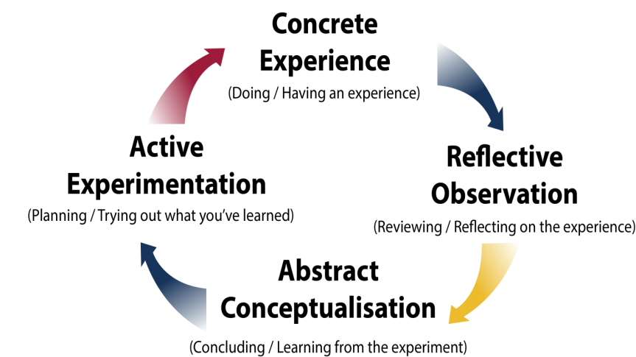
Figure: Kolb’s Reflection Cycle (Boissy et al, 2016).
Besides, as an interviewer, I also gain some effective experiences which are also significant for my career development. According to the Kolb’s cycle, as an interviewee, I notice that the examiner always keep focusing the candidate manners, attitudes and general knowledge. That’s why; I try my best to achieve these skills properly so that the examiner can satisfy with me and will have provided an opportunity (Keevy et al, 2018).

Besides, by maintaining Kolb’s reflection cycle, I can evaluate my experiences successfully. For example, as an interviewer and interviewee I find out which area is my experience and then I highlight the positive experience and gain knowledge from the negative experiences which support me to the career development plan successfully (Custodio et al, 2019).

Career development planning
Career planning refers to a process of job that establishes what a person does for a living. In shortly career planning is the process of augmenting an employee’s future value. Career development planning is related to systematically matching career goals and individual abilities with opportunities for their complete satisfaction (Dansieh, 2011)
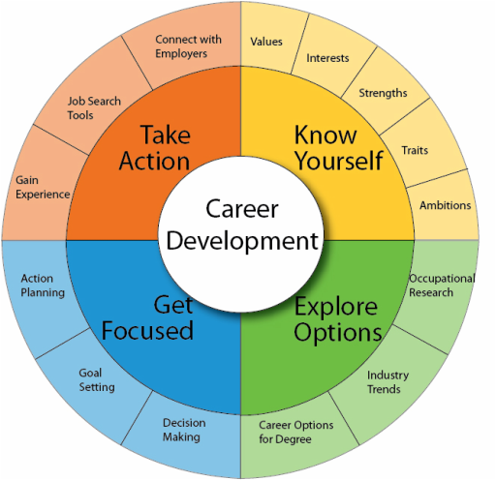
Figure: Career development planning (Cottrell, 2017).
Take action
In this section, I need to give focus on gain experiences, job search and connect with employers. For example in this stage, I need to take action on my mission, vision and my purpose. Here I need to gain practical experiences in formal and informal ways. Job search tools and connect with employees is related to this stage (Keevy et al, 2018).

Know yourself
In this sector, I need to get focus on my skills, weaknesses, interests, values, traits and ambitions. We all know that know yourself is the most difficult thing in life but it is the beginning of wisdom. So in this step, I need to analysis myself very carefully (Cottrell, 2017).
Explore options
In this stage, I need to explore options. Explore option is related to occupational research, industry trends, career options for a degree etc. For example, here I need to find out the best job-related company as well as I need to know the recent trends of the industry. In this stage, I also need to match my degree in my career sector (Dansieh, 2011)
Get focus
This is the last or final stage of career development planning. This stage is related to decision making, goal setting and action planning. For example, here I need to decide what I want to do as well as how to do it. Here I also need to enquiry the job field and give my best effort to make my goal fulfil (Arnold et al, 2019).

An understanding of the knowledge and skills which contribute toward working effectively
To development professional and personal life an individual needs to have exercised some core skills and knowledge. Here, I try to gain some basic skills and knowledge e.g. communication skills, critical thinking, time management, decision-making, teamwork etc. so that I can work effectively (Maxwell et al, 2015).

Figure: Effective skills and knowledge (Dawson et al, 2018).
Communication skills
I think that communication skills are more effective than any other skills because the skills help to build an effective relationship with people. Also, the skill will help me gather some core information and ideas which will so beneficial for my personal and professional life (Mumford et al, 2017).
Critical thinking
Critical thinking is the ability to analyse the problems and solves it easily. I think that to set my mind or to overcome the present and future challenges the critical thinking ability is so effective. The ability also supports me to any business problems in any organisations (Kesson et al, 2012).

Working effectively in a team
I always try to work with an effective team because an effective team is so important for career development. Besides, I can solve many problems and also make a positive decision when I work together. Also, teamwork develops my morale that is very effective for improving performance (Cottrell, 2017).
Determination and patient
Determination and patient both are highly required for career development. When I have the ability of determination and patient I can do any tasks successfully. Besides, the ability also enhances my performance and efficiency which is also important for a career development plan (Mackenzie et al, 2009).
Effective time-management
Time-management skill is also a vital skill to develop an individual career. When I have time management skills I can do that right task at the right time. Besides, I can also control my personal and professional life which is so beneficial for my career (Dawson et al, 2018).
Decision-making abilities
Finally, decision-making ability is very helpful for an individual to make a positive decision in any critical situation. I also need to consider have exercised this ability because the ability will support me to make an effective decision based on my personal and professional improvement plan (Keevy et al, 2018).

An understanding of personal strengths and areas for further development
Personal SWOT analysis
Personal SWOT analysis is the techniques of analysing the strength, weakness, threats and opportunities. I also need to consider evaluate personal SWOT analysis so that I can make an effective plan based on my career (Bartfiled et al, 2010).
Personal SWOT analysis
Strength  - Primarily, I am very creative and I often excite customer with a new viewpoint on the brands.  - I communicate well with all classes people to gather core information and idea.  - I have communication, teamwork, decision-making and innovation skills. Also, I can able to ask the key question (Kesson et al, 2012). | Weakness  - I cannot make a quick decision and I feel nervous during an answer to any question.  - I have insufficient knowledge in technology that’s why I feel pressure to get a satisfying job.  - I have lees of presentation and motivation skills. Also, I have less knowledge in other countries languages like China, Japan, Spain etc. (Custodio et al, 2019).
Opportunity  - Some new technology like artificial intelligence, block-chain, robotics, edge computing, intelligence apps etc. is very beneficial for my career development.  - To increase the number of industries is also beneficial for me.  - Different loan and grant system are also so supportive of my career (Dansieh, 2011) | Threats  - Now all people are interested to gain a satisfying job that is pressure for me to get a sustaining job.  - Government legislation sometimes badly impact on my career.  - High employment rates and a poor economy are also a threat to my personal and professional sectors (Keevy et al, 2018).

Personal & Professional Development Plan
Personal development plan refers to self-improvement. Personal development is a process that creates an action plan based on aim and goal. Everyone has their own plan goals and he or she improves strategies to achieve it. On the other hand, Professional Development Plan refers to career development. Professional Development Plan is a process that maintains professional credentials such as academic degrees to formal course, attending conferences. It also refers to informal learning from various sectors (Keevy et al, 2018).
I also need to consider the personal and professional development plan to ensure a better future by improving myself. I need to consider different stages to create a personal and professional development plan such as (Cottrell, 2017).
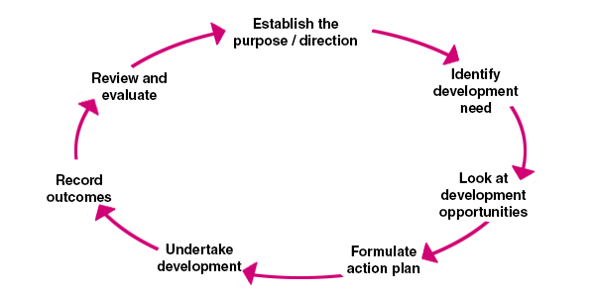
Figure: Personal and professional development plan (Arnold et al, 2019).
Establish the purpose
In the beginning, I need to establish the purpose. For example, in this step, I need to select the exact purpose of what I need to develop. This stage is also involved with setting goals and aim. For myself, I want to be an entrepreneur. So here my purpose is to be a successful entrepreneur (Kesson et al, 2012).

Identify the development needed
In the second stage, I need to identify which development I need. In this stage, I need to analyse my strengths and weaknesses. For example, I need to develop my communicative skills (Custodio et al, 2019).
Look at development opportunities
In the third stage, I need to look at development opportunities. For example, find out the regional training centre from where I can achieve proper guideline. Proper training and course help me to develop my communicative skill (Arnold et al, 2019).
Formulate action plan
In the fourth stage, I need to formulate the action plan to perfectly implement the personal and professional development plan. For example, I need to set up my action plan about what to do, how to do, when to do etc. by scheduling my planned activities (Cottrell, 2017).
Undertake development
In the fifth stage, I need to undertake development. For example, I need to start taking all my formal and informal process for the development of my communicative skills. Here I achieve my proper training to implement my development plan (Custodio et al, 2019).
Record outcome
In the sixth stage, I need to record my outcome because it will help me to review my development plan at any time. This stage is very important for any future references (Cottrell, 2017).
Review and evaluate
This is the last stage where I need to review and evaluate my outcomes. For example, here I need to evaluate my outcome that I acquire previous stages. In this stage, I need to review the entire outcome and identify the errors within my implementation. Finally, I need to make the necessary corrections if further changes required (Kesson et al, 2012).

Personal Development Plan
Goals | Actions | Obstacles | How can I improve? | Review | Timeline
Communication skills | To ensure a better communication | Obstacles in making communication within different sectors | Making communication with appropriate channels and effective means of medium | Good | Within 6 months
Interpersonal skills | To improve my interpersonal skills | Lacking in appropriate skills to make interpersonal relationship | Engaging with other persons to ensure a better relationship | Moderate | Within 6 months
Team working skills | To develop team working skills | Problematic situation in collaborative and shared working practices | Building strong commitment with team members | Good | Within 1 year

Conclusion
Thus, after completing my entire assignment it can be concluded that the personal and professional development plan is essential for me. In this assignment, I have learned so many things about the personal and professional development plan. Now I realise that personal and professional development ranges beyond educational fulfilment and is more significantly a plan that relates something about the entire person. Forgiving a good outcome I should acquire a good personal skill in communication. I should also be very careful about applying all my plans and skills. Including all my values, goal and missions I should go forward bravely to fulfil my passion in my future career (Arnold et al, 2019).

References
Arnold, E.C. and Boggs, K.U., 2019. Interpersonal Relationships E-Book: Professional Communication Skills for Nurses. Elsevier Health Sciences.
Kesson, E.M., Allardice, G.M., George, W.D., Burns, H.J. and Morrison, D.S., 2012. Effects of multidisciplinary team working on breast cancer survival: retrospective, comparative, interventional cohort study of 13 722 women. bmj, 344, p.e2718.
Bartfeld, E. and Lass, A., Irody Inc, 2010. System and method for real-time management of a drug regimen. U.S. Patent 7,747,454.
Boissy, A., Windover, A.K., Bokar, D., Karafa, M., Neuendorf, K., Frankel, R.M., Merlino, J. and Rothberg, M.B., 2016. Communication skills training for physicians improves patient satisfaction. Journal of general internal medicine, 31(7), pp.755-761.
Cottrell, S., 2017. Critical thinking skills: Effective analysis, argument and reflection. Macmillan International Higher Education.
Custódio, C., Ferreira, M.A. and Matos, P., 2019. Do general managerial skills spur innovation? Management Science, 65(2), pp.459-476. MURAD_FB
Dansieh, S.A., 2011. SMS texting and its potential impacts on students' written communication skills. International Journal of English Linguistics, 1(2), p.222.
Dawson, P. and Guare, R., 2018. Executive skills in children and adolescents: A practical guide to assessment and intervention. Guilford Publications.
Keevy, M. and Mare, D.J., 2018. Pervasive skills development for aspirant chartered accountants: Academic versus training programmes. Journal of Economic and Financial Sciences, 11(1), pp.1-9.
Kesson, E.M., Allardice, G.M., George, W.D., Burns, H.J. and Morrison, D.S., 2012. Effects of multidisciplinary team working on breast cancer survival: a retrospective, comparative, interventional cohort study of 13 722 women. BMJ, 344, p.e2718.
Mackenzie, A. and Nickerson, P., 2009. The time trap: The classic book on time management. Amacom.
Maxwell, S.M., Hazen, E.L., Lewison, R.L., Dunn, D.C., Bailey, H., Bograd, S.J., Briscoe, D.K., Fossette, S., Hobday, A.J., Bennett, M. and Benson, S., 2015. Dynamic ocean management: Defining and conceptualizing the real-time management of the ocean. Marine Policy, 58, pp.42-50.

