Resit:
ACCA5011
Habib Muin
1650547
Advanced Software Development
Lecturer: Gordon Dickers
Date: 28/05/2020

1/.
*Func1 – The time complexity for this function is Cubic O(n³) the reason why this is a cubic is because of its triple nested for function.
2/.
The student was required to produce a graph for each function in table 1 showing the relationship between time and data size, followed by an estimation of the time complexity of each function using the big O notion.
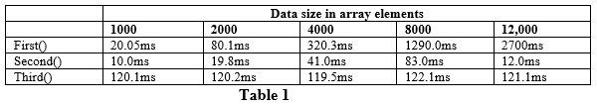
ANSWER:
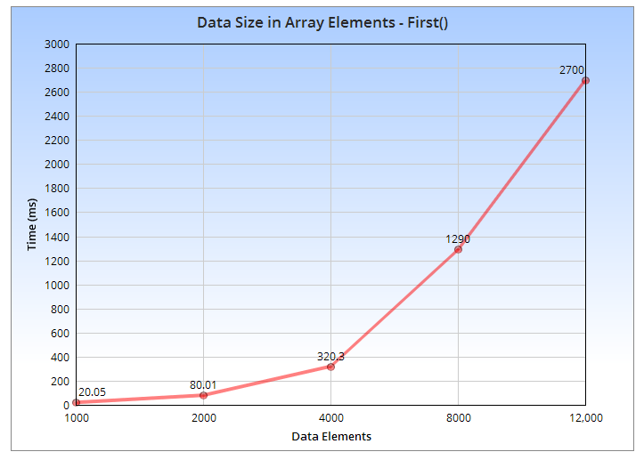
Figure 1: First() Line Graph
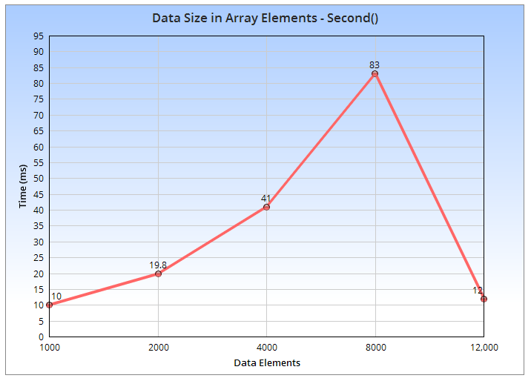
Figure 2: Second() Line Graph
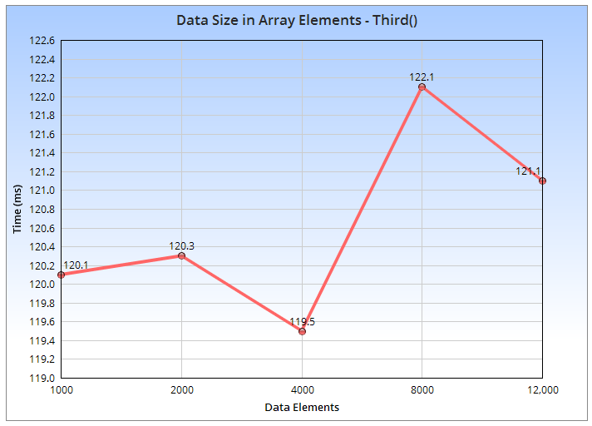
Figure 3: Third() Line Graph
A line graph has been created form Table 1 for First() Figure 1, Second() Figure 2 and third() Figure 3 function showing the relationship between the data size and time.
First() is Quadratic = O(n²). This is because as the data doubles the time quadruples.
Second() is linear = O(n²). This is because the time taken is proportionate to the data i.e. as the data doubles so does the time taken to complete. However, there appears to be an outlier within the data which has been assumed to be 120.0ms instead of 12.0ms which could mean that the time complexity of the second function may be inaccurate but given the first four samples it wouldn’t be unrealistic to deem this linear.
Third() is Constant O(c) or O(1) this is because the time stays very much the same with little fluctuations, both up and down as the data increases.

3/.
For question 3, the student is required to perform a pre-order traversal of the tree (Figure 4), followed by a post-order and in-order traversal. The student will indicate which is the first node (FN) in the answer bellow.
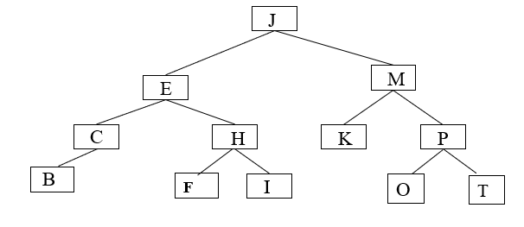
Figure 4: Binary Search Tree
ANSWER:
PRE-ORDER TRAVERSAL, (PLR) Parent Left Right:
OUPUT: (FN = J) J E C B H F I M K P O T
POST-ORDER TRAVERSAL, (LRP) Left Right Parent:
OUPUT: (FN = B) B C F I H E K O T P M J
IN-ORDER TRAVERSAL, (LPR) Left Parent Right:
OUPUT: (FN = B) B C E F H I J K M O P T

4/.
Question 4 required the letter L to be inserted into the binary search tree from figure 4. Followed by a description of the procedure taken.
ANSWER:
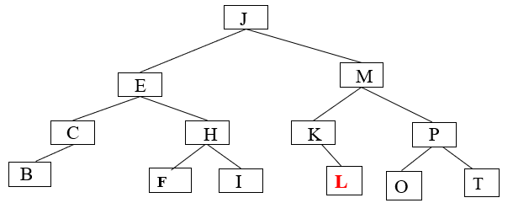
Figure 5: Inset Letter L
In order to insert the letter L into the binary search tree, there are steps that need to be taken into consideration. The steps that were taken for the letter L to be inserted begins at the first node of the binary tree (J). In the alphabetical table, L is greater than J, so the recursion is followed down to the right sub-tree. The letter M is less than L, meaning the recursion will follow to the left of the parent, taking the letter L to the letter K. K is less than the letter L so L is inserted as a leaf to the letter K stemming from the right as displayed in figure 5.
5/.
The student was asked to explain how the letter E is deleted from the search tree that is displayed in figure 4, followed by a redraw of the resulting tree.
ANSWER:
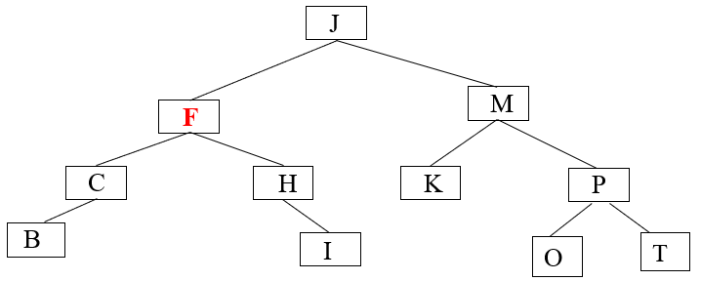
Figure 6: First Approach
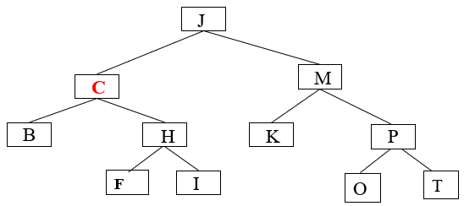
Figure 7: Second Approach
As seen in Figure 4, the letter E has 2 children. In order to delete the letter E from the search tree there are two approaches that can be taken as shown above in figure 6 and figure 7. An ‘in-order’ traversal is result in the sorted list.
In figure 6, the letter E is deleted and replaced with the letter F. This is done by locating the highest value/letter in the right sub-tree. Using the in-order traversal, the predecessor node of the letter E is F. For figure 7. Unlike the right sub-tree, the left has 1 child leaf. This makes it slightly easier to do. As displayed in figure 7, the letter E has been deleted and replaced with the letter C. In this case, the letter C is the successor node and the predecessor node are the letter E.

6/.
This question required the student to describe how a stack data structure and while loop can be used to implement a Depth First Search (DFS) Algorithm. The DFS algorithm to be applied in figure 8, displaying the contents of the stack after each iteration of the loop. Followed by listing the node contents in order that the nodes were visited.
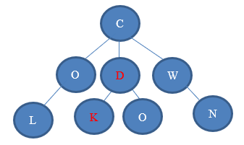
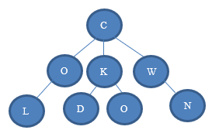
Figure 8 Figure 9
ANSWER:
First and foremost, the data structure of a Stack is LIFO, meaning Last In First Out. The access is deemed to be at one end for bot adding to and removing from the stack. []There are two operations that only exist for stack manipulation. These are ‘Push’ and ‘Pop’. ‘Push’ is the operation that adds an item to the stack, whereas ‘Pop’ is opposite.
DFS = O(|V| + |E|)
|V| = Number of nodes
|E| = Number of edges in the graph
Depth First Search
The start node is added to the Stack, which is important, and is popped from the top of the stack and its adjacent nodes are added to the stack. This is continued until their all nodes have been visited and popped from the stack.
Algorithm for figure 8:
While Loop
push(start); Stack =
while(!stackEmpty() Push ();
{ Pop ();
current=pop(); Peak ();
pushAdjacentNodes(current);
}
In order (L,C,R)
Output: LOCDKOWN
Pre-Order (C,LR)
Output: COLKDOWN
Post Order (L,R,C)
Output: LODOKNWC
If the letters D and K were switched around (figure 8) it would spell “LOCKDOWN” in the traversal.

References

