Module title: Managing Guest Service Operations/BMIH6003
Assignment title: Housekeeping, maintenance seamless guest experience
Student name: Judit Aniko Lengyel
Student ID: 2025465
Module tutors: Lisa Bassler, Natalie Brailsford, Neil Dyer
Date: 13.11.2023

Contents

Introduction 2
Main body 3
Personal growth, conclusion 7
Reference list 8

Introduction
Reflecting to my workplace experience and personal developments in Novotel London Wembley may wish to summarise the placement objectives and personal learning outcomes about the back of house management including housekeeping and maintenance departments. I am very excited to share my further experience and involvement in the hotel industry and I embark on this journey at Novotel London Wembley. Providing 236 comfortable and fully equipped rooms: all type of travelers will enjoy their stay in Novotel London Wembley. This modern hotel is located near to Wembley Stadium, offers meeting facilities, contemporary accommodations and a convenient access to Wembley Park tube station (NOVOTEL LONDON WEMBLEY - Updated 2023 Reviews, n.d.). This piece of work will refer what kind of new experience I observed, will describe the atmosphere of a workplace, involving relationships with my colleagues and duty managers. Using the Gibbs Reflective Cycle will support my work and demonstrate how this structure can apply to the back of house placement. Gibbs framework is providing thoughtful analysis and including specific questions where support needed. (MindTools | Home, n.d.)

Main body
So far my largest development during my workplace experience when I spent some days in housekeeping department and work in a systematic establishment. My tasks were including helping the team cleaning and sanitizing hotel rooms, bathrooms and public areas. I have been able to follow my colleagues’ daily routine which made me feel amazed, realising how crucial role ensuring that all hotel rooms are comfortable clean and well maintained. The hotel has 236 rooms and 10 floors, where many cleaning details and specific tasks are required. This is not the easiest job role in my opinion; within one hour 2.6 rooms need to be done usually. The housekeeping manager does mainly administration tasks using the Opera system. I had the chance to spend also time with her ensuing duties and responsibilities. Referring Gibson Reflective Cycle which typically includes various stages like feelings, description, evaluation, analysis and conclusion parts (Gibbs’ Reflective Cycle, 2020d). I would like to outline my feelings firstly In the beginning I felt very insecure as I have never spent time in similar environment during my previous employment history and recognised it could be a very challenging occupation in so many aspects. Firstly when the hotel was fully booked was impossible to keep up the required number of clean rooms, because at the same time some of the employees called sick. Almost every day operational challenges are taking place in the hotel. Housekeeping is an essential component of the hotel industry so ensuring a proper daily plan and coordination is essential. Every morning we had a team talk at 7am where daily tasks and information been shared with all employees. I would like to attach a picture about ‘Job of the day’ which normally refers to an extra specific job highlighted on a particular day. Starting in the housekeeping was overwhelming as I had to follow specific job description. Having a new job role experience made me feel worried how to cope with certain situations and some days were greatly challenging. Getting support was essential, as I mentioned the hotel was operating with fully booked capacity on different sports event days in Wembley. The duty manager took action straight away, asked for extra people the next day to give the team helping hand. The positive part was definitely when employees were supporting each other, showed empathy and being there for each other when help needed. Also I would like to include some maintenance challenges which also had an impact on the teams work morale. Having broken lift will not make any employees working programs easier and also the service lift was out of order at the same time. The issue has been reported promptly and repair needed as soon as possible. Only one lift was functioning for one day which made completing the tasks complicated as most of the employees are using lifts between floors carrying their cleaning equipments. The duty manager made sure to coordinate the team and tried to report the repair promptly which lead to a smooth service for the next day fixing the lifts issues.

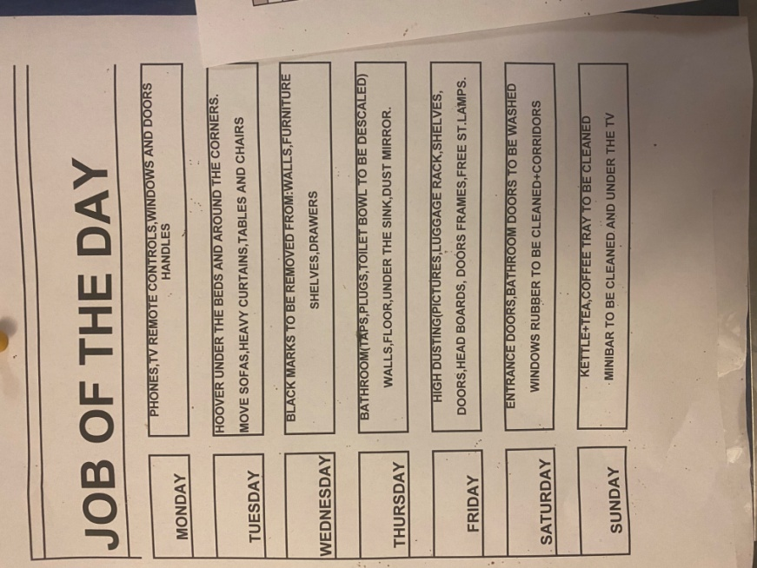

As Novotel Hotel has a contract with housekeeping department calls Hotel Care the company has outlines special terms and expectations about their cleaning standards. I would like to demonstrate and support my work with an example attaching a picture. Following the coloring system is a specific requirement and mandatory for all housekeeping members. Duty manager with a clear communication put a consistency in cleaning practices and this unique coloring system helps any streamline processes. Personally for me this was an amazing experience seeing a well organized team it’s very motivational. The idea is crucial for efficiency and supporting to ensure cleaning tasks are completed in an organised manner.
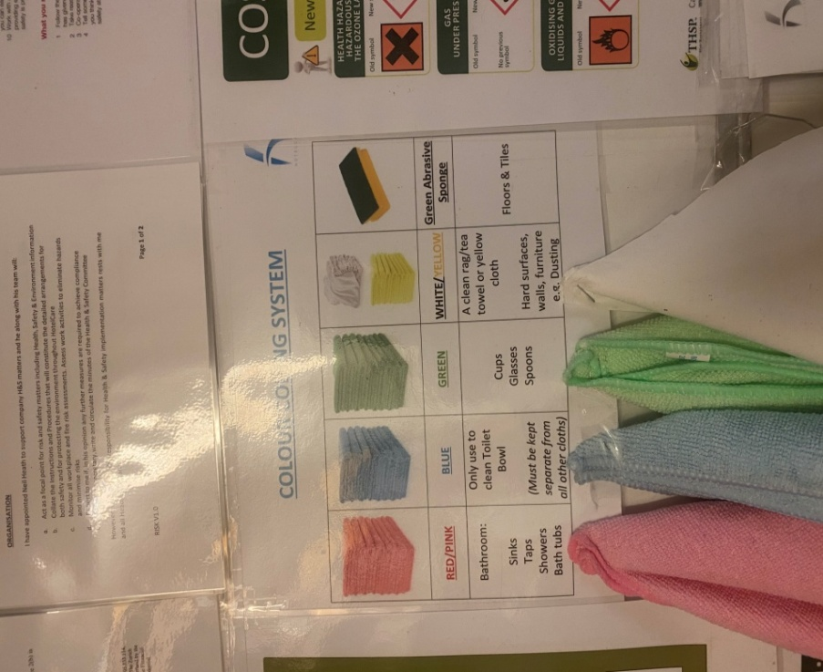

Discussing the different stages of Gibbs Reflective Cycle to the evaluation part I would like to add the importance of time management, as there is a framework for completing the rooms which gave to everyone the chance to prioritize their work efficiently. This helped me to clean within the allocated time all the rooms and no tasks are overlooked. I have a funny experience what I would like to include into my piece of work, how my colleague had confusion about a request from the hotel room and how we managed to find out the solution after facing a challenge. One traveler asked one of the housekeepers via telephone to provide an adapter to his computer device. The lady who picked up the phone heard ‘doctor’ word instead of ‘adapter’. She missed this two words somehow and didn’t double check with the guests what he exactly needed. This situation where someone failed to comprehend the required item correctly was resulting lack of clarity. The front of house team was about to organise a medical seek from the hotel, but once they were about to make an arrangement the customer made another phone call asking where is the requested adapter as it was urgent to his work. After getting the adapter to the customer next day the housekeeping manager organised a team meeting highlighted the importance of clear communication. This mistake should not happen again as everyone’s responsibility to verify the information if it’s correct and make sure there is no error or oversights. This situation was a good example to identify confirming details prevents misunderstanding and maintains a high level of customer service from the back of house side.

Personal growth, conclusion
Overall my back of house experience and being part of the housekeeping team was a great experience to have a clear view of maintaining cleanliness in Novotel Hotel Wembley is essential. My working skills were improved and gained more knowledge about following strict cleaning guidelines which leads to have a better time management, have more attention to details and also improved my communicational skills at the same time. Also experienced to understand my hard skills needed to be developed such as vacuuming, dusting or providing deep cleaning services.

Reference list

- 10 common housekeeping issues that damage hotel profits. (2017, March 15). Shoes for Crews GB. Available at: https://www.sfceurope.com/uk/blog/10-common-housekeeping-issues-that-damage-hotel-profits
(Accessed 04 November 2023)
- Axelrod, S. (2023, June 4). 15 basic skills you need to be a good housekeeper. wikiHow. Available at: https://www.wikihow.com/What-Basic-Skills-Do-You-Need-to-Be-a-Good-Housekeeper (Accessed 03 November 2023)
- Gibbs’ Reflective Cycle - 864 words | Essay example. (2023, October 29). IvyPanda. Available at: https://ivypanda.com/essays/gibbs-reflective-cycle/ (Accessed 01 November 2023)
- Gibbs’ reflective Cycle. (2020c, November 11). The University of Edinburgh. Available at: https://www.ed.ac.uk/reflection/reflectors-toolkit/reflecting-on-experience/gibbs-reflective-cycle#Evaluation (Accessed 05 November 2023)
- Hennigan, L. (2023, October 16). 12 Essential Customer Service Skills In 2023. Forbes Advisor. Available at: https://www.forbes.com/advisor/business/customer-service-skills/ (Accessed 05 November)
- Hotelcare. (2023, November 7). Home - Hotelcare. Hotelcare. Available at: https://hotelcare.co.uk/ (Accessed 03 November)
- NOVOTEL LONDON WEMBLEY - Updated 2023 reviews. (n.d.). Tripadvisor. Available at: lblehttps://www.tripadvisor.co.uk/Hotel_Review-g528820-d6227058-Reviews-Novotel_London_Wembley-Wembley_Greater_London_England.html (Accessed 05 November 2023)
- OPERA Hotel Property Management Solutions (PMS). (n.d.). Oracle. Available at:https://www.oracle.com/hospitality/products/opera-property-services/ (Accessed 05 November 2023)
- Risks Associated with Housekeeping and How to Avoid Them. (2019, April 29). Shoes for Crews GB. Available at: https://www.sfceurope.com/uk/blog/4-risks-associated-with-housekeeping-and-how-to-avoid-them (Accessed 05 November 2023)

- Walter Geering. (2023, August 10). Hotel housekeeping: the challenges in 2023. Available at: https://www.waltergeering.co.uk/blog/hotel-housekeeping-the-6-key-challenges-facing-hotel-housekeeping-managers-in-2023/
(Accessed 05 November 2023)

