

Marketing Management

Li Ning's innovative customer experience strategy

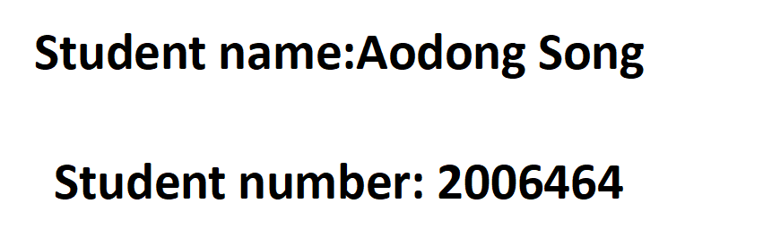

CONTENTS

EXECUTIVE SUMMARY 3
INTRODUCTION 3
THEORETICAL BACKGROUND - service marketing strategy theory 5
Online Service Marketing Strategy And Implementation 6
Manage And Evaluate Customer Service 11
CONCLUSION 13
RECOMMENDATIONS 14
REFERENCES 16
Appendix 1 18
Appendix 2 18

EXECUTIVE SUMMARY
This report is a continuation of the previous presentation by our team, which analyzed the relevant situation of Li-Ning Company and came up with 4P promotion strategies. This report will take customers as the center, put forward the online platform customer service strategy based on the service marketing strategy theory, and make a detailed explanation. The report also analyzes the management and evaluation of customer service. It is believed that it will provide reference for Li-Ning to create higher profit value and promote the healthy development of enterprises.

INTRODUCTION
In fact, Li Ning is a company that attaches great importance to customer experience. It is mainly manifested in the following four aspects:
- Products conform to national pride
Alex Colville （2021）said The Li-Ning Company has always been tied to National Pride.Recently, for example, after Nike, H&M and other foreign apparel companies announced their positions on Xinjiang cotton, Li Ning's products carried the logo "Xinjiang cotton is used in our products." Li Ning's share price has continued to rise.Yan Wanni（2021） once mentioned that Li Ning benefited greatly from the combination of national feelings and national tide.Juliette Duveau and Sophia Dumenil（2020） also mentioned China's rapid recovery from COVID-19 -- and the ensuing economic and political Importance it has earned around the world -- has made citizens feel even more proud in their country.Consumers' sense of identity with traditional culture also enables them to support Li Ning brand with practical actions.

- Actively embrace young people
At the end of March, Li Ning officials announced that Xiao Zhan had become the global spokesperson for its sporty fashion brand. Just as Meng Ying (2021)said, "Fashion star spokespersons explain the pace of youth transformation of Li Ning in recent years, and also deepen the brand image of Li Ning's fashion trend, thus occupying a more favorable position in the hearts of consumers.

- Enthusiasm for public welfare
During the epidemic, Li Ning donated 10 million yuan to support the prevention and control of Coronavirus, Zhang Yingying(2020) reported.Li Ning Group is involved in almost every major philanthropic activity. This makes consumers feel that Li Ning is a warm company, so they buy its products.

4.Online and offline experiences
According to LEI Feng Network(2021), in order to effectively manage data, Li Ning has set up its own data center, realizing the integration of members, supply and channels. The integration of members can facilitate the service of members, which will enhance the customer experience.Li Ning has set up distinctive fashion stores offline. Li Ning conveys its brand connotation and design philosophy to consumers through immersive sensory experience. As Meng Ying (2021)said: Offline pop-up stores have become an important channel for Li Ning to communicate directly with consumers.

Due to the epidemic situation and the prevailing environment of online sales, Li Ning should not only focus on the above, but also focus on the customer service of online sales to improve customer experience. Continue to create value for the enterprise. Therefore, this report will propose innovative customer service strategies for online platforms, and analyze and discuss them.

THEORETICAL BACKGROUND - service marketing strategy theory
Service marketing refers to a series of marketing activities taken by enterprises to meet customer needs on the basis of comprehensive investigation or understanding of customer needs. Service marketing is built on the basis of marketing and expands the content of marketing effectively. In addition to the initial product, price, channel and promotion, it also adds three elements: people, process and tangible display (Zhang Ze, 2017). This is the marketing theory of the seven Ps is a combination of seven factors, refers to the product factor, channel factor, price factor, promotion factor, human factor, physical display and process factor. Comparatively speaking, 4PS focuses more on the earlier products, mainly for the sake of products and services, while 7PS aims to transform one-time customers into long-term customers. In the 1970s, marketing scholars in European and American countries found that the marketing theories and methods based on physical products could not fully adapt to the objective reality of service marketing, which opened the prelude of service marketing research. Service marketing has gone through three stages (Brown,Fisk & Bitner,1994) : initial (before 1980), exploration (1980-1985) and advance (1986-present). These three stages have developed into relatively mature theories. As an innovative service concept, service marketing has been paid more attention to in the field of public cultural service. (Yoke D A, 1977) Service marketing has the following five characteristics: dispersed supply and demand, single marketing method, complex and changeable marketing objects, flexible demand of service consumers, and high skills, skills and technical requirements of service personnel.

Online Service Marketing Strategy And Implementation
The following will mainly put forward the whole process of online sales according to the process control of the 7Ps theory: the specific strategies of pre-sale, in-sale and after-sale, and describe the details.

- Pre-sales preparation strategy

First of all, before online sales, Li Ning should provide professional and personalized products according to the actual needs of consumers, to win the recognition of customers, online and offline to achieve a scientific layout of product prices. With the advent of the new retail era, high quality products and high price will become the main trend of its future development, and high quality and low price will be the focus of consumers. Price is not only an important factor affecting consumption, but also a key factor determining whether consumers establish a buying relationship.
In addition, only on the basis of consumer demand, can Li Ning provide professional sales services to attract more consumers. In the increasingly competitive buyer's market, consumer demand, as an important content, is the first link to achieve new retail by providing them with professional and personalized products.

In order to achieve rapid marketing, Li Ning's online platform needs to provide consumers with professional and personalized services, such as customized professional sportswear and sneakers. With the development of The Times, the cultural level of consumers will gradually improve. They are unrestrained and enthusiastic, pursue individuality, and have a strong dependence on the Internet. Secondly, Liu Cun(2019) proposed to induce old customers to consume, to strengthen data integration and analysis by using big data technology, to sort out and classify the information browsed by old customers, and on this basis, to develop and stimulate old customers in a targeted way.

At the same time, if the old customers feel that the pushed information or the published E-mail seriously disturb their life, the effect will be counterproductive, so Li Ning's marketing personnel need to pay attention to this. Hou Haitao (2020) showed that the old customers are the key to promote the stable development of an industry. Only by stabilizing the old customers and improving the satisfaction of the old customers can we lay a foundation for the expansion of new customers. Li Ning marketing personnel need to attach great importance to the old customers

- Customer service strategies in sales
Combined with the actual needs of customers, to provide professional services, so that customers are not affected by time, region and other factors, timely purchase to meet their actual requirements of the products.
Only in this way can customers get a good consumption experience, and have a full understanding of the market development according to the actual needs of customers.
First, important order information is pushed in real time. Yang Haolei (2018) mentioned that in the process of online shopping, what consumers pay more attention to is whether the purchased goods can be delivered in time. Real-time and time-limited distribution of logistics information is the key content, which should be combined with the supply and marketing agreement to complete the distribution work smoothly.
Wang Yu (2019) once proposed that the logistics time limit is not controlled by the seller, but the whole delivery process is more open and transparent.Wang Yu (2019) once proposed that the limitation of logistics would not be controlled by the seller. But the whole delivery process is more open and transparent. Li Ning can combine the distribution time point for customer service, timely inform customers of the actual situation, so that customers have no worries, get customer satisfaction and recognition.Secondly, offline stores provide physical experience and delivery services. Li Ning itself has many offline stores, so that consumers can experience the real things, and realize the full integration of online and offline. In this way, the virtual scene is transferred to the real scene, and the distance between customers and products is narrowed, which can effectively improve the product conversion rate and achieve precision marketing. Li Ning should let stores provide delivery and other services to meet the different needs of consumers. Or the store can provide customized service, which is the key point of personalized service strategy.

3. After-sales care strategy

First of all, Li Ning should provide customers with continuous support services to help and guide customers to choose products suitable for them, so as to relieve customers' choice pressure and concerns. Customers can get the products and feel the after-sales service in the online procurement, and they have a strong interest in the products and services they choose. Mao Yongqiang(2018) showed that due to the lack of physical experience, there would be a sense of strangeness. Small defects or places that do not meet their requirements would make consumers disappointed or dissatisfied, which would greatly reduce the overall impact of the product. At the same time, continuous service will show the actual value, which can not only be forward-looking but also be forward-looking. In the case of ensuring the credibility of products and services, it can also be recognized by customers and improve customer satisfaction.

Li Ning can only guarantee the good image of after-sales service for enterprises to win more customers. At the same time, good return service merchants can adhere to the principle of customer first, have the courage to take responsibility, timely deal with the return of goods and other matters, rather than negative confrontation with buyers. In the future development, return and exchange service will provide conditions for the establishment of corporate brand image. If the return and exchange service is not reasonable, customers will be shut out, reduce customer flow and affect their own development.

Manage And Evaluate Customer Service
Enterprises should focus on providing service process control for users, understand the true feelings of customers in this process through interactive communication, and timely improve enterprise services to meet customers' expectations. (Lei Ping, 2019)
1. Data control
In practical management, e-commerce marketing enterprises need to fully analyze the development situation of big data, and according to the analysis results, love the actual situation and interests of consumers
Good and fully understand, help enterprise management to grasp the development trend, formulate appropriate marketing strategy, combining the reality of enterprises, to adopt effective marketing methods, create a run that could satisfy the requirement of development of enterprise management system, and actively introduce big data technology, establishing database, facilitate the integration of various data and classification, realize the data rapid extraction. (Yang Ziyan, 2020) At the same time, Li Ning regularly updates the database information, does a good job of data backup, understands the significance of cooperation between enterprises from the root, and establishes an information sharing platform to provide guarantee for internal communication among enterprises.
2.Technical control
With the advent of the era of big data, influenced by the background factors of big data, the demand gap for data integration and analysis technology is gradually expanding, which objectively requires enterprises
Strengthen the development of data collection system, focus on analyzing various data show the problems in the enterprise marketing activities, active introduction of modern data analysis equipment, according to business development status and future development trend, choose some high value of information, strengthen the information data analysis, applying the results of the analysis in the enterprise marketing strategy, improve the level of enterprise marketing, Create more marketing benefits for enterprises. At the same time, in the context of big data, technical personnel professional requirements are more strict, enterprises through regular organization of professional training, take effective assessment methods, improve the professional level and comprehensive quality of personnel at all levels, set up a professional talent team, skilled use of big data marketing equipment, improve the level of enterprise marketing.

- Marketing control
The implementation effect of e-commerce marketing methods and marketing strategies is often affected by the actual demand of consumers. In other words, the demand of consumers themselves will have a direct impact on the use of e-commerce marketing strategies. In order to achieve stable development in the market competition, enterprises should have a full understanding of the current market development, timely find out the differences between customer groups through data analysis, and adjust their marketing strategies by using big data technology to promote product upgrading (Zhu Yin, 2020). At the same time, big data can predict consumers' hobbies and needs, analyze the future consumption development trend, take consumers' own needs as the side entry point, strengthen product publicity, and effectively improve the success rate of marketing.

CONCLUSION
All in all, through this report and the previous research, we can understand the strategy of optimizing Li Ning's online customer service under the new background, which can help enterprises to stand in the market, quickly complete the marketing objectives and obtain more benefits. In practice, Li Ning should strengthen the exploration of customer service management, provide professional customer service according to the actual needs of different consumers, strengthen data collection, integration, analysis and other work, give full play to the data advantages, create higher interests for the enterprise, and promote the healthy and sustainable development of Li Ning.

RECOMMENDATIONS
Li Ning should establish a sound customer relationship management system and information platform, and customer relationship management also needs to improve the internal system construction:
1.Li ning shall set up customer relationship management committee, in order to service, to guide, inspect and coordination as the work goal, work content is embodied in: to execute and implement the management of customer relationship management rules and regulations, coordinate internal departments of cooperation, have the function of the bridge and hub, establish and effective play to take the customer as the center of system rules.

- Li Ning shall establish a customer service center, which consists of complaint handling department, technical support department and customer information management department. The responsibility of the complaint handling department is to solve all kinds of customer complaints, and have the right to coordinate the internal departments of the company; The technical support department is responsible for providing technical support in customer relationship management for internal departments and external customers. The responsibility of the customer information management department is to organize and analyze customer information, classify and summarize customer information according to different categories, conduct customer satisfaction surveys, etc., so as to provide the basis for the production and operation strategy decision-making of the company's management.

REFERENCES

Zhang Yingying, (2020) baijiahao,
http://https://baijiahao.baidu.com/s?id=1657136430653265275&wfr=spider&for=pc, 2021

Lei feng network, (March 20, 2021) Ifeng, http://https://tech.ifeng.com/c/84leiBH3nSt, 2021

Meng Ying, (April 13, 2021) gsdata,
http://https://mp.weixin.qq.com/s/14pZmNKsv2YWTdGH8cmrVw, 2021

Alex Colville, (April 27, 2021) supchina,
http://https://supchina.com/2021/04/27/li-ning-chinas-prince-of-gymnastics-turned-sportswear-titan/, 2021

Yan WanNi, (April 1, 2021) Blog world,
http://https://mp.weixin.qq.com/s/_Zs2M13_oA9X0HTV2_Y0IA, 2021Christine Vallaster,Adam

Lindgreen.Corporate brand strategy formation:Brandact ors and thesituational context
fora business-to-business brand[J].IndustrialMarketing Management,2011(7):113-1143.

Juliette Duveau and Sophia Dumenil, (November 5, 2020) jingdaily,
http://https://jingdaily.com/china-pride-chinese-consumers-kering-nike/, 2021

Zhang Ze, Lu Ming.（ 2017） Discussion on the service quality evaluation system of freight forwarders based on customers [J]. China Quality and Standards Review, 10 (04):69-73.

Brown SW，Fisk RP，Bitner MJ，（1994）The Development and Emergence of Services Marketing Thought，International Journal of Service Industry Management，5:21-48.

Yoke D A．（1977）Marketing the Library Service.Library Association Management Pamphlets. London: Library Association．

Lei Ping（2019）Performance and Market Development Trend of Community O2O E-commerce Retail under "New Retail" [J]. Journal of Business Economics,(02):76-78.

Liu Cun，（2019）， Research on Strategy of Improving Customer Service Level of Social E-commerce Platform . Modern Agents Business,2019(13):43-44.

Hou Haitao, Zhao Chuyue, Chen Xinyu, Ning Xinyue, Zhao Rui, （2020）Zhai Mengni.Research on Post-purchase Sharing Motivation of Social E-commerce Users [J]. Journal of Business Economics, (22).

Wang Yu, Li Rongjin.（2019）Innovation and Development of New Retail Model in Post-E-commerce Era . Journal of Business Economics,(16):27-31.

Yang Haolei. （2018）Research on the New Retail Business Model in the Era of "Internet Sharing Economy" . Commercial Economy Research. (03)

Mao Yongqiang.(2018)Research on the Impact of Customer Experience and Merchant Offline Existence on the Acceptance Intention of Community O2O E-commerce . . Economic and trade practice.

Yang Ziyan.（2020） Analysis on the Operation Mode of Hema Fresh Retail under the New Retail Environment . Modern Business Industry,41(02):57-58.

Zhu Yin, Xu Geng. （2020）Analysis of Customer Service Based on Rural E-commerce Environment . E-commerce,(02):33-34.

Appendix 1
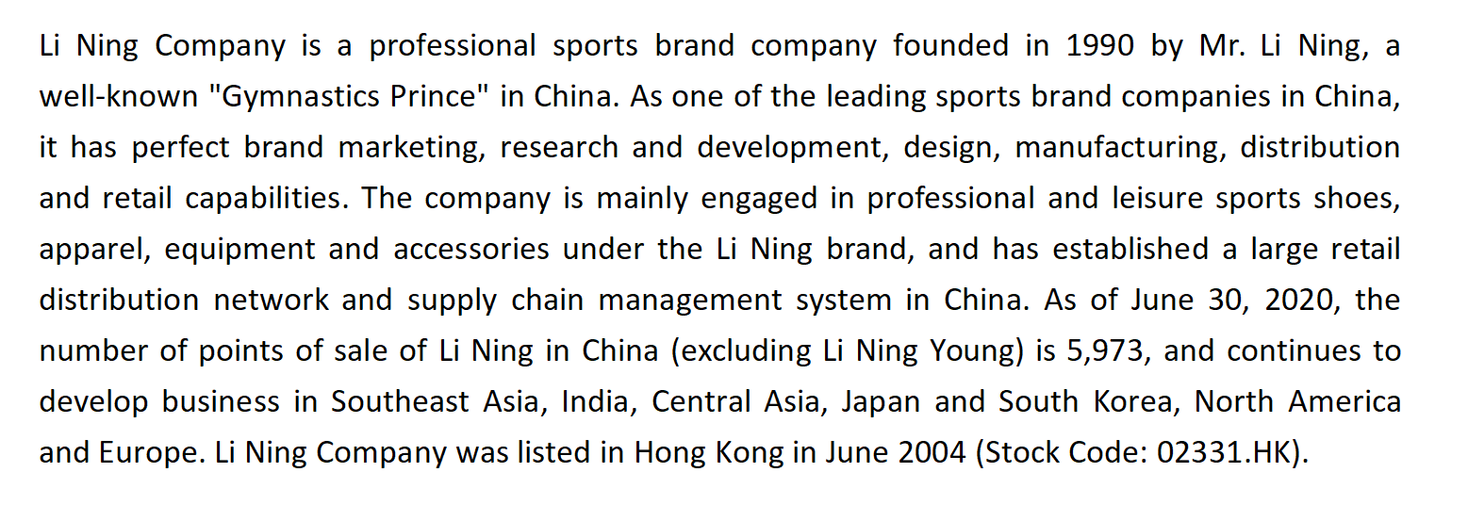

Appendix 2



