The Thing (2011)
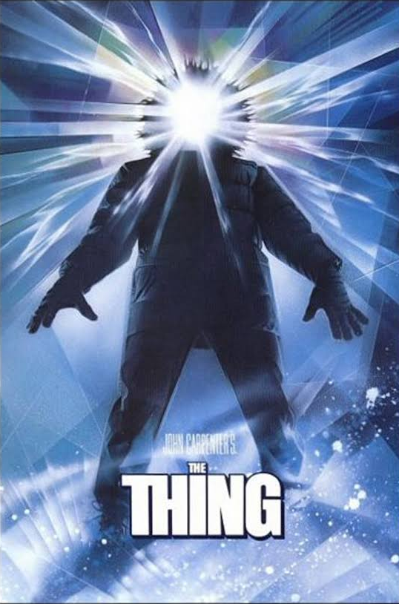
Thirty years on from John Carpenter’s original film of The Thing, the 2011 version, directed by the Dutch film-maker Matthijs van Heijningen Jr, is a prequel to Carpenter’s 1982 film. Both films are based on John W Campbell Jr’s shadowy horror story ‘Who Goes There’. Both films have terrifying aspects and strong deliver themes exploring issues of lack of trust, the soundtrack of the 2011 film echoes the Carpenter with the addition of some nice Norwegian folk music. It takes the shape and structure of the original and ties up the knots, fills in the gaps and builds on the narrative.

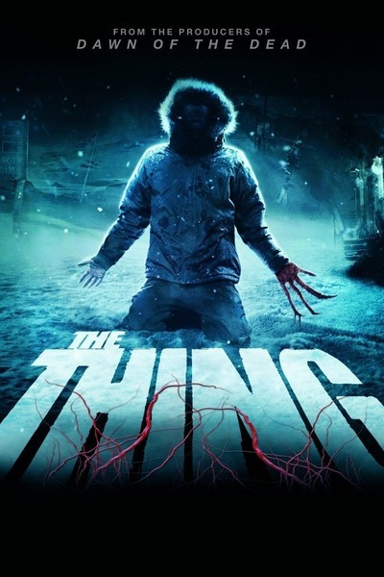
The story of the 2011 Dutch, Swedish and Norwegian financed film is based on a Norwegian exploration and scientific research centre very similar to the John Carpenter film. In the 2011 version, the explorers have unearthed an unidentified alien ship or UFO. Even more extraordinary to the discovery, they work out that the ship has been in ice for roughly 100,000 years and buried 100 yards away from the spaceship they find an unidentified organism that the scientists believe may have escaped from the spaceship. Dr. Sanders (actor Ulrich Thomsen putting in a good performance), keen to identify this extinct terrestrial creature, travels to find a paleontologist to complete his work and theory in identifying the thing imprisoned in the ice It is here the main protagonist of the film, Kate Lloyd, enters (Mary Elizabeth Winstead). Similar to McCready (Kurt Russell) in the 1982 Carpenter version, Kate learns to understand the reanimated creature in order to outwit it. With brilliant performances from the rest of the cast, the film’s machine gun like tension delivers a satisfying result that gives insights into the plot of the earlier Carpenter.
The way the 2011 film looks compared to the original, and how the tension and terror are handled, is more complex and leaves more to the imagination - surely this film should be given more praise, as it brings the original back with a shock to the cortex that will make you jump out of your skin. It is genuinely frightening.

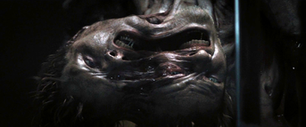
Summary

As you can see, the two films really do come together and the understanding of Carpenter’s The Thing makes more sense. The more you watch one the more you see the clues and the 2011 version brings the jigsaw pieces together. The narratives of the story blend one into the other, but to me the main star of both movies is the Thing itself. It needs to survive more than the human race needs to, and its own way of viewing and identifying with the enemy is the Thing’s gruelling task for survival. A perfectionist with camouflage, his killing ways are better than Bear Grylls! My recommendation is to go and see it. It’s a must-see film to perceive with your own vision, visually the special effects will make you blink and rub your eyes with the possibility this film isn’t over, there are plenty more opportunities for the Thing to return!
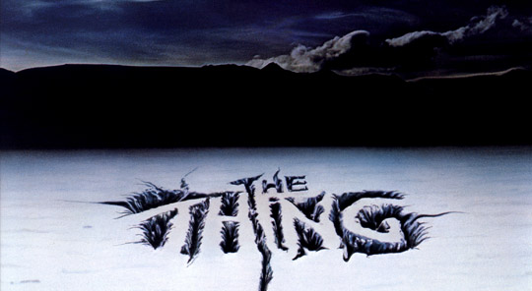

M. S Douglas 29/ 10 2017

Van Heijningen Jr, Matthijs, dir, The Thing, (Morgan Creek Productions 2011). http://www.imdb.com/title/tt0905372/?ref_=fn_al_tt_2 (accessed 29.10.17)
Carpenter, John, The Thing (Universal Pictures 1982). http://www.imdb.com/title/tt0084787/ (accessed 29.10.17)
Campbell Jr., John W., Who Goes There, (London:Gollancz 2011).

