
Skills for the Workplace
Module Assignment Submission
Student Name: | Frank Aning Barfour
Student Number: | 1715049
Module No: | BMSK4003
Module Title:  Lecturer:  Date: | Digital Skills and Research Methods  Balendran Kandasamy  2 July 2018

Table of Contents
Introduction 3
Evaluating the effectiveness of the use of modern technologies 3
Technology 1 Cloud computing. 3
Evaluate the use of cloud computing technology at the workplace. 4
Compare two providers of Cloud Computing 4
Recommendation. 5
Technology 2 Artificial intelligence 5
Evaluate the use of Artificial intelligence technology at the workplace. 6
Compare two providers of artificial intelligence 6
Recommendation 6
Exploring social media as a tool for marketing, information gathering and communication. 7
my own professional online presence to illustrate and evidence this research. 8
Conclusion 12
Bibliography 14

A report which evaluates the effectiveness of the use of modern Technology at workplace

Introduction

This report will be evaluating the influence of modern technology at the workplace. With technology such as cloud computing, artificial intelligence and other modern technologies such as social media platforms. The report will focus on the impact it has on business and customers. The report also will explore social media utilization as tool for marketing and information gathering, communication by organizations. Furthermore, why the use of such technologies is so important to business and individuals.

Evaluating the effectiveness of the use of modern technologies

Technology 1 Cloud computing.

Cloud computing
Cloud computing technology is being used by small and big business now a day. To begin with, cloud computing in computer terminology is better explained as service to business and customers, as indicated by (DIXON and Herbert, 2012,pp.36-38) cloud computing is when a customer with access to the internet by application of a web browser .Furthermore, cloud computing is described by the NIST as ’’ IT resources refer to hardware (Infrastructure as a Service, IaaS), development platforms (Platform as a Service, PaaS), and applications (Software as a Service, SaaS), and they ‘can be rapidly provisioned and released with minimal management effort or service provider interaction’’(Mell and Grance, 2011).

Evaluate the use of cloud computing technology at the workplace.
In the present time, you can just sit in the comfort of my home and access Oracle E-business suite cloud-(provider) to see your payslip online or even arrange leave days off work, this enables the employer to cut down on paperwork.
In addition, as mention by(Rajaraman,2014,pp.242-257) Organisations save allot of money getting only the essential software and minimum hardware they need for business. But if you did not know you might be using a cloud service on a daily basis as suggested by (Rajaraman, 2014,p.242) services such as basic email, Hotmail, Gmail, Yahoo mail and cloud storage for example Dropbox, OneDrive and other applications. Most of the time you get a choice to upgrade to a premium service. Finally, customers are only billed for the service they need, it is a new form of modern technology service just like: electric, gas, water utility on pay as you use.

Nevertheless, there are problems with adopting cloud computing at the workplace for example network dependency or security concerns. Therefor business owners must always outweigh these challenges in form of security attacks, privacy laws and also the cost involved in switching to cloud from other systems(Azeem and Sprott, 2013,pp.6-8).Furthermore, there is no universal agreement to data coordination by providers and the availability of fast internet connections. Finally, storing Big Data with personal information of customers and related privacy issues that changes in every country.(Rittinghouse and Ransome,2010)

Compare two providers of Cloud Computing

Amazon AWS
Amazon AWS is briefly outlined with the following services for example: compute, storage, database, migration, networking, and delivery content. Amazon AWS offers 12 months free trial on some products and AWS Lambada option offers first 1million request free for 12 months and indefinitely but charges £0.20 /million request thereafter(aws.amazon.com,2018).

Microsoft Azure
In the same way, Microsoft Azure provides app service: virtual machines, Azure SQL database, blob storage, azure kubernetes. In contrast to Amazon AWS Microsoft Azure offers free service for the first 12 months, however, the functions compute option is not included, and customers will be charged after 1 million requests each month at £0.15 / million executions (azure.microsoft.com,2018).

Recommendation.
For Cloud computing service provider Amazon AWS will be recommended because they offer competitive pricing for more services than Microsoft Azure. However, not all services are free for first 12 months on Amazon AWS. But it benefits small businesses in long-term savings on cost.

Technology 2 Artificial intelligence

Artificial intelligence
Artificial intelligence is briefly outlined a new form of computer technology, for example, a computer that recognise your voice commands or as more high tech such self-driving cars and drones that can fly halfway around the world without a pilot As mentioned by (Mills, 2018)he explains when a machine can execute a function intelligently, whereby it is not programmed to do so. It learns itself new ways of doing it effectively by constantly improving his ways without the need for human intervention.

Also, artificial intelligence as suggested by (Rich,1991, pp.583-603) “Artificial Intelligence is the study of how to make computers do things at which, at the moment people are better.” In our daily lives, we are affected by the advancement of artificial intelligence, in good and bad ways.
Usually, artificial intelligence is divided into two groups expandable and limited as indicated by (Siegel, 2018, pp.26-28).The expandable version can complete a difficult task or complex operations just like an individual sometimes even better. In comparison with, the limited group that can complete a simpler task for example like a computer that can play games or language decoder.

Evaluate the use of Artificial intelligence technology at the workplace.
There is a revolution going on with artificial intelligence in workplaces at the moment machine against human in different sectors of the workforce for example banking, retail ,transport .According to (Brougham and Haar,2018,pp.239-257)you can see the effect of this innovation when you step out for grocery shopping with automated till service or even when you enter a bank with self-service deposit machines. It is all more efficient and quick automation saves the employer money.
There is critical consideration we face with artificial intelligence as mentioned by (Khalil, 1993,p.313)that are the making of human-like judgments that are righteous .Finally future systems will have the ability to evolve as stated by (intelligence.org, 2018) ‘’ AI systems may come to surpass humans in science and engineering abilities without being particularly human-like in any other respects — artificial intelligence need not imply artificial consciousness, for example, or artificial emotions.’’ These facts are all major security problems we need to consider.

Compare two providers of artificial intelligence

Apple Siri
Apple Siri is voice assistant that has machine learning algorithm to have the capability of looking at your email and keep a diary also to edit schedules. In addition, Siri can transfer funds and make payments to business or customers. Another essential point Siri can make a shopping list very important for business orders.(Apple.com, 2018)

Google assistant
Google assistant is demonstrated to be able to call business contact or others on your contact list. Furthermore, the Google assistant can search for information for example weather, news and make complex calculations. As well as translations assistant can send text from voice very essential to improve productivity at the workplace.(Google .com, 2018)

Recommendation
The Artificial intelligence that will be recommended is Apple Siri as it has advanced options for business use, for example, making payments to customers and email look up. Google assistant is also widely used but apple Siri is utilised on variety of hardware such as, iPod, iPad, iPhone ,Mac ,Airpods , Appletv, HomePod. Google assistant is mainly used in android platforms and google chrome browser.

Exploring social media as a tool for marketing, information gathering and communication.

Facebook as a tool for marketing
Facebook is one of the biggest social media platforms in this world, that is been utilize by small and medium business for Marketing purposes as mentioned by (DeMers, 2015).Facebook is been used by small and medium business for access to 2.20 billion active monthly users as potential customers(pressfb.com, 2018).Secondly, they provide a variety of platforms ,for example, Facebook ads, Facebook pages, messenger , Instagram, audience network. Facebook has different ways to advertise for its customers mainly based on appearance and location where it can be viewed.(Facebook business, 2018)

Social media as a tool for information gathering.
As mentioned by (Hern, 2018) Facebook can gather information on users and non-users of its social media platforms. Furthermore, Facebook already gives business customers information to ‘’ targeting, delivery and conversion measurement across devices. With the new cross-device report, advertisers are now able to view the devices on which people see ads and the devices on which conversions subsequently occur.’’(Facebook Business, 2014)Finally, Facebook asks users personal information such as gender, religion, location ,relationship status ,work status , education history to build a profile.(barfour, 2007)

Social media as a tool for communication
The majority, of online social media platforms, have the option to have users communicate without any cost involved only network or WIFI charges. Users can call with HD technology and live video calls and chat messaging.(messenger.com, 2018)
Moreover, Facebook messenger can reach a lot of customers, to have direct conversations with. Furthermore, businesses can promote their products or facilitate payments it is also a hub for direct customer service. (messengerfb ,2018)

my own professional online presence to illustrate and evidence this research.

1: Evidence of Facebook page link and screenshot


Source 1 (Accessed 30 July 2018):https://www.facebook.com/Akwasi.aka.Gyeabour

2: Evidence of Facebook business link and screenshot

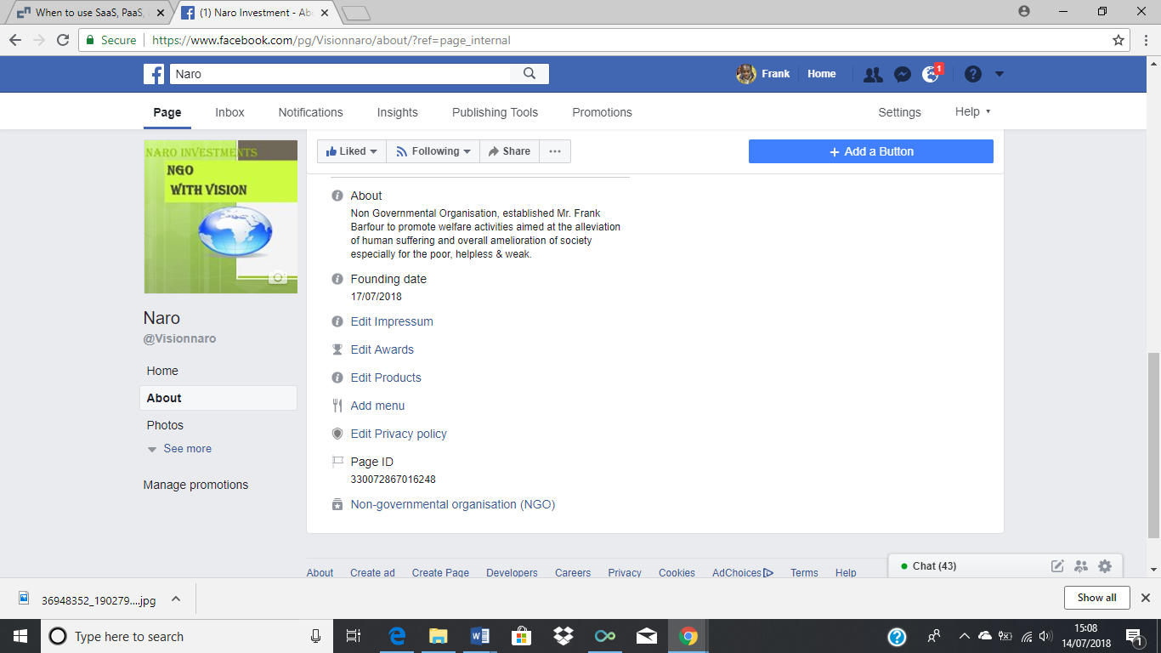
Source 2(Accessed 30 July 2018) : https://www.facebook.com/Visionnaro/

3: Evidence of twitter page link and screenshot

Source 3(Accessed 30 July 2018): https://twitter.com/frankBnaro

4: Evidence of LinkedIn page link and screenshot.
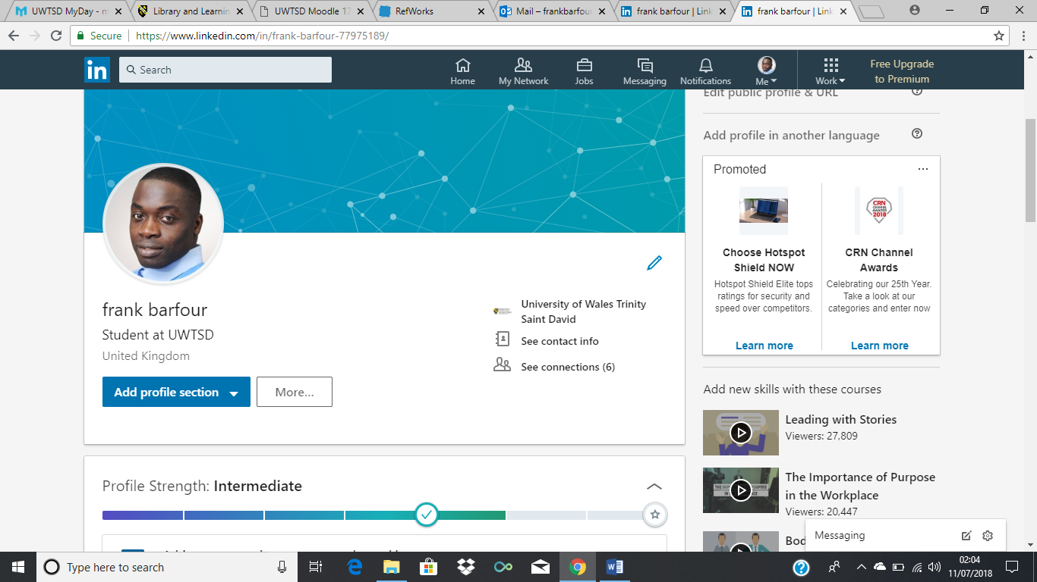

Source 4(Accessed 30 July 2018): https://www.linkedin.com/in/frank-barfour-77975189/

Conclusion

It has been shown that technology generally improves our productivity at work and in private lives. Cloud computing has advanced the way businesses conduct management of resources available to them. In a comparison of heavily investing in hardware and software for the smooth running of a business. However, a new industry has arisen from cloud computing whereby on-demand service a major option is.
On the other hand, Artificial intelligence is innovation of modern times, that will be helping mankind to a brighter future. We do not even realize the dangers it could bring or the problems associated to it for society.
Social media change the world we are living in today with social networking you can make business contacts stay InTouch with friends and free calls. furthermore, you can advertise your business for a large audience. Technology is a good thing from a business point of view when security is prioritized. The social aspect of it can become a problem for most individuals. That can be because of abuse of information or lack of education on how to use it appropriately.

Bibliography

Amazon Aws, (2018) Aws lambada pricing[online]. Available from: https://aws.amazon.com/pricing/ (Accessed: 22 July 2018).
Apple.Com, (2018) Apple siri [online]. Available from: https://www.apple.com/uk/ios/siri/ (Accessed: 23 July 2018).
Azeem and Sprott, (2013) Let me in the cloud: analysis of the benefit and risk assessment of cloud platform. Journal of Financial Crime, (1), pp. 6-24.
Barfour, (2007) About profile[online]. Available from: https://www.facebook.com/Akwasi.aka.Gyeabour/about?lst=652001742%3A652001742%3A1531820344 (Accessed: 17 July 2018).
Brougham and Haar, (2018) Smart technology, artificial intelligence, robotics, and algorithms: Employees' perceptions of our future workplace. Journal of Management and Organization, (2), pp. 239-257.
Demers,(2015) the definitive guide to marketing your business on facebook[online]. Available from: https://www.forbes.com/sites/jaysondemers/2015/08/20/the-definitive-guide-to-marketing-your-business-on-facebook/#4f4f13f72f51 (Accessed: 14 July 2018)
Dixon and Herbert, (2012) Cloud computing: The Judges' Journal, pp. 36-38.
Facebook Business, (2018) Facebook ads guide&nbsp[online]. Available from: https://www.facebook.com/business/ads-guide (Accessed: 15 July 2018)
Facebook Business,(2014) Measuring conversions on facebook, across devices and in mobile apps[online]. Available from: www.facebook.com/business/news/cross-device-measurement (Accessed: 17 July 2018).
Google.com, (2018) Google assistant[online]. Available from: https://assistant.google.com/explore?hl=en_uk (Accessed: 23 July 2018)
Hern , (2018) Facebook admits tracking users and non-users off-site[online]. Available from: https://www.theguardian.com/technology/2018/apr/17/facebook-admits-tracking-users-and-non-users-off-site (Accessed: 17 July 2018)
Inteligence.Org, (2018) Why ai safety?[online]. Available from: https://intelligence.org/why-ai-safety/ (Accessed: 21 July 2018)
Khalil, (1993) Artificial decision-making and artificial ethics: A management concern. Journal of Business Ethics,(4), pp. 313.
Mell and Grance, (2011) The nist definition of cloud computing[online]. Available from: https://csrc.nist.gov/publications/detail/sp/800-145/final (Accessed 13 July, 2018).
Messenger.Com,(2018 Conversations come to life on messenger[online]. Available from: https://www.messenger.com/features#hdcalls (Accessed 24 July, 2018).
Messengerfb.Com, (2018) Reach your audience with messenger[online]. Available from: https://messenger.fb.com/consumer-journey/awareness/ (Accessed 22 July, 2018).
Microsoft Azure, (2018) Azure pricing[online]. Available from: https://azure.microsoft.com/en-gb/pricing/ (Accessed 22 July, 2018).
Mills,(2018) Machine Learning vs. artificial intelligence: How Are They Different?[online]. Available from: https://www.forbes.com/sites/forbestechcouncil/2018/07/11/machine-learning-vs-artificial-intelligence-how-are-they-different/#28232e333521 (Accessed12 July, 2018).
Pressfb.Com, (2018) Newsroom[online]. Available from: https://newsroom.fb.com/company-info/ (Accessed 15 July, 2018).
Rajaraman, (2014) &nbsp;Cloud Computing. (Resonance: Journal of Science Education), pp. 242-257.
Rich, (1991) Artificial intelligence. 2nd ed. New York ; London: New York ; London : McGraw-Hill.
Rittinghouse and Ransome, (2010) Cloud Computing. Boca Raton , Florida USA: CRC Press Taylor & Francis Group.
Siegel, (2018) Simplifying AI and machine learning. Applied Radiology,(5), pp. 26-28.

