Module Code-BMMB7005D
Module Name- Finance For Business Manager
Month and Year - January
Student Name -Manna Barua
Student ID-2428346

Executive Summary
The report is an assessment of the financial performance to infer the investment decisions of Next Plc based on a detailed ratio analysis. Some of the key financial ratios were analysed to determine the profitability, liquidity, efficiency, gearing, and investor performance. Results indicate improved sales and operational productivity, less financial risk, but a portion is still found in the decrease of profitability and liquidity. NPV and Profitability Index (PI) techniques were utilized in the selection of investment alternatives of Westward Plc with a cost of capital of 6% under a limited capital base. The findings suggest that more emphasis should be put on projects that enhance the greatest incremental value and achieve sustainable long term growth. Altogether, the report provides clear actionable information as the basis of the efficient financial management and decision-making.
Table of Contents
Introduction 4
Part 1 4
1.1 Financial Ratios of Next Plc 4
1.2 Critical evaluation of ratios 4
1.3 Recommendation 5
Part 2 5
2.1 Evaluation of three projects using NPV 5
2.2 Internal rate of return 5
2.3 Interpretation of results for management 6
2.4 Optimal investment policy and the resulting total NPV 6
Conclusion 7
References 8
Appendices 9
Appendix 1: Next Plc’s Income statement and Balance Sheet 9
Appendix 2: Ratios of Next Plc for the year ended 2025 and 2024 11
Appendix 3: Calculation of NPV 13

Introduction
This discussion compares the financial performance of the Next Plc and investment prospects of the Westward Plc using some of the key financial ratios, as well as, a Net Present Value (NPV) analysis. The ratios define profitability, liquidity, efficiency, and risk, whereas the NPV analysis helps to identify the value-adding of most investment decisions in the limited financial resources and budgetary limitations.
The report will analyze the financial performance of the company as well as the investment choices made using simple and sensible financial instruments. Financial analysis is a necessity because it helps the managers understand the performance of the business and where there is need to improve on. In that regard, the ratio analysis is used to evaluate such essential fields as profitability, liquidity, gearing, efficiency, and performance of its investors. Such ratios provide helpful insights concerning the use of resources, the use of cost, control of risks, and the provision of values to the shareholders of the company. The trends can be identified by comparing financial data provided over time to make improved decisions and plans in the long term. In addition to the ratio analysis, the report focuses on methodologies of investment appraisal, that is, the Net Present Value and the Profitability Index. These techniques will help the managers to decide if the suggested projects will create value to the company as well as to spend scarce funds selectively.

Part 1

Financial Ratios of Next Plc
Profitability Ratios
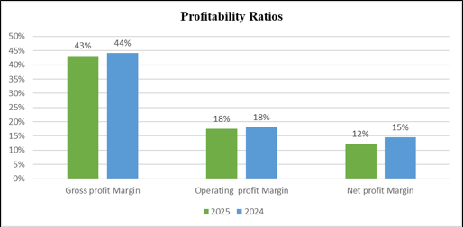
Figure 1: Next Plc’s Profitability Ratios
(Source: Created using Excel)
The ratios of profitability are used to demonstrate the efficiency with which Next Plc uses its sales to generate a profit. The revenue growth was recorded with sales improved to 6,118.1 million pounds as compared to 5,491.0 million pounds. However, the gross profit margin dropped to 43 0.5 %, which represents high-cost production and sourcing of the product. The operating profit margin was steady at 18 %, and these show that the company operates the earnings well. The net profit margin also decreased by 15 % to 12 % that contained higher interest and tax charges. This is an indication that, though the sales have been on the increase, the final profits are being strained (Pallathadka et al. 2023). To maintain profitable growth and shareholder returns, it is therefore important to ensure that cost efficiency is enhanced.
Liquidity Ratios
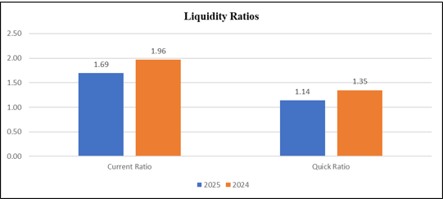
Figure 2: Next Plc’s Liquidity Ratios
(Source: Created using Excel)
The liquidity ratios determine the ability of Next Plc to meet its short-term commitments. The change in the current ratio was 1.83 in 2024, while in the year 2025, the current ratio was 1.6,9 showing that there is a decline in the short-term financial standing. Similarly, the quick ratio dropped to 1.14 after having been 1.3,5 indicating that the percentage of resources that remain unutilised in inventory is greater. Even though the ratios have been above the standard of 1, the decreasing trend is an issue of concern (Gallagher, 2022). The reduction of liquidity would put a limit on the flexibility of the company during economic uncertainty. Better inventory management and faster receivables collection are needed to strengthen the cash flow and support the future growth of the business and its stability.
Gearing Ratios
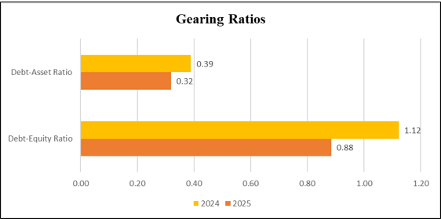
Figure 3: Next Plc’sGearing Ratios
(Source: Created using Excel)
Gearing ratios measure the dependence of debt funding by Next Plc. The debt-equity ratio in 2024 was 1.12, and in 2025 it was 0.88, which is a lower reliance on borrowed funds. The debt asset of the company also contracted by the ratio of 0.39 to 0.32, showing that there is less use of debt to finance its assets. This decreases the risk of finance and interest payments, thus making it more stable in the long run. The benefit of the lower gearing position is during inflation and uncertainty in the economy however, overly low debt can hamper growth opportunities (Rao et al. 2023). By maintaining a balanced gearing structure, it will be easy to finance future growth and protect shareholders against financial risk.
Efficiency Ratios
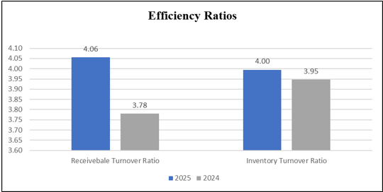
Figure 4: Next Plc’s Efficiency Ratios
(Source: Created using Excel)
Efficiency ratios are used to determine the level of efficiency with which Next Plc uses its resources. The receivables turnover ratio improved by an increment of 3.78 to 4.06, including improved cash earnings through a faster payment period, along with increased cash inflows. There is also a slight improvement in inventory turnover as 3.95 changed to 4.00 that indicates faster stock turnover and efficient inventory control. These profits lower carrying expenses and lower the chances of obsolete stocks. Sturdy efficiency supports the cash flow without the need to draw extra loans (Rane, 2023). Further improvement will allow Next Plc to grow sales profitably, reduce operational costs, and maintain competitiveness in the retail business segment.
Investors Ratios
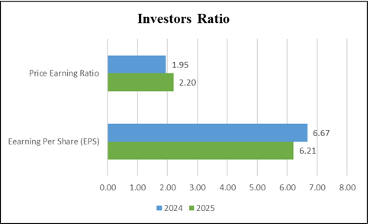
Figure 5: Next Plc’s Investors Ratios
(Source: Created using Excel)
The Shareholder returns are expressed through investor ratios, as they show confidence in the market. Lower net profits also led to a decline in the earnings per share to 6.21 by 0.46, and thus the reduction of the short-term income of the shareholders. Still, the ratio increased to 2.20, as an indicator of high confidence of investors in future performance. This shows that the investors hope that they will return to profitability and long-term growth (Calderon-Monge and Ribeiro-Soriano, 2024). Increasing profitability will enhance dividends, attract new investors, and lead to capital appreciation of long-term accounts by Next Plc.
[Refer to Appendix 2]

1.2 Critical evaluation of ratios
The ratio analysis of Next Plc shows that it is performing mixedly in the period aforementioned (2024-2025). Sales are up, a good gesture but the problem is that profitability is going to be poor. The gross profit margin decreased by a little bit and the net profit margin reduced by 15% to 12% implying that the cost of the company in terms of wages, transport, and inflation has increased faster compared to sales. The operating profit margin has not changed, which means that the company is operating at a relatively acceptable level of operating costs (Nworie and Nwoye, 2023). However, the decrease in net profit has reduced the shareholder earnings as evidenced by a drop in the net profit.
Liquidity is also worse as the current ratio and the quick ratio have all declined indicating that the Next Plc now has less financial flexibility in the short-term and its money is invested in the inventory or payables. However, the levels of liquidity are satisfactory.
Gearing ratios have also been favourable (“Debt-equity” and “Debt-asset ratio”) and show that the borrowed resources used by the company have reduced, which lowers the cost of financial risk and increases the stability of the company in the long term. Additionally, there have been moderate improvements in efficiency ratios which indicate that the company manages stocks better and customers pay in a shorter period of time (Lee, 2023).
The investor confidence seems also to be solid because there is growth in the share price and in the P/E ratio with low profits suggesting the prospects of future growth. Nevertheless, ratio analysis is not a complete quantification because it uses the past data, misses out on inflation, and even the management calibre or market forces are not considered (Jaksties and Lindblad, 2022).
Evaluation of Profitability
The profitability ratios paint a picture of how much profit is realized by an individual company because of sales. Next Plc increased revenue in 2025 as its sales increased from £5,491.0 million to £6,118.1 million, indicating that the organisation is moving in the right path since it gained more sales than the previous year. Growth in sales is usually a good sign that the customers are spending an increased amount, hence consolidating the position of the company in the market (Sriram, 2023). However, even after sales increased, the firm was not able to bring in more profit. The gross profit margin had decreased slightly, from 44% to 43% in 2024 and 2025, respectively, and this showed that the cost of acquiring or producing goods was more than the sales. This can be explained by the fact that the prices of raw materials have skyrocketed, transport expenses and salaries are increasing, and inflation is rising. These rising costs tend to impact the retailers as well, like Next Plc.
Both operating profit margins stood at 18%, indicating that the company was well managed in terms of its primary operating expenses, such as marketing and administrative expenses. Although costs increased, the management managed to keep the operating costs at an acceptable limit, which portrays stability in its internal governance.
On the other hand, net profit margin declined significantly from 15% to 12% As a result, the company was left with a smaller amount of profit after considering all costs, which included interest and tax, which contributed to decreasing the final profit. This fall in net profit has a direct cause on the shareholders as they experience low returns since the profit is less (Mandipa and Sibindi, 2022). Overall, there is a mixed performance in terms of profitability, where sales have a positive trend, and increasing costs have reduced the ultimate profit at the firm.
Evaluation of Liquidity
The liquidity ratios determine the ability of a company to meet its demands in the short run. Compared to 2024 the current ratio declined to 1.69 in 2025 and this implies that 2025 had PS1.69 of current assets against 1.00 of short-term liabilities. Even though this ratio is higher than 1, the fact that it is declining demonstrates that the short-term financial strength is becoming weaker (Gouzoulis et al.,2023). The quick ratio also declined to 1.14 as compared to 1.35. The quick ratio includes all liquid assets or accounts receivable which are not easy to convert into cash, thus the quick ratio shows that a higher percentage of the liquid assets or accounts receivable is tied up as opposed to being in the form of cash. This is because by eliminating the inventory that may be not readily available as cash (Badakhshan and Ball, 2023). Both liquidity ratios have declined but they still remain acceptable as it implies that Next Plc will not need to struggle to meet its short-term commitments. Still, the decreasing trend of the company is one of the red lights; further, in case it continues, the firm will experience liquidity strains in the future.
Evaluation of Gearing
The Gearing ratios are used to determine the dependence of a company on borrowed funds as compared to its own funds. The “debt-equity ratio” of Next Plc decreased with time such that in 2025 it was 0.88 compared to 1.12 in the previous year meaning that the company now generates less debt compared with the equity of the shareholders. Less debt will reduce the financial risk as less debt will reduce the pay to finance the business positions.
“Debt-asset ratio” also decreased as 0.39 was reduced to 0.32 which means that a smaller percentage of the company assets are funded through debts. This is a good move towards financial stability in the long-run and risk reduction in case of financial uncertainty (Kirikkaleli et al.,2022). The rise in gearing can be as a result of repayments of loans, increase retained earnings or a provision of equity. The reduction of gearing makes the company less risky and more stable especially in times of inflation and the low rate of economic growth.
Evaluation of Efficiency
The efficiency ratios are used to assess the company effectiveness in its use of resources. Receivable turnover ratio rose to 4.06, as compared to 3.78 meaning that customers are paying on time in the year 2025. The accelerated payments increase the cash flow and reduce chances of delayed payments (Yang et al.,2024). The inventory turnover ratio increased a little as it increased by 3.95 to 4.00 which indicates that inventory is being sold at a greater rate. Selling stocks at a faster rate will save storage expenses, moreover, the risk of outdated stock will decrease. These enhancements imply a better inventory and customer payroll management. Generally, efficiency has improved showing that Next Plc operates its activities more efficiently.
Evaluation of Investors
Investor ratios are the measure of the appeal of a company in the eyes of the shareholders. The ratio of the earnings per share decreased by 0.46 to 6.21 because the net profit decreased. Reduction in the earnings per share implies that the shareholders receive less profit per share held (Alsamhi et al.,2022). However, the stock value went up and the “price-earnings ratio” went up to 2.20. This means that the investors are still optimistic about the company not facing the same future with the possibility of turning around the profits or just having strong long term growth opportunities. Therefore, the feeling of investor confidence depends not only on the present profitability; a more significant effect may be produced by the perspectives about the future.
Limitations of Ratio Analysis
Although ratio analysis is very useful, it has several limitations. Ratios are based on past financial data, so they may not show the company’s current or future performance accurately (Olayinka, 2022). Ratios also do not consider inflation, which can make comparisons between years less accurate. In addition, different companies use different accounting methods, which can affect the results of ratios. Ratio analysis also ignores non-financial factors such as management quality, brand reputation, customer loyalty, and competition. External factors like economic conditions, government rules, and changes in consumer behaviour are also not included (Barbu et al.,2022). Therefore, ratio analysis should not be used alone and should be supported with other financial and business analyses.

1.3 Recommendation
A stringent focus is to be given on cost management with a view of improving profit margins especially costs incurred in production, transport and staff. The company would better control inventory that would result in the holding of too much inventory. Further boosting of cash flow should be achieved by continued growth in the pace of collections by customers. Next Plc should also ensure that debt is kept at a reasonable level and it does not engage in excessive borrowing to minimize the financial risk. Lastly, the company must make investments in the technology and data systems to enhance efficiency, predicting and decision-making, hence, long-term financial stability and growth.
Recommendation 1: Enhance cost management and quality of profits.
Next Plc ought to work on the cost control and maximise its profitability. The increase in sales has been accompanied by a reduction in profits due to the increase in operating, transport, and material costs. The management should evaluate the contract agreements with suppliers, logistics costs and energy use to reduce unwarranted costs. Excess inventory and discounting can also be avoided by better demand forecasting (Graña-Alvarez et al 2024). Small efficiency improvements in both the stores and online business will safeguard the margins without affecting the customer experience. Being able to sustain high operating profit margins is an indication of good internal control, but to continue the growth in the long run, an improvement in net profit is necessary. Next Plc can maximize the shareholder returns by the prudent management of costs without compromising the quality of the product offered and its competitiveness to promote trust in its future performance (Nextplc, 2025). This is a practical and feasible approach that would not require significant modifications in the business model.
Recommendation 2: Have a balanced liquidity and low-risk funding.
Next Plc should pay close attention to the liquidity and maintain the low-risk borrowing policy. The decrease in liquidity ratios in spite of the fact that the latter are acceptable is also indicative of a strain on short-term cash flows (Umair and Dilanchiev, 2022). The management needs to increase the cash planning process through quicker customer payment and reducing the holding stock. At the same time, the lower gearing of the company is also a strength that ought to be retained. Reduction of debt reduces interest expense and protects the business in cases of uncertainty in the economy. However, in cases where returns are visible, the selective borrowing should nevertheless be considered by Next Plc in making profitable investments. One will strike the right balance between cash and wise financing to maintain stability (Bertoni et al. 2022). This caution would ease the concerns of investors, shield their day-to-day business, and allow the firm to be flexible in terms of its finances in the future.

Part 2

2.1 Evaluation of three projects using NPV
Comparing two investments considering the NPV method with a cost of capital of 6%, the three alternatives are deemed as acceptable since they will have a positive net present value hence adding value to the company. The first option, which is the expansion of the retail outlet, has a NPV of £643,000, the smallest of the three- thus it is not the most appealing option to take. Option C which applies to remanufacturing of wooden and Roman blinds will have an NPV of £742,000 which shows that it will have strong returns. On the other hand, the highest NPV of £792,000 is registered under the internet sales making the Option B dominant, hence adding the greatest value. To this end, it is necessary to choose Option B which has the greatest net of capital cost, greater returns and which is expected to promote future expansion and market expansion [Refer to Appendix 3].
The three project investments have been analyzed using the Net Present Value technique, which has been outlined in Appendix 3, and a cost of capital of 6%. Net Present Value is used to estimate the discrepancy between the present value of anticipated cash inflows and the investment made in the project, thus telling the managers whether a project will be value-adding to the company (Risman, 2024). The three of them have positive NPVs, and therefore, all the projects are expected to drive returns that are above the cost of capital. This implication shows that there would be no investments that would devalue shareholders. The value of the NPVs in comparison is, however, different among the projects, and this is a large factor in choosing the most appropriate option. The lowest of the three, the NPV of the retail outlet expansion, is found to be £643,000 (Destriwanti et al. 2022). Though acceptable, it adds little value to the project and could face increased operating risks due to the expenses of the stores and the changing consumer shopping behaviour. It is therefore the least appealing alternative, the least viable in comparison with the alternatives, as far as the financial aspect is concerned (Acemoglu et al. 2022). An alternative that would be more profitable in terms of NPV would be priority on remanufacturing of wooden and Roman blinds, with a good value of £742,000, and the remanufacturing has better chances of good returns over a longer period, due to reduced material wastage, efficient utilization of the existing materials, and increased customer interest in sustainable products.
The cash flows in Appendix 3, the option will be more stable in the long term, which makes it economical and effective in terms of operations. However, the one that results in the highest value is option B, which is the internet sales investment, as it shows an NPV of £742,000 . This option is by all means superior to the rest, giving maximum surplus including cost of capital (Lefebvre, 2022). Online sales also facilitate expansion of market penetration, reduce the expenses of fixed operations, and increase scalability compared to store-operating operations. Additionally, the demand amongst consumers is moving more towards online shopping, which will further consolidate the cash flow of the business. According to the NPV analysis, the best alternative to choose should be Option 2, which maximizes the value of shareholders, has better growth potential, and coincides with the long-term strategic expansion goals of the company. Such a decision also benefits risk, as it avoids deep-rooted investment in stores, augmented flexibility amid economic cycles, and empowers the management to react fast to customer trends, pricing plans, and overseas prospects, and embrace technology to facilitate competent operations and sustainable cost-cutting expenses across numerous overseas markets over the next few years.[Refer to Appendix 3].

2.2 Internal rate of return
The initial investment of the company in the first year is considered to be equal to 1600 pounds, which is the price of online infrastructure construction, online platforms enhancement, and logistics and marketing support. This is a huge initial investment, but it is normal in digital expansion projects. Since the year 1, the project has been paying off cash inflows of £417.5, which indicates that there is substantial customer adoption and increasing customer demand for online systems. This is a continued increase of the cash inflows to £605 in year 2 and to £755 in year 3, with an indication of better operations, brand presence in the online world, and confidence of customers to buy online (Ren, 2022). The cash inflow will be the highest in year 4, and it is going to be £ 980, which means that the online sales channel will be highly profitable by now, since the allocation of fixed costs will be done against higher amounts of sales.
The internal rate of return on this project amounts to 22 %, which is significantly high when compared to the cost of capital of the company, which is 6 %, in which case the project will yield returns much higher than the required level and is therefore financially promising. A high IRR is also a source of safety buffer, which means that the project will be profitable even when the cash flows in the future are slightly lower than projected. The solid IRR, combined with the increasing annual cash flows, helps highlight the expansion potential and prospect of the internet sales in the long run. Online sales have low ongoing costs as compared to physical store expansion, and they have a wider market coverage (Tang et al. 2022). In general, Option B is a sound strategic option, which can help the sustainable growth and improvement of financial results, as well as correspond to the changing consumer shopping behaviour and current trends in the digital market.
B: Develop into internet sales
Year | Cash Flow (£'000)
0 | -1600
1 | 417.5
2 | 605
3 | 755
4 | 980
IRR | 22%
Table 1: IRR calculation for option B
(Source: Created using excel)

2.3 Interpretation of results for management
NPV methodology is the most dependable tool for management in investment appraisal in that it takes time value of money in consideration and recognizes the higher value of cash at present. NPV uses the cost of capital to show whether a project is adding real value to the corporation (Dai et al.,2022). Positive NPV is thus an indicator of wealth growth to the shareholders, and this is the central financial goal of the enterprise. However, the approach of non-discounting including the payback period and accounting rate of return have been preferred due to their ease, clarity, and quick calculation. The method of payback is also especially important to the managers, as it focuses its attention on the speed of cash recidivism and this reduces the risk factor and enhances liquidity (Kumar, 2025). Before making a conclusive decision on investments, the management should consider other aspects such as risk and uncertainty, market demand, competitive forces, availability of finances, congruence with strategic objectives, capacity to undertake the operations, and possible environmental or legal issues.
The Net Present Value approach can provide the management team with a solid and reliable model of investment results interpretation since it is all-encompassing in terms of the time value of money. It recognizes the fact that the money you receive now will have more value than you can receive in the future, provided you have the chance to reinvest that money, to reduce the debt, or even to protect yourself against uncertainties (Mogaji and Nguyen, 2022). NPV clearly shows whether a project receives veritable economic value to the firm by discounting future cash flows using the cost of capital. When NPV is positive, then there is a significant difference between the returns projected and the cost of financing, and, therefore, it positively affects the shareholder wealth. This is critical to the management because it supports the value creation over the long term, as opposed to short-term profit-making. The NPV also allows fair comparison of projects of different outstanding sizes and time horizon hence enhancing the precision of capital-allocation decisions (Sharma et al. 2024). Based on this, the managers would be able to place more emphasis on investments that strengthen financial stability and sustainable growth, and also strengthen the overall financial position of the organisation in a measured and methodical manner.
In spite of the merits of NPV, the management continues to use less sophisticated appraisal methods, such as payback period and accounting rate of return. The payback period would be especially useful because it helps to address the speed of the payback of the initial investment, and helps the managers concentrate on the liquidity and other short-term risks. Recovery of the cash fast is attractive in an environment of uncertain economic conditions when long-term forecasts can be less accurate (Widagdo and Sa’diyah, 2023). Nevertheless, such approaches are not comprehensive in the value creation and ignore the timing of post-payback cash flows, which only produce a partial picture. Hence, the management is not supposed to involve one technique during the interpretation process of results. Broader business aspects that include the market demand, competition pressure, capacity to operate, availability of funds, and alignment with the strategic goals should also be considered in investment decisions. Legal, environmental, and regulatory issues should also be evaluated. With informed judgment and strict financial analysis, the management is likely to come up with balanced, realistic, and well-informed decisions regarding an investment.

2.4 Optimal investment policy and the resulting total NPV
Considering the limited funds of £2,500,000 and the fact that the projects are divisible, the Profitability Index (PI) method is the most suitable approach for Westward Plc, as it helps management choose projects that generate the highest value per £1 invested.
PI = NPV ÷ Initial Investment
Therefore,
- Option A: 643 ÷ 600 = 1.07
- Option B: 792 ÷ 1,000 = 0.79
- Option C: 742 ÷ 1,600 = 0.46
Ranking the three projects based on their PI may place Option A in the first position then option B and option C. Following this, the total amount of available funds (£2,500,000) is to be allocated in different options.
Therefore,
- Invest fully in Option A → £600,000 (NPV = £643,000)
- Invest fully in Option B → £1,000,000 (NPV = £792,000)
- Remaining funds = £2,500,000 − £1,600,000 = £900,000
Since projects are divisible, invest £900,000 in Option C, which is 56.25% of the project (900 ÷ 1,600). Which means NPV from option C will be 742 × 56.25% = £417,000.
Therefore,
Maximum total NPV = (643,000+792,000+417,000)=£1,852,000.
This implies that the best investment strategy is to fully invest in Options A and B and partially invest in Option C, resulting in a maximum total NPV of £1,852,000, which makes the most efficient use of the limited funds.
Profitability Index Ranking under Capital Rationing
Profitability Index method is the most accurate tool when the amount of investment is limited, due to the fact that they calculate the value that each project will add for each single pound of investment. Westward Plc can access capital of £ 2,500, 000 which is not enough to finance all the projects. The projects can be divided, so the Profitability Index allows the management to focus on the priorities of projects. Profitability Index is obtained satisfactorily by dividing Net Present Value by initial investment. The Profitability Index of option A is 1.07, and every pound invested in the project yields 1.07 pounds, hence making it the most efficient project. The Profitability Index of Option B is 0.79, and the Profitability Index of Option C is the lowest, with an index of 0.46. According to these findings, Option A comes first, then there is Option B, and finally there is the option C. This ranking is significant in the sense that it puts emphasis on efficiency as opposed to being large in size (Fahim and Mahadi, 2022). Whilst Option C offers a high NPV, it is an investment that is much more costly, making it inefficient. Through the Profitability Index, limited capital is distributed to projects that have the maximum value creation per pound invested, and hence, superior financial decision-making is supported.
Optimal Fund Allocation and Maximum Total NPV
Having ranked the projects on the basis of Profitability Index, the next thing is to allocate the £ 2,500,000 in such a way that the total Net Present Value is made as high as possible. The reason why option A is chosen before others is that it has the highest value per pound invested (Achim, et al. 2022). The company makes a full investment in Alternative 1, which is £600,000, resulting in an NPV of £643,000. Then there is option B, where the entire amount of the capital (N1,000,000) is invested, and the NPV is equal to 792,000. As it stands, the capital invested amounted to a total of 1,600,00,0 and 900,000 pounds were left over. Given that these are divisible projects, the dividend capital is invested in part in Option 3. The value of the 900000 is 56.25 % of the total investment of option C of 1600000. Hence, the NPV of option C generated is the UK Euro 417, 000. The company makes maximum use of the available funds by taking full investments in Options A and B and partaking in Option C (Cleverley et al. 2023). This allocation gives a total of NPV of £1,852,000. This will ensure that it does not waste any capital and gives maximum value to the shareholders within the available budget constraint.

Conclusion
In conclusion the ratio analysis has demonstrated Next Plc to have a stable performance, but with slight strain on profitability and liquidity; the risk level has also improved. The NPV findings indicate that working capital such as capital is maximised when it is invested in high-value projects to benefit Westward Plc. The combination of financial ratios with NPV makes the management decisions more value-oriented.
This report presents an examination of the financial position of the company and the investment decisions with regard to ratio analysis and capital investment appraisal techniques. The ratio analysis indicates a mixed performance that is stable. Sales growth appears in profitability and net margin pressures in view of increased costs, indicating the need to develop greater cost control. The liquidity is also above the safe level’s though the ratios are dropping, which means that there are tightening liquidity management requirements in the short term. There has been a decrease in gearing, hence a decrease in financial risk, and the stability of the business is better in the long run. Efficiency ratios have also increased, showing improvement in the turnover of the inventory and the speed at which customers pay up. The investor ratios indicate reduced short-term returns but maintained confidence in the market towards growth. The investment appraisal section reveals how Net Present Value and profitability Index can be useful in decision-making by the managers. NPV affirms that any project will be creating value, whereas the Profitability Index helps determine the best combination of investment choices to select when capital limitations exist.

References
Acemoglu, D., He, A. and Le Maire, D., 2022. ECLIPSE OF RENT-SHARING: THE EFFECTS OF MANAGERS'BUSINESS EDUCATION ON WAGES AND THE LABOR SHARE IN THE US AND DENMARK.
Achim, M.V., Safta, I.L., Văidean, V.L., Mureșan, G.M. and Borlea, N.S., 2022. The impact of covid-19 on financial management: evidence from Romania. Economic Research-Ekonomska Istraživanja, 35(1), pp.1807-1832.
Alsamhi, M.H., Al-Ofairi, F.A., Farhan, N.H., Al-Ahdal, W.M. and Siddiqui, A., 2022. Impact of Covid-19 on firms’ performance: Empirical evidence from India. Cogent Business & Management, 9(1), p.2044593.
Badakhshan, E. and Ball, P., 2023. Applying digital twins for inventory and cash management in supply chains under physical and financial disruptions. International Journal of Production Research, 61(15), pp.5094-5116.
Barbu, A., Catană, Ș.A., Deselnicu, D.C., Cioca, L.I. and Ioanid, A., 2022. Factors influencing consumer behavior toward green products: A systematic literature review. International journal of environmental research and public health, 19(24), p.16568.
Bertoni, F., Bonini, S., Capizzi, V., Colombo, M.G. and Manigart, S., 2022. Digitization in the market for entrepreneurial finance: Innovative business models and new financing channels. Entrepreneurship Theory and Practice, 46(5), pp.1120-1135.
Calderon-Monge, E. and Ribeiro-Soriano, D., 2024. The role of digitalization in business and management: a systematic literature review. Review of managerial science, 18(2), pp.449-491.
Cleverley, W.O., Cleverley, J.O. and Parks, A.V., 2023. Essentials of health care finance. Jones & Bartlett Learning.
Dai, H., Li, N., Wang, Y. and Zhao, X., 2022, March. The analysis of three main investment criteria: NPV IRR and payback period. In 2022 7th International Conference on Financial Innovation and Economic Development (ICFIED 2022) (pp. 185-189). Atlantis Press.
Destriwanti, O., Sintha, L., Bertuah, E. and Munandar, A., 2022. Analyzing the impact of Good Corporate Governance and Financial Performance on predicting Financial Distress using the modified Altman Z Score model. American International Journal of Business Management (AIJBM), 5(2), pp.27-36.
Fahim, F. and Mahadi, B., 2022. Green supply chain management/green finance: a bibliometric analysis of the last twenty years by using the Scopus database. Environmental Science and Pollution Research, 29(56), pp.84714-84740.
Gallagher, T.J., 2022. Financial management: principles and practice. SAGE Publications.
Gouzoulis, G., 2023. What do indebted employees do? Financialisation and the decline of industrial action. Industrial Relations Journal, 54(1), pp.71-94.
Graña-Alvarez, R., Lopez-Valeiras, E., Gonzalez-Loureiro, M. and Coronado, F., 2024. Financial literacy in SMEs: A systematic literature review and a framework for further inquiry. Journal of Small Business Management, 62(1), pp.331-380.
Jaksties, D. and Lindblad, M., 2022.Unveiling the Impact of Inflation–A Study of Technical Analysis as a Strategic Tool for. perspective, 69(1), pp.83-101.
Kirikkaleli, D., Castanho, R.A., Genc, S.Y., Oyebanji, M.O. and Couto, G., 2022. The asymmetric and long-run effect of financial stability on environmental degradation in Norway. Sustainability, 14(16), p.10131.
Kumar, R., 2025. Cash flow management in modern businesses: techniques for liquidity optimization. International Journal of Exploring Emerging Trends in Engineering, 11(4), pp.1-12.
Lee, C.C., 2023. Analyses of the operating performance of information service companies based on indicators of financial statements. Asia Pacific Management Review, 28(4), pp.410-419.
Lefebvre, V., 2022. Performance, working capital management, and the liability of smallness: a question of opportunity costs?. Journal of Small Business Management, 60(3), pp.704-733.
Mandipa, G. and Sibindi, A.B., 2022. Financial performance and working capital management practices in the retail sector: empirical evidence from South Africa. Risks, 10(3), p.63.
Mogaji, E. and Nguyen, N.P., 2022. Managers' understanding of artificial intelligence in relation to marketing financial services: insights from a cross-country study. International Journal of Bank Marketing, 40(6), pp.1272-1298.
Next Plc, 2025. Next Group plc - AnnualReports.com. [online] www.annualreports.com. Available at: https://www.annualreports.com/Company/next-group-plc [Accessed 7 Jan. 2026].
Nextplc, (2025). ABOUT US. Available at: https://www.nextplc.co.uk/ [Accssed on: 10.1.2025]
Nworie, G.O. and Nwoye, U.J., 2023. Drivers of operating profit: A focus on selected firms’ costs. CECCAR Business Review, 4(2), pp.62-72.

Appendices

Appendix 1: Next Plc’s Income statement and Balance Sheet
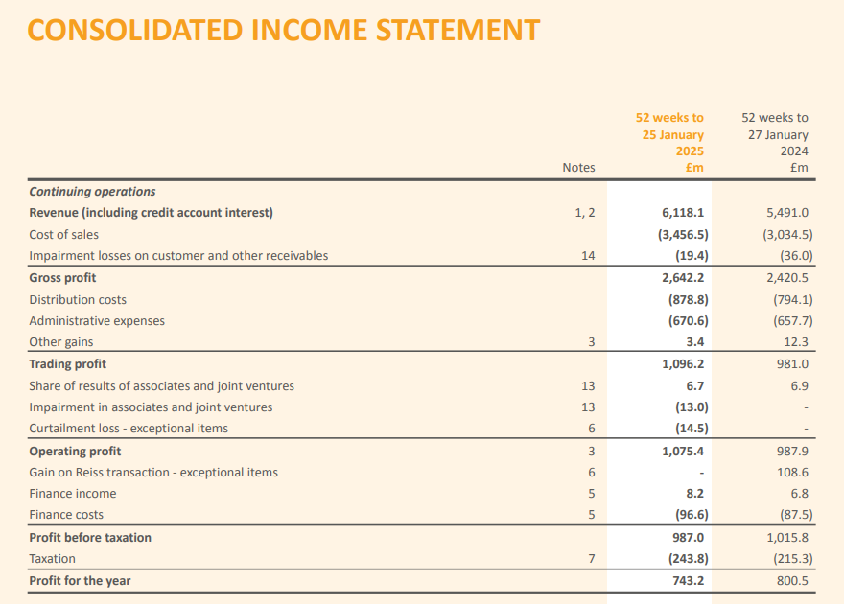
Figure 1: Next Plc’s Income statement
(Source: Next Plc , 2025)
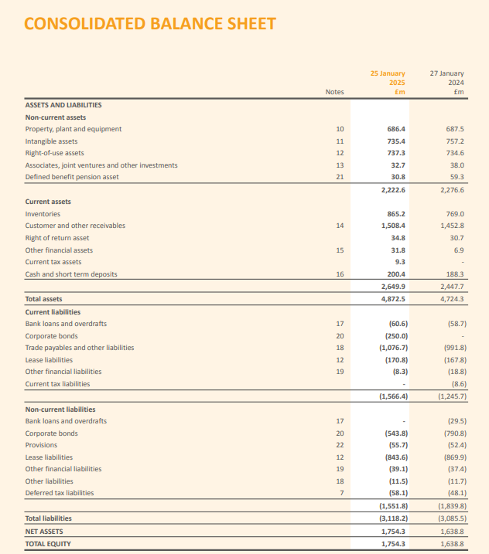
Figure 2: Next Plc’s Balance Sheet
(Source: Next Plc , 2025)

Appendix 2: Ratios of Next Plc for the year ended 2025 and 2024
Profitability Ratios
 | 2025 | 2024
 | £m | £m
Revenue | 6,118.10 | 5,491.00
Gross profit | 2,642.2 | 2,420.50
Operating profit | 1,075.40 | 987.9
Net Profit | 743.2 | 800.5
Gross profit Margin | 43% | 44%
(Gross Profit/Sales)*100
Operating profit Margin | 18% | 18%
(Operating Profit/Sales)*100
Net profit Margin | 12% | 15%
(Net Profit/Sales)*100
Liquidity Ratios
 | 2025 | 2024
 | £m | £m
Current Assets | 2,649.90 | 2,447.70
Inventories | 865.2 | 769
Current Liabilities | 1,566 | 1,246
Current Ratio | 1.69 | 1.96
(Current Assets/Current Liabilities)
Quick Ratio | 1.14 | 1.35
(Current Assets- Inventories)/Current Liabilities
Gearing Ratios
 | 2025 | 2024
 | £m | £m
Total debt | 1,551.80 | 1,839.80
Total Equity | 1,754.30 | 1,638.80
Total Assets | 4,872.50 | 4,724.30
Debt-Equity Ratio | 0.88 | 1.12
(Total debt/ Total equity)
Debt-Asset Ratio | 0.32 | 0.39
(Total Deb/Total Assets)
Efficiency Ratios
 | 2025 | 2024
 | £m | £m
Revenue | 6118.1 | 5491.00
Accounts receivables | 1,508.40 | 1,452.80
Inventories | 865.2 | 769
Cost of Sales | 3,456.5 | 3,034.5
Receivable Turnover Ratio | 4.06 | 3.78
(Sales/Account Receivables)
Inventory Turnover Ratio | 4.00 | 3.95
(Cost of Sales/ Inventories)
Investors Ratios
 | 2025 | 2024
 | £m | £m
Net Profit | 743.2 | 800.5
Number of Shares Outstanding | 120 | 120
Share Price | 14 | 13
Earnings Per Share (EPS) | 6.21 | 6.67
(Net Profit/Outstanding Shares)
Price Earnings Ratio | 2.20 | 1.95
(Share Price/EPS)

Appendix 3: Calculation of NPV
Step 1: Capital Allowances & Tax Shield
Capital Allowances & Tax Shield
Capital allowance = 20% straight line per year
Tax rate = 25%
Option | Initial Cost (£000) | Annual Capital Allowance (£000) | Tax Shield = (Capital Allowance*25%) (£000)
A: Expand its flourishing retail outlet to include all products. | 600 | 120 | 30
B: Develop into internet sales | 1000 | 200 | 50
C: Produce wooden blinds and Roman blinds | 1600 | 320 | 80
Step 2: After-Tax Cash Flow Formula
After-tax cash flow=(Cash flow×0.75)+Tax shield
(75% because tax is 25%)
Step 3: After Tax Cash Flow and NPV
A. Expand its flourishing retail outlet to include all products.
Year | Cash Flow (£'000) | After Tax Cash flow  (Cash flow×0.75)+Tax shield) | Discounting Factor (6%) | PV of Cash Flow (£'000)
0 | 600 | 600 | 1 | 600
1 | 200 | 180 | 0.943 | 170
2 | 400 | 330 | 0.890 | 294
3 | 500 | 405 | 0.840 | 340
4 | 700 | 555 | 0.792 | 440
Total PV | 1243
NPV (£'000) = Total PV- Initial Investment | 643
B: Develop into internet sales
Year | Cash Flow (£'000) | After Tax Cash flow  (Cash flow×0.75)+Tax shield) | Discounting Factor (6%) | PV of Cash Flow (£'000)
0 | 1600 | 1000 | 1 | 1000
1 | 400 | 350 | 0.943 | 330
2 | 450 | 387.5 | 0.890 | 345
3 | 720 | 590 | 0.840 | 495
4 | 980 | 785 | 0.792 | 622
Total PV | 1792
NPV (£'000) = Total PV- Initial Investment | 792
C. Produce wooden blinds and Roman blinds
Year | Cash Flow (£'000) | After Tax Cash flow  (Cash flow×0.75)+Tax shield) | Discounting Factor (6%) | PV of Cash Flow (£'000)
0 | 1600 | 1000 | 1 | 1000
1 | 450 | 417.5 | 0.943 | 394
2 | 700 | 605 | 0.890 | 538
3 | 900 | 755 | 0.840 | 634
4 | 1200 | 980 | 0.792 | 776
Total PV | 2342
NPV (£'000) = Total PV- Initial Investment | 742

