Engineering Skills Technical Report

Ali Nalbant
SN: 2502009
ACHA4022A
Deadline: 22:00 7/12/2025

Contents
Introduction 3
Health and safety 3
Security Risk matrix 5
Ransomware Attacks 5
Keyless entry 5
Charging stations 6
GPS spoofing 6
Engineers role in society 7
Engineering Council 7
Institution of Mechanical Engineering 7
Problem solving 8
Team structure 9
Personal reflection 9
Alternative team structure 9
References 11

Introduction
In this report the following will be covered:
Health and safety – This will include a risk assessment of a task with relevant legislation.
Security risk matrix – Topics will be covered on the severity and likelihood of threats to the automotive industry. With research and references bedded within.
Engineers’ role in society – How engineers work to a standard provided by a board and complete their job in a sustainable and environmental manner.
Problem solving – Covering how engineers can go about solving issues in the real world and the hurdles on developing new ideas.
Personal review – A personal review into a situation where teamwork is needed

Health and safety

Health and safety is embedded in engineering and is always a big factor on any application. For instance, in a university workshop stripping and engine although sounds basic and can be considered not risky; there are factors that must be considered such as manual handling, use of power tools and exposure to substances hazardous to health when completing this task. Starting off with the Health and Safety at Work Act (Uk Government, 1974). Although it is a university, they still have a duty to ensure the health and safety of students. Members of staff would have carried out the required risk assessments and implemented specific control measures to reduce accidents and near misses. This in question is conforming to the Management of health and Safety at work Act (UK Government, 1999) which requires the employer to carry out said tasks. Specifically, regarding stripping an engine, the Provision of use of work equipment Regulations 1998 (HSE, 1998) mandates that all tools from basic tools (For example ratchet and torque wrench to power tools (impact gun and drills) need to be maintained, inspected and adequate training to be provided by the employer. This can then be documented in a workshop book for future reference.

With the task at hand the control of substances hazardous to health 2002 requires the university to provide PPE for instance gloves due to the exposure to lubricants, degreasers and oil which can cause skin conditions. Steal toe cap boots for in the workshop as items can be dropped. All the above would have been carried out during the risk assessment such as the one below.
Hazard | Initial risk  (LxS=R) | Control measure | Residual risk
Manual handling injuries | 3x4=12 | - Use 2 people to carry the head instead of an individual.  - Keeping floors clear at all times.  - Remove ancillaries to reduce weight. | 2x3=6
Pinch/ crush injuries | 3x4=12 | Keep fingers away from rotating objects when manually cranking engine. | 2x3=6
Tool related injuries | 3x3=9 | Maintenance/inspection of tools with adequate training. Use of non-slip gloves. | 2x2=4
Chemical Exposure | 3x3=9 | - COSHH assessments.  - Gloves (for oils/solvents)  - Overalls.  - Handwashing facilities available close by. | 2x2=4
Slips/Trips | 3x3=9 | - Spill kits for immediate clean-up of spilt substance on the floor  - Anti slip footwear | 2x2=4

Likelihood (L): 1–5 (Rare to Almost Certain).
Severity (S): 1–5 (Minor to Catastrophic).
Risk (R): R = L × S.
Risk Levels: 1–5 Low, 6–10 Moderate, 11–15 High.

Security Risk matrix
As modern Vehicles rely heavily on computers, software, sensors and connected platforms. They face a wide range of cyber security threats whether this be attacked digitally or physically in which poses a risk to safety, privacy and security.

Ransomware Attacks
One threat can be through remote ransomware attacks to remotely immobilise vehicles or compromise platforms using the car as a gateway to the manufactures systems. Data from Upstream’s 2024 report found that there were over 100 ransomware attacks which targeted the automotive industry and more than 200 data breaches (Upstream, 2025). These attacks can bring manufactures to completed standstill with great financial losses and a negative impact on their position within the automotive industry.

Keyless entry
In recent years, the UK has seen a significant rise in keyless entry relay attacks—a method where criminals use signal amplifiers to mimic the presence of a key fob near the vehicle. This allows them to unlock and start the car without physical access to the key. According to data from Tracker, nearly 94% of all car thefts recovered by themselves in London during 2022 were attributed to this technique. Jaguar Land Rover (JLR) has been notably affected (Tracker, 2022). Tracker reported that 44% of all vehicles they recovered in 2022 were JLR models, highlighting the brand’s vulnerability to this form of theft (Tracker, 2022). In response, JLR invested £10 million to enhance vehicle security and address the issue. By 2023, the impact of these measures was evident. Theft rates for newly released models dropped significantly, with only 0.07% of new Range Rovers and Range Rover Sports, and 0.3% of new Defenders reported stolen. Additionally, JLR deployed security updates to over 65,000 existing vehicles, demonstrating a proactive approach to safeguarding their fleet (Jaguar Land Rover, 2023).
As JLR have started to battle this issue with software updates, all manufactures going forward should really invest heavily in further encrypting the communication between the key and the car. Such as motion sensitive key fobs in which Ford has now implemented with the key going into “sleep mode” once it is stationary for more than 40 seconds. This then stops all connections with the car so that hackers are unavailable to intercept any transmissions as they simply do not exist until the key is moved (Ford, 2025).

To mitigate keyless entry relay attacks, a multi-layered approach is essential. Firstly, implement ultra-wideband (UWB) technology in key fobs and vehicles, which prevents signal relay by requiring precise distance measurement. Secondly, integrate rolling encryption codes that change dynamically with each authentication attempt, reducing replay attack feasibility. Thirdly, add motion sensors and sleep-mode functionality to key fobs, ensuring they transmit only when moved. Finally, manufacturers should deploy intrusion detection systems within the vehicle’s CAN bus to identify abnormal access patterns. Combined, these measures provide a proportional and holistic solution addressing both hardware and software vulnerabilities.

Charging stations
Thirdly with electrical vehicles being pushed greatly by the world as it is deemed more “environmentally friendly” there comes a threat of cyber-attacks. Charging stations for said vehicles have become a hotspot for criminals to damage the car physically. By altering components inside the station to deliver incorrect voltage or current to fry circuit boards and damage batteries. Or data theft by installing components with software to intercept highly sensitive data such as payment cards and manufacture vehicle identification with the users credentials (Scoblete, 2023).

GPS spoofing
The last threat that the industry and vehicles have is GPS spoofing. This threat only applies to cars of which have the capability to be autonomous. Hackers can manipulate satellite signals in, so this misleads the vehicle about it’s current location. This poses a massive threat as this can cause unsafe lane changes, speeding, misjudging vehicle distances with active cruise control and more importantly causing collisions (Sriram, 2023).
Threat | Likelihood | Impact | Risk level
Ransome ware attacks | Medium | High | Very High
Keyless entry | High | Very High | Very High
Charging stations | Low | Medium | Moderate
GPS spoofing | Low | High | Moderate

Engineers role in society

Engineers play a vital role in our society weather that is through innovation of new ideas, safety and more importantly currently sustainability. Two key organisations that are used within the UK that publish a code of conduct for engineers are the Engineering council and Institution of Mechanical Engineers or otherwise known as IMechE.

Engineering Council
Firstly, the Engineering Council sets ethical standards promoting sustainability, integrity and public safety to name a few. Regarding motorsport engineers, reciting the code of conduct of which they have been provided. They can make formative decisions such as improving fuel efficiency or using biofuels and carbon neutral fuels to reduce emissions. On the other hand, using sustainable materials in which can be recycled after they have been damaged like bodywork as they are damaged regularly. The code of conduct provided guides engineers to weigh up their ideas with reflection on how they can increase sustainability for future generations (Engineering Council, 2017).

Institution of Mechanical Engineering
The IMechE strongly focuses on four principles. They expect for an engineer to practice their code of conduct competently and further learn with any updates. For engineers to be honest with their work and be respectful of others weather that be colleagues, suppliers, customers etc. Like the Engineering Council it also covers sustainability looking into environmental factors and socioeconomic factors. Lastly it covers engineering leadership. This entails contribution to group projects, when encountering issues or risks that they are taken in a positive and correct manner. Within motorsport engineers are working together towards one goal, winning. This means that engineers need to be respectful of others and allowing for individuals to voice their ideas and opinions on the job at hand (Institution of Mechanical Engineers, 2025).

Problem solving
Engineers often encounter issues during product development. Over time they have been able to create structured problem-solving methods. One for instance being root cause analysis or also known as RCA. This identifies the underlying cause rather than highlighting the symptoms. Another tool used by engineers is the 5 whys which systematically questions each layer of the problem until the root cause is revealed (County of Los Angeles Public Health, n.d.).
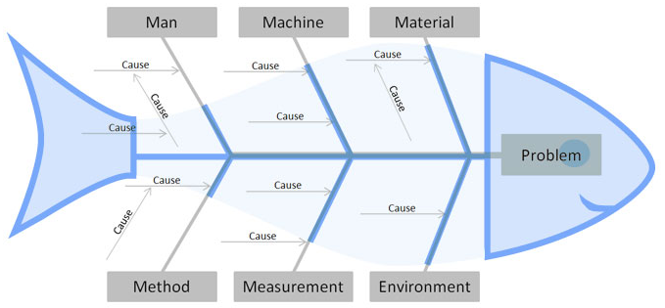

Furthering this, another tool such as stated in the photo above is the Fishbone diagram created by Kauru Ishikawa. This tool categorised potential causes to the problem under headings such as methods, materials and environment to name a few. This visual approach aids engineers and aids more of a collaborative brainstorm and ensures that all factors have been considered (ASQ, n.d.). Whilst the fishbone diagram shows all factors in better detail the failure mode and effects analysis or known as (FMEA) assesses the potential failure points, their severity and likelihood. This allows teams to prioritise the problems in which to solve.
Lastly the Plan-do-check-act or PDCA cycle incorporates a structured framework for implementing solutions and monitoring the effectiveness of said solution further down the line. This unlike the others is widely recognised in quality management standards such as ISO9001:2015. Within the automotive industry for instance these are critical for ensuring safety, reliability and compliance with industry set standards.

Team structure

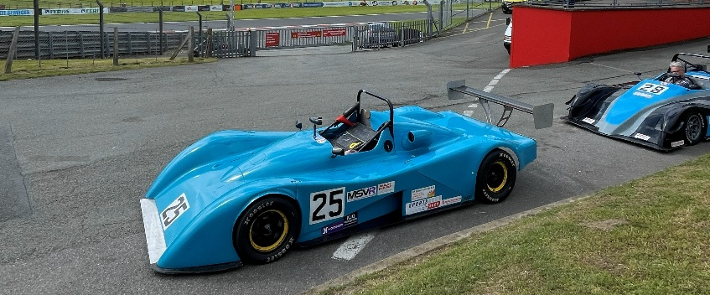

I am fortunate enough to be able to work on a Van Diemen RF02 race car which taught me how crucial teamwork is within motorsport. Our Small race team consisted of myself as trainee mechanic, Josh as the driver, Josh C as performance engineer, Lee head mechanic and John who is the aerodynamist.

Personal reflection
We used a functional team structure, where each member had their own specified role. This working when preparing the car for the race weekend as everyone focused on their of expertise, this ensured that all work was carried out to a high degree. However, during race weekends, this structure began to show signs of weakness. The driver requested a gear ratio change to improve out of corner acceleration at Brands Hatch. The lead mechanic needed to confirm they had the correct ratios for the gearbox, and the performance engineer and aerodynamicist both had to approve the work which one opposed the idea due to not having the correct final drive and the other due to the change in speeds. This back-and-forth slowed us down, and we couldn’t implement the change before qualifying. A cross-functional structure would have allowed quicker collaboration and decision-making.

Alternative team structure
One of the ways in which my team could have been more effective is a Hierarchical team structure. In this format, there is a clear chain of command with the head mechanic having the final say with the other roles beneath them. With the pressure between practice, qualifying and racing this would allow my team to make final decisions quickly without the need to converse with others. This ensures accountability and avoids any confusion in these high-pressure moments.

Positives | Negatives
Clear roles and accountability | Communication gaps between functions
High expertise per role | Slower decision making under pressure
Efficiundent for specialised tasks | Limited flexibility during race day

If we had this structure at Brands Hatch, then the gear ratio change could have been implemented and completed due to the final say of the lead mechanic without the need of multiple consultations. While functional teams are great preparation, hierarchical teams really excel in critical high-pressure moments when quick and decisive actions are needed.

Conclusion
This report has explored critical aspects of engineering practice, including health and safety compliance, cybersecurity challenges, professional ethics, problem-solving methodologies, and team dynamics. The analysis highlighted the importance of legislation and risk management in practical tasks, the growing need for robust security measures in connected vehicles, and the role of engineers in promoting sustainability. Furthermore, structured problem-solving tools and effective team structures were shown to be vital for successful project outcomes. Collectively, these elements underscore the responsibility of engineers to uphold safety, security, and ethical standards while driving innovation in a rapidly evolving industry.

References
Engineering Council, 2017. Guidance on ethical principles. [Online]
Available at: https://www.engc.org.uk/resources-and-guidance/guidance-for-the-profession/ethical-principles
[Accessed 20th 11 2025].
Ford, 2025. Motion Sensing Key Fob. [Online]
Available at: https://www.ford.co.uk/support/how-tos/keys-and-locks/door-locks-and-alarms/how-does-the-motion-sensing-key-fob-work
[Accessed 18th 11 2025].
HSE, 1998. [Online]
Available at: https://www.hse.gov.uk/work-equipment-machinery/puwer-overview.htm
[Accessed 16 11 2025].
Institution of Mechanical Engineers, 2025. Code of conduct explained. [Online]
Available at: https://www.imeche.org/about-us/imeche-governance/governance-and-finance-reviews/code-of-conduct-explained
[Accessed 20th 11 2025].
Jaguar Land Rover, 2023. JLR INVESTS IN VEHICLE SECURITY TO REDUCE THEFTS. [Online]
Available at: https://www.jlr.com/news/2023/11/jlr-invests-vehicle-security-reduce-thefts
[Accessed 18th 11 2025].
Scoblete, G., 2023. Electric Vehicles in Focus, Part V: The Evolving Cyber Threat to EV Charging Stations. [Online]
Available at: https://core.verisk.com/Insights/Emerging-Issues/Articles/2023/September/Week-4/The-Cyber-Risks-of-Electric-Vehicle-Charging-Stations
[Accessed 20th 11 2025].
Sriram, R., 2023. GPS spoofing: a cyber security threat to in car navigation & AVs. [Online]
Available at: https://focalpointpositioning.com/resources/insights/blogs/gps-spoofing-a-cyber-security-threat-to-in-car-navigation-avs/
[Accessed 20th 11 2025].
Tracker, 2022. London Is The Capital For Culture And Stolen Cars!. [Online]
Available at: https://www.tracker.co.uk/tracker-hub/news/london-capital-culture-and-stolen-cars
[Accessed 18th 11 2025].
Tracker, 2022. Range Rover Sport Most Stolen And Recovered Car In 2021. [Online]
Available at: https://www.tracker.co.uk/tracker-hub/news/range-rover-sport-most-stolen-and-recovered-car-2021
[Accessed 18th 11 2025].
Uk Government, 1974. Health and Safety at Work etc. Act 1974. [Online]
Available at: https://www.legislation.gov.uk/ukpga/1974/37/section/2
[Accessed 16th November 2025].
UK Government, 1999. The Management of Health and Safety at Work Regulations 1999. [Online]
Available at: https://www.legislation.gov.uk/uksi/1999/3242/contents
[Accessed 16th 11 2025].
Upstream, 2025. Global-automotive-cybersecurity-report. [Online]
Available at: https://upstream.auto/reports/global-automotive-cybersecurity-report/
[Accessed 17th 11 2025].

