

Module: Managing Food and Beverage Operations
Module Code: BMIH6002
Student Learning Log
Student ID Number: 2212736
Student Name: Violeta-Ionela Necsoi

Table of Contents
1 Introduction 3
2 Applying Gibbs’ Reflective Cycle to a Key Experience 4
2.1 Description (What Happened?) 4
2.2 Feelings (How Did I Feel?) 5
2.3 Evaluation (What Was Good and Bad?) 5
2.4 Analysis (What Can Be Learned?) 6
2.5 Conclusion (What Else Could Be Done?) 7
2.6 Action Plan (How Will This Experience Shape My Future?) 7
3 Reflection on Organisational Challenges and Proposed Solutions 7
4 Conclusion and Future Career Aspirations 8
References 9

Introduction
Delta Hotels by Marriott Swindon is a business and leisure hotel that provides premium hospitality services, including a large food and beverage (Food and Beverages) department (ASET, 2017). The department includes restaurant, bar, in-room dining and event catering. To meet the expectations of the Marriott brand, it is important to maintain high levels of food quality, service efficiency and guest experience. The Food and Beverages department at Delta Hotels runs within a fast-paced hospitality industry, where it is important to work well in a team, communicate effectively and display leadership qualities for a smooth service operation (Fallon and Rutherford, 2010).
My main objective was finally getting a more academic standpoint regarding service standards, guest relations and general operational challenges in this field. My learning objectives were to learn workflow management in high-volume service operations, acquire key work-based skills like problem-solving, leadership and time management, learn and analyse management performance in Food and Beverages operations, identify organisation challenges and propose effective solutions. Gibb’s Reflective Cycle was used to reflect critically on the experience (Markkanen et al., 2020).

Applying Gibbs’ Reflective Cycle to a Key Experience
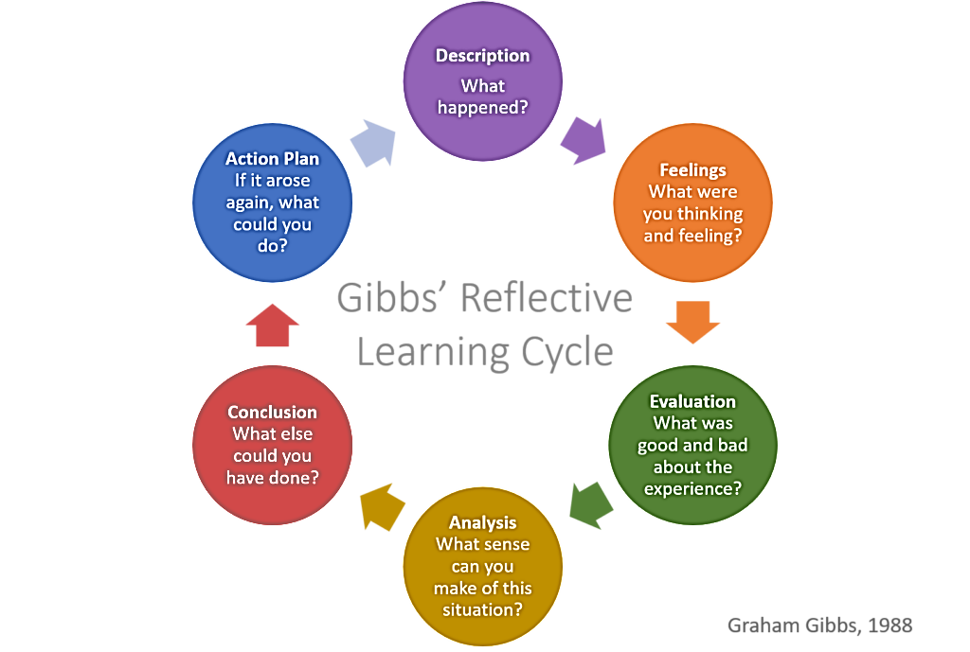
Figure 1 Gibbs Reflective Cycle
Source: Gibbs (1988)

Description (What Happened?)
It is evident that one of the most significant experiences I experienced during my placement was a busy Friday evening service. Because of the unexpected staff shortage, the Food and Beverages manager had to assign more supervisory duties to me. Having a limited number of servers, the restaurant was experiencing service delays, the staff being overwhelmed and guest dissatisfaction (Hagg, 2013). The shift was hard; there were high guest volumes, orders were delayed, and guests complained about wait times. I had to be able to communicate with kitchen staff, delegate tasks to the team available and work on guest relations to manage their expectations. One particular guest was dissatisfied because food service took 30 minutes, and a strategic resolution was required to achieve a positive guest experience (Johnston et al., 2012).

Feelings (How Did I Feel?)
At first, I thought it would be too much to handle supervisory responsibilities without experience in this line of work. The urgency and stress of balancing multiple tasks, guest complaints, ensuring staff coordinated things, and ensuring everyone was doing their job (Vallen and Vallen, 2014). However, as the shift went on, I also began to feel more comfortable with the adapting I had to do. I felt intensely responsible for finding a way to resolve service delays when guests complained. I maintained a professional and composed composure to ensure that the guests felt like they were acknowledged and appreciated (Serwa, 2021). I was able to de–escalate guest dissatisfaction by offering a sincere apology, complimentary drinks, and maintaining brand service standards.

Evaluation (What Was Good and Bad?)
One of the positive points of this matter is that I handled it. Firstly, it helped to showcase my leadership and problem-solving skills by taking charge of a position of supervision when a team was needed (Fabianova and Scholz, 2024). I could delegate effectively, communicate with the kitchen staff, and keep my head on dealing with guest issues. According to Marriott’s guest satisfaction policies, I offered service recovery measures like complimentary drinks as a sign of value to my customers. But it wasn’t all smooth sailing, as it came with many challenges to improve. At first, I had so much trouble with time management and prioritisation that I would fall behind in addressing guest complaints and order coordination. In addition, the communication with the kitchen team was not constructed to improve synchronisation between the front and back of the house (Jnr and Dzogbewu, 2021).

Analysis (What Can Be Learned?)
This experience gave me several key lessons in hospitality operations management, leadership, and crisis communications. This was an important scenario for time management and prioritisation. The Eisenhower Matrix classifies tasks as urgent and important (Spezie and Bragantini, 2023). Initially, I was done with rush-like guest complaints and other things, and then I learned to prioritise tasks strategically. According to Lean Hospitality Management (Ohno, 1988), service inefficiencies should be reduced (Rodić and Marić, 2021). People also learned about key aspects of leadership and how to coordinate with other team members. Individuals in teams assume Belbin’s Team Role Theory have different team roles (e.g., Co-ordinators (leaders) and Implementers (executors) (Spezie and Bragantini, 2023).
I moved from being a team member to a co-co-ordinator, meaning everyone had a place to be and work and knew what they would do. The Situational Leadership Model states that leadership styles should change according to different challenges (Rodić and Marić, 2021). Handling customer interaction was largely dependent on guest service and emotional intelligence. According to Goleman’s Emotional Intelligence Model, self-awareness, empathy, and social skills are part of customer service (Jnr and Dzogbewu, 2021). I did this by using active listening and emotional regulation to ensure that guests felt heard and valued, even when delays happened. Furthermore, the Service Recovery Model stresses that compensatory service recovery (such as offering complimentary drinks) should be provided to keep guest satisfaction at a high level (Serwa, 2021).

Conclusion (What Else Could Be Done?)
Moreover, upon retrospection, I realise that if we had a more structured way of dealing with a crisis, efficiency in handling the whole thing would have been greatly improved. Having a pre-service briefing to discuss potential challenges could have assisted in coordinating the team (Markkanen et al., 2020). Moreover, better communication with the kitchen team would have prevented misalignment in order processing. In addition, staff shortages indicate a larger operational problem that cannot be resolved in the short term and requires long-term measures, such as cross-training employees to help in different roles (ASET, 2017).

Action Plan (How Will This Experience Shape My Future?)
I will improve my time management skills by applying prioritisation techniques (Eisenhower Matrix) in real–life situations to develop my leadership and crisis management skills further. By seeking mentorship from Food and Beverages managers, I can learn from them about staff coordination and operational efficiency (Fabianova and Scholz, 2024). Furthermore, I plan to attend Marriott’s internal training, leading to leadership training workshops to improve my team management ability. Moreover, I would like to improve my communication skills to better synchronise front-of-house and back-of-house operations.

Reflection on Organisational Challenges and Proposed Solutions
Staff shortages were one of the biggest challenges faced during the placement, as they had a direct effect on service efficiency and guest satisfaction (Fallon and Rutherford, 2010). As a result, employees were overburdened, service was slower, and staff was stressed out. The Food and Beverages department can improve this issue by using proactive staffing strategies (Hagg, 2013). Additional support during peak hours would be offered through cross-training the staff to work in multiple roles. Flexible scheduling, e.g. rotations, should be implemented to avoid burnout and make the employees happier.
Additionally, installing digital table management applications will improve the restaurant’s service efficiency by facilitating better order processing and team communication (Johnston et al., 2012). From a theory perspective, Hertzberg's Two Factor Theory points out how improving employee working conditions and reducing job pressure will increase employee motivation and retention (Vallen and Vallen, 2014). In addition, Bitner’s Service Blueprinting can contribute to optimising workflow processes by eliminating bottlenecks and enhancing efficiency in F&B operations.

Conclusion and Future Career Aspirations
This experience has helped me shape my leadership skills, my obvious problem-solving ability, and my knowledge of F&B operations. Communication, teamwork, and guest service excellence are more important in a high-pressure service environment, and managing one has reinforced this importance. Once I conclude my hospitality management training, I look forward to further training in the field to gain more experience in service optimisation and operational leadership. My goal is to improve my decision-making and staff coordination techniques to move up the chain into managerial positions in the hospitality industry.

References
ASET (2017) Good Practice Guide for Workbased and Placement Learning in Higher Education. Sheffield: ASET. https://www.uos.ac.uk/media/uniofsuffolk/website/content-assets/documents/policies-and-procedures/Work-based-and-Placement-Learning-Policy.pdf?utm_source=chatgpt.com
Fabianova, T., and Scholz, M. (2024). Exploring Strategies of Small and Medium-sized Enterprises within the Food and Beverage Industry to Contribute to Sustainable Development: Through the Lens of Dynamic Capabilities and Leadership. https://www.diva-portal.org/smash/record.jsf?pid=diva2%3A1863523anddswid=8675
Fallon, M. and Rutherford, D. (2010) Hotel Management and Operations. London: Wiley. https://books.google.com.pk/books/about/Hotel_Management_and_Operations.html?id=G0AnmDecKpQC&redir_esc=y
Gibbs, G., 1988. Learning by Doing: A Guide to Teaching and Learning Methods. https://assignmentstudio.net/gibbs-reflective-cycle/
Hagg, E. (2013) Internship Guide: Work Placements Step by Step. 5th Ed. The Hague: Eleven International Publishing. https://openlibrary.org/books/OL31058026M/Internship_guide
Jnr, S. A., and Dzogbewu, T. (2021). Goleman’s Intrapersonal Dimension of Emotional Intelligence: Does it Predict Effective Leadership?. Organizational Cultures, 21(2), 35. https://www.proquest.com/openview/39b34162ea9f6408670e69e75e6fe722/1?pq-origsite=gscholarandcbl=5527633
Johnston, R., Clark, G. and Shulver, M. (2012) Service Operations Management: Improving Service Delivery. 5th Ed. London: Pearson. https://www.pearson.com/en-us/subject-catalog/p/service-operations-management-improving-service-delivery/P200000004570/9781292098050
Markkanen, P., Välimäki, M., Anttila, M., and Kuuskorpi, M. (2020). A reflective cycle: Understanding challenging situations in a school setting. Educational Research, 62(1), 46-62. https://www.tandfonline.com/doi/abs/10.1080/00131881.2020.1711790
Rodić, M., and Marić, S. (2021). Leadership style and employee readiness: Basic factors of leadership efficiency. Strategic Management-International Journal of Strategic Management and Decision Support Systems in Strategic Management, 26(1). https://smjournal.rs/index.php/home/article/view/21
Serwa, A. (2021). Sustainability in Ghanaian restaurant service The role of service recovery (Doctoral dissertation, University of Education Winneba). http://ir.uew.edu.gh:8080/handle/123456789/2481
Spezie, M., and Bragantini, D. (2023). The Development of a Task Management Software (TMS): A bridge between Project Management’s sub-activities (especially in multi-project context) and" ordinary" assignments to follow. PM World Journal, 12(4). https://pmworldlibrary.net/wp-content/uploads/2023/04/pmwj128-Apr2023-Spezie-Bragantini-development-of-task-management-software.pdf
Vallen, G.K. and Vallen, Jerome J. (2014) Check-In Check Out: Managing Hotel Operations. 9th Ed. Harlow: Pearson Education Limited. https://www.pearson.com/en-gb/subject-catalog/p/check-in-check-out-pearson-new-international-edition/P200000005651/9781292034355

