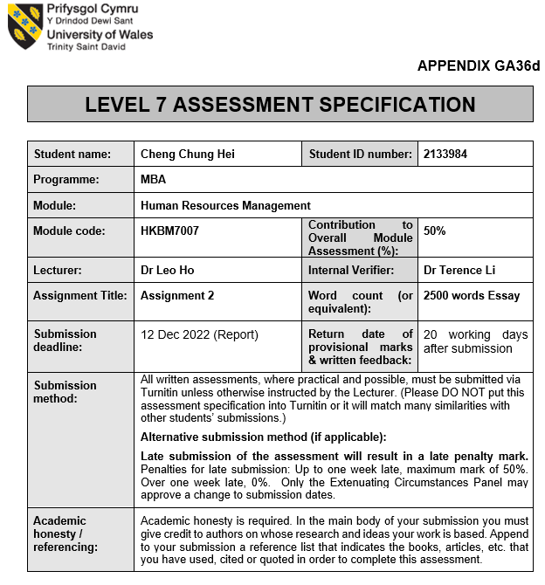

Table of Contents
1. Introduction 3
2. Case Study
2.1 Company background 3
2.2 The main challenge of HK & Japanese company is expanding the IHRM in China 3
2.3 Solving approach of HR manager in China 4
3. The benefits and disadvantages of the recruiting method in the IHRM in China
3.1 Management trainee (MT) program 5
3.2 benefits for headhunting company 5
3.3 Disadvantages of headhunting company 6
4. Recommendation
4.1 Short term action plan 7
4.2 Mid-term action plan 7
4.3 Long term action plan 7
5. Conclusion 8
6. Reference 9
7. Appendices 11

1. Introduction
In 1978, China's agricultural management system was liberated, the rural productive forces resulted in significant changes to the rural economy and social development. Simultaneously, as industrialization and urbanization have advanced, farmers' income has been increasingly transferred (Lai, Chen and Liu, 2020). So, a huge amount of labor appeared in the market. Up to date, China has become the 2nd largest economy in the world. Many companies want to expand their business in China, because China citizens have already improved their standard of living and they are affordable for any consumption.

As a result, Hong Kong local companies or overseas big companies move their brand to China due to this attractive requirement. So, the companies require their HR to consider how to expand their IHRM in China. For example: recruitment, compensation and benefits.

2. Case Study
Now we are going to select 2 companies for case study, 1 is Hong Kong local company – Giordano and the other is Japan company – Fast Retailing (UNIQLO).

2.1 Company background
Giordano International Limited (Giordano, 2022) was established in Hong Kong in 1981. It is one of the most well-known and long historical clothing retailers in the Asia Pacific region, up to date, it has about 2,100 stores operating and employing about 5,900 employees globally. Giordano represents the modern lifestyle fashion currently with superior material and simple design. Giordano's mission is to provide clothing for all, regardless of race, nationality and culture.

Fast Retailing Co, Ltd is clothing and fashion holding company and one of their famous brands is UNIQLO which is a fast fashion significant representative in Asia. In Japan, their first store was established in 1984. The brand began to grow in the international market in 2001 (Fast Retailing, 2022), and today their stores operate globally.

The most visible challenge for IHRM (International Human Resource Management) is staff recruitment. This essay will examine the effects of China's expansion, using the above 2 companies present a real-world situation for further analysis, and offer recommendations for how to get better outcomes.

2.2 The main challenge of HK & Japanese company is expanding the IHRM in China
Different features of Japan and Hong companies expand the IHRM in China as below.
Japan companies adopted carrier long employment, which will provide a high resource to those selected by the company. The selected employee will grow with the company in the next few decades and will accept different kinds of training to fulfill the company requirement. This method cannot apply to recruitment in China, because the carrier mobility of the young generation is very high, because they always look for the higher salary, sense of accomplishment and satisfaction of working environment rather than stay in the same company

Hong Kong companies expand IHRM in China, they should have challenges in the recruitment process. Hong Kong employees commonly should have a high education knowledge, so they can take necessary action in order to solve the problem without doubt. As we all know, China implemented the One-Child Policy in 1980. This policy mainly controls the high birth rate (Zhang, 2017), but it brings the impact to the new generation. That only children commonly have less trusting, self-centered, conscientious (Cameron, 2013). So, it may take more time to hire the suitable candidates.

Similar features of Japan and Hong companies expand the IHRM in China as below.
According to the survey of the State of the Global Workplace (State of the Global Workshop, 2022), the number one region of daily stress in the workplace is East Asia. Hong Kong and Japan are notorious for long working hours. 8 hours working per day is conceptual, but most employees need OT to complete their job every day and result in unhealthy problems and death “karoshi” (Eguchi, Wada and Smith, 2016). So, if the IHRM applies this working culture in China. It is not easy to recruit the candidates. Although China can provide a lot of manpower for HR selection. However, the new generation in China will not be willing to work under the stress and long working hours.

Hong Kong and Japan also concern the hierarchical relationship between a senior and a junior. This significance of hierarchy may be traced back to Confucianism (Chen and Chung, 1994), which emphasizes social relationships depending on every individual's position in society, the junior must follow the instruction from the senior. However, the young generation has an independent thinking to analyze whether the issue is right or wrong. So, it is very difficult to hire an obedient employee.

2.3 Solving approach of HR manager in China
Normally, the IHRM will use different kinds of recruitment methods, such as hiring headhunting companies. These companies will use the apps in China, such as MeiMei (xinergy, 2022) to find the suitable candidate in the job market. Also, they will take responsibility to do an interview and filter some unsuitable candidates and pass to IHRM for the final interview. This procedure can assist IHRM to reduce the time for recruitment. Finally, the headhunting company can receive the recruitment fee from the company if the candidate passes the probation period.

The above method is a very common method for recruitment. On the other hand, the IHRM can publish the recruitment on their official website. In the recruitment page, the IHRM will list out the vacancy which mention the key responsibility and requirement. This traditional recruitment method is not so efficient for the IHRM, because they cannot fully understand the local culture of the market.

IHRM has been required to attract the talent for business expansion in China. So, they start a management trainee program every year to attract graduate university students finally. Giordano and Fast retailing companies also launch this kind of program to attract candidates. Using Fast Retailing for the case study, they launched the UMC - Uniqlo Management Candidate this year in May 2022, their official website will show the attractive benefit as below (Fast Retailing, 2022):
- Perfect training system
- Fast promotion channel
- Competitive salary
- National and global job opportunities
- Control quarter working hour

The above attractive requirements will draw the attention of the fresh graduate’s university student because they did not have much working experience in the society.

3. The benefits and disadvantages of the recruiting method in the IHRM in China
IHRM will commonly use the above recruitment methods to hire the candidates in the market.

3.1 Management trainee (MT) program
With guidance and information about the company background and business units, a management trainee program is created for new employees. The company conducts this training that new employees will be able to take on the more strategic roles in the company's management. Company uses a comprehensive competency management system to assist in enhancing employee potential and skills.

Trainees will be trained and educated on all aspects of the company's operations, including risk management, management planning, business control, etc. Trainees also receive on-the-job training or hands-on experience through regular company events.

Some of the benefits that companies get when implementing MT are:
- Increasing company productivity.
- Improving Management Capabilities.
- The knowledge of relevant Standard Operating Procedures among employees has improved.
- Provide insight and character development for future leaders.
- Ensure that the company will have a higher level of talented human resources in the future.
- Ability to evaluate, screen, and assess qualified candidates.

The program is only for attracting the high-quality talented human resource to join the companies, so no significance issue to define it bad.

3.2 benefits for headhunting company
Open hiring only targets the labor market segment that is actively searching for work; headhunters target a wider market of individuals who are clearly satisfied with their current jobs. Clients are attracted to this market due to its size, however there is also an assumption that the top candidates are likely to be satisfied and doing well in their current jobs. Unemployed executives in frustrated need of work generally have lower market values. The practice of headhunting ought to promote the more effective use of human resources, and the headhunting market has the potential to benefit the economy (Macdonald, 1986). Compared with the traditional recruitment approach, headhunting has some impressive advantages.

First, traditional recruitment publishes the job advertisement in the job’s website and newspaper, so the companies limit to access the talent pool is market. An experienced headhunter should understand the abilities you require and should be inventive in searching for the suitable candidates who possess those skills.

Second, traditional recruitment is like a long campaign, the HR creates the attractive job advertisement, then pays a lot of effort to browse a huge number of applications
forms to try to find out the best of the best candidates in the market. This is absolutely a waste of time and money. Headhunting works by identifying high-quality candidates and persuading them to join the company. So, the HR only focuses on qualified candidates who already meet the requirements.

Third, headhunters may be a special effective recruitment approach, because it can speed up the recruitment of telnet people. As we all know, traditional recruitment requires a long and tedious process for a few weeks or more, such as filtering the applicants, creating the list of successful applicants and arranging the interview. Headhunters can reduce the tedious process for the HR.

Fourth, speeding up the recruitment process can lower the cost. headhunter assists the HR to filter the first-round applicants and choose the suitable candidates in the list. HR can save the advertisement cost significantly.

Finally, cooperating with the experienced headhunting company can help to find the suitable candidates, especially if the HR is seeking for senior staff or people with unusual skill. Because the headhunters already had a potential and well skilled staff who are willing and waiting for new opportunities in the market. These well skilled staff will bring their experience to enrich the company (Ayala, 2014).

3.3 Disadvantages of headhunting company
Seems the headhunting method can assist the IHRM to recruit the potential talent from the outside market, at the same time, IHRM can also reduce the cost and time to increase productivity. However, in some circumstances, it might not be the greatest choice.

First, assume IHRM hires the headhunting company to recruit the employee, then the headhunter must determine whether they have knowledge in that field. They will either need to have the necessary knowledge or they must make sure of your criteria as clearly as you can. IHRM may have certain unique requirements that need to be communicated for knowledge of that industry.

Second, traditional headhunters typically work on a commission basis, their fees scale with the amount offered. So, if they would do it for their own benefit rather than the company, there could be a conflict of interest. IHRM should be able to find and trust the headhunters and know they are working hard to achieve the best results for your business.

Finally, headhunter provides a range of services from searching the candidates to finalizing the interview. If IHRM does not join the interview, the interview might end up with someone they don't like. So, the IHRM must take over the final interview before hiring the candidate.

4. Recommendation
According to the analysis of the IHRM, the current recruitment method should solve most of the problem. However, everyone has an unlimited desire to maximize their needs under the limited resources. so, below are some recommendations for the IHRM for recruiting new employees.

4.1 Short term action plan
The most serious problem affecting IHRM is how to recruit the ideal candidates and attract them to keep staying in the company. Although the existing method can attract the new candidates to join the company, the IHRM can offer more extra benefits in the recruitment package.

The extra benefits are non-monetary barter transactions which are provided for employees, such as dental care, free meals, free children care and even in-office massages. These employment advantages will very certainly generate productivity benefits for the company (Jones, Molitor and Reif, 2019). Therefore, if the company is able to provide the competitive benefit among the competitors, the talent must choose the wide range of benefit’s company which can satisfy their desire and needs. The company also has no need to train up the new candidate who is willing to stay longer. The competitive benefits are a win-win situation for employers and employees. Short term action plans just get the approval from the management level of the HQ, so taking few months evaluation can launch them.

4.2 Mid-term action plan
According to the Employer Brand Statistics (linkedin, 2015), over 70% of recruiting leaders recognize that employer brands have a big impact on hiring. Employer branding has a big impact on how well a recruitment plan works, because it affects how candidates consider a company. Therefore, creating a distinctive and credible brand is essential to attracting top talent.

Companies can conduct a survey of their current employees and then make a conclusion based on the results and share in the social media sites. On their social media sites, they can describe their workplace culture and provide employee endorsements. Candidates will be engaged to a company if they perceive a favorable working environment of the company. Mid-term action plan is not easy to run, because a valued brand name requires development and management (Meyers-Levy, Louie and Curren, 1994), so it may take a few years or more for establishment. Therefore, many stakeholders are required to involve this plan, especially the management level in the company.

4.3 Long term action plan
Using the unique technology for the talent recruitment which can overcome the three main challenges which reduce time to recruit, reduce cost per recruit and increase quality of recruitment (Walford-Wright and Scott-Jackson, 2018).

Technology innovation can make it possible to have a conversation with potential employees and take them on an interactive journey where they discover more about the company through a realistic job preview and about themselves through a psychometric test. Of course, there is a chance that candidates with little computer skills might feel frustrated and put at a disadvantage by a recruitment approach based on technology. Being "tech savvy" is a requirement for most organizations at this moment. Therefore, if a company can automatically disqualify and eliminate applicants who are unable to finish the application process, this adds value to the process and offers candidates a realistic idea of what working for a technology-based company enquiry. Technology innovation is a huge investment for every company. No exact time can provide for this action plan, but I believe AI can replace the entire recruitment process in the future.

5. Conclusion
In conclusion, human resource management always must face different challenges when the headquarters expands overseas. Due to regulations, and cultural differences can create many problems for the expansion’s country. The IHRM should depend on the local headhunting company for the candidate's recruitment until adapted to the local legislation and working environment. Recruitment' efforts will be ineffective if the culture doesn't change because employees are the most important aspect of IHRM.

6. Reference:
Aljayi, Y., Fjer, A., Guennioui, M., and Tamek, A. (2016). Multinational companies’ human resource management practices and their organizational culture impact on employees’ loyalty: Case of Japanese multinational company in Morocco. Procedia-Social and Behavioral Sciences

Ayala Ortuño, D. (2014). Recruiting and assessment functions in samper head hunting.

Cameron, L. at al. (2013). Little emperors: behavioral impacts of China's One-Child Policy. Science, 339(6122), pp. 953-957.

Chen, G. M., and Chung, J. (1994). The impact of Confucianism on organizational communication. Communication Quarterly, 42(2), pp. 93-105.

Compass office (2017) How Hong Kong's Working Hours Stack Up In Asia. Available at:
https://www.compassoffices.com/en/about-us/blogs/how-hong-kong-s-working-hours-stack-up-in-asia/ (Accessed: 20 Nov 2022)

crooton (2022) Six major advantages of headhunting. Available at:
https://www.crooton.com/2022/09/20/six-major-advantages-of-headhunting/ (Accessed: 20 Nov 2022)

Eguchi, H., Wada, K., and Smith, D. R. (2016). Recognition, compensation, and prevention of karoshi, or death due to overwork. Journal of occupational and environmental medicine, 58(8), pp. e313-e314.

Fast Retailing (2022) Recruitment page. Available at: https://event.uniqlo.cn/hrchina/recruitment/?type=umc&from= (Accessed: 19 Nov 2022)

Giordano (2022) Recruitment page. Available at: https://m2.giordano.com/recruit.aspx (Accessed: 19 Nov 2022)

Jones, D., Molitor, D., and Reif, J. (2019). What do workplace wellness programs do? Evidence from the Illinois workplace wellness study. The Quarterly Journal of Economics, 134(4), pp. 1747-1791.

Linkedin (2015). The Ultimate List of Employer Brand Statistics. Available at: https://business.linkedin.com/content/dam/business/talent-solutions/global/en_us/c/pdfs/ultimate-list-of-employer-brand-stats.pdf (Accessed: 20 Nov 2022)

Macdonald, S. (1986). Headhunting in high technology. Technovation, 4(3), pp. 233-245.

MaiMai (2022) The Chinese LinkedIn. Available at: https://www.xinergy.global/maimai-the-chinese-linkedin/ (Accessed: 20 Nov 2022)

Meyers-Levy, J., Louie, T. A., and Curren, M. T. (1994). How does the congruity of brand names affect evaluations of brand name extensions? Journal of Applied Psychology, 79(1), p. 46.

Walford-Wright, G., & Scott-Jackson, W. (2018). Talent Rising; people analytics and technology driving talent acquisition strategy. Strategic HR Review.

Zhang, J. (2017). The evolution of China's one-child policy and its effects on family outcomes. Journal of Economic Perspectives, 31(1), pp. 141-60.

析道上海管理咨询有限公司 (2022) 在华日资企业人力资源管理现状浅谈. Available at: https://zhuanlan.zhihu.com/p/432458869 (Accessed: 19 Nov 2022)

杨毅 (2022) 大多数的年轻人为什么会频繁的换工作？Available at:
https://www.zhihu.com/question/536765609 (Accessed: 20 Nov 2022)

7. Appendices:
UMC - Uniqlo Management Candidate 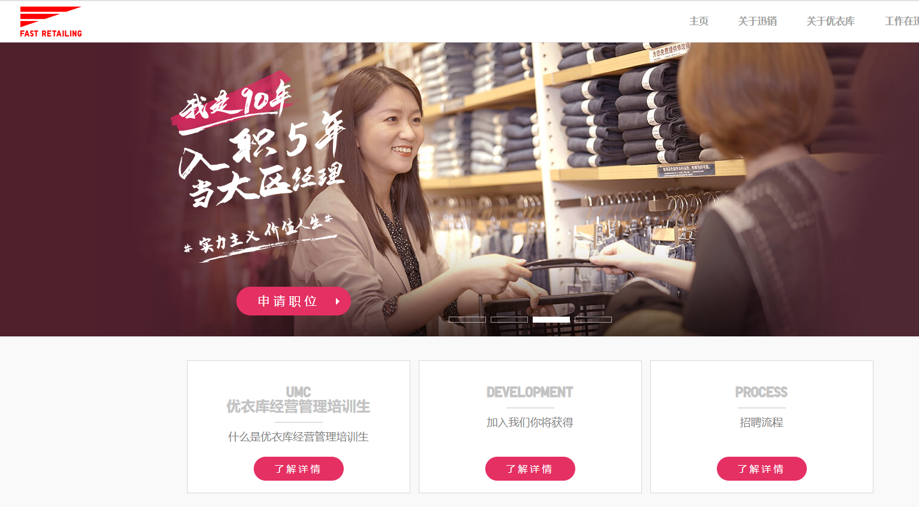
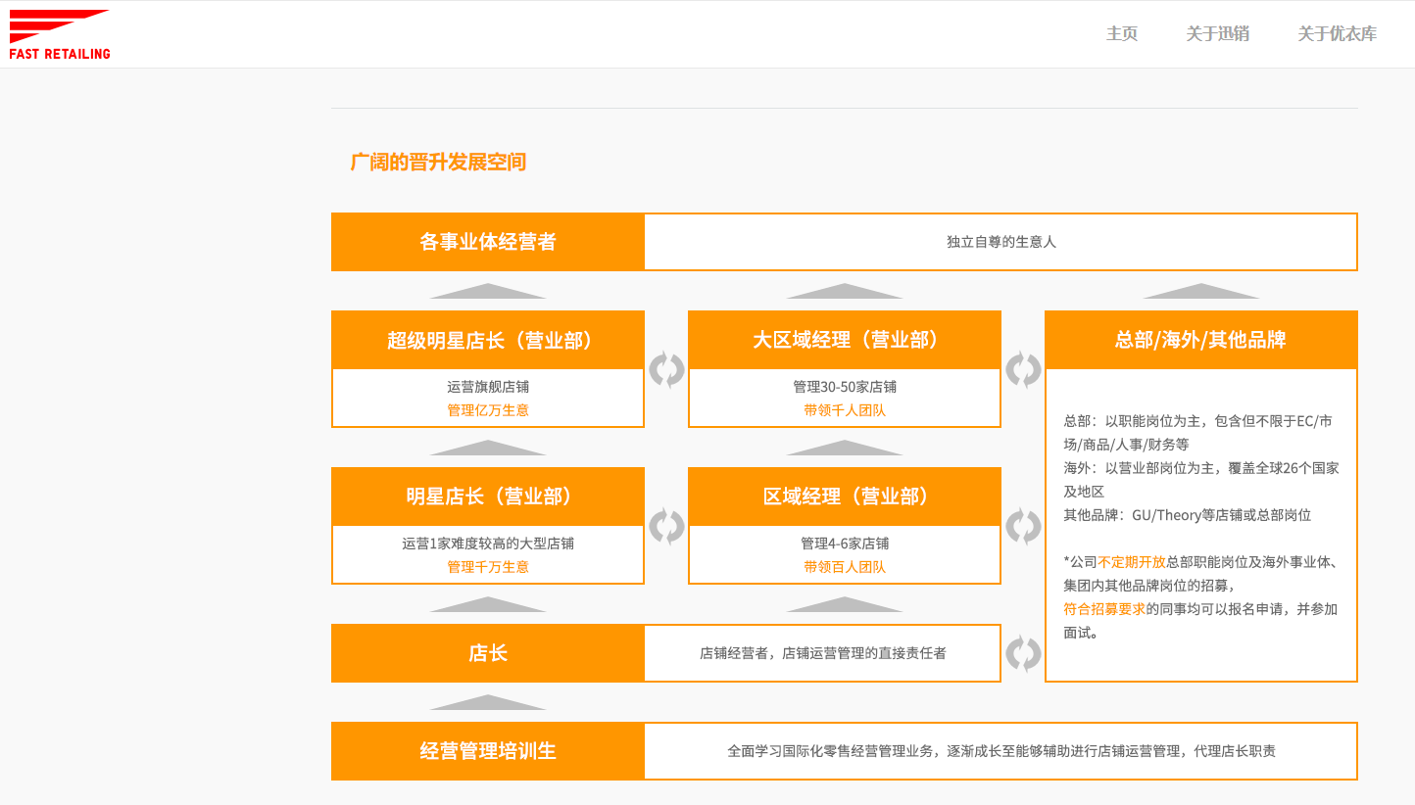

Giordano - MT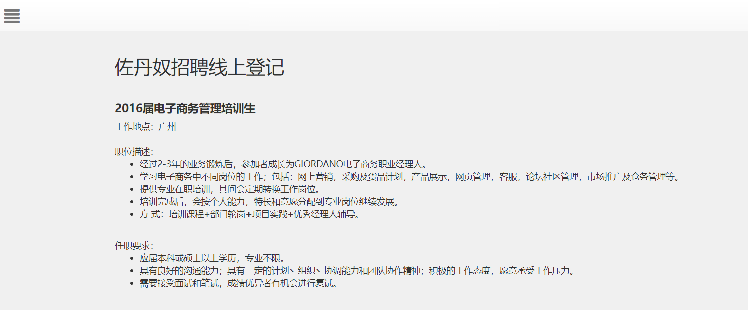

Linkedin - 75% job seekers consider an employer’s brand


