What does it mean to commemorate? How do memorials create personal meaning in a public place?
Josh Morgan
1703780
BA Graphic Design
Word count: 1914
Sarah Tombs

Introduction
Outgunned, outnumbered, out of their minds on a suicide mission. But the mud on and the rocks stained with thousands of years of warfare. We will remember them for this because out of all our vast array of nightmares, this is the one they choose for themselves. They go forward like a breath exhaled from earth with vigour in their hearts and one goal in sight. That they will win. This essay analyses the importance of war and how we signify the past. A simple breakdown of the importance war is and how it really impacts the world. How we remember those that left a hole in our hearts. Those brave individuals that fought their own lives, so we can see the sun rise in the morning. The selflessness of the individuals that brought so many changes to our future. We often take for granted what they truly did for us. They were on the front line so we could be safe with our families. To be reunited as a nation. We aspire to be as brave as these individuals and look up to them as heroes. This essay breaks down the importance and the impact these soldiers did for us and how we recognise them to this day. Why is it so important to commemorate? What signification do we get from remembering? Most importantly, does this bring us as a nation closer together? Collectively, all these small memorial events we create, cause a big impact. What makes us so proud of these soldiers?
Memorials
Public memorials or better known as public landscapes are designed to keep us the public to respect and remember past events which have helped made our world what it is today. For example, a war memorial. It reminds us of the lives that were lost and the sacrifices that were made so that we can live the life we do today. We the public are in constant debt to all of the soldiers who will and have lost their lives fighting for our freedom and our rights today. The healthy human mind does not wake up in the morning and think this is its last day on god’s green earth. But for all the men and women who did battle and sacrificed there’s lives for our freedom for them, I believe this was a luxury, not a curse. Knowing that they were close to the end of something that would go down in history and that has changed the landscape of all humanity. I believe that their sacrifice was the most courageous and noble act in human history. We, the people who walk free today are forever in their debt.

Commemorate
Commemorate is to honour the memory of someone or something with a ceremony. To serve as a memorial to someone or something. The world that we live in today is still the world that the First World War created. If we can’t understand what went on during the war. Then it is improbable to understand what our country is going through today. It is important to commemorate all wars, not only world war one and world war two. There is chance that we can learn something from it. The first and second world war have had the biggest impact on our world. Count the millions of lives lost for our freedom. If we strip down to essentials war is a lethal force against human beings. The biggest sacrifice in war are the armed forces to shield their country no matter what. “Its sacrifice, honour and bravery to any person who puts their lives on the line for their countries.” (Matthew Buck, unknown). It is a choice made that would change their lives forever it would change our lives forever. There is a clock tower in Herford where the names of the dead are inscribed. We try to honour their deeds even as their faces fade from our memory. Those memories are all that is left when the government have taken everything else. All warfare is based on deception. For centuries democracy has made the world a battle field. The corrupt talk while our brothers and sons spill their own blood. The bigger the lie the more people will believe it and when a nation cries out for vengeance the lies will spread like a wild fire. The fire builds devouring everything in its path. Our enemies believe that they alone dictate the course of history and all it takes is the will of a single man.
(Matthew Buck, Unknown).

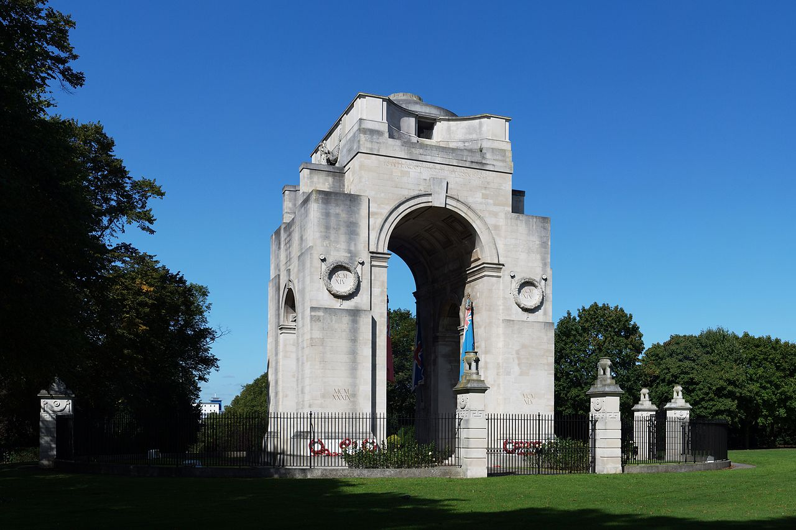

(Sir Edwin Lutyens ( 23 February 1955). The Arch of Remembrance. Leicester, Leicestershire: First and Second World Wars.)
The Arch of Remembrance
This is one of my favourite memorials. It was created by a man called sir Edwin Lutyens back in 1995. Its location is in Leicestershire in the Victoria Park. Its purpose is to commemorate the 10,000 men who lost their lives for their city and country. Lutyens wanted to create something special it is a remarkable demonstration of what has been described by the people of Leicestershire as a “stripped classism. It’s a style of architecture which Lutyens made his own and it perfectly demonstrates the sense of loss and respect that the British people feel in the years after” (Ebru Erbas Gurker, 2012). If you look closely on the memorial you can see the names of the 10,000 men. The sheer sight of seeing so many names that have only come from one city gives people the idea of how many lives were actually lost. (Ebru Erbas Gurler. (2012)


(unknown, unknown). HISTORY OF THE POPPY. Available: https://www.britishlegion.org.uk/remembrance/how-we-remember/the-story-of-the-poppy/. Last accessed 8/12/18.)

The Red Poppy
Many people in the UK between the months of late October and early November wear a red poppy on their clothing. The wearing of a red poppy is done symbolically. It is to commemorate to those who have died during the war. “The landscape swiftly turned to fields of mud: bleak and barren scenes where little or nothing could grow”. The symbolism of the poppy is a strong one as the flower itself is often associated with such themes as sleep, peace and death. The origins of wearing a red poppy date back to well over 100 years. Their brilliant red colour became a symbol of the blood spilled in the war. These days’ paper poppies are worn with the proceeds from their sale going to good causes. Poppy day is still held each year with a 2-min silence at 11am in the morning. The ceremony takes place around the world in country’s which belong to the British common wealth. Such as The United Kingdom, Australia, Canada and New Zealand. Some people chose to wear a white poppy instead of the torsional red. The white poppy is sign of remembered for all the civilian deaths during the war. Although it was the soldiers who fought for our freedom. The women and children who were at home lost their lives in most brutal selfish way possible. There is also a purple poppy. The purple poppy is to commemorate all the service animals who lost their lives during the war. In this day and people forget about these animals who lost their lives. All of the dogs and horses who went to battle and did not know they would not return home to see their families seems very cruel. These animals did not have a choice as did the soldiers. Imaging not having a choice imagine being forced to go to war and kill. Many of the soldiers were just children who were still in school who were still made to fight or their punishment would be prison. A tough punishment for such a young age wouldn’t you say. Can you imagine if that were the case in this day and age. Many children don’t know what work is and if we asked them to go and fight for their country well simply we would not have our freedom anymore. The field flander in west Belgium was covered with red poppies after the first world war because it was the scene of the most brutal blood battle grounds of the entire war. The red poppies symbolize the blood that was spilled on the mud and the lives lost. (unknown, unknown).

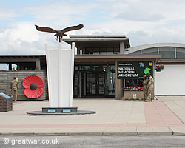
(Entrance to the National Memorial Arboretum. (1997). The Nation Remembers. Available: http://www.greatwar.co.uk/organizations/national-memorial-arboretum.htm. Last accessed 8/12/18.)

The National Memorial Arboretum
The National memorial arboretum Staffordshire is one of the most special and the biggest public attraction in the UK. “It’s a memorial of trees and plants dedicated to the concepts of remembrance”. It’s a truly stunning structure with its curved walls it holds all of the names of the servicemen who fought and died. The people of Staffordshire are very proud of their memorial and have great respect. One name who’s stands out on the memorial is H Jones. It’s because of the way he died and the story of his sacrifices he made. H Jones received an OBE for his work and for some reason people always seem to remember his name. They like to touch the memorial and run their fingers along his name so the actual name on the memorial became very shiny and stood out. What makes the arboretum stand out from all the other memorials around Britain is that’s its more than just names on a wall. it’s beautiful trees which many believe that the service men would live on through. It’s a beautiful symbol to remember the soldiers who have died. (National Memorial Arboretum, Staffordshire, unknown).

Conclusion
To conclude, this essay analysed how we remember these soldiers. Although many of the nation weren’t even born during the harsh times of the war. We still celebrate the bravery of the soldiers of all ages, that took their lives to protect our country. That spends years away from our families, just so we could be with ours. The ones that never got to be greeted by their loved ones. It is an honour to celebrate their selflessness and is so vitally important that we never take them for granted. As if it weren’t for them, we as a nation would not be here. As if it weren’t for them, we would not have the freedom to have a say. Our safety was all that mattered in the minds of the soldiers that fought for us. The soldiers that most of us never got the chance to meet. It is vitally important that we celebrate their courage through a memorial. Thorough Remembrance Day, having a silence to really remember what they went through during the war. The harsh conditions, the scariest of times. That minute of silence is nowhere near enough time to make up for their courage in the battlefield. But that minute of silence is so important for respect. May we never forget. As it is the least we can do. As they’ve done more than enough for us. The statues that we create to embrace them. For us to remember them as the individuals they are, that each and every one of them are important. Breaking down key factors in memorial shows the respect that we have. For may many of them rest in peace. But they can rest knowing that we as a nation are forever grateful for what they have done for us. We cannot thank them enough for their hardship, their courage, their strength and most importantly, their passion for protecting their country and their families.

Bibliography
(Ebru Erbas Gurler. (2012). The Effects of Public Memorials on Social Memory and Urban Identity. Available: https://ac.els-cdn.com/S1877042813014286/1-s2.0-S1877042813014286-main.pdf)

(unknown. (unknown). HISTORY OF THE POPPY. Available: https://www.britishlegion.org.uk/remembrance/how-we-remember/the-story-of-the-poppy/. Last accessed 8/12/18.)

(National Memorial Arboretum, Staffordshire. (unknown). The Nation Remembers. Available: http://www.greatwar.co.uk/organizations/national-memorial-arboretum.htm. Last accessed 8/12/18.)

(Matthew Buck . (unknown). Why do we commemorate?" – The military historian. Available: https://ww100.govt.nz/why-do-we-commemorate-viewpoints-the-military-historian. Last accessed 8/12/18.)

