Innovative marketing strategies applicable to Primark

Programme: MBA

Module: Marketing Management
Module code: LCMB 7001

Assignment Title: 1
Student Name: Anastasiya Petrova
Student Number: 1816952

Lecturer Name: Tushara Balendran

Table of content:
Introduction ………………………………………………………………………………… p. 3
Background of the Primark organisation……………………………………………… p. 4
Communication …………………………………………………………………………….. p. 4
Integrated marketing communications …………………………………………….... p. 7
New promotional strategies that Primark can use to raise brand awareness…... p.10
Branding and brand equity ……………………………………..……………………..... p.11
Keller's Customer-Based Brand Equity model relating to Primark …………...… p.12
Customer journey and customer touchpoints of Primark .................................... p.16
Customer journey .............................................................................................. p.16
Customer journey map ...................................................................................... p.19
Customer satisfaction ........................................................................................ p.20
Total engagement model ......................................................................................... p.22
Customer experience strategies ....................................................................... p.22
Recommendations ............................................................................................ p.24
References ............................................................................................................... p.25

Introduction
Marketing management refers to the process by which organisations strategise how they can seek and address the opportunities available to them in the marketplace (Wertenbroch, 2021). It is important to note that marketing management usually concentrates on two aspects. The first aspect is finding a profitable opportunity for the organisation, and the second is ensuring that the capabilities selected for the market are focused on the customer's needs. The marketing department usually carries out marketing management, ensuring that the organisation has a complete guide to what consumers require for their satisfaction and what is currently available to meet their requirements (Duralia O.,2018). From this information, management can strategise how to fill the gap in the market. For an organisation to succeed in marketing management, it must conduct in-depth market research and external and internal analysis and have sufficient knowledge of the marketing mix that the organisation can apply to meet consumer demand. All about what the company can provide for customer satisfaction. An organisation that commits to and ensures a good marketing management process should increase its market share and improve customer satisfaction, profitability, brand reputation, and market awareness.
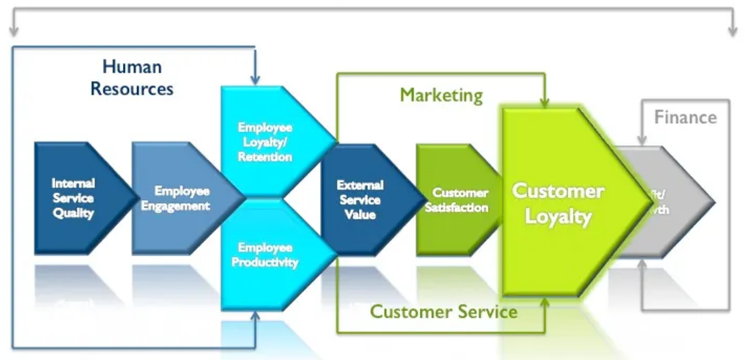
Source: infosurv.com
This report presents the evaluation of marketing activities, analysis and evaluation of marketing management in the company Primark, ensuring the fulfilment of the stakeholders' expectations. In addition, the report presents an analysis of the communication patterns and communicational channels. Promotional strategies, branding and brand equity are analysed, as well as the customer card. In the last part of the report, the total engagement model is discussed, indicating some recommendations to ensure that stakeholders' current and future expectations are met.
Background of the organisation
Primark is a global retail organisation that sells clothing. The organisation is expanding daily as it now operates in around 14 countries. It also operates with an employee base of 71,000 spread across the countries where the company operates. The organisation's beginnings date back to 1969 when the first Penneys store opened in Ireland. In 1973 the first international store opened in Darby, and as such, it gradually grew exponentially. The company appears under the Primark brand, an Associated British Foods Group subsidiary on the global market. The organisation's founder Arthur Pyan's mission when starting the company was to ensure that they provided affordable clothing to anyone who wanted to be a consumer of their products.
There are a variety of products that the organisation offers to different people. The company provides customers with "design-led fashion and everyday essentials at wallet-friendly prices." (Primark, 2022). Men's and women's lines offer quality products that ensure they are stylish and can be picked out from the crowd as they stand out. The kids also have a clothing line. Primark also offers beauty products, home goods and accessories. Primark's 407 stores are in Europe and the USA, where it is looking to expand and meet other opportunities. It is also important to note that the organisation has the vision to ensure accessibility is done sustainably. As such, the organisation aims to provide that it will be available in far-flung places by the end of 2030. This sustainable fashion is also made possible by the fact that it can recycle its clothes to contribute to the environment (Primark, 2022).
Communication
The goal of any business is to make a profit by providing products and services to as many customers as possible, satisfying their needs. The company must promote its product/service by communicating with customers and transferring information in both directions to share attitudes, opinions, and behaviour through direct or indirect channels (Amin M., Priansah P., 2019). Through various communication techniques that extend the reach of the product, the business conveys promotional messages to its target audience and optimises its effectiveness.
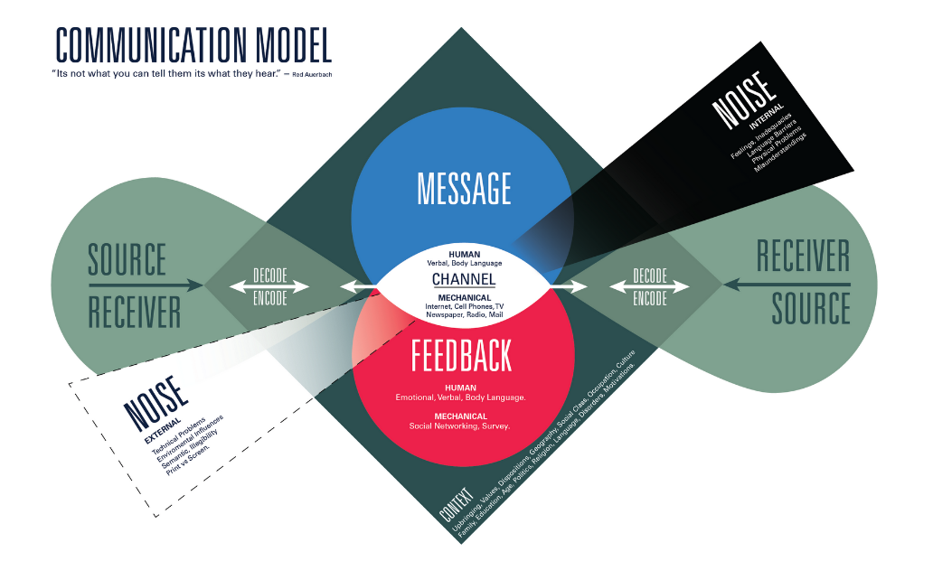
The diagram presents the main factors for building an effective communication relationship. It is important to note that prior qualified market research and customer attitudes are necessary before sending a message. Kuznar L.A. and Yagerfor M. (2022) argue that for effective marketing communication, the message must be persuasive and customised according to the requirements and expectations of the customers. In addition, it is necessary to plan and design the message depending on the communication channel used. It is finally gathering information from feedback to improve communication.


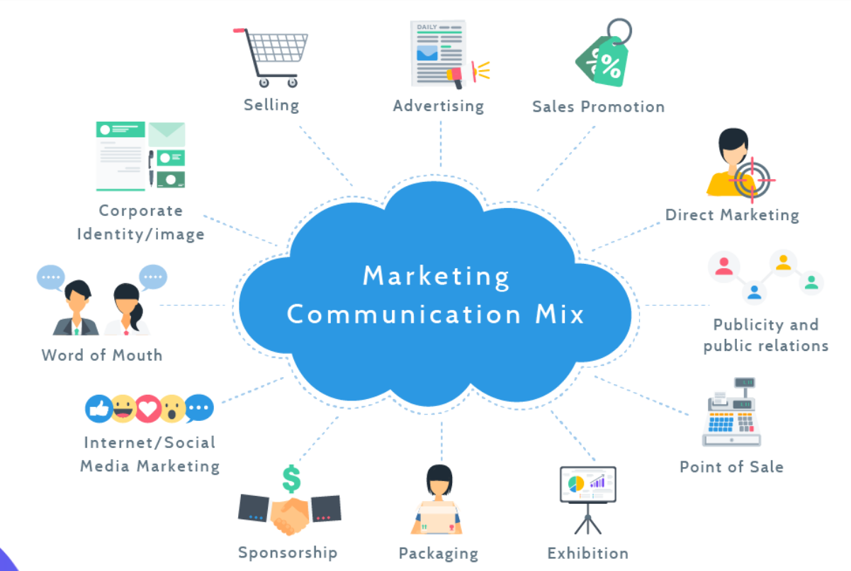
Using a push strategy, Primark pursues its ambitious goals. Through sales channels, the company pushes its product. The company uses real customers as models for its advertising campaigns, connecting consumers emotionally to the brand (Sciarretto A., 2018). It is an excellent approach to inclusion as it shows that Primark captures the style its customers are looking for, as shown in the images below.

Another communication model, the company, uses through social network channels is the AIDA model.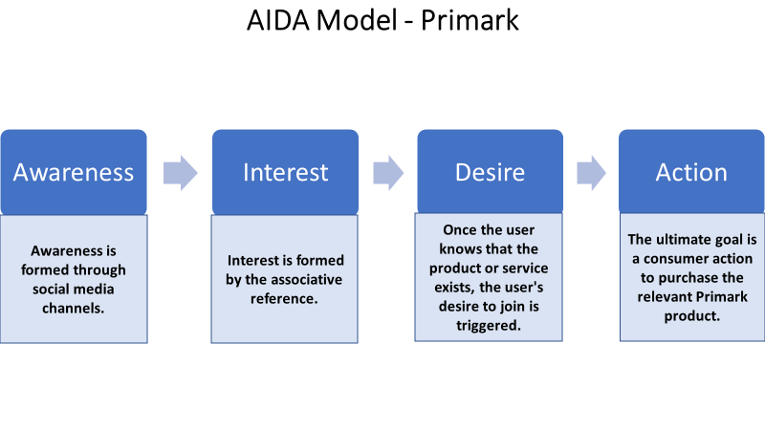
The company's main communication channel remains word of mouth, but it also uses other marketing channels such as television, radio, newspapers, and billboards at various stages. Even though the company has accounts on various social networks, many users do not use them often (Arriaga J. et al., 2017).
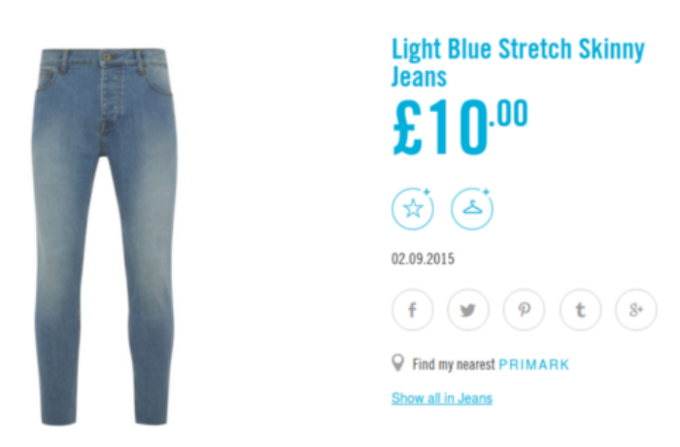
The company's website presents the product ranges but does not yet offer the possibility of online purchases, thereby missing out on a large part of the flow of customers, respectively profits. These facts create a communication gap between the company and its target customers.
Integrated marketing communications
Integrated marketing communication is a holistic approach applied by organisations that combine traditional and modern strategies to achieve their goals on a large scale instead of managing them separately (Chitty B. et al., 2017). In this way, it is ensured that all the strategies the company has put in place are sufficiently coherent, provide good product promotion, and are aligned and made more powerful. In this context, integrated marketing communication combines all the elements and components implemented in an organisation to have consistency and the same brand identity. Integrated marketing communication effectively allows an organisation to connect with consumers and other stakeholders. Moreover, it enhances the organisation's brand reputation as it is deeply embedded in its relationships and fills the gaps with consumers.
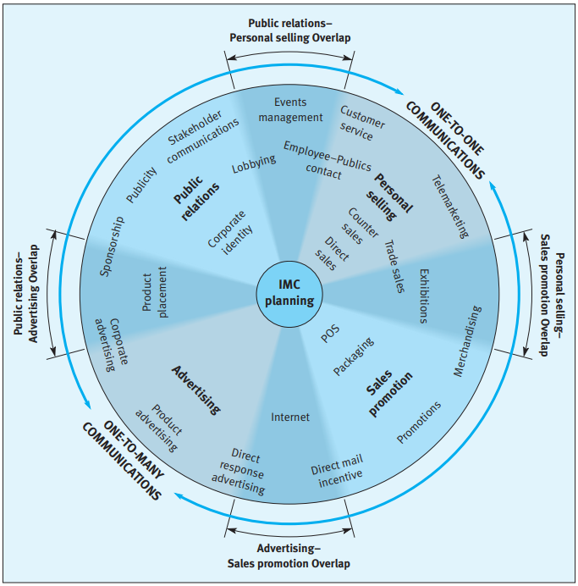
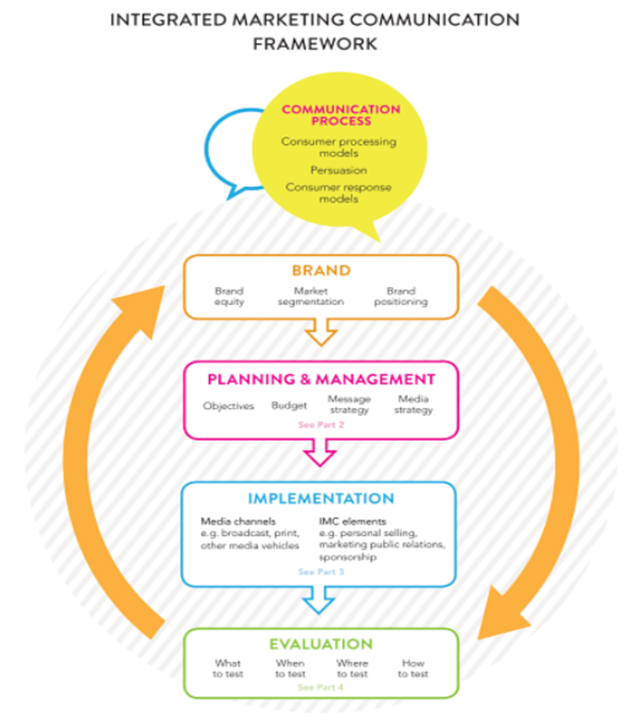
A marketing communication framework helps define the activities for planning a successful communication and their effective execution to make that plan successful (Duralia O., 2018).
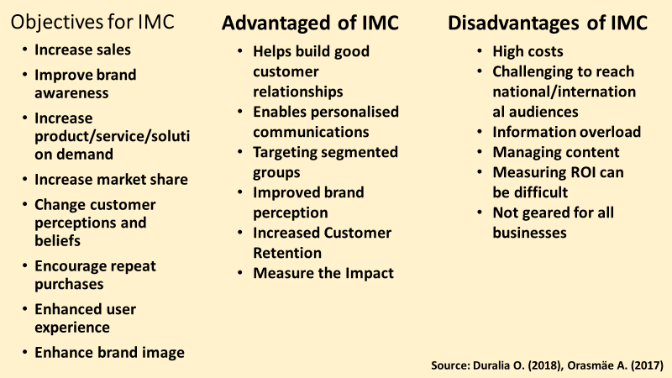
New promotional strategies that Primark can use to raise brand awareness
Primark can gain more from promoting its products online as most consumers have digital media that they can use to encourage, shop and search for products they need. Moreover, it ensures that the organisation has available data and information that it can use to measure the progress and success of these used forums. All this helps the company analyse what it needs to succeed in fulfilling the set goals. New offline and online promotional strategies that an organisation can use to improve brand awareness are as follows:
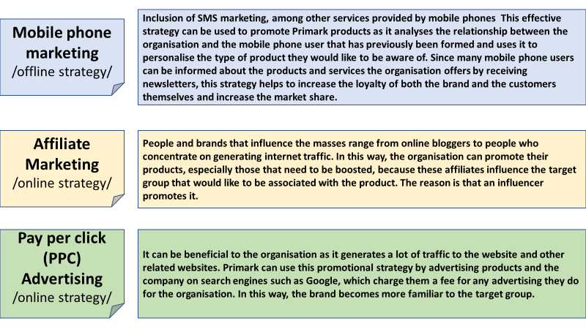
The Internet and social media channels are changing how businesses and consumers communicate, leading to growth. This strategy provides two-way communication that allows both parties to create content by developing and engaging with new products.
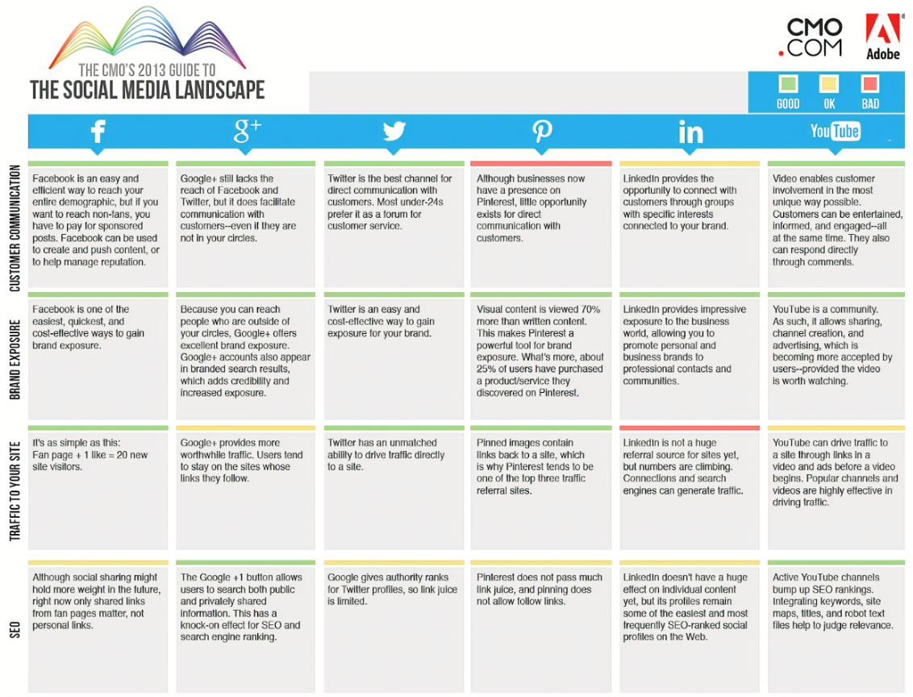
Branding and brand equity
The literature review presents various definitions of branding over the years.
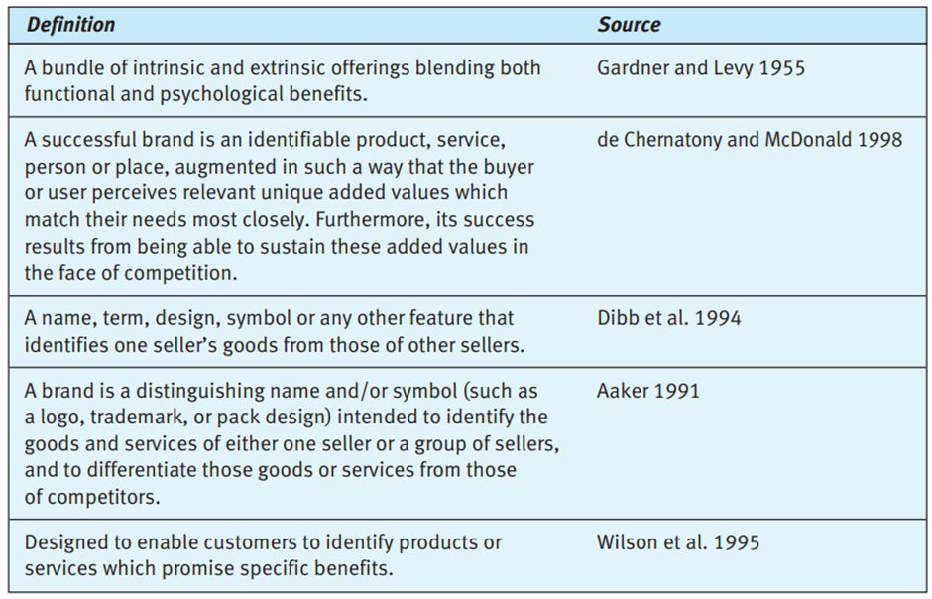
Branding refers to how organisations create and renew a perception of themselves and their products in a positive way to attract their target consumers (Jain R., (2017). Organisations need to brand themselves because this enables them to differentiate themselves from the competition in the minds of their consumers. Branding is about visual appeal and brand perception. For visual perception, companies create logos, mission statements, and designs that differentiate themselves from competitors in the same industry. Apart from this, organisations must do branding that helps them in marketing and management.

The Primark logo is concise in a light turquoise colour, and it can stand out clearly on light and dark backgrounds, making it look professional and visible.
Brand equity, on the other hand, refers to the brand value of a product or service. According to Anselmsson, J. et al. (2017), brand equity relates to how certain marketing activities and assets, such as the brand name, link to customer perceptions, image, purchase outcomes or willingness to purchase, and customer loyalty. It usually equates to either positivity or negativity regarding how consumers view brand value. When consumers believe that an organisation's brand is good, it is considered positive brand equity and vice versa. An organisation with positive brand equity enjoys certain privileges compared to its peers. For example, it may have higher prices for its products or services and a higher price on market shares and extensions. Moreover, they have the advantage of doing well in the market due to the value of brand equity.
Keller's brand equity model relating to Primark
The consumer-based brand equity model, known as Keller's CBBE model, looks at a brand's consumers and their perception of it. Yousaf A. et al. (2017) argues that according to this model, for an organisation to have positive brand equity, consumers' perceptions, preferences, and behaviours must be positive and built on brand awareness. In addition, the model clarifies that the organisation must ensure that consumers have set themselves the goal of becoming loyal to the brand and contributing positively to it in a feeling of buying their products. The model is based on a pyramid developed as a guide for organisations to consider as they operate and form consumer relationships. The pyramid includes the stages of brand development, group building blocks and branding goals.
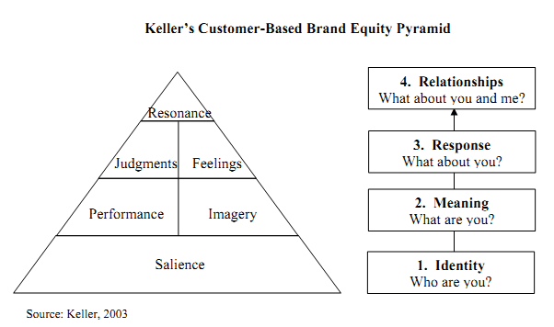
The pyramid is in reverse, where identity is at the base and relationships occupy the top. For a pyramid to be stable, in this case, a strong brand of the organisation, it is vital that its base is stable.
Brand identity is the building block of this model as it aims to communicate what the brand stands for and drive consumer perception, also known as brand salience. As such, the organisation must ensure that consumers have a positive attitude towards the brand and can be associated with it. Through the right message, the organisation must impose in the minds of consumers a positive attitude and association so that they recognise it even before making a purchase. Primark's message is that they offer quality fashion clothing at the lowest possible price (Primark, 2022). In addition, in 2021 (Cobham T., 2021), the brand announced that all its items would be produced with recycled or sustainable materials, and it promised that the prices would not change. The two messages communicate to consumers that Primark, in addition to quality and fashion, guarantees a low cost for its products.
With a common identity established, the next step is building brand meaning that builds loyalty among the target audience. The brand's purpose is built around to what extent the product satisfies customer needs and expectations, and the social message is how customers view the brand. These can all include a commitment to specific social causes, customer service dedication and convenience, price, and design. Good perception of messages depends on their correct construction and direction to give people a reason to be proud of their purchases and to return again and again. Regarding Primark, Associate Director Davis S. (2018) shared that the company is a leader in the fast fashion clothing industry, providing easily accessible and on-trend items even when people are on a budget. These declare a clear expression of the position and the company's offer to its current and future customers. The company continues to expand by opening new stores to offer its products in easily accessible places for its customers, providing them with comfort. Primark allows its consumers to define their individuality through the rich product range in response to new consumer preferences and expectations. Consumers promote the brand on social networks in response to the messages declared and provided by the company. They present their unique individuality and proudly share where they got their new form acquisitions. Customer-based marketing tactics to promote brand equity allow Primark to use minimal resources, enabling the company to keep prices low for its customers. Primark wins loyalty with its quick adaptability to customer preferences, developing its store design, and providing convenience, attention and quality of service.
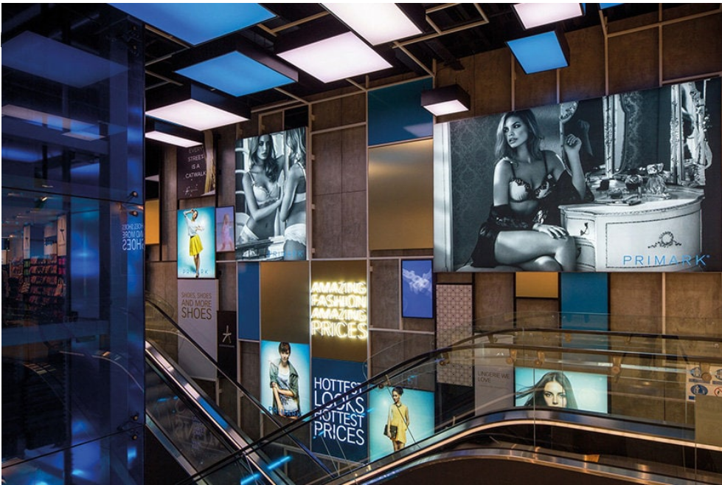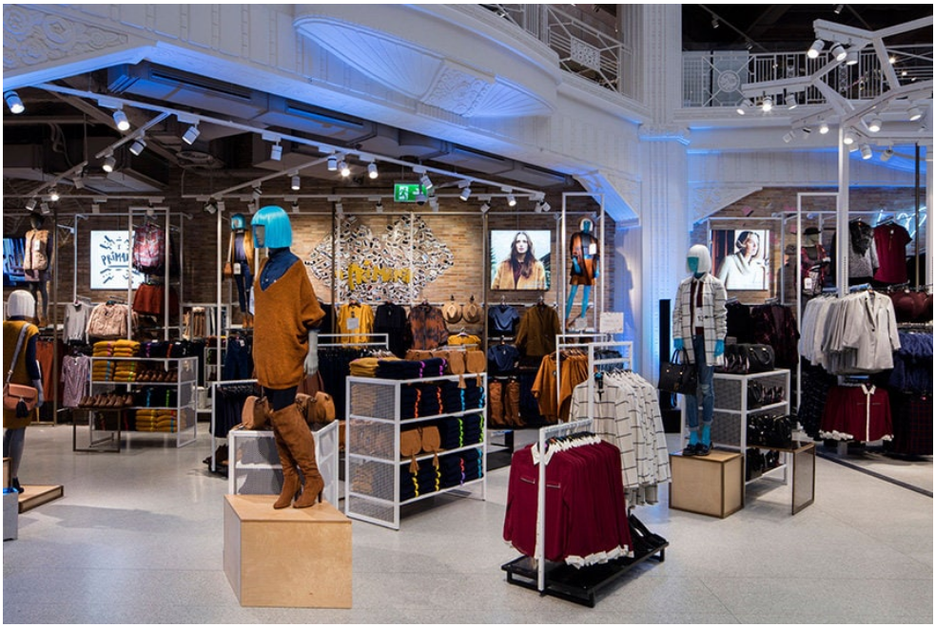
These confirm that the company is doing well with the model's next step, the brand's meaning that represents the resonance with consumers. Through social media, customers share their positive impressions of the product's quality and price, the service's convenience and efficiency, and the design.
Next is the brand response, which affects how the consumers view the products they have purchased concerning how it has been able to satisfy them. Their personal opinions should be positive for the organisation to have positive brand equity. An excellent example of the respondents mentioned by Duff K. (2017) is the Disney Chip cup that Primark presents for sale before the premiere of "Beauty and the Beast". Quickly, chip cups become very popular on social networks, leading to the rapid sale of the entire quantity available in stores. Many customers still want to get the product, but the lack of the product and their dissatisfaction is causing adverse reactions on social media. The great interest in the product drives customers to eBay, where the price is several times higher, and other customers reject the product. Duff K. (2017) also points to an excellent example of how in social media, the brand is promoted, and trends are created, the product is promoted and receives a positive response. The product is an imitation luxury brand pair of boots.
The examples confirm that it is necessary to carefully monitor the reaction of customers and the possibility of the company being able to fulfil what it declared. Positive responses strengthen brand power, but negative responses hurt, sometimes taking a long time to recover and other times to fail.
Finally, brand resonance assesses the relationship between consumers and the brand. The brand must ensure a strong connection with consumers so that in addition to being loyal customers, they are also brand advocates and proud to promote it (Duman T. et al.). Resonance is the hardest part of building brand equity, ultimately leading to lasting consumer loyalty. Social media and the word-of-mouth approach Primark uses create emotional connections, which are good tactics for building resonance.
In conclusion, the model ensures that the brand name is known and resonates well with consumers in the market. Primark confirms that the brand is in the minds of consumers, which proves sustainability. The sustainability promise ensures that consumers can resonate and identify with the brand through its sustainable way of ensuring that it is aligned with protecting the planet from human-caused destruction - forms of production and distribution.
There is an advantage to Primark using brand ambassadors to endorse its products. Ambassadors play the role of vouching for the qualities and value they present to consumers. Also, they have a way of making sure they appeal to the masses they are targeting. It allows the organisation to have positive buys in the brand's name as they advertise with people they consider influential in society. Moreover, the brand name has benefited some of the company's lines. It has been strengthened over the years, ensuring its success as an organisation. The perception of the organisation and its brand provides that Primark can influence consumers' purchasing decisions to remain loyal to it despite the competitive environment.
Brand equity is about building interaction in the relationship between consumers and the company. The advantages of Keller's model are that it gives the company advantages in distribution and design and an opportunity to evoke emotional reactions in customers towards the brand, such as fun, social approval, security and self-esteem, thus increasing their loyalty. As a disadvantage of the model, it is more suitable for B2C businesses. In addition, it cannot always predict adverse reactions due to the diversity in customer characteristics. Therefore, the company must be careful with its messages to ensure the fulfilment of its promises to customers.
Primark's limited advertising budget relies on word of mouth, in-store marketing and social media. Her photo-sharing platform Primania allows shoppers to showcase their recent purchases and enables customer engagement. The company's marketing approach focuses entirely on the consumer experience by providing quality products at low prices, making it difficult for its competitors (Impression, 2022). Because of this, they channel much of their investment into a 'place-in-store' approach to drive 'worthwhile entry.
Customer journey and customer touchpoints of Primark
Customer journey and customer touchpoints
According to Duncan's (2005) definition, a touchpoint is every opportunity for the customer to connect with the brand. Yachin J. (2018) defines the customer journey as a journey through the various phases of customer interaction with the brand. Interactions are direct, such as when customers contact the team serving them. In the case of indirect interactions, the contact with the customer takes place, for example, by receiving information about some event. Aoki et al. (2019) define the customer journey as a buyer's steps to becoming a brand customer. Differently defined, the customer journey is the involvement of the customer through various channels providing him (her) with the opportunity to individualise the path he (she) takes to contact the brand and subsequent mutual commitment.
Classifying the touchpoints, Duncan T. (2005) prioritises them based on their effect on improving the customer's brand experience. Furthermore, he claims that the appropriate management of communication touchpoints contributes to building customer brand loyalty and increases brand equity.

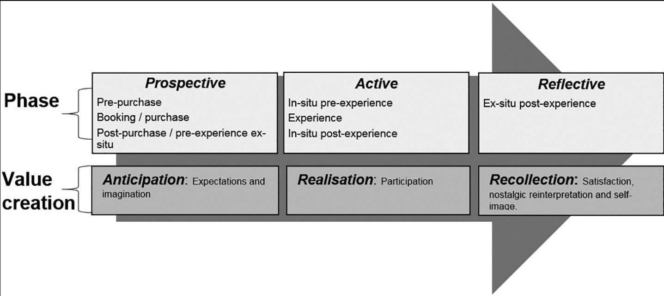
Yachin J. (2018) describes the three phases of customer interaction with the brand: pre-purchase, purchase and post-purchasing. Pre-purchase is the phase in which the customer's first interest in the brand's product or service appears. During this stage, the customer seeks information to make a decision, desire to carry out his (her) decision is formed. In this process, the customer builds impression expectations and experiences before contact with the product or service. During the purchase phase, an active connection between the client and the company occurs, where the participation is mutual, and the expectations and the image are satisfied. In the third phase, post-purchase, value is built by recalling the experience and satisfaction.
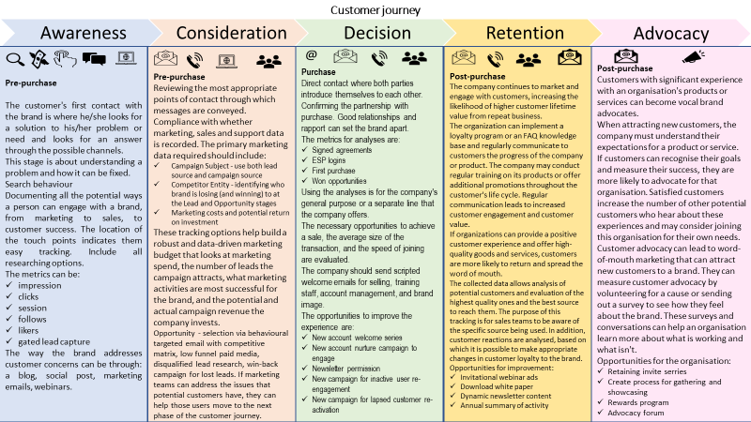
Primark recognises the importance of mapping the customer journey and their touch points. It can cater to consumers' needs and create a relationship with them at every step, from when they come in contact with them to their after-sales. There are some touch points in the consumer journey when in contact with Primark discussed above.
The first is when the consumer approaches Primark from its social media platforms, such as Facebook and Twitter (Primark Cares, 2022). In this case, the user can read and gain knowledge about what it offers, as there are descriptions of the products and what they can gain from them. At this point, they can also interact with the organisation's employees as they seek clarity and more information about their products. Customers can go to the stores where they can get the products they have seen and asked about on social media, where they can interact with other employees of the organisation while buying those products. They can also engage with the company through the developed online platforms or the stores for their after-sales services (Primark Cares, 2022).
The other customer journey begins when the organisation enters the community. In this way, they can use the sales and marketing team to ensure that the community is aware of the products on offer and the benefits they derive from them. Then, when they decide, they can interact more with the organisation on its online platforms to complete purchases and deliveries.
Customer journey map
Primark recognises the importance of mapping the customer journey and their touch points. A customer journey map helps an organisation cater to the needs of consumers and connect with them every step of the way, from the moment of contact to their after-sales services (Micheaux A., Bosio B., 2019). There are several touchpoints in the consumer journey when engaging with Primark, discussed earlier in this section. The company's marketing approach to customer engagement is task-based. Greater control over outcomes leads to increased psychological well-being and customer engagement.
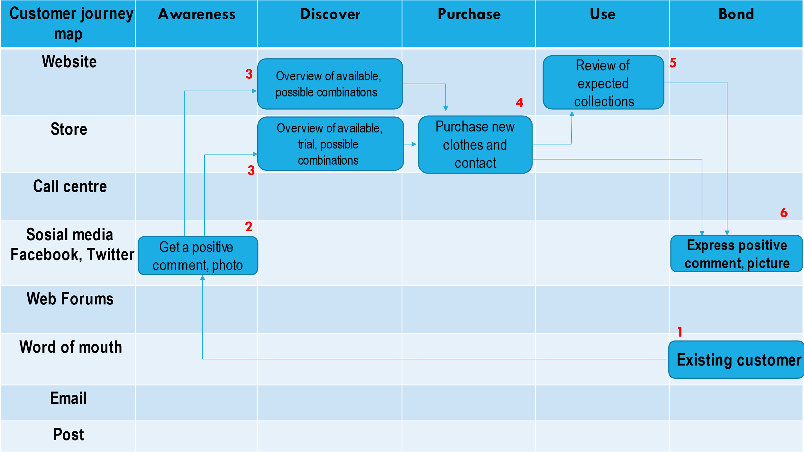
The first touchpoint is when the consumer approaches Primark from its social media platforms, such as Facebook and Twitter. In this case, the user can read and gain knowledge about what it offers, as there are descriptions of the products and what they can gain from them. At this point, they can interact with the organisation's employees as they seek clarity and more information about their products. They can then go to the stores where they can get the products they have seen and asked about on social media and interact with other employees while buying those products. The next step is when they can engage with the company through the developed online platforms or the stores for their after-sales services (Primark Cares, 2022).
The other customer journey also commences when the organisation gets into community involvement. This way, they get to use the sales and marketing team to ensure that the community is aware of the products that are offered and the benefits they accrue from them. Finally, when they have decided, they can interact more with the organisation on its online platforms for the purchases and deliveries to be completed.
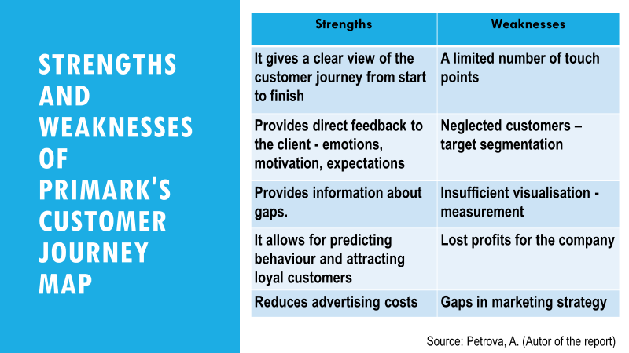
Customer satisfaction
Maechler N. et al. (2016) argue that customer journey performance is more strongly related to customer satisfaction than touchpoints, which increases revenue and repeat purchases for the company. For this reason, organisations strive to provide -high levels of customer satisfaction. It ensures repeat purchases, sharing positive recommendations with friends who also become committed customers.
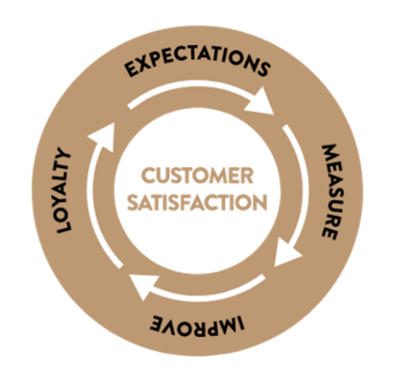
The Kano model measures how well a functional performance, product, service and customer experience meets customer expectations (Rotar L., Kozar M. 2017). In other words, customer satisfaction is the echo that the company's products and services leave on customers.
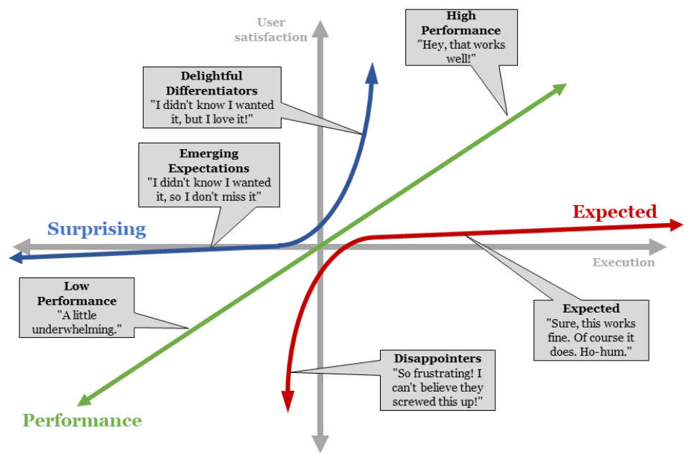
The model analyses the customer's needs and determines the product's characteristics. Customers have different needs, therefore, different priorities related to these needs. In response to customers' expectations, the competitive product must possess maximum efficiency and many exciting attributes. With the help of this analysis, the company has a clear view of its potential customers and the appropriate products and services, contributing to the entire experience and increasing customer satisfaction.
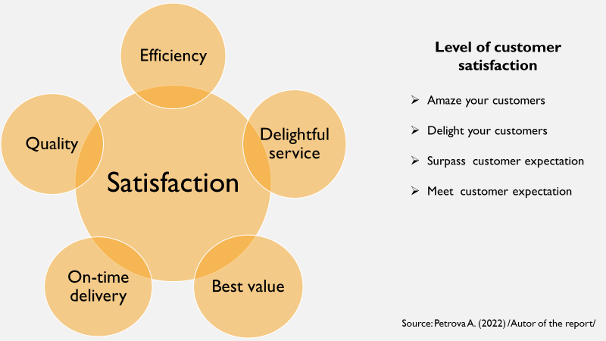
Total engagement model
The business is successful when a company has a high share of engaged customers. Establishing a strategic relationship and relationship between committed employees and customers is essential to achieving long-term growth (Stackpole B., 2022). The total engagement model presents a business strategy to drive the customer experience and employee experience and collaborate with intentional functions.
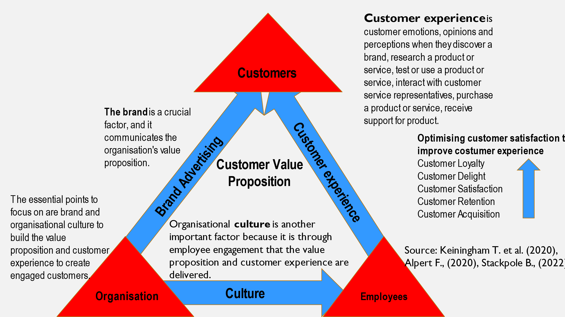
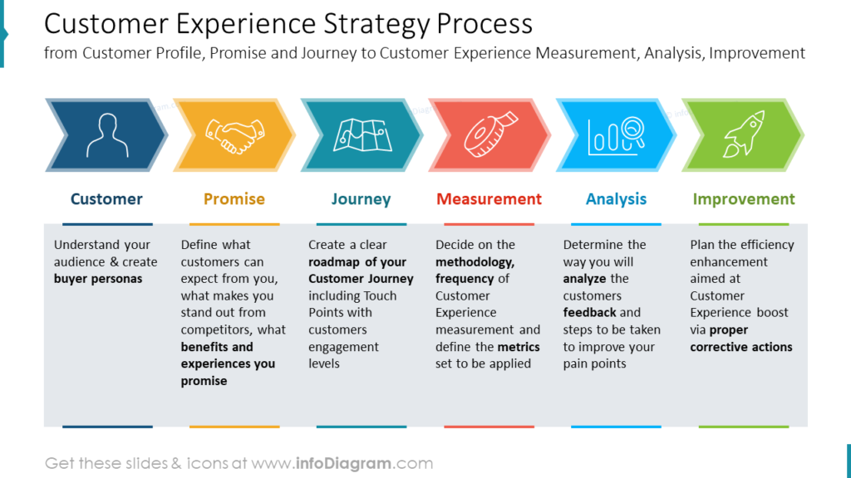
A full engagement model adopted by Primark ensures it can effectively align all the activities it is responsible for to ensure consumer engagement across all platforms, such as through advertising and the organisation's internal culture.
Primark defines its sustainability mission and vision to bring its target market closer and ensure it is competitive in the long term. The company includes all the engagement techniques in its framework model because it allows the organisation to engage with users and other stakeholders. To make this a reality, the organisation has compiled a list of stakeholders it can align with, such as consumers, people, shareholders, government and customers.
One of how Primark succeeds in doing this is by attracting a model of transparency through employees, as they have an obligation to other stakeholders such as the organisation's customers. The organisation has a Code of Business Policies that is important in shaping the relationships between stakeholders and the organisation. Ensures that the organisation is transparent with its activities, such as donations and interaction with the government. One of these is Primark's code of conduct, which aligns suppliers' specifications with the company and how they expect to conduct a symbiotic business.
In addition, Primark has an ethical way of doing business that ensures it can verify engagement with stakeholders in various ways. The organisation's employees number 71,000 and are spread across more than 14 countries. Customers have a platform where they can engage with the company. One way they can do this is through a Facebook page survey where they engage users to understand their needs and wants. Understanding what needs to be done, the company takes the necessary actions to achieve complete satisfaction in line with its goals. Employees also have forums with leaders every two weeks to address issues related to the organisation.
Following the users, the organisation introduces ways to engage with the users, which amounts to 3.4 billion. The marketing and sales team conducts market research to gain insight into what they require to be used by the various platforms.
Furthermore, governments also play a role in the standard equity model of the commitment organisation as they are in tune with the company because they are involved in the law-making processes.

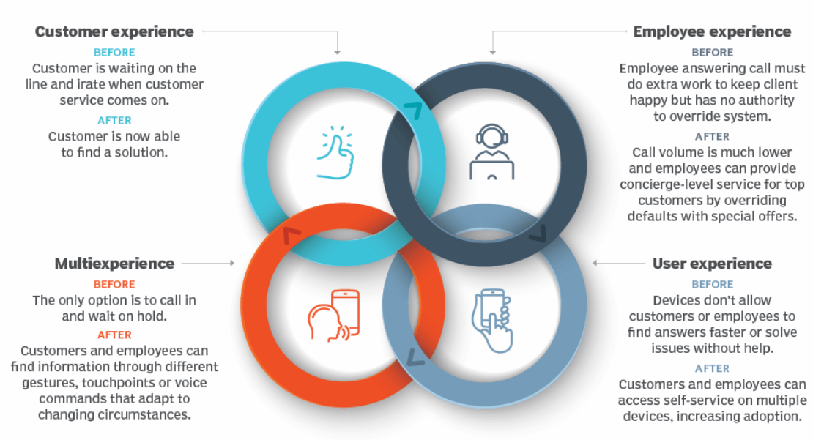
Recommendations
Primark can improve its engagement strategy by incorporating digital technologies in addition to its in-store sales. In addition to Primark's website, which displays the clothes and directs customers to the nearest store, the company can vary the offline and online promotional strategies discussed earlier in the report to improve brand recognition. The changes will lead to increased followers on social networks sharing the product ranges and campaigns, expanding the reach of potential customers and their subsequent engagement. In addition, the changes made ensure that the organisation has more data and information to measure the progress and success of these used forums and customer needs and expectations.
Marketing management in Primark should consider using new technologies because they increase the number of touchpoints in the customer journey map. More and more customers use Internet technologies through their mobile phones, laptops, and computers, which leads to increased sales and promotion of its products. In addition, new promotional strategies improve two-way communication and increase engagement and brand equity. The possible inclusion of celebrities in advertising inevitably leads to expansion in social networks, a fact that the company must use effectively.
References:
- Adaptive Solutions & Advisory Group, (2022), Customer Satisfaction, [online]
Available at: https://adaptivesag.com/en/99-customer-satisfaction.html
Accessed: 16.08.2022
- Amin M., Priansah P., (2019), Marketing communication strategy to improve tourism potential, Budapest International Research and Critics Institute-Journal (BIRCI-Journal), [online]
Available at: https://pdfs.semanticscholar.org/5563/334c881bb2a151493ffdc805c7e0a8915281.pdf
Accessed: 27.07.2022
- Anselmsson, J., Burt, S., Tunca, B., (2017), An integrated retailer image and brand equity framework: Re-examining, extending, and restructuring retailer brand equity, Journal of retailing and consumer services, [online]
Available at: https://librarysearch.uwtsd.ac.uk/discovery/openurl?institution=44WHELF_UWTSD&vid=44WHELF_UWTSD:44WHELF_UWTSD_VU1&volume=38&date=2017&aulast=Anselmsson&issn=0969-6989&spage=194&id=doi:10.1016%2Fj.jretconser.2017.06.007&auinit=J&title=Journal%20of%20retailing%20and%20consumer%20services.&atitle=An%20integrated%20retailer%20image%20and%20brand%20equity%20framework:%20Re-examining,%20extending,%20and%20restructuring%20retailer%20brand%20equity&sid=google
Accessed: 05.08.2022
- Aoki et al. (2019), Can brand experience increase customer contribution: How to create effective sustainable touchpoints with customers?, Journal of Global Scholars of Marketing Science, [online]
Available at: https://scholar.google.co.uk/scholar?output=instlink&q=info:nfAcB6O9l1YJ:scholar.google.com/&hl=bg&as_sdt=0,5&as_ylo=2017&as_yhi=2022&as_vis=1&scillfp=5721031808986625646&oi=lle
Accessed:12.08.2022
- Arriaga J., Domingo D., Silvente V.(2017), Facebook in the low-cost fashion sector: the case of Primark, Journal of Fashion Marketing and Management: An International Journal, [online]
Available at: https://scholar.google.co.uk/scholar?output=instlink&q=info:3HXGP6K6A4EJ:scholar.google.com/&hl=en&as_sdt=0,5&scillfp=14284195129620766953&oi=lle
Accessed: 28.07.2022
- Bika N., (2022), How to Create a Customer Experience Strategy: 14 Ways, Acquire, [online]
Available at: https://acquire.io/blog/customer-experience-strategy/
Accessed:16.08.2022
- Broderick A., Pickton D. (2005), Integrated marketing communications, Prentice Hall, 2nded., p. 17
- Broderick A., Pickton D., (2005), Integrated marketing communications, Prentice Hall, 2nded., p.243
- CFI Team, (2022), AIDA Model, CFI, [online]
Available at: https://corporatefinanceinstitute.com/resources/knowledge/other/aida-model-marketing/
Accessed: 27.07.2022
- Chitty B. et al. (2017), Integrated Marketing Communications, Cengage, 5th Asia-Pacific ed, pp. 2-14
- Cobham Т., (2021), Primark promises to make a big change to all its clothes in stores across the UK, My London News
Available at: https://www.mylondon.news/news/primark-promises-make-big-change-21583803
Accessed: 11.08.2022
- Davis S. (2018), Why Primark is thriving on today's high street, Prosper
Available at: https://www.prosper-design.com/why-primark-is-thriving-on-todays-high-street/
Accessed:11.08.2022
- Demmers J., Weltevreden J.W.J., Van Dolen W.M., (2020), Consumer engagement with brand posts on social media in consecutive stages of the customer journey, International Journal of Electronic Commerce, [online]
Available at: https://scholar.google.co.uk/scholar?output=instlink&q=info:L9PpbvDmNtEJ:scholar.google.com/&hl=bg&as_sdt=0,5&as_ylo=2017&as_yhi=2022&as_vis=1&scillfp=11110430594237674399&oi=lle
Accessed: 11.18.2022
- Duff K. (2017), An investigation into how the Primark brand use social media to influence the buying behaviour of Irish female customers, google scholar, [online]
Available at: http://norma.ncirl.ie/2916/1/karlduff.pdf
Accessed: 11.08.2022
- Duman T., Ozbal O., Duerod M. (2018), The role of affective factors on brand resonance: Measuring customer‐based brand equity for the Sarajevo brand, Journal of Destination Marketing & Management, Volume 8, Pages 359-372 [online]
Available at: https://www.sciencedirect.com/science/article/pii/S2212571X17300136?casa_token=Nbwb3TDaFJsAAAAA:Cq77TjZpliWa2sY4PrFF0bC4sCrsPnWz3dMyTEqUrYoMCjJRkeAjUL8pQonumF0tguU5LD7xFUs
Accessed: 11.08.2022
- Duncan, T. (2005), Principles of advertising & IMC, New York, NY: McGraw-Hill Companies, 2nded
- Duralia O. (2018), Integrated marketing communication and its impact on consumer behavior, Studies in Business and Economics, [online]
Available at: https://scholar.google.co.uk/scholar?output=instlink&q=info:ZDMGgoEWI4IJ:scholar.google.com/&hl=bg&as_sdt=0,5&as_vis=1&scillfp=9948923689157570168&oi=lle
Accessed: 28.07.2022
- Haak T. (2020), Communication models, from Aristotle to White, HR Trend Institute, [online]
Available at: https://hrtrendinstitute.com/2020/09/28/communication-models-from-aristotle-to-white/
Accessed: 27.07.2022
- Herhausen D., Kleinlercher K., Verhoef P.C., Emrichd O., Rudolphb T., (2019), Loyalty Formation for Different Customer Journey Segments, Journal of Retailing, Volume 95, Issue 3, [online]
Available at: https://www.sciencedirect.com/science/article/pii/S0022435919300247?casa_token=ki1zrPghpS4AAAAA:-zToPdW2A7OuhGSb_en7QetudK6aaPJkWVZQQJc9CwQls1o_MHuzwr4ei3G-h5BJCteaIbhp2OQ
Accessed: 15.08.2022
- Impression, (2022), A lesson from Primark on customer experience marketing, [online]
Available at:
https://www.impression.co.uk/blog/a-lesson-from-primark-on-customer-experience-marketing/
Accessed:11.08.2022
- Jain R., (2017), Basic branding concepts: brand identity, brand image and brand equity, International Journal of Sales & Marketing Management Research and Development, [online]
Available at: https://www.academia.edu/download/54947286/1.IJSMMRDAUG20171.pdf
Accessed: 05.08.2022
- Keiningham T. et al. (2020), Customer experience driven business model innovation, Journal of Business Research, [online]
Available at: https://www.sciencedirect.com/science/article/abs/pii/S014829631930462X
Accessed: 16.08.2022
- Kuznar L.A., Yagerfor M. (2022), The Development of Communication Models, Quick Look, apps.dtic.mil, [online]
Available at: https://apps.dtic.mil/sti/pdfs/AD1118283.pdf
Accessed: 27.07.2022
- Laursen, L., Andersen, P. (2016), Supplier involvement in NPD: a quasi-experiment at Unilever, Industrial Marketing Management, [online]
Available at: https://scholar.google.co.uk/scholar?output=instlink&q=info:GuH_PgeOYnAJ:scholar.google.com/&hl=en&as_sdt=0,5&scillfp=17042264575289063193&oi=lle
Accessed: 29.07.2022
- Maechler N. et al. (2016), From touchpoints to journeys: Seeing the world as customers do, McKinsey&Company, [online]
Available at: https://www.mckinsey.de/~/media/McKinsey/Business%20Functions/Marketing%20and%20Sales/Our%20Insights/From%20touchpoints%20to%20journeys%20Seeing%20the%20world%20as%20customers%20do/From_touchpoints_to_journeys_Seeing_the_world_as_customers_do.pdf
Accessed: 15.08.2022
- Micheaux A., Bosio B., (2019), Customer journey mapping as a new way to teach data-driven marketing as a service, Journal of Marketing Education, [online]
Available at: https://scholar.google.com/scholar?output=instlink&q=info:Py0fgcPvH2EJ:scholar.google.com/&hl=bg&as_sdt=0,5&scillfp=10700343340473981931&oi=lle
Accessed: 18.08.2022
- Orasmäe A. (2017), Integrated marketing communication, Theseus. fi, [online]
Available at: https://www.theseus.fi/bitstream/handle/10024/145426/Orasmae_Avery.pdf?se
Accessed: 28.07.2022
- Primark (2022), About Us, Primark. [online]
Available at: https://www.primark.com/en-gb/about-us
Accessed: 27.07.2022
- Primark Cares (2022), [online]
Available at: https://corporate.primark.com/en/newsroom/primark-cares
Accessed: 28.07.2022
- Rotar L., Kozar M. (2017), The use of the Kano model to enhance customer satisfaction, Organizacija, [online]
Available at: http://organizacija.fov.uni-mb.si/index.php/organizacija/article/viewFile/808/1189
Accessed: 16.08.2022
- Scherschligt J., (2019), Kano like a boss, [online]
Available at: https://jason.scherschligt.com/2019/05/29/kano-like-a-boss/
Accessed: 15.08.2022
- Sciarretto A., (2018), This Major Store Used Customers As Models In A New Ad Campaign & The Results Are Amazing, Bustle, [online]
Available at: https://www.bustle.com/p/primark-is-using-customers-as-campaign-models-in-its-new-ads-its-all-in-the-name-of-inclusion-8917599
Accessed: 27.07.2022
- Stackpole B., (2022), Why you need a total experience strategy to drive CX and EX, Tech Target, [online]
Available at: https://www.techtarget.com/searchcustomerexperience/feature/Why-you-need-a-total-experience-strategy-to-unify-CX-and-EX
Accessed:17.08.2022
- Tech Target, (2022), [online]
Available at: https://www.techtarget.com/searchcustomerexperience/feature/Why-you-need-a-total-experience-strategy-to-unify-CX-and-EX
Accessed:17.08.2022
- Yachin J. (2018), The 'customer journey': Learning from customers in tourism experience encounters, Tourism Management Perspectives, [online]
Available at: https://www.sciencedirect.com/science/article/pii/S2211973618300795
Accessed: 12.08.2022
- Yousaf А., Amin I., Gupta А., (2017), Conceptualising tourist based brand-equity pyramid: an application of Keller brand pyramid model to destinations, Tourism and hospitality management, [online]
Available at: https://scholar.google.co.uk/scholar?output=instlink&q=info:50v_iLBzJSQJ:scholar.google.com/&hl=en&as_sdt=0,5&as_ylo=2012&scillfp=5370510257639089791&oi=lle
Accessed: 06.07.2022

