Investigating the Impact of Staff Shortages on Service Quality and Operational Efficiency: A Case Study of Premier Inn North Southampton
Student Name: Mihaiela Violeta Bugarschi
Student Number: 2107140
Module Name: Hotel Placement Research Project
Module Code: BMIH6008
Project Supervisor Name: Dr. Ernest Balutie Wavei
Date: 12/06/2025

Declaration
This research solely belongs to my original piece of writing, hence there is no use of any AI-generated content and applications. This research has used online readings and Google Scholar to gather the latest trends and data.

Signature
M. Bugarschi

Acknowledgement
Thank you to all the people who made this research possible. I would also like to thank my family and friends, who backed me throughout my studies. Further, I am heartily grateful to my supervisor, who helped me and solved all my doubts during my research. Lastly, I would like to thank all the respondents who have participated in this research.

Yours thankful,
M Bugarschi
Abstract
The objective of this research was to determine how staff shortages affect customer satisfaction and Premier Inn's operational efficiency which is one of the largest hotel groups in the UK. The study utilised a mixed-method approach, utilising both quantitative and qualitative approaches to collectively achieve a full understanding of the issue. Surveys with 50 hotel guests were conducted to gather quantitative data and interviews with 5 hotel staff members from housekeeping, front desk and food services were conducted to get qualitative insights.
A study of the survey results showed most guests rated their experiences on par or above expectations, especially in terms of room cleanliness, food quality and friendliness of staff. However, there were several repeat complaints of guest dissatisfaction. Mostly, these were concerns about service delays, slow response to requests and service availability randomisation. Both guests and interviewed staff agreed often that these negative experiences stem from understaffing.
The interviews went in depth about the staffing challenges in operation. Employees said they were drowning in overwork, temporarily abandoning tasks, forcing guests to wait longer, and seeing more errors in the service provided. In addition to hindering the efficiency of day-to-day operations, it also led to burdened employees, stress, burnout, and low morale. Results revealed that the understaffing significantly destabilises the different key operational areas such as housekeeping, reception desk and restaurant service. Finally, the qualitative data verified that staff believed that they could not continue to provide consistent levels of service under pressure and the overall guest experience suffered because of it.
Several recommendations are presented to tackle the problems raised in the findings. This research used strategic workforce planning to ensure the right staff levels, cross-trained staff to result in flexibility in task allocation and implemented technology solutions like self-check-in kiosks that relieved pressure on the front desk. Furthermore, the research emphasised the necessity of designing employee well-being programmes to boost job satisfaction and alleviate staff turnover.
Finally, the research showed firms can attribute customer dissatisfaction and operational inefficiencies to staff shortages. Combined with guest feedback, the first-hand staff experiences enabled me to approach the problem more nuanced. The results of the research provided useful insight for hospitality managers and industry stakeholders in identifying the need for proactive human resource and operational strategies. If hotels can adequately address their staffing issues such as Premier Inn, then they can maintain service quality, and employee morale and stay competitive in a supply-driven hospitality market.
Table of Contents
Chapter 1: Introduction 8
1.1 Research Background 8
1.2 Overview of the Case Study 8
1.3 Research Aim, Objectives, and Questions 9
Chapter 2: Literature Review 10
2.1 Introduction 10
2.2 How does the staff shortage issue impact the guest service quality and operational efficiency of the Premier Inn in North Southampton 10
2.3 Evidence-Based Recommendations to Improve Overall Service Quality 11
2.4 Conceptual Framework 11
2.5 Literature Gap 12
Chapter 3: Research Methods 14
3.1 Overview of the Selected Methodology 14
3.2 Research Philosophy 14
3.3 Research Strategy 14
3.4 Research Approach 15
3.5 Data Analysis Process and Techniques 15
3.6 Data Collection Methods 16
Chapter 4: Findings and Discussion 17
4.1 Introduction 17
4.2 Findings 17
4.2.1 Primary Quantitative – Survey 17
4.2.2 Primary Qualitative – Interview 25
4.2.3 Survey and Interview Analysis Using Themes 26
4.3 Discussion of the Secondary Qualitative Thematic Analysis 26
4.3.1 Theme 1: Impact of Staff Shortages on Service Quality 26
4.3.2 Theme 2: Operational Efficiency Challenges and Recovery Post-Pandemic 27
4.3.3 Theme 3: Employee Wellbeing and Morale Amid Staff Shortages 28
4.3.4 Theme 4: Customer Perceptions and Expectations in a Competitive Market 29
4.4 Evaluation and Analysis 29
Chapter 5: Conclusion and Recommendations 31
5.1 Conclusion 31
5.2 Linking with Research Objectives 31
5.3 Recommendations and Practical Strategies 33
References 36
Appendices 43
Appendix 1: Survey Questionnaire 43

Chapter 1: Introduction

Research Background
The staffing shortages have significantly disrupted the hospitality industry globally over the past few years. The mass layoffs that the COVID-19 pandemic has caused, the shift in the preferences of the employees and the general uncertainties surrounding employment conditions, have further compounded this challenge (Kumodji, 2024). However, several hospitality organisations faced severe labour shortages as the sector began to recover and this has become an ongoing operational issue. Not only do these shortages hamper service delivery, but they also endanger the operational efficiency and sustainability of hotel businesses in the long run (Giousmpasoglou and Marinakou, 2024).
One of the most visible areas affected by staffing issues is that of service quality. For example, in this industry, service quickness, specific attention and standard operational standards produce high-quality guest experiences (Perdomo-Verdecia et al., 2024). The problem with hotels is limited staff, with which they cannot maintain the service promised to customers at a specified time. These areas in themselves are full of operational inefficiencies which directly impact how customers of the brand stay retained, their online reputation and finally how they perceive the brand (Tan et al., 2025).
This research project, in the context of Premier Inn North Southampton, analyses the repercussions of staff shortage in service quality and operational efficiency. The real-world, case study approach assesses the impact of staff constraints on guest experience as well as the operational effectiveness of an internal hotel environment. These insights are meant to give practical, evidence-based recommendations to help ease issues like these and increase performance.

Overview of the Case Study
Whitbread PLC is a premier hotel operator in the UK with hotels under the name including the Premier Inn. This study evaluates the discussion of an individual case of Premier Inn, North Southampton which is suffering from sector-wide staffing issues. As a busy hotel in a business travel centre, the hotel caters to business travellers, tourists, and families. The reports indicate that staff shortages at this location are responsible for longer service wait times, lower room cleanliness standards and stress on the staffing already on the floor. The result is operational inefficiencies that can severely impact customer satisfaction, employee morale and ultimately their ability to deliver consistent service quality (Wu et al., 2024). Taking a placement-based perspective, this research draws on real experiences within the hotel and real insights from both employees and guests.

1.3 Research Aim, Objectives, and Questions
Aims
This project aims to investigate the impact of staff shortages on the Premier Inn core service quality in terms of operational efficiency in North Southampton and provide actionable insights to mitigate these impacts.
Objectives
- To evaluate the impact of staff shortages on consumer satisfaction at Premier Inn.
- To assess the way staff shortage impacts overall operational efficiency.
- To provide evidence-based recommendations to improve overall service quality.
Questions
- How does the staff shortage issue impact the service quality and operational efficiency of the Premier Inn in North Southampton?
- What practical recommendations can be provided to lower the negative impact of staff shortage in terms of consumer satisfaction?

Chapter 2: Literature Review

2.1 Introduction
The hospitality sector is an important part of the global service economy. Nevertheless, it is one of the most affected industries when it comes to staffing crises, especially after the COVID-19 pandemic. It is alarming due to the problems arising in the areas of customer satisfaction, service quality and operational efficiency of the hotel organisations involved (Bas and Sivaprasad, 2022). Existing academic research and industry reports related to staff shortages are critically examined in this literature review, including the effects on operational performance and how hotels can overcome these issues through various means. It will also reflect a conceptual framework and point out the prominent gaps in the literature to justify the research.

2.2 How does the staff shortage issue impact the guest service quality and operational efficiency of the Premier Inn in North Southampton
Impact on Guest Service Quality
Service delivery is a factor that substantially determines the guest experience in hotels. Al-Kumaim et al., (2025) stated that this typically leads to a decrease in the number of interactions between hotel staff and customers which in turn affects the personalised and attentive service guests expect. Since fewer employees are available, the check-ins, room cleaning and dining operations are delayed which in turn reduces the perceived service quality. As a midscale budget hotel brand, Premier Inn promises consistent comfort, cleanliness, and service. According to Schmidt et al., (2025) even in the UK, particularly in North Southampton, Premier Inn has publicly accepted the fact that there is operational strain due to staffing issues affecting the quality of service and customer complaints. Long wait times and incomplete services serve as disservices as they decrease overall guest satisfaction and this is often carried over to online reviews and brand loyalty (Li and Long, 2024).
Impact on Operational Efficiency
Labour productivity, task management and service timing are essential to increase operational efficiency in the hotel industry (Lei et al., 2025). During periods of low staffing, existing employees are asked to multitask, outside their normal roles which reduces efficiency and increases the likelihood of errors. As argued by Bakir et al., (2025) suffer higher employee burnout and turnover which in turn maintain inefficiency and stifle recovery planning. For Premier Inn North Southampton, the problem with housekeeping staff leads to longer room turnaround times and thereby limits the number of guests the hotel can serve per day. When front desk staff is forced to also deal with back-of-house tasks, its guest support can no longer be both effective and efficient, leading to compounded inefficiencies (Cain et al., 2024).

2.3 Evidence-Based Recommendations to Improve Overall Service Quality
Various strategies to protect organisations from the negative effects of staff shortages are provided by academic and industry research:
- Workforce Flexibility and Cross-Training: Mattila et al., (2025) attribute the ability to cross-train employees to handle multiple roles to increasing their labour flexibility and enabling hotels to shift human resources in a cost-effective manner during high-demand periods. For instance, hiring front desk agents to assist with simple housekeeping tasks may alleviate some stress during peak times (Marques et al., 2022).
- Leveraging Technology: The use of digital check-in systems, mobile key access and automated housekeeping management software can all help reduce staff workload and increase efficiency. According to Anderson, (2025), hotels can make up for the loss of manual labour, while still delivering the same quality, in terms of customer satisfaction, through service automation. Low-cost technological interventions like self-service kiosks and QR code-based menus can be introduced for a brand like Premier Inn which operates on very tight budgets (Fang and Partovi,2022).
- Strategies of Staff Retention and Motivation: Greater employee retention is the result of higher wages, better working conditions and recognition programmes, as it reduces dependence on new recruitment (Ahmed, 2025). Small incentives, mental health support and clear paths of career progression could stabilise workforce numbers for Premier Inn.
- Flexible Hiring and Outsourcing: In acute labour shortages, hotels can work with third-party staffing agencies or on a temporary basis import workers for specific roles. This has implications on costs but ensures the continuity of service delivery during peak seasons or in case of unforeseen absences (Birdir and Sahilli Birdir, 2024).

2.4 Conceptual Framework
To analyse this relationship, this research uses a conceptual framework combining the SERVQUAL model and the input-process-output (IPO) model to determine the relationship between staff shortages, effects on service quality and operational efficiency in Premier Inn, North Southampton. Together, these two frameworks present a structured way of viewing external customer experience and internal operational processes.
One recognised theoretical approach commonly used in the assessment of service quality is the SERVQUAL model, which assesses the gap between what the customers expect and their experiences. The five dimensions of the concept Tangibles, are Relationship, Responsiveness, Assurance and Empathy (Wider et al., 2024). All these areas are going to be directly impacted by staff shortages. For example, reduced staff (limited availability of personnel) can result in lesser responsiveness (delay in service), reliability (variation in giving service) and empathy (lack of personal contact) and can consequently deteriorate the perceived service quality of customers (Arli et al., 2024). This theory can be used to structure a measurement of how consumers evaluate their stay at Premier Inn in particular, when employees are constrained.
This is complemented by the Input-Process-Output (IPO) model which is an elegant (but powerful) operational model to understand how organisational performance unfolds. This research input is found in available staff resources, skills, and support systems (Das, 2023). Such process includes internal hotel operations like check-in, room cleaning and restaurant service. The output includes consequences in terms of service quality, guest satisfaction and operational efficiency (Hückstädt and Leisten, 2024). In the case of the use of this model, for example, we trace (input) of shortage of staffing services impact (output) the day-to-day processes and are the source of customer dissatisfaction and degraded efficiency. This is the case particularly with Premier Inn, as the hotel has very much relied on standardised operations and process streamlining that drives upfront service consistently (Reddy et al., 2025).
This research combines SERVQUAL and IPO to take the dual perspective of how internal limits impact external service delivery. In addition, this framework supports the mixed method approach used in this study to combine employee (qualitative interviews) and guest (quantitative surveys) insights and map them against the theoretical dimensions to provide a comprehensive analysis of the Premier Inn North Southampton staffing issue.

2.5 Literature Gap
Existing literature offers significant insights into the ailments of staff shortages in the wider hospitality industry, but there are several key gap areas. Firstly, most studies generalise the findings, applying them to various regions and hotel categories, without any in-depth specific insights such as in the case of Premier Inn, North Southampton. It strains a lack of nuanced understanding of how such hotels experience and respond differently to staffing challenges. Secondly, several studies are focused on either guest experiences or employee perspectives in isolation, rather than using a comprehensive mixed methods approach that incorporates both. In bridging this gap, this research integrates qualitative interviews with staff members with quantitative survey data from hotel guests to provide a holistic understanding of the issue. Thirdly, the operational data sources like online review platforms (TripAdvisor and Glassdoor) are sometimes underutilised which can offer real-time and unfiltered information on the performance of staff and service quality. Finally, a large portion of existing works focus on the immediate effects of the COVID-19 pandemic with limited emphasis on the post-pandemic recovery stage which is an increasingly important transition period for hotels to reboot their operations.

Chapter 3: Research Methods

3.1 Overview of the Selected Methodology
This research utilises a case study methodology and the central unit of analysis is Premier Inn North Southampton. The case study approach allows the researcher to understand real-life organisational phenomena in a practical context (Tusquellas et al., 2025). It is especially appropriate for studying issues which are complex, for example - the influence of staff shortages on the quality of services and operational efficiency. Perhaps one of the main strengths of a case study approach to conducting research is its ability to utilise both quantitative and qualitative data as sources, thus leading to a richer analysis (Park et al., 2024). Yet its main shortcoming includes limited generalisability of findings outside the context of the study. This study adopts a mixed method (primary quantitative data (guest surveys), primary qualitative data (interviews of employees) and secondary qualitative data) from the existing literature. This triangulation of these methods improves the reliability and richness of the findings.

3.2 Research Philosophy
The study uses positivist philosophy to carry out the survey and the interview stages of the research. Positivism backs the use of such data to explain associations between variables such as the ones that are measurable and observable (Hazari, 2024). This means that, for the survey structured responses can be collected and statistically analysed. Interviews are qualitative, but the use of a deductively structured format is consistent with positivist principles and allows the researcher to test for pre-established themes drawn from the existing literature. On the other hand, the secondary data analysis (thematic reviews) has informed an interpretive base, reflecting the subjectivity and contextual nature of data from consumer reviews (and other existing qualitative literature) (Kumar and Praveenakumar, 2025). The interpretive aspect provides the researcher with the ability to interpret themes and insights beyond mere frequency counts.

3.3 Research Strategy
The research strategy uses the case study design as the main research design with complementing descriptive and exploratory components. The first quantitative strategy was the design of 15 closed-ended questions using an online survey through Google Forms. The link to the form was sent to 50 guests who had visited Premier Inn North Southampton within the last 6 months. The results of these responses were related to trends in service quality and operational efficiency during times of staff limitation.
In addition to this, the main qualitative strategy concerned with conducting semi-structured interviews with 5 staff members in different departments (housekeeping, front desk, restaurant) has also been adopted. Interviews were conducted through Zoom or Microsoft Teams and the time span was approximately 20-30 minutes. The two core open-ended questions were followed with subsequent probing as appropriate. Informed consent was obtained from all participants and their right to withdraw at any time was assured and confidentiality was guaranteed.
The secondary qualitative data collected used an ethnographic approach. The themes for customer satisfaction, staff behaviour and service efficiency were investigated through analysis of online consumer platform data (TripAdvisor, Glassdoor, and Google Reviews) to identify how these elements may contribute to business success. A good integration of internal (employee) and external (guest) perceptions was gained.

3.4 Research Approach
This research takes a dual approach (both deductive and inductive). Data from the survey and interviews were analysed through a deductive approach, starting with existing theories and frameworks from the literature and respecting them to the new empirical data from the case study. In contrast, the secondary qualitative data was inductively driven, where emergent themes were derived from open-ended and unstructured content (reviews and comments).

3.5 Data Analysis Process and Techniques
Data for the quantitative survey will be exported to Microsoft Excel and analysed graphically and statistically. Guest satisfaction will be analysed utilising descriptive statistics to see trends in satisfaction with perceived service delays, cleanliness, and staff responsiveness. A process of thematic analysis will be used to manually code and categorise interview data. Braun and Clarke’s (2006) six-stage process for performing qualitative analysis will be applied which includes familiarisation, coding, the development of themes, theme refinement, naming themes and final reporting (Marra and Nielsen, 2025). This will be supported using a thematic analysis, gathered from online platforms and scholarly sources which will extract common customer concerns, staff feedback patterns, and generalised operational observations. The triangulation of this research guarantees the research benefits of both statistical reliability and interpretive depth (Verma et al., 2024).

3.6 Data Collection Methods
A multi-source data collection was used in this research - specifically secondary data were used as the main data source and this was accompanied by primary data through observations done during a placement at Premier Inn North Southampton.
Consequently, secondary data was obtained from publicly available online platforms such as TripAdvisor, Google Reviews and Glassdoor which was huge ground for unfiltered guest and employee feedback. These reviews were in real-time related to service quality, operational bottlenecks, and employee conduct during staff shortages. Other means of obtaining insights into staffing trends experienced in the sector and their ramifications for functions typically found in the hotel operations were analysed, by looking at relevant academic journals, industry reports and trade publications. Thematic content analysis was used to find recurring issues like delayed room service, varying cleanliness, and staff morale that is attributable to insufficient levels of staffing.
To enhance the practical relevance of this data primary data was collected through non-participant observation during a professional placement at the case study site. Staff allocation, guest, staff interactions, waiting times and operational workflows were observed. These were not the core source of data but, through such insights, the researcher could cross-check the secondary findings in real-time placement in a hotel environment.
This study is primarily focused on presenting research findings that are drawn from the analysis of the secondary data. Persistent guest dissatisfaction, for example, delayed check-ins, slower turnaround housekeeping and reduced front desk responsiveness are being indicated. These sounded locally across online platforms and there was a growing service gap. These challenges were validated through observational insights that showed staff frequently multitasking beyond their role and unable to meet service expectations during peak hours. Secondary sources served to validate their themes, but many of those themes found validation in real-world encounters where there was a deeper understanding of the contexts at play.
The integration of secondary and observational primary data corroborates the findings making for a grounded view of how staff shortages directly affect services delivered and the operational efficiency of Premier Inn North Southampton.

Chapter 4: Findings and Discussion

4.1 Introduction
In this chapter, the findings of the mixed-method research at Premier Inn North Southampton are discussed and presented. The analysis draws on survey data from 50 guests and interviews with 5 hotel staff that have been integrated that reflect the effects of the shortage of staff on service quality and operational efficiency.

4.2 Findings

4.2.1 Primary Quantitative – Survey
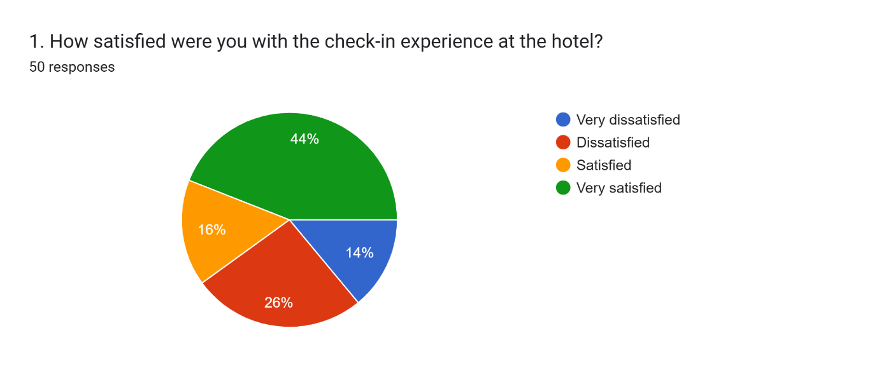
Interpretation: A pie chart of customer satisfaction with hotel check-in is shown using 50 responses. Analysis of results shows 44% of guests were "Very satisfied", 16% were "Satisfied", 26% were "Dissatisfied" and 14% were "Very dissatisfied". Most of the respondents had a good experience, but a significant portion were unhappy with something about the check-in process (40%).
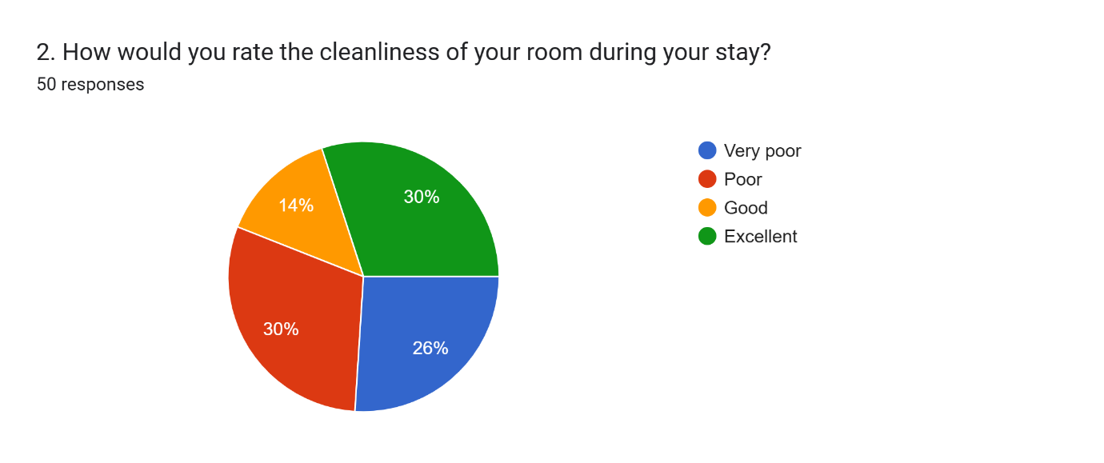
Interpretation: This is a pie chart of the room cleanliness ratings for 50 responses. Overall, overall participants rated the cleanliness of the exhibit as “Good” (14%) or “Excellent” (30%), making up a combined 56% of participants. A large segment (30% "Poor" and 26% "Very Poor") however indicates that almost half of our respondents did not find the condition of the toilets to be satisfactory.
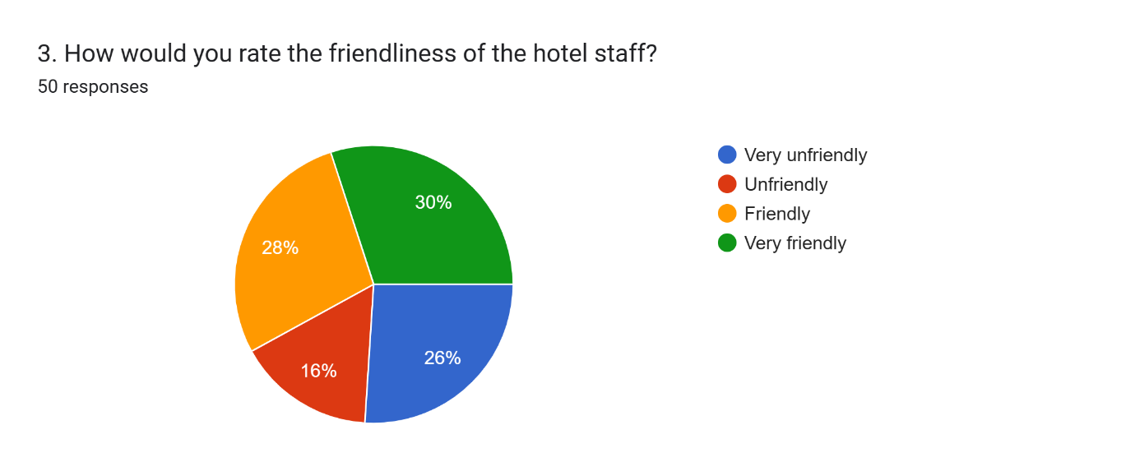
Interpretation: The pie chart below includes ratings for hotel staff friendliness from 50 responses. 58% of respondents thought the staff was "Friendly" or "Very friendly" - the vast majority indicated a positive impression of the staff. A major 42% however, felt unfriendliness (26% "Very unfriendly" and 16% "Unfriendly"). This tells that many guests had bad experiences which signals room for improvement in staff training or customer service.

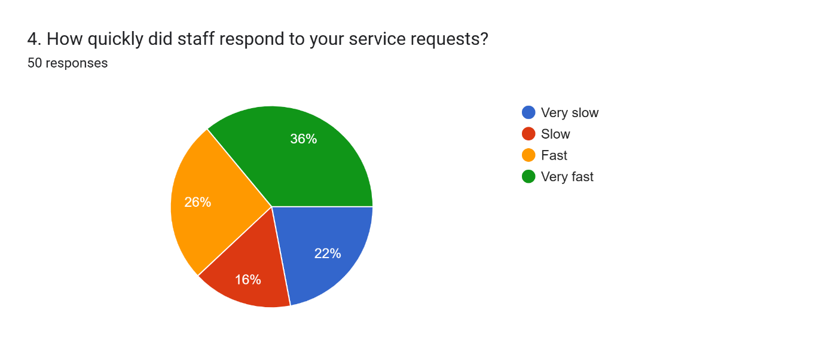
Interpretation: Using the staff responsiveness to service requests pie chart below (50 responses), one can see that the highest number is from users (55 of 55 or 100%). There was also some good news, with 62% of respondents rating responses as "Fast" (26%) or "Very fast" (36%), i.e. relatively efficient service. On the other hand, 38% experienced “Slow” (or 16%) and “Very slow” (or 22%). The results indicate that there are many guests who get quick service, but that a sizable share wait and thus this is an area where service speed can be more consistent.
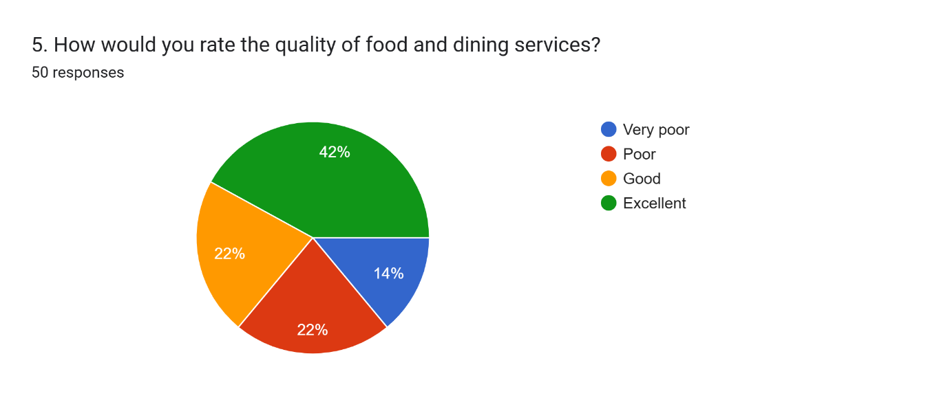
Interpretation: Food and dining service quality from 50 responses in this pie chart. Some 64% said that it was "Good" (22%) or "Excellent" (42%) - solid satisfaction numbers. Still, many guests; a total of 36% rated conditions as 'Poor' (22%) or 'Very poor' (14%) suggesting room for improvement.
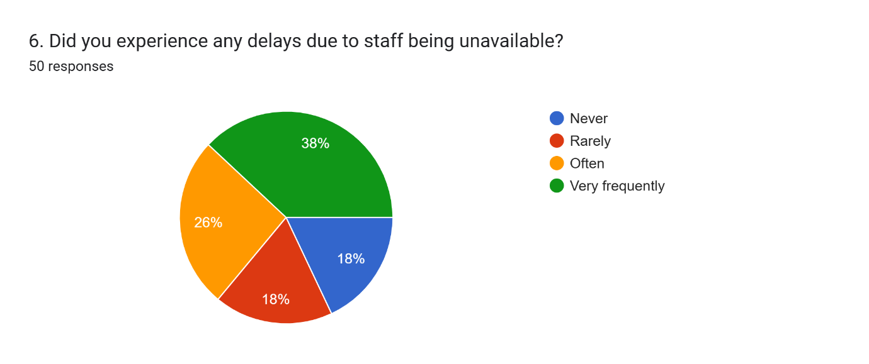
Interpretation: This pie chart which is based on the responses of 50 participants, depicts experiences with delays caused by staff unavailability. In fact, only 18% of the group "Never" had delays. A major issue was reported by some 64% of respondents, who said staff availability is a problem, with 26% of those reporting delays being 'Often' experienced and 38% 'Very frequent'. In fact, the majority had some form of inconvenience which means 18% "Rarely had delays," which suggests there is a staffing or resource allocation problem to be fixed.
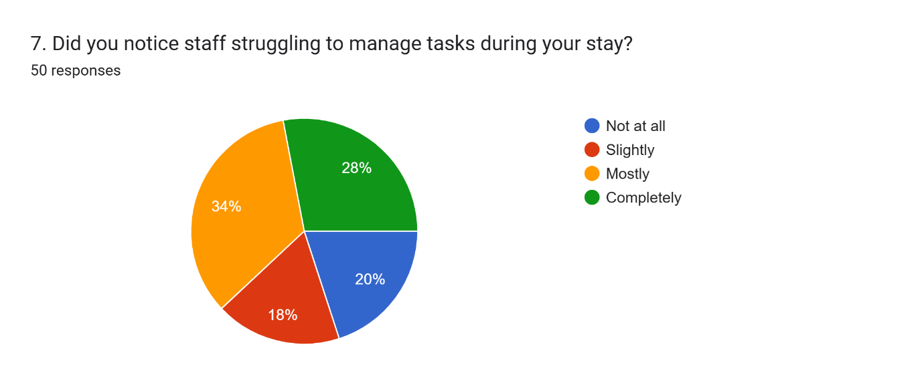
Interpretation: From 50 responses this pie chart displays staff perception of staff struggling with tasks. Specifically, 62% found staff struggling "Mostly" (34%) or "Completely" (28%) so a substantial body of evidence points toward people seeing staff being overwhelmed. However, while 20% had responded 'Not at all' and 18% 'Slightly,' there is a large potential that labour force, training or workload management requires better staffing to improve service efficiency.
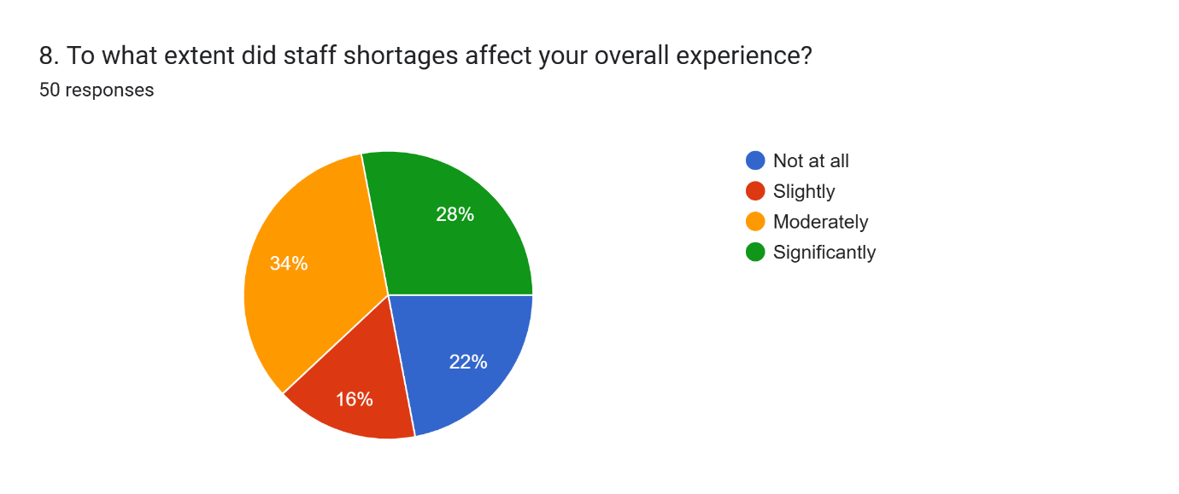
Interpretation: Staff shortages have the greatest impact on overall experience as demonstrated by this pie chart which represents 50 responses. An overwhelming 62% of those questioned were “Moderately” (34%) or “Significantly” (28%) affected. Moreover, it has been found that 22% are "Not at all", showing that staff shortages are an important factor impacting guest experience.
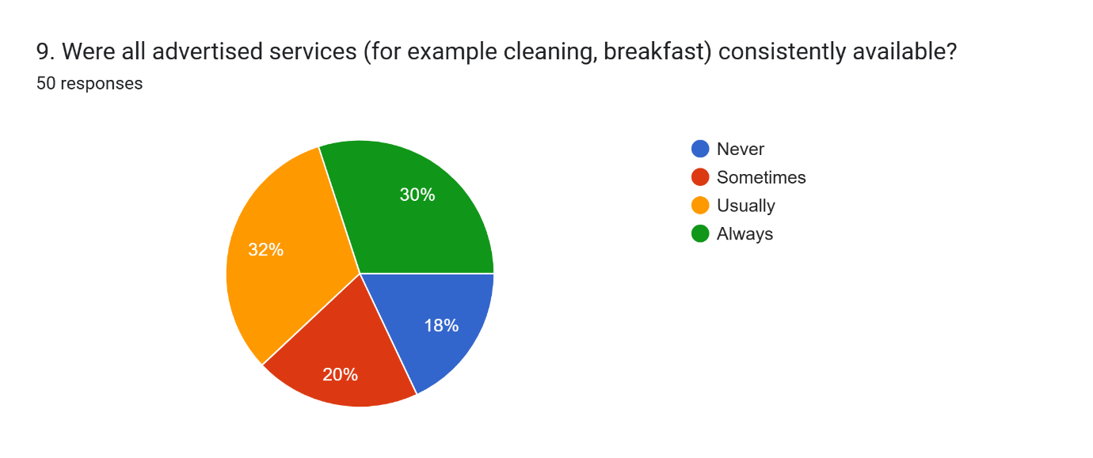
Interpretation: The chart above shows the relative consistency of advertised services being consistently available. Only 30% 'Always' and 32% 'Usually' available, however, 38% reported these services were available 'Sometimes' (20%) or 'Never' (18%). This implies that a substantial chunk of guests ran into issues with the promised services and the output and input fell short of the services.
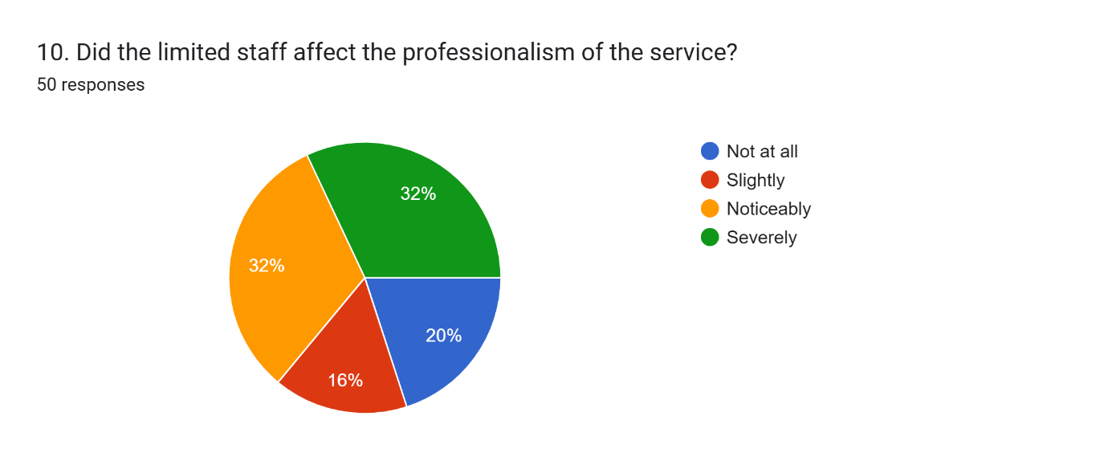
Interpretation: Noticeably or severely limited staff affected professionalism for a significant majority (64% combined "Noticeably" and "Severely"). 20% of participants felt they were 'Not at all' affected. This shows clearly that understaffing often undermines the provision of professional services, affecting the perception of guests.
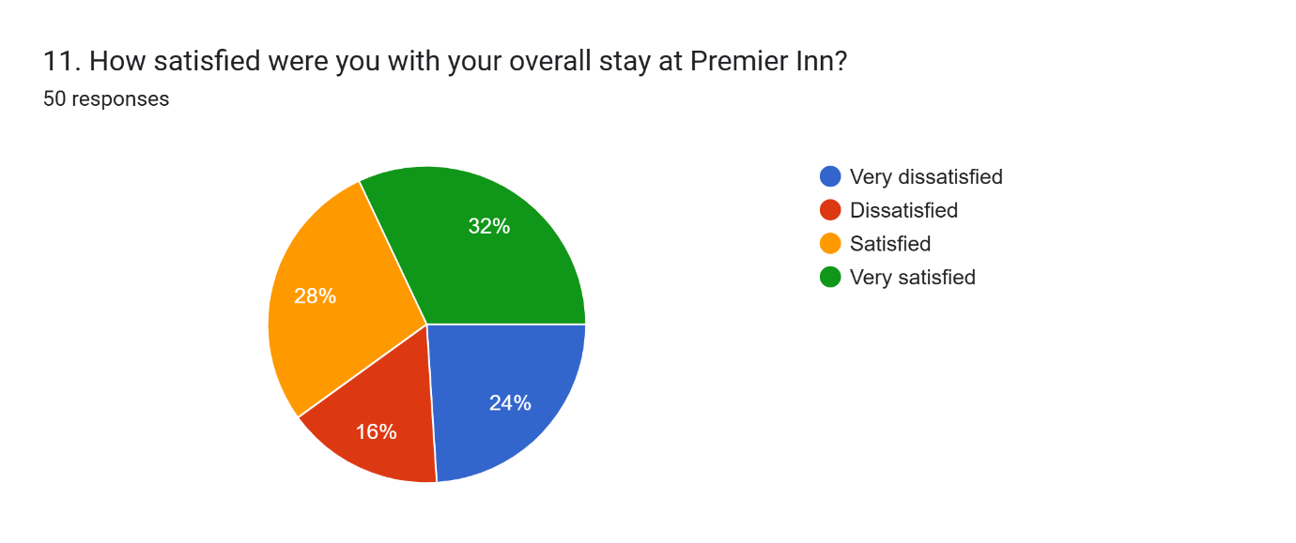
Interpretation: Based on 50 responses, this is how respondents felt about getting overall stay satisfaction. They were "Very satisfied" with 32% and a combined 60% "Satisfied" (28%). Yet, 40% knew they were dissatisfied (a quarter "Very dissatisfied," and a sixth "Dissatisfied"). This also implies a good portion of guests had bad experiences, pointing out areas where targeted improvement can be implemented to increase the ultimate satisfaction of guests.

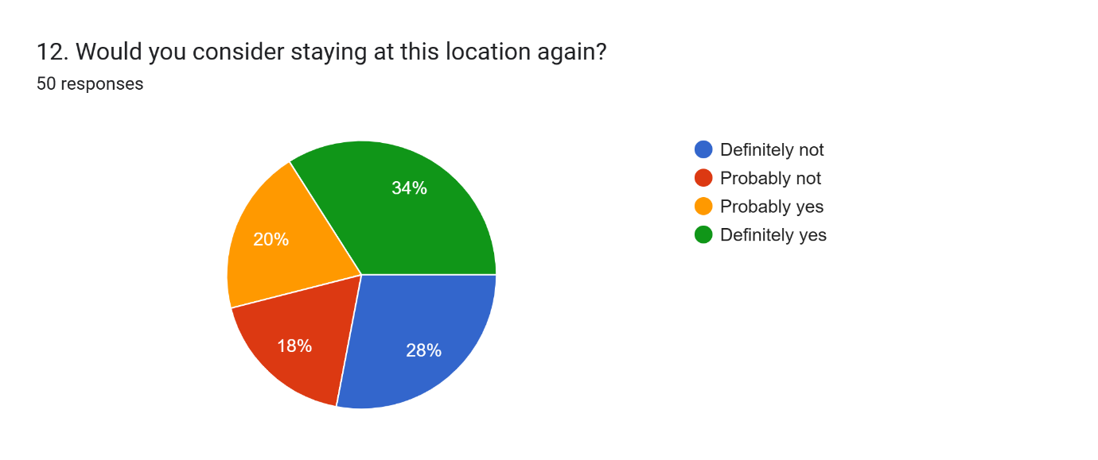
Interpretation: The pie chart below summarises 50 responses of repeat stays. 34% would "Definitely yes" repeat and 20% "probably yes". However, 28% would "Definitely not" and 18% would "Probably not" repeat the visit, suggesting slightly more momentum for return.
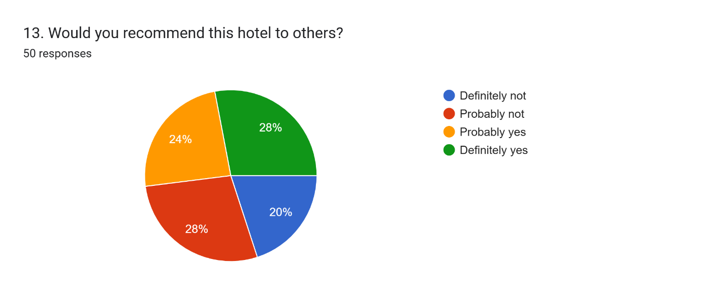
Interpretation: Based on 50 responses hotel recommendation rates are shown in the pie chart above, 28 % would "Definitely yes" recommend, while 24 % would "Probably yes." However, 28% would 'probably not' and 20% would 'definitely not' recommend which would show mixed guest satisfaction.

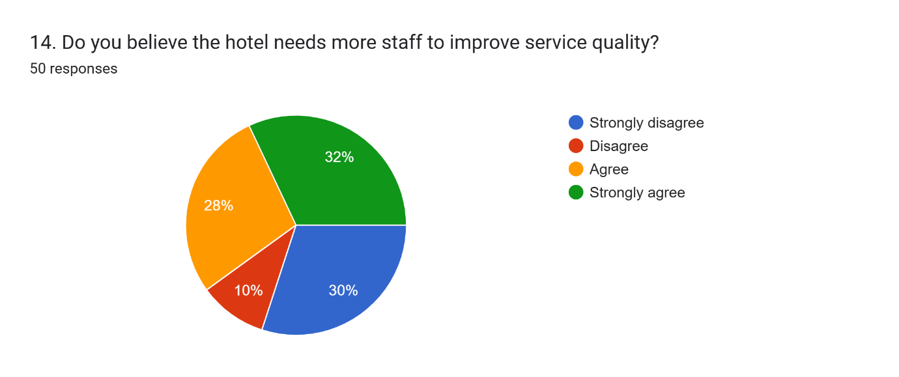
Interpretation: The opinions of 50 respondents on staffing to improve service quality are reflected in this pie chart. They are also nearly equally split as to whether more staff is needed (60% combined Strongly Agree and Agree, 32% and 28% respectively). On the other hand, 40% (30% Strongly Disagree, 10% Disagree) do not. A majority believe service needs staffing increases to offer service.
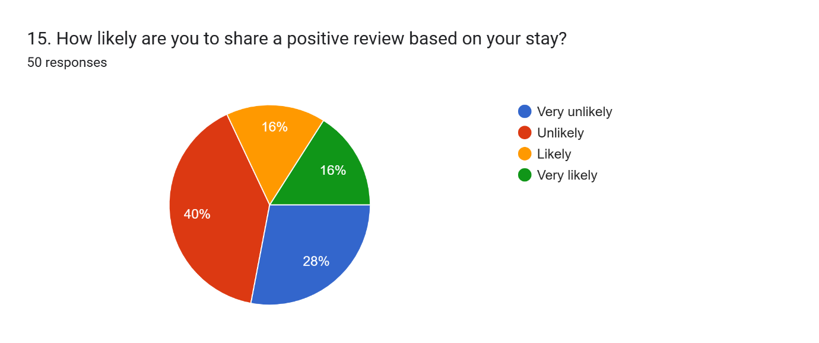
Interpretation: Based on 50 responses, this pie chart shows the probability of a guest leaving a positive review. 40% are "Unlikely" and 28% are "Very unlikely". While 16% are "Very likely" and 16% are "Likely" to share a positive review, online footprint may be a difficult task to achieve.

4.2.2 Primary Qualitative – Interview
Staff Member | Department | Question 1: How has the staff shortage impacted your ability to maintain service quality during your daily tasks? | Question 2: What strategies do you think could help improve operational efficiency despite the current staff shortages?
Staff Member 1 | Housekeeping | With less time for proper cleaning, sometimes guests see missed spots and we end up being delayed. Trying to keep up with guest expectations is stressful. | Temporary staff can be hired in peak seasons and the scheduling can be enhanced to prevent burnout. It could also improve flexibility through cross-training employees to cover multiple roles.
Staff Member 2 | Housekeeping | Very often we are rushed which makes room preparation inferior. With limited or no team members, it is hard to stay on top of things. | Invest in automated cleaning tools that will cut costs and improve things like better communication between departments. It also may reduce turnover by offering incentives to retain staff.
Staff Member 3 | Front Desk | Check-in and Check-out are done in long queues and giving personified attention is a tough job. This has a bearing on guest satisfaction. | Self-check-in kiosks and online check-in would reduce the pressure to implement. Better management of peak times might be through more flexible shift patterns.
Staff Member 4 | Front Desk | The lack of staff means there is more work and stress and sometimes, mistakes or slow responses to guest’s requests. | Software tools can streamline administrative tasks and empower frontline staff to make good quick decisions. And, improved staff well-being can help cut down absences.
Staff Member 5 | Restaurant | When we have busy hours and have trouble serving our guests quickly, we all get frustrated. We also do not have staff we can always offer full menu options. | Part-time or casual staff could be introduced when busy and inventory control improved. They would also make a big difference in better teamwork and communication.

4.2.3 Survey and Interview Analysis Using Themes
The results of the quantitative survey varied regarding the satisfaction level of different services such as lack of staff, slow service speed, as well as lack of some advertised amenities. Although most guests rated hotel cleanliness, staff friendliness and food quality positively, there was a large percentage who were unsatisfied, signifying unreliable service rendering. 62% of respondents experienced moderate to significant staff shortages affecting professionalism and operational efficiency.
These findings are supported by interviews with staff that highlight the burden of understaffing. Allied with this, housekeeping staff reported cleaning was rushed resulting in missed spots and front desk employees experienced long queues and stress when dealing with guests. During peak times, service speed was an issue, as was the limited menu that restaurant employees could provide. Hiring temporary or part-time staff during busy periods, cross-training employees to become more flexible and using technology such as self-check-in kiosks to make operations in the hotel run smoother were also considered as solutions for this scenario (George, 2025). Better staff well-being and communication, to minimise turnover and errors, were also suggested. Both pieces of data point toward the impact staffing problems have on guest satisfaction and in turn, service quality. These challenges could be addressed by improved resource management, adoption of technology and support for employees towards making operations more efficient and improving the overall guest experience (George, 2021).

4.3 Discussion of the Secondary Qualitative Thematic Analysis

4.3.1 Theme 1: Impact of Staff Shortages on Service Quality
The secondary data reveal the obvious theme of staff shortages impinging service quality in a major way. Various reports and customer feedback show service delivery delays, increased staff unavailability and lowered guest-employee interaction (Fenech, 2025). For example, longer waiting times at reception and slow service for cleaning rooms are often mentioned in the relevant TripAdvisor reviews. According to industry reports, these delays are consistent with staff shortages adding to the workload and stress for existing employees who are unable to provide the attentive and personalised care which underlies the customer service experience (Gursoy et al., 2022).
According to Premier Inn, their reports have stressed how this shortage has backed up operational routines - housekeeping and front desk roles being most impacted. Due to the reduction in staff, management had to put emphasis on core service, sometimes even making lack of restaurant services or additional guest assistance. In many cases, this prioritisation surfaces in very noticeable ways, by way of declining guest satisfaction scoring that shows up in online reviews mixed reviews (Çeltek, 2024). Moreover, the burnout and morale problem also caused by understaffing as per current and former employees' Glassdoor comments adds to the prevailing situation of decline in service standards.
In accordance with academic literature, this theme relates to staff shortages resulting in diminished HR with insufficient service quality due to operational inefficiencies leading to employee burnout (Kumar et al., 2024). Secondary data analysis has been used to confirm that this industry-wide challenge affects Premier Inn North Southampton in its guest experiences in both directions.

4.3.2 Theme 2: Operational Efficiency Challenges and Recovery Post-Pandemic
The second important key theme focuses on why operational efficiency challenges are magnified during the post-pandemic recovery phase. This was intensified by pandemic-induced temporary closures, layoffs, and a struggle to rehire which continue to create staff shortages (Shivekar et al., 2024). As the labour market stays tight in a post-pandemic world, backend recruiting to meet hopes for operational recovery is slowed in the industry articles.
Among other factors, these reports, along with prominent guest reviews, begin to depict a rebound in occupancy rates, but there is still some catching up to do to match operational efficiency given continued staffing shortfalls. One of the indicators was service delays, scheduling inconsistency, and decreased capacity in prime service areas like restaurants and the housekeeping departments (Van Nguyen and Ngoc, 2024). Documentation of the hotel application of flexible staffing and cross-training initiatives is provided, but challenges in achieving full pre-pandemic high levels of efficiency remain.
Furthermore, the secondary data has also shown the customer's frustration during this recovery phase as their expectation of service has risen but has not been matched by the staffing levels of all the service providers. The gap creates risk for the brand's reputation and requires strategic intervention. Research on the current operational challenges within hospitality is compatible with scholarly discussions on the post-pandemic workforce issue in the hospitality industry (Hsieh et al., 2025). Recruitment, training, and retention are highlighted as the main focuses.
Overall, the thematic analysis of secondary qualitative data revealed two compounded problems for Premier Inn North Southampton in terms of maintaining service quality amidst staff shortages and in the process of operational inefficiency in its state of post-pandemic recovery. These themes provide context to interpret primary research findings and to develop evidence-based recommendations.

4.3.3 Theme 3: Employee Wellbeing and Morale Amid Staff Shortages
Secondary data sources consistently show staff shortages have a major effect on employee wellbeing and morale. According to reviews on Glassdoor, Premier Inn North Southampton employees are subjected to high levels of stress, fatigue, and burnout because of increasing workloads and diminishing staff numbers (Niewiadomski, 2025). However, it is abundantly clear that many employees are frustrated and dissatisfied because they feel that management is not backing them enough.
According to industry reports, understaffing for long periods of time not only leads to decreased operational efficiency but also directly impacts staff motivation and mental health (Chan, 2025). In particular, the hospitality sector is susceptible to these challenges since frontline roles in the sector are often demanding in nature and include guest interaction that requires constant physical effort. This has resulted in a vicious cycle where low morale also engenders higher absenteeism and turnover rates which in turn, also exacerbates the staffing challenges (Yağmur et al., 2024).
Furthermore, employee testimonials highlight that problems with morale prevent teamwork and communication, key elements for the sustenance of service standards (Pickles et al., 2025). Besides, several reports point out that the initiatives of management on mental health support, workload balancing and recognition programmes can be a way to enhance employee satisfaction. Hence, the secondary data implies that Premier Inn needs to attend to workforce well-being as expeditiously as possible to ensure operational stability and service quality. This theme resonates with academic literature that has generally shown that employee well-being is linked to service delivery in the hospitality industry (Giousmpasoglou and Marinakou, 2024).

4.3.4 Theme 4: Customer Perceptions and Expectations in a Competitive Market
The last theme derived from secondary qualitative data is about changes in customers' perceptions and expectations in the mid-budget hotel market. Looking at their recent guest reviews on Google and TripAdvisor, analysis suggests while a lot of customers are sticking to Premier Inn because it is affordable and a well-known brand, more customers are scrutinising service consistency and quality (Walker and Nickson, 2024). While staff shortages are a fact of life (many guests recognise this), they also rightfully expect a smooth experience, courteous service, and everything to run as smoothly as it ordinarily would, ignoring the internal operational tit-for-tat taking place. Reviews have demonstrated a diminishing tolerance of delays and mistakes and these changing norms are a partial byproduct of broader shifts in customer expectations, fostered by mounting competition and alternative accommodation options like Airbnb (Wood, 2024). Customers often mention that choosing or even avoiding, Premier Inn is based on what they have experienced about the service recently and others have spoken about it online, emphasising the necessity of protecting our positive guest relations.
Furthermore, the findings of industry analyses reveal that brand reputation management using internet platforms is an essential factor for engaging in attracting and retaining customers in the post-COVID-19 hospitality landscape (Magnini et al., 2024). If not proactively approached, negative reviews connected to a staff shortage can greatly decrease the booking rate and a potential customer’s trust. In this theme, Premier Inn North Southampton must address the management of customer communications in the face of workforce challenges while improving service reliability. This fits in with research highlighting the need to fulfil changing customer expectations to maintain the competitive advantage found in the hospitality industry (Kumar and Ekka, 2025).

4.4 Evaluation and Analysis
All identified themes were evaluated and analysed to understand better how staff shortages impact Premier Inn North Southampton service delays and guest dissatisfaction, operational inefficiency, employee wellbeing and morale and changed customer perceptions.
Theme 1 showed firstly that timely and consistent service delivery which is directly affected by the service delays leads to guest dissatisfaction in understaffed departments such as housekeeping and front desk. Theme 2 discussed the inherent operational inefficiencies due to low staffing, with core operations such as check-in, food service and room turnover impacted by disruptions. Moreover, these inefficiencies hamper daily operations and cause wastage of resources, further impeding the capacity to keep up with demand - particularly at peak times (Manoharan et al., 2024). Theme 3 looked at employee wellbeing, working with data from Glassdoor and industry reports that overworked staff burn out, stress out, become less morale and hence have higher turnover and absenteeism (Stoimenov, 2025). As if that was not bad enough it further compounds the staffing issue starting a feedback cycle of decreasing service quality and dissatisfied employees.
Lastly, Theme 4 focused on how customers perceive customer service in a competitive market and that some customers are empathising with this problem, but they still want to rely on their service providers. Booking decisions are significantly influenced by online reviews and insufficient staff can turn a negative guest experience into destroying the brand image of the hotel (Giousmpasoglou and Marinakou, 2024). From this evaluation, it appears that customer satisfaction and retention conclusively depend on internal staffing. This reveals the necessity for Premier Inn to invest in staff support systems like well-being programmes fair scheduling and customer communication strategies to moderate expectations better (Ampountolas, 2025). In general, the combination of thematic insight from primary and secondary data shows the importance of resolving staff shortages as a labour problem and a complicated issue that can affect just service delivery, operational resilience, staff morale and long-term business reputation.

Chapter 5: Conclusion and Recommendations

5.1 Conclusion
The research shows that the hotel performs at an acceptable level for several key elements including room cleanliness, food quality and staff friendliness, but these are inconsequential if they cannot beat some other hotel in terms of overall satisfaction. Quantitatively, a large percentage of guests are significantly unsatisfied with parts of the hotel's services such as the check-in process, staff handling and consistency of advertised amenities. Service quality suffers from the lack of staff, and comes with delays, and rushed tasks - a service provider can provide substandard services. Qualitative insights from staff interviews strongly support this and show the conditions and associated pressures caused by reduced manning that bring stress, and errors and reduce the staff’s ability to meet guest expectations. Quantitative and qualitative evidence combine to confirm that staffing at insufficient levels impedes service efficacy, alongside the negative impact on employee morale and guest perceptions. In addition, different levels of service speed and availability of promised services indicate that operational inefficiency and resource mismanagement are also responsible for guest dissatisfaction. However, most guests have had a positive experience so far, suggesting that with specific improvements, the hotel has considerable potential to increase overall satisfaction.
The conclusion is that robust strategic interventions including, more effective workforce planning, smarter technological solutions that facilitate operations and stronger employee support systems would be needed. Resolving those core concerns will enable the hotel to enhance service consistency, decrease turnaround time, and increase staff professionalism. These measures would ultimately create a more consistent, high-quality guest experience that would foster loyalty, positive reviews and greater recommendations and lead to the hotel's competitiveness in the market.

5.2 Linking with Research Objectives
- To evaluate the impact of staff shortages on consumer satisfaction at Premier Inn
Justification: Premier Inn is reliant on understanding the impact of staff shortages to make it easier for them to maintain and improve upon their market reputation (Chaudhary et al., 2025). Wherever visitors are, staff are critical - they are part of the delivery of the experiences and where they are available and how they are available determines how efficiently and effectively guests are delivered to (Bernard, 2025). This allows hotel management to identify what areas of the organisation are befallen by staffing deficiencies which create guest dissatisfaction (long wait times, unclean rooms, and bad customer interaction) By quantifying this relationship Premier Inn can allocate resources proactively and address the sharpest pain points of guest experience (Petie et al., 2025). In the highly competitive hospitality sector, customer satisfaction is a significant driver of repeat business, positive reviews, and overall profitability and thus this objective is justified.
- To assess the way staff shortage impacts overall operational efficiency
Justification: Running a hotel operation successfully largely depends on how efficiently several key departments such as housekeeping, front desk and food services are coordinated. An immediate consequence of staff shortages is bottlenecks which stress out employees, increase workload and lower the speed and quality of service delivery (Ashton et al., 2025). Thus, the assessment of such impact is important to show how understaffing affects daily operations: from timeliness of the room readiness to promptness of service requests. Such assessment can help reveal indirect costs like higher employee burnout, greater rates of turnover and compromised guest safety or hygiene standards (Zientara et al., 2025). Operational inefficiencies which affect guest satisfaction, like they cause additional cost and decrease profitability, are thus justified on this objective. The clarity of these inefficiencies gives management the opportunity to develop specific strategies that mitigate poorly bid work, lead to overstaffing, has poor workflow and employee morale which combine to create a more resilient and efficient operation (Alharbi et al., 2025).
- To provide evidence-based recommendations to improve overall service quality
Justification: Data is collected and analysed for patterns of staff shortages and their effects, allowing for tailored evidence underpinning recommendations to be designed. The recommended solutions to these proposed issues include - hiring strategies and employee training, technology integration and process improvements (Nagirikandalage et al., 2025). Recommendations are based on evidence to guarantee that the proposed intervention is based on operational realities and not assumption and anecdotal evidence. This is a task that is justified because businesses within the hospitality industry require constant improvement to fulfil changing guest expectations and to withstand contemporary competitive pressure. Data-driven successful implementation increases the chances of having better guest satisfaction, better employee retention and better service consistency (Agag et al., 2025). Additionally, the recommendations are clear and supply management with a roadmap for actionable change and accountability, where progress is not only measurable but achieved in incremental steps over time (Jogarao, 2024).
Main Key Findings
A study finds that the Premier Inn has severe staff shortages which completely affect consumer satisfaction as well as operational efficiency. A significant share of quantitative data indicates that although guests tend to rate cleanliness, food quality and friendliness of staff positively, a great number of dissatisfied guests complain about delays, inconsistent service, and unavailability of promised amenities. Perhaps most notably, 62% of respondents said understaffing moderately or severely impacted their experience which is a big problem. These challenges were confirmed by qualitative interviews with staff which indicated that understaffed situations are rushed and lead to longer queues and higher stress and error levels across housekeeping, front desk, and restaurant services. In turn, these pressures make both service quality and employee morale turn for the worse. Results suggest that without resolving staffing shortages, the hotel runs the risk of declining guest satisfaction and resultant inefficiencies. Yet the existence of positive feedback means that investments in staffing, technology and training can incrementally improve service quality and guest loyalty.

5.3 Recommendations and Practical Strategies
Based on the comprehensive analysis of the survey data, staff interviews and operational observation, several key recommendations, and practical strategies to alleviate the challenges of staffing and promote quality of services and efficiency are suggested for Premier Inn.
1. Optimise Staffing Levels Through Strategic Workforce Planning: Among the most crucial discovered is the shortage of employees across the board within the departments that follow, as these situations result in lack of deliverance, hurrying of the processing of guests and of course guest dissatisfaction (Sarwar et al., 2024). Workforce planning should be performed in depth by Premier Inn based on patterns of demand in relation to staffing levels that should be maintained. This means that the hotel will analyse peak and off-peak periods to schedule the staff optimally so that they are not overworked at peak times and underutilised during quiet times (Wilson, 2025). Blending permanent and temporary or part-time staff during peak season allows a better service without overloading the permanent staff. By implementing a flexible scheduling system, employees will be able to swap shifts or change hours, leaving less room for absenteeism and boosting morale amongst the staff (Giousmpasoglou and Marinakou, 2024).
2. Cross-Train Employees for Greater Flexibility: Due to the shortage of staff, cross-training employees to be able to carry more than one role within the hotel can help reduce the effects of those shortages. For example, front desk staff can be trained to handle basic housekeeping questions during times when slow check-in is experienced or house cleaning staff can step in with basic food service tasks when the restaurant is busy (Bordian et al., 2024). A cross-trained workforce will be able to help cover gaps when people are absent. This helps to add value to the employees’ skill sets, it will help promote a culture of collaboration, all contributing towards higher job satisfaction and ultimately leading to higher retention as well (Sofi et al., 2025).
3. Implement Technology Solutions to Streamline Operations: Technology is an enabler that can drive transformational change to enable efficiency and guest satisfaction (Marín-García et al., 2025). To reduce front desk queues and devote more staff time to personalised face-to-face guest service Premier Inn should invest in digital tools such as self-check-in kiosks and/or mobile check-in options. When dealing with automated housekeeping management systems they track better room readiness and distribute cleanings efficiently (Nazarian et al., 2024). Moreover, with the process of adopting communication platforms connecting departments in real-time, guest requests can be answered in real-time and coordinated. For example, delays may be reduced by notifying housekeeping or maintenance staff instantly with perhaps mobile apps or internal messaging systems as soon as a room needs attention (Park et al., 2025).
4. Enhance Staff Training and Development Programs: Well-trained staff is the beginning of improving customer service skills and operational efficiency (Duan et al., 2025). To make good on their promise Premier Inn should conduct ongoing training programmes to deal with training aspects such as customer engagement, problem-solving and time management. Importance should be placed on dealing with peak periods, conflict resolution and professionalism under severe pressure (Chotisarn and Phuthong, 2025). To alleviate such issues, it is also essential to train against the use of new technologies. In addition, leadership development programmes help prepare supervisory staff to better support their teams leading to increased organisational morale and operational flow (Sihombing et al., 2025).
5. Focus on Employee Well-being and Retention Strategies: The results of the study showed that service quality is greatly affected by staff burnout and stress. However, this must be overhauled through employee wellbeing initiatives for Premier Inn to launch. Reducing stress and absenteeism can be done by offering flexible working hours, making sure the workloads are reasonable and providing mental health support (Chou et al., 2025). Motivational and loyal employees can be recognised and rewarded through incentives, employee appreciation programmes and bonuses. A supportive work environment keeps them from leaving or, if they do leave, it takes less time, effort, and money to bring on a new staff member (Adiningtyas and Millanyani, 2024).
6. Improve Resource Allocation and Inventory Management: Inventory or resource shortages discipline the restaurant and the housekeeping departments where shortages create some challenges impacting the quality and variety of services offered (Widiyanti and Tukiran, 2024). Robust inventory control systems will be implemented to ensure that enough supplies and equipment are available during peak times and that service is minimal. For example, this includes better control of stock would mean menu variety could be kept up even through staff shortages without resorting to final-minute substitutions that did not please the customers (Talukder et al., 2025).

References
Adiningtyas, H. and Millanyani, H., 2024, February. Analysis of Customer Satisfaction Levels in Five-Star Hotels Based on Online Customer Reviews. In 2024 2nd International Conference on Software Engineering and Information Technology (ICoSEIT) (pp. 167-174).
Agag, G., Yousaf, A., Mishra, A. and Amin, I., 2025. How and when do marketing analytics pay off in the travel and tourism industry? The role of marketing agility and fit perspective. International Journal of Hospitality Management, 126, p.104060.
Ahmed, M., 2025. AI Revolutionizing Hospitality: Insights from the MENA. In AI in the Middle East for Growth and Business: A Transformative Force (pp. 217-236).
Alharbi, A.A., Elshamly, A., Shawky, N.M.A. and Mahgoub, I.G., 2025. Unlocking Sustainable Performance in SMEs: The Interplay of Green AI Management, Pro-environmental Behaviour in the Tourism and Hospitality Sector: UK. Journal of Posthumanism, 5(4), pp.271-290.
Al-Kumaim, N.H.S., Samer, M., Hassan, S.H., Shabbir, M.S., Mohammed, F. and Al-Shami, S., 2025. New demands by hotel customers post COVID-19 era. Foresight, 27(1), pp.1-28.
Ampountolas, A., 2025. Predicting hotel booking cancellations: a comprehensive machine learning approach. Journal of Revenue and Pricing Management, pp.1-12.
Anderson, M., 2025. Understanding the Impact of Service Quality on Customer Loyalty in the Hospitality Industry.
Arli, D., van Esch, P. and Weaven, S., 2024. The impact of SERVQUAL on consumers’ satisfaction, loyalty, and intention to use online food delivery services. Journal of Promotion Management, 30(7), pp.1159-1188.
Ashton, M., Filimonau, V. and Tuomi, A., 2025. How the Metaverse can add new layers of hospitality services: a perspective of senior industry practitioners. International Journal of Contemporary Hospitality Management, 37(4), pp.1231-1256.
Bakir, S., Dogru, T., Bilgihan, A. and Ayoun, B., 2025. AI awareness and employee-related outcomes: A systematic review of the hospitality literature and a framework for future research. International Journal of Hospitality Management, 124, p.103973.
Bas, T. and Sivaprasad, S., 2022. An Exploratory Insight into the Impact of COVID-19 on the Travel and Tourism Sector: UK Evidence. Bas, T. & Sivaprasad, S.(2022). An exploratory insight into the impact of COVID-19 on the travel and tourism sector: UK evidence. In S. Karabulut (Ed.), Economic and Financial Analysis of Global and National Developments, pp.355-369.
Bernard, D.M., 2025. The Dissertation Research Proposal Process: A Systematic Approach. Journal of Research Initiatives, 8(5), p.6.
Birdir, K. and Sahilli Birdir, S., 2024. Staff shortages in hospitality and tourism industries: how technology influences?. Worldwide Hospitality and Tourism Themes, 16(5), pp.551-554.
Bordian, M., Gil-Saura, I., Berenguer-Contri, G., Ruiz-Molina, M.E. and Marín-García, A., 2024. Boost effect of sustainable practices and relational innovation on value co-creation and brand equity: outcomes of hotel size moderation. Journal of Marketing Analytics, 12(3), pp.717-733.
Cain, L.N., Mistry, T.G., Douglas, S., Rahman, I. and Moreo, A., 2024. Luxury hotel technology trends: a multigenerational analysis. International Journal of Contemporary Hospitality Management, 36(12), pp.4031-4054.
Çeltek, E., 2024. Unmanned smart hotel: applications and examples. Worldwide Hospitality and Tourism Themes, 16(5), pp.611-626.
Chan, J., 2025. Second chances in hospitality: analyzing the employment prospects for rehabilitated offenders. International Journal of Contemporary Hospitality Management.
Chaudhary, H.K., Singh, M. and Ghosh, P., 2025. The impact of green technology on guest safety: the mediating roles of responsible tourism practices and guest satisfaction. Journal of Hospitality and Tourism Insights.
Chotisarn, N. and Phuthong, T., 2025. Impact of artificial intelligence-enabled service attributes on customer satisfaction and loyalty in chain hotels: Evidence from coastal tourism destinations in western Thailand. Social Sciences & Humanities Open, 11, p.101306.
Chou, S.F., Horng, J.S., Liu, C.H., Yu, T.Y., Huang, Y.C., La, Q.P. and Ng, Y.L., 2025. Comparison of hotel fine dining and chain restaurant consumer perceived service quality and satisfaction predictions. Journal of Hospitality and Tourism Insights, 8(5), pp.1927-1953.
Das, M.P., 2023. Technology and Guest Experience: Innovations Reshaping Hotel Management. International Journal for Multidimensional Research Perspectives, 1(3), pp.76-95.
Duan, B.Y.C., Zhang, Y., Dai, J. and Ma, E., 2025. Emotional Intelligence and Customer Satisfaction: A Comparison Between Guesthouses and Hotels. In Emotional Intelligence and Networking Competencies: Implications for Effective Leadership (pp. 113-126).
Fang, J. and Partovi, F.Y., 2022. Technology planning in the hotel industry. Tourism Management Perspectives, 44, p.101018.
Fenech, M.C., 2025. Corporate Sustainability Reporting. New Trends in Tourism, p.35.
George, R., 2021. Tourism and Hospitality Products, Branding, and Pricing. In Marketing Tourism and Hospitality: Concepts and Cases (pp. 249-283). Cham: Springer International Publishing.
George, R., 2025. Tourism and Hospitality Product-Offerings, Branding, and Pricing. In Marketing Tourism and Hospitality: Concepts and Cases (pp. 225-255). Cham: Springer Nature Switzerland.
Giousmpasoglou, C. and Marinakou, E., 2024. Current Challenges and Future Perspectives. In The Contemporary Hotel Industry: A People Management Perspective (pp. 213-236). Cham: Springer International Publishing.
Giousmpasoglou, C. and Marinakou, E., 2024. Human resources management in hotels. In The contemporary hotel industry: A people management perspective (pp. 129-158). Cham: Springer International Publishing.
Giousmpasoglou, C. and Marinakou, E., 2024. The Contemporary Hotel Industry.
Giousmpasoglou, C. and Marinakou, E., 2024. The Contemporary Hotel Industry: A People Management Perspective. Springer Nature.
Gursoy, D., Buttle, F. and Bowie, D., 2022. Hospitality marketing: Principles and practices. Routledge.
Hazari, A., 2024. Introduction to research methodology. In Research Methodology for Allied Health Professionals: A comprehensive guide to Thesis & Dissertation (pp. 1-6). Singapore: Springer Nature Singapore.
Hsieh, Y., Hirudayaraj, M. and Hsieh, W.C., 2025. Rethinking housekeeping job quality: insights from hotel housekeepers and managers. Current Issues in Tourism, pp.1-15.
Hückstädt, M. and Leisten, L.M., 2024. Internal factors promoting research collaboration problems: an input-process-output analysis. Scientometrics, 129(4), pp.2007-2035.
Jogarao, M., 2024. AI in the Hospitality Industry: Revolutionizing Guest Experience. In Technology and Luxury Hospitality (pp. 199-210). Routledge.
Kumar, A. and Praveenakumar, S.G., 2025. Research methodology. Authors Click Publishing.
Kumar, P. and Ekka, P., 2025. Demand Forecasting for Ensuring Safety and Boosting Operational Efficiency in Hotel Hospitality Using ARIMA Model. Journal of Hospitality & Tourism Education, pp.1-15.
Kumar, S., Kapoor, B. and Shah, M.A., 2024. Contemporary Issues and Challenges Facing the Hospitality Industry. In The Framework for Resilient Industry: A Holistic Approach for Developing Economies (pp. 55-64). Emerald Publishing Limited.
Kumodji, B.D., 2024. “Where are the staff?” Where did they go? From Brexit, Covid ‘19 and Cost Hikes to HR Leaders struggling to fill the talent gaps”–Navigating uncertainties in the UK Hospitality Workforce Market.
Lei, S.S.I., Wu, D., Liu, G.G. and Law, R., 2025. The customizing customer journey in hotels: A focus on human touch. International Journal of Hospitality Management, 124, p.103956.
Li, R. and Long, T., 2024. Research on improving customer satisfaction of hotel robot service based on Web text analysis. In ITM Web of Conferences (Vol. 60, p. 00018). EDP Sciences.
Magnini, V.P., Dorn, E.C., Adkins, C.L., Crotts, J.C. and Uysal, M., 2024. Understanding hospitality labour shortages: An importance-performance analysis of hospitality career preference drivers. Journal of Human Resources in Hospitality & Tourism, 23(3), pp.465-486.
Manoharan, G., Ashtikar, S.P. and Kumar, S., 2024. Extenuating Digital Transformation: Revolutionizing Hotel Operations Through AI Technology. In Hotel and Travel Management in the AI Era (pp. 257-274). IGI Global.
Marín-García, A., Moise, M.S., Bordian, M. and Gil-Saura, I., 2025. Sustainable practices as a driver of brand value and satisfaction: is it the same for all guests? Tourism and hospitality management, 31(1), pp.37-47.
Marques, I.A., Borges, I., Pereira, A.M. and Magalhães, J., 2022. Hotel technology innovations as drivers of safety and hygiene in hotel customers. In Advances in Tourism, Technology and Systems: Selected Papers from ICOTTS 2021, Volume 2 (pp. 571-583).
Marra, M. and Nielsen, B.B., 2025. Research methodology: Best practices for rigorous, credible, and impactful research. Journal of International Business Studies, pp.1-3.
Mattila, A.S., Wu, L. and Wang, P., 2025. Closing the Gap: Advancing service management in the hospitality and tourism industry amidst the AI revolution. Journal of Hospitality and Tourism Management, 62, pp.237-245.
Nagirikandalage, P., Lakhoua, C., BInsardi, A., Tzempelikos, N. and Kerry, C., 2025. Expert perspectives on factors shaping metaverse adoption for cultural heritage experiences in the hospitality industry within an emerging economy. International Journal of Contemporary Hospitality Management, 37(4), pp.1332-1349.
Nazarian, A., Ranjbaran, A., Afifi, M., Atkinson, P. and Sadeghilar, N., 2024. Cross-cultural examination of effects of ethical leadership of independent hotels based on Social Exchange Theory. International Journal of Cross-Cultural Management, 24(3), pp.463-484.
Niewiadomski, P., 2025. A Long Way to Go: Sustainability Transitions in the Hotel Industry. Available at SSRN 5254216.
Park, H., Lee, M., Back, K.J. and DeFranco, A., 2024. Is hotel technology a double-edged sword on customer experience? A mixed-method approach using big data. Journal of Hospitality & Tourism Research, 48(5), pp.881-894.
Park, H., Lee, M., Back, K.J., DeFranco, A. and Suh, J., 2025. Dynamic roles of hotel mobile application in customer satisfaction and dissatisfaction: integrating text analytics and impact asymmetry analysis. International Journal of Contemporary Hospitality Management.
Perdomo-Verdecia, V., Garrido-Vega, P. and Sacristán-Díaz, M., 2024. A fsQCA analysis of service quality for hotel customer satisfaction. International Journal of Hospitality Management, 122, p.103793.
Petie, O., Phillimore, J. and Allsopp, J., 2025. Exploring hospitality, hostility and (un) home in hotel accommodation for asylum seekers in the United Kingdom. Hospitality & Society, 15(1-2), pp.23-44.
Pickles, M., Duffy, P.O.R. and Stewart, J., 2025. Addressing global labour challenges: An integrative model for sustainable hospitality workplaces, informed by resource-based view theory and the kaleidoscope career model. International Journal of Hospitality Management, 131, p.104258.
Reddy, M.S.S., Nijhawan, G., Adnan, K., Khan, M.A. and Lakshmi, P., 2025. Analyzing the Difference Between Metaverse and Video Conference by Input Process and Output Models of Teamwork. In Optimizing Virtual Reality and Metaverse for Remote Work and Virtual Team Collaboration (pp. 67-80). IGI Global.
Sarwar, H., Ishaq, M.I. and Franzoni, S., 2024. Influence of HRM on CSR and performance of upscale hotels in developed and developing countries. Environment, Development and Sustainability, 26(1), pp.335-357.
Schmidt, A.L., Koerten, K., Tuomi, A., El‐Manstrly, D. and Wiegerink, K., 2025. Human Versus Robot: Comparing Service Agents in Hospitality Settings—Insights From a Field Study. Strategic Change.
Shivekar, R., Padave, P. and Lukose, W., 2024. EVALUATING SERVICE PERFORMANCE OF FINE DINE RESTAURANTS: KEY DETERMINANTS, CUSTOMER EXPECTATIONS, AND INDUSTRY CHALLENGES.
Sihombing, D., Tambunan, S.G. and Sinay, K.Y., 2025. Analysis of work motivation of room division employees and service quality room on guest satisfaction. Journal of Management Science (JMAS), 8(1), pp.348-356.
Sofi, M.R., Bashir, I., Alshiha, A., Alnasser, E. and Alkhozaim, S., 2025. Creating exceptional guest experiences: the role of engagement and relationship building in hospitality. Journal of Hospitality and Tourism Insights, 8(3), pp.891-914.
Stoimenov, V., 2025. Advancing sustainability in the hospitality industry through green skills development, 13(1), pp.72-83.
Talukder, M.B., Rahman, M.Z. and Khan, M.R., 2025. Enhancing Guest Experience Through Smart Hotel Technologies. In Adapting to Evolving Consumer Experiences in Hospitality and Tourism (pp. 301-324). IGI Global.
Tan, Y., Park, S., de Medeiros, A.M.A. and Wanke, P., 2025. Cost-benefit analysis in UK hotels: A hybrid SOCP-MCDM approach. Tourism Management, 106, p.105034.
Tusquellas, N., López-Villanueva, D., Palau, R. and Santiago, R., 2025. Educational Conceptual Model Design Research Methodology. UTE Teaching & Technology (Universitas Tarraconensis), (2), pp.e4103-e4103.
Van Nguyen, N. and Ngoc, T.T.B., 2024. Service Quality as a Catalyst for Competitive Advantage and Business Performance in Hotel Industry: An Empirical Analysis by PLS-SEM Algorithm. International Journal of Analysis and Applications, 22, pp.141-141.
Verma, R., Verma, S. and Abhishek, K., 2024. Research methodology. Booksclinic Publishing.
Walker, V. and Nickson, D., 2024. Socially irresponsible HRM: findings from the UK hotel sector. Journal of Business Ethics, pp.1-15.
Wider, W., Tan, F.P., Tan, Y.P., Lin, J., Fauzi, M.A., Wong, L.S., Tanucan, J.C.M. and Hossain, S.F.A., 2024. Service quality (SERVQUAL) model in private higher education institutions: A bibliometric analysis of past, present, and future prospects. Social Sciences & Humanities Open, 9, p.100805.
Widiyanti, W. and Tukiran, M., 2024. Customer satisfaction in the hospitality sector: a narrative literature review. International Journal of Social and Management Studies, 5(2), pp.11-17.
Wilson, O., 2025. Enhancing Operational Efficiency and Guest Satisfaction in Hotel Management: A Strategic Approach. OTS Canadian Journal, 4(5), pp.72-81.
Wood, R.C., 2024. Working in hotels and catering. Taylor & Francis.
Wu, X., Xiang, H., Wang, Y. and Huo, Y., 2024. How does customer satisfaction change after hotels start using self-service kiosks? International Journal of Hospitality Management, 122, p.103872.
Yağmur, Y., Demirel, A. and Kılıç, G.D., 2024. Top quality hotel managers' perspectives on smart technologies: an exploratory study. Journal of Hospitality and Tourism Insights, 7(3), pp.1501-1531.
Zientara, P., Adamska, J. and Bąk, M., 2025. Social Sustainability and the Employee: Labor, Employment Relations, and the Hospitality Industry. Taylor & Francis.

Appendices

Appendix 1: Survey Questionnaire
- How satisfied were you with the check-in experience at the hotel?
- Very dissatisfied
- Dissatisfied
- Satisfied
- Very satisfied
- How would you rate the cleanliness of your room during your stay?
- Very poor
- Poor
- Good
- Excellent
- How would you rate the friendliness of the hotel staff?
- Very unfriendly
- Unfriendly
- Friendly
- Very friendly
- How quickly did the staff respond to your service requests?
- Very slow
- Slow
- Fast
- Very fast
- How would you rate the quality of food and dining services?
- Very poor
- Poor
- Good
- Excellent

- Did you experience any delays due to staff being unavailable?
- Never
- Rarely
- Often
- Very frequently
- Did you notice staff struggling to manage tasks during your stay?
- Not at all
- Slightly
- Mostly
- Completely
- To what extent did staff shortages affect your overall experience?
- Not at all
- Slightly
- Moderately
- Significantly
- Were all advertised services (for example cleaning, and breakfast) consistently available?
- Never
- Sometimes
- Usually
- Always
- Did the limited staff affect the professionalism of the service?
- Not at all
- Slightly
- Noticeably
- Severely
- How satisfied were you with your overall stay at Premier Inn?
- Very dissatisfied
- Dissatisfied
- Satisfied
- Very satisfied
- Would you consider staying at this location again?
- Definitely not
- Probably not
- Probably yes
- Definitely yes
- Would you recommend this hotel to others?
- Definitely not
- Probably not
- Probably yes
- Definitely yes
- Do you believe the hotel needs more staff to improve service quality?
- Strongly disagree
- Disagree
- Agree
- Strongly agree
- How likely are you to share a positive review based on your stay?
- Very unlikely
- Unlikely
- Likely
- Very likely

