Rochester Castle
In this commentary I will be analysing Rochester castle. I shall be making references to both primary and secondary sources as a part of my commentary. I will be focusing on the castle after the date of 1066 as this is when the Normans won the battle of Hastings, and examining the aftermath effect on Rochester castle and the history after this.
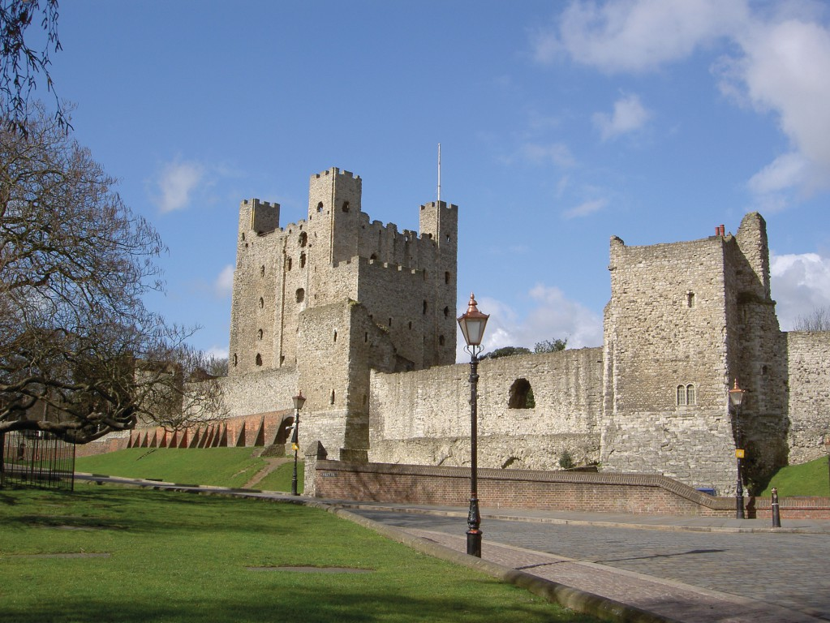
Rochester castle stands to this day in Rochester, Kent, England. The castle itself at the time was made from timber and earthworks. The grounds on which the castle stands was once a Roman city and an important one, as it was built at the junction of the River Medway and Watling Street. A fort was built there by the Romans was called Boley Hill, which is what the land the castle was built on was called.The front Boundary walls were still standing strong long after the Romans left England. After the Normans won the battle of Hastings in 1066,William I built was arguably the first castle of Rochester after his victory in Hastings. The castle was built by the Medway river, which at this time was a crossing point where ships would pass though from Dover and London. This was one of the reasons why the Romans built their fort in Rochester on the same land, so it could be argued that the William I followed the idea that the Romans had in order to keep charge of his now new lands. The Normans at this point where feared by most other countries and seen as wolf like creatures that were wild animals, as in Dudo of St Quentin chapter ten, where he speaks of Rollo.
In 1077 Gundulf, who was a monk from Normandy, was appointed to be the new Bishop of Rochester by William II. Gundulf had to make an appeal for Rochester Castle as he wanted to ensure the monks who had been living in the castle had a home. William demanded the bishop pay £100 for the grant to be passed. The bishop knew this was impossible, so he came to the agreement to build a new stone castle for the King instead. The stone that was used was Kentish ragstone along with stone from Normandy, though it is unclear which type was used. It is very possible that Gundulf used stone from his home land of Normandy to show his respect to the king and his old country. Motte and Bailey was the design used by William I. Norman were advocates for this style of castles, it can be suggested that these castles’ design helped the conquest of Britain. This design had outstanding defensive capabilities as any attackers of the castle found out. The best advantage from building these types of these of castles was that it was cheap and the materials they used meant that anyone could help build the castle, so with how fast these castles were built it meant the Normans could consolidate their power faster and move on their next chosen region. Normans were known to build castles on land they conquered as a scare other from invading their land and to show their strength. They also used how fast they could build as a defensive method in war as it shows that they were always ready for war. The size of Rochester castle stands at 34 meters which could be intimidating to anyone who wished to invade or fight against the Normans.
William the Conqueror probably gave Rochester to Bishop Odo the castle and the city to Odo. That was until the rebellion of 1088 were William Rufus and Robert Curthose fought over the succession of the English throne. Some Norman barons objected to the lands being split. Bishop Odo supported Robert’s claim to the English throne, Robert was the Duke of Normandy and wanted to have both England and Normandy like his father before him. The bishop then got Rochester ready for what could have war. Odo made Rochester one of the headquarters for this oncoming rebellion. Kent made an excellent base for raids on London, William knew this and sent men from London to Rochester to deal with his brother. The he heard the news of Odo going to Pevensey Castle and he man his men headed to that castle where he found Odo and made him hand over Rochester to him and his men. William II had to lay siege to the city of Rochester which may have began in 1088. There were two siege castles built to cut the city off from supplies and to protect others from outside of Rochester. Life inside of Rochester after that was worse than death and they soon came to an agreement, which then left the Castle and its grounds abandoned afterwards. It was then as if the siege never happened.
It could be argued that Bishop Odo only had Rochester because he might have been the half-brother of William the Conqueror, and without that fact Odo might not have been given the Castle and the city in the first place leading to there not even being a Castle on the grounds today, although the only reason a Castle stands there to day is because of William the Conqueror. Another part of the reason Rochester had a castle built on these grounds was because William not only wanted to protect his lands but also show just how powerful he was going to be as the new king of England. Normans used anything they could to show to others just what they were capable of doing. A great example of this is a tale of when the Normans wanted to scare the Greeks before actually fighting them. Hugh Tudebusis apparently pushed a horse in the neck and knocked the horse out in one blow to show his strength to a Greek soldier, so he would go back and report this to his leaders to show them just what they were facing.
Something that could be considered important about this castle is that it was made not only out of Kentish ragstone but also stone from Normandy, which shows that Gundulf wanted to be respectful of both cultures. This is something the Normans were known for doing, they did not just invade lands and make the people already living their follow what they believe in, they would accept the different type of cultures. A good example of this from when the Normans invaded Sicily is The tombstone for Anna. This is a beautiful artwork that has four different languages written, one of course being Norman and the other three being Arabic, Latin, and Greek.
In 1127 the then Archbishop of Canterbury William de Corbeil Was granted Rochester castle by the now King Henry I. Corbeil was given permission to build tower that still stands now. This is when the bishop of Rochester lost his right to the Castle after he had spent many years rebuilding the walls. And that is how we see the castle to this very day. It is now owned by English Heritage and is one of the many castle to visit in England.

bibliography
Toy, S., (1966). The castles of Great Britain. 4th ed., London: Heinemann. (Accessed 30 October 2018)
McNeill, T. (1992). Castles. 1th ed. English Heritage (Accessed 30 October 2018)
Brown, R.A., (1969). Rochester Castle, Kent, London: H.M.S.O. (Accessed 30 October 2018)
Armitage, E.S. & Montgomerie, D.H., 1912. Early Norman castles of the British Isles, London: J. Murray. (Accessed 30 October 2018)
Pohl.B,Bainton.H,L.b,Mortensen (2015) ‘Dudo of St Quentin’s Historia Normannorum: Tradition. Innovation and Memory’ Available at: https://www.jstor.org/stable/10.7722/j.ctt9qdm20 (Accessed 30 October 2018)
Harfield.G.C (2001) ‘A Hand-List of Castles Recorded in the Domesday Book’ Available at: https://www.jstor.org/stable/pdf/573107.pdf (Accessed 31 October 2018)
Stokstad.M (2005) ‘Medieval Castle’ Greenwood Press (Accessed 31 October 2018)
Creighton.O.H (2002) ‘Castles and Landscapes: Power, Community and Fortification in Medieval England’ Equinox (Accessed 30 October 2018)
The tombstone for Anna: the symbol of a Medieval melting pot (2018) Available at: https://squarekufic.com/2018/03/30/the-tombstone-for-anna-the-symbol-of-a-medieval-melting-pot/ (Accessed 31 October 2018)
Johns, J., 1997. Making History. The Normans and Their Historians in Eleventh-Century Italy. The English Historical Review, 112(448), pp.959–960.

Tim McNeill, Castles,(English Heritage 1992)p.48
Marilyn Stokstad,Medieval Castles (Greenwood Press 2002)P.81,P.7,P.36
Marilyn Stokstad,Medieval Castles (Greenwood Press 2002)P.81,P.7,P.36
Benjamin Pohl, Herny Bainton,Lars Boje Mortensen,Dudo of St Quentin's Historia Normannorum: Tradition, Innovation and Memory (Jsotre 2015)
Tim McNeill, Castles,(English Heritage 1992)p.48
Marilyn Stokstad,Medieval Castles (Greenwood Press 2002)P.81,P.7,P.36
Marilyn Stokstad,Medieval Castles (Greenwood Press 2002) P.7
Marilyn Stokstad,Medieval Castles (Greenwood Press 2002) P.36
Tim McNeill, Castles,(English Heritage 1992)p.87
Oliver Creighton Castles and Landscapes: Power, Community and Fortification in Medieval England (Equinox 2002)
Oliver Creighton Castles and Landscapes: Power, Community and Fortification in Medieval England (Equinox 2002)
Kenneth Baxter Wolf.In Making History. The Normans and Their Historians in Eleventh-Century Italy ( Oxford University Press 1997)
The tombstone for Anna: the symbol of a Medieval melting pot (Squarekufic 2018) Marilyn Stokstad,Medieval Castles (Greenwood Press 2002)P.81,P.7,P.36
Oliver Creighton Castles and Landscapes: Power, Community and Fortification in Medieval England (Equinox 2002)

