School of Optometry and Visual Sciences, Cardiff University

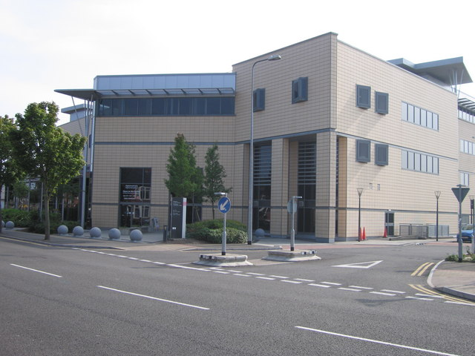

Contents

List of Photo Page 3
List of Plans Layouts Page 4
Introduction Page 5
Benchmarking and Data Analysis Page 10
Maintenance Applications Page 12
HVAC Systems Page 14
- Heat Pump Page 14
- Invertors Page 15
- Air Handling Units Page 16
- Fan Coil Units Page 17
- Hot Air Curtain Page 18
Lighting Page 19
Building Management System Page 20
Conclusion and Recommendations Page 21
References Page 23

List of Pictures
Picture 1. Overhead view of the Optometry Building Page 7
Picture 2. Heat Pumps Page 15
Picture 3. Lobby Space Page 15
Picture 4. Invertor Driven Pumps Page 15
Picture 5. AHU, BMS Daigram Page 16
Picture 6. AHU Page 16
Picture 7. AHU Ducting Intake and Extarct Page 16
Picture 8. FCU Layout BMS Page 17
Picture 9. AHU, BMS Page 17
Picture 10. Hot Air Curtain Page 18
Picture 11. Ground Floor Lobby Page 19
Picture 12. BMS Front Page Page 20
Picture 13. Solar Film Page 21
Picture 14. Revolving Door Page 22

List of Plans and Layouts
Figure 1. Ground floor layout Page 8
Figure 2. First Floor Layout Page 9
Figure 3. Benchmarking Energy Usage from current DEC, 2014 Page 10
Figure 4. Annual Energy Consumption 2017 Page 11
Figure 5. Categories of Maintenance Page 13
Figure 6. Carbon Trust Energy Consumption in Building Page 14

Introduction
On Thursday 1st February a visit was taken to the Cardiff Universities building of School of Optometry, it is just one of the 130 buildings within the university property portfolio (Cardiff University Maps).
The building was constructed in 2007 as a modern, contemporary design with a total floor space of 7523m2. The building was built to fit in with the surrounding area this as partly achieved by stepping the building to allow all roof highs to align, and the use of terracotta wall tiles on the external cladding to blend into the current local housing designs. The building operates as a mixture of laboratories, offices, and lecture rooms, there is a public clinic located on the ground. The general operating hours of the building are 0800 – 2000. The building can be entered from the street through sliding doors into a large atrium area which has a small sitting area for the public clinic, one central staircase leading to the first and second floors with 2 further stair cases used as fire escapes and 3 lifts. Throughout the audit, we will be reviewing the operations of the building, looking at current efficiency’s, how the management are implementing programs to help achieve targets and modern day expectations of students and guests.
Highlighted in the pre-site site audit through DEC and Air Conditioning report (DEC, 2014), which indicated a poor energy rating of an F (140), and no renewables on site. When comparing benchmarks to set out in CIBSE Guide F where typical buildings of this type should be consuming around 129Kwh/m2/year, and after reviewing the data provided by Cardiff University calculations work out to be 190Kwh/m2/year. This indicating that the building is currently inefficient in electrical consumption. The natural gas consumption is better reading in comparing benchmarks with a typical building 132Kwh/m2/year where the current consumption is actually 36Kwh/m2/year. With further research of reviewing the Air Conditioning report mentions that there are ground source heat pumps, which under L2A guides its deemed a high efficiency system (Building Regulation 2010, L2A) that provide both heating and cooling, which would displace the benchmark guidelines in the Guide F as this isn’t taken into account. A Building management system (BMS) is in place but it requires improvements through faulty sensors and inputs. It was highlighted through the data analysis process that the historical meter read incorrect and not totally accurate, so the total consumption doesn’t equal the valve of all the sub meters. Further investigations would be required to understand the cause.
Throughout the site visit my focus were on the main contributors to energy consumption including HAVAC (Heating, Ventilations and Air Conditioning), where as the heat pump system is in place and operating to the correct efficiency’s layout in the non domestic building services guide 2013, having a recommended COP (coefficient of performance) of 2.5. The natural gas boilers are in operation with a set point of 80 degrees, a boiler system of this type should be operating around 86% efficiency’s (Non Domestic Guide).

With any HAVAC system, as seen through the audit AHU’s (Air Handling Units) and FCU’s (Fan Coil Units) are required to move air throughout the building, the controls from the building management system need to be able to meet a minimal standard as covered in the non-domestic guide, these guidelines are
- Controls are required to be fitted to the system to enable better control of the energy consumption increasing the energy efficiency for the building
- Zoning controls of the building are required to be designed to allow natural exposure of external influences e.g solar gain. The area should have independent control.
- With duel systems of heating and cooling, considerations need to be made so both systems are not operating at the same time
- Time controls and occupancy sensors should be required so that the system is only in operation when required
- Reduce access to the controls so that only trained competent persons are able to adjust
Lighting is another key area and another main focus during the walk around on site, as noted in the CIBSE guide F that lighting is the single greatest electrical consumptions if air conditioning is not present. It can account up to 40% of energy consumed in a natural vented building (CIBSE Guide F, 2012). Some areas of focus should be to reduce the energy consumed by lighting and to increase energy efficiency’s, this could be achieved through the use of natural lighting, and as seen in the overhead picture of the building there are atrium glass panels fitted on the roof (Figure 1). The use of the most efficient luminaires, by means of LED’s, or compact fitting, but to remember not to excessively illuminate the areas keeping the lux levels around 300 – 750 depending on application of the area use (CBSE F, 2012, Table 9.1). Another area for consideration is how the lighting is controlled and how efficient and effective the controls are in controlling the light. Throughout the visit it was visibly a number of local operated switches, but also noted on the BMS system is zone lighting for some of the areas generally common areas.
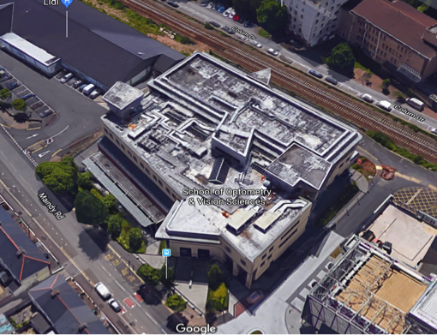
Picture 1. Overhead view of the Optometry Building
With any building the efficiency’s of the plant and equipment relies on tailored maintenance programs, to maintain the equipment, to operate efficiently and prolong the life cycle (CIBSE Guide M, 2008) During the audit it was identified that Cardiff university’s have in-house maintenance teams consisting of 30 engineers covering all maintenance of the building, plant and equipment. From time to time specialised contractors are called in to repair plant equipment, and when bigger projects are tended they are generally outsourced. Due to the large property portfolio of 130 buildings this can be a justified expense to have a direct maintenance team. Maintenance can be generally categorised into basic areas areas of planned or unplanned maintenance. Planned maintenance is periotic services of equipment/plant through manufactures recommendation, to comply with legislation or insurance compliance. Unplanned maintenance is repairing failures in equipment when they breakdown. It’s not recommended to run an unplanned maintenance programme solely as the building operating is at risk of not meeting statutory requirements and been prosecuted. (CIBSE Guide M, 2008).

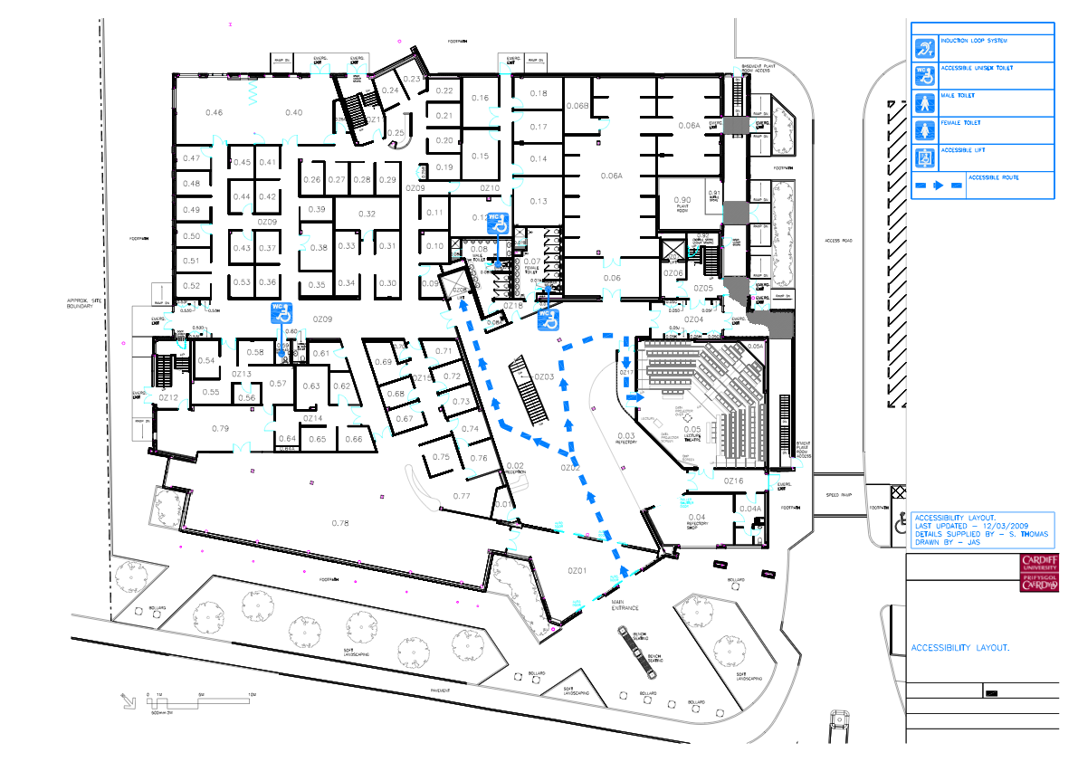

Figure 2. Ground floor layout

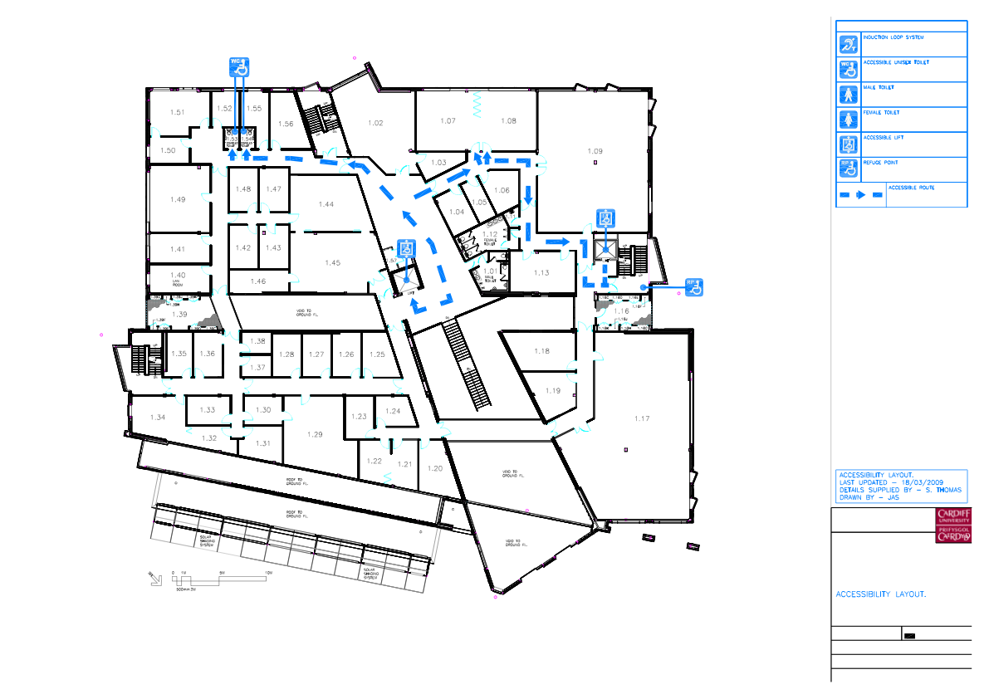

Figure 2. 1st Floor Layout

Benchmarking and Data Analysis
Data analysis is a crucial element of controlling energy as it provides information to management to enable them to highlight potential improvements for efficiency’s in energy. This can be done by reviewing year on year data, which can then be broken down in half hourly data for accurate information. Similar building types can also be compared, from a benchmark of energy usage. CIBSE Guide F highlights good to monitoring should aim to
- Set current consumption
- Review current data with historical data and benchmarks
- Set targets
- Compare consumptions with the targets
- Highlight current trends in energy usage
- Product reports on how the targets were met
- Review how new energy efficient projects have reduced energy consumptions, by ensuring that the project meets the saving promised.
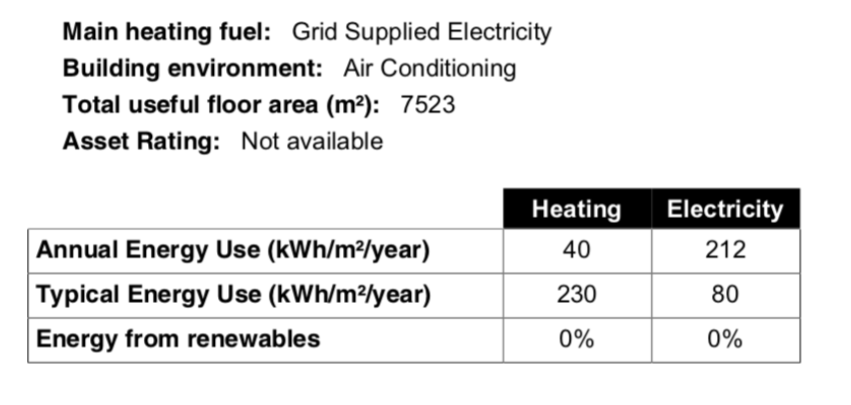
After reviewing the data given to us by Cardiff University energy manager it was clear that all the data was not totally accurate. As total electrical consumption didn’t add up the sub meter consumption. Going forward this will need to be investigated to the reasons why. We only had access to 2017 energy data on gas and electrical this reducing the same elements of data analysis. I was unable to review year on year data analysis to see if any improvements in reducing energy consumption had been made. There was enough data with the total energy consumed to benchmark the Optometry building to similar building. This is done looking at the best practice for the kilowatt-hour per square meter for educational building, with lecture room and science labs (CIBSE, Guide F, 2012, Table 20.1). Which states that a building of this type of use for good practice should be 110 kWhm2 fossil fuel and 113kWhm2 for electricity, a target practice should be 132kWhm2 fossil fuel and 129kWhm2 electricity. The current DEC for the building done in 2014 shows that this building is operating above typical usage in electricity but achieving great results in fossil fuel consumption (DEC, 2014) see figure 1 .

Figure 3 Benchmarking Energy Usage from current DEC, 2014
As I had the data of the total floor area of the current DEC and with the consumption data provided I was able to review if there has been any improvements in energy efficiencies compared to the 2014 DEC. Annual consumption electricity for the building was 1,424,027.96kWh giving an annual energy usage of 190kWhm2, although an improvement in 2014 still more than the typical usage of a building of this type. The annual fossil fuel consumption was 267,647.90kWh giving an annual energy usage of 36kWhm2 which is below the typical building for this type. With this information you could draw a conclusion that year on year there has been an improvement in energy efficiency in the optometry but this is inconclusive as benchmark using the table 20.1 does take into consideration the heat source pump as its not a typical install of a building of this type.
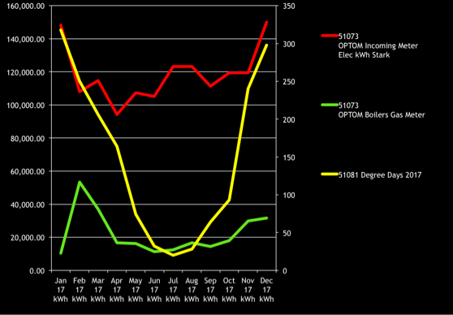
Figure 4. Annual Energy Consumption 2017,(Durdin, 2018)
Total annual consumption of both gas and electricity (figure 2), including degree day. Degree-days can aid in the reviewing the performance of the building, by comparing outside temperature conditions to the amount of energy used to heat the building. Its based on a set temperature of 15.5 degree (Carbon Trust, degree days)

Maintenance Applications, School of Optometry and Sciences
Maintenance in any building isn’t a one stop shop, it requires a number of various trades, engineers all pulling in one direction to achieve a single goal of keeping the building operational for it attended applications, occupants of the building comfortable by means of heating, cooling and lighting systems, and a safe environment to work in. The hidden element of maintenance is also the energy efficiency of the plant, which is why maintenance and energy management should operate together as they both share a common goal. Continued fine-tuning of the system controls through regular maintenance can ensure that the building service remains efficient (CIBSE Guide F, 2012).
In deciding on the right maintenance strategy on weather the business is better suited for in-house or outsource maintenance approach, various factors will need to be considered. Some of the direct advantages of in house maintenance teams to directly employ by the business (Seeley, 1987)
- The business has full control of the maintenance plans, permitting reasonable flexibility, a quicker turn around on breakdowns, and quality of works carried
- A better standard of works, due to the fact the employee have continued works, and knowledge about the building. Employees have a sense of ownership on completing the task to a high standard
- There is always staff available to carry works and compliance tasks
- Enhanced maintenance culture as the management team can set incentive driven tasks to increase productivity and work environment
- Good knowledge of site means that emergency breakdowns can be repaired quickly as maintenance team is trained on all equipment on site and knows location of spares required.
On the other hand there are various reason why outsourcing maybe the best way forward for the business, its noted by Burdon that companies can have a better or similar service but at a lower cost, this increasing profitability of the business. Burdon continues to say that companies “have been reported that many firms find it increasingly difficult to acquire, develop, and retain the people and technical know- how in-house necessary to maintain existing complex systems and develop and implement new technologies”(Burdon, 2005). With the forever developing market of new technologies but also the changing expectations of the users the need for continued training and improvement might be to higher cost for a business to continue in-house. Along with sickness of around 6 per cent could tip the hat in contractor extra cost.
Taken all the variable factors into consideration and that the School of Optometry is only one building within a estate of around 130 building, and using the assumption as there was limited information regarding budgets and structures with the organisation. I believe that keeping the current maintenance strategy of In-house team of around 30 will not only benefit the business but also allowing the building to grow in better energy efficiency’s and productivity. As a training and research organisation this reduces the element of high training and redevelopment cost as it could be done in-house with no added costs, this would need to be explored further for suitability.
I would advise a planned maintenance programme is followed as opposed to unplanned maintenance, this reducing the risk of untimely breakdowns and the loss of energy efficiency’s of the building services. Due to the building been used for multiple applications as research centre, lecture rooms, public clinics it is essential that the all legislation requirements are fulfilled. Some example of planned maintenance tasks will include annual gas checks of the boilers with regular servicing of the boilers can save you up to 10% of energy (Carbon Trust, 2017), regular servicing of the heat pumps to ensure energy efficiency’s of the system. These could be daily, weekly, and monthly checks of the operation of the equipment. Including could be weekly or monthly checks of the AHU or FCU this could include belt, filter, and temperature sensor checks through the BMS system. It’s important to remember that records of these checks are a vital part of maintenance management and compliance of the building. These records require being stored safety for future requirement.
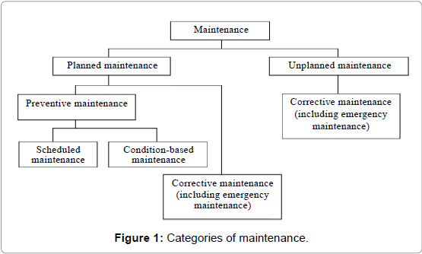
Figure 5. Categories of Maintenance

HVAC Systems, School of Optometry and Science
Within a modern building of this design the HVAC would commonly consume around 60% of the energy consumed as per figure 3. (Carbon Trust, 2017) This is formed on the basis that the equipment is maintained by the guidelines set and running as efficient as possible. As the heating forms a large proportion of the energy consumed I felt it was important to look at the various heating systems in the building, including the heat pump, boilers, AHU and FCU. With a newer build you would expect to have good controls over the plant and equipment like a BMS system.
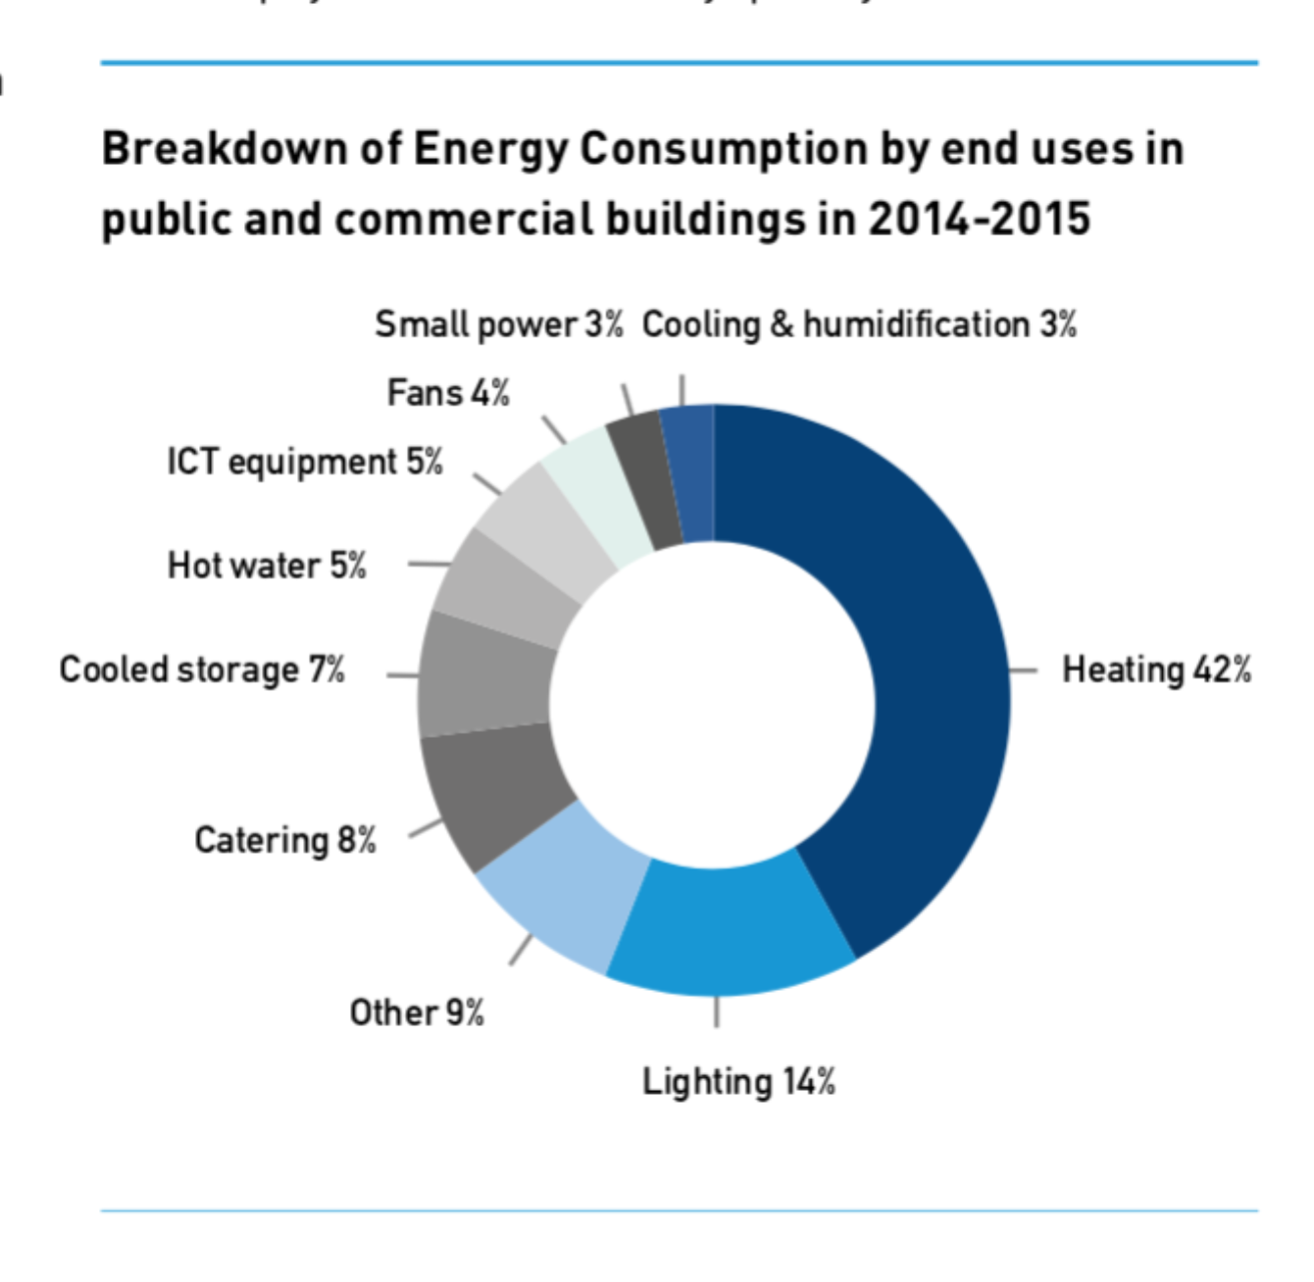
Figure 6, Carbon Trust Energy Consumption in Building

Heat Pump
With the installation of a ground sourced heat pump system, which is classified high efficiency system under L2A, and a sustainable fuel source. It provides a clean and efficient way to heat the building and in this case also cool the building in the summer months. The energy used is electrical power to control the exchange of heat through compressors, and circulation pumps. It provides a low risk, as no fuel is required like other conventional system of gas boilers. As it requires less statutory maintenance checks the general cost of maintenance is lower. No burning is required so lower CO2 emissions compared to other forms of heating (Ground Source Heat Pump Association, 2018). With the open spaces in the building and the number of FCU’s, AHU’s, and under floor heating in the lobby the heat pump makes an ideal application to these system given great energy efficiencies to the building. With the added benefit of the under floor heating which generally operating at 35-40 degrees so heat pumps are ideal for this application, this can result in reduced heat losses and potential energy savings of 5-10%. (CIBSE, Guide F, 2012)
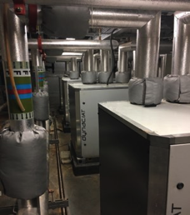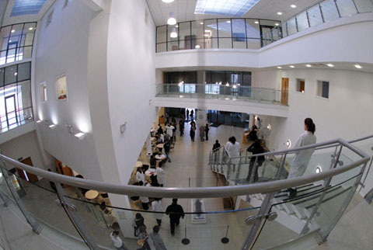

Picture 2. Heat Pumps Picture 3. Lobby Space

Inverters

During the audit it was also noted most if not all the pump sets had inverter driven pumps, as a posed to direct on\off pumps that run 100% load. With inverter driven pumps the driver adjusts the frequency output that controls the speed of the motor, so in low demand period that the motor can run at half the speed using the amount of energy this in turn reduces total power consumption.

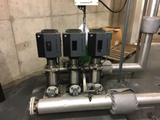
Picture 4 Invertor Driven Pumps

AHU’s
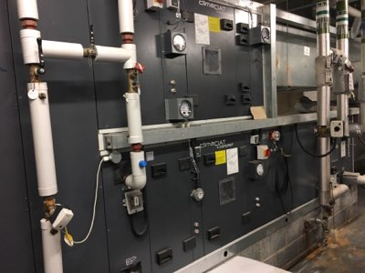
Although throughout the audit there were limitations due to plant being in operation and as the building was in opening hours I was unable to isolate the equipment safety to fully inspect, but you can see by the BMS diagram that the AHU use a heat recovery which are effective way of reducing costs, the BMS suggest is a plate recovery system, as the warm or cool extract air passes over the plate it transfers the energy and the supply air used this to pre heat or cool, looking around 30-70% energy efficiency. With inverter driven fans control there is an added energy efficiency of the unit, been able to monitor the air quality and temp the inverters can optimize the speed to allow better control of the energy consumption.
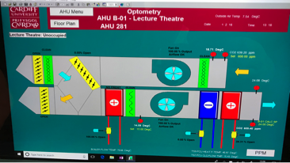

Picture 5. AHU diagrams from BMS Picture 6. AHU
Its important to remember that part of the energy efficiency’s is in design and layout of plant, it was noted during the audit that the AHU supply air intake and extract air ventilation were side by side in a lower walk way area. That means the AHU is short circuiting and that the air supply isn’t that fresh and it potentially drawing warm air back into the building the it trying to remove.
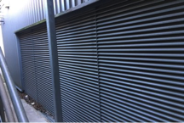
Picture 7. AHU ventilation intake and extract

FCU’s
Again due to time restrictions and being able to isolate equipment some assumptions will need to be make. Using the age of the building and assuming the its been fitted at the time with energy efficient equipment FCU are variable air volume, which are 80% more efficient than the older FCU. (CIBSE Guide F, 2012). By the diagrams shown on the BMS there seems to be good zoning of FCU, watch will enable the building to regulate the temperature in accordance with demand from solar gain will increase the energy efficiency’s.
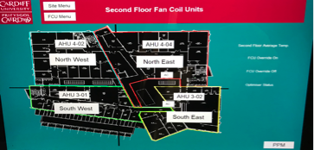
Picture 8 FCU layout, BMS

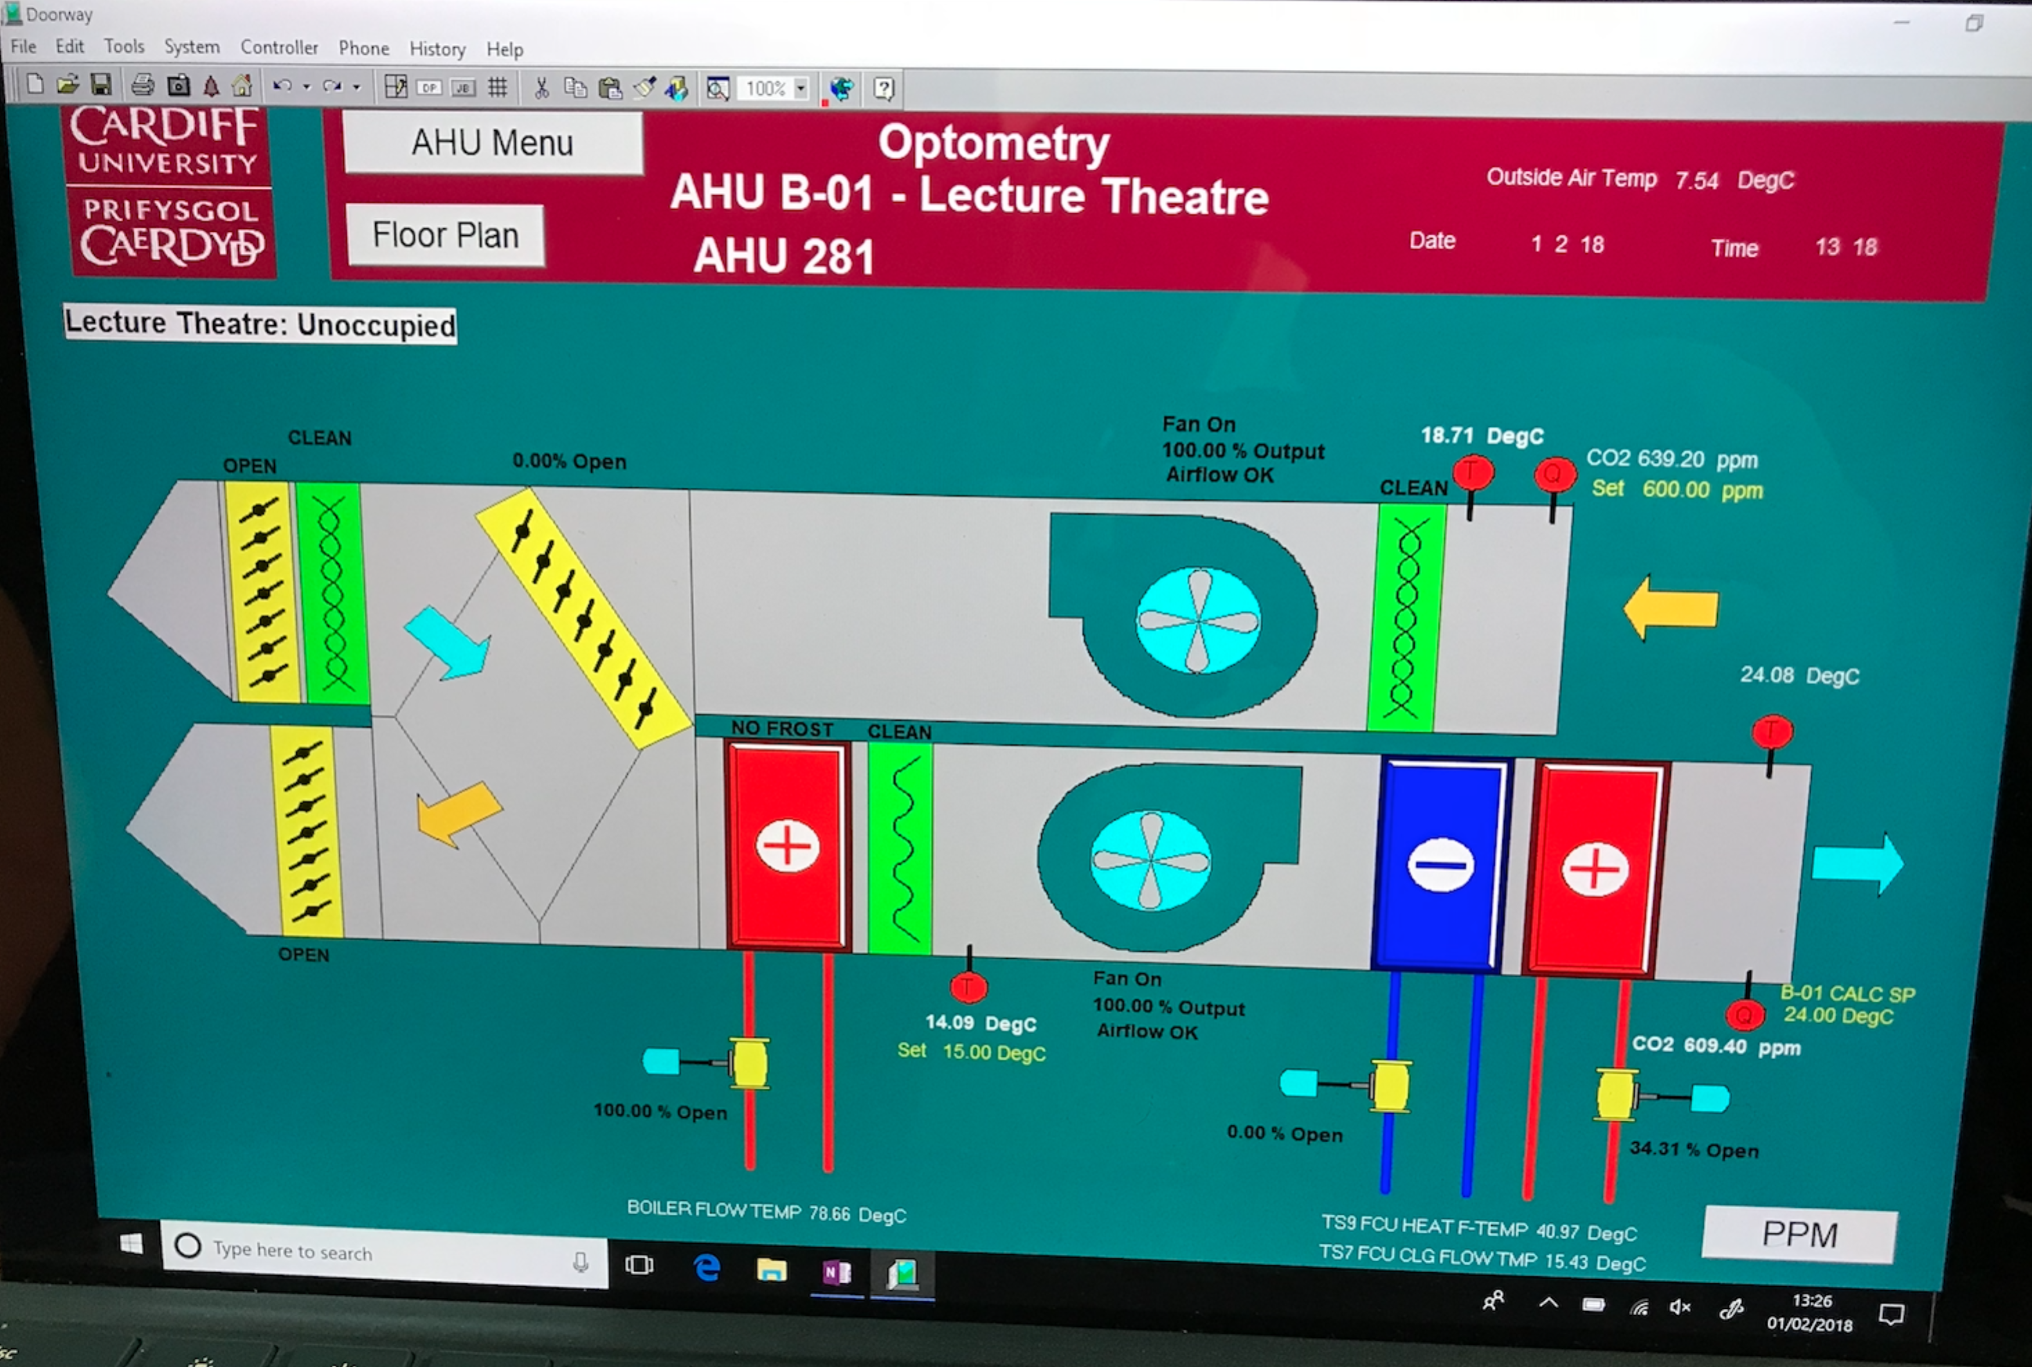
One of the main issues with the combined heating and cooling is that it can cause problems if both the systems can fight against each other, its critical to have the systems interlinked and with good zone selections. As shown in picture 9 the supply air temperature into the area is higher than the extract air temperature, which would suggest that the room is been cooled some how. This means the plant is working harder and longer than it should, being wasteful in energy. Further investigation will need to be required to establish the cause.

Picture 9. AHU BMS
Hot Air Curtain
As you pass through the sliding main entrance door on the ground floor you are hit with a blast of warm air, which was rushing directly outdoors, and directly past that, walking further into the atrium it was noticeably cooler.
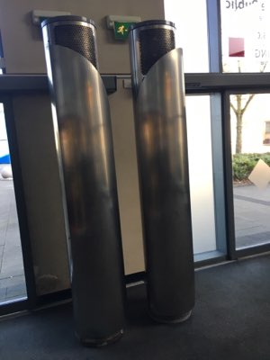

Picture 10. Hot Air Curtain

Lighting
As lighting is one of the biggest consumers of energy around 14% of total energy within a commercial building (carbon trust, 2017), only second to that of heating it’s important that utilisation of natural lighting is used as much as possible, as highlighted in the pre-visit research there are a number of vertical windows around the building, but also atrium glass panels. It was a bright sunny day when the audit was under taken, but there seemed to a large amount of lighting switched, notable was the one of the atrium on the ground floor where there was natural lighting available through the roof top glass, but all lighting was switched on including uplighters and wall lights. The glass looked dirty and could have been affecting the efficiency of natural lighting into the area.
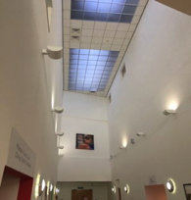
Picture 11. Ground Floor Lobby
A number of lecture rooms and science rooms that were unoccupied all lighting switched on. Although local controls were present there seemed to be disregard to how much energy could be saved by simply switching off the lights when not in use. There is an argument that switching off compact fluorescent lights in short periods isn’t saving any energy as the main energy consumption is in the start up of the lamp, and with continued on/off start up this will shorten the life of the lamp. General rule of thumb is if the area is going to be unoccupied for more than 15mins there is potential savings, that is why the conventional on/off manual switch could be changed to a occupancy sensor with a built on delay of movement for 15 minutes to optimise the energy efficiency’s of the lamp. (energy.gov, 2018)

BMS
Within the optometry building the plant including heating, air handling units, fan coil units, pumps and some lighting is controlled through a centralised trend building management system, which is accessed through a front end system called doorway. The good practice guide of 246 building management systems indicates that maintaining a BMS system can save energy consumption by 10-20% while maintaining and in some cases improving the comfort levels within the environment. (best practice guide 246, 1998), this is also backed up in the CIBSE guide F, 2012. With BMS controls present the plant is able to run efficiently by the using various inputs like room temperature sensor allowing the air handling units or fan coil units to regulate the room temperature automatically ensuring its optimising the energy efficiencies of the plant, by the use of outputs to heating or cooling control valves to open and close when required. Its important that the BMS is serviced regularly and maintained to achieve the high performance of energy efficiency, with an 1% increase in overheating of the area can increase the general cost up to 10 – 15% (Dicks, 1997). Under reviewing the BMS schematics a few sensor were reading -40degrees and +40 degrees which is a default setting on the BMS indicating the sensor is faulty. With the faulty equipment the BMS will be unable to run at full efficiencies even overheating rooms causing increase in consumption.
It was noted that there were Fan coil units in the stairway in operation blowing out warm air where there was very little requirement for a FCU in a fire stairwell, the BMS shows zoning of the FCU units, so saving could be made through the system by reducing the use of these units by reprogramming the run times or by a lower space temperature set back.

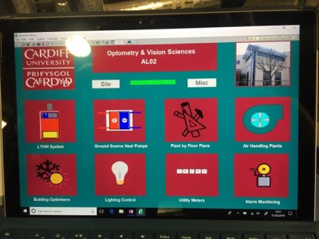
Picture 12. BMS Front Page
Conclusion/Recommendations
Quick wins
Through the walk around of the building is was unclear what the energy culture was within the building, is all the students, staff and guests entering the building aware how they could influence the CO2 reduction of the building. The green board was located on the top floor down one of the back corridor, with out of date literature. It would be a good idea and cost good exercise to locate the board in a more forward position, setting current targets, potentially offering an incentive scheme for any energy suggestions that are taken up and implemented into the building. This will try and create a positive energy culture with an added bonus of incentives, which maybe a free eye test or free glasses. Another idea, which is low cost, is a yellow card red card for employees that repeatedly leave equipment switch on which maybe computers over night and lights. A lift policy of one up and two down could be implemented this reducing the operation of the lift saving in energy consumption, without knowing the Kw rating of the motor it would be hard to determine the savings.
In the analysis of the data it was highlighted the energy readings were not actuate and required further investigation, to be unable to monitor and set targets, this is information being an essential asset if they are to work to their full potential
In the site visit you could see that there is a proactive maintenance strategy as in most of the plant rooms there were a number of old pumps and motors that had been replaced, and around £80K being spend on the BMS system (Durdin, 2017), with this large investment all systems should be in full operating order, but as highlighted the BMS system had sensor faults, and a few plant failures including one of the heat pumps, a full service of the BMS correcting any faults will benefit the energy efficiency’s .
Long Term Capital Investment
It was noted in one of the lecture rooms that the solar gain was high even in the winter months so the curtains were pulled this reducing the effects of natural lighting as all the lights were switched on. To make the most out of the natural lighting but also repel the effects of solar gain it would be recommended to install solar film to the window with up to 78% of solar energy rejected back into the atmosphere
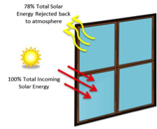 Picture 13. Solar Film

Another potential area of investment to save energy but also enhance customer experiences while using the facilities, would be upgrading the current sliding entrance doors to revolving doors. Case study done by MIT researchers in America on campus, found that revolving doors could save up to 15 ton of CO2 emissions a year, up to 74% saving in energy (Christopher Curtland, 2013). By providing a continues seal to the outside and inside air, this will decrease the amount of heating air currently escaping through the sliding doors, resulting in the heating system being more efficient and placing less demand on the energy consumption to the building. The added effects with it will reduce the risk of slips on a wet floor due to wet fee, as feet get shuffled when passing through the revolving door, but also the guests will enjoy the comfort of a the room temperature being stable.

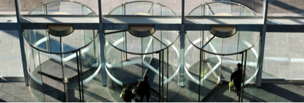
Picture 14. Revolving Doors

References
A.Lewry, 2013, BRE, Energy Survey and Audits
Best Practice Guide 246, 1998, Web: https://www.cibse.org/getmedia/02efe17e-5efe-4171-b272-c5e2c10c53ce/GPG246-Building-Management-Systems-in-Further-and-Higher-Education-(1998).pdf.aspx
BURDON, S. BHALLA, A. (2005) Lessons from the Untold Success Story: Outsourcing Engineering and Facilities Management, European Management Journal, V23, N5, pp 576-582
Carbon Trust, 2012, Degree days for energy management, web: https://www.carbontrust.com/resources/guides/energy-efficiency/degree-days/#docdownload-6431
CHRISTOPHER CURTLAND, 2013, web:https://www.buildings.com/article-details/articleid/15979/title/automatic-doors-vs-revolving-doors
CIBSE Guide F Energy Efficiency in Buildings (2012) The Chartered Institute of Building Services Engineers, London.
DICKS, M.J, BROWN, R.G. (1997) Heating Control in Large Spaces, The Building Research and Information Association, Bracknell
DURDIN, Mark (2017) Energy Manager, Cardiff University, Site walk with Author, 1st Feb 2016.
Ground Source Heat Pump Association, 2018, Web: https://www.gshp.org.uk/ground_source_heat_pumps.html

J Armstrong, 2008, Chartered Institution of Building Services Engineers, Guide M Maintenance engineering and management
J W Field, 2006, Chartered Institution of Building Services Engineer, Energy assessment and reporting methods
Mills, E.D., 1994. Building maintenance and preservation : a guide for design and management 2nd ed., Oxford: Butterworth-Heinemann.

Non-domestic Building Services Compliance Guide (2010) HM Government,London
Seeley., 1987. Building maintenance. 2nd. ed., Macmillan.

US department of energy, 2018, web: https://www.energy.gov/energysaver/when-turn-your-lights
Visit us [online] Cardiff University, last accessed on 12 March 2018 at https://www.cardiff.ac.uk/visit/map
Wood, B., 2003. Building care, Oxford: Blackwell Science.

