Daniel Adam Carlson (2001079) NETWORK OPERATING SYSTEMS AND SERVICES - ACCA5023 - Due Date: 29/04/2022
Manage and maintain network resources, and its services applying suitable policies and drafting security and redundancy practices.
School Of Applied Computing
Table of Contents
Worksheet 2 – Task 1 - MANAGING AND MAINTAINING NETWORK RESOURCES USING NETWORK POLICY AND SECURITY PRACTICES 3
Shared Folder and Document Creation 3
Permission Modification and Implementation 4
Default Permissions: 4
Configured Permissions: 4
Verification: 5
Server Share Drive 5
Client Shared Drive Access: 6
Group Policies 6
Organisational Unit Creation 6
GPO 1 – Control Panel Moderation 7
Verification 7
GPO 2 – Command Prompt Moderation 8
Verification 8
GPO 3 – Removable Drive Access 8
Verification 9
GPO 4 – Software Download Moderation 9
Verification 9
GPO 5 – Enforcing a Password Policy 10
Verification 10
Worksheet 2 – Task 2 - ROUTING AND PACKET FILTERING WITHIN CORE TCP/IP SERVICES AND CRITICAL FAILOVER/REDUNDANCY PRACTICES 11
ARP and Routing Commands 11
FTP Server Installation and Configuration 11
Site Access Configuration and Setup 12
Dedicated User Setup 12
FTP Upload File Creation 13
Client FTP Access 13
Verification 14
Routing and Remote Access Installation and Setup 14
Enabling Routing and Interface Config 15
Verification of Connectivity 15
IP Packet Filtering 16
Filter 1 – PrivateNet1 Moderation 16
Filter 2 – FTP Access 17
Filter 3 – Specific Host Access 18
Password Principles 19
Failover Clustering 19
Network Construction 23
Policies 23
Security and Threat Management 24
References 25

Assignment 2- Network Operating Systems and Services

Worksheet 2 – Task 1 - MANAGING AND MAINTAINING NETWORK RESOURCES USING NETWORK POLICY AND SECURITY PRACTICES
The first part is understanding and implementing share and NTFS principles within server management. This section introduces the methods and functions of configuration and implementation of shared drive access and use of file access and permission settings.

Shared Folder and Document Creation
Initially, it was required to create a dedicated file for this activity. The file created would then be used to demonstrate permission configuration and implementation.
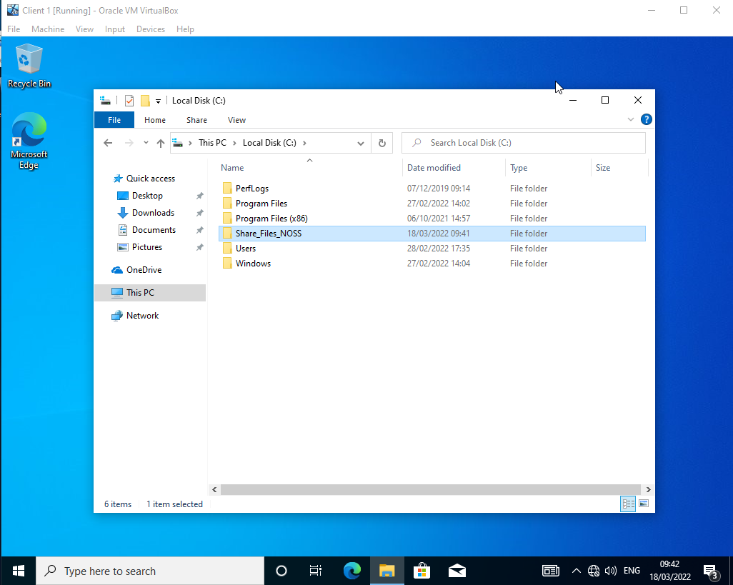

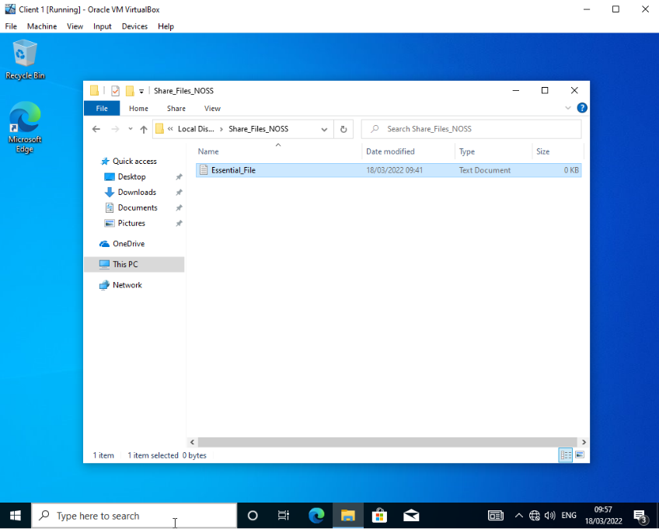

Permission Modification and Implementation
To restrict access to some regions of the file, e.g., a specific file, specific permissions can be given to each user regarding their access level. Using this method allows management to restrict files within an organisation. As Demonstrated below:

Default Permissions:
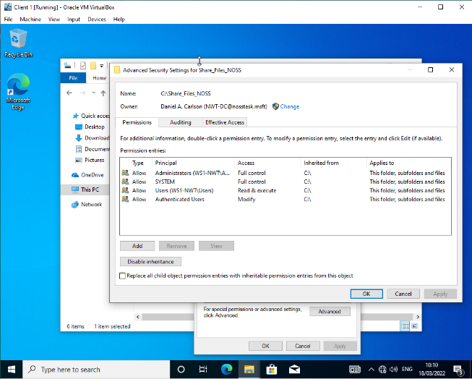

Configured Permissions:
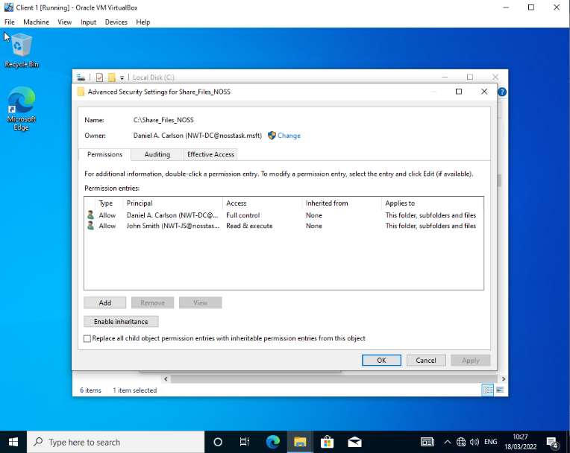

Verification:
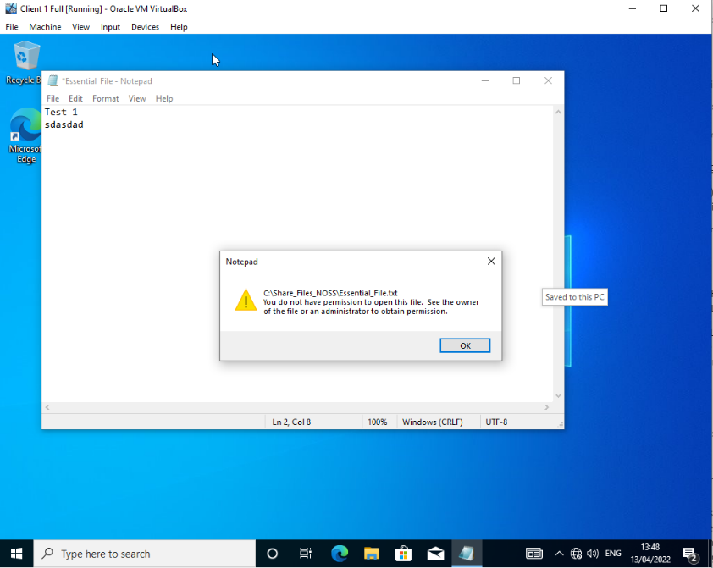
Permission verification, to verify the permission changes, it was essential that each user was checked. Below is the non-Admin user. It is unable to save or modify the file.

Server Share Drive
Within a server, it was essential that to configure a shared access file within a client device, it must be set up within the share page on the server, which would allow specific user accounts to access the shared drive if added.
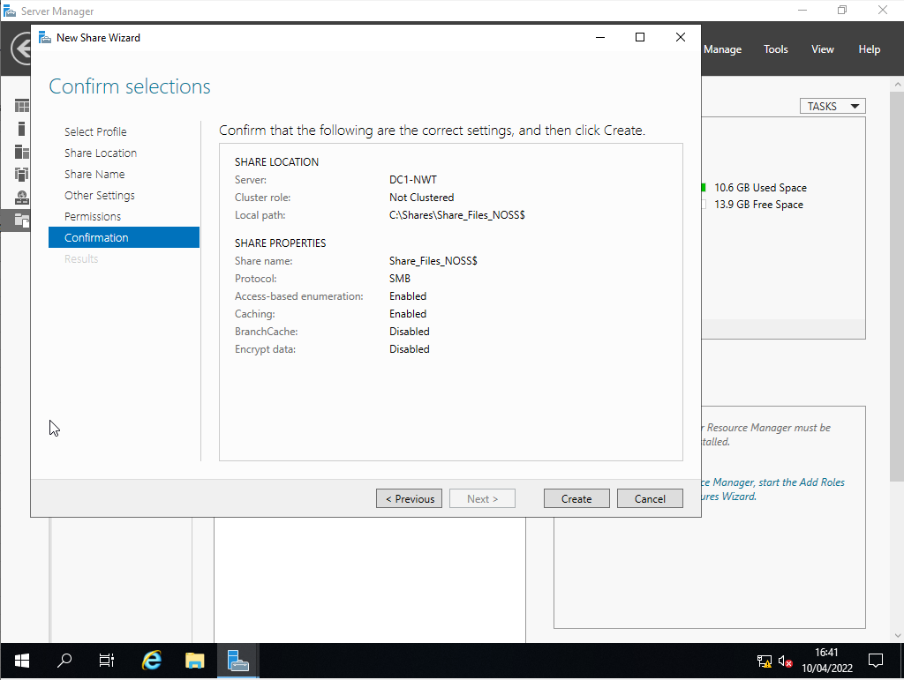

Client Shared Drive Access:
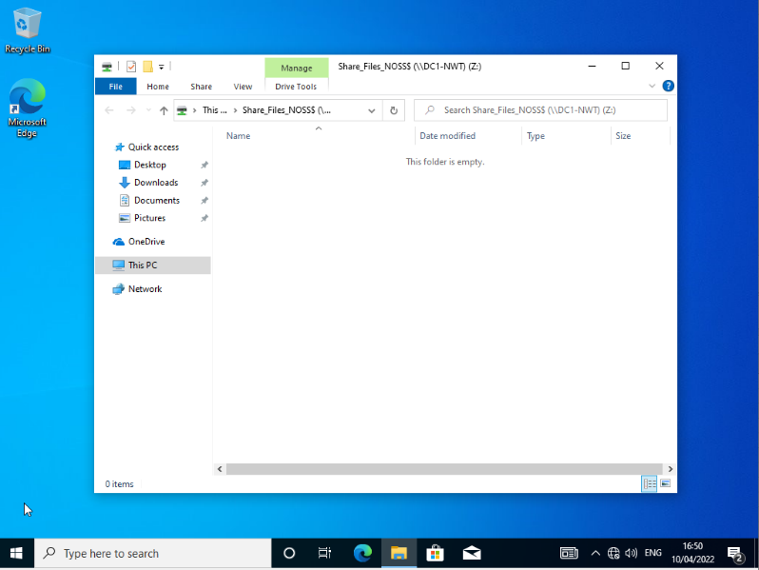
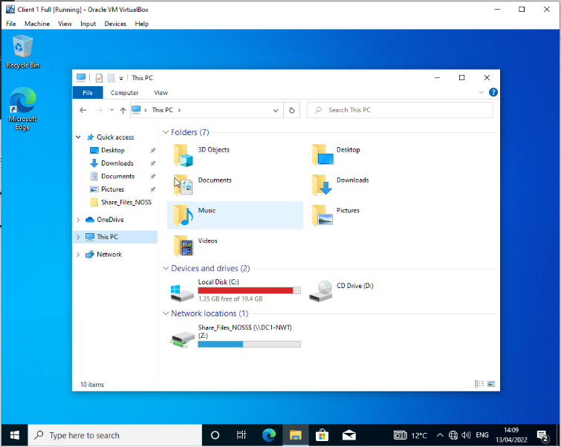
After initial configuration, for the client to receive the created share drive, it must be added by the client administrator within the host client. It is required to have the full root name of the shared drive location within the server for it to be added.

Group Policies
Group Policies are a crucial part of the server and organisational management. GPs are used to send widespread configurations and settings to user groups. There are numerous levels of Group policies, but this task requires the use of Organisational Unit Policies. It is necessary to configure four different policies within this task.

Organisational Unit Creation
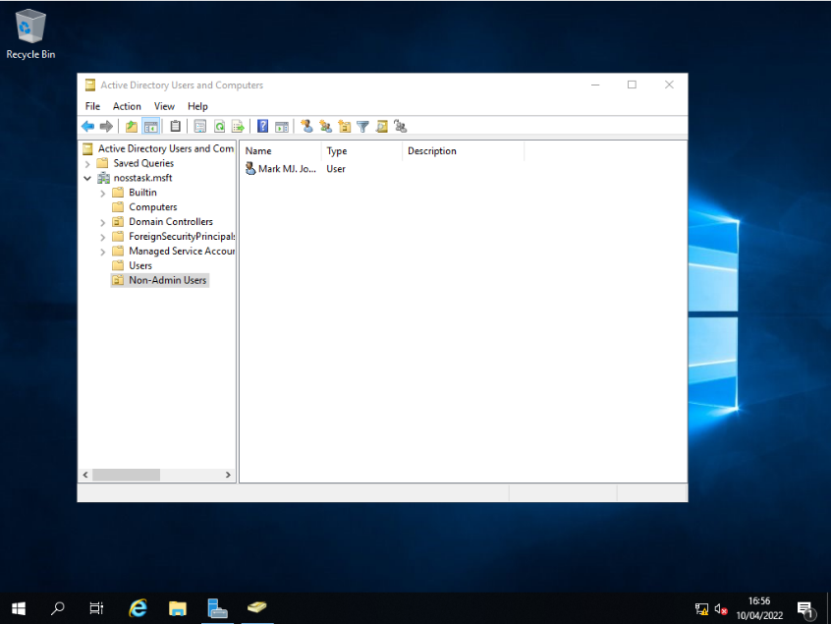
Within the worksheet, before creating the policies, it was essential to create a new OU where the guidelines would be applied.

GPO 1 – Control Panel Moderation
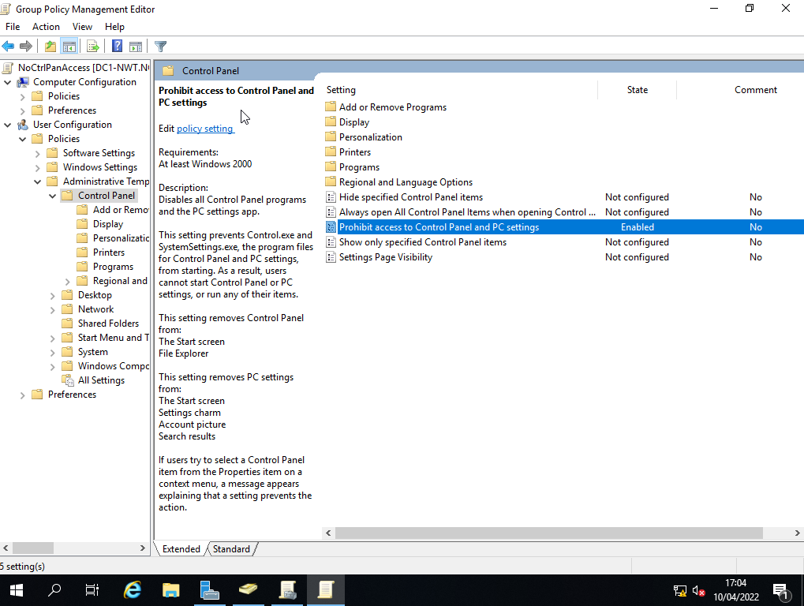
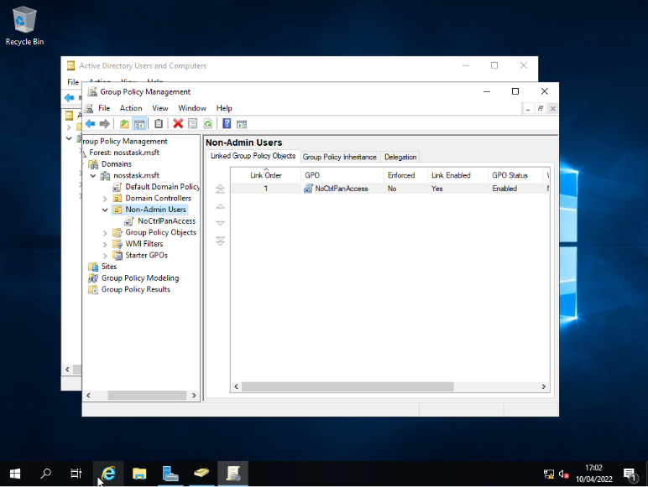
Firstly, it was necessary to create, configure permissions and moderate access to the control panel for non-Admin users within the created OU.
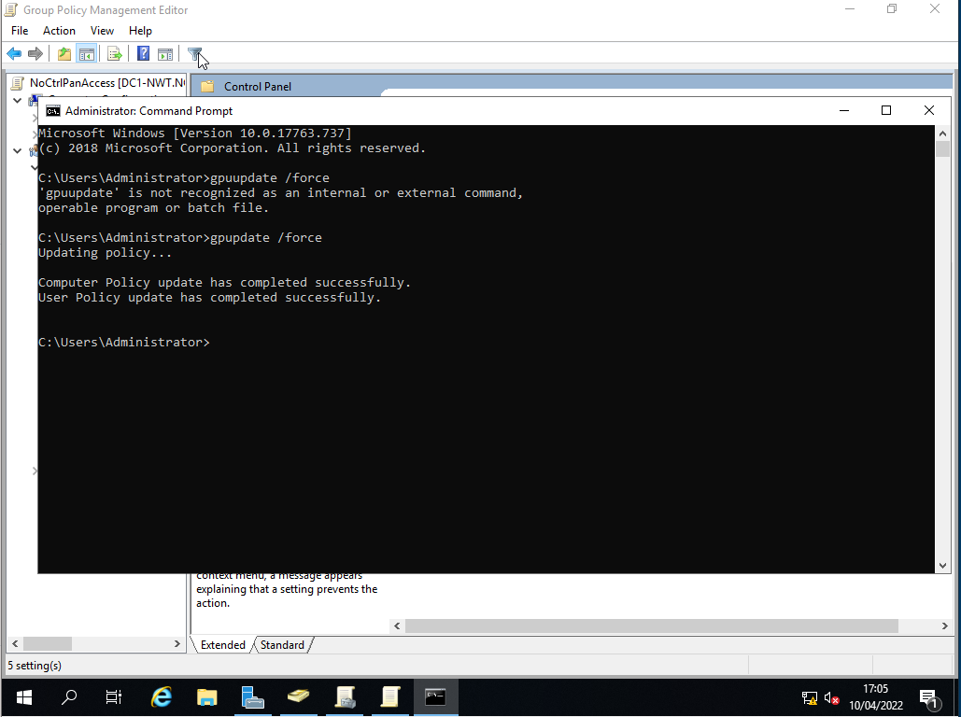
After implementation, the next step was to force an update to the domain to apply the changes. This method is universal to each GP.

Verification
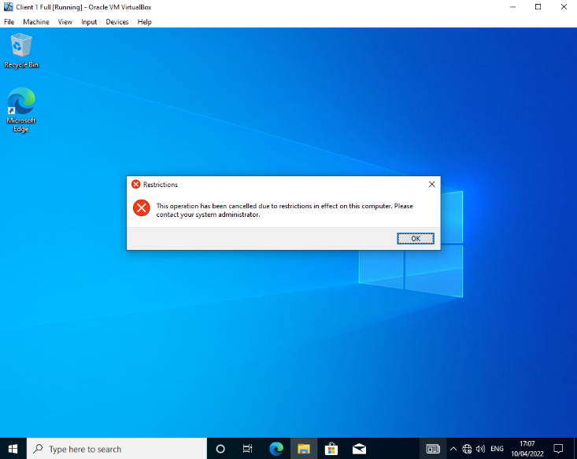
Finally, every policy created needs to be verified within the user account.

GPO 2 – Command Prompt Moderation
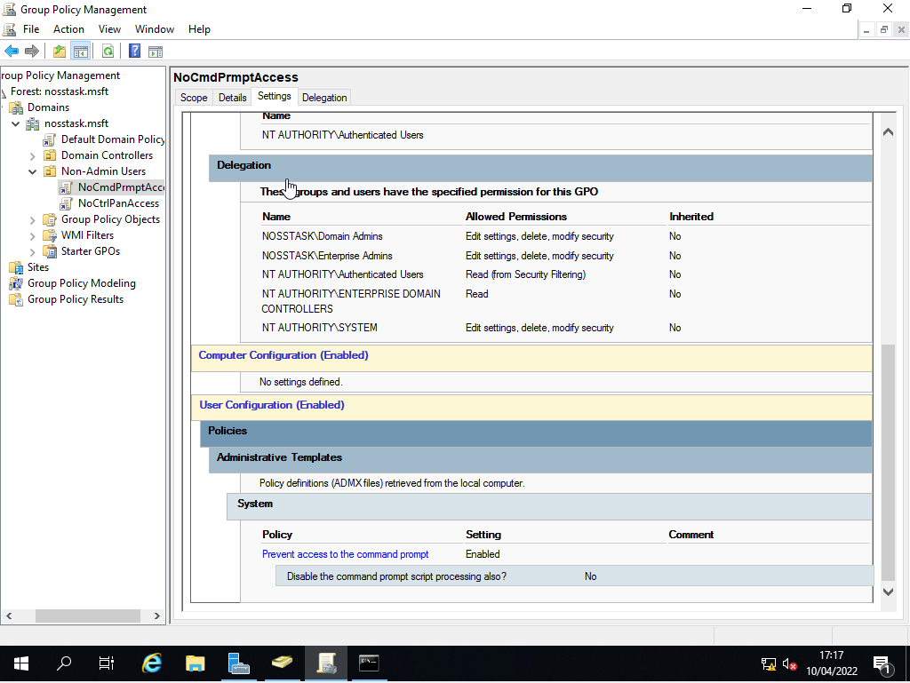
Next was the moderation of access to the internal command prompt within the client machine by a non-Admin user.
As demonstrated previously, the forced update would then be required to enforce this policy.

Verification
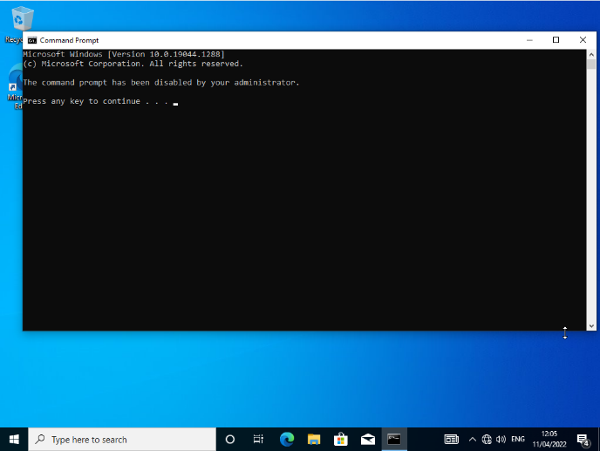
Verification of GP creation and implementation.

GPO 3 – Removable Drive Access
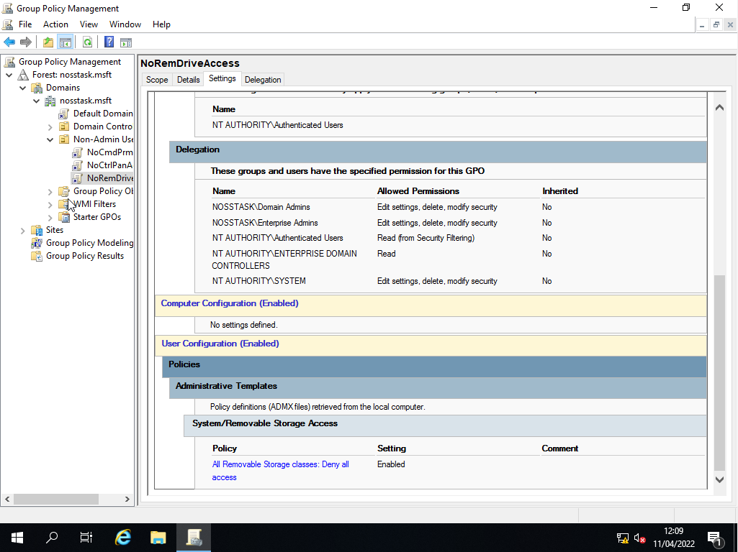
Removable drives are a massive cause for most major viruses and malware within organisations and devices. Therefore one central policy restricts all unauthorised users’ access to any removable drives within the host client.

Verification
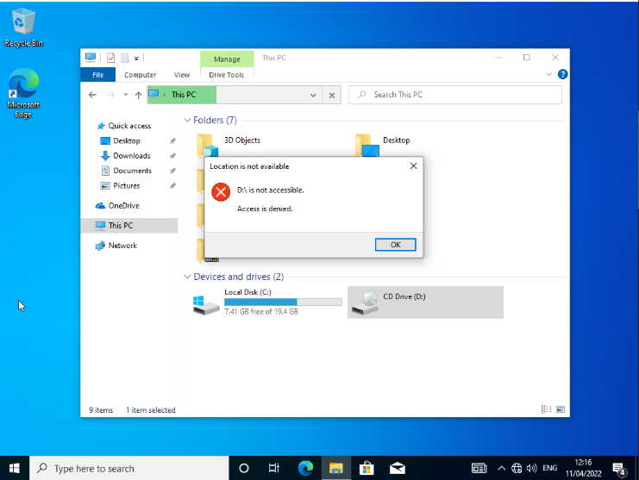
Verification of Policy:

GPO 4 – Software Download Moderation
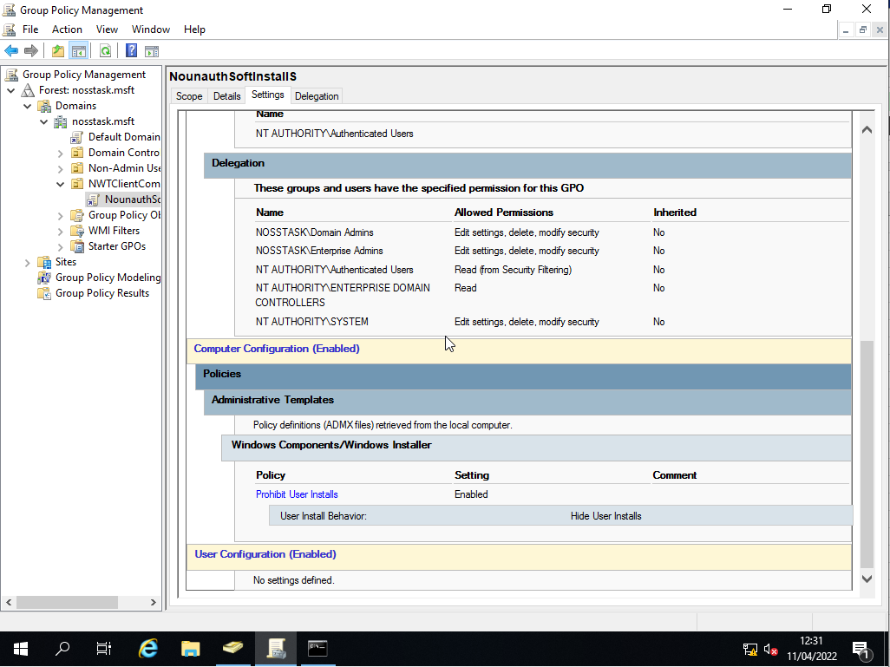
Moderating software installations ensures the safety and threat negation within an organisational network. One of the main threats within a network is unknown software downloads. This policy provides the dissolution of this problem.

Verification
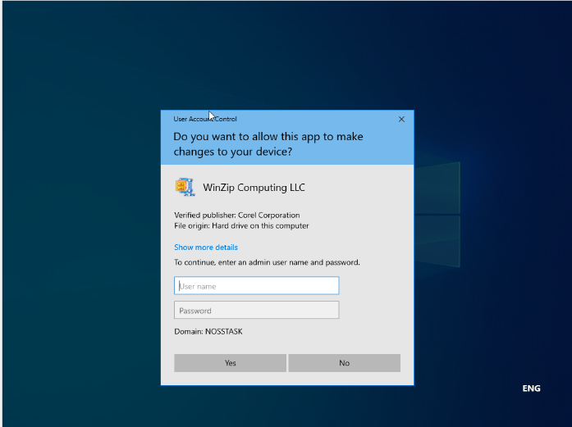
Software Install Denied

GPO 5 – Enforcing a Password Policy
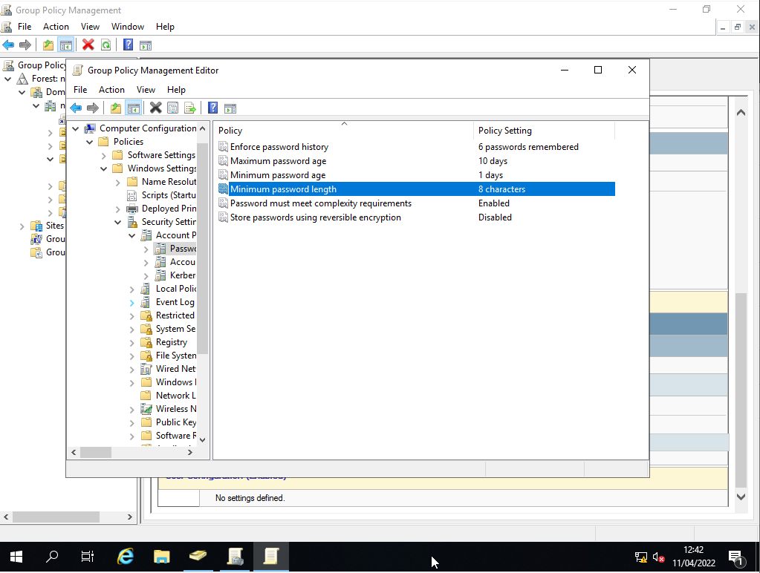
The final policy within the worksheet for Task 1 was enforcing a strict password policy. A firm password policy ensures that the chance of passwords being cracked/bypassed is highly reduced.

Verification
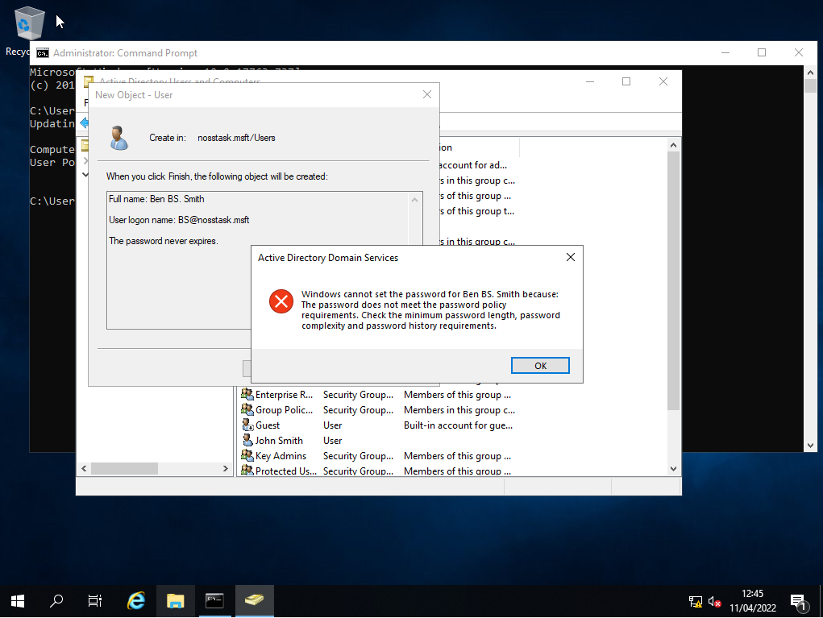
To verify the policy, it was necessary to create a new user and attempt to create a password that did not reform the policy.

Worksheet 2 – Task 2 - ROUTING AND PACKET FILTERING WITHIN CORE TCP/IP SERVICES AND CRITICAL FAILOVER/REDUNDANCY PRACTICES
The final aspect of the worksheet was to understand the use of ARP and Routing Tables and the configuration and implementation of Routing and Remote Access services within a network. But also understanding and implementing the use of FTP protocol.

ARP and Routing Commands
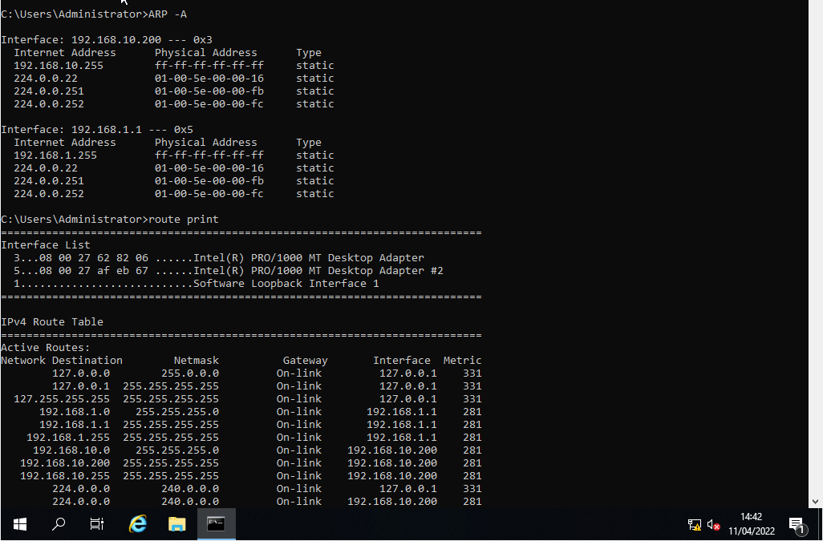
We can use ARP protocol to identify and investigate what devices or servers have been connected to the host device or whether the ping command has been successful. The outlook of the table is demonstrated below:

FTP Server Installation and Configuration
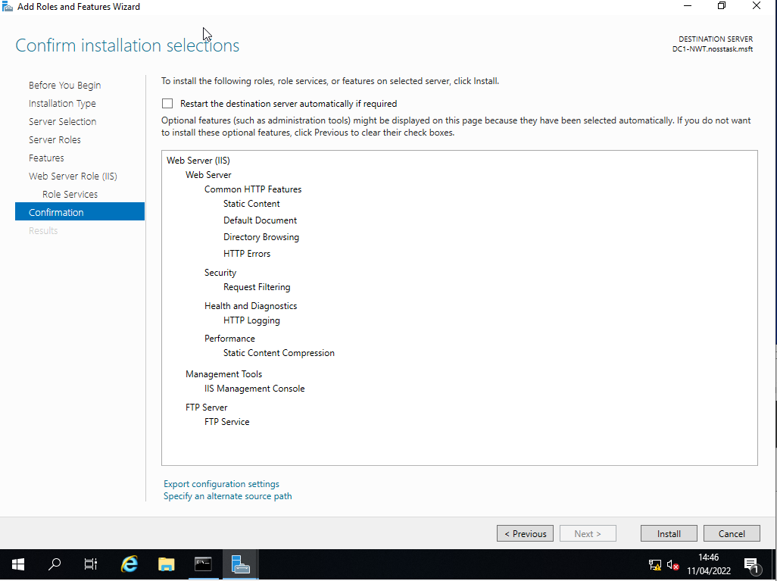
Firstly, it was nessecarry to install the relevant features within the server that would allow the use of FTP services.

Site Access Configuration and Setup
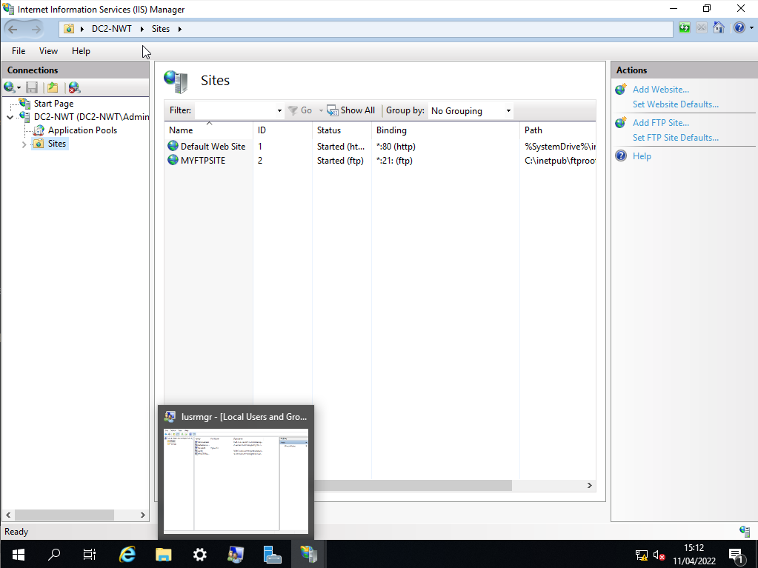
Next, after the initial configuration, the next step was to create a dedicated FTP Site that the client could access within the host machine.

Dedicated User Setup
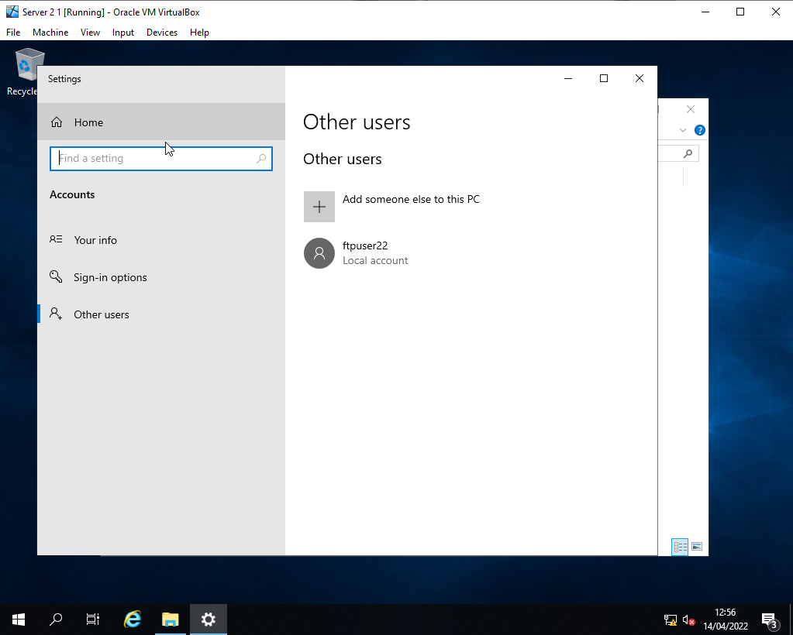
A dedicated user is required for the FTP server to be accessed by a host. The user is configured as needed below:

FTP Upload File Creation
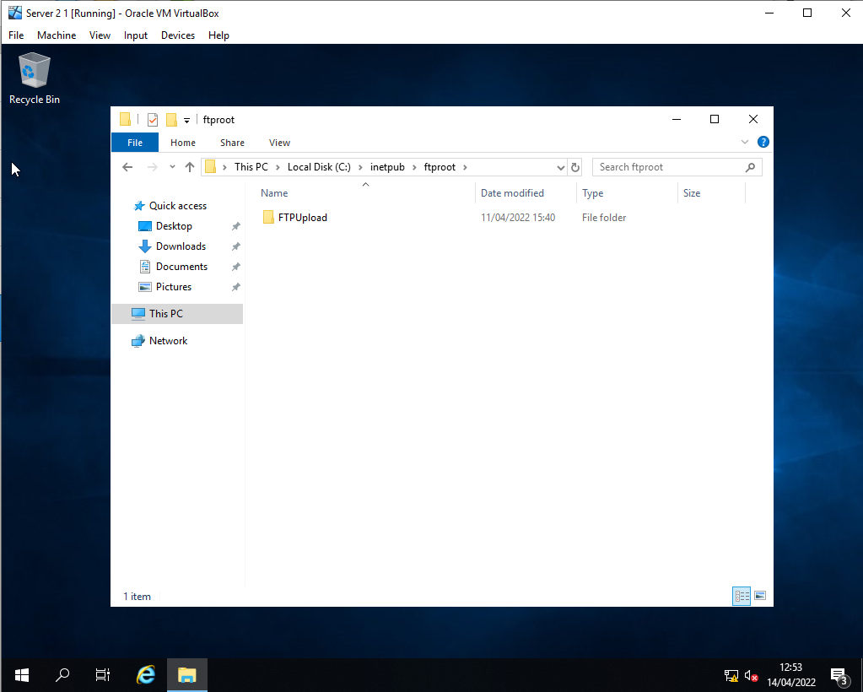
Before anything is allowed to be created, A destination for upload is requested within the worksheet. This folder will be used to store all uploaded files through FTP.

Client FTP Access
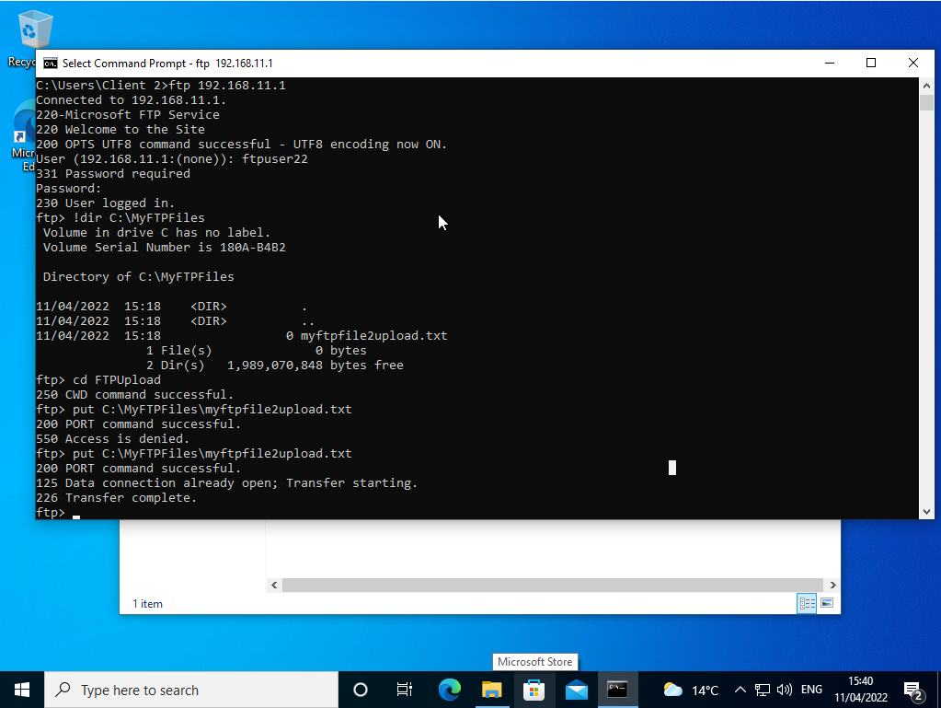
Next was verifying that the client machine/user could remotely access the FTP server and upload the relevant files using the newly created user.

Verification
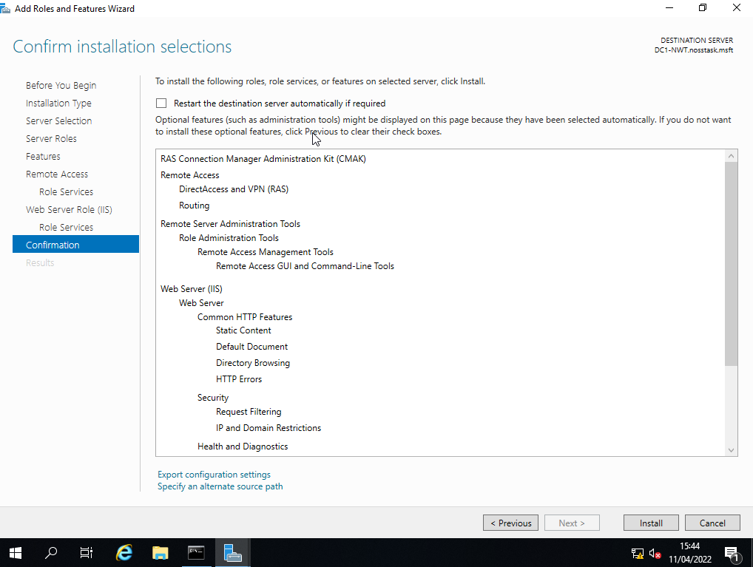
The final task was to verify that the uploaded file/command was successfully uploaded to the relevant directory within the server.

Routing and Remote Access Installation and Setup
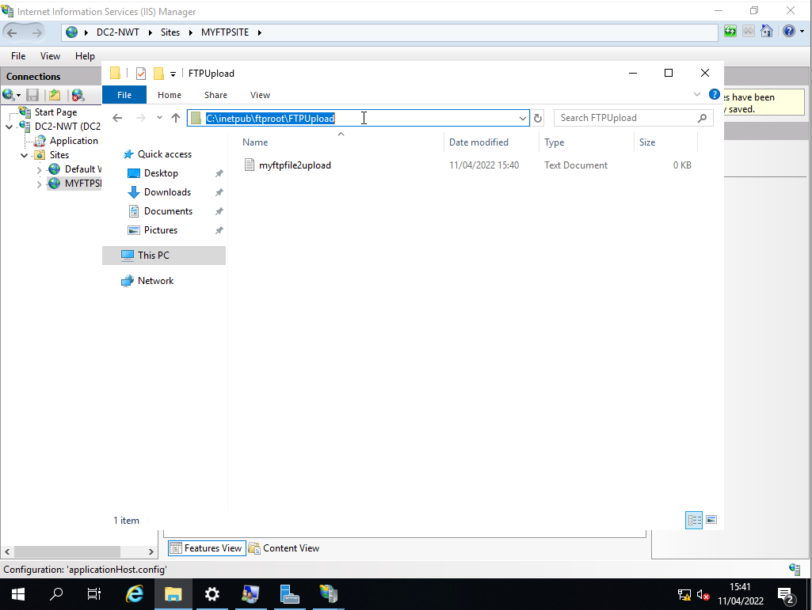
The Routing and Remote Access protocol will allow us to create a few networks to enable each network to communicate. In this case, Server 1 and Client 1 can communicate with Server 2 and Client 2.

Enabling Routing and Interface Config
Here, routing is enabled within the server, RIP is added within the server, and each interface within the server is added. These steps are universal to both servers.
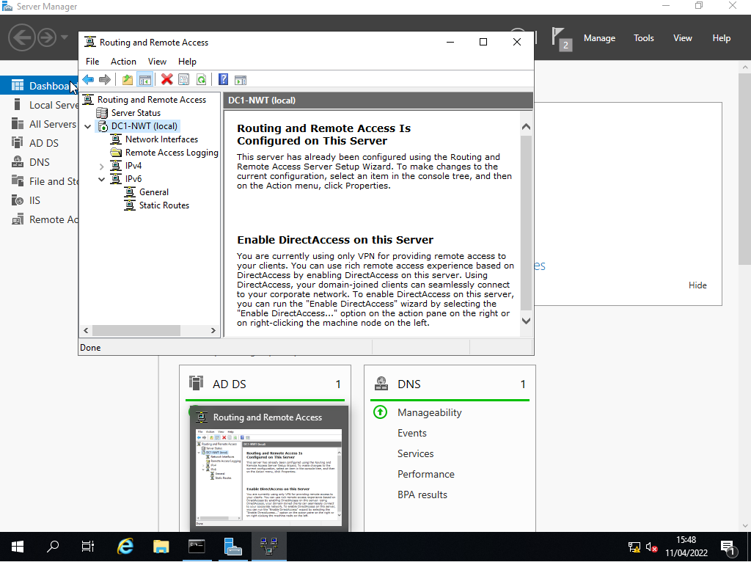
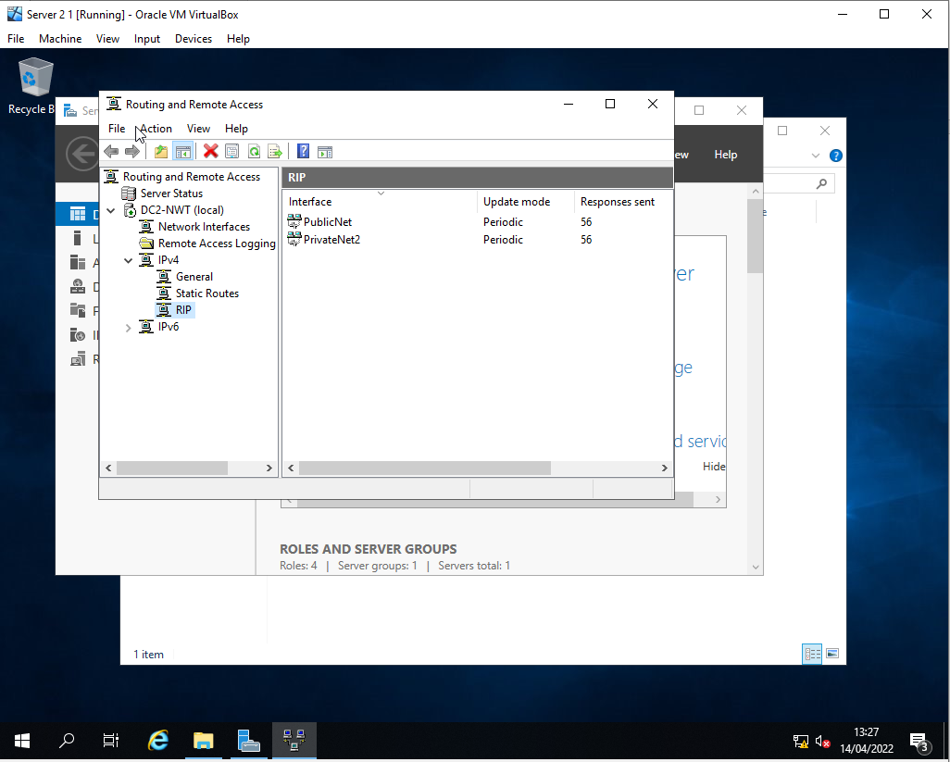

Verification of Connectivity
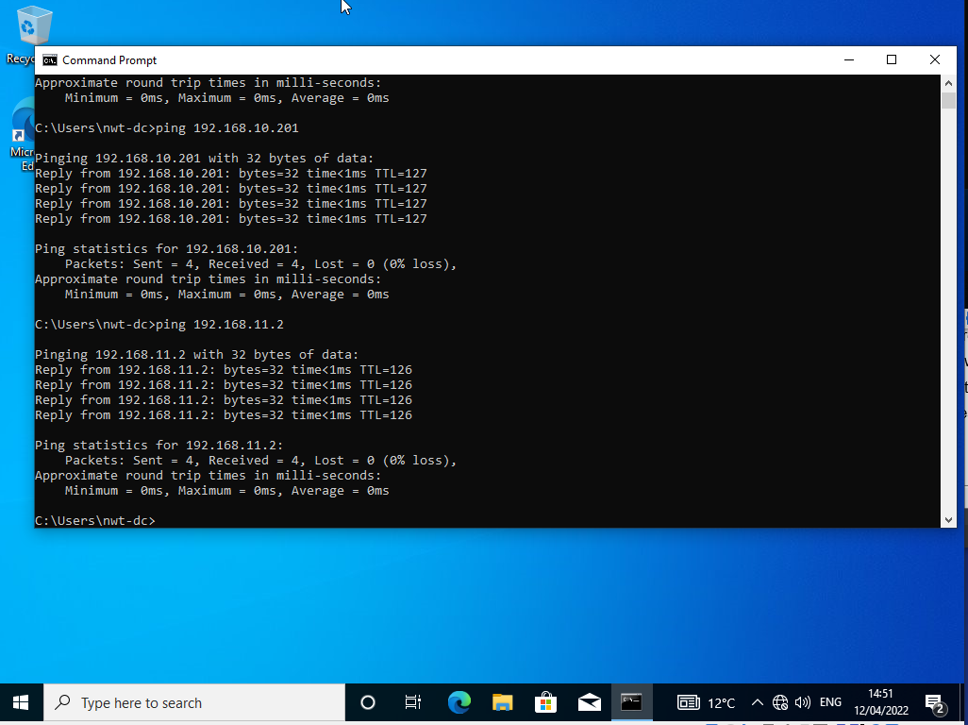
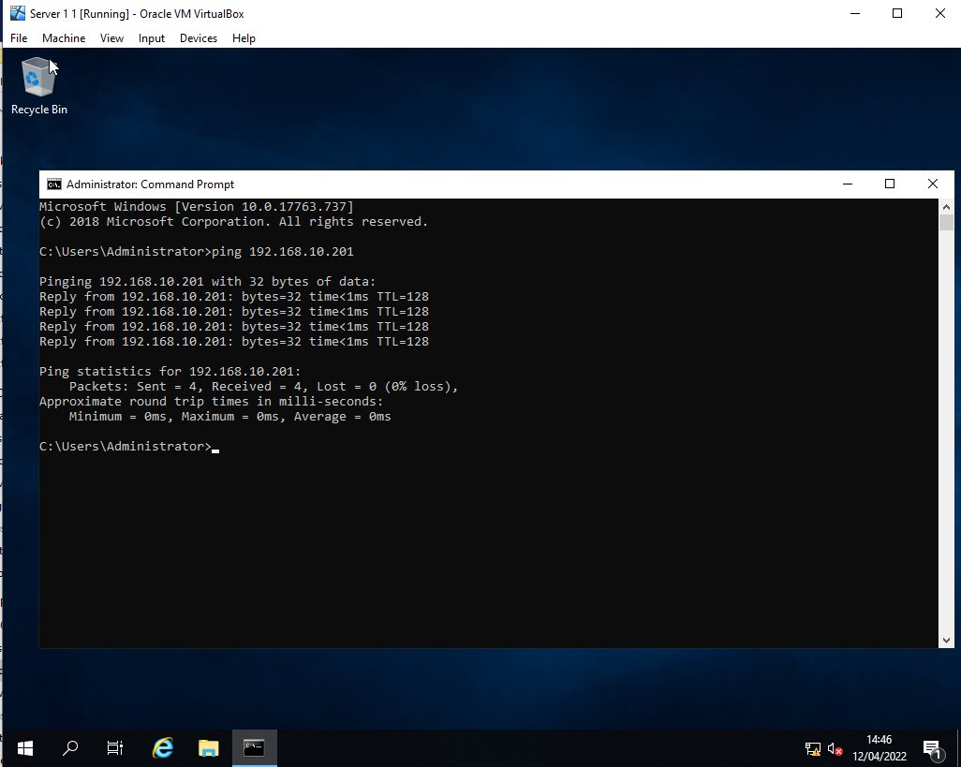
Finally, verification was needed to ensure that the routing was configured correctly.

IP Packet Filtering
Packet Filtering is one of the most basic firewall configurations available. It is used to restrict specific access to IP addresses etc. It helps control and moderate access to critical services and protocols within the network.

Filter 1 – PrivateNet1 Moderation
The first filter ensures that no device on PrivateNet1 can access anything within Server 1, including protocol commands.

Configuration
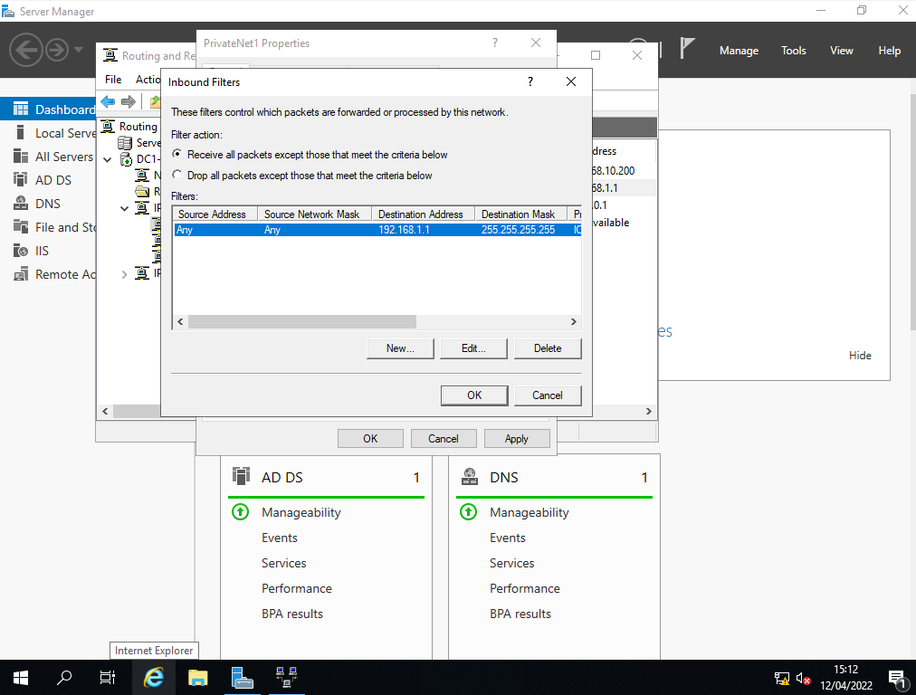

Verification
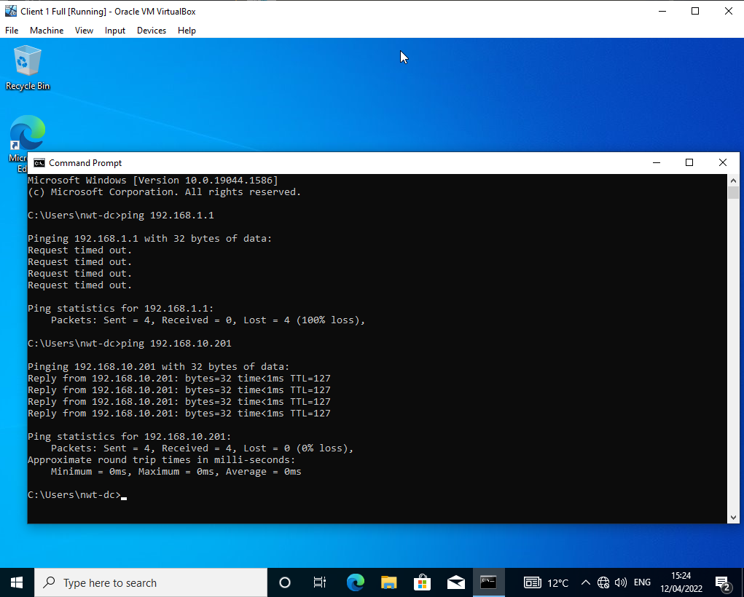

Filter 2 – FTP Access
Filter 2 restricts all access to the FTP server apart from PrivateNet2 Clients. Any other access attempt would be denied. This is done using Outbound Filters on Server 1 for any IP address within Server 2.

Configuration
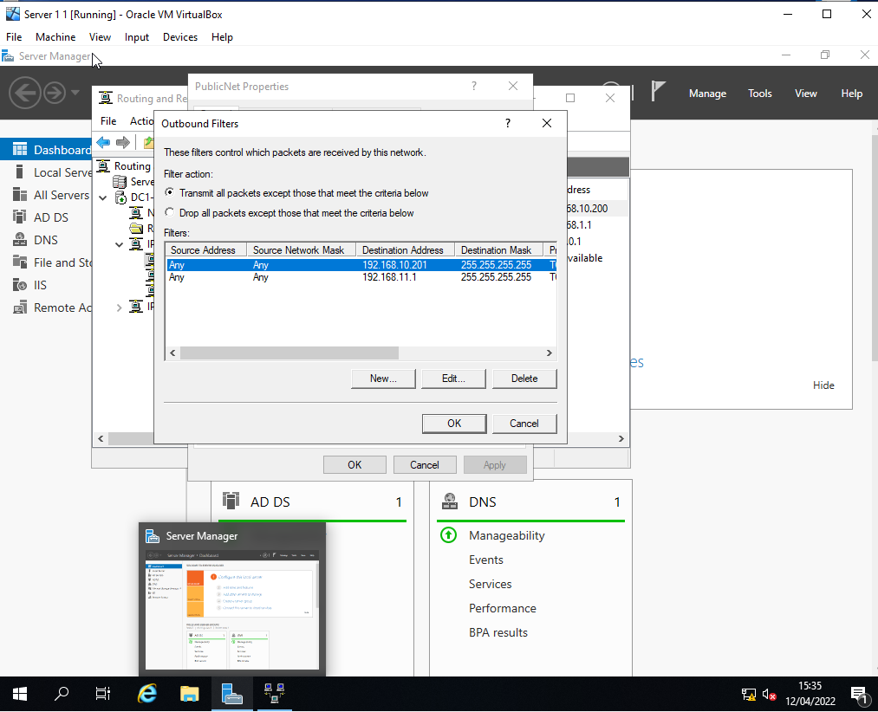

Verification
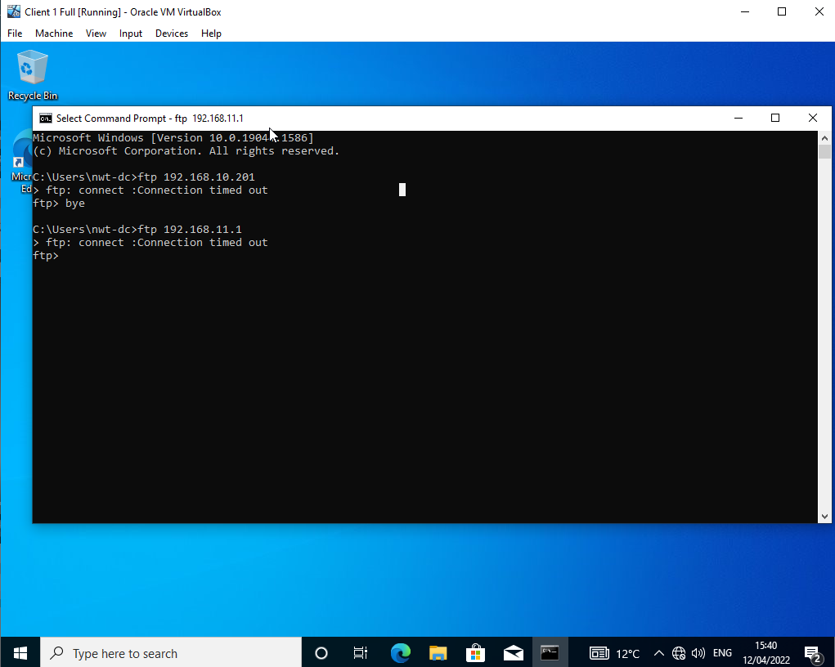

Filter 3 – Specific Host Access
The final filter was to restrict all access to the FTP server apart from the Client 1 host. Inbound traffic filters were used to specify access to Client 1 only. Inbound Filters for 192.168.1.2 on Server 1 and Server 2 Inbound Filter for 192.168.11.2 were used to restrict access.

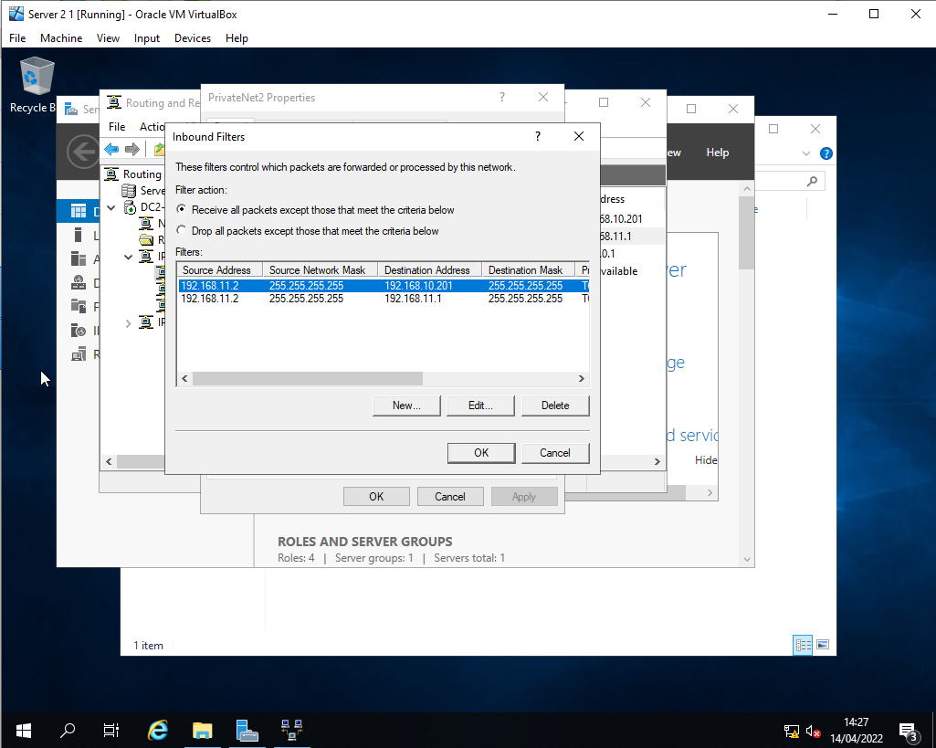
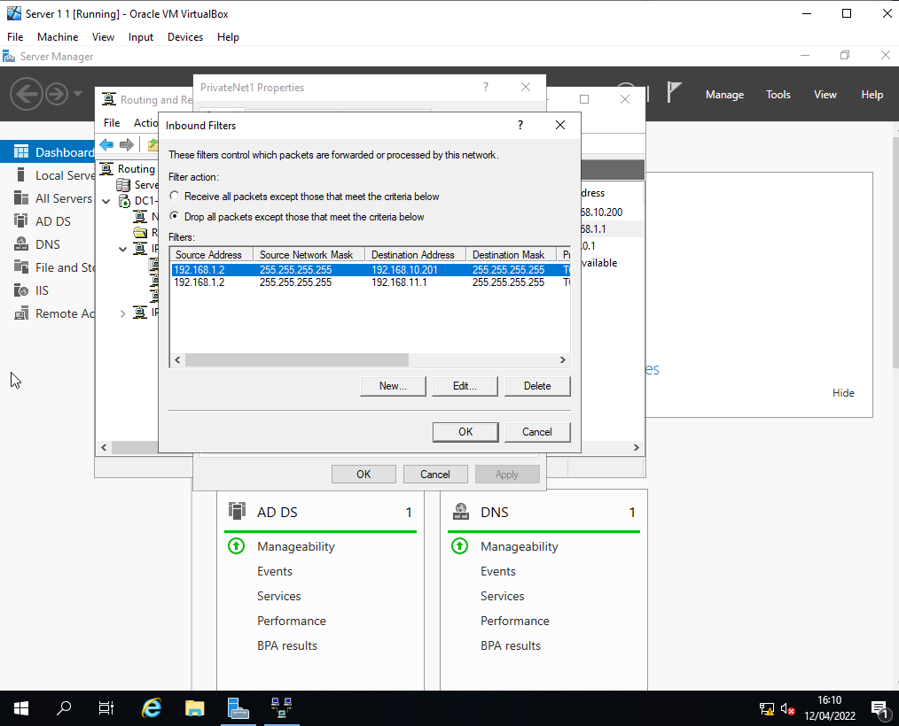
Configuration

Verification
This is undertaken by verifying that client one can connect to the FTP server and that Client 2 is denied access.
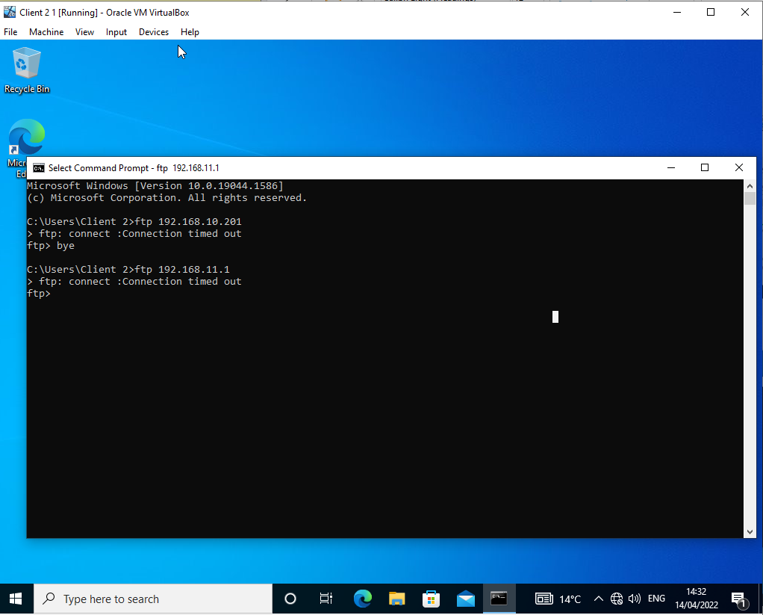
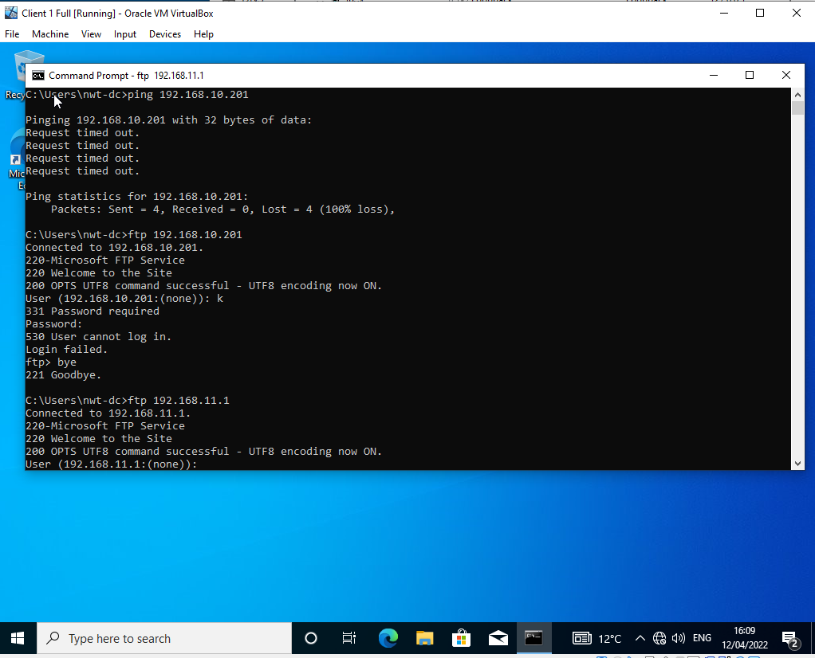

Task 3 – Observational Tasks

Password Principles
Passwords are used in everything in this modern age. Password principles are highly used in our security and threat reduction, but what are sound and good password principles? Each password should vary in length and always be unique. The use of first names and surnames within passwords is the most common bypassed or breached passwords. Especially within modern networking, a solid and secure password is a must. One of the most critical password principles is Unique passwords, and no password should be reused more than once. Passwords should be difficult to memorise; each password should be different and contain a different sequence of symbols and alphanumerical digits and Lower- and Upper-case letters.
Next, each password should also have another authentication/password attached; most passwords and networks now use Multi-factor Authentication, ensuring greater security within the passwords. For example, Microsoft uses a text message to verify your identity. Also, passwords should be changed in a rotation, and each password should be active for around 60-90 days and then be changed. Finally, never should you have your system remember your password; many people select remember my password. Then the complex password would AutoFill, but the problem is a Hacker with the relevant view software installed would be able to view the saved passwords.

Failover Clustering
A failover cluster is mainly used within organisations and enterprise networks that require a high or continuous availability environment. A failover cluster enables a server to function if there are internal errors as the failover cluster would always have fallbacks and redundant clusters ready. “If one or more of the cluster nodes fail, other nodes begin to provide service (a process known as failover)” [1].
Numerous concepts require thorough consideration and evaluation before deploying an FC within a system. There are many requirements to successfully installing and creating a failover cluster that must be considered, such as each node within the cluster must have a unique IP address within the same subnet – this would cause the range of network IP addresses to decrease significantly and could affect the expandability and scalability of the enterprise network. Also, every individual node within the Cluster is required to run the same operating system for the management software to work correctly; the main drawback of this is that each node would have to have its unique licence key to the OS, which can cost a significant sum to implement on top of the hardware costs. The final central concept is the space required to implement a Failover cluster; each node within the cluster must be within the same domain/organisational unit. Suppose an enterprise runs a small enclose network and wants a failover cluster installed. In that case, the web will become significantly more extensive and require more management and maintenance to ensure each node remains operational.
Configuration of a Failover Cluster within a server requires several aspects and other roles enabled to install successfully; numerous steps need to be undertaken to be successful.

The first essential step is creating dedicated storage drives for the implementation of the FC:
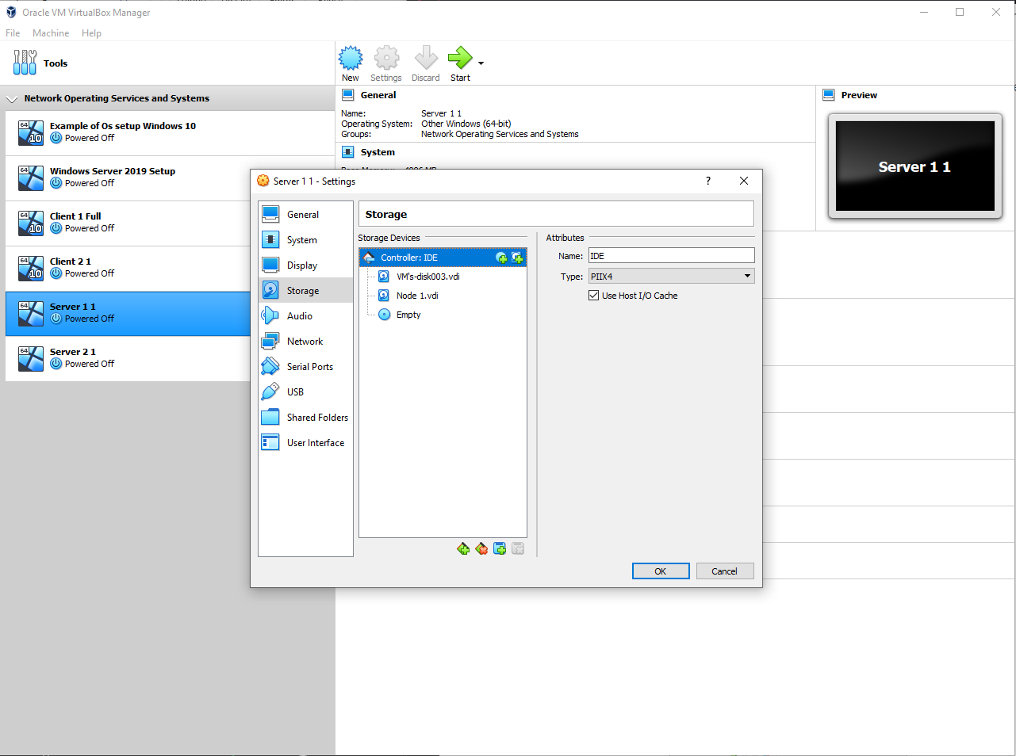

And then formatting them within the iSCSI function to create initiator and target servers – As stated by KindsontheGenius:
iSCSI stands for Internet Small Computer Systems Interface. It is standard network-based storage. iSCSI allows you to create storage devices on the network that are accessible via Internet Protocol. The storage disks are provisioned using the iSCSI protocol and are accessible to computers on the network as if they are local to that computer. [2]
To do this, the iSCSI role installation is required if not completed already:

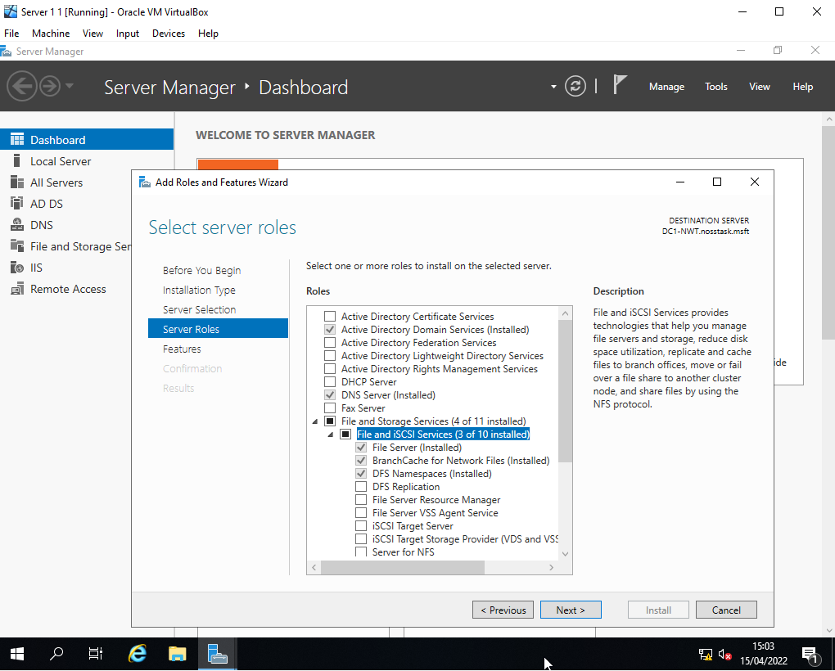

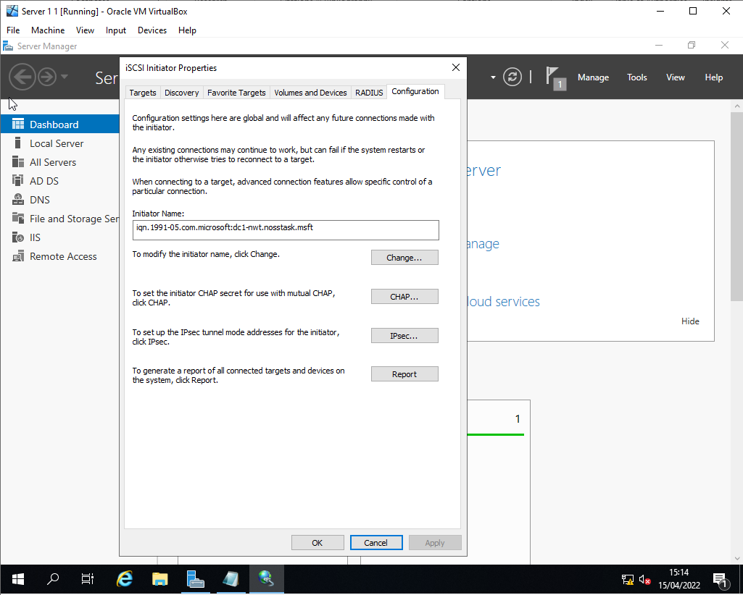
Configuration of iSCSI:

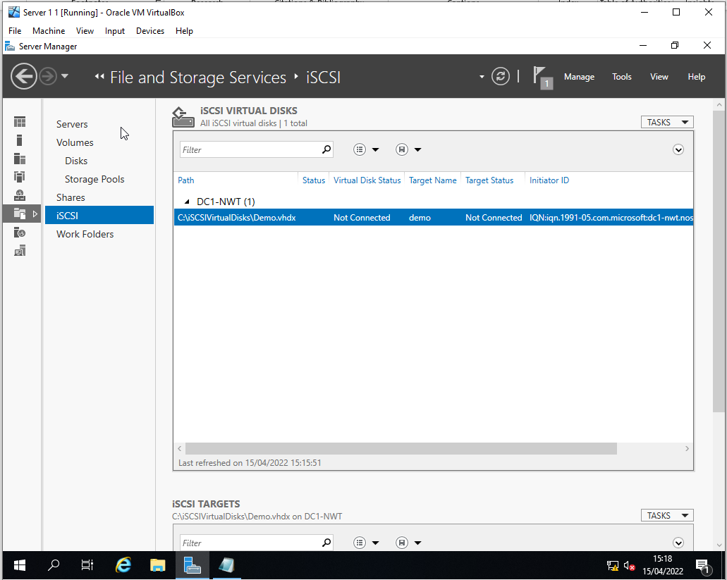

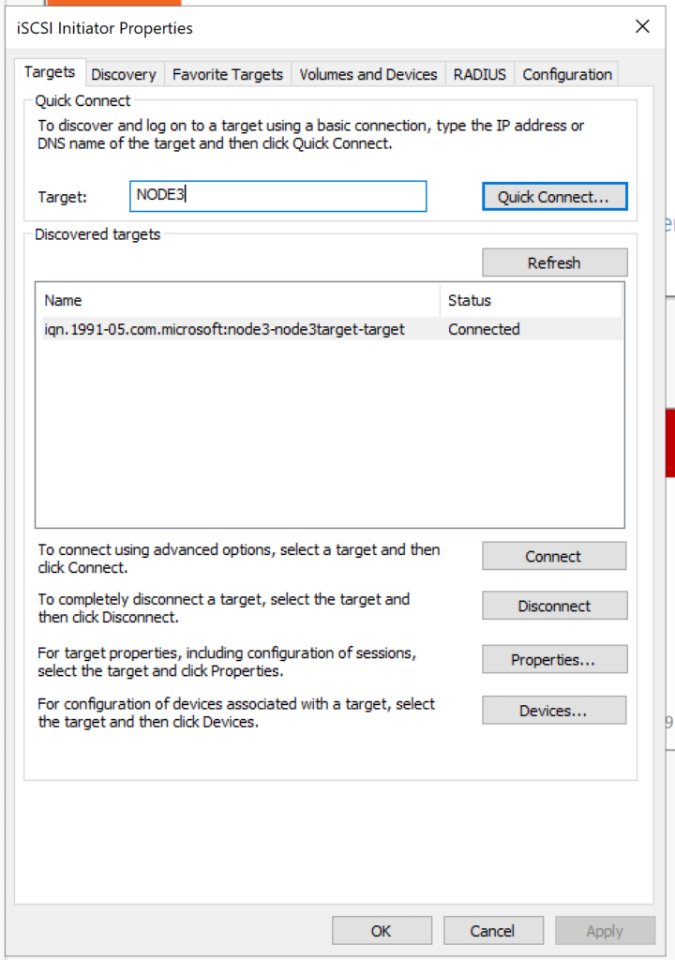
After the steps above, the target server must be specified in the initiators, and the failover cluster can begin to be configured.

Figure 1 – Adapted from [2]

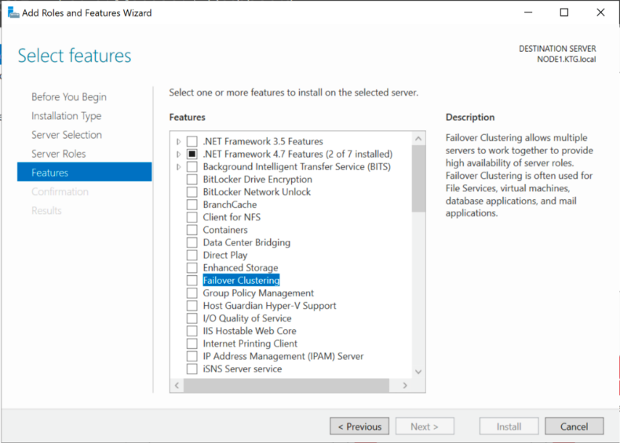
The Failover Cluster can now be configured and created as demonstrated in the figures below:
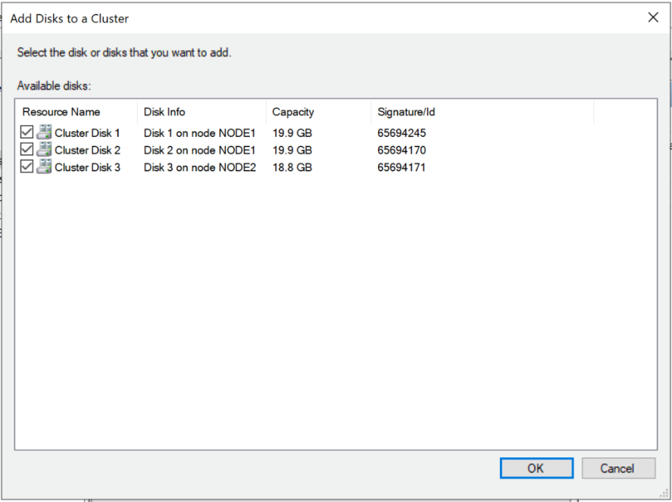
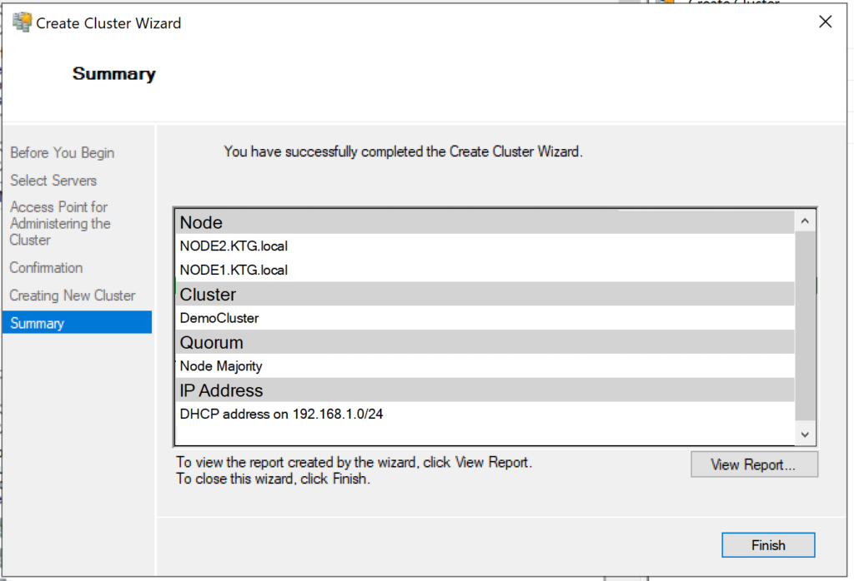
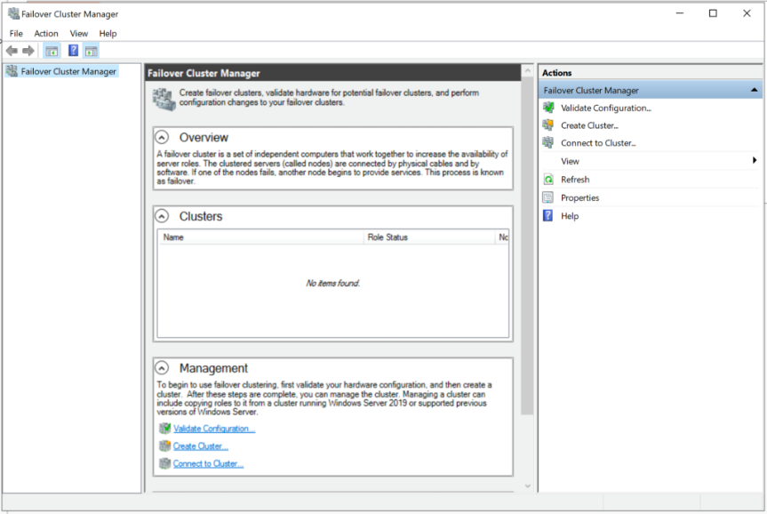

Figures 2 , 3, 4 and 5 – Adapted from [3]
The steps above are, in essence, the configuration and setup of a Failover Cluster. The sole importance of a failover cluster within an enterprise network can be described as the line between failure/loss and success. A failover cluster would ensure that if any application or piece of hardware fails, then they would still be available due to the failover cluster nodes taking over and initiating the process of Load Distribution – which is if any specific node fails or has an issue, then that particular data load will be transferred to another node. The use of an FC is essentially an insurance policy for application, hardware and data protection.

Network Construction
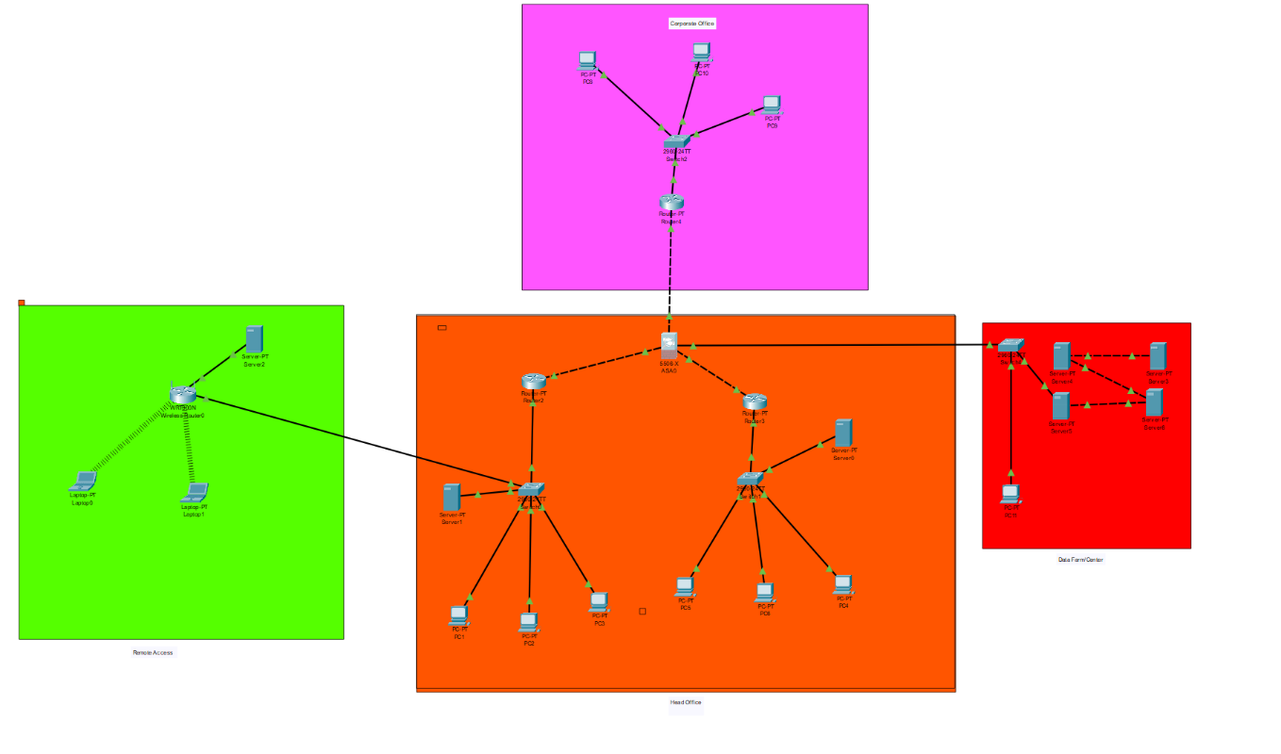
When building and designing a network, we must consider numerous aspects that could affect the overall success and efficiency of the network constructed. A typical enterprise network topology should consist of a central server/hub, an internet/server network, and a dedicated data centre, each with internal servers/switched based on relevant departments within the enterprise. Below is an example topology of a medium-sized network:
The topology above demonstrates a brief overview of a district/country enterprise network; each network is connected through a firewall for security filtering. There is a remote access function for home working and a data centre/farm to store all corporate data externally to make it more secure.

Policies
It is essential to have numerous policies within a network based on specific functions such as work and data storage and security, etc. I will suggest the most critical guidelines I would implement within an enterprise network.

Account Management and Creation Policy
The first initial policy to consider is Account Management and Creation Policy. This policy is essential to have secure users and account creation within the network. Below are a few of the main policy concepts to implement in this network:
- Every Account created must have signed approval from a manager/higher up for that company service.
- Shared Accounts will not be Permitted.
- Every Default Password must conform to the company/organisational password policy.
- After termination of staff, their associated account should be immediately deleted.
- System Administrators have the right to enable and disable accounts and edit any information that does not conform to company policy.

Password Policy
This policy can be regarded as the most critical policy within information security. Without a solid and failproof policy, the network could quickly become compromised.
- Passwords must be Unique, and no common names used
- Passwords cannot be reused
- Passwords must contain a variety of alphanumerical characters and symbols.
- Passwords should be changed every 60-90 days
For Administrator Accounts:
- Administrators should not forgo the above policy due to ease of use
- Passwords should be a minimum of 12 characters while adhering to the guidelines above
- Administrators should ensure that the same passwords are not used on multiple accounts.

Security and Threat Management
The final most important thing within a network is its internal and external security. Security within the network can be done in numerous ways, such as through policies. Still, there are further improvements and software than can be used to ensure proper security and threat mitigation.
The first important thing is to run an anti-virus and anti-malware software within every device on the network. This can be done by specific programming to install new software on each new device added to the network automatically. Next, using an MFA (Multi-Factor Authentication) method To login into the internal devices and networks would increase overall security. We could use bit locker drive lock, VPN and Authenticators simultaneously to improve safety.
Finally, when thinking about overall security, it is essential that the network administrators would be able to monitor all active devices and users and monitor their activity. This would ensure no unauthorised activities would occur. This can also be mitigated by administrators setting privileges levels within user accounts. An example of this is that non-Admin users are not allowed to download the software but can browse the internet, etc.

References

[1] | Microsoft Corporation, “Failover Clustering in Windows Server and Azure Stack HCI,” 11 02 2022. [Online]. Available: https://docs.microsoft.com/en-us/windows-server/failover-clustering/failover-clustering-overview#:~:text=A%20failover%20cluster%20is%20a,physical%20cables%20and%20by%20software.. [Accessed 15 04 2022].
[2] | kindsonthegenius, “How to Configure iSCSI Virtual Disks in Windows Server 2019,” 2 October 2020. [Online]. Available: https://www.kindsonthegenius.com/how-to-configure-iscsi-virtual-disks-in-windows-server-2019/#t1. [Accessed 15 4 2022].
[3] | kindsonthegenius, “Windows Server 2019 Failover Cluster Installation and Setup – Step by Step,” 4 October 2020. [Online]. Available: https://www.kindsonthegenius.com/windows-server-2019-failover-cluster-installation-and-setup-step-by-step/. [Accessed 15 4 2022].

