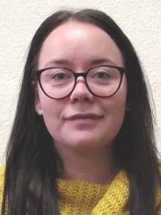

Name: Kelly Louise Divers

Student number:2000155

Student e-mail address:2000155@student.uwstd.uk

Contact number:07757724739

I’m 28 years old and currently working within the health profession, I have worked in this industry for ten years now and within my ten years this I have worked with the elderly within their own homes and out in the community, also in care homes, young children and adults with learning difficulties, and also in a nursey but also worked my way up to a senior member of staff also. I’m currently working one to one with a young girl with cerebral palsy which has can be challenging at time and also rewarding this is within her own home but after working with the same girl for 3 years I have decided that I wanted to further my education and knowledge professional into the nursing degree, I enjoy my job and helping others and find it very rewarding so by choosing this course I will be able to continue to do this whilst also bettering myself and gain the knowledge to one day be a nurse.

