Sustainable tourism strategic planning process is centered around helping tourism stakeholders answer 4 main questions:
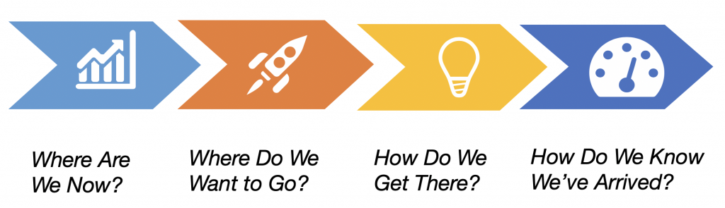
- Where are we now? – what is the current situation with our tourism industry? How is the industry performing? How do we compare to our competition? What are our tourism assets? What tourism services are available for visitors? Who is responsible for tourism policy, management, marketing, investment, etc? How is the industry organized? But most importantly – what are the main challenges that are preventing our industry from reaching its full potential? Through a careful review of tourism statistics, previous studies, online research, and interviews and surveys with tourism stakeholders we are able to develop a tourism sector analysis or a tourism situation analysis that sets the foundation for the tourism strategy.
- Where do we want to go? – the vision statement is one of the most important components of a tourism strategy. The objective of the visioning process is to build consensus around a shared vision for the future of the tourism industry in the destination. Solimar uses a variety of different approaches to create a shared vision but this is mainly achieved through a participatory planning workshop where stakeholders come together and think into the future and describe a tourism industry that they would like to see for their destination. How has tourism changed from today? What is improved? What remains the same? Asking tourism stakeholders to describe their desired future of the tourism industry shows that while stakeholders have many different opinions about what needs to be done and what should be prioritized, they often share a common vision for what they want tourism to look like in the future for their destination.
- How do we get there? – Once a shared vision is agreed upon, the next question is how the vision will be achieved and how best to organize action plans to be implemented. While every tourism destination is unique and has its own challenges and priorities, most tourism strategies tend to prioritize 5-6 main pillars of the strategy that we call strategic objectives or strategic goals. These tend to be focused around improving Policy/Coordination, Marketing, Product/Destination Development, Workforce Development, Sustainability and other topics that flow from the participatory planning process. After defining these main pillars, the next and most important step of the strategic planning process is to define the specific strategies to be implemented to achieve these goals. Individual strategies are the main components of the document and what provides the direction for the industry to realize the vision. Through stakeholder interviews and outcomes from the tourism planning workshop these strategies are identified and grouped under the corresponding goals. A description of each strategy is important to help everyone understand what is being proposed and why. The last and very important step is the creation of detailed action plans. These action plans are developed through working groups that include the public and private sector, conservation and community organizations, and other stakeholders. The key to action planning is aligning the action plan updating and reporting with the government’s own annual work planning and budgeting.
- How do we know we’ve arrived? – Indicators are an important tool in a strategic plan to define quantifiable targets that can be used to measure the results of the strategy implementation process. Indicators should include not only economic performance, but also sustainability and other policy focused metrics that demonstrate progress towards realizing the vision and communicate progress.


