

Management Economics
Brexit Essay

Student Name and ID: Oana–Florentina Bolocan 2009953
University of Wales Trinity Saint David
Module Number: LCBB5003
Module Name: Management Economics
Module Tutor: Vasilios Tavlaridis
Table of Contents
Introduction 3
Main body 4
The impact of Brexit on the UK government’s trade policies is significant and addressed 4
There are various positive and negative impacts of Brexit on UK business 5
Conclusion 10
References 11

Introduction
Brexit is the shorter version for “British exit” from the EU, “the economic and policy union”. The UK has been one of the most influential members of the EU but this scenario changed on June 23, 2016. It nearly took four years to complete after the 2016 vote. The essay will narrate the impact of Brexit on the UK business firms. The companies were heavily affected by the departure of the UK from the EU. It will highlight the managerial decision of business due to Brexit.
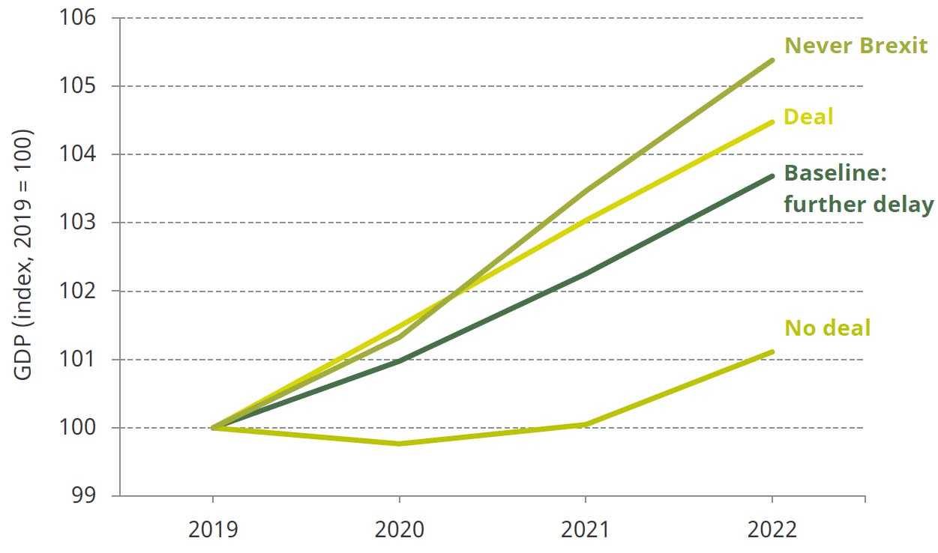

Figure 1. UK Economic outlook ( Source: www.ifs.org.uk )

Main body

The impact of Brexit on the UK government’s trade policies is significant and addressed
The “conservative party” called for the popular ballot. Most of the Brexit voters were older and they were worried of the free movement of immigrant, laborers. The small business sectors were depressed by the EU fees, regulations. Many of the stakeholders thought that UK was giving more to the EU and received less (Bloom et al., 2019). The person who nominated to stay in the EU dwelled mostly in London, Scotland and Northern Ireland. Since the emergence of the popular vote Brexit occurred nearly 6 years ago it has become an increasingly popular topic in economic research. When a “withdrawal out agreement” has been set forth into power the future terms between the EU and UK are still negotiated. The economic and trade results of Brexit have come up with various challenges. The free motion between the UK and EU has been put to stop. European citizens who are living in the UK must have credentials from the government of the Uk o permit them to stay in the country. The UK government have to pay a “divorce bill “ of near about 35 billion pounds by 2064 to fulfill the economical gap when it was a member of the EU.
The global; outline of the UK trade agreement could be found by the interactive world map. The dashboard helps to analyze and recognize countries with which the UK has signed new deals bowled over pre-existing “European Union agreements” and lost pre-existing free trade agreements (FTA)Brexit has led to noteworthy changes in the associations of the UK with other European countries and it has also reopened the facility to reconcile trade agreements directly with other non-EU countries. It is necessary to find out how Brexit has affected the Uk economic performance in the long run or not. It is seen that Brexit will enhance future economic output up to 8% through and it is predicted that it can also reduce by 19% as constrasted to what would occur if the UK remained an associate of the EU block. The economic theory and proof provide a much healthier and more powerful basis for making long term prophecies.
The majority of economic predictions state Brexit will hamper UK economic growth has been stated here. According to a large number of economic studies, many predicted that Brexit policy will harm the progress of UK economic growth. They have suggested how the level of UK output will be different in 2030 post Brexit as compared to previous years when it was part of the EU. It has foreseen that it had healthier relationships and strong bonds with other countries in the past and that resulted in progressive economic growth (De and Siles 2019.). There is a wider agreement among UK based economists that influential trade, investment and migratory connections will likely enhance the country's economic growth and development.
There are various insights along with predictions that Brexit will increase barriers in trade between UK and other countries. The UK economy will grow at a slower pace due to the Brexit policy. The predictions also suggest that there will be a reduction in outcome by 18.5%. It is also assumed that they will create strong obstacles to trade and stuck between the UK and the EU. As for example if both UK and EU were to commerce with each other on WTO terms then it will be a big obstacle. It is very comprehensible that Brexit had given rise to trade barriers in the form of tariff and nontariff between the EU and the United Kingdom. The economic results are much negative for the United Kingdom. The free trade flow between the EU and UK will be hindered due to the Brexit policy (Simionescu et al., .2018)
Another study by Economists has stated that Brexit will significantly enhance the UK economy. The UK national income would be at least 3.8% higher after Brexit
The exact nature of post-Brexit UK, EU trade is certainly not known and there may be an uncertain future for a long period. . In early 2020 the trade of the UK will have to face various challenges due to Brexit (Hix 2018).

There are various positive and negative impacts of Brexit on UK business
After Brexit, it is faced with lesser restrictions of EU regulations. It has allowed them to freely trade with non-EU markets. The developing markets like China, South Africa and Brazil are driving more customers as the fall of pounds has made the products of the UK cheaper. If they have good opportunities UK businesses will apply for Authorized Economic Status and that implies that they will have a more convenient time for moving goods among the countries. There will be a fall in migration flow from the EU to UK after Brexit. The lower FDI will hamper both EU and UK businesses to the single market. The macroeconomic effect of Brexit has a lower level of exactness (Simionescu 2018). The important aspects which are linked to confidence effects and financial channels are complicated and are difficult to introduce into the existing models. The potential policy response across the vast arrangement of policy, especially in the case of the UK is another factor not taken efficiently into account in the numerical analysis. Studies often find out that Brexit affects the growth rate on a temporary basis but the level was hampered permanently. Brexit has led to losses in well being and GDP for the UK and other EU states.
There are various concerns about the plane of public and parliament membership and the external pressure placed on the UK by the “covid 19 global pandemic”. These issues have led to responses from public advocates for trade union conference to be delayed. The degree of participation they are being managed chiefly in the appeasement of intercontinental trade agreements is of exceptional concern.
The most exacting impacts of Brexit on economic growth are seen through the impact on trade and productivity. The European board launched new guidelines on future affairs in March 2018, calling for a one relationship with the United Kingdom. The guidelines stated that it requires upholding the honesty of the single market and the ethnicity union and taking care of the autonomy of the EU decision-making process. The position of the UK government regarding the future relationship was originally defined by Prime Minister May. The speech stated that the United Kingdom aimed to take hold of laws and borders by leaving the Single Market. For the future relationship in the economy between the EU and the United Kingdom The PD was introduced, the parameters of a motivated, broad, profound and supple partnership across trade and economic cooperation. For a trade of goods, the free trade area is combined with deep regulatory and customs operation. The PD predicted that the possibility of switching information and a clear, transparent relationship from each side is regulated.
Firstly the UK decision to break from the EU has created a high risk, broad and persistent uncertainty. The Brexit uncertainty index shows the share of industry reporting that Brexit was the primary driver of uncertainty. Even after three years of the Brexit vote firms examined extremely high chances of Brexit uncertainty. The uncertainties are also very complicated in nature. The supply of migrant labour and the UK product regulations are affected by the Brexit policy. It will be understood in time how these relationships will be looked at different points in time and what each of them explains for the future prospects.
The expectation of Brexit has decreased the UK’s investment by cutting around 11.2%. After the referendum, the investment growth would surely fall after Brexit.
Lastly, it is estimated that the Brexit process has decreased the level of UK productivity by 3% to 6% in the coming years. It is especially from a negative approach because the firms are committed to many hours per week of higher management to Brexit planning (Lightfoot et al., 2018).
It is noted that both UK and non-Uk firms have been affected by the Brexit policy. When it is analyzed the Brexit sentiment to the country level no single country has commented for a positive change. There are some incidents where they see positive changes or are toned towards positivism.
Brexit has hampered the British young workers. The employers are also having tough times finding applicants ad the main reason is that EU born workers left the UK and their numbers would be reduced by 95%.
The Brexit vote has forced three tough choices for the UK. Without a trade, agreement ports would be restricted and airlines grounded. For that reason, there will be a shortfall of imported food and drugs. The voters failed to understand the hardships or must struggles that will be imposed upon them due to Brexit.
In the service sector if the UK loses its passport rights it will definitely suffer. The Irish authorities stated that they made deals with more than 13 banks of London inclusive of one American bank that planned to move to Ireland to maintain their place in the single market.
In the manufacturing unit, the risk is very high. They are dominated by multinational companies. These companies are likely to be inspired by the single market operations. Half of the automotive sector in the UK is owned by firms which are the part of EU while 45% of the healthcare business are possessed by non-UK businesses.
The impact of Brexit on managerial decision is seen very significant. Since UK ballot to leave the EU on 23rd June 2926 numerous changes have been analyzed. The impact of vote has made a significant change on economic growth. The past and future economic performances are judged by the factors such as Business decisions to invest, deprive, re-invest, locate and business activities. The British pound has reduced sharply and that has impacted the managerial decision. The depreciation has made things a bit cheaper. The managers had to cut down the prices of various products to draw attention from the customers and stay sustainable in the market. The companies who imported things outside needed to reduce the prices and were punished if they made the things expensive (Matti and Zhou 2017).
Investment decisions have taken a longer time to make adjustments required for the business. The investment decisions will be shifted towards a more stabilized jurisdiction.
The decision making mostly depends on the wide agreement across the company. They make the decision in order to face the changing landscape. Brexit has compelled them to alter many decisions.
Small businesses have been badly affected by Brexit. They are finding it hard to state when their shipment will reach the destination. There was a delay in delivery and they had no other choices at first.
The food supply sector was affected by Brexit. The introduction of border checks between Northern Ireland and the Republic of Ireland was causing the delivery delay. The goods need to be custom checked resulting in a delay of food supplies(Pappas 2019).
Brooks Island used to sell bicycles from West midland but it had stopped its import to UK recently. The products had to go through the Italian logistics center before they were dispatched across the globe. The new taxation procedure for exporters to the UK market is finding it difficult to market and non profitable.
The new sets of rules have made a hectic schedule for small enterprises. The EU based businesses now don't take the risk of selling their goods to the UK. The UK business managers find it hard to make a choice in giving up a big market as the EU.
There are various explanations for the negative effects of the withdrawal of the UK from the EU. it has led to changing of various decisions led by the mangers. The relocation of activity from the intense productive global business towards less productive national firms is observed. The productive firms have faced huge reductions in size as a result of Brexit. The productivity was reduced by 5% in the past three years. The negative effects are predominately seen in the small firm.
The business has to rethink the supply chain strategies as they did not receive the same benefit as they used to enjoy prior to the Brexit Referendum. Brexit has applied uncertainty in the supply chains. The uncertainty is not short-lived and they will remain for a longer period of time (Steinberg 2019). So Brexit has been a keen concern for the business managers and they need to change the supply chain strategy. The consumer goods manufacturing companies were very concerned about the influence of tariff and border conflict on the supply chain (Roscoe et al., 2020). They are focusing on implementing effective business strategies in order to stay profitable in the market.
They are reshaping the sourcing strategy. The companies need to explore coastal opportunities and develop local suppliers to make sure that they are maintaining sustainability. The companies have to modify the structure to safeguard against short and medium-term challenges.
The companies need to maximize the manufacturing and logistics impressions by reconsidering the scope and time frame of investments. They can enhance their decision making more effectively by using advanced digital technology and analytical tools. It will help them to cut down the costs.
They must be prepared and adaptive to the changes coming on the way. They should have the ability to change their manufacturing process and be flexible to the changes. The uncertainties in demand should be dealt with.
The managers must think about improving the R & D strategies to administer the product specializations. The changes can be operated by Brexit related dogmatic changes. They could shift the needs and expectations of the customers.
They must enforce digital enabled effective teams to make the product more dynamic and exclusive. The capabilities should be strengthened and they should quickly respond to the changes in the market.
The managers must be efficient enough to make the decisions in a proper way. They must implement cost effective decisions to decrease their cost of production. As they cannot import raw materials and labor from EU countries they must find other resources available which are cheaper. They must look for their own country's labor which will decrease the labor costs. They must train the workers more effectively to make them skilled to bring in more innovative products.

Conclusion
The Brexit vote has forced three tough choices for the UK. Brexit has led to losses in well being and GDP for the UK and other EU states. The essay has broadly narrated the Brexit policy and its impact on the business of the UK. The UK firms are heavily affected by Brexit. It is seen that it has many adverse effects of Brexit. The decision making mostly depends on the wide agreement across the company where Brexit has given rise to many changes in the decision making of the managers.

References
Bloom, N., Bunn, P., Chen, S., Mizen, P., Smietanka, P. and Thwaites, G., 2019. The impact of Brexit on UK firms (No. w26218). National Bureau of Economic Research.
De Ville, F. and Siles-Brügge, G., 2019. The impact of Brexit on EU policies. Politics and Governance, 7(3), pp.1-6.
Hix, S., 2018. Brexit: Where is the EU-UK relationship heading. J. Common Mkt. Stud., 56, p.11.
Lightfoot, S., Mawdsley, E. and Szent‐Iványi, B., 2017. Brexit and UK international development policy. The Political Quarterly, 88(3), pp.517-524.
Matti, J. and Zhou, Y., 2017. The political economy of Brexit: explaining the vote. Applied Economics Letters, 24(16), pp.1131-1134.
Mohamed, M., Pärn, E.A. and Edwards, D.J., 2017. Brexit: measuring the impact upon skilled labour in the UK construction industry. International journal of building pathology and adaptation.
Roscoe, S., Skipworth, H., Aktas, E. and Habib, F., 2020. Managing supply chain uncertainty arising from geopolitical disruptions: evidence from the pharmaceutical industry and brexit. International Journal of Operations & Production Management.
Simionescu, M., 2018. The impact of Brexit on the UK inwards FDI. Economics, management and sustainability, 3(1), pp.6-20.
Simionescu, M., Strielkowski, W. and Kalyugina, S., 2017. The impact of Brexit on labour migration and labour markets in the United Kingdom and the EU. Terra Economicus, 15(1), pp.148-156.
Steinberg, J.B., 2019. Brexit and the macroeconomic impact of trade policy uncertainty. Journal of International Economics, 117, pp.175-195.

Pappas, N., 2019. UK outbound travel and Brexit complexity. Tourism Management, 72, pp.12-22.

