Digital Skills for Personal and Professional Growth (BMSW4008)
Student name: Sandra Gorolova
Student ID: 2311229

24th June 2024

Table of Content
Task 1 3
The Significance of Storytelling in Building and Advancing a Brand 3
Introduction 3
Definition of Storytelling in Branding 3
Real-World Example: Nike 3
The Power of Storytelling in Branding 4
Establishing a Distinct Identity 4
Building Emotional Connections 4
Enhancing Brand Recall and Recognition 4
Driving Consumer Engagement 4
Supporting Brand Authenticity 5
Influencing Consumer Perception and Behavior 5
Task 3 6
Results of Questionnaire: 6
Analysis of Key Questions 8
Question 1: What additional services or amenities would enhance your nail salon experiences? 8
Question 2: How often do you visit a nail salon? 9
Question 3: What is the most important factor when choosing a nail salon? 9
Question 4: How do you typically find out about new nail salons? 9
Task 4 11
Introduction 11
Analysis of Questionnaire Data 11
Home Page 11
Services/Booking Page 13
Marketing Materials Design Using CANVA 13
Flyers and Posters 13
Social Media Posts 14
Images 14
Segmentation and Targeting 15
SEO Optimization 15
References: 16

Task 1

The Significance of Storytelling in Building and Advancing a Brand

Introduction
Brand storytelling has become acclaimed as one of the key approaches to strategic management in the 21st century (Bajpai & Kumar, 2018). This calls for creative promotion and differentiation strategies that can help brands and organisations to stand out, especially when competition is high. In this context, storytelling refers to the process by which traditional and digital stories are used to inform consumers about the character of brands (Herskovitz & Crystal, 2010).
Storytelling is not merely about conveying information; it is about crafting a compelling narrative that resonates with the audience on an emotional level. This involves integrating the brand’s history, values, and mission into stories that reflect the brand's identity and ethos. According to Aaker (2014), successful brand stories create an emotional connection with consumers, fostering loyalty and trust. These stories can be communicated through various channels, including advertising, social media, and content marketing, making them versatile tools for engagement.
Effectively, this essay seeks to look at the significance of storytelling for brand establishment and creating differentiation and sustainability by referring to an exemplar project that proves the effectiveness of the tool when it is applied to brands in market (Gill, 2015). The role of storytelling in branding can be seen in several key areas:

Definition of Storytelling in Branding

Storytelling in branding is defined as the processes through which narrative tools are employed in branding activities in order to convey the brand meaning, values, and promises to the target (Heath & Heath, 2007). It is not just about marketing commodities or services but also about weaving believable stories that consumers can readily relate to (Fog, Budtz & Yakaboylu, 2005). Brand content elements include the brand’s history, its purpose or mission, the values it upholds, and its vision, among others, which, when woven into a comprehensive and consistent story, can be shared with different audiences (Herskovitz & Crystal, 2010).

Real-World Example: Nike
Nike's "Just Do It" campaign, launched in 1988, is one of the most iconic examples of brand storytelling. This campaign was not just about selling athletic apparel; it was about inspiring people to overcome their personal and physical challenges. By featuring athletes from various backgrounds and highlighting their struggles and triumphs, Nike created a powerful narrative that resonated deeply with its audience (Pulizzi, 2012). Nike's storytelling is rooted in authenticity. The campaign features real athletes and real stories of perseverance, which adds credibility and relatability. By showcasing the personal journeys of athletes, Nike not only highlights the physical aspect of sports but also the mental and emotional challenges, making the brand's narrative more compelling (Herskovitz & Crystal, 2010). This storytelling approach not only positioned Nike as a brand that supports and empowers athletes but also forged an emotional connection with its customers (Holt, 2016).

The Power of Storytelling in Branding

Establishing a Distinct Identity
Due to high competition, it is very important to define a company's brand image. Using storytelling enables a brand to stand out, given that the focus is placed on aspects that set the firm apart (Bajpai & Kumar, 2018). For example, TOMS Shoes utilises narratives to communicate their "One for One" campaign, which means that for every pair of shoes sold, a pair is donated to the needy. This narrative also helps in setting apart TOMS from other brands of shoes as well as associating the brand with a noble cause, thus becoming an ethical brand to consumers who wish to make the right choices (Gill, 2015).

Building Emotional Connections
The use of storytelling is effective since it triggers an emotional response in the audience. Consumers prefer certain brands due to the proximity they have with them due to emotions. According to research by Harvard Business Review, emotionally connected customers are more valuable than highly satisfied ones; they are more than twice as valuable (Groysberg & Slind, 2012). Brands like Coca-Cola use storytelling to evoke feelings of happiness and togetherness, reinforcing their brand promise and ensuring a loyal customer base (Salmon, 2010).

Enhancing Brand Recall and Recognition
Stories are inherently memorable. Where storytelling is implemented, the probability of improving recall and recognition among the target market is always high among brand-focused organisations. Research by Stanford University proved that through a story, information is as much as 22 times more likely to be retained by the listener (Pulizzi, 2012). Apple's storytelling, centred around innovation and creativity, has created a strong brand recall that positions it as a leader in the tech industry (Bajpai & Kumar, 2018).

Driving Consumer Engagement
It has been noted that if consumers are to be retained, proper interaction with them has to be made. Unlike conventional advertising methods, storytelling pays a lot of emphasis on consumer participation, where the consumer is allowed to be part of the story (Simmons, 2006). For instance, GoPro currently has a "User-Generated Content" campaign where customers are encouraged to share their experience using GoPro HD cameras. Thus, not only existing customers are interacted with, but also potential clients are attracted with real-life content (Herskovitz & Crystal, 2010).

Supporting Brand Authenticity
In a world that is already full of outside interruptions, the last thing a consumer wants is yet another advertisement that intrudes upon their life in a vaguely promotional way. Storytelling makes it easy for brands to tell a real story of their dedicated work to their brand’s values and promises to consumers. Using information about its environmental activism as well as sustainability goals, Patagonia adds clarity to its messages and environmentalism, engaging the group of consumers interested in environmentalism and sustainability (Heath & Heath, 2007).

Influencing Consumer Perception and Behavior
Well-told stories have an impact on the formation of the consumer’s attitudes toward the brand and their decision-making. Consumers develop a positive attitude towards brands when they hear or read information in a certain way, and this is because a product is sold through the story a brand tells (Bajpai & Kumar, 2018). For example, Dove’s “Real Beauty” campaign was unique in challenging conventional beauty ideals for women and advancing body image psychology (Pulizzi, 2012).

Task 3

Results of Questionnaire:
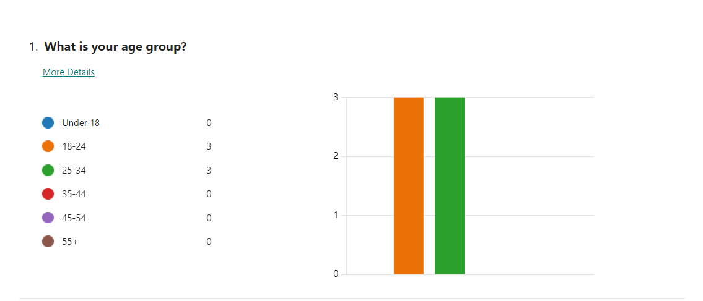
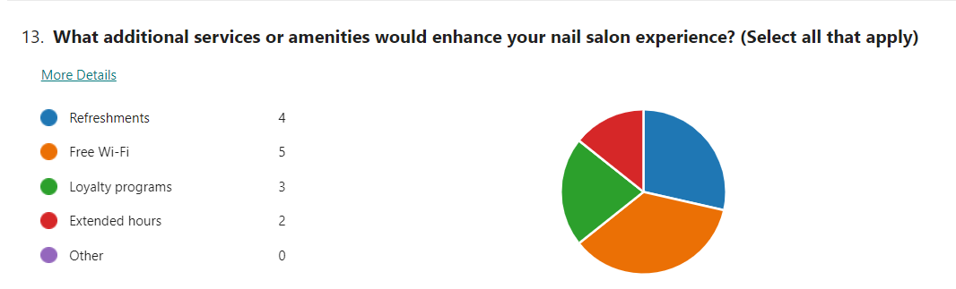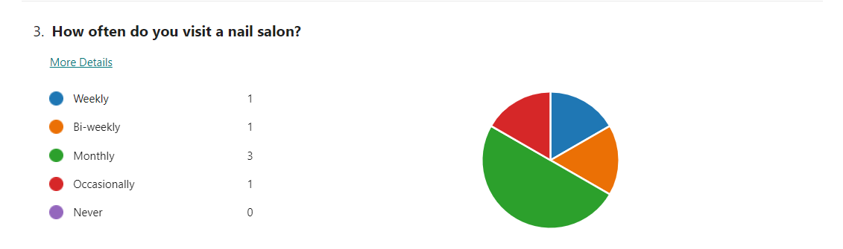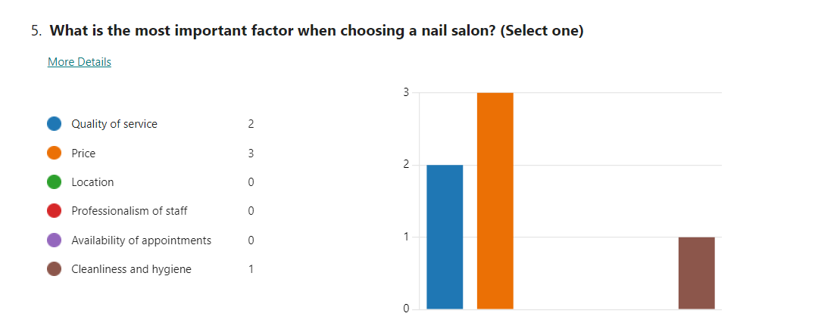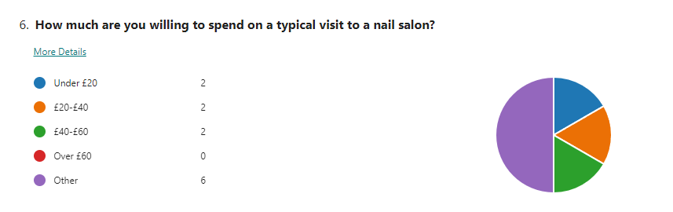
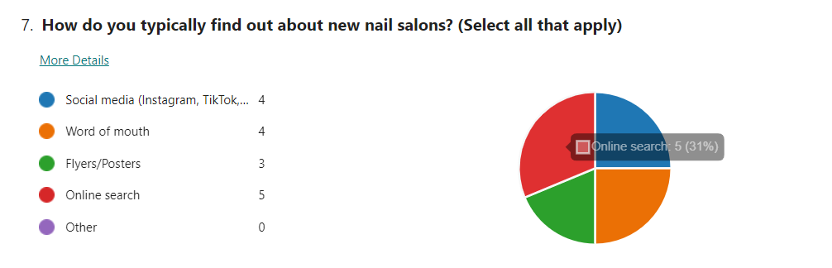
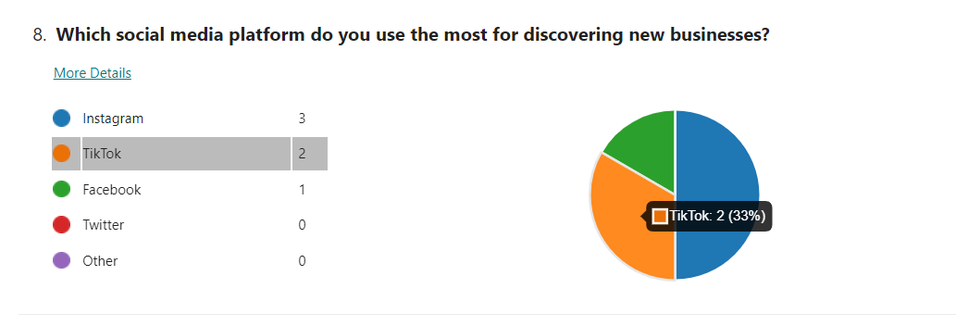
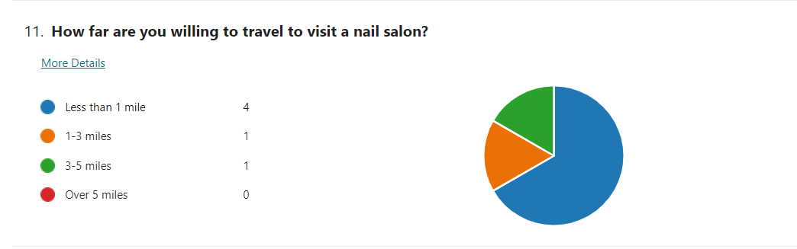

Analysis of Key Questions

Question 1: What additional services or amenities would enhance your nail salon experiences?
Trends and Patterns: The responses to this question reveal a clear trend towards enhancing customer loyalty and convenience. Three out of six respondents highlighted loyalty programs as a desired service, indicating a strong interest in benefits that reward repeat visits (Armstrong et al., 2018). One respondent stated for ‘free wifi’ which though not as common as amenities like free breakfast, can collectively enhance customer experience as patrons of the modern digital landscape expect complimentary Wi-Fi. (Hair et al., 2017).
Insights: The demand for extended hours suggests that the users require the salon to open at odd hours based on their flexibility to provide for their availability suggesting that this will make it easy for the users to access the salon thus making it more appealing (McDaniel & Gates, 2018).
Utilisation for Business Improvement: To benefit from these ideas, the nail salon could consider adopting a formalised frequency reward plan that uses more discounts, free services, or special promotions after a number of services have been availed. This program could be advertised through social media and in-salon information and details to make it outwardly very apparent (Armstrong et al. , 2018).

Question 2: How often do you visit a nail salon?
Trends and Patterns: With regards to how frequently the restaurant is visited, only one participant visits the restaurant weekly while two visits the restaurant monthly; three visits it occasionally. From this distribution, it can be noted that while a portion of the consumer population visits nail salons as part of their normal schedule, others only occasionally patronize the salons (McDaniel & Gates, 2018).
Insights: With regards to population, the majority of the respondents stated that they visit the place occasionally this means that there is potential to transform occasional patrons to constant ones. By identifying factors that hinder such customers from coming frequently, whether due to price, accessibility, or perceived utility, one might be able to develop a plan of enhancing their relentlessness (Burns, Veeck & Bush, 2017).
Utilisation for Business Improvement: For frequent usage, the current organizational strategy which could be applied to the salon is making promotions or a package of services available for infrequent customers including affordable rates for successive bookings and other specials during low business periods (Malhotra & Birks, 2019). Furthermore, this aspect would have applied the findings on the aches to attract and respond to feedback from customers in order to make the salon appealing for multiple visits (Brace, 2018).

Question 3: What is the most important factor when choosing a nail salon?
Trends and Patterns: When choosing a nail salon, three respondents prioritised price, two emphasised quality of service, and one highlighted cleanliness and hygiene. This indicates a strong emphasis on cost-effectiveness, but also significant consideration for service quality and health standards (Hair et al., 2017).
Insights: The emphasis on price suggests that customers are price-sensitive and look for good value. However, the fact that quality of service and cleanliness are also key factors indicates that while customers want affordability, they are not willing to compromise on the service quality and hygiene standards (Burns, Veeck & Bush, 2017).
Utilisation for Business Improvement: The salon should ensure its pricing strategy is competitive while maintaining high standards of service and cleanliness (McDaniel & Gates, 2018). Offering various service tiers—basic, standard, and premium—can cater to different budgets while ensuring quality across all levels (Malhotra & Birks, 2019).

Question 4: How do you typically find out about new nail salons?
Trends and Patterns: Four respondents indicated that they find out about new nail salons through social media platforms like Facebook, Instagram, and TikTok, while two rely on online searches. This highlights the dominant role of digital channels in discovering new businesses (Armstrong et al., 2018).
Insights: Once again, the results point out overwhelmingly that social media is preferred and this underlines that having as strong an online profile is important in order to entice new customers. Instagram and TikTok can be considered the most suitable for the given salon since they are rather recognizable for organising promotional campaigns (McDaniel & Gates, 2018).
Utilisation for Business Improvement: They should focus on the creation of group and page where they should often post photos, stories and videos about services, customers’ testimonials and current promotions (Hair et al. , 2017). Also, it might target the segment of people who use search engines to look for a salon, engaging in the optimisation of the website for search and making sure that it has positive reviews (Burns, Veeck & Bush, 2017).

Task 4

Introduction
Most importantly, it is crucial for each business to have an ideal web strategy and the overall marketing strategy which plays a crucial role in achieving successful results and is especially important in the beauty and personal care market (Aaker, 2014; Kotler & Keller, 2016). The data obtained from the Market Research Questionnaire form the base for creating a website and marketing materials that potential customers would relate to (Creswell & Creswell, 2018).

Analysis of Questionnaire Data
- Quality of Service: It was found that quality and professionalism of the service providers stood out as the key concerns that compel the respondents to select a particular nail salon (Belch & Belch, 2018).
- Social Media Preferences:The most common sources that people used to find out the existence of new businesses were Instagram and the TikTok (Solomon, 2017; Kumar, 2018).
- Online Booking Importance: Fifty-five percent of the respondents deemed the feature to book appointments online as very important (Malhotra & Peterson, 2014). This reflects a growing preference for convenience and accessibility in service bookings. An integrated online booking system not only streamlines the appointment process but also enhances customer satisfaction by allowing clients to schedule services at their convenience. This feature can reduce no-shows and improve operational efficiency by providing real-time availability updates. Promoting the online booking option through social media and the salon’s website can further encourage its use.
- Additional Amenities: Most of the items deemed as valuable were the ones such as free loyalty programs, food and drinks, and free Wi-Fi (Clow & Baack, 2016; Doyle, 2012). These additional amenities contribute to a superior customer experience and can differentiate a salon from its competitors. Loyalty programs incentivize repeat visits by offering rewards and exclusive offers, thus fostering customer loyalty..

The website consists of two main pages: the Home page and the services/booking page.

Home Page
Header and Navigation: The header includes the salon’s logo, a primary navigation bar with Home, Services/Booking, About Us, and Contact Us buttons; social media icons of Instagram and TikTok follow buttons to exit the salon’s handles.
Hero Section: The hero section showcases a high quality of image of perfectly groomed nails, which is capped by the ‘Perfect Nails, Perfect You’ tag line The hero section clearly states the salons specialty (Aaker, 2014).
About Section: A short background of the salon, its purpose of offering great nail services, as well as information on the qualified personnel. This part of the paper plays the role of creating trust and demonstrating professionalism (Belch & Belch, 2018).
Testimonials: Such a feature as customer feedback is shown to promote the activity and positive feedback of previous clients, which contributes to the strengthening of the company’s reputation for professionalism.
Call to Action (CTA): There is a large “Book Now” button that leads the visitors to the Services/Booking page, which stresses the significance of online booking.

https://mazer4571.wixsite.com/luxury-nail-salon
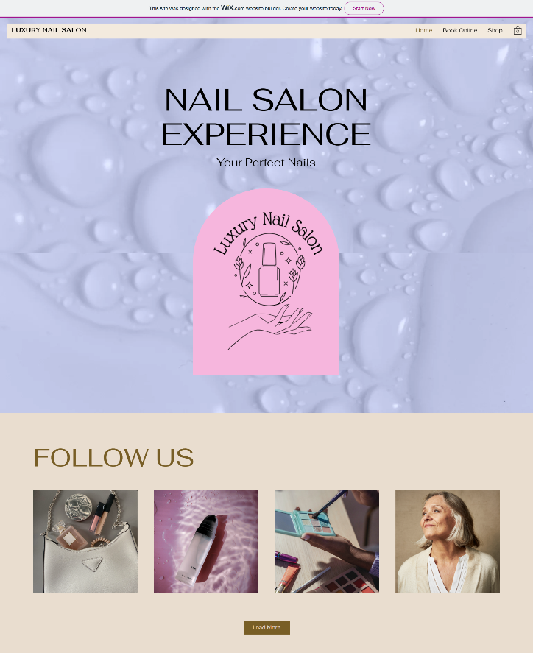

Services/Booking Page
Services List: A list of services provided by the centre; these are manicures, pedicures, nail designs, artificial nails and gel nails services. Every service is described in detail with great images and the prices for each service are also included.
Online Booking System: Online scheduling means that clients can arrange for appointments using the company’s website. The absence of a surcharge is underscored as one of the important advantages, which is consistent with the respondents’ online booking option.
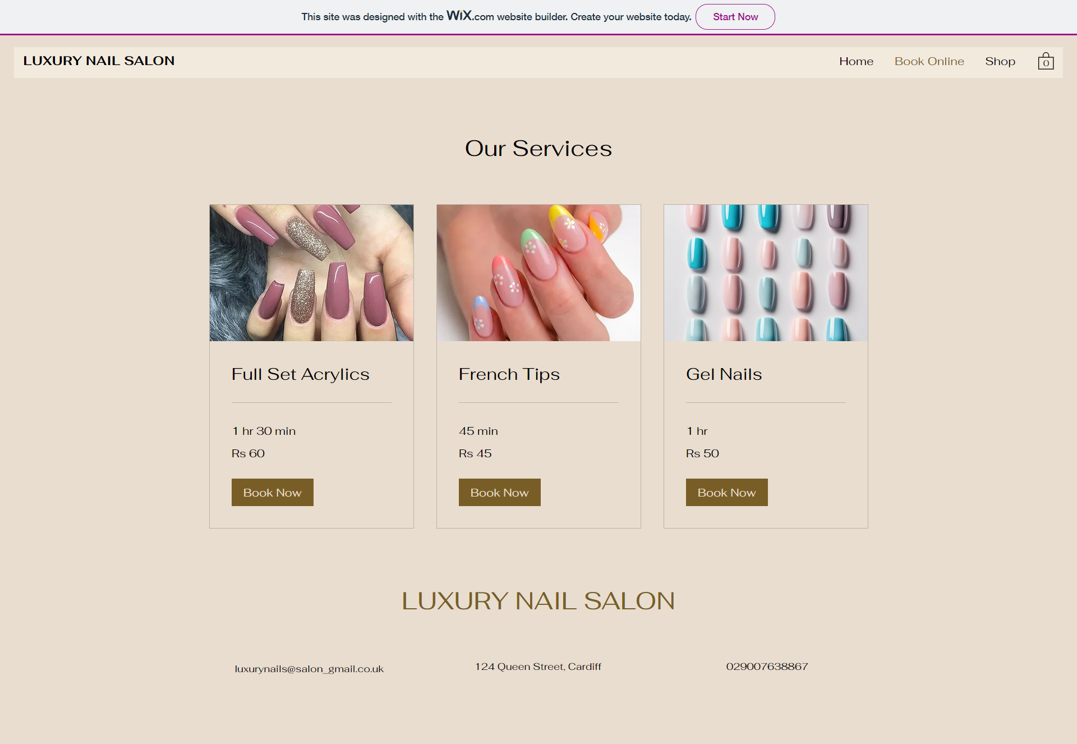

Marketing Materials Design Using CANVA
For the promotion of Luxury Nails Salon, the marketing media was developed using CANVA and the primary elements of interest included interesting images and messages.

Flyers and Posters
- Design Elements: The flyers and posters feature vibrant colours, elegant fonts, and high-resolution images of nail art. The design is visually appealing to attract attention (Solomon, 2017).
- Content: The content includes the salon’s name, logo, tagline, a brief description of services, and contact information. Social media handles for Instagram and TikTok are prominently displayed to drive traffic to the salon’s social media pages (Kumar, 2018).
- Call to Action: Each flyer and poster includes a CTA, encouraging potential customers to book appointments online or visit the salon.

Social Media Posts
- Platform-Specific Design: Posts are tailored for Instagram and TikTok, focusing on engaging, visual content. For Instagram, square images and short videos showcasing nail designs and behind-the-scenes content are used. For TikTok, short, engaging videos featuring quick nail art tutorials and client testimonials are created (Kotler & Keller, 2016).
- Content Strategy: The content strategy includes a mix of promotional posts, educational content (e.g., nail care tips), and user-generated content to foster community engagement (Doyle, 2012; Saunders, Lewis & Thornhill, 2019).

Images
Here are the images of the marketing materials created on CANVA:
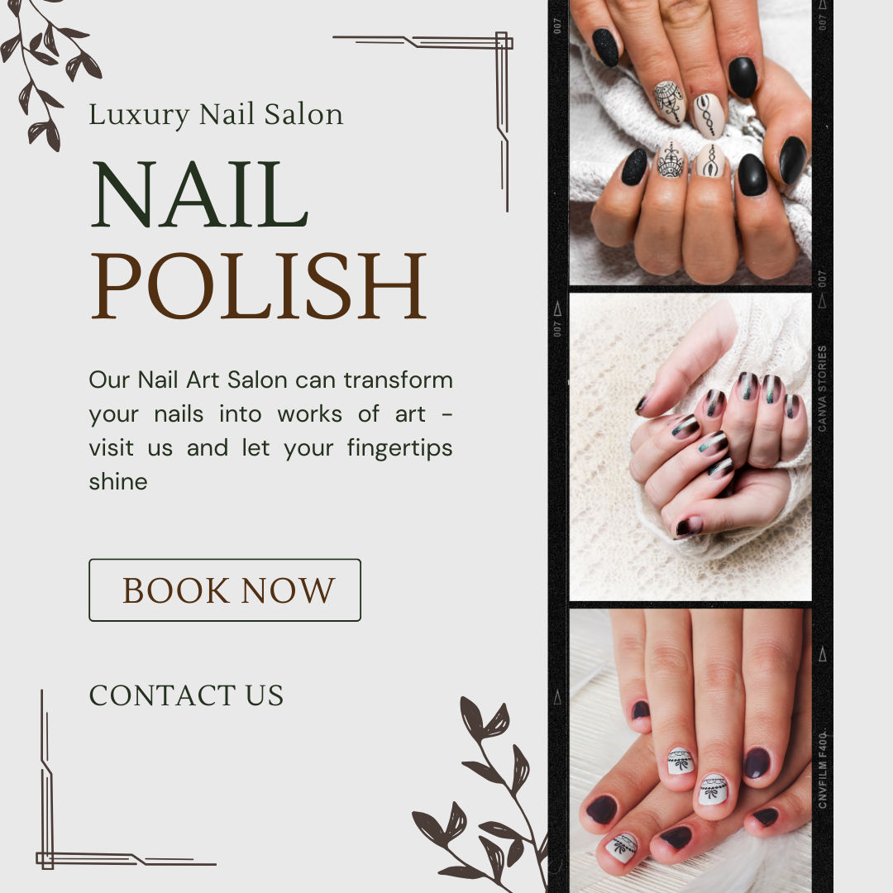
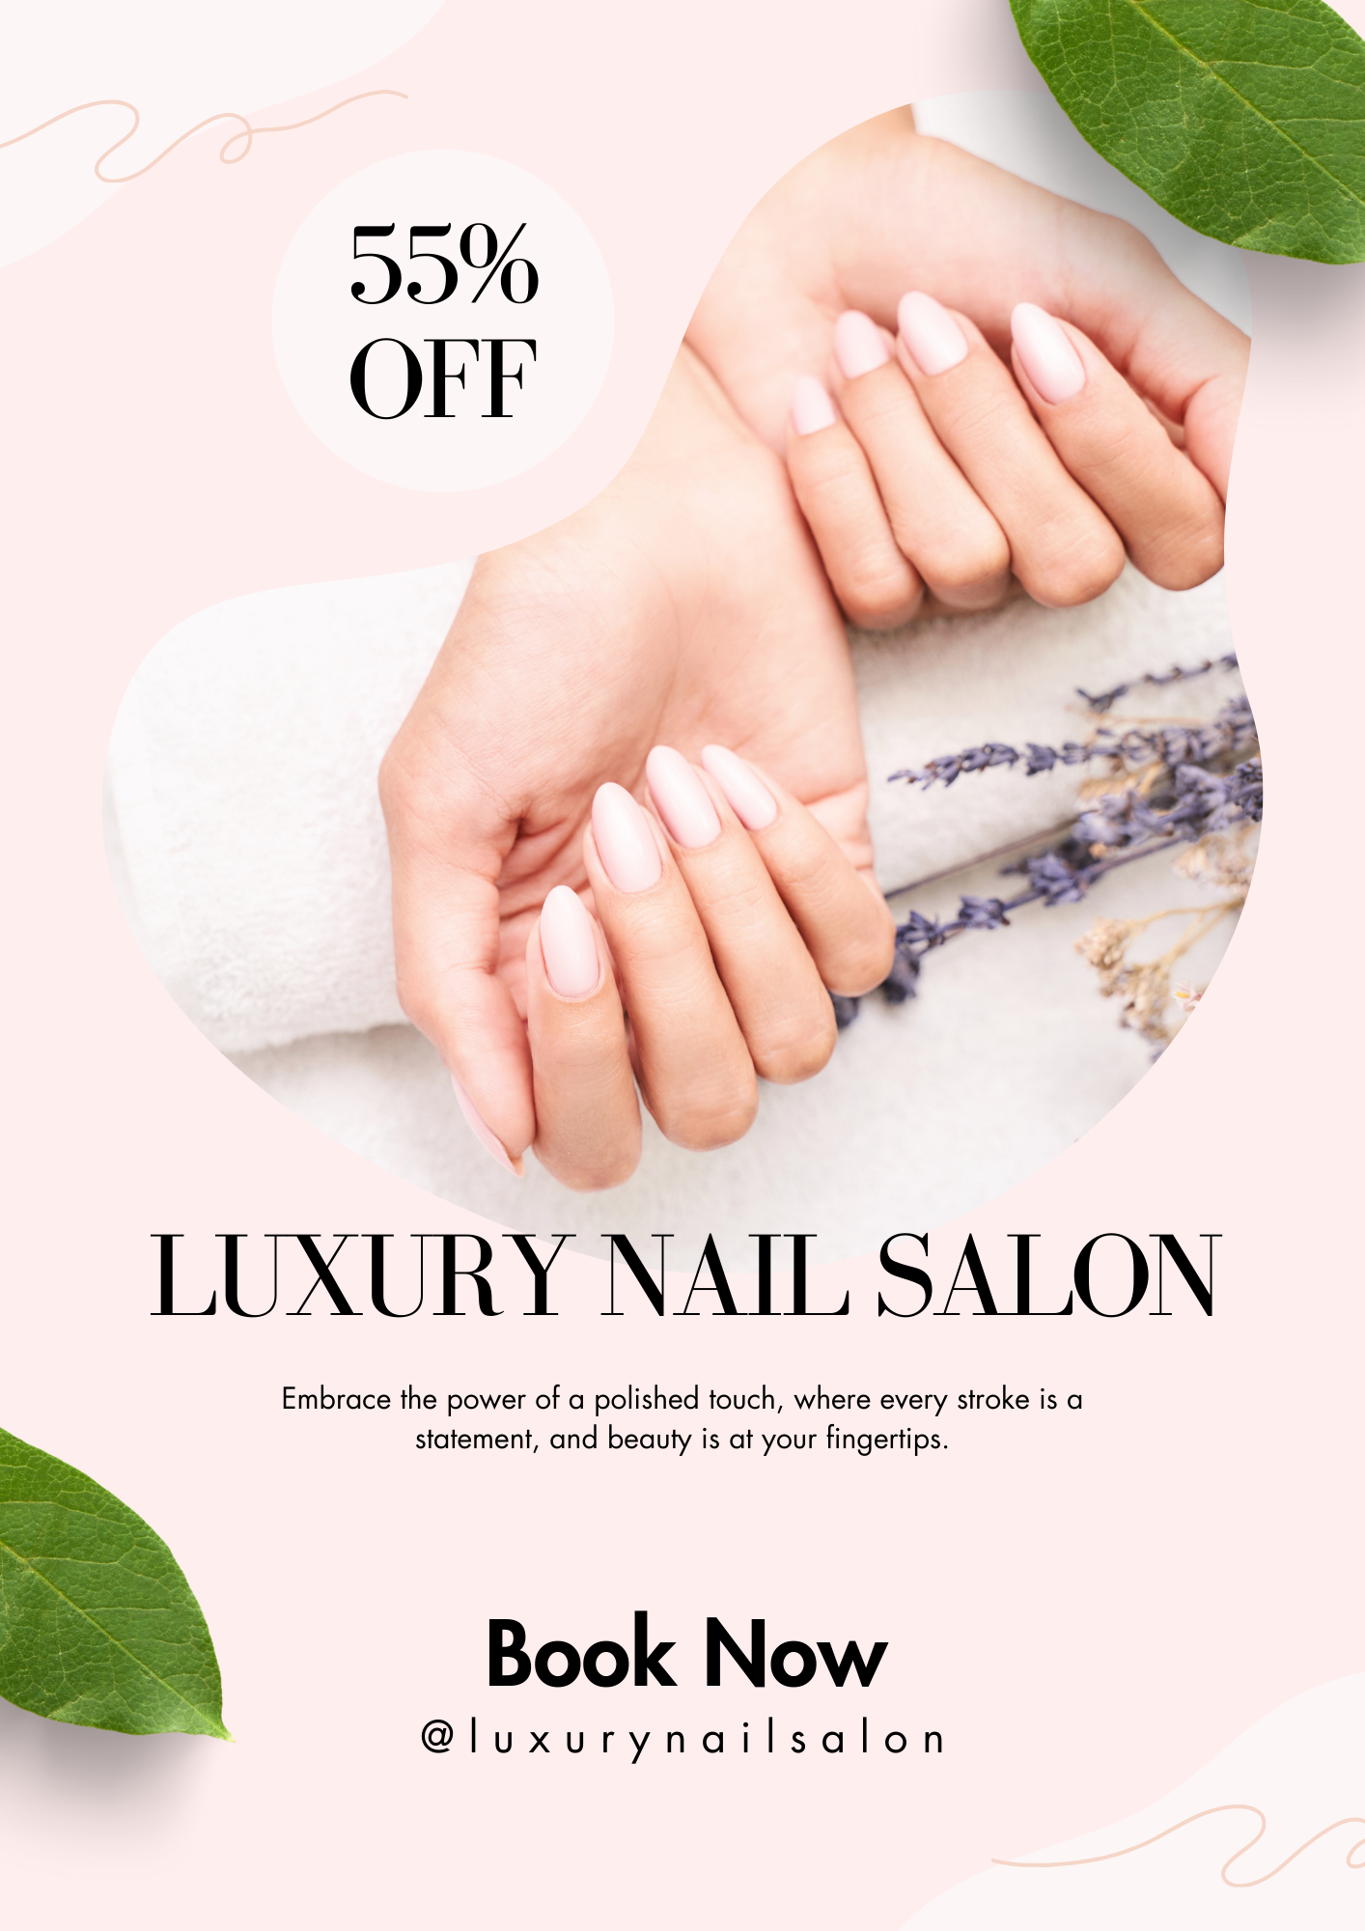
Flyer Design Poster Design Instagram Design
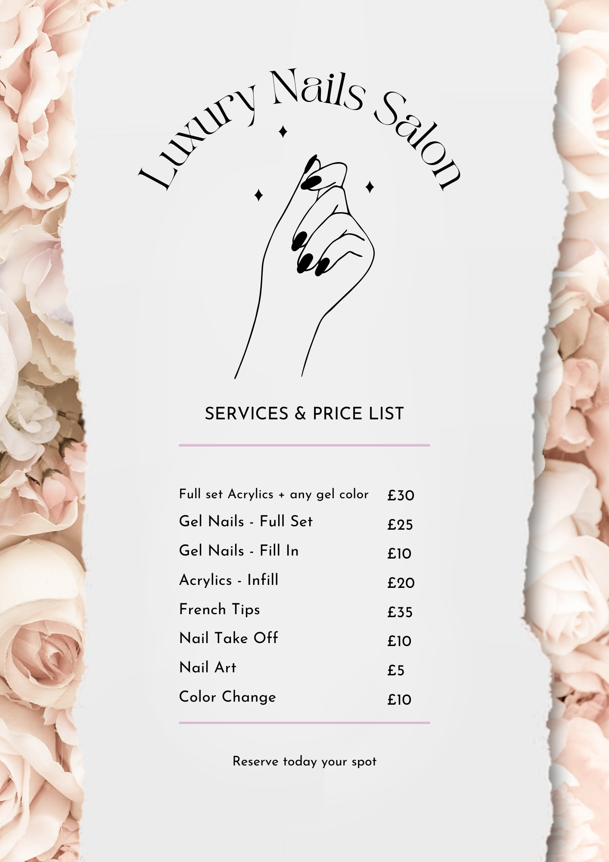
Facebook Design
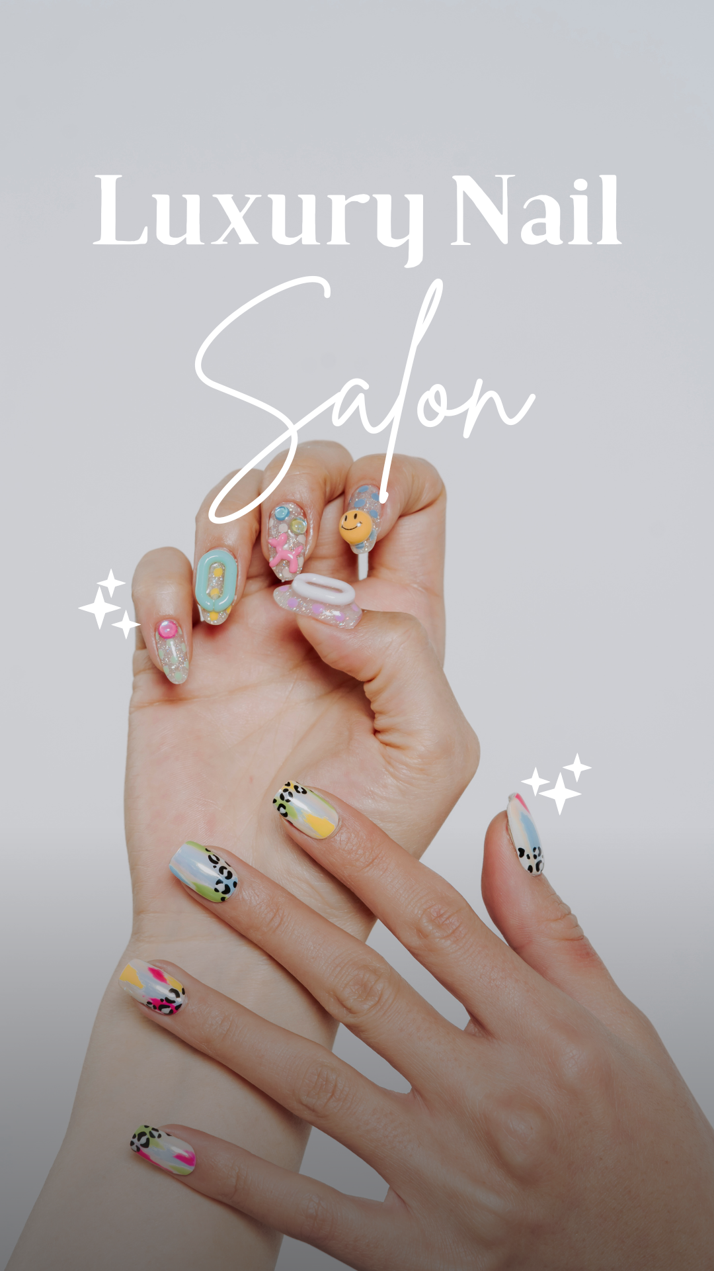

Segmentation and Targeting
The questionnaire data helped identify key segments within the target audience:
Social Media Enthusiasts: Those customers, who come across new businesses on social media platforms with increased popularity, namely Instagram and TikTok. These are the platforms through which the marketing strategy majorly revolves to reach this target consumer group (Solomon, 2017; Kumar, 2018).
Convenience-Oriented Customers: Those clients who prefer an easy process of reservation. This need is met by the website’s integrated online bookings, helping them with their appointment schedules (Aaker, 2014; Kotler & Keller, 2016).

SEO Optimization
To ensure the website ranks well on search engines and attracts organic traffic, several SEO strategies were implemented:
Keyword Research: Some of the phrases that were incorporated into the web content, meta descriptions, and image alt text included luxury nail salon, manicure and pedicure, nail art, book nail appointment online (Malhotra & Peterson, 2014).
Local SEO: Since the salon is located in the city center, local SEO strategies were utilized. The address and a Google Map are present on the website. Moreover, the content is optimized with the phrase “nail salon near me” (Doyle, 2012; Saunders, Lewis & Thornhill, 2019).
Content Quality: Other simple content related to nails and the services provided will be included to increase the information relayed on the site. Blog posts containing tips and trends relevant to nail care will help improve the SEO process (Clow & Baack, 2016; Belch & Belch, 2018).

References:
- Bajpai, N., & Kumar, N. (2018). The psychology of storytelling: Why content marketers must get it right. Journal of Marketing Communications, 24(7), 689-701.
- Fog, K., Budtz, C., & Yakaboylu, B. (2005). Storytelling: Branding in practice. Springer.
- Gill, R. (2015). Why storytelling in marketing is important. International Journal of Market Research, 57(4), 437-439.
- Groysberg, B., & Slind, M. (2012). Leadership is a conversation. Harvard Business Review, 90(6), 76-84.
- Heath, C., & Heath, D. (2007). Made to stick: Why some ideas survive and others die. Random House.
- Herskovitz, S., & Crystal, M. (2010). The essential brand persona: storytelling and branding. Journal of Business Strategy, 31(3), 21-28.
- Holt, D. B. (2016). Branding in the age of social media. Harvard Business Review, 94(3), 40-50.
- Pulizzi, J. (2012). The rise of storytelling as the new marketing. Publishing Research Quarterly, 28(2), 116-123.
- Salmon, W. J. (2010). Storytelling: The secret sauce of content marketing. Content Marketing Institute.
- Simmons, A. (2006). The story factor: Inspiration, influence, and persuasion through the art of storytelling. Basic Books.
- Armstrong, G., Kotler, P., Harker, M., & Brennan, R. (2018). Marketing: An Introduction (13th ed.). Pearson Education.
- Brace, I. (2018). Questionnaire Design: How to Plan, Structure and Write Survey Material for Effective Market Research (4th ed.). Kogan Page.
- Burns, A. C., Veeck, A., & Bush, R. F. (2017). Marketing Research (8th ed.). Pearson Education.
- Hair, J. F., Celsi, M. W., Ortinau, D. J., & Bush, R. P. (2017). Essentials of Marketing Research (4th ed.). McGraw-Hill Education.
- Malhotra, N. K., & Birks, D. F. (2019). Marketing Research: An Applied Approach (5th ed.). Pearson Education.
- McDaniel, C. D., & Gates, R. (2018). Marketing Research (12th ed.). John Wiley & Sons.
- Tull, D. S., & Hawkins, D. I. (1993). Marketing Research: Measurement and Method (6th ed.). Macmillan Publishing Company.
- Aaker, D. A. (2014). Aaker on Branding: 20 Principles That Drive Success. Morgan James Publishing.
- Belch, G. E., & Belch, M. A. (2018). Advertising and Promotion: An Integrated Marketing Communications Perspective (11th ed.). McGraw-Hill Education.
- Clow, K. E., & Baack, D. (2016). Integrated Advertising, Promotion, and Marketing Communications (7th ed.). Pearson Education.
- Creswell, J. W., & Creswell, J. D. (2018). Research Design: Qualitative, Quantitative, and Mixed Methods Approaches (5th ed.). SAGE Publications.
- Doyle, P. (2012). Marketing Management and Strategy (5th ed.). Pearson Education.
- Kotler, P., & Keller, K. L. (2016). Marketing Management (15th ed.). Pearson Education.
- Kumar, V. (2018). Customer Relationship Management: Concept, Strategy, and Tools (2nd ed.). Springer.
- Malhotra, N. K., & Peterson, M. (2014). Basic Marketing Research (4th ed.). Pearson Education.
- Saunders, M., Lewis, P., & Thornhill, A. (2019). Research Methods for Business Students (8th ed.). Pearson Education.
- Solomon, M. R. (2017). Consumer Behaviour: Buying, Having, and Being (12th ed.). Pearson Education.

