

Investigating the Distance-to-Origin Method as a means to Bypass the Effects of Lossy Compression on Steganographic Images

by
Jonathan S. Davies

Supervisor: Gordon Dickers
Second Marker: Andrew Baker

A Dissertation submitted as required for the award of BSc (Hons) Computing (Games Development) to the School of Science and Art of the University of Wales Trinity Saint David

April 2020
Declaration

I, Jonathan S. Davies, declare that I am the sole author of this Project; that all references cited have been consulted; that I have conducted all work of which this is a record, and that the finished work lies within the prescribed word limits.

This work has not previously been accepted as part of any other degree submission.

Signed: Jonathan S. Davies

Date: 26th April 2020

Form of Consent

I, Jonathan S. Davies, hereby consent that my Project, submitted in candidature for the B.Sc.(Hons) Computing (Games Development) degree, if successful, may be made available for inter-library loan or photocopying (subject to the law of copyright), and that the title and abstract may be made available to outside organisations.

Signed: Jonathan S. Davies

Date: 26th April 2020

Abstract
This paper serves to firstly determine whether the Distance-to-Origin method of steganography can indeed allow data that has been embedded within images that have been subjected to lossy compression to successfully be returned to a reasonable degree. The approach was first outlined in a report by Currie & Irvine, in which they outlined a data return rate of approximately 30%. This result shall be validified and a proposal of a means to enhance it will be outlined. Finally, both performance and retrieval results of the Least Significant Bit method, Currie & Irvine’s approach and also the end result of this project shall be analysed.

Table of Contents
Abstract 3
List of Figures 9
List of Tables 10
List of Code Samples 10
List of Abbreviations 11
Glossary 12
1. Introduction 13
1.1 Aim 13
1.2 Objectives 13
1.3 Report Target 13
2. Research and Review of Literature 14
2.1 Introduction 14
2.1.1 Organisational Layout 14
2.1.2 Scope of the Review 14
2.1.3 Defining the Topic 14
2.2 Image Compression 15
2.2.1 Preface 15
2.2.2 History of Data Compression 15
2.2.3 The Need for Compression 15
2.2.4 Image Compression Types 16
2.3 Steganography 17
2.3.1 Preface 17
2.3.2 Historical Background 18
2.3.3 How Steganography Can Be Used 19
2.3.4 Steganalysis 20
2.3.5 Steganography and Cryptography 21
2.3.6 Bits, Bytes & Pixels 21
2.4 Image Based Domains 22
2.4.1 Spatial Domain 23
2.4.2 Transform Domain 23
2.4.3 Domain Summary 23
2.5 Popular Steganography Methods 23
2.5.1 Least Significant Bit 24
2.6 Related Works 25
2.6.1 Enhanced LSB (ELSB) 25
2.6.2 Selected Least Significant Bit (SLSB) 26
2.6.3 Pixel-Value Difference (PVD) 27
2.6.4 Distance-to-Origin Method 28
3. Project Methodology 31
3.1 Introduction 31
3.2 Research Methodology 31
3.2.1 Philosophy 31
3.2.2 Approach 31
3.2.3 Strategies 32
3.3 Risks 33
3.3.1 Risks to the Project 33
3.3.2 Combat Measures 34
3.3.3 Risk Matrix 35
3.4 Generalisability, Reliability & Validity 35
3.4.1 Generalisability 35
3.4.2 Reliability 35
3.4.3 Validity 36
3.5 Data Collection 36
3.5.1 Qualitative or Quantitative 36
3.5.2 Time Horizon 36
3.6 Development Methodology 37
3.7 Resources 37
3.7.1 Hardware 37
3.7.2 Software 37
3.7.3 Human 38
3.8 Conclusion 38
4. Requirements, Design and Implementation 38
4.1 Introduction 38
4.2 Requirements Engineering 38
4.2.1 Requirements Specification 39
4.3 Design 42
4.3.1 Design Decisions & Considerations 42
4.3.2 Key Aspects 44
4.3.3 UML 44
4.4 Implementation 45
4.4.1 Distance-to-Origin Algorithm 45
4.4.2 LSB Algorithm 49
4.4.3 BMP 50
4.4.4 JPEG 51
4.4.5 Problems & Setbacks 51
4.4.6 Successes & Achievements 52
4.4.7 Implementation Timeline 53
4.5 Conclusion 54
5. Analysis 54
5.1 Introduction 54
5.2 Algorithmic Analysis & Comparison 54
5.2.1 Distance-to-Origin Results 54
5.2.2 Least Significant Bit Results 59
5.2.3 DTO & LSB Comparison 60
5.2.4 Performance Analysis 61
5.3 Project Analysis & Comparison 62
5.3.1 Comparing Against Currie & Irvine’s Results 62
5.3.2 Meeting the Software Requirements 63
5.4 Conclusion 64
6. Evaluation & Reflection 64
6.1 Introduction 64
6.2 Meeting the Aim 64
6.3 Expectations formed from Research 66
6.4 Literature Review 66
6.5 Project Methodologies 67
6.6 Requirements, Design & Implementation 67
6.6.1 Requirements 67
6.6.2 Design 68
6.6.3 Implementation 68
6.7 Analysis 69
6.8 Conclusion 70
7. Project Conclusion 71
8. Future Work 71
9. References 72
10. Appendices 77
10.1 – Appendix A 77
10.2 – Appendix B 78
10.2.1 – B1 78
10.2.2 – B2 78
10.2.3 – B3 79
10.3 – Appendix C 80
10.3.1 – C1 80
10.3.2 – C2 80
10.4 - Appendix D 81
10.4.1 – D1 81
10.4.2 – D2 82
10.4.3 – D3 83
10.4.4 – D4 84
10.5 – Appendix E 85
10.5.1 – E1 85
10.5.2 – E2 85
10.5.3 – E3 86
10.5.4 – E4 86
10.5.5 – E5 87
10.6 – Appendix F 88
10.6.1 – F1 88

List of Figures
Figure 1 - Steganographical Uses [25] 20
Figure 2 - RGB 'bit' Value alongside its binary format 22
Figure 3 - Bit Weighting Table 22
Figure 4 - Embedding Process 24
Figure 5 - Bit Remainder Line 29
Figure 6 - Risk Severity Map [53] 35
Figure 7 - Distance-to-Origin Results - Modulus 42 55
Figure 8 - Distance-to-Origin Results - Modulus 12, 22 & 32 56
Figure 9 - Distance-to-Origin Results - Modulus 22, 62 & 82 57
Figure 10 - Distance-to-Origin Results - Modulus 142 & 242 58
Figure 11 - LSB Results 60
Figure 12 - Visual Similarities between the DTO & LSB methods 61
Figure 13 - Algorithm Performance Tests 62
Figure 14 - P1 (Original Point) & P2 (New Point) 78
Figure 15 - P1's Vector is Normalised 78
Figure 16 - P1 Normalised is then scaled by the distance of P2 79
Figure 17 - GitHub History 1 80
Figure 18 - GitHub History 2 80
Figure 19 - BMP Related Classes 81
Figure 20 - Steganography Related Classes 82
Figure 21 - File Input/output Related Classes 83
Figure 22 - JPEG Related Classes 84
Figure 23 - Differences between images at Mod(42) 85
Figure 24 - Differences between images at Mod(12) 85
Figure 25 - Differences between images at Mod(82) 86
Figure 26 - Differences between images at Mod(142) 86
Figure 27 - Differences between images at Mod(242) 87

List of Tables
Table 1 - ELSB Advantages & Disadvantages 25
Table 2 - SLSB Advantages & Disadvantages 27
Table 3 - PVD Advantages & Disadvantages 28
Table 4 - DTO Advantages & Disadvantages 30
Table 5 - User Stories 40
Table 6 - Specification Requirements 41
Table 7 - Software Requirement Assessment 63
Table 8 - Non-essential System Requirements 77

List of Code Samples
Code Sample 1 - Finding distance and modulus 45
Code Sample 2 - Find the native segment 46
Code Sample 3 - Enum & Pair Object 46
Code Sample 4 - Find Distance and Direction to safe zone 47
Code Sample 5 - Internal condition from the first 'if' statement in Code Sample 4 47
Code Sample 6 - Switching segments 48
Code Sample 7 - Vector Mathematics to Move the Pixel 48
Code Sample 8 - LSB Nested For-Loop 49
Code Sample 9 - Pixel LSB & Bit Comparison 49
Code Sample 10 - LSB XOR Operation 49
Code Sample 11 - Inverse Condition 50
Code Sample 12 - Randomised String Creation 53
Code Sample 13 - Code Timing 88

List of Abbreviations

STL – Standard Template Library in C++
DTO – Distance-to-Origin
LSB – Least Significant Bit
MSB – Most Significant Bit
ELSB – Enhanced Least Significant Bit
SLSB – Selected Least Significant Bit
MVP – Minimum Viable Product
JPEG – Joint Photographic Experts Group
RGB – Red, Green, Blue
POW – Prisoner of War
CIA – Central Intelligence Agency
NSA – National Security Agency
UML – Unified Modelling Language
BMP - Bitmap

Glossary

- Stego – used to describe objects or artefacts that contain embedded data, e.g. stego-image; an image with embedded data inside.
- Payload – refers to all the data that is/has been embedded into an object.
- Cover – depicts an object (usually an image) that is used as the canvas from which data can be entered in to.
- Steganalysis – the act of performing an attack on a stego-object with the intention of discovering hidden information.
- Human Visual System – refers to the way in which humans observe the world, i.e. through their eyes.
- Least Significant Bit – describes the bit of data within a byte that holds the smallest weighting.
- Visual Attack – Studying an image purely through looking with one’s eyes. No computational aids involved (aside from the screen by which the image is viewed).
- Lossy – A form of compression whereby data is permanently lost in an effort to reduce the file size as much as possible.
- Lossless – A form of compression with which the file can be restored in its entirety when needed. No data is lost.
- 4Chan – A popular message board website that allows users to post content anonymously to topics of their interest.

Introduction
The objective of this report is to present detailed documentation of all work carried out in relation to the title above. The core ideology of the project is to determine whether the Distance-to-Origin method can preserve sensitive data inside an image when it has undergone a lossy compression attack, specifically JPEG. Not only will efforts of physical implementation be presented in the form of an analysis and software design but also; the reviewing of key literature in the field, an in-depth observation of different methodologies that were adopted to form the foundations of the project, and an evaluation of each stage to determine how effective and efficient they were.

Aim
The intent of this project is to:
explore, apply and evaluate the Distance-to-Origin technique that allows for steganographical images to be subjected to lossy compression and retain its hidden data upon retrieval.

Objectives
- To critically review the key literature pertaining to the topic area in order to further understand the field and measure the limitations of the project.
- To develop and document methodologies related to both the research and developmental aspects of the project.
- To establish a set of requirements that will eventually lead to the design of software that is capable of testing the method in question and record key phases of its implementation.
- To conduct an in-depth analysis on all results obtained from the software and provide a comparison to works previously discussed in the literature review.
- To perform an evaluation to reflect on both the theoretical and practical elements to the project.

Report Target
This report will serve as the collective pool of all theoretical and practical aspects of the project. It will comprise of all background literature and research, project methodologies, design blueprints, discussion of results and evaluative measures.

Research and Review of Literature

Introduction
This section aims to provide the necessary background material relating to the topic being investigated. It forms the base knowledge and should not be considered a comprehensive guide. Section 2.1 through to 2.3 cover general information relating to both Steganography and Compression respectively, whilst section 2.4 covers work that has been undertaken by researchers in the field.

Organisational Layout
The structure of the literature review has been designed to ensure that the meanings of key words are explained first, followed by the context and their relation to the project, and finally some historical background information where applicable.

Scope of the Review
The review will primarily focus on the following points:
- Digital steganography
- Spatial vs Transform domain methods
- Lossy compression
- Previous studies within the same topic area
- Steganographic methods involving text document or image-based platforms

However, the following points are out of the scope of this project:
- Using steganographic techniques in conjunction with cryptographic techniques
- Audial and video-based platforms such as .mp3 or .mp4
- Steganography in interactive media such as video games

Defining the Topic
There are two major topics involved within this project and it is how they interact that forms the basis of all the research that is to be conducted. The first topic area is Steganography, which involves hiding messages within files, and the second is Compression, which allows the modifying of files and documents in order to reduce their size. Literature surrounding each of these fields shall be explored in detail throughout the review process.

Image Compression

Preface
This chapter of the literature review will provide a comprehensive overview of image-based compression methods as well as a brief insight to its roots and the need of its existence. The first section shall cover both the history of data compression and the preliminary knowledge needed to understand future content. The second section’s focus is specifically on lossless compression, while the final section delves into lossy compression.

History of Data Compression
Compressing data into its smallest possible state, whilst not damaging the contents beyond repair, has long been a large part of data transmission and storage efforts. This is due to smaller messages being sent and received quicker and take up less space when stored. Throughout the duration of the Twentieth Century there are many examples of compression used both by military and civilian organisations. However, the root of data compression is thought to have be conceived in 1844 when Samuel Morse created a method of communication called Morse Code [1]. In the Code, each letter of the alphabet is given a unique sequence of dots and/or dashes that allow every letter to be easily distinguished from others. The user would then construct sentences out of these characters, and it would be sent via telegraph to the recipient. Each dot was given the allotment of one unit, whilst a dash was three units. One problem that Morse expected and circumvented was that the messages would be extremely long and therefore take a vast amount of time to create and transmit. This issue was addressed by setting the most common letters of the alphabet to take up the least amount of units, essentially giving them the smallest footprint, whilst giving the lesser used letters the most amount of units [2].

The Need for Compression
Compressing data is far more than a mere convenience in the Twenty First century, where 4K video file sizes are looking to replace the 1080p standard high definition format and 8K looking to make an entry soon. Without compression, these files would be so large that only a very limited amount of them could be stored on even the largest hard drives currently available on the market. A single, one-minute uncompressed consumer 4K (3840x2160) video running at 60 frames per second would create a file size of approximately 80-90GB [3], [4]. This would mean that a 2TB hard drive could hold roughly 22 4K uncompressed films. When placed in comparison with compressed 4K films that usually sit on the 25-35GB mark as they need to fit onto a Blu-ray CD which will hold a maximum of 50GB [5], the hypothetical 2TB hard drive could now store 60-80 4K films. The equation below provides a way to calculate how large a file size will be, whereby w and h represent the width and height of the frame in pixels, c equates to the number of colour streams (e.g. RGB would be three), f is the number of frames and s equals the number of seconds in the video. The output of the equation is b which is the total number of bytes that will be produced.

$$\left(\left(w⋅h\right)⋅c\right)⋅\left(f⋅s\right)=b$$
Equation 1 – Compression Equation
Aside from the aforementioned storage problems associated with uncompressed files, there are also massive networking implications for passing uncompressed data through a network. The less data that is needed to transfer from one location to another, the quicker the whole process becomes, alleviating traffic issues on the network. With video streaming services such as Netflix and YouTube now offering the streaming of 4K and even 8K videos, file compression is more essential than ever to ensure that these massive files can be sent across the internet in a reasonable timeframe [6].

Image Compression Types

Lossless Compression
Lossless compression allows file sizes to be reduced without compromising the integrity of the data within, allowing for a complete reconstruction of the file to its original state when decompressed [7], [8]. This form of compression is critical in environments where files need to be stored and transferred but are also of high importance and key information cannot be at risk of loss. Such environments may include offices or universities, where missing data may corrupt or render files illegible, all the way through to medical and military image files where subtle losses in detail may lead to misdiagnosis or life-threatening, ill-informed decision making [9].

Lossy Compression
Lossy compression also decreases the size of a file but does so in a different manner. Whereas its lossless counterpart will allow a complete restoration of the contents of the file, lossy compression will strip and delete data that is deemed unnecessary and those changes are permanent. While the file is now forever changed, and the deleted data cannot be retrieved, it does allow for a compression of far greater intensity, allowing for vastly smaller file sizes than a lossless compression method [10], [11].

Steganography

Preface
The word ‘Steganography’ itself is derived from the Greek word ‘Steganos’, meaning “covered, concealed” [12], and the Germanic/French word ‘Graphia’ meaning “to write, to describe” [13]. It is the motion of concealing secret information in an unsuspecting mode of transmission with the objective of hiding in plain sight until it reaches the appropriate recipient [14]. A successful digital steganographic transfer is one in which a payload has been embedded into a cover object, with optional encryption if desired, and passed through some medium of conveyance (such as a computer network) and reaches the target destination without the arousal of non-authorised bodies [15], [16].
Prior to the digital era, this was achieved through a wide variety of means on a multitude of platforms with examples including invisible ink, pin prick markers and using animals as transport vessels [17]. Digitalised steganography can be far harder to recognise however, with the ability to store an entire document or image within another document or image whilst still retaining a high degree of quality [15].
Steganography is a relatively niche area of computer security that, when done successfully, renders the payload invisible to the unsuspecting observer. It often falls under the shadow of its relatively well-known cousin, Cryptology, even though there are very distinct differences between the two. Whilst both are methods of secret communication, the means in which they achieve success are what differentiate them. The goal of each approach is to deliver information from the source to the destination securely without third parties discovering the contents of the message.

Historical Background
It is believed that the coining of the word ‘Steganography’ holds its roots somewhere between 1462-1526 when German monk Johannes Trithemius completed his first work entitled “Steganographia”, a publication that considered the artefacts of both steganography and cryptology as forms of magic [18], [19]. However, the application of the act is much older and can be cited as far back as ancient Greece.
There are many examples throughout history of leaders, politicians and military commanders utilising steganography as a mode of communication, particularly during times of conflict or when under other forms of scrutiny. One such example is that of Histiaeus, a Greek tyrant, who would shave the head of a trusted slave and tattoo a message on their scalp. Once the hair had grown back and the tattooed message was concealed, the slave was then sent to meet with the desired beneficiary, upon which the slave’s head would be shaved yet again to reveal the message [18], [20].
World War One saw the increased use of invisible ink with both the Allied and Axis’ War Departments testing of various formulae to produce the most effective type. At the time, the most common was a simple heat-based invisible ink that was widely used not just used by the military, but also by intelligence services and resistance fighters [21].
The Second World War brought with it a new era of cryptologic and steganographic methods, most notably with the United States creating a censorship organisation. The purpose of this office was to conceive ways in which enemy spies could communicate both with other spies and with the states that sponsored them [21].
A major epoch for steganography was during the Vietnam war. United States prisoners, who were captured and detained in various camps throughout Vietnam, devised numerous techniques for contacting other prisoners within their compounds. Techniques such as ‘Tap Code’ were used, which is a variation of Morse code, and ‘Sweep code’, whereby prisoners charged with “sweeping” duties would use the rhythmic strokes of the brush to send code to fellow inmates. However, more elaborate means of communication were developed that allowed prisoners’ messages to reach their families back home and even high-level American government offices. These types of communications resulted in a planned escape from the most notorious of the Vietnamese prisons Hoa Lo, ironically referred to as the Hanoi Hilton by those that spent time there [22], [23].
Possibly the most famous covert message to be sent at the time was that of decorated U.S Navy Commander Jeremiah A. Denton, who was shot down and captured whilst conducting an air raid on a military installation in Northern Vietnam. Upon his confinement at Hao Lo prison, he was subjected to ruthless and continuous torture, something that Vietnamese officials denied being true throughout the war. Denton was forced to appear on a televised interview as part of a propaganda campaign and, unbeknown to his captors, blinked the word ‘torture’ in Morse code while on camera. The footage was circulated, and the hidden message was quickly uncovered by the Central Intelligence Agency, confirming suspicions of POW torture in Vietnam [24].

How Steganography Can Be Used
Steganography can be useful in a multitude of different scenarios depending on the needs of the individual. Three of the most popular ways have been explored and presented below [25]:

- Data Hiding – Whether legal or illegal, steganography provides individuals with the means to covertly send information with a lessened fear of reprisals.
  - Legal Uses –
    - Citizens who are concerned with governmental legislation that may inhibit their privacy may choose to protect messages when sending them to their destination.
    - In 2012, a mysterious post on “4Chan”, led thousands of people on a journey of puzzles that started in the digital world but also ventured into reality. The shadowy group that posted the challenge, known only as Cicada 3301, claimed that there was a reward for the first one hundred people who finished. The puzzles required vast cybersecurity knowledge, particularly in the fields of steganography and cryptology. There are theories that this challenge was a recruitment campaign set up by the CIA, NSA or some other intelligence service, however, these claims have never been confirmed [26], [27].
  - Illegal Uses –
    - In many countries, the use of encryption is against the law, ensuring that communications that are deemed unwanted can be traced by the government [28]. As a result of this, some individuals resort to steganographic techniques to mask their messages.
    - Criminal or terrorist organisations have been found to use steganography techniques to mask their plans and operations. It is believed that pornographic websites, web-based bulletin boards and public auction sites may have been used to hide stego-images containing plans or orders of various terrorist attacks around the globe [29], [30].
- Data Storage – Some individuals may choose to use steganography to store sensitive data without the act of transporting it anywhere. Information may be embedded into a cover file that could just sit on a user’s desktop, again, hiding in plain sight.
- Digital Watermarking – The main difference between watermarking and steganography is intent. Steganography is primarily used for data hiding, whilst watermarking is used for adding extra data to a file for authentication purposes. Although different, they do both share similar methods and techniques.
Figure 1 below depicts a simple tree with some of the more common branches of steganography.
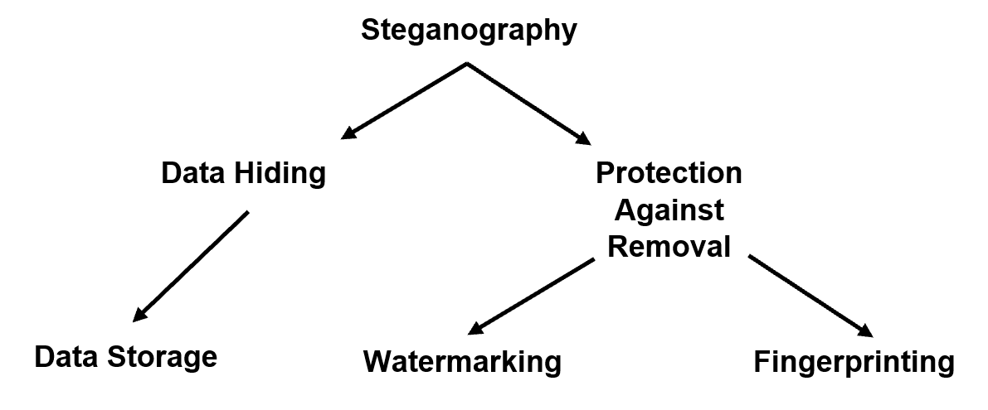
Figure 1 - Steganographical Uses [25]

Steganalysis
The searching and discovery of stego matter falls into a field called Steganalysis and can be broken down further into two main investigatory techniques, passive and active. When preparing a stego-object, such as a message that will be embedded into an image, the creator must be aware of countermeasures that could be employed by steganalysists in order to detect the secret information that is being transmitted.
Upon suspecting an image to contain hidden data, the attacker has multiple tools at their disposal by which to uncover the data. Firstly, a visual attack is conducted, by which the image is simply examined by the human eye to see if there are any obvious blemishes or out of place artefacts in the image, usually caused by a poor embedding algorithm or packing in too much data.
Secondly, a statistical attack can be used whereby the data stored within each pixel is converted into a histogram, allowing experts to see exactly what information is contained within.

Steganography and Cryptography
Steganography and Cryptography are both areas of computer security that have the same goal and that is to transmit data from a source to a destination without the interference of third parties who may compromise the integrity of the data. The way in which they undergo this transmission is the key difference between the two. Cryptography uses encryption to hide the contents of a message so that if looked upon, it is illegible unless a secret key is applied, in which case the cypher can be reversed. Using this method, the fact that a secret message is being sent is rather obvious due to the clear attempt of scrambling the data. Steganography, on the other hand, hides the very existence of the message in the first place, leading to the medium of transport not arousing any suspicion, and therefore scrutiny. Due to this secretive approach, it is not always necessary for steganographical material to encrypt the data that is embedded within. However, for maximum data security it is advisable to do so.

Bits, Bytes & Pixels
All digital images are represented on screen via thousands, or more commonly millions, of pixels. The contents of each of these are part of an array of information that stores the light and colour intensities for every point on the screen [31] [32]. These pixels are usually made up of three different colour groups - Red, Green and Blue. Each colour component is eight bits in size, whereby the range in which it can exist lies between 0-255. A typical RGB value has been shown below in Figure 2 next to its binary state:

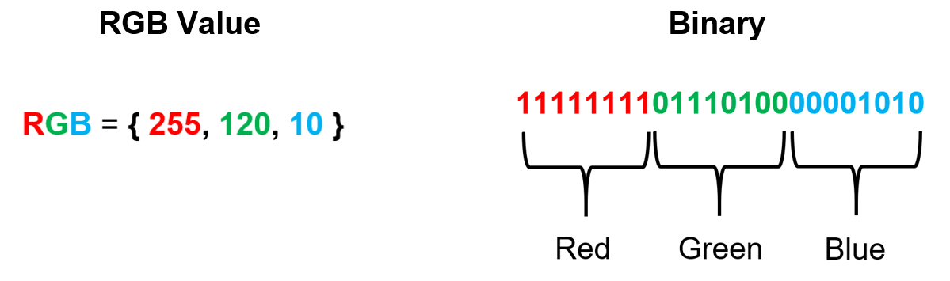
Figure 2 - RGB 'bit' Value alongside its binary format

Just by reading the values in each section, it is not difficult to assume the colour that is being represented. With Red at its maximum, Green at half intensity and a miniscule amount of Blue, the RGB value would display as the colour Orange.
By referencing Figure 3 below, it is clear that each consecutive bit is larger than its predecessor and that the farther left along the table you travel, the more impact that bit has on the overall colour.

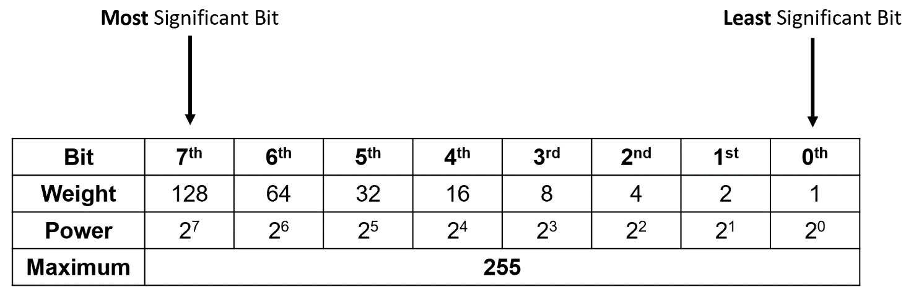
Figure 3 - Bit Weighting Table

Image Based Domains
The two major domains in which steganographic methodologies reside are the spatial domain and transform domain. Both aim to reach the same objective but do so in massively different ways and have distinct advantages and disadvantages associated with them. Most of the spatial domain methods are far easier to implement and still produce a stego-image that will fool the human eye but one of the major limitations is that virtually any lossy compression algorithm will devastate any secret information that is hidden within due to its many levels and layers of data removal. By complete contrast, the transform methods are harder to create but do protect the contents of the hidden message to a high degree, even when subjected to lossy compression.

Spatial Domain
Steganographical techniques that are conducted in the spatial domain modify the physical elements of each image that they are working on, namely the pixels themselves. If data is to be hidden within an image, each pixel’s colour components are modified in some way to reflect the hidden message and it is due to this simplicity that there are ample spatial domain steganography methods that were developed early on. An advantage of working in the spatial domain, when developing a data hiding method, is that implementation is relatively simple and can be done quite quickly. On the contrary, one of the major disadvantages of employing a method from the spatial spectrum is that if the resulting image is to be compressed, it must only undergo lossless compression, as the algorithms that enact lossy compression will usually completely destroy any hidden data within [22 pp. 69-70].

Transform Domain
Methods that use the altering of image frequencies fall under the umbrella of transform-based techniques. These techniques are far more complex than those found in the spatial domain but do offer a far greater robustness and solidarity against visual and computational attacks [22 pp. 146-147].

Domain Summary
To summarise this section, spatial domain techniques allow simple manipulations of physical data within the image to be modified and are generally simpler to implement. That simplicity does come at the cost of nearly all spatial domain techniques having great difficulty protecting data whilst being attacked with anything more complex than a visual attack.
However, transform based methods are the inverse of this, with the level of difficulty of implementation increasing but with the added benefit of greater protection against not only visual attacks, but also statistical and compression attacks too.

Popular Steganography Methods
Within the field of Steganography, there exists a multitude of methods and techniques with which to create a stego-image, each of them incorporating various degrees of difficulty, time and computational expense to implement. Image Steganography focuses its efforts on manipulating images so that when the payload is implanted, the Human Visual System is unable to detect that any foul play has occurred.

Least Significant Bit
This method is considered to be among the easiest and most popular means of embedding a secret message into an image [34], with the reason being that the concept is fairly simple to comprehend.
As the name suggests, it is focused around manipulating the least significant bit, and this can be done on either of each component of a pixel’s RGB value or on the parity bit of the entire pixel [31]. The message that is to be embedded is first converted into its binary representation and once this is complete, it can be separated into smaller parts and loaded into the LSB of each component of each pixel. It is possible to use more than one bit per RGB element, but this comes with consequences as the higher the weighting on the bit, the more visually distorted the image becomes. If the eighth bit were changed to a ‘0’ from a ‘1’, this would drastically change the colour that is displayed. However, if the first bit was changed, the difference in colour would most likely not be noticeable to the human eye.
The LSB method operates under a ‘security through obscurity’ principle meaning that besides the hiding of the message, there is no other security measure in place in the event of a breach. If the stego-image falls victim to a visual attack, and the attacker holds suspicions of it, it would not be difficult to extract the secret information. A common practice is to combine the obscurity of steganography and the security of cryptology to produce an artefact that is both able to deceive most onlookers but also able to stop any determined attackers from uncovering the message. The diagram in Figure 4 shows the entirety of the letter ‘d’ and the first bit of the letter ‘o’ from the word ‘dog’ being embedded across the LSB of three pixels.
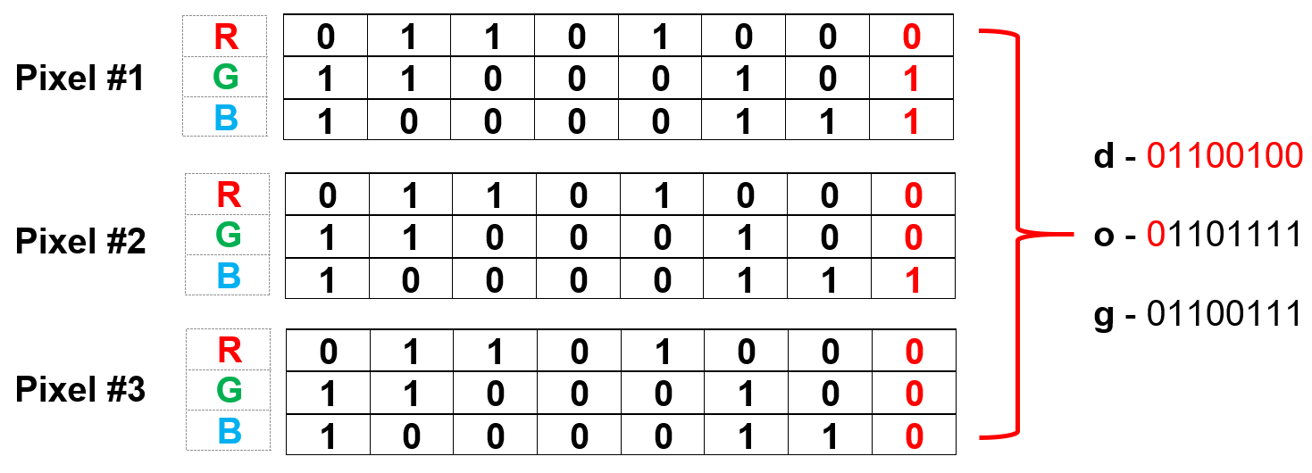
Figure 4 - Embedding Process

Related Works
The aim of this section is to provide the reader with research and techniques that are related to the field of study and cross-compare them to expose the potential flaws or merits in each.

Enhanced LSB (ELSB)
Gupta et al. [35] suggest a way of upgrading the standard LSB method by only modifying the least dominant component of each pixel’s RGB values. More often than not, Blue is the chosen value with their argument being that out of the Red, Green and Blue elements, Blue can tolerate the greatest change and still remain undetectable to the human eye [36], [37].
The aim of this method is to provide a higher level of security against visual attacks by further taking advantage of the HVS’s weaknesses. If one were to measure the usefulness of this technique by the size of the payload, it could be considered as a sub-satisfactory approach because only one of each pixel’s components is modified, resulting in a third less data that can be stored within the cover image. Adam et al. [38] deem that the enhancements achieved in the added security outweigh the limited payload size.

Advantages | Disadvantages
Higher levels of resistance against visual attacks when compared to the standard LSB method. | Less information can be stored inside each cover image.
Less chance of uncovering a hidden artefact when subjected to a statistical attack. | Provides no means of ensuring hidden data can survive a lossy compression attack.
Less complex to implement than standard LSB.

Table 1 - ELSB Advantages & Disadvantages

Selected Least Significant Bit (SLSB)
In terms of keeping embedded data hidden, there are two main methods of attack that may uncover the message; visual and statistical. Roque & Minguet [39] outline the potential for a successful statistical attack when operating within traditional LSB guidelines due to the massive spike in colour value on the colour scale when changing the least significant bits of each of the three components of a pixel. They argue that changing the least significant bits of every component of a pixel shifts that colour 65793 values, which when mapped on a graph, such as a histogram, would show a massive distortion in the image, thereby rendering the stego-transfer a failure.
The way that they propose to tackle this issue is to store three bits of information inside one of the pixels components instead of all three. For example, the Red and Blue elements would remain unchanged, but the last three least significant bits of the Green element would store that pixel’s allotted hidden data. When mapped, the new method only changes that pixel’s colour by 1792 values, which is a huge improvement from before.
Roy et al. [40] highlight the issues surrounding this method’s susceptibility to statistical attacks, even when coupled with the security gains achieved by Gupta et al.’s [35] technique. However, it does still achieve a greater level of protection than a standard LSB implementation and with the added benefit of extra data storage, does provide an agreeable balance between security and the amount of data to be concealed.
Osunade & Ganiyu [41] extend this method further with their Enhanced SLSB method which involves the same methods as described for Roque & Minguet’s, but using two pixel components instead of one, which results in slightly less security but a greater hidden data capacity. This method is completely defenceless against a lossy compression attack of any kind.

Advantages | Disadvantages
Provides a middle ground between the level of security and payload size. | Takes on a ‘jack of all trades’ approach and does not specifically aim to combat the problems encountered at each extreme.
Still retains a relatively high degree of resistance against HVS attacks. | Insufficient levels of protection against statistical attacks.
Takes advantage of the least dominant colour component within a given pixel and is therefore fairly adaptive. | Provides no means of ensuring hidden data can survive a lossy compression attack.

Table 2 - SLSB Advantages & Disadvantages

Pixel-Value Difference (PVD)
Wu & Tsai [42] devised a method to ensure that stego-images retained their integrity even when compared alongside their original counterpart. It involves hiding the majority of the hidden data in the LSBs of pixels that have stark contrasts to their neighbours and embedding minimal data in areas that are considered smooth. The algorithm achieves this by blocking together two pixels located next to each other on the $x$ axis and calculating the difference between them. The smaller the differing value, the closer those pixels colour match, and therefore that area of the image is smoother. If, however, the differing value is large, it means that the two pixels are on an edge and therefore maximum data can be embedded.
This technique drastically improves the chances of successfully deterring a visual attack when compared to standard LSB methods [42], but cannot withstand the changes made when subject to a lossy compression attack.
Luo et al. [43] along with Zhang & Wang [44] claim that this method is substandard as it does not adequately use the edge data from an image as a mask for the information and is also ineffective at preventing a statistical attack, even stating that analysis conducted upon a histogram of said image may reveal the amount of data that is hidden within.

Advantages | Disadvantages
Provides a greater protection to an HVS attack by only hiding data in areas of the image where colour contrast. | Falls hopelessly short of maintaining integrity when undergoing a statistical attack.
Can pack a generous size of data into the image. | Provides no means of ensuring hidden data can survive a lossy compression attack.

Table 3 - PVD Advantages & Disadvantages

Distance-to-Origin Method
Currie & Irvine [45] proposed a means of achieving this to the United States Navy, and was delivered as part of the National Information System Security Conference. The method involves passing a stego-image through JPEG compression as it is an extremely popular way of compressing images and is exceptionally efficient at this task, which is one of the reasons that it has become the standard of image compression[46][47].
The concept of the technique involves taking each pixel’s RGB value and thinking of them as a point in 3D space as opposed to a colour scheme, thus allowing mathematical operations to be performed that would have otherwise not have been thought relevant. In order to aid understanding, the scheme has been subdivided into two key areas, encoding and decoding, with the former being discussed first.
The encoding process commences by taking each pixel’s position (RGB value) and calculating the distance between that pixel and the origin of the image (0, 0, 0), and this is done via Pythagorean theorem, $d=\sqrt{x^{2}+y^{2}+z^{2}}$. The next stage requires an undetermined number by which the distance can be modulated (this shall be expanded upon later). Thus far, the equation can be expressed as $r=ⅆ\operatorname{mod}\left(n\right)$, whereby $r$ represents the remainder, $d$ is the distance between the pixel and the origin and $n$ is the number that the distance will be modulated by. The remainder will be a value that lies somewhere between 0 and $n$, and once found, can be mapped to a point on the scale shown in Figure 5 below. If the remainder falls between 0 and $\frac{n}{2}$, then it shall be expressed a 0 in the decoding process and if it falls between $\frac{n}{2}$ and $n$ it shall be a 1.
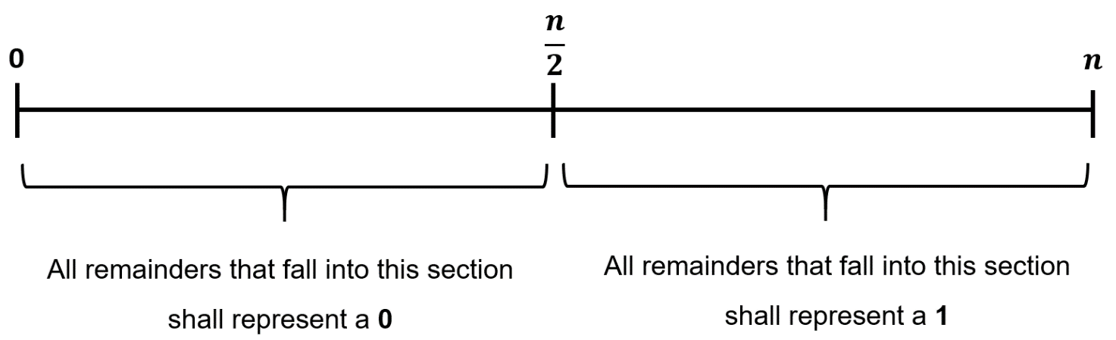
Figure 5 - Bit Remainder Line

As an example, let an arbitrary pixel’s RGB value (202, 94, 145) be thought of as a point in 3D space, with the distance to the origin of the image being calculated as $d=\sqrt{{202}^{2}+{94}^{2}+{145}^{2}}=265.82$, taking note to round the answer to the nearest integer value. The next stage works to find a remainder from the modulated distance, and it is at this point that a modulus value is to be chosen. Whilst selecting a modulus value, it is important to consider a number that is large enough to have a central point that still has at least 12 units either side before hitting either 0 or $n$. This is to allow a cushioned area around the final remainder to account for JPEG interference. Currie & Irvine chose a modulus value of 42 and the same shall be done in this example. The remainder can now be found by way of $r=266\operatorname{mod}\left(42\right)=14$, which would be mapped onto the left portion of Figure 5. At this point, moving the value 14 down the scale to either 11 or 12 may prove beneficial as the more centralised the values are within their respective zones, the safer they are from JPEG interference. In order to adjust the value however, the distance to the origin, and therefore the pixels position (RGB value) must be changed.
The process is somewhat repeated when retrieving the hidden message in the decoding section of the method. Each pixel’s position is found, the distance calculated and then modulated by the same integer as was used in the encoding process. This will reveal a value that when placed on the scale in Figure 5 corresponds to either a zero or one depending on where it lies. These binary values can then be stored and used to form the message.
Both Currie & Irvine and Jain & Gupta [48] assert that this method will only be able to retain approximately 30% of embedded data and also created obvious artefacts in the image.

Advantages | Disadvantages
Claims to have some resistance to lossy compression attacks | High level of redundancy needed if subjected to lossy compression.
Harder to uncover technique as it is not well known. | Weak to statistical attacks.
 | Can hold a hold as much data as the standard LSB method.

Table 4 - DTO Advantages & Disadvantages

Project Methodology

Introduction
This part of the report will facilitate the uncovering and documentation of all methodologies related to the design, direction and approaches of the project. The means by which the data shall be used, tested and analysed, and the optics through which they are viewed can be found here.

Research Methodology
The Distance-to-Origin method proposed by Currie & Irvine [45] forms the foundations of this project, outlining algorithm methodologies and test results. Currie & Irvine state that after exposing their stego-image to JPEG, 30% of the secret message was salvageable using three layers of redundancy (each bit was embedded three times in a row). After many months of research into the field of steganography, no confirmations of their findings or approach has been found to reaffirm their claim, which leads onto the purpose of this project.
This project endeavours to complete the following tasks. Firstly, to recreate the method in its entirety and test whether the original statement of a 30% message retrieval rate at a modulus of 42 is accurate. Secondly, to experiment with modulus values other than 42 and determine what benefits or shortcomings can be associated to them. Finally, to perform tests to see how the algorithm operates when subjected to JPEG at different levels of compression ratio and detail the results graphically.

Philosophy
With the primary purpose of implementing steganographical techniques being to evade suspicion by way of hiding information without adding noticeable artefacts or discrepancies to the cover file, it could be assumed that a phenomenological approach would be best suited as a subjective survey could be performed measuring the changes that are perceived by different individuals. However, as the study is focused more on determining if Currie & Irvine’s results are accurate, a positivist manner has been adopted as it harbours the ideals of the ‘natural scientist’, offering an objective, nonpartisan overview of the project throughout all potential avenues and all information that it utilises or generates [49][50].

Approach
Whilst formulating an approach style for this project, several integral factors were considered. Firstly, as stated above, the project is centred around a report produced by Currie & Irvine [45], who delivered an acceptable rate of data retrieval from the Distance-to-Origin method consisting of approximately 30% of the hidden message using three layers of redundancy (each bit to be hidden was embedded three times in a row).
Next, differing the modulus values and creating a testing stage to assess whether the desired results can be achieved by both the standard algorithm and the enhanced version shall be made. These tests will then be used to either confirm or reject the statements expressed in the original report.
Drawing from the points discussed above, the research approach that best fits this project is one of a deductive nature. The theory has been set in place by Currie & Irvine in “Surmounting the Effects of Lossy Compression on Steganography”, the hypothesis has been outlined by the changing of modulus values increasing the data retention, and a set of observations has been drafted to better explain the testing procedure and provide a confirmation/rejection of the project aim.

Strategies
To ensure that the project has the greatest chance of success possible, three strategies have been chosen that envelop the foundations of the study and have been highlighted and explained below:
- Document Review – This consists of a review of literature, conducted in Section 2, aiming to collate both the background information deemed critical and also work that has been done by researchers in the field.
- Software Development – This involves developing a program that will be used to test the credibility of all hypotheses that have been outlined. Both the algorithms needed, and the actual tests used in the analysis stage will be created.
- Case Study – The document by Currie & Irvine has been selected for examination and implementation. It has been chosen, at is the only literature from the document review that claimed to provide a means of passing a stego-image through a lossy compression algorithm with any degree of data retrieval in the spatial domain.

Risks
Risk has been defined by Prince2 [51] as:

“The chance of exposure to the adverse consequences of future events.”

Risks to the Project
On account of the project involving different levels of complexities combined with a limited timescale, risks of varying degrees expose themselves. This section aims to both identify the risks and categorise them from most to least significant. Every risk that has been highlighted will also be given two numbered values ranging from 0-5, each representing the likelihood and the impact of the event happening. This will allow for a graphical collation to map the results [52]. As comprehensive as the following list attempts to be, it obviously cannot foretell every conceivable risk to the project, and it is for this reason that only the most relevant appear.

- Software Integration (A) – For example, during the testing stage, the stego-image will have to be subjected to JPEG and this handover may not be error free. Likelihood – 1, Impact – 2.
- Gold Plating (B) – There is a chance of additional software that is neither on the requirements specification or design plans and has been added purely because of the interest of the programmer. Whilst this may seem benign, it wastes valuable project time and resources. Likelihood – 3, Impact – 2.
- Long-term absence due to sickness or external factors (C) – This could come from either the student or supervisor and both would have detrimental effects on the project. Likelihood – 2, Impact – 4.
- Knowledge absence (D) – Should the developer’s knowledge reach its limit and the level of research needed seems unachievable in the timescale, this would raise serious concerns to the project’s success. Likelihood – 3, Impact – 4.
- Complete project/software loss (E) – Should the entire project be lost due to fire, theft, technical issues etc. the impact would be extremely substantial. However, this is unlikely due to a multi-level backup system for both theory and practical work. Likelihood – 1, Impact 5.
- Forced increase of scope (F) – If an element of the project is found to be insufficient, there may be a need to expand it. Potentially, this means new research further into the field. Likelihood – 4, Impact – 3.
- Project backlog (G) – As the project is the not the sole focus of the developer (other works, each with their own deadlines), the project may find itself taking a step back as the busiest part of the year begins. Likelihood – 5, Impact – 4.

Combat Measures
To accompany the above list, measures have been taken to reduce the effects of each risk. These measures come in two forms, active and passive and are outlined as follows:

- (A) – Research will be undertaken to select software/libraries that have been tried and tested with a large user base. Reviews of particular libraries shall be looked at for compatibility issues. Where possible, the most updated versions of software will be used.
- (B) – During the design process, requirements shall be laid out comprising of both the general idea of the requirement, and also a more specific technical requirement. These requirements will form an MVP which shall be developed first. Any development that does not directly benefit an MVP will not be undertaken.
- (C) – This risk can affect not only the developer of the project, but also the supervisor. For this reason, all hardware, software and communication tools have been setup to allow the project to be run remotely from anywhere. All tools needed will be downloaded as soon as possible to ensure that if internet access becomes an issue, the majority of work can be completed offline.
- (D) – To ensure that knowledge boundaries are not breached, proper design principles shall be adhered to, allowing for a full analysis of potential theories or solutions before they are implemented.
- (E) – Multiple backups exist of both the report and of the program files. The use of GitHub has allowed for a completely remote backup as well as version control. Physical backups are made weekly on to two different external hard drives.
- (F) – Unfortunately, there is not much that can be done to reduce this risk aside from performing thorough research at the start of the project. Instead, steps shall be taken to ensure that the right problems are being researched and time for these shall be monitored.
- (G) – Google Calendar provides an effective means of time management whilst ensuring that not too much time is spent doing one thing.

Risk Matrix
Using the values discovered above, a map can be generated displaying the most and least serious risks; this has been shown in Figure 6 below.
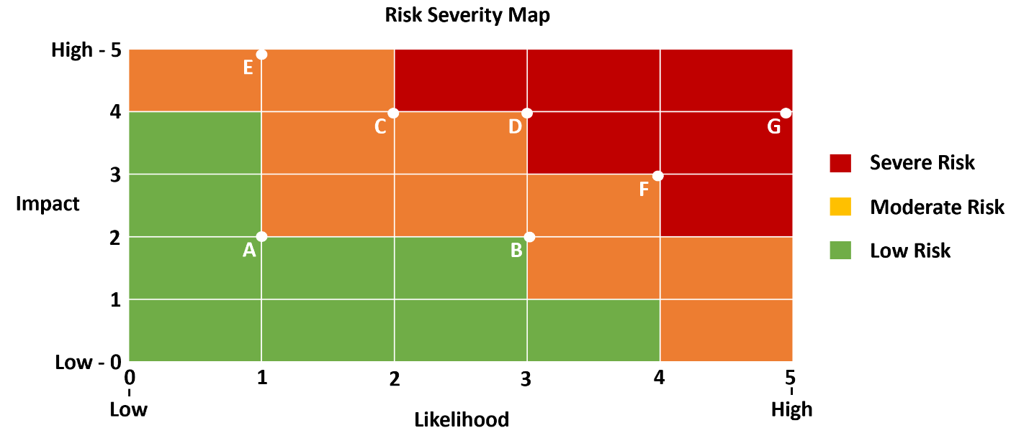
Figure 6 - Risk Severity Map [53]

With the greater risks leaning towards the top right and the lesser at bottom left, this map creates a visual picture of which risks are worth monitoring and which could be set aside.

Generalisability, Reliability & Validity

Generalisability
The method in question is a niche technique in an already obscure field in computer science so the probability of the algorithm being used in other situations with different problems is extremely low.

Reliability
Once the algorithm has been formalised and tested, it will provide the same results no matter the researcher, providing that a basic criterion has been met. Firstly, the file type used must a BMP and the compression type must be JPEG. Secondly, the size of the image dimensions must be larger than the number of characters multiplied by three. Lastly, the level of redundancy must be kept at the same level as was successful in the test.

Validity
A comprehensive testing scenario probing many different aspects of the algorithm with the intention of both legitimising the original method and also enhancing its retrieval rate has been considered an effective means to carry out this project.

Data Collection
To test whether any data can be recovered from the stego-image, a system has been devised to give success the best possible chance. The message will have to be ingrained into the image multiple times and to avoid potential overlaps of information; each copied message shall be placed on a different row. This will help prevent the mixing of messages in the event of JPEG scrambling the end of one string with the start of the next.
During the extraction process, the decoder will know that only one message is contained for each line, so that when the entire line is analysed, each pixel shall once again be subjected to the DTO method to find out the binary unit that it represents. These binary units shall be blocked into groups of eight to form the necessary level of information to convert it to an ascii character. Each character shall then be entered into a list to form a string and compared against the original message.
Every string comparison shall be graded and given an accuracy percentage. Once this has happened for every row in the image, an average percentage shall be calculated, taking care to note the compression ratio that was used by JPEG. This test shall be run on multiple images to ensure that a fair analysis has been carried out.

Qualitative or Quantitative
The data produced from this project will be primarily quantitative, relying on the comparison of one data set to another. Results will be charted on a graph to show how series of tests performed.

Time Horizon
As the resulting data will be immediately produced after the test, the time horizon for the analysis is cross-sectional. There will be no long-term testing that will produce results over a greater length of time.

Development Methodology
The software development model that has been implemented is Feature-Driven Development. It is a good fit as it matches the iterative, progressive nature of the project and is customisable enough to work well in a singular-developer situation. The general layout of the development stage has, thus far, been to:

- Design a purely high-level account of what the intended feature should be able to do.
- Comprise a list of sub-problems within said feature.
- Construct a plan for each sub-problem and how best to tackle it.
- Determine an architectural blueprint of how each sub-problem will fit into the larger structure.
- Develop the feature on a problem-by-problem basis.
- Conclude with a test phase to ensure compatibility.

This approach to development of the software allows for components to be built, tested and integrated in a modular fashion, allowing for concepts that don’t quite work to be removed or upgraded easily.

Resources
This section will outline the necessary resources to ensure that the project can be designed, developed and analysed to a degree appropriate to the task.

Hardware
The only hardware needed for the project is a standard computer with an Internet connection. Faster processors are preferable however, for example, Intel’s i5 series and above would provide faster testing times.

Software
Access to an Integrated Development Environment (IDE) is essential to the project and specifically Microsoft’s Visual Studio (VS). Although backwards compatibility is not an issue, much of the designing and prerequisite code has been written in the 2019 version of VS. To document the theoretical aspect of the project, Microsoft Word was considered the best option due to widespread availability and compatibility. Diagrams are created and modified in a mixture of Microsoft PowerPoint and Paint 3D. To manage references in the report, Mendeley has been used as a way of storing and organising all external works.

Human
There are many people who will contribute to the success of this project including; Gordon Dickers (Project Supervisor), Y Fforwm (Library) Staff, Gaynor Thomas (Major Project Co-ordinator) and Andrew Baker (Personal Tutor).

Conclusion
To summarise, the methodology branch of this paper has expressed not only the varying ways in which the project has been planned and approached, but also how it is intended to be delivered and analysed. The type of data to be procured from testing was discussed along with descriptions of techniques that are to extract that data and strategies that will guarantee a particular level of study and research has been conducted prior to the development stage. Risks that pose the greatest threats to the success of the project along with countermeasures have been identified and evaluated, allowing for monitoring and regulation. Finally, a collection of essential resources has been listed, without which the project will be hindered.
This section has constructed the necessary foundations for the design and implementation stage to begin. It has outlined the manner with which to proceed and a final direction point for the project that is critical not only to the physicality’s of the software, but also to the time management of the project as a whole.

Requirements, Design and Implementation

Introduction
The aim of this section is to conceive requirements for the practical elements of this project, including both high-level and technical specifications. These will be examined and prioritised to make for a smoother design process.

Requirements Engineering
This section will function as a collation point of all requirements that are related to the software development aspect of this project. Each requirement will initially be formed in high-level context, in this case a User Story, without any technical terminology to ensure that the general idea of the requirement is always easy to understand and cannot be misconstrued. Following this, each story shall be dissected, and a deeper, more literal requirement is produced that defines any of the ambiguities that may exist.

Requirements Specification

User Requirements
The method of requirement collection used is User Stories as its sole purpose is to keep the needs of the end user and end functionality in the forefront of the design process. However, a slight modification has been made to the approach by splitting the standard user story sentence construct down into four separate statements that represent the MoSCoW filter, therefore enabling the operation to both express the needs of the user and simultaneously allow them to set the level of priority that is needed. The statement below is the foundational user story statement put forward by Mike Cohn [54] and it, along with a multitude of variations, is used extensively in the software development industry.

“As a <USER>, I want to <GOAL>, so that I can <REASON> [55][56].”

For this project however, the adaptation was deemed appropriate and allows the user to place a priority on each requirement at the time of requirement creation.

“As a <USER>, I MUST be able to <GOAL>, so that I can <REASON>.”
“As a <USER>, I SHOULD be able to <GOAL>, so that I can <REASON>.”
“As a <USER>, I COULD be able to <GOAL>, so that I can <REASON>.”
“As a <USER>, I WOULD like to be able to <GOAL>, so that I can <REASON>.”

Using this approach, the following stories have been developed:
ID | User Story | Priority Level  (1 = High, 4 = Low)
1 | As a user, I must be able to choose a BMP, so that I can use them as cover images. | 1
2 | As a user, I should be able to create new BMPs, so that I can use them as cover images. | 2
3 | As a user, I should be able to create new messages, so that I can hide them within an image. | 2
4 | As a user, I must be able to import text files, so that I can hide the text inside an image. | 1
5 | As a software tester, I must be able to select which steganographical method to use, so I can conduct comparative tests between each of them. | 1
6 | As a user, I would like to able to navigate using a graphical interface, so that I can better understand what I am doing. | 4
7 | As a software tester, I must be able to export test results, so that I can visualise them easier. | 1
8 | As a software tester, I could be able to run multiple algorithms at the same time, so that I can make testing faster. | 3
9 | As a user, I must be able to navigate the program via a menu system, so that I can select exactly what I want to do. | 1
10 | As a user, I must be able to import a JPEG and check it for a secret message, so that I can see if the algorithm works. | 1
11 | As a user, I would like to encrypt my message, so that an extra layer of protection is added. | 4

Table 5 - User Stories

System Requirements
The next stage of the requirement engineering pipeline is to take the user stories and remove any vagueness that is likely to be there. In the table below, each user story has been referenced via its ID from the previous section and a technical breakdown has been added. For the sake of readability, only the highest priority stories have been detailed in the main body of the report, while the remaining ones can be found in 10.1 – Appendix A.
User Story ID | System Requirement
1 | - The program must accept a file path to a BMP file.  - A check must be performed to ensure that the file is a BMP.  - If successful, the entirety of the BMP must be copied into memory.  - If unsuccessful, notify the user of the error.  - Only one BMP can be worked with at any one time.
4 | - A notification will tell the user on message limit sizes to ensure image can handle the embedding.  - A file path to a .txt file should be entered by the user.  - A check will be taken to see if the file is a .txt.  - If successful, the entirety of the message is stored in memory.  - If unsuccessful, display an error to the user.
5 | - Through a menu system, display a list of the available methods to carry out the operation.  - This stage can only be reached once a message and cover image have been selected.  - User will be prompted as to whether they would like the results exported via .csv or viewed within the program.
7 | - User will be prompted as to whether they would like the results exported via .csv or viewed within the program.  - Updates of the export process will be delivered to the user via the programs console output.  - A file name and file path will be provided to the user post-completion.
9 | - A menu will be available that will contain all necessary navigation information.  - Instant commands will be available via key presses (e.g. Esc will quit the program).
10 | - The program must accept a file path to a JPEG file.  - A check must be performed to ensure that the file is a JPEG.  - If successful, each pixel in the image can be read and the contents can be checked for secret data.  - If unsuccessful, notify the user of the error.

Table 6 - Specification Requirements

Feasibility Study
To ensure that the requirements laid out in the previous two sections are not too demanding, a feasibility study will be conducted. The model used to undergo this exercise is TELOS [57] - Technical, Economic, Legal, Operational and Schedule. The technical and economic sections question if the requirements are too demanding for the developer in terms of both skill/knowledge competency and potential financial costs. Legal refers to whether the project faces any legality problems or hosts any ethical issues that may need to be addressed. The operational category assesses how effective the project will be at solving the problem outlined in the requirements stage and lastly the schedule field will check if the project can be completed to a satisfactory level within the time frame allocated.

  - Technical – Although the main method of this project (Distance-to-Origin) has not been thoroughly explored outside of the creator’s initial paper, the steps involved in manufacturing it exists in common C/C++ libraries. Research has been carried out into the construction of BMP files, along with their manipulation and more primitive steganography techniques like the LSB.
  - Economic – The nature of this project (it being an undergraduate dissertation) and the fact that all resources can be found within the infrastructure of the university mean that no financial factors contribute to its outcome.
  - Legal/Ethical – The use, production and transmission of steganographical (as well as cryptographic) content are legal within the United Kingdom and considering that no compromising or personal data is being hidden, there are also no ethical concerns in the project.
  - Operational – The planning of this project took into consideration the requirements provided by the university and resulted in a task that was large enough to encompass all work that is considered an essential part of a developmental major project. The algorithm that was chosen is an obscure method that itself lies within a niche area of Computer Science. This has led to the project being sophisticated enough both technically and in terms of the requirements of a successful dissertation.
  - Schedule – With much of the research having been completed prior to the official starting date of the project, a brainstorming session to map out the rest of the work needed highlighting to ensure that there was more than enough time for completion.

Design
This section will explore some of the key features, decisions and principles of the program that is to be developed.

Design Decisions & Considerations
During the pre-construction planning phase of development, it was quickly realised that an in-depth knowledge of the workings of an image file structure would first need to be researched, neatly leading on to the selection of such an image type. An uncompressed file type was needed that was universally accepted and could be used by third party libraries later for JPEG conversion. For this reason, the end selection choice consisted of BMP and PNG. Ultimately, BMP was chosen due somewhat to its native Windows compatibility but largely due to its simple file structure. Something worth noting, however, is that the BMP files read pixel values as BGR (Blue, Green, Red), which is the opposite of the normal RGB; but this can easily be catered for with a simple conversion function.
With such emphasis being placed on knowing the intrinsic workings of the BMP files, it was thought best to create a custom BMP reader - which could take open BMP files and extract all the header/file information along with pixel values and store them in a custom-made data container – and BMP writer – which could create, clone and amend BMP files. Without this understanding, pixel manipulation would have been extremely hard to successfully carry out, and although a third-party library could have been used, it would have done nothing to aid with the development of the target algorithm (Distance-to-Origin).
The project has been planned from an object-orientated approach, allowing not only for modular testing and adding of functionality, but also for exploration into some of the not-so-obvious aspects of C++ and a deeper look into the STL (Standard Template Library). In most cases, the C-style ways of performing operations have been replaced with their C++ counterparts. For example, vectors have been used in place of heap allocated arrays because of the added benefits and functionality that comes with the object. This bonus functionality outweighs the performance gains that the older C style methods have for this particular project.
The project relies on a BMP image being converted into a JPEG and then decoded. For the conversion, third-party software has been used in place of creating a conversion algorithm, as the time needed to produce it would have been far too great. Due to the complicated nature of reading JPEG images, an external library named ‘STB_Image’ was used to read the pixel data, which was then stored in a custom data container.
A major design component that presented a huge problem for the software was the fact that the decoder needed to know the number of pixels to read and the modulus value that the encoder used. To combat this, at least initially, hard coded values have been used (i.e. the decoder knows ahead of time that it is to read 32 pixels and use a modulus value of 42) which allows for a satisfactory, albeit slower, testing phase. Two other workarounds may be implemented with the first storing key data inside the header of the BMP in memory positions that are classed as ‘reserved’. These memory positions are very rarely used but on the off chance that they are, the data relevant to the project will be lost. Another issue that arises with this storage option is that it is unclear as to what happens to this information once the image is converted to JPEG, which renders this approach too unpredictable. The second method involves encoding the relevant data inside the first few pixels of the image. This would allow the data to be transported with the image without fear of losing file header information but is also subject to the same scrutiny as the actual pixel data that it is there to represent. However, as the purpose of this project is to simply test the effectiveness of the algorithm, and not its ability to subvert attention during transit, the decoding algorithm having knowledge of the modulus value in advanced is acceptable.

Key Aspects
During the design process, three concepts were considered to be the most important to be implemented from the beginning because as the program grew in size, they would ensure that the adding, removing and updating of code would be a far simpler task. These three areas have been explained below.

Extensibility
The software has been built with the idea in mind that future work will most likely be done on the program. This has led to a design whereby new features can be bolted on with minimal effect on the structure of the underlying program. For example, the current two image formats, JPEG and BMP, hold an intermediary class called ‘PixelContainer’ which essentially holds the raw RGB data for an image. This means that when the program reads an image format, all pixel data can be stored in a format that is known and accepted across the rest of the program, making manipulation of the data far easier.

Modularity
With an Object-Orientated approach having been taken, modularity is already tightly bound to the design of the project. However, further considerations have been made by generalising as many of the functions as possible so that they can be used across many class structures.

Maintainability
To ensure that the code can be easily understood and therefore maintained, key parts of all algorithms have been commented to provide a breakdown and understanding.

UML
For a visual representation of what the design stage has complied, various UML diagrams have been made, each focusing on a different set of class relationships that are fundamental to the project. Some variables in the diagrams have been emphasised with associational connectors to highlight their reliance or relation to other classes. These diagrams can be found in 10.4 - Appendix D.

Implementation

Distance-to-Origin Algorithm
The algorithm has been broken down into a set of functions that belong to the ‘Stego’ class, a class that would house all steganography techniques. A function has been made for each of the key steps in the algorithm and are all called from within a single function called ‘DistanceToOrigin’. The remainder of this subsection will elaborate on how the method was programmed, providing description for parts that could be considered rudimentary and code snippets for the more intricate sections.
Firstly, considering the RGB values of a given pixel as 3D coordinates, the distance between said pixel and the origin of the image – (0,0,0) – were calculated and the result was converted to an integer value. This distance value is then modulated by 42 (see reasoning for this number in 2.6.4), which in turn returns a remainder that lies between 0-41.

Code Sample 1 - Finding distance and modulus
The next stage is to determine whether the remainder value lies between 0-21 or 22-41. If the value lies in the smaller segment, the pixel’s native encoded bit shall be a 0, otherwise it is a 1. The remainder is passed into the function along with the modulus value.

Code Sample 2 - Find the native segment
Following the discovery of the pixels segment, the distance from the remainder to the nearest safe point (i.e. values that range between 10-12 in the lower segment and 30-32 in the higher) will need to be found. For example, if the remainder of an arbitrary pixel were 2, it would need to be shifted 8 values larger to be considered safe. To achieve this, a pair object was created from the STL that held the distance that the value needed to travel in to be safe and the direction that it needed to travel in (smaller or larger) which was represented as an Enum.

Code Sample 3 - Enum & Pair Object

Finding the native segments of each pixel was not enough for the algorithm to be successful. Pixel remainders needed to be able to cross segment boundaries if the next encoded bit was the opposite of the pixels. For example, if the next bit to be encoded from the secret message was a 1, but the remainder of the pixel lay in the lower segment (0-21), then the pixel’s remainder (and therefore position) would have to be moved until it represented a 1, which would mean crossing the boundary from 0 to 1. The function that was responsible for finding all distances and directions was DistanceToSafeRemainder, and initially performed a clearing check to see whether the message bit to be encoded (represented below as ‘BitValue’) matched the native segment from the pixel (represented as ‘segment’ below). The ‘if’ statements shown below are the top-level checks inside this function.

Code Sample 4 - Find Distance and Direction to safe zone
Within each of these conditions is another condition that further queries the exact location of the remainder, and once it finds this, determines both a distance and direction to the safe area. Only two of these nested conditions have been added, the first one can be found in the first ‘if’ statement found above and showcases an ideal scenario where both the next bit to encode and the native segment of the pixel match up.

Code Sample 5 - Internal condition from the first 'if' statement in Code Sample 4
The following code snippet is from the fourth condition in Code Sample 4. It illustrates when a distance above 32 needs to be moved to the safe zone of the lower segment, essentially going up past 42 and reverting to 0, therefore allowing it to move the required 10 spaces to the lower segments safe area.

Code Sample 6 - Switching segments
Once this stage has been completed, much of the conditional checking that generates the correct move sequences has been calculated and all that is left is to physically move the pixel. To do this, the pixel distance is normalised, and a new function was created that accepts the distance and direction as a pair and the pixels original distance to the origin. The normalised vector is scaled using the newly acquired distance to create an entirely new vector with new positions (RGB values) based entirely off the moved remainder value. When these new values undergo the process of finding its remainder for encoding or decoding, it now reflects the value of the desired segment. 10.2 – Appendix B shows a diagram for the mathematical representation of this method. These last steps have been provided in code below.

Code Sample 7 - Vector Mathematics to Move the Pixel
As previously stated, this functionality is wrapped inside a master function called ‘DistanceToOrigin’, which itself is called inside a ‘for’ loop. This for loop will iterate for the number of bits that the message contains (i.e. eight multiplied by the number of characters in the message).

LSB Algorithm
The LSB algorithm fits precisely inside one function, completely encapsulating all needed variables and workings. The algorithm runs systematically for the number of bits that are to be embedded into the image. This takes form of a nested ‘for-loop’ which houses the rest of the implementation.

Code Sample 8 - LSB Nested For-Loop
The first instruction inside the loop is a condition that checks if the Red component of a given pixel is an odd or even number. It does this because if the value of the component is even, then its least significant bit is zero, and if it is odd, then it is one. It compares this with the result of checking whether the binary bit is zero or one. Essentially, if the bit to be embedded is zero, and the pixel’s Red component is odd, then we need to change the LSB to match that of the desired bit.

Code Sample 9 - Pixel LSB & Bit Comparison
If this condition returns true, the final part of the problem can be solved which is to actually perform the changes required to the LSB of the pixels Red value. This is done by way of the XOR bitwise operation. This operation will set any complete matches (i.e. 0&0/1&1) to equal zero, whilst any non-matches (i.e. 1&0/0&1) to equal one.
Code Sample 10 - LSB XOR Operation
If this condition is not entered, an else catches the operation and the inverse check is performed.
Code Sample 11 - Inverse Condition

BMP
A set of classes were created that together could collectively represent a Bitmap image. It was thought to be important to build this set of classes instead of importing the functionality through a third-party library because it would encourage more of a complete understanding of the format and how data could be manipulated and created for it. In total, five classes were developed for BMP’s, each with a different task or set of data.
Firstly, two classes needed to be made that could construct a file header and an information header for the new image. The BMP file headers contain information such as the signature of the file, the size of the file and the position of the starting pixel to be read, whilst information headers contain data relevant to the internals of the image such as the dimensions, bits per pixel, compression data and resolution data. The information header needs to be created first, with its data then supplied to the file header.
A utility class was made to provide common functionality between any classes that may need to modify BMP images by way of inheritance. The main reason for including this class was to avoid code duplication.
Next, a BMP writer was added that could not only create BMP’s from nothing, including all file/information headers and pixel data along with it, but also clone BMP’s that were saved in the project directory. These clones are to be the cover images that the user selected, and a BMP writer object is used whenever there are modifications that need to be made to an existing BMP.
Lastly, a class to represent an actual BMP was made. This object composites a file header and an information header as well as its own file loading system and pixel container for storing all pixel information. Each BMP object can read and scan pixel data and display debugging information such as the contents of headers and pixel values to the console.

JPEG
Although the building of JPEG class completely was considered, it was later thought that trying to implement the compression algorithms would be very time costly. It was for this reason that a simplified version was made with some of the key components coming from a third-party source called STB_Image. The class consists of a name for the file, a pixel container and basic image data. Most of this data is received from an intermediary class called ‘JPEGio’. This class performs much of the data collection/creation with functions for writing new JPEGs, moving pixel information into JPEG objects, converting BMPs to JPEGs and clean-up operations such as changing file extensions.

Problems & Setbacks

4.3.4.1 Data Inversion
An issue that occurred early on in the development process was when pixel data was scanned and the pixel values stored, all dimension data inverted when displayed to the console or a new image was generated using that data and the colour values were reversed. After some research it became apparent that the Windows operating system will read a BMP file from bottom to top instead of top to bottom and will store the values as BGR (Blue, Green, Red) instead of the traditional RGB. Once this was realised, conversion functions could be added in that would automatically rectify this during the extraction/creation process.

4.3.4.2 Padding Data in BMP Files
One aspect of the software that accumulated a substantial amount of debugging time was the process of writing colour data into a new BMP file. BMP files require each line length to be a multiple of four, and if they are not, then extra padding data can be added to make up the difference. Without the required padding at the end of each line, the BMP would not open when completed and would instead display a message telling the user that the file was corrupted. Once the padding size for the image was known, it could be stored inside the image file header so that an application that was opening the file could successfully display it.

4.3.4.3 Number of Pixels to Decode
Another issue that has not yet been fully resolved is the problem of informing the decoding side of the software about how many pixels contained secret data. The decoder needs to know how much data to read, otherwise it will be drawing out data from unnecessary pixels, thereby ruining or contaminating the desired information. This problem and solutions to it have been explored in 4.2.1.

4.3.4.4 Memory Optimisation
A small optimisation was implemented in regard to the storage of pixel values. Instead of storing one large block of contiguous data, the values are spread into three smaller, yet still contiguous, streams of data. This offered the speed increase of not constantly swapping between each different element when accessing the data via pointer arithmetic. Instead, each separate stream could access its own elements one after the next. This did present some issues with data storage but circumvented the need for complicated loops to access the right part of one stream without overlapping.

Successes & Achievements

The Bitwise Library
Through using the STL, a good solution was found as to how to store the binary data in an easily accessible and modifiable way. The Bitwise library allowed for any number of bits to be stored together in a data structure that was similar to that of a standard vector. To chain together entire strings into their binary representation, a vector of bitwise objects was used, and provided a clear and concise way of storing this data. Each binary bit could be iterated through for encoding/decoding and the vector that this data was stored in gave access to overall sizes and lengths that made automating the iterations far simpler.

Changing File Extensions
It was important that the BMP files that were being converted to JPEGs were indeed converted files and not just a new JPEG with the specifications received from the BMP. One problem encountered with this was how to change the file extension from ‘.bmp’ to ‘.jpg’. Another library from the STL that was used was the Filesystem library. It contains functionality for working with file directory systems. This allowed a search to be conducted via a variadic function that accepted an unlimited number of strings to be passed as arguments. In this case, the strings passed were file extensions that needed to be changed, so ‘.bmp’ and ‘.BMP’. Then an iteration through every file inside a directory could be done and a check to see whether any of the extensions matched that of the BMPs. If it did, a simple amendment and concatenation could be made to change it to a JPEG.

Automating the Testing Process
A menu was created for the user to select which cover files to use and messages they wish to embed but testing the program in this way was cumbersome and time intensive. To speed this process up, a test class was created that had full range to run through the pipeline of creation, importing, embedding, converting and decoding. Now, not only could a test be done autonomously but also the compression ratio could be gradually reduced whilst selecting a number of tests to be run per compression level. For example, by default in the program, a series of 25 tests are run each time the compression level drops by 1%. An average is taken of those 25 tests and that value is then stored as the return rate for that level of compression.

Creating Randomised Strings for Testing
For testing, it was important to give the choice of using one constant string that could be used throughout the entirety of a test or generate random strings of varying size and use those. For the string generation, a user-defined Random class was created that would select random number that would be the amount of characters. Next a for loop would iterate that many times, with each pass concatenating a random value between 97-122 (this covers the alphabet in ASCII) that was cast to a ‘char’, an example has been provided below.

Code Sample 12 - Randomised String Creation

Implementation Timeline
Much of the project’s practical work has consistently taken place throughout the academic year with not too much concentrated work in any given month. Appendix 10.3.1 – C1 and 10.3.2 – C2 show screenshots of captured GitHub History surrounding the program including dates of commits, along with the work that was done at that time in a comment.

Conclusion
To summarise, the implementation section of this report has introduced the reader to some of the key classes and functions within the code base, highlighting particular areas of interest that are relevant to the successful operation of both the DTO algorithm, and the background functionality that make it possible. Coupled with this are some of the problems and successes that were faced during the development of this program.

Analysis

Introduction
This section will document the results that have been extracted from all algorithmic testing along with an examination into possible reasoning for them. Use of graphs has been implemented along with text-based discussions to properly showcase all findings.

Algorithmic Analysis & Comparison
This subsection will discuss the results of both the Distance-to-Origin and Least Significant Bit methods and compare the results to determine what information could be retrieved after a lossy compression attack. The results of successful data decoding have been showcased in graph format for ease of understanding and in each methodology a variety of test conditions have been exercised.

Distance-to-Origin Results
When performing the tests that led to the evaluation of this technique, two different terms are used due to the terminology used by the third-party software that performs the compression. When selecting a level of compression, STB_Image allows the user to select a value based on the desired quality of the image, instead of compression ratio. This leads to results that may state; “compressed at 90% quality”, which is the same as; “using a 10% compression ratio”.
To determine how successful the algorithm might be, the test method decided in 3.5 was to embed a message into an image, convert it into a JPEG and then extract the hidden data. Each character that was pulled out of the image would be checked against the original message and a comparison percentage would be assigned. To ensure that a satisfactory level of testing had taken place, thirty separate tests were conducted for each level of compression quality, starting with a compression quality at 100%. These tests were run until the compression level had reached 1% (this makes for a total of 3,000 tests per modulus value tested), as this was the point when there was consistently no data that could be extracted from the image.

Figure 7 - Distance-to-Origin Results - Modulus 42
The results of the testing stage show that data can indeed be retrieved from images using this technique. Considering that spatial domain related methods of embedding usually offer no guarantee of any data surviving a lossy compression attack, the Distance-to-Origin proves that not only can it return parts of the message, but also at low levels of compression ratio, can return the entirety of it. The majority of successful data retrieval takes place in the 100%-90% compression quality range with a modulus value of 42, whilst each decrement of 10% compression quality initiates a steady decline in lost data that is to be expected from the greater levels of lossy compression that are applied the longer the tests go on. As can be seen from Figure 7 above, the lower the compression quality is, the less amount of data that can be extracted. This is due to the smearing process that is undergone by JPEGs DCT algorithm, whereby pixel values are altered to reflect what the average pixel values are for their 64x64 block neighbourhoods, and as the quality rate drops, the smearing is more aggressive. Appendix 10.5.1 – E1 shows the visual difference between the original image as a BMP, the embedded image as BMP and the embedded image as a JPEG.

Figure 8 - Distance-to-Origin Results - Modulus 12, 22 & 32
For a comparison of the effects of different modulus values, Figure 8 shows the retrieval rate of data when the modulus was decreased by decremental values of 10, resulting in modulus values of 12, 22 and 32. This graph shows a promising start for both modulus values 22 and 32, but not so much for 12. This is due to an issue highlighted by Currie and Irvine and discussed in section 2.6.4 whereby a modulus value large enough to accommodate 12 values between the central points of both 0 to $\frac{mod}{2}$ and $\frac{mod}{2}$ to mod. With a modulus value of 12, the resulting segments are far too small to offer any buffer space for JPEG noise elimination. What can also be noticed is a sharper loss of retrieval rates the further away from 42 the modulus becomes which further reinforces the need of an adequate buffer zone from which to place the hidden data. Lastly, these modulus values lose all ability to retrieve data between 65% and 85%, with the lower modulus values reaching that state sooner. Using the threshold of a 30% retrieval rate, most data on or above this value can only be retrieved when the compression quality is at 90% or greater, with anything lower than that quickly tapering off to zero. Appendix 10.5.2 – E2 shows the original and embedded of Mod(32) images for visual comparison.

Figure 9 - Distance-to-Origin Results - Modulus 22, 62 & 82
To see whether more accuracy could be gained by increasing the modulus value, tests were undertaken using values of 52, 62 and 82. It was thought that offering an even larger buffer space would ensure that more data could be successfully hidden at lower levels of compression. This approach seemed to work, offering far less of a steeper decent of retrieved data. What can be noticed from these results is that the higher modulus values grant a much higher (nearly triple in some cases) percentage of retrieved data than lower values especially when the compression quality sat between 30% and 80%. By using this data, one would rightly assume that using a higher modulus value greatly increases the chance that more data can be brought back after a compression attack, but there is one major downfall that accompanies this. A higher modulus value leads to larger segment sizes that the remainder values can be, which means that when the remainders need to be moved into their safe areas, the distance that they have to travel is far greater. This leads to pixel values being drastically different from those that they started with, ultimately rendering the visual similarities between the new embedded image and the original far less alike. With a modulus of 82, the new image and the original still share a near exact colour to the human eye, as can be seen in Appendix 10.5.3 – E3.

Figure 10 - Distance-to-Origin Results - Modulus 142 & 242
In an effort to see how much data could be recovered from the image, a modulus of 142 and 242 were tested, with the results shown above in Figure 10. Using values this large shows extremely positive results in regard to hidden data being successfully decoded. A far gentler trendline is produced, with Currie and Irvine’s 30% retrieval rate being extended as far down as 60% for Mod(142) and 40% for Mod(242). However, these positive results also suffer from the same issue discussed in the previous set of modulus ranges, and that is the changing pixel values. In this case, the pixels are changed so enormously that the image bears no resemblance to the original that it is meant to imitate. There is an argument that if there is no way for a third-party to access the original image, then it does not matter what the state the embedded image is in, but if a like-to-like end result along with a high rate of information return is what is required, using modulus values this large will not work. An example of the original image along with an embedded image for both Mod(142) and Mod(242) has been provided in Appendix 10.5.4 – E4 and 10.5.5 – E5.
As can be interpreted from the results above, the higher the modulus value, the greater the percentage of successful extractions there are at the cost of image quality. Currie and Irvine state that changing the pixel colours too much causes JPEG to focus in on those areas, i.e. the mere act of embedding information attracts the attention of the JPEG algorithm. This has shown to be true when analysing the results above, as when the modulus was made larger, there was a far greater change in pixel colour (because of the larger distances that the remainders would have to move to be safely seated inside the optimal zone) and therefore the more interference from JPEG there is (because of the aforementioned smearing effect). One might assume that having a higher modulus would provide greater accuracy because of the larger segment sizes, but it is actually harmful to the process and also allows for the distance of a pixel to be moved much further, meaning that the pixel element changes are far more noticeable in terms of their colour which destroys the idea of passing a message secretly.
A major potential improvement to this algorithm that was contemplated but not implemented was that of additional redundancy in the form of multiple messages being implanted into a single image to provide a greater chance of even just one of those messages retaining its integrity. Each message could be placed next to the previous with a padding pixel in between, or one message could be placed on each line.

Least Significant Bit Results
As the LSB method relies solely on modifying the physical bits of each component of the image, it is extremely easy for JPEG to wipe all bits from any elements that it regards as unnecessary. It is because of this simple approach that the results reflect the expectation of zero data being captured from the embedded image. Should the most significant bit have been changed instead, it is likely that some of the data may have survived, however this would have drastically changed the visual output of the image, negating the point of using steganography entirely.

Figure 11 - LSB Results

DTO & LSB Comparison
With regard to hidden information bypassing a lossy compression algorithm from within the spatial domain, the Distance-to-Origin method (set with a modulus value between 42 and 82) vastly out-performs the standard Least Significant Bit algorithm in all compression quality configurations above 61%, with those under that mark matching at a return value of 0% retrieval.
One area where the LSB is superior to the DTO method is in storage capabilities. The LSB method is able to store three bits per pixel, one in each of the Red, Green and Blue components. Alternatively, the DTO can only store one bit per pixel as it uses every component to determine what the bit representation should be, leading to the LSB being able to hold three times as much data as the DTO.
To ensure that the new algorithm still performs visually as well as the LSB does, two images created in the program have been included below and both have a message containing the word ‘Steganography’ inside them.

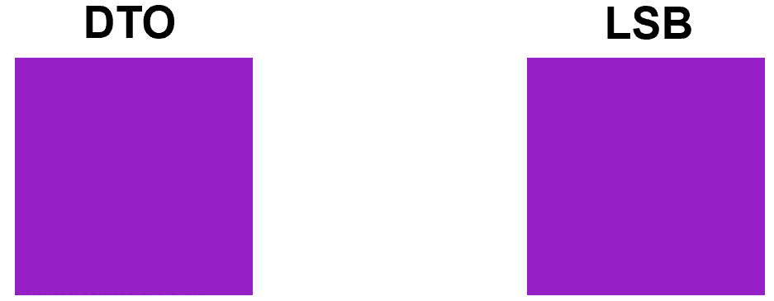
Figure 12 - Visual Similarities between the DTO & LSB methods

Performance Analysis
The final type of analysis that the two algorithms were subjected to was to see how fast each implementation took to execute in its entirety. Both methods were run one-hundred times sequentially, with each pass creating a timing object that started a timer upon construction and recorded the elapsed time upon destruction (code for this can be seen in Appendix 10.6.1 – F1).
Each algorithm was made with the use of a nested ‘for-loop’ to iterate through each pixel within a 2D assortment of pixels in the image, and although this allowed the work to be comprehended and modified far easier, one adverse effect of this is that both methods have a time complexity of O(N * M).
In the majority of cases, the LSB was executed far quicker than the DTO method and this is due to the extra mathematical operations required by the DTO to successfully perform. The internals of the LSB simply include three comparative checks per pixel and potentially up to three binary swaps. The DTO by comparison must first calculate the distance away from the origin of the image, modulate it and then move the remainder into a safe part of the desired segment (with this process demanding a recalculation of everything up to this point). The graph below in Figure 11 shows the aforementioned speed test along with a linear average of the two timings.

Figure 13 - Algorithm Performance Tests

Project Analysis & Comparison

Comparing Against Currie & Irvine’s Results
The original paper that outlined the steps needed to create this type of algorithm stated that a return rate of data at approximately 30% was achieved. However, they did not state at what level of compression this was done. For this reason, it is difficult to determine whether or not this project has matched the results attained by Currie & Irvine, but what can be noted is that when the compression quality was between 89%-91%, the retrieval rate was roughly 30% constantly through testing. All tests above 91% reached far higher levels of data recovery, with some testing showing close to 100% retrieval.
It should be acknowledged however that Currie & Irvine achieved this with added redundancy coding, meaning that the message was encoded into the image multiple times. This layer of redundancy was not implemented into the project but using images that consist of the same colour for every pixel circumvented need for it. In Currie & Irvine’s example, the images used were scenic and contained pixels with differing colour information, therefore JPEG would react differently to different parts of the image, meaning that the decoding process on one line of pixels could have recovered massively different hidden data to that of the line below, even when both contain the same message. The approach taken in this project was to have one solid colour make up the image but only embed the message once. It would not matter if the message was multiplied over different lines in the image because JPEG would not react differently as all pixels are the same colour.

Meeting the Software Requirements
To validate the tangible outcome of this project, an assessment has been completed to see which of the requirements laid out in section 4.2.2.1 have been added. Table 7 below provides the ID and a summary of each requirement, along with a declaration of completion and brief comments surrounding it.
ID | Req. Summery | Completed (Yes/No) | Comments
1 | Choose a cover BMP | Yes | The user can select any BMP images that are located in either the project directory or the folder labelled BMP inside the images folder.
2 | Create new BMP images | Yes | The user can create a BMP by providing a file name, width/height dimensions and an RGB colour.
3 | Create a new hidden message | Yes | The user either has the option to create a new message themselves or allow the program to generate a random one for them.
4 | Import text files | Yes | The user can import any .txt file from either within the project directory, or the folder labelled Messages.
5 | Select steganography method | Yes | It is possible to select which method to use from within the menu system.
6 | Implement GUI | No | The only form of interaction with the user takes place using the console window.
7 | Export test results | Yes | The results from both the accuracy of the method along with the performance data can be exported in .csv format.
8 | Multithread application | No | Getting the methods to work correctly was deemed more important that getting them to run quickly.
9 | Implement menu | Yes | The user can navigate the program using a menu system in the console.
10 | Import & check JPEGs | Yes | The user can import JPEGs from the project directory or folder labelled ‘JPEG’ in the images directory.
11 | Encrypt messages prior to embedding | No | Encryption of any kind is currently unavailable to the user.
Table 7 - Software Requirement Assessment
All requirements that were given a priority level of 1 and 2 have been successfully engineered into the application whilst those with levels 3 and 4 have been left out for future work.

Conclusion
Overall, the project was successful. However, there were many things that could have been improved upon and these will be explained in the next section. The results prove that not only does Currie and Irvine’s algorithm work; but that it can be further developed through the use of manipulating the modulus albeit at the detriment of image quality. The DTO algorithm could not match LSBs storage capabilities or performance speed but did bypass lossy compression to a respectable degree.

Evaluation & Reflection

Introduction
The purpose of this section is to iterate through each major part of the report and note any comments whether they are positive or negative. Particular aim shall be addressed to key areas of the project such as the aims, literature review and analysis stages.

Meeting the Aim
The aim of the project used three key terms to indicate the intentions of this report; explore, apply and evaluate. This part of the report will identify if the project met these requirements and if so, remark on how well they were implemented.

Exploration of the Technique
The technique used in this project is not well known when compared to others such as the LSB, SLSB or DCT for example. These methods have plenty of literature surrounding them and variations of them, the DTO on the other hand has an extremely small literature base due to its relatively unknown approach to tackling the issue of a lossy attack. It was for this reason that the report that conceived the idea was the one that was studied the most, and even then, many details of the algorithm were not mentioned or discussed, resulting in a list of topics for further research prior to the implementation of the DTO method.
To ensure that the technique was feasible from an algorithmic standpoint, various tests were carried out that verified the mathematical soundness (i.e. checking how the remainder values were to be changed and how the initial pixel values could be modified using a new distance value) and the syntactical features that would need to be explored (discovering libraries that would abstract the bit manipulation). Much of this in-depth scrutiny can be found in 2.6.4.

Applying the Technique
By referring to the results shown previously in this section and the accompanying code solution, it would be fair to state that the DTO technique has been successfully implemented. The correlation between the results of this project and that of Currie & Irvine’s suggest that the practical aspects of the technique have been recreated to a sufficient level and promote the use of the application as a base for future work. Section 4.4.1 supplies key code samples that detail how each stage was made and what it does. The report by Currie & Irvine does not include any syntactical or programming reference, and as a result of that, the implementation that this project has provided is purely an individualistic approach as to how this problem could be solved.

Evaluating the Technique
In terms of hiding a message and subjecting it to lossy compression with the hopes of retrieving data, this method is not the perfect tool for the job. It offers some reassurances, but overall, there are much better tools available to accomplish the same task. That said, so long as the compression level is not too high, the majority of data can be brought back in most cases, and if this technique was coupled with redundancy measures, it may bring back even more. The leading factor that differentiates this technique from others is that it successfully negates some of the adverse effects of lossy compression from within the spatial domain instead of the transform domain.
A negative side-effect to using the DTO is that pixel element values are adjusted more during the process than other methods outlined in section 2.6, leading to images with a greater colour variation. Due to this colour change, visual attacks are likely to be more successful and statistical attacks even more so.
Another downside is that it cannot hold as much data as more rudimentary techniques can. Each pixel is used to represent a single bit, which makes for eight pixels being needed to store a single character. Compare this with the LSB where each pixel can store three bits, when scaled up to take account for an entire image, the DTO loses out on a two-thirds of the LSBs storage capabilities.
However, due to the extremely obscure nature of the DTO technique, it is highly unlikely that a third-party would know how to extract this information, even if they knew that there was a secret message inside.

Expectations formed from Research
With much of the literature review focusing on two methods within the spatial domain, LSB and DTO, the expected outcomes of each of these were analysed and finally implemented. In the case of the Least Significant Bit, the results were exactly as depicted in the research stage. When subjected to lossy compression, all data hidden within the image was lost permanently, and this aligns completely with what all researchers referenced in the literature review proclaimed.
For the most part, the findings of the DTO method from this project coincided with what was stated in Currie and Irvine’s report. However, there were small inconsistencies with some of the finer details that they expressed. The major issue was the modulus of 42 being deemed as the best value to use to embed the data. This project found that there is a fine line between data retrieval rates and image quality compromises. With a modulus value of 82, a capacity to return the same rate of data as the original modulus was found but it could sustain it for much lower levels of compression quality. Some testing pushed the modulus up to 132 and while small artefacts could be visually seen in the image, the retrieval rate tripled that of 82.

Literature Review
Generally, it is felt that the literature review provided a very stable platform from which to build the structure of both the practical portions of the project along with laying out expectations of what is likely to come. Although this historical background was insightful and interesting, the project would likely have benefitted from placing less emphasis on researching this and placing more time into understanding more advanced techniques in the transform domain such as DCT.
Acquiring relevant related works was difficult because from the research conducted, there are no other methods that attempt to bypass lossy compression in the spatial domain, so in place of that, techniques that offered no protection against this form of attack but still resided in the spatial domain were explored instead. Researching the DCT and variants of it would have proved interesting as it could have provided an alternative set of pre-determined results from which comparisons could have been made.
Although the sources used in the literature review are of a good quality, more work could have been done to find more modern references. This is not to say that there are no modern references, but the majority of key work that has been done in the field took place between 1980-2000.
The descriptive sections between 2.2.6 and 2.6 should provide a reader with enough information to understand the concepts of what is discussed in the related works section.

Project Methodologies
The project and development methodologies are suitable and relevant to the scale, timeline and direction of the project. The data produced was indeed quantitative and the deductive approach outlined was adhered too as Currie and Irvine helped form the expectation, the application provided means to test this and the analysis section discussed these results ending with a confirmation of project success.
In terms of risks to the project, a major worldwide pandemic - COVID-19 -arose, which could have potentially posed a serious threat. In section 3.3, a risk was outlined – Long term absence due to sickness or external factors – that allowed measures to be put in place if such an event happened. In reality, such a massive issue was not explicitly considered, this risk was thought of more for sickness that may require someone involved in the project to not be present physically for some matter of weeks. However, the measures put in place to combat this risk allowed for the easy transition to deal with the effects of COVID-19 and allowed for the project (along with all hardware, software and external support) to carry on regardless.

Requirements, Design & Implementation

Requirements
The requirements that were documented were generally of a decent quality, with those holding the highest priority providing enough work for an MVP to be produced. Some of the high-level requirements were slightly vague, and this left a little too much scope for unimportant work.
The blending of user stories and the MOSCOW criteria proved to be a positive approach as it gave emphasis to key areas of the project in a manner that allowed for easy, visual categorisation. Although the standard user story initiative does allocate a priority rating, the text-numerical based approach was favourable over a purely numerical one.

Design
Although many design features were considered when conceiving plans for the project, it is felt that more could have been done during this stage that would have streamlined the latter parts of the build process. Building for optimisation (some optimisation features have been used) would be heavily researched and incorporated into the design process if the program were to be recreated in the future. Simple additions such as passing data by reference instead of by value, limiting the size of vectors if the intended size is known and using short strings (the string library now supports short strings, whereby if a string is under 15 characters long it is declared on the stack instead of the heap) are all examples of smaller optimisations that would be used right from the start. Larger optimisations (not strictly speed related) may come in the form of design patterns. The Observer, Command and Factory pattern may have been good candidates to tackle various problems encountered during the program’s creation.

Implementation
To evaluate the finished result, the advantages and disadvantages have been comprised and discussed in this section, and after these points have been noted, a final thought on potential improvements will be highlighted.
The first major advantage of the algorithm is the design and layout. It has been constructed in a way that allows for components to be added with ease and can itself be taken and used in other projects. The naming of variables and functions aimed to make the understanding of each section as clear as possible, and operator overloading and Enums were used to enhance the readability of the solution. Although this is not necessarily an advantage of the specific working of the algorithm, without it would make the adding/removing/modifying of features extremely problematic.
The algorithm itself was designed so that it could work with images of different sizes and colours, messages of varying lengths, and different modulus values for testing multiple scenarios. This has made the testing process far simpler in that images and messages can be created at run time that are either compliant with the desires of the user or randomised inside a test harness which can be run hundreds of times automatically. Modularity was also considered to be paramount with each problem being functionalised, allowing for quick implementation and access during both real use-cases and use within test environments.
The STL provided means to store data in ways that would have been cumbersome to implement solely for the project. Specifically, the ‘std::pair’ object was used intensely throughout the algorithm as it offered a means of binding a distance-to-move with a direction-to-move. This created an easier means of moving key data around and into other functions that required both sets of data.
One of the major design issues that did not present an easy work around was the problem of having to use the algorithm in conjunction with a nested ‘for-loop’. It was deemed to be the simplest way of making sure that it worked although thread-based solutions were considered. Using threads presented a larger series of problems and for the sake of time, the for-loops were used instead. Threads would have allowed the performance of the application to be far more optimised however and could be a feature implemented in the future.
The DTO method was created as a method in the ‘Stego’ class, with the idea that any other techniques (such as LSB) could also have their own function, with the Stego class being able to just call a technique whenever it needed to be used. However, utility functions were required to handle small subsections of the algorithm which quickly amounted into the main DTO function calling several sub-functions that all resided inside the Stego class. On reflection, creating one class per method would have been a far better way of handling this problem. All functionality pertaining to a particular technique could have been neatly encapsulated inside a single class, greatly eliminating any cross-over of method use and ownership ambiguity.

Analysis
Once a plan of how the analysis of the project was going to happen, the main tests that were going to be run were fairly simple to execute. Firstly, it was inevitable that tests that compared the LSB and DTO were going to take place, as the LSB is one of the most well-known embedding techniques that exists in the spatial domain. This test needed doing to ensure that the DTO had an advantage over the LSB, considering that it cannot hold has much data. Next, testing on different modulus values were made to see if the assessment made by Currie & Irvine were accurate and to test the validity of the project. In 10.5 – Appendix E, like-for-like comparisons of images embedded with data using different modulus values are available, along with an original that has no secret data inside. In hindsight, creating histograms of each of these images and displaying those would have been a far more accurate way of showing the difference in image quality as the current method relies on the reader performing a visual analysis, which shows that for the most part the images are useable stego-images, but fail to show the exact differences that the algorithm made.
If the project were to be restarted, redundancy messages would be implanted into the cover images so that test data could show the difference between stego-images that only have the message embedded once, and ones where the message is embedded multiple times, thereby increasing the chance that the message would be successfully retrieved.

Conclusion
To summarise the evaluation, it was felt that the literature review was a strong section of the report, encompassing many different prerequisite areas of knowledge into a text that delivered it, not only via language, but understandable diagrams.
The methodologies were considered to be an accurate depiction of the underlying thought process behind the project and due to its detail, allowed a solid foundation from which the design, implementation and analysis could be completed.
The requirements section was not the strongest. More work could have been done to further refine the system requirements that could have led to a series of formal steps from which to build the program. The design process lacked specific long-term design thoughts and instead focused on the design of each main component of the build. However, it did include a good amount of detail and research into these components which ultimately led the way to a successful utilisation. The implementation provided detail of key areas of the algorithm via code samples and discussion and was considered an effective clear section of the report. It also featured parts of the implementation that were both difficult and provided problems, as well as parts that were very successful, which highlights the areas of programming that the developer may need to improve upon.
The analysis section is thought to be one of the stronger areas of the report, presenting information in a visual manner where possible and providing discussion alongside.

Project Conclusion
Overall, the project has succeeded in the task of bypassing lossy compression through the medium of digital imagery using the Distance-to-Origin method. It has composed a number of analytical segments that not only validate the work of Currie & Irvine, but also detail the means by which their methodologies may be improved upon. A comprehensive evaluation has taken place to provide a catalogue of topic areas by which the author can improve and learn from.

Future Work
At present, the program has been built to prove only that the Distance-to-Origin method is a viable means of bypassing the dangers of lossy compression with a steganographic image, not successfully transmit stego-images. Future work would include creating a way of storing the modulus value inside the image so that the decoding part of the software does not need to explicitly have knowledge of the modulus in advance.
The addition of a user-friendly GUI could also be added so that users can instinctively command the software with ease and minimal confusion. This could be done in conjunction with a web-based solution, allowing the software to work online.
Including the option for users to encrypt the data that they wish to hide prior to embedding it would be a useful adaptation of the software by adding an extra layer of protection.

References
[1] CodeBug, “Morse Code Alphabet.” [Online]. Available: http://www.codebug.org.uk/learn/step/540/morse-code-alphabet/. [Accessed: 25-Sep-2019].
[2] D. Salomon, “Preface,” in Variable-Length Codes for Data Compression, Northridge: Springer, 2007, pp. vii–ix.
[3] CovertLIVE, “Convert Bytes to Gigabytes (B → GB),” 2019. [Online]. Available: https://convertlive.com/u/convert/bytes/to/gigabytes#89579520000. [Accessed: 27-Sep-2019].
[4] Toolstudio, “Video filesize calculator,” 2019. [Online]. Available: https://toolstud.io/video/filesize.php?dimensions_w=3840&dimensions_h=2160&framerate=59.94&timeduration=60&timeduration_unit=seconds. [Accessed: 27-Sep-2019].
[5] Blu-ray, “Blu-ray Disc for Data.” [Online]. Available: http://blu-raydisc.com/en/Technical/FAQs/Blu-rayDiscforData.aspx. [Accessed: 27-Sep-2019].
[6] K. Sayood, “Introduction,” in Introduction to Data Compression, 4th ed., Andrea Dierna and Meagan White, Eds. Elsevier, 2012, pp. 1–3.
[7] Scottish Qualifications Authority, “Lossless Compression,” SQA, 2007. [Online]. Available: https://www.sqa.org.uk/e-learning/BitVect01CD/page_83.htm. [Accessed: 30-Sep-2019].
[8] K. . Ramya and M. Pushpa, “A Survey on Lossless and Lossy Data Compression Methods,” Int. J. Comput. Sci. Eng. Commun., vol. 4, no. 1, pp. 1277–1280, 2016.
[9] R. U. Habib, “Optimal Compression of Medical Images,” Int. J. Adv. Comput. Sci. Appl., vol. 10, no. 4, pp. 133–140, 2019.
[10] The Consultative Committee for Space Data Systems, “Image Data Compression,” Washington, DC, 2017.
[11] J. F. Pane and L. Joe, “Making Better Use of Bandwidth: Data Compression and Network Management Technologies,” Santa Monica, 2005.
[12] Lexico, “steganography | Definition of steganography.” [Online]. Available: https://www.lexico.com/en/definition/steganography. [Accessed: 02-Sep-2019].
[13] Online Etymology Dictionary, “-graphy | Origin and meaning of suffix -graphy by Online Etymology Dictionary.” [Online]. Available: https://www.etymonline.com/word/-graphy. [Accessed: 02-Sep-2019].
[14] N. F. Johnson and S. Jajodia, “Exploring Steganography: Seeing the Unseen,” 1998.
[15] S. Channalli and A. Jadhav, “Steganography An Art of Hiding Data,” Int. J. Comput. Sci. Eng., vol. 1, no. 3, pp. 137–141, 2009.
[16] T. Jamil, “Steganography: The Art of Hiding in Plain Sight,” 1999.
[17] D. Kahn, “The history of steganography,” in Lecture Notes in Computer Science (including subseries Lecture Notes in Artificial Intelligence and Lecture Notes in Bioinformatics), 1996, vol. 1174, pp. 1–5.
[18] D. A. Whitiak, “The Art of Steganography,” 2003.
[19] J. Judge, “Steganography: Past, Present, Future,” 2001.
[20] K. Rabah, “Steganography-The Art of Hiding Data,” Inf. Technol. J., vol. 3, no. 3, pp. 245–269, Mar. 2004.
[21] G. Kipper, Investigator’s Guide to Steganography. Auerbach Publications, 2004.
[22] G. Peterson and D. Taylor, “Intelligence Support to Communications with US POWs in Vietnam,” Stud. Intell., vol. 60, no. 1, pp. 1–6, 2016.
[23] S. I. Rochester, The Battle Behind Bars. 2010.
[24] Eyewitness, “Scenes from Hell.” [Online]. Available: https://www.archives.gov/exhibits/eyewitness/html.php?section=8. [Accessed: 02-Sep-2019].
[25] A. Kumar and K. Pooja, “Steganography-A Data Hiding Technique,” Int. J. Comput. Appl., vol. 9, no. 7, pp. 975–8887, 2010.
[26] Michael Grothaus, “Meet The Man Who Solved The Mysterious Cicada 3301 Puzzle,” 2014.
[27] Alex Hern, “Cicada 3301: I tried the hardest puzzle on the internet and failed spectacularly,” The Guardian, 2014. [Online]. Available: https://www.theguardian.com/technology/2014/jan/10/cicada-3301-i-tried-the-hardest-puzzle-on-the-internet-and-failed-spectacularly. [Accessed: 03-Sep-2019].
[28] Amnesty International, “Encryption - A Matter of Human Rights,” 2016.
[29] T. Kellen, “Hiding in Plain View: Could Steganography be a Terrorist Tool?,” 2019.
[30] M. Conway, “Code Wars: Steganography, Signals Intelligence, and Terrorism,” Knowledge, Technol. Policy, vol. 16, no. 2, pp. 45–62, 2003.
[31] K. Bailey and K. Curran, “Image Structure and Image Processing,” in Steganography - The Art of Hiding Data, New York: BookSurge Publishing, 2004, pp. 11–16.
[32] J. Sachs, “Digital Image Basics,” 1996.
[33] Z.-M. Lu and S.-Z. Guo, “Lossless Information Hiding in Images on the Spatial Domain,” in Lossless Information Hiding in Images, Elsevier, 2017, p. 69.
[34] A. Kaur, R. Kaur, and N. Kumar, “A Review on Image Steganography Techniques,” 2015.
[35] S. Gupta, G. Gujral, and N. Aggarwal, “Enhanced Least Significant Bit algorithm For Image Steganography,” IJCEM Int. J. Comput. Eng. Manag. ISSN, vol. 15, no. 4, p. 22307893, 2012.
[36] U. S. D. of T. F. A. Administration, “Study of the Factors Affecting the Sensitivity of Liquid Penetrant Inspections,” 2002.
[37] E. Hecht, Optics, 5th ed. Harlow: Pearson Education Limited, 2017.
[38] N. Adam, M. Mashaly, and W. Alexan, “A 3DES Double-Layer Based Message Security Scheme,” in 2nd International Conference on Computer Applications and Information Security, ICCAIS 2019, 2019.
[39] J. J. Roque, “SLSB: Improving the steganographic algorithm LSB,” in Security in Information Systems - Proceedings of the 7th International Workshop on Security in Information Systems - WOSIS 2009 In Conjunction with ICEIS 2009, 2009, pp. 57–66.
[40] R. Roy, S. Changder, A. Sarkar, and N. C. Debnath, “Evaluating image steganography techniques: Future research challenges,” in 2013 International Conference on Computing, Management and Telecommunications, ComManTel 2013, 2013, pp. 309–314.
[41] O. Osunade and I. A., “Enhancing the Least Significant Bit (LSB) Algorithm for Steganography,” Int. J. Comput. Appl., vol. 149, no. 3, pp. 1–8, 2016.
[42] D. C. Wu and W. H. Tsai, “A steganographic method for images by pixel-value differencing,” Pattern Recognit. Lett., vol. 24, no. 9–10, pp. 1613–1626, 2003.
[43] W. Luo, F. Huang, and J. Huang, “Edge adaptive image steganography based on lsb matching revisited,” IEEE Trans. Inf. Forensics Secur., vol. 5, no. 2, pp. 201–214, Jun. 2010.
[44] X. Zhang and S. Wang, “Vulnerability of pixel-value differencing steganography to histogram analysis and modification for enhanced security,” Pattern Recognit. Lett., vol. 25, no. 3, pp. 331–339, 2004.
[45] D. L. Currie and C. E. Irvine, “Surmounting the Effects of Lossy Compression on Steganography,” in 19th National Information System Security Conference, 1996, pp. 294–201.
[46] G. K. Wallace, “The JPEG Still Picture Compression Standard,” Maynard, 1991.
[47] P. R. Parwe and N. N. Mandaogade, “International Journal of Computer Science and Mobile Computing A REVIEW ON IMAGE COMPRESSION TECHNIQUES,” 2015.
[48] A. Jain and I. Sen Gupta, “A JPEG compression resistant steganography scheme for raster graphics images,” in IEEE Region 10 Annual International Conference, Proceedings/TENCON, 2007.
[49] P. Žukauskas, J. Vveinhardt, and R. Andriukaitienė, “Philosophy and Paradigm of Scientific Research,” in Management Culture and Corporate Social Responsibility, InTech, 2018, p. 123.
[50] R. Irshaidat, “Interpretivism vs. Positivism in Political Marketing Research,” J. Polit. Mark., p. 3, 2019.
[51] C. Bentley, PRINCE2 : A Practical Handbook. Butterworth-Heinemann, 2009.
[52] R. Newton, Project Management Step by Step: How to Plan and Manage a Highly Successful Project, 1st ed. Pearson Education Limited, 2006.
[53] P. M. Institution, “Risk analysis and management.” [Online]. Available: https://www.pmi.org/learning/library/risk-analysis-project-management-7070. [Accessed: 27-Jan-2020].
[54] M. Cohn, “The Product Backlog,” in Succeeding with Agile: Software Development Using Scrum, K. Gettman, Ed. Boston: Addison-Wesley, 2010, pp. 239–249.
[55] G. Lucassen, F. Dalpiaz, J. M. E. M. van der Werf, and S. Brinkkemper, “Improving agile requirements: the Quality User Story framework and tool,” Requir. Eng., vol. 21, no. 3, pp. 383–403, 2016.
[56] Y. Wautelet, S. Heng, S. Kiv, and M. Kolp, “User-story driven development of multi-agent systems: A process fragment for agile methods,” Comput. Lang. Syst. Struct., vol. 50, pp. 159–176, Dec. 2017.
[57] J. A. Hall, “Preliminary Project Feasibility,” in Accounting Information Systems, 7th ed., South-Western Cengage Learning, 2010, p. 579.

Appendices

10.1 – Appendix A
User Story | System Requirement
2 | - The user is prompted to enter the width & height, name and colour of the new image.  - A new BMP is created and saved under the file name specified.  - Notification upon completion is given to the user.
3 | - Allow an option in the menu for the user to create a new message.  - Message shall be checked for size restrictions to see if it will fit into the cover image.  - Option will be given to confirm or change the message before submitting it to the cover image.
8 | - The menu may allow for two algorithms to be selected in a ‘test mode’.  - Multiple threads will run in parallel and either export or display the results.  - This feature is optional.
6 | - Multiple pages consisting of a homepage, test page and results page.  - Navigation would be completed via mouse primarily rather than keyboard, unlike the non-GUI version.
11 | - Through the menu, the user would be asked whether they would like to add another layer of protection.  - Multiple levels of encryption could be used.  - A password would both lock and unlock the encryption.
Table 8 - Non-essential System Requirements

10.2 – Appendix B

10.2.1 – B1
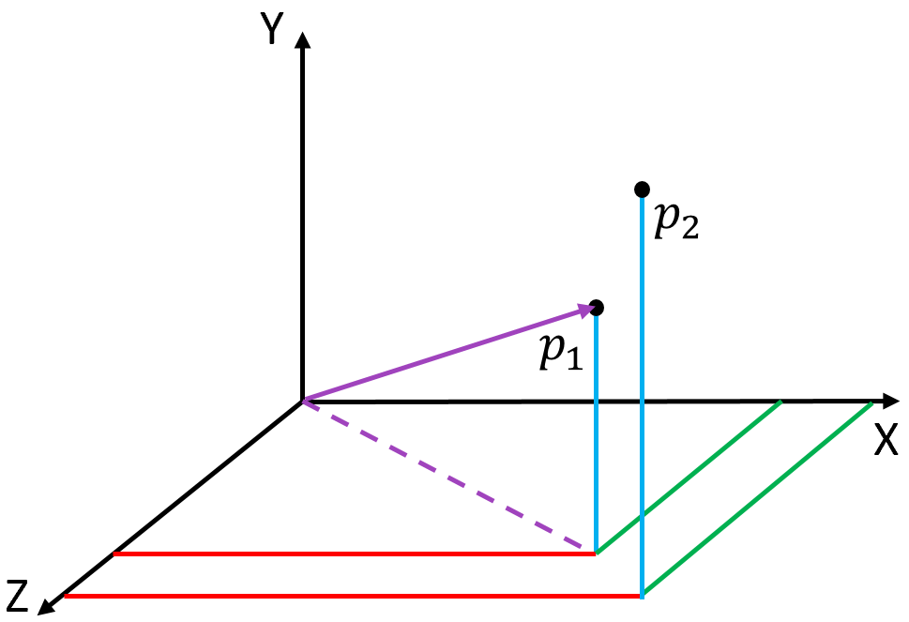
Figure 14 - P1 (Original Point) & P2 (New Point)

10.2.2 – B2
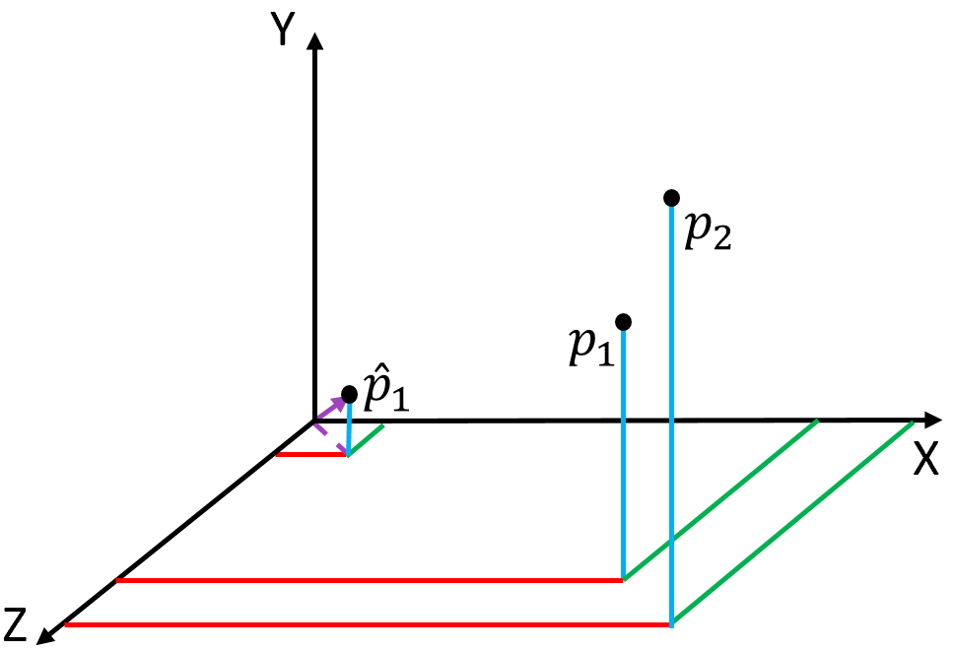
Figure 15 - P1's Vector is Normalised

10.2.3 – B3
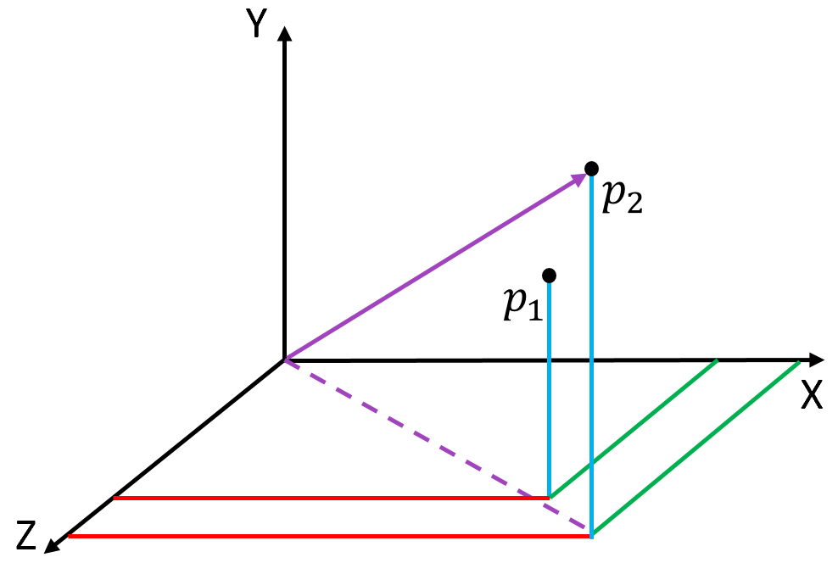
Figure 16 - P1 Normalised is then scaled by the distance of P2

10.3 – Appendix C

10.3.1 – C1
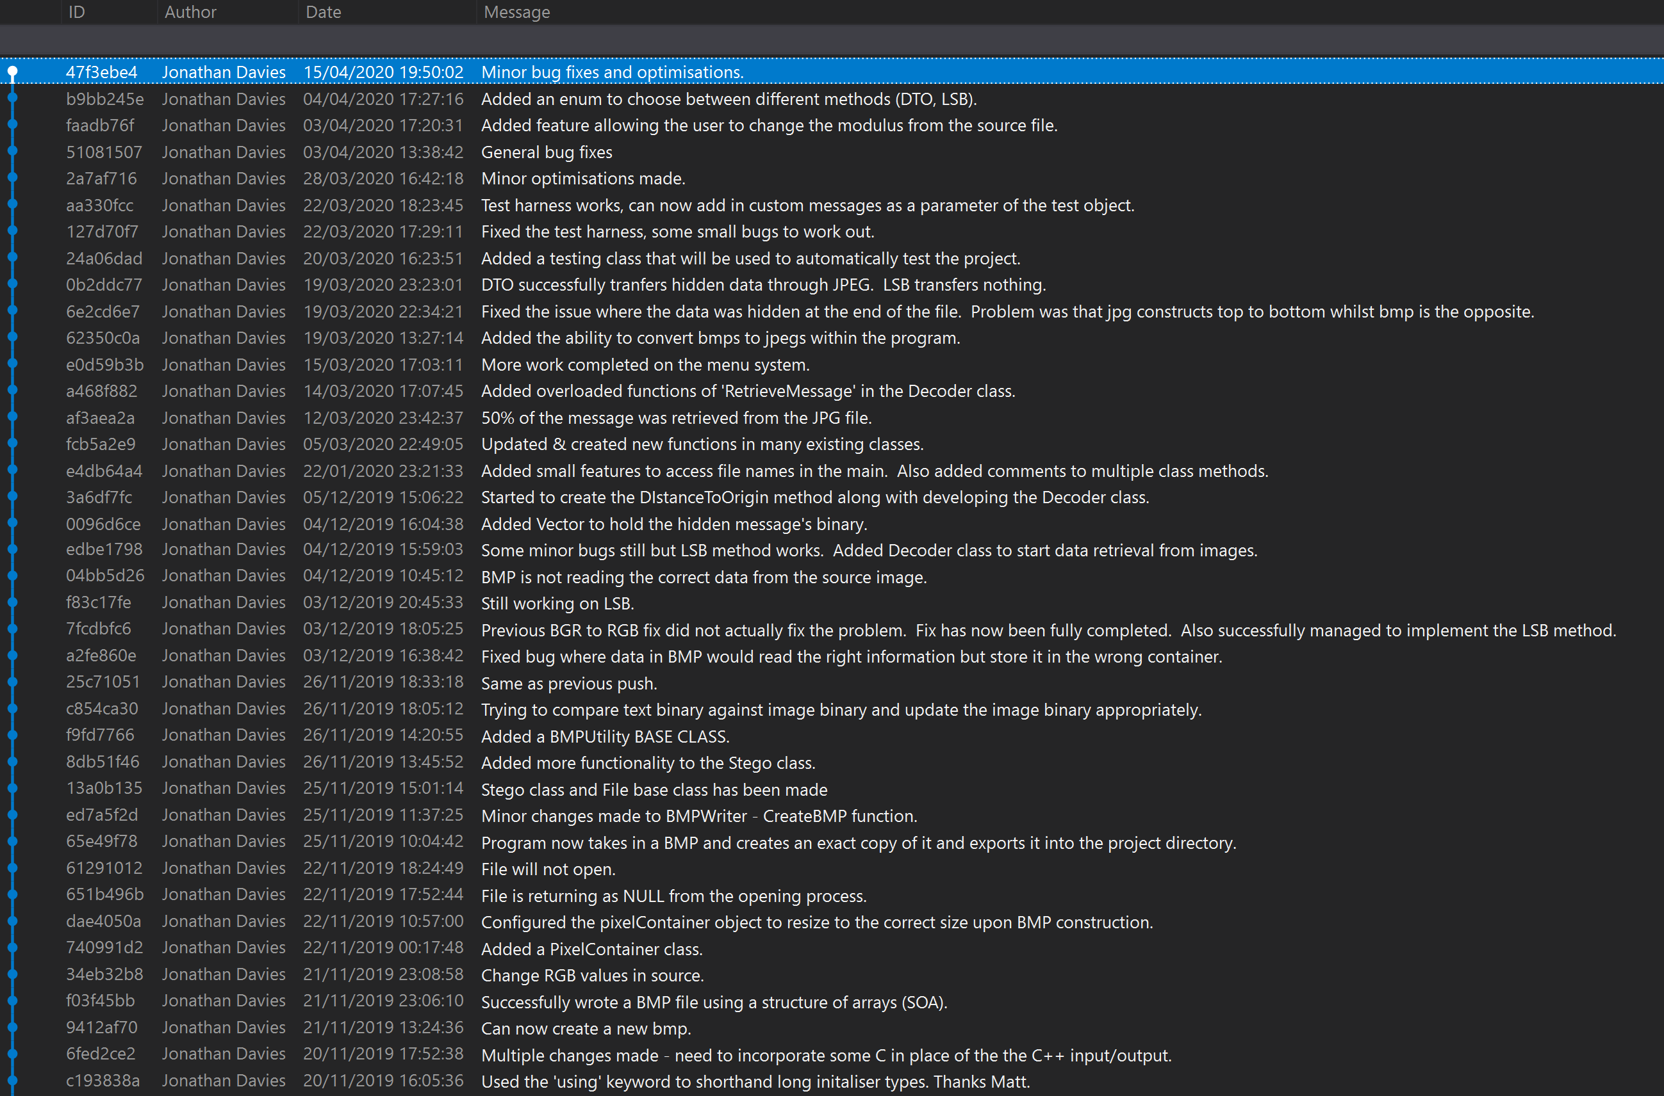
Figure 17 - GitHub History 1

10.3.2 – C2
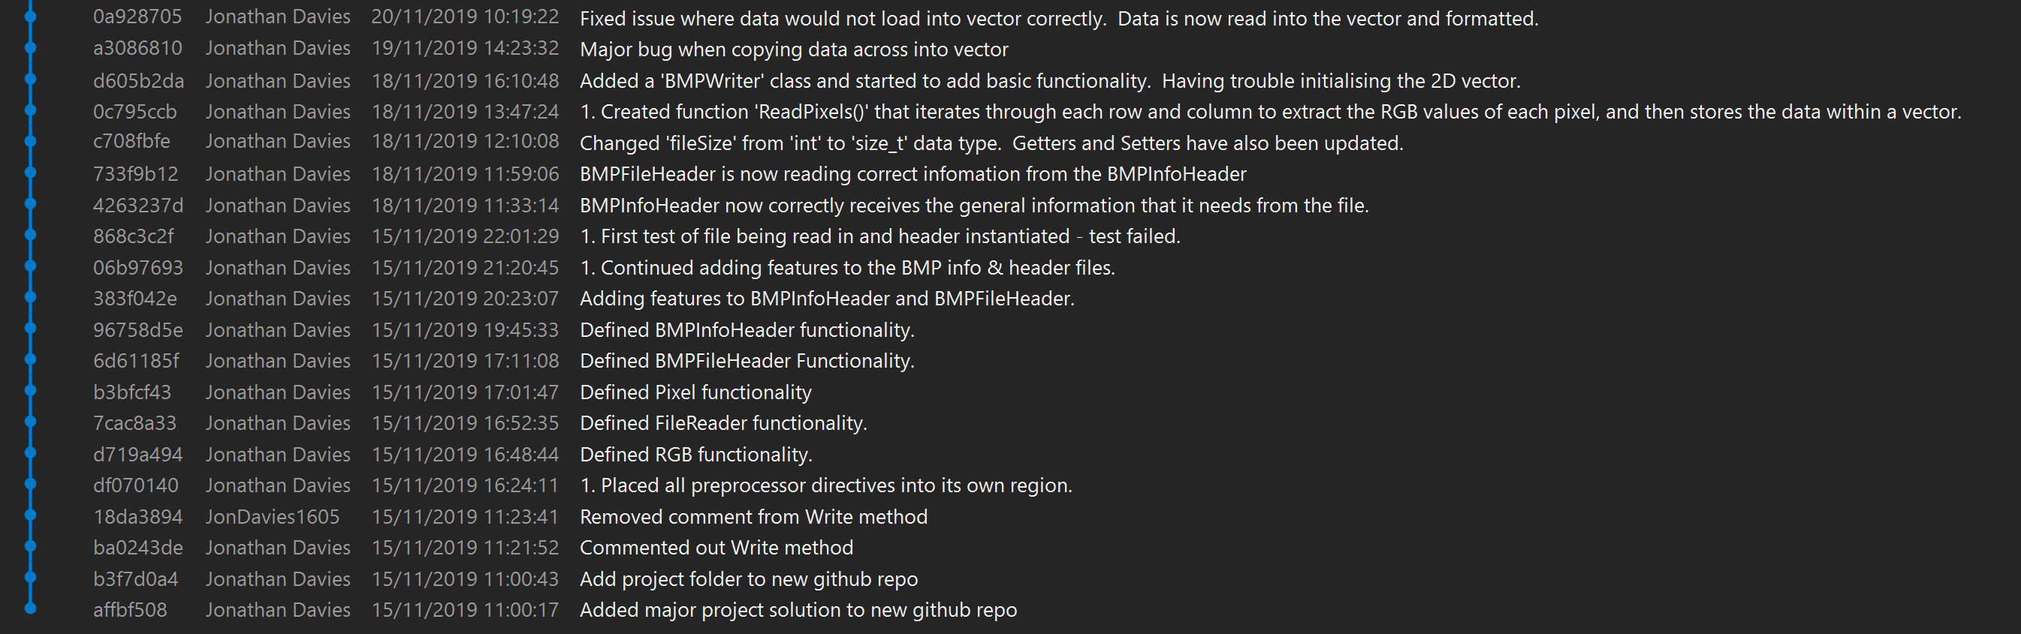
Figure 18 - GitHub History 2

10.4 - Appendix D

10.4.1 – D1

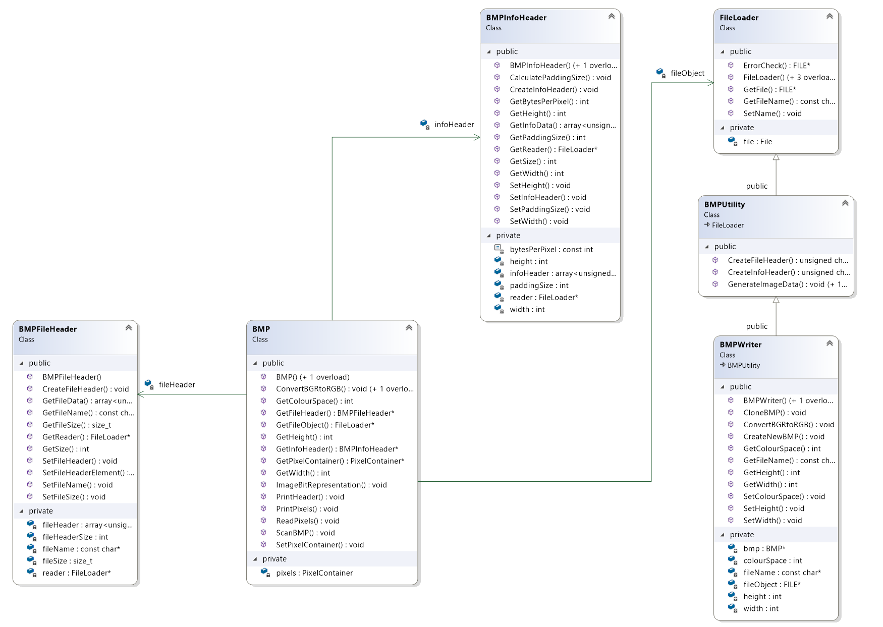
Figure 19 - BMP Related Classes

10.4.2 – D2

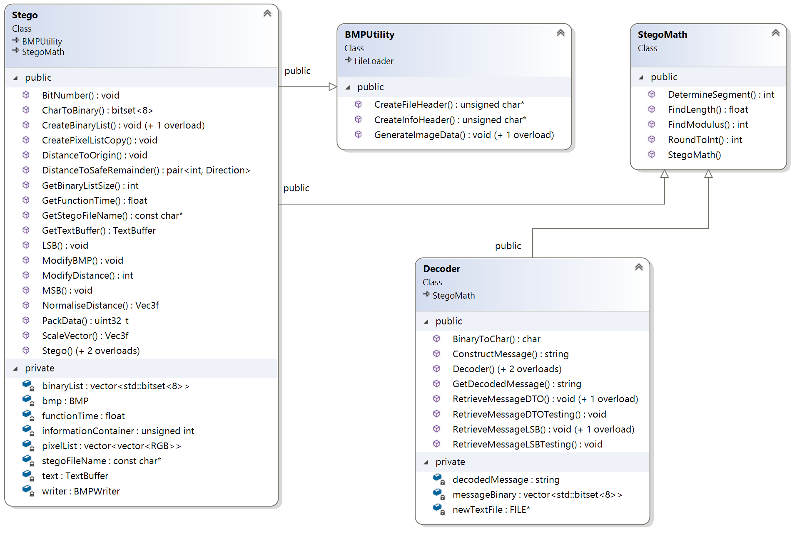
Figure 20 - Steganography Related Classes

10.4.3 – D3

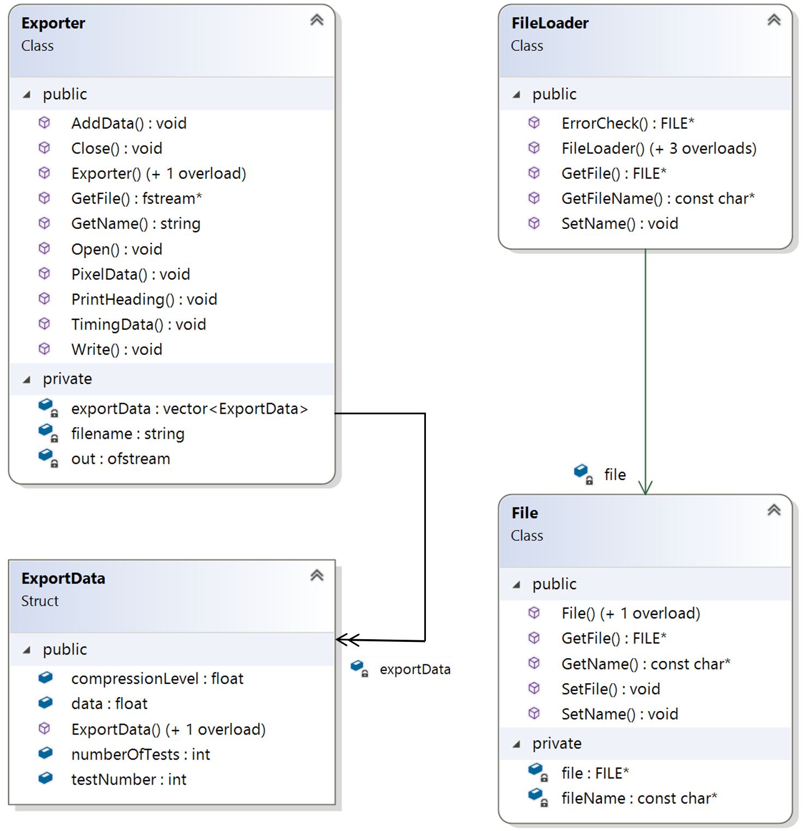
Figure 21 - File Input/output Related Classes

10.4.4 – D4

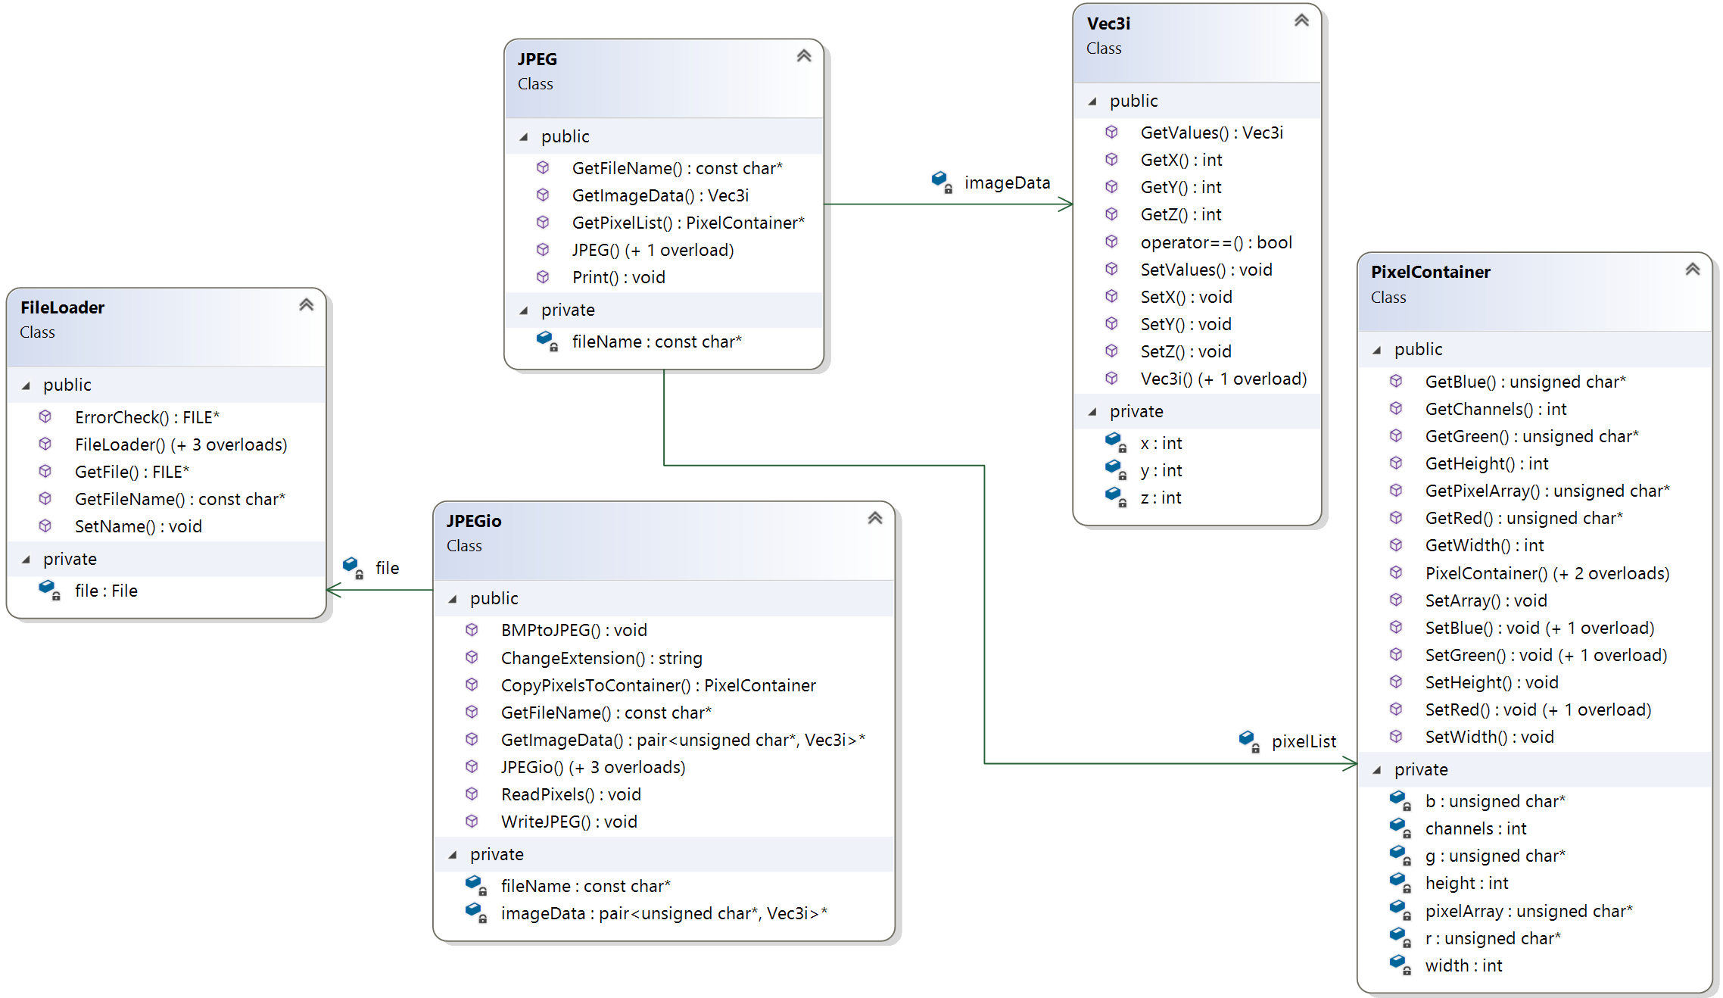
Figure 22 - JPEG Related Classes

10.5 – Appendix E

10.5.1 – E1
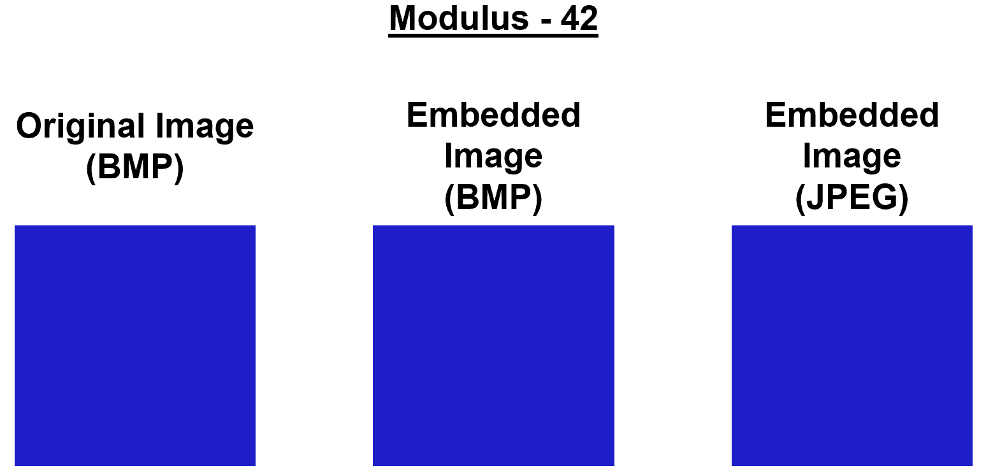
Figure 23 - Differences between images at Mod(42)

10.5.2 – E2
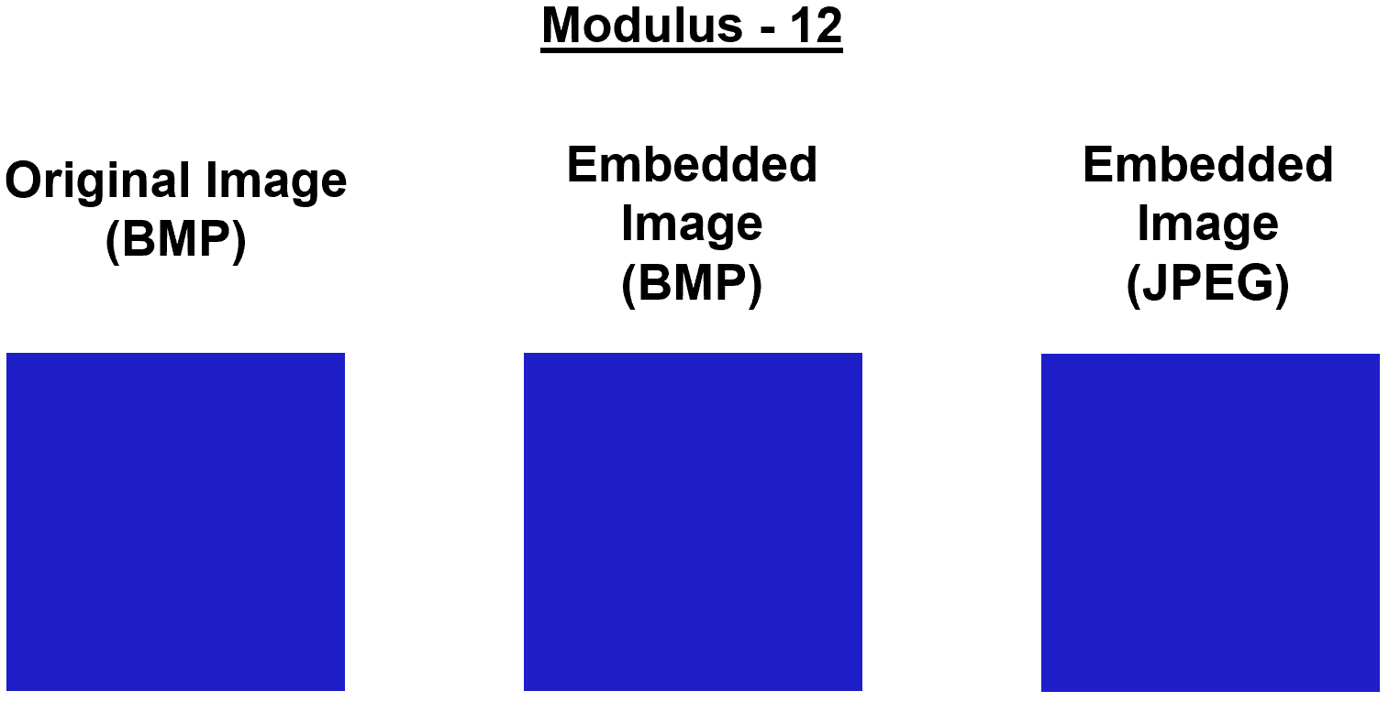
Figure 24 - Differences between images at Mod(12)

10.5.3 – E3
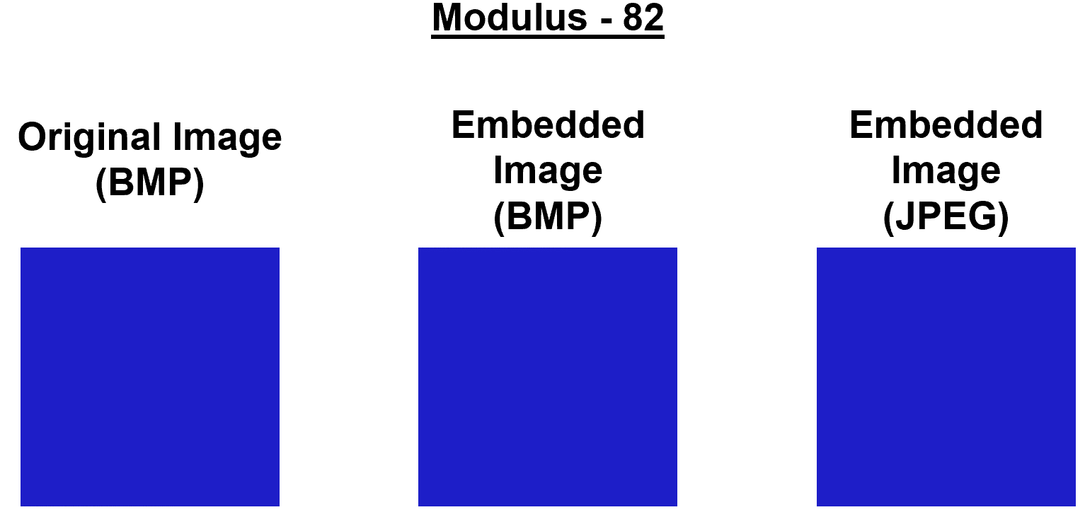
Figure 25 - Differences between images at Mod(82)

10.5.4 – E4
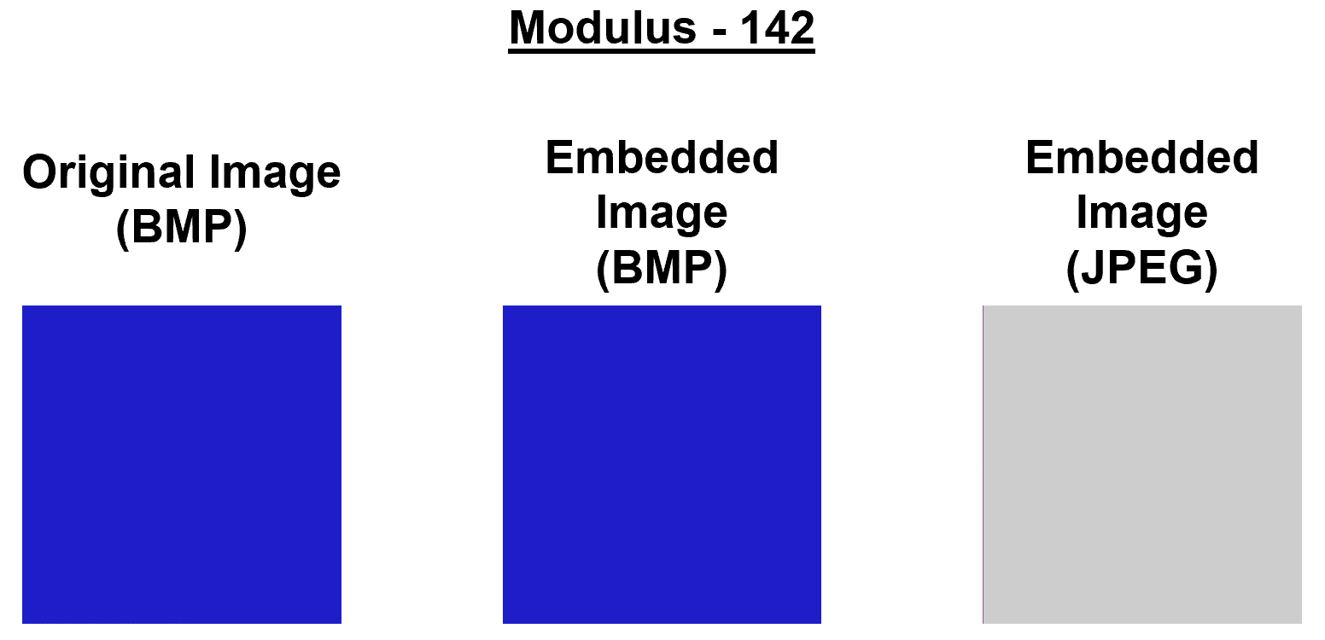
Figure 26 - Differences between images at Mod(142)

10.5.5 – E5
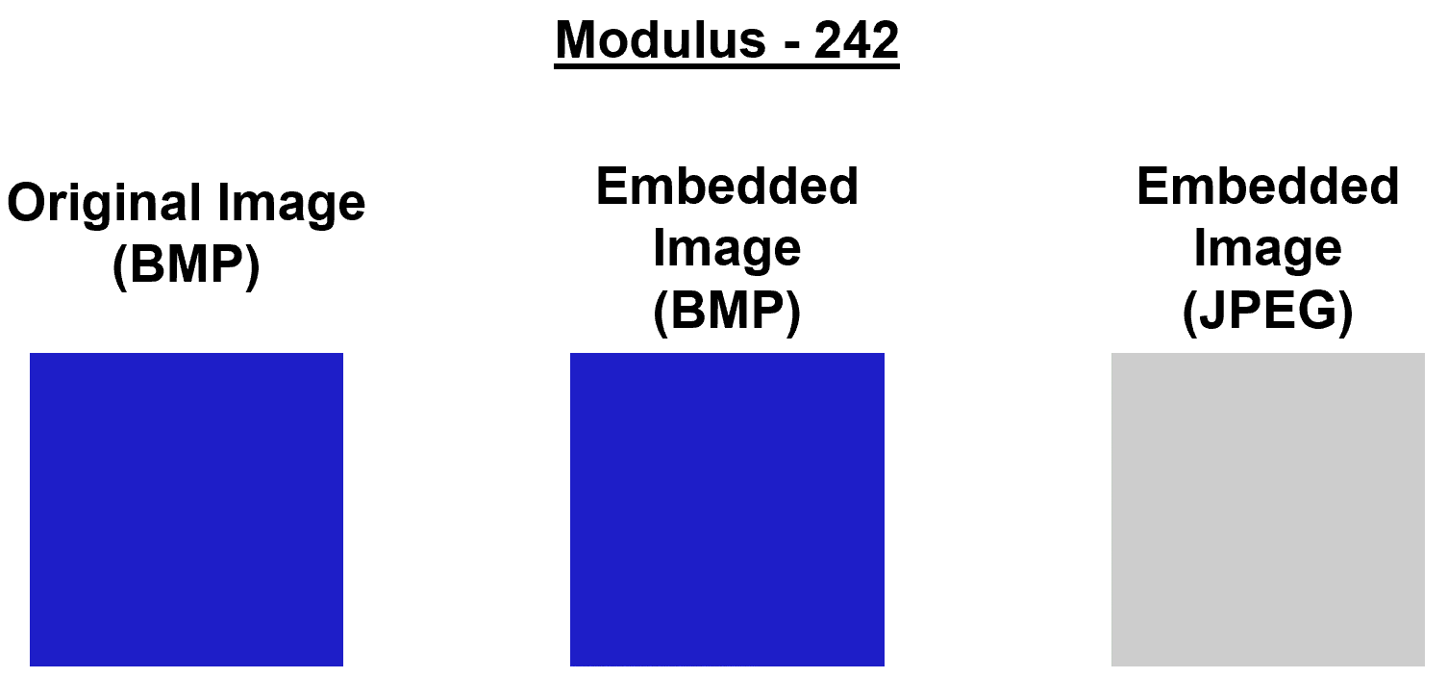
Figure 27 - Differences between images at Mod(242)

10.6 – Appendix F

10.6.1 – F1
Code Sample 13 - Code Timing

