

Entrepreneurship
Portfolio 6 Elements
Task 1
Submission Deadline
10/04/2026
Karibuni
Proptech and Fintech
Ltd

Name: Badru Keanene
Students Id: 2416450
Module code: LCBB5013
Module Name: Entrepreneurship
Lecture: Dr Toyin Adisa
Table of Contents
KARIBUNI PROPTECH AND FINTECH LTD 5
1 Element 1 Business Idea, Product/services, Objectives and USP 5
1.1. Introduction 5
1.2. Business Idea 5
1.3. How It will Work 6
1.4. Mission Statement 6
1.5. Business objectives 6
1.51. Formalise and Structure the Rental Market 6
1.5.2. Eliminate Hidden Fees and Promote Pricing Transparency 6
1.5.3. Provide Verified, Reliable Property Listings 6
1.5.4. Deliver Secure, Traceable, and Convenient Payment Systems 7
1.5.5. Digitise and Automate Rental Documentation 7
1.5.6. Strengthen Trust and Predictability in Tenant–Landlord Relationships 7
1.5.7. Improve Property Management Efficiency 7
1.6. Core Values 7
1.7. Unique selling point (USP) 7
1.7.1. Karibuni’s USP 8
2. Element 2: Business Environment and Competitor Analysis 9
2.1. SWOT Analysis 9
2.1.1. Strengths 10
2.1.2. Weaknesses 10
2.1.3. Opportunities 10
2.1.4. Threats 11
2.2. PESTLE Analysis 11
2.2.1. Political Factors 12
2.2.2. Economic Factors 12
2.2.3. Social Factors 12
2.2.4. Technological Factors 13
2.2.5. Legal Factors 13
2.2.6. Environmental Factors 13
2.3. Competitor Analysis 13
2.3.1. Direct Competitors 13
2.3.2. Indirect Competitors 14
2.3.3. Competitive Positioning 14
2.3.4. Barriers to Entry 14
2.3.5. Sustaining Competitive Advantage 14
3. Element 3: 4Ps, Market Segmentation, Marketing Mix and Online Marketing 14
3.1. Market Segmentation and Target Customers 14
3.2. Segmentation Approach 15
3.2.1. Demographic Segmentation 15
3.2.2. Geographic Segmentation 15
3.2.3. Behavioural Segmentation 16
3.2.4. Psychographic Segmentation 16
3.3. Target Customers 16
3.3.1. Primary Target Market 16
3.3.2. Secondary Target Market 17
3.4. The 4Ps of Marketing Framework 17
3.4.1. Product 17
3.4.2. Price 18
3.4.3. Place 18
3.4.4. Promotion 19
3.5. Online Marketing Strategies 19
3.5.1. Search Engine Optimisation (SEO) 19
3.5.2. Pay-Per-Click (PPC) Advertising 20
3.5.3. Social Media Marketing 20
3.5.4. Content Marketing 20
3.5.5. Referral and Incentive Programmes 20
3.5.6. Customer Retention Strategies 21
4. Element 4: Legal, Management, and Financial Planning Karibuni 21
4.1. Definitions of Key Legal Structures (UK) 21
4.2. Legal Structure of Karibuni 22
4.3. Proposed Organisational Structure 22
4.4. Start-up Funding Requirements (Estimated) 24
4.5. Potential Funding Sources 24
5. Recommendation 25
6. Conclusion 25
7. References 26

KARIBUNI PROPTECH AND FINTECH LTD
Formalising and Modernising the Rental Market

1 Element 1 Business Idea, Product/services, Objectives and USP

1.1. Introduction
Karibuni Proptech and Fintech is a mobile App and web-based digital platform designed to connect landlords and tenants directly in a secure, transparent, and broker-free environment. The platform addresses longstanding challenges in the rental market, including informal processes, hidden agent fees, unreliable listings, and lack of secure digital payment systems.
Headquartered in the UK and designed with overseas market insight, Karibuni aims to modernise the rental ecosystem by providing verified property listings, digital agreements, secure rent payments, and property management tools all within one seamless application.

1.2. Business Idea
Karibuni Proptech and Fintech is a mobile and web Application that enables:
- Direct landlord and tenant connections
- Secure digital rent payments
- Legally recognised digital rental agreements
- Verified property listings
- Digital property management tools
The platform removes intermediaries and brokers, reducing unnecessary costs while increasing transparency and efficiency. By provide a secure digital platform that enables landlords to manage rent payments and tenants to rent properties seamlessly through verified listings, digital contracts, and secure payment systems.

1.3. How It will Work
- Search verified listings using smart filters
- Connect directly with landlords
- Sign digital agreements securely
- Pay rent through trusted digital channels
- Track your rental history and documents
- Manage properties with real‑time insights

1.4. Mission Statement
Rent Smarter. Live Better.
That is why Karibuni Proptech and Fintech Ltd exists to modernise the rental market.

1.5. Business objectives
Short term

1.51. Formalise and Structure the Rental Market
To formalise and modernise the rental market across the UK by providing a transparent, digital, and broker-free ecosystem for tenants and landlords. By establishing a transparent, standardised digital ecosystem that replaces informal and inconsistent rental practices. Introduce clear processes, digital workflows, and compliance aligned documentation to professionalise landlord and tenant interactions.

1.5.2. Eliminate Hidden Fees and Promote Pricing Transparency
Build a fee transparent platform that removes unnecessary agent charges and ensures users understand all costs upfront. Implement fair, predictable pricing models that increase trust and reduce exploitation.

1.5.3. Provide Verified, Reliable Property Listings
Create a trusted property database with verified listings, real time availability, and fraud prevention mechanisms. Use digital verification tools to ensure accuracy and reduce misinformation in the rental market.

1.5.4. Deliver Secure, Traceable, and Convenient Payment Systems
Integrate fintech solutions that enable safe rent collection, automated receipts, and secure digital transactions. Offer landlords and tenants a reliable payment trail that supports accountability and financial planning.

1.5.5. Digitise and Automate Rental Documentation
Replace manual paperwork with digital contracts, automated renewals, and secure document storage. Reduce administrative burdens for landlords and tenants while improving compliance and record‑keeping.

1.5.6. Strengthen Trust and Predictability in Tenant–Landlord Relationships
Provide tools for tenant verification, rental history checks, and landlord identity validation. Build a reputation based ecosystem that rewards responsible behaviour and reduces disputes.

1.5.7. Improve Property Management Efficiency
Offer landlords dashboards for rent tracking, maintenance requests, tenant communication, and financial reporting. Enable data driven decision making to optimise property performance and reduce operational inefficiencies.
Long-Term Vision
A future where renting is simple, secure, and dignified powered by verified data, smart tools, and trusted digital infrastructure. Position Karibuni as Leader in Proptech (Tagliaro et al., 2025) and Fintech (IBM, 2024) Innovation and develop scalable solutions tailored to UK and emerging markets with potential for global expansion. Set new industry standards for transparency, security, and digital transformation in the rental sector.

1.6. Core Values
- Transparency Clear processes and honest pricing
- Trust Verified listings and secure systems
- Efficiency No intermediaries or unnecessary friction
- Community Empowering both tenants and landlords
- Innovation Building the digital backbone of UK rentals

1.7. Unique selling point (USP)
A product, service, or brand's unique and appealing quality or feature is what is referred to as its 'Unique Selling Point or Proposition' (USP). Basically, this concept is used in the marketing purpose of the product. It may be determined by various factors such as product characteristics quality, cost, efficiency, client service, or any other trait that differentiates the product being sold from others on the market or brand from its competitors (GeeksforGeeks, 2023). A USP might boast the lowest cost, the highest quality, the most experience, the first in its product class or another trait that sets the offering apart from the competition. A unique selling point can be thought of as "what you have that competitors don't." (Sheldon, 2022).

1.7.1. Karibuni’s USP
For Tenants
- Broker-free renting
- Verified property listings
- Digital agreements
- Secure online payments
- Rental history tracking
- Direct communication with landlords
For Landlords
- Direct access to tenants
- Automated rent tracking
- Secure payment collection
- Digital agreement management
- Real-time property insights

2. Element 2: Business Environment and Competitor Analysis
Understanding the business environment is essential to evaluating the strategic viability of Karibuni. This section applies SWOT and PESTLE frameworks, integrated with contemporary digital platform literature, to assess internal capabilities and macro-environmental influences. A competitor analysis further evaluates Karibuni’s strategic positioning within the UK rental market. Strategic analysis enables organisations to align internal strengths with external opportunities while mitigating risks (Johnson et al., 2020).

2.1. SWOT Analysis
SWOT analysis evaluates internal strengths and weaknesses alongside external opportunities and threats, enabling firms to assess current position and future potential (Peterdy, 2024). In digital platform markets, competitive advantage increasingly stems from ecosystem orchestration rather than asset ownership (Cennamo, 2021). Karibuni’s strategic logic reflects this shift through its integrated, broker-free rental lifecycle model.
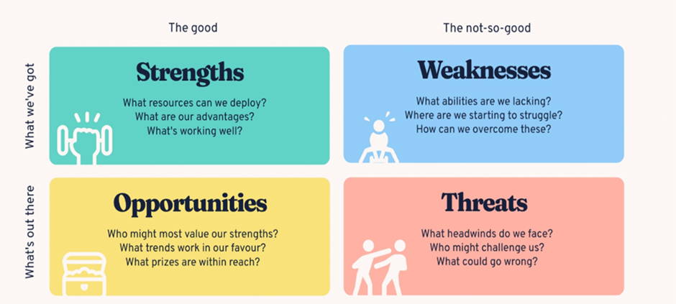
Source: (Bitesize, 2024)

2.1.1. Strengths
Karibuni’s primary strength lies in its broker-free digital model, reducing transaction costs while increasing transparency. This aligns with growing consumer demand for cost-efficient, transparent digital services (Deloitte, 2023).
The platform offers an end-to-end rental lifecycle integrating verified listings, digital contracts, and secure payment systems. Such integration enhances differentiation and value capture within digital ecosystems (Teece, 2017).
Its mobile App and Web platform infrastructure supports accessibility and scalability, particularly given rising UK smartphone penetration and fintech adoption (Ofcom, 2023).
Additionally, rental history tracking formalises tenant records and strengthens long-term customer value. This aligns with broader digitisation of financial identity systems (World Economic Forum, 2023).

2.1.2. Weaknesses
As a new entrant, Karibuni lacks brand recognition compared to established platforms. Trust is a critical success factor in digital marketplaces (Statista, 2024).
Significant investment is required in cybersecurity, regulatory compliance, and system development. High upfront digital infrastructure costs are common within fintech-enabled models (Pulse of Fintech H2’23, 2024).
Furthermore, the platform depends on network effects. Two-sided platforms must achieve critical mass to generate sustained value (Parker, Van Alstyne and Choudary, 2016).

2.1.3. Opportunities
The UK rental sector continues expanding due to housing shortages and affordability pressures (Office for National Statistics, 2024). Demand for flexible renting solutions remains strong. Accelerating digital transformation across service industries creates opportunities for platform-mediated transactions to replace traditional intermediaries (Trabucchi and Buganza, 2019). Karibuni can leverage data analytics to enhance tenant screening, risk assessment, and personalised services.
Geographic expansion across UK cities and potential international markets offers further growth potential.

2.1.4. Threats
Competitive intensity poses a major threat. Incumbents may replicate features or leverage scale advantages (Cennamo, 2021).
Rapid technological change necessitates continuous innovation (Teece, 2017).
Competition from established platforms such as Rightmove and Zoopla remains significant due to their high traffic and brand recognition (Statista, 2024).
Regulatory changes in housing and digital payments may increase compliance costs (Deloitte UK, 2025). Cybersecurity risks also threaten reputation, particularly amid rising digital fraud in property transactions (Pulse of Fintech H2’23, 2024). Macroeconomic instability, inflation, and interest rate fluctuations may reduce tenant affordability (Bank of England, 2024).
Therefore, SWOT’s strength lies in linking internal capabilities with external conditions, supporting strategic direction. However, it often produces broad or subjective insights and does not prioritise issues or prescribe action. It functions best as a diagnostic tool rather than a standalone strategy (Samson, 2017).

2.2. PESTLE Analysis
PESTLE evaluates macro-environmental forces shaping strategic decisions (Johnson et al., 2020). It examines Political, Economic, Social, Technological, Legal, and Environmental influences, enabling organisations to anticipate risks and identify opportunities (Makos, 2022).
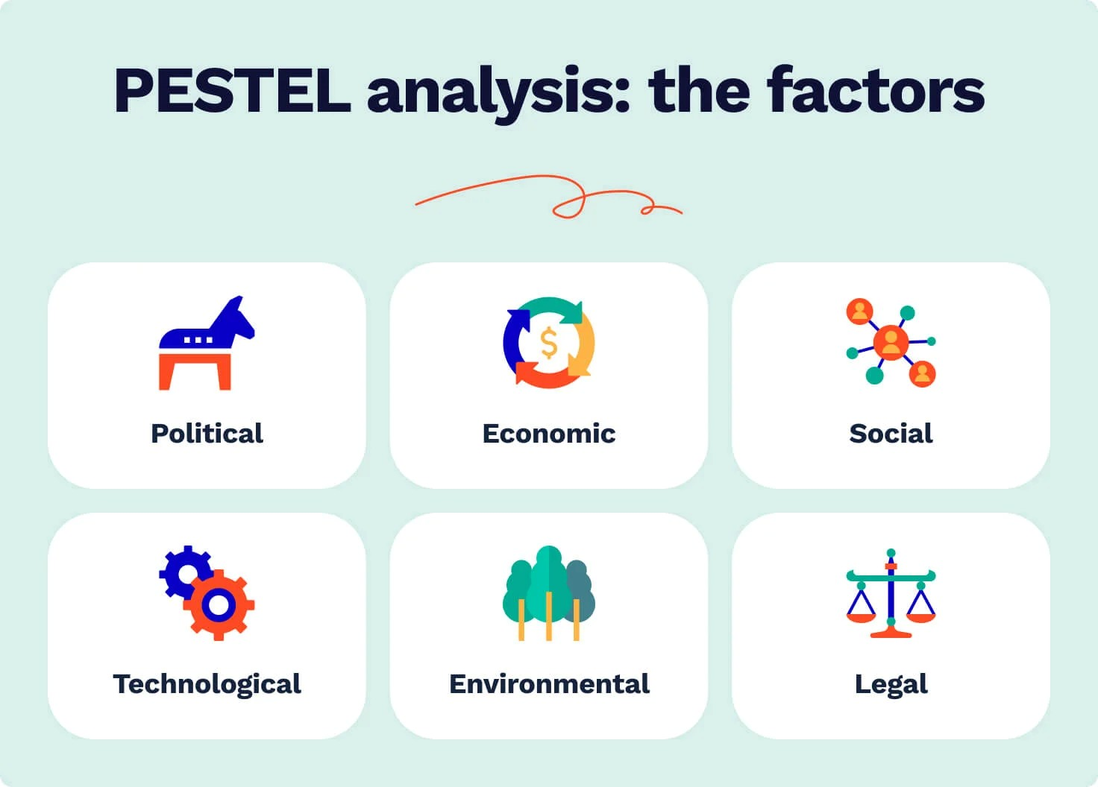Source:(Studycorgi.com, 2026)

2.2.1. Political Factors
Ongoing UK rental sector reforms, including tenant protection and landlord compliance measures, may influence platform demand (Martyn, 2025).
Government support for digital innovation and fintech development provides a favourable policy environment for digital property solutions.

2.2.2. Economic Factors
Inflation, wage growth, and housing affordability directly affect rental markets. High property prices continue to sustain rental demand (Office for National Statistics, 2024). However, economic downturns may reduce disposable income and payment reliability (Bank of England, 2024).

2.2.3. Social Factors
Urbanisation and demographic trends indicate sustained reliance on rental housing among younger populations. Digital-first expectations among Millennials and Generation Z favour app-based financial services (Deloitte, 2023).
Increasing demand for transparency and secure transactions aligns with Karibuni’s value proposition.

2.2.4. Technological Factors
Cloud computing, AI-driven verification, and secure digital payments enable integrated rental ecosystems (World Economic Forum, 2023).
However, rapid technological change requires ongoing investment and cybersecurity capability (Pulse of Fintech H2’23, 2024).

2.2.5. Legal Factors
Karibuni must comply with UK General Data Protection Regulation, tenancy regulations, and digital payment compliance frameworks. Regulatory enforcement in digital markets has intensified (Deloitte UK, 2025). Legal recognition of digital contracts strengthens the viability of e-signature integration.

2.2.6. Environmental Factors
Digital platforms reduce paper usage and administrative processes, supporting sustainability objectives. ESG (Environmental, Social, Governance) considerations increasingly influence investor decisions in Proptech ventures (PricewaterhouseCoopers, 2023).
Furthermore, PESTLE encourages outward-looking strategic thinking and supports early identification of threats and opportunities. However, it may oversimplify complex data or generate assumptions that quickly become outdated in volatile environments. Regular updates are therefore essential (CIPD, 2025).

2.3. Competitor Analysis
The UK Proptech market includes dominant property portals and emerging fintech-integrated platforms. Digital transformation and platform consolidation shape competitive intensity (PricewaterhouseCoopers, 2023).

2.3.1. Direct Competitors
Rightmove and Zoopla dominate listing traffic but primarily operate as advertising platforms rather than full lifecycle rental management systems (Statista, 2024).

2.3.2. Indirect Competitors
Traditional estate agents provide end-to-end services, albeit with higher commission costs. Emerging fintech-enabled rental platforms are also entering niche segments.

2.3.3. Competitive Positioning
Karibuni adopts a differentiation strategy focused on integrated digital lifecycle management rather than listing-only services. Platform-based ecosystem strategies enhance competitive advantage in digital markets (Teece, 2017).

2.3.4. Barriers to Entry
High technological development costs and complex compliance obligations create significant barriers to entry. Establishing user trust is particularly challenging where data security and transaction handling are central.
Network effects further reinforce barriers, as growth on one side of the platform attracts users on the other, creating self-reinforcing advantages for early movers (Kira et al., 2021; Fu, Avenyo and Ghauri, 2021).

2.3.5. Sustaining Competitive Advantage
Long-term competitiveness of Karibuni will depends on:
- Continuous technological innovation
- Robust cybersecurity systems
- Brand trust development
- Strategic fintech partnerships
Ecosystem-based digital value creation strengthens sustainability in platform markets (World Economic Forum, 2023).

3. Element 3: 4Ps, Market Segmentation, Marketing Mix and Online Marketing

3.1. Market Segmentation and Target Customers
Market segmentation involves dividing a broad market into distinct groups with similar needs, behaviours or characteristics to allow targeted marketing strategies (Kotler and Keller, 2016). For a digital rental platform such as Karibuni, segmentation is critical because it operates in a two-sided marketplace, serving both tenants and landlords simultaneously.

3.2. Segmentation Approach
Karibuni applies demographic, geographic, behavioural and psychographic segmentation.

3.2.1. Demographic Segmentation
For tenants, key demographic segments include:
- Students
- Young professionals (ages 20–40)
- Urban families
- Relocating workers
These groups typically have high rental dependency due to housing affordability constraints (ONS, 2024). Young professionals and students represent digitally literate users who are comfortable with mobile-based financial transactions (Smaje, LaBerge and Zemmel, 2022).
For landlords, segmentation includes:
- Individual private landlords
- Small-scale property investors
- Portfolio landlords managing multiple properties
These segments seek cost efficiency, payment security, and administrative convenience.

3.2.2. Geographic Segmentation
Initial targeting focuses on major UK urban centres with high rental demand such as London, Manchester, and Birmingham. Urban areas exhibit higher rental density and stronger digital adoption (ONS, 2023). Concentrated geographic entry supports network effect development in two-sided platforms (Eisenmann, Parker and Van Alstyne, 2006). (Trabucchi and Buganza, 2019).

3.2.3. Behavioural Segmentation
Karibuni targets:
- Tenants seeking broker-free rentals
- Price-sensitive renters
- Digitally active users preferring app-based services
- Landlords dissatisfied with agent commissions
Behavioural targeting aligns with cost-conscious and efficiency-oriented consumers.

3.2.4. Psychographic Segmentation
Karibuni appeals to users valuing:
- Transparency
- Financial control
- Convenience
- Technological innovation
This aligns with growing demand for frictionless digital experiences (PricewaterhouseCoopers, 2023).

3.3. Target Customers

3.3.1. Primary Target Market
The primary target segment comprises urban young professionals and private landlords.
Young professionals:
- High rental dependency
- Frequent relocation
- Strong digital engagement
- Preference for mobile financial services
Private landlords:
- Cost-sensitive
- Interested in eliminating agent fees
- Seeking secure payment tracking
Targeting both sides is essential because digital marketplaces rely on network effects for value creation (Trabucchi and Buganza, 2019).

3.3.2. Secondary Target Market
- Students
- Small property investors
- International renters relocating to the UK
These groups offer expansion potential once brand credibility is established.

3.4. The 4Ps of Marketing Framework
The 4Ps framework (Product, Price, Place, Promotion) provides a structured approach to marketing strategy (Kotler and Keller, 2016). This concept was introduced in the 1950s by Harvard advertising scholar Neil Borden, remain the core framework for shaping how any product or service is brought to market. They outline what is being offered (product), the amount charged (price), where it can be accessed (place), and the methods used to communicate and persuade (promotion). Effective marketing depends on the coordinated alignment of all four components; success cannot be achieved by focusing on promotion alone (Watson, 2026).

3.4.1. Product
Karibuni is a digital service product integrating:
- Verified property listings
- Digital rental agreements
- Secure rent payment processing
- Rental history tracking
- Landlord property management dashboard
The core benefit is trust and efficiency. The augmented product includes customer support, data security, and potential financial partnerships.
Critically, Karibuni’s differentiation lies in managing the entire rental lifecycle, not just property advertising. This supports a differentiation strategy (Key, 2023), (Kavitha, 2025)

3.4.2. Price
Karibuni will adopt a multi-stream pricing model:
- Subscription fees for landlords
- Small transaction fee on rent payments
- Premium listing options
- Penetration pricing strategy may initially be adopted to accelerate platform adoption. Lower introductory fees can stimulate network growth, which is critical in two-sided marketplaces (Kang et al., 2024)

3.4.3. Place
Karibuni operates through:
- Mobile application (iOS and Android)
- Web-based platform
Digital distribution ensures national reach with low marginal cost scaling. Cloud infrastructure enables rapid geographic expansion. Unlike traditional estate agencies reliant on physical offices, Karibuni’s digital place strategy reduces overhead costs and supports convenience.

3.4.4. Promotion
Promotion will focus primarily on digital channels, including:
- Social media advertising
- Search engine marketing
- Influencer partnerships
- Referral programmes
- University partnerships
Promotional messaging will emphasise:
- “Broker-free renting”
- “Secure digital payments”
- “Verified listings”

3.5. Online Marketing Strategies
Digital marketing is essential for platform-based businesses because Customer Acquisition Cost (CAC) and retention directly impact profitability (Chaffey and Ellis-Chadwick, 2019).

3.5.1. Search Engine Optimisation (SEO)
SEO will target keywords such as:
- “No agent rental UK”
- “Direct landlord rental”
- “Secure rent payment app”
High search visibility reduces long-term acquisition cost. Organic traffic builds sustainable growth compared to paid advertising alone.

3.5.2. Pay-Per-Click (PPC) Advertising
Google Ads and social media ads will target:
- Urban renters
- Property investors
- Students
Behavioural targeting increases conversion rates. However, Pay-Per-Click (PPC) (CFI, 2022) requires careful budget optimisation to maintain positive return on advertising spend (Chaffey and Ellis-Chadwick, 2019).

3.5.3. Social Media Marketing
Platforms such as Instagram, LinkedIn, and TikTok will be used to:
- Educate users about broker-free renting
- Share success stories
- Build brand trust
Social proof is critical in reducing perceived risk in digital platforms.

3.5.4. Content Marketing
Educational blogs and video content will address:
- Tenant rights
- Digital contracts
- Rental market trends
- Content marketing enhances authority and improves SEO performance.

3.5.5. Referral and Incentive Programmes
Referral programmes offering discounts or transaction fee reductions can accelerate user acquisition. Word-of-mouth marketing is highly effective in trust-based services (Kotler and Keller, 2016).

3.5.6. Customer Retention Strategies
Retention strategies include:
- Loyalty rewards
- Secure rental history records
- Seamless payment reminders
- Responsive customer support
Retention is more cost-effective than acquisition, particularly in digital marketplaces (Chaffey and Ellis-Chadwick, 2019).

4. Element 4: Legal, Management, and Financial Planning Karibuni

4.1. Definitions of Key Legal Structures (UK)
- Limited company is a legally separate entity from its owners, where liability is limited to shareholders’ investment. It must register with Companies House and comply with the Companies Act 2006 (GOV.UK, 2022).
- Sole trader is an individual operating a business personally, retaining full control but bearing unlimited liability for debts (GOV.UK, 2024).
- Partnership involves two or more individuals sharing profits and liabilities. In a general partnership, liability is unlimited, whereas a Limited Liability Partnership (LLP) offers some protection (GOV.UK, 2022).
- Franchise is a business model in which a franchisor licenses its brand and operating system to a franchisee in return for fees and royalties (Martin, 2025).
- Online enterprise operates primarily through digital platforms, delivering products or services via the internet. Such firms must comply with UK e-commerce, data protection and consumer legislation (Group, 2023)
- Social enterprise is a business that reinvests profits primarily for social or environmental objectives rather than shareholder distribution (Social Enterprise UK, 2025).

4.2. Legal Structure of Karibuni
Karibuni should be registered as a private limited company (Ltd). This structure is justified for several reasons:
- Limited Liability Protects founders’ personal assets from business debts, critical for fintech-enabled rental platforms exposed to contractual and regulatory risks.
- Investor Attraction Venture capital and angel investors typically require equity structures only available within limited companies (Söderblom and Samuelsson, 2025)
- Scalability Platform-based ventures require future equity issuance for growth funding.
- Credibility and Compliance Formal incorporation enhances trust among landlords and tenants, particularly where digital contracts and financial transactions are involved.

4.3. Proposed Organisational Structure
Karibuni should adopt a lean, functional structure in its early stage:

Founder/CEO
- Strategic direction
- Investor relations
- Partnerships
Chief Technology Officer
- Platform development
- Cybersecurity
- System scalability
Operations and Compliance Manager
- Regulatory compliance
- Customer onboarding
- Dispute resolution
Marketing and Growth Manager
- Digital marketing
- User acquisition
- Brand management
Finance and Administration Officer
- Budgeting
- Payroll
- Reporting
This structure supports agile decision-making while maintaining regulatory oversight, consistent with digital platform governance research (Cennamo, 2021).

4.4. Start-up Funding Requirements (Estimated)
Cost Category | Estimated Cost (£)
App & platform development | 20,000
Legal & compliance | 8,000
Marketing & launch campaign | 5,000
Cybersecurity & hosting | 7,000
Working capital (6 months) | 10,000
Total Estimated Start-up Cost | £50,000

4.5. Potential Funding Sources
- Founder Equity refers to the ownership stake granted to the founding members of a company, typically in the form of common shares issued at or shortly after incorporation. It establishes the initial ownership structure, aligns incentives among founders, and forms the basis for future dilution as the company raises external investment. (Guide, 2025). Equity-based funding is preferable due to Karibuni’s growth-oriented digital platform model, which may not generate immediate cash flow during user acquisition phases

- Angel Investment refers to a form of early‑stage equity financing in which wealthy individuals allocate personal capital to nascent ventures in exchange for an ownership stake or a convertible debt instrument that may subsequently be converted into equity. Such investors typically intervene at a developmental stage where firms have limited trading history and may not yet satisfy the eligibility criteria for bank lending or institutional venture capital. The term reflects the comparatively high levels of risk assumed by these individuals, who often base their investment decisions on the prospective growth potential of the enterprise rather than on established financial performance. This mode of financing is particularly relevant for technology‑oriented startups as Karibuni seeking seed‑stage capital to support initial development and market entry (Lennox, 2023).

5. Recommendation
Karibuni Proptech and Fintech Ltd should prioritise building a secure, user-friendly digital platform while focusing on rapid user acquisition to achieve the network effects required for marketplace success. Strategic partnerships with fintech providers, property investors, and universities can accelerate trust and adoption. Additionally, strong investment in cybersecurity, regulatory compliance, and brand credibility will be essential to differentiate the platform from established competitors and ensure sustainable long-term growth within the UK rental market.

6. Conclusion
In conclusion, Karibuni Proptech and Fintech Ltd presents an innovative solution to the inefficiencies and lack of transparency in the traditional rental market. By integrating verified property listings, digital contracts, and secure rent payment systems into a single platform, the business aims to simplify and modernise the renting experience for both tenants and landlords. Strategic analysis through SWOT, PESTLE, and competitor evaluation demonstrates that although the market is competitive and highly regulated, significant opportunities exist due to increasing digital adoption and rising rental demand. Through a clear marketing strategy, targeted segmentation, and a scalable digital platform model, Karibuni is well positioned to create value in the Proptech and Fintech sectors. With strong governance, effective funding strategies, and continuous innovation, the company has the potential to establish a trusted and sustainable presence in the evolving UK rental ecosystem.

