Management Economics

Module code: LCBB5001

Assessment 1 –

Student Name: Svetoslav Hristov Radev

Student ID: 2030542

Table of Contents
Introduction 4
Main body 4
Conclusion 12
Reference list 14

Introduction
In the economy there are various changes in the market due to the supply and demand of the product. This can bring change in the global context due to the fall or rise in the demand or supply. Suppose in the case of the logistic company when any natural disaster occurs then it impact the company’s supply chain and operation which create huge change in the market and economy. It then creates difficulties for the logistics managers to maintain a stable process of supply and demand (Li et al., 2018). In this context, management economics has gained significant attention as it suggests the application of economic theory to deal with the problem of business economics. The purpose of this essay is to describe the business of IKEA in the United Kingdom by identifying its demand and market equilibrium. Furthermore, this study indicates the elastic or inelastic demand of IKEA’s products in the context of the study.

Main body
Description of the business – IKEA
IKEA is selected as the business firm operating in the furniture market of the United Kingdom and selling a wide range of conventional as well as customised furniture products. The organisation is a renowned home-furnishing retailer popular for its easy assemble furniture and customised sofas, and recognized as the largest seller of furniture across the globe in the early phase of 21st century (Ozturkcan, 2021). IKEA is particularly specialised in selling low-price products in the compact “flat-pack” form, which is easy to assemble by consumers at home. The flat-packing aspect of furniture is an innovative approach introduced initially by IKEA in 1956, which served as a key factor in reducing the operational costs for the company. The organisational structure of IKEA is identified as a hierarchical, demonstrating substantial size of business, which integrates eleven franchisees functioning in more than 500 locations across 63 nations (Ngai and Falkheimer, 2017).
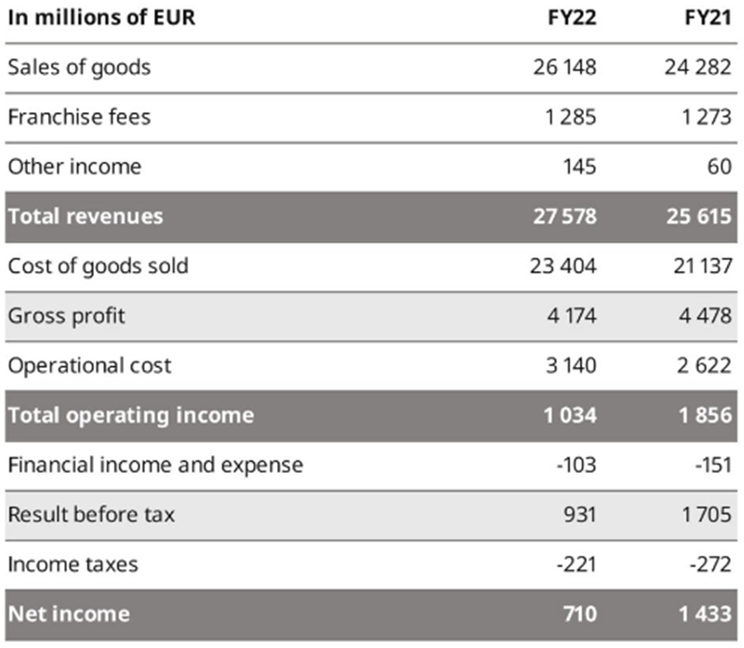
Table 1: Consolidated income statement of IKEA in 2021 and 2022
(Source: Inter IKEA Group., 2022)
IKEA is controlled and regulated through a large number of holding companies, non-profit foundations and operating companies instead of shareholders in case of the other organisations. The corporate structure of IKEA was developed partly in response to the high Swedish taxation. Extensive knowledge about the purchasing behaviour and preferences of consumers constitutes one of the competitive advantages for IKEA. The organisation understands the buying factors, which influence the consumers to purchase and implements the preeminent practices to induce customer decision (Ozturkcan, 2021). In addition, low pricing of products served as the cornerstone for IKEA as the company always seeks to adopt cost-efficient and efficient procedures in its business (Lewis, 2022). In the post pandemic period, IKEA has witnessed an increase in revenue generation of 27,578 million Euros in 2022 compared to revenue of 25,615 million Euros generated in the fiscal year 2021. However, increased operational cost and rate of goods sold decreased the total operating income of 1034 million Euros and net income of 710 million Euros of the company compared to previous year net income of 1856 million Euros and net income of 1433 million Euros. The gross profit margin of IKEA decreased from 13 percent in 2021 to 10.6 percent in 2022 due to the imbalance in the market and demand equilibrium generated as a result of changing demographics, consumer preferences and price of substitutes (Inter IKEA Group., 2022).
Identification of the demand and market equilibrium
Price of Substitute
Price | Q. Demanded | Q. Supplied | Q. Demanded 2
12 | 42 | 6 | 35
15 | 36 | 13 | 29
18 | 30 | 20 | 23
21 | 24 | 27 | 17
24 | 18 | 34 | 11
Table 1: price, demand, supply and change in demand

Figure 1: demand and supply equilibrium
Source : self

The above diagram is showing the shifting of the demand curve. The shifting of the demand curve occurs when the price of the substitute products changes. If the price of the substitute product rises it will lead to increase the demand for that product. Similarly, if the price of substitute products falls, then it will lead to decrease the quantity demanded for that product. In this given case, the data has been obtained regarding the selected countries to show the new equilibrium that has been obtained after the shifting the demand curve to the right ward. The table that is shown above is used to derive the demand and supply curve. Here from the given data set, the initial equilibrium is mentioned at the point Q1 where the demand and supply curve intersect each other. After rising the price of the substitute product, the quantity demanded for product at given price of level has been increased. This increment of the price of the substitute products have led to shift of the demand curve to the right. As a result, the new equilibrium of market has been obtained at the Q2. At the point Q2, both of the quantity and price of the products have increased due to rise of the quantity demanded at given price level.
According to Wessels (2018), the substitution effect is defined as the alteration in demand for a product as a result of a transformation in the relative price of products when compared to price of other substitute goods. Although IKEA possesses a strong credibility of brand through its products such as easy to assemble home furniture and customised sofas, the organisation is subjected to stiff competition from different competitors in retail furniture offering similar products and services such as Wayfair, Tesco, American Woodmark and Home Depot. For instance, Wayfair generated revenue of $14.145 billion along with net profit of $9.127 billion in 2020. The price of a wide range of substitute products offered by Wayfair ranges from 120 Euros to 4000Euros, whereas the retail furniture provided by IKEA ranges from 150 Euros to 3000 Euros. Availability of the substitute product at comparatively low prices has created a negative impact on the demand of products and services provided by IKEA in the retail furniture industry (Quirino and Salter, 2022). In other words, the decreasing price of Wayfair has reduced the demand for IKEA's products.

Price | Q. Demanded | Q. Supplied | Q. Demanded 2
12 | 32 | 6 | 35
15 | 28 | 13 | 31
18 | 24 | 20 | 27
21 | 20 | 27 | 23
24 | 16 | 34 | 19
Table 2: price, demand, supply and change in demand
The complementary products are considered to those products that are consumed simultaneously with that product. Therefore, the increment of the price of the complementary products leads to fall the quantity demanded for the product.

Figure 2: demand and supply equilibrium for complement product
Source : self

Complement price refers to the pricing of a product at the most favourable level, regardless of profit or cost considerations in order to raise the demand of other products which is utilised with it, thus, it ensures maximum profit from both the products. Complement products are items, which are often brought together with the main primary product (Wang et al., 2017). In contrast to its competitors, IKEA went one-step further by selling complementary items with its furniture products such as batteries for electrical items and light bulbs for light fittings. Although the price of complement products are increasing, however, it did not create much impact on the demand of the retail furniture (Varn, 2022).
Consumer income is defined as the amount of capital, which a consumer earns either from employment or from investment such as dividends of shareholders. Although the average consumer income across the U.K decreased significantly due to the emergence of the pandemic, however, recuperates the initial state of the business industry reflected in the increased rate of consumer income in the post-pandemic period (Cranfield, 2020). Increased rate of consumer income has impacted the business of IKEA in a positive way as the revenue generated in the fiscal year of 2021 and 2022 are comparatively higher compared to the revenue generated during pandemic.
As opined by Khojasteh-Khosro et al., (2022), consumer preferences are the subjective tastes, predispositions, likes and dislikes of an individual, which influences their preferences and purchasing habits. The consumer preferences are transforming from luxurious lifestyles to more towards necessity such as health related processes as the pandemic has made people more aware and cautious regarding maintenance of safe health amidst challenging circumstances. However, widespread globalisation and current trends has inspired a small base of customers towards luxury and comfort standard of living in the United Kingdom (Ozturkcan, 2021). The change in consumer preferences has affected the demand of easy to assemble furniture and customised sofa to a certain extent as an increased rate of product sales of IKEA is witnessed in 2021 followed by slight decrease in sales and profitability in 2022.
Although a low proportion of individuals belonging from high class society still prefer quality over price and intend to purchase the easy to assemble table and customised sofas of IKEA, however, the majority of the consumers expect to purchase retail furniture available at reasonable and comparatively low prices. For instance, Wayfair instigated to sell its products considering the consumer expectation of price, which aided them to gain significant profit margin in 2021 and 2022 (Quirino and Salter, 2022).
Demographics are the study of statistics, which describes the characteristics of populations such as age, gender, income or interest toward high standards of living. Despite the barriers posed by the several catastrophes, the number of consumers responsible for purchasing the easy to assemble furniture has increased to a certain extent. However, external and internal factors are affecting the purchasing behaviour of IKEA’s consumers, which is reflected in the annual performance of the company in terms of sales of furniture such as customised sofa and modern fittings (Varn, 2022). As a result, the demand of the product in the current times failed to attend stability in the competitive market.
Indication of demand in terms of more elastic or more inelastic
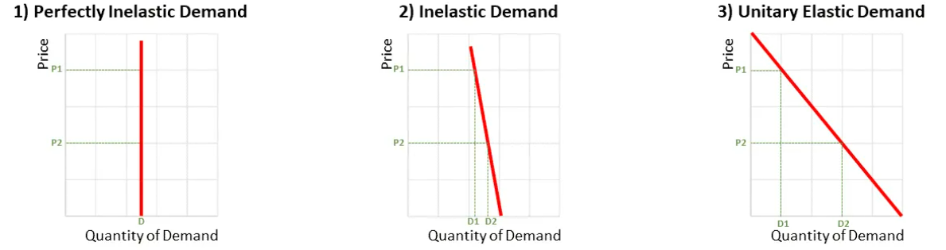
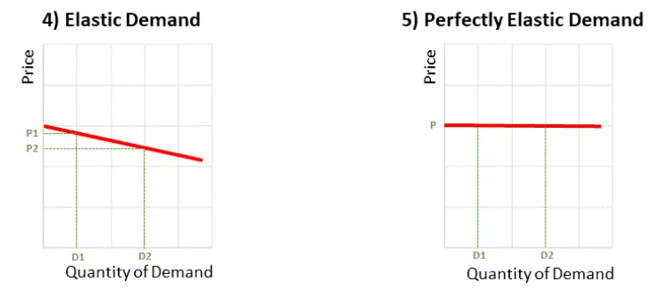
Figure 3: Types of price elasticity of demand
Source: RUSITH, (2021).
The price elasticity of demand can be defined as the measurement of the consumer preferences to buying the products to the change in the price of the products. The price elasticity of demand is calculated as the percentage change in the quantity demanded for the products due to the percentage change in the price of that product. On the basis value, the price elasticity demand is categorised into five components such as inelastic, elastic, perfectly elastic, perfectly inelastic, unitary elastic. The value of the price elasticity lies between negative infinity to positive infinity. If the value of the price elasticity is 1, then demand curve is treated as the unitary elastic.
Substitution product provides an opportunity to the customers to have access to a better product and lower prices as it provides alternatives and choices for the customers while maintaining competition and lower prices in the marketplace (Cullen and Farronato, 2021). For instance, the rise in the price of customised sofas and easy to assemble furniture of IKEA shifted the consumer base towards the substituted products of Wayfair and Amazon. Substitution effect is viewed as a process of decreased rate of sales for a product, which is caused due to customers switching to better alternatives offering similar products at low prices. In the case of IKEA, the substitution effect has been identified as the majority of the consumers view the customised sofas and easy to assemble furniture as luxury in the post pandemic period, however a small portion of the consumer base considered it as a necessity for living a decent lifestyle (Inter IKEA Group., 2022). Demand elasticity takes place when demand for a particular product changes in response to alteration in price and other factors, whereas inelasticity of demand indicates that demand for a product remains constant despite transformation in economic factors such as price range. Based on the substitute effect experienced by IKEA in terms of demand for their customised sofas and easy assemble of furniture, it can be stated that demand is more elastic, which tends to change with alteration in diverse factors including pricing of products. As the strong competitor of IKEA offered substituted products at comparatively low price ranges than IKEA by addressing the concern of consumers in the post-pandemic era; a large proportion of IKEA’s consumer base switched to the well-equipped furniture of Wayfair (Lewis, 2022).
According to Haig (2020), the effect of income in microeconomics refers to the resultant alteration in demand for a service or good, which is stimulated by an elevation or reduction in real income or purchasing power of the consumer. It can be further categorised into two types of effect – positive effect of income and negative effect of income. For instance, as the income grows as a result of increased employment opportunities, the income effect predicts that consumers of IKEA will initiate to demand more diversified products by demonstrating their purchasing power. The higher the amount of income spent on a particular product, the more elastic the demand for that good (Li et al., 2018). Percentage of income plays a vital role in determining the capacity of the consumer in terms of making a purchase. For instance, an individual responsible for earning a substantial amount of capital is likely to spend a greater amount on purchasing customised sofas and easy to assemble furniture, whereas an individual earning an insignificant amount of capital is likely to spend minimum expenses on purchasing furniture products. Therefore, it can be stated that purchase of the retail furniture represents the status of consumer income, which can be significantly large or inconsequentially low. Highly elastic products will experience their demanded quantity changes rapidly with income effect, whereas inelastic products will witness the similar demanded quantity even after changes in income status (Miah and Fatema, 2021). Analysis of these factors indicates that the demand for easy to assemble fittings and customised sofas of IKEA is more elastic, which tends to alters with respect to the changes in consumer’s income
Based on the analysis of substitution and income effects on the demand of customised sofas and easy to assemble furniture, IKEA needs to consider the pricing policy of dynamic strategy, which will enable them to adjust the price according to the demand of the products. Demand pricing, also known as time-based pricing, is a pricing strategy in which businesses such as IKEA are provided with the opportunity to adjust the prices of a wide range of retail furniture to account for the changing demand caused due to substitution and income effects. Implementation of dynamic pricing policy will aid IKEA to maintain the optimal balance between the number of products sold and profit acquired per good (Chen and Farias, 2018).

Conclusion
This essay highlights the important role of managing different components economics by demonstrating the business operations of IKEA in terms of identifying market and demand equilibrium and analysing the elasticity and inelasticity of demand. Price of substitution product, complementary product pricing, consumer income, preferences of consumer along with demographics plays an essential role in regulating the demand of customised sofas and easy to assemble furniture in the competitive industry. Furthermore, both substitution and income effects on the demand of IKEA’s product suggest that demand is more elastic and recommends the implementation of dynamic pricing policy to overcome the problem.

Reference list
Arnold, R.A., Arnold, D.R. and Arnold, D.H., ()2022. Microeconomics. Cengage Learning.
Baglioni, S. and Sinclair, S., (2018). Social innovation and social policy: Theory, policy and practice. Policy Press.
Besanko, D. and Braeutigam, R., (2020). Microeconomics. John Wiley & Sons.
Browning, E.K. and Zupan, M.A., (2020). Microeconomics: Theory and applications. John Wiley & Sons.
Carney, M., (2016). The spectre of monetarism. Speech presented at Roscoe Lecture at Liverpool John Moores University in Liverpool, UK.
Chen, Y. and Farias, V.F., (2018). Robust dynamic pricing with strategic customers. Mathematics of Operations Research, 43(4), pp.1119-1142.
Cranfield, J.A., (2020). Framing consumer food demand responses in a viral pandemic. Canadian Journal of Agricultural Economics/Revue canadienne d'agroeconomie, 68(2), pp.151-156.
Cullen, Z. and Farronato, C., (2021). Outsourcing tasks online: Matching supply and demand on peer-to-peer internet platforms. Management Science, 67(7), pp.3985-4003.
Erixon, L., (2018). Progressive supply-side economics: an explanation and update of the Rehn-Meidner model. Cambridge Journal of Economics, 42(3), pp.653-697.
Inter IKEA Group. (2022) Financial Year 2022 (FY22) financial results. Available at: https://www.inter.ikea.com/en/performance/fy22-financial-results.
Kaldor, N., (2015). Keynesian economics after fifty years. In Essays on Keynesian and Kaldorian Economics (pp. 27-74). Palgrave Macmillan, London.
Khojasteh-Khosro, S., Shalbafan, A. and Thoemen, H., (2022). Consumer behavior assessment regarding lightweight furniture as an environmentally-friendly product. Wood Material Science & Engineering, 17(3), pp.192-201.
Lavoie, M., (2022). Post-Keynesian Economics. Books.
Lewis, R. (2022) Furniture, Encyclopædia Britannica. Encyclopædia Britannica, inc. Available at: https://www.britannica.com/technology/furniture.
Li, L., Chi, T., Hao, T. and Yu, T., (2018). Customer demand analysis of the electronic commerce supply chain using Big Data. Annals of Operations Research, 268(1), pp.113-128.
Miah, M.D. and Fatema, N., (2021). Cross Elasticity of Demand of Selected Wooden Furniture in Respect to Alternative Furniture in Chittagong City. The Chittagong University Journal of Science, 43(1), pp.1-20.
Ngai, S.B.C. and Falkheimer, J., (2017). How IKEA turned a crisis into an opportunity. Public Relations Review, 43(1), pp.246-248.
Nissley, C., (2022). Which System Works for Capitalism?: An Analysis of Supply Side and Demand Side Economics Tax Policy.
Ozturkcan, S., (2021). Service innovation: Using augmented reality in the IKEA Place app. Journal of Information Technology Teaching Cases, 11(1), pp.8-13.
Pinker, R., (2022). Social theory and social policy. Taylor & Francis.
Quirino, C. and Salter, J. (2022) Wayfair vs. IKEA: Which Furniture Giant is better?, Home Of Cozy. Available at: https://homeofcozy.com/brand-comparisons/wayfair-vs-ikea/.
RUSITH, (2021). 5 Types of Price Elasticity of Demand – Full Explanation (2021). Available at: https://learnbusinessconcepts.com/types-of-price-elasticity-of-demand/ (Accessed: 6 January 2023).
Tucker, I.B., (2022). Microeconomics for today. Cengage Learning.
Vaggi, G. and Groenewegen, P., (2016). A concise history of economic thought: From mercantilism to monetarism. Springer.
Varn, T. (2022) 11 tips that a trip to IKEA taught us about web marketing and SEO |, Varn. Available at: https://varn.co.uk/08/17/11-tips-trip-ikea-taught-us-web-marketing-seo/.
Wang, L., Song, H. and Wang, Y., (2017). Pricing and service decisions of complementary products in a dual-channel supply chain. Computers & industrial engineering, 105, pp.223-233.
Wessels, W.J., (2018). Economics. Simon and Schuster.

