
Nicole Denise Smith (1650693) University of Wales Trinity Saint David Module: Driving Change and Building Business Cases (BMHR7014) Word Count: 2944 Words + 906 Words in Poster = 3850

Identify trends and shortcomings in the Induction process at Wall Colmonoy, to inform and standardise the process for increased engagement and retention
Acknowledgments
Thank to everyone who took part in this research, your insights were invaluable and will help drive change at Wall Colmonoy.
On a personal note; Julie, thank you for all your love, support and ‘sitting with Nellie’ moments offered over the last 3 years.
Keep being and doing ‘you’.

Abstract
The UK is currently facing the tightest labour market in decades (Faragher, 2021) with a ‘jobseeker-friendly’ market (Churchill, 2022). The tight labour market has emphasised the need for the adjustment of recruitment strategies (CIPD, 2020) and has been a catalyst for Wall Colmonoy to evaluate its current induction process.
Lawson (2018) defines induction as a process to either help new starters settle into an organisation or help internal employees transition into a new role.
The aim of this report is to identify trends and shortcomings in the Induction process at Wall Colmonoy, to help inform and standardise the process for increased engagement and retention.
Wall Colmonoy’s turnover YTD (2022) is currently 11.53%, up from 8% in 2021 (Wall Colmonoy, 2022b). Whilst in the current tight labour market an uplift in turnover is to be expected, in 2022 46% of leavers left in their first year (Wall Colmonoy, 2022b).
Cluster sampling was used to collect data as it would be impracticable to collect data from everyone associated or impacted by WCL’s induction process (Saunders et al, 2019, p315). Sample size in this research was 28.
The qualitative nature of this research lent to a interpretivist approach which focused on data collection through interviews and an interactive, cooperative and participative approach (BRM, 2022).
The following employees would be included in the research group:
• Employees who have 1 year or less service at Wall Colmonoy
• Employees who have changed roles in the last 12 months
• Managers
Braun and Clarke (2006) 6-step Guide to Good Thematic Analysis model was used to analysis the qualitative data collected. Three distinct themes become apparent from the research:
• Lack of Ownership
• Lack of Structure
• Poor Communication
The focus post research is how the data gathered can be utilised to instigate valid and effective change.
Using Kotter’s 8 Step Process for Leading Change as the framework for driving change, Wall Colmonoy need to standardise and enhance the induction process for all levels of employees to increase engagement and retention.

Contents Page

1.Introduction 6
1.1 UK Labour Market 7
1.2 WCL’s Employee Turnover 8
2. Literature Review 8
2.1 WCL’s current induction process 9
2.2 Benefits of a standardised and thorough induction programme 10
2.2.1 Structured induction 10
2.3 Pitfalls of a poor induction 11
2.4 Example of a structured and extensive Induction Plan 12
3.1 Research group: Sample selection 14
3.1.1 Cluster Sampling 15
3.2. Data Collection 15
3.3. Validity, reliability and limitations of research 15
3.4 Thematic analysis of data collected 16
4. Results and Findings 18
4.1 Lack of Ownership 18
4.2 Lack of structure 19
4.3 Poor Communication 20
6. Conclusion 21
6. Appendices 22
6.1 Change of role employee questionnaire on Wall Colmonoy’s current induction process 22
6.2 Managerial questionnaire on Wall Colmonoy’s current induction process 23
6.3 New Starter questionnaire on Wall Colmonoy’s current induction process 24
6.4 Kotter’s 8 Step process for Leading Change 25
6.5 Pro and Cons of different data collection methods 26
6.6 Primary Data from Questionnaires 27
7. Reference List 32

1.Introduction
Wall Colmonoy (WCL) are a global engineering group engaged in the manufacturer of precision castings, engineered components, brazing products and coatings across different industries and sectors (Wall Colmonoy Ltd, 2022a).
The UK is currently facing the tightest labour market in decades (Faragher, 2021) with a ‘jobseeker-friendly’ market (Churchill, 2022). The tight labour market has emphasised the need for the adjustment of recruitment strategies (CIPD, 2020) and has been a catalyst for WCL to evaluate its current induction process.
Lawson (2018) defines induction as a process to either help new starters settle into an organisation or help internal employees transition into a new role. In a recent survey by Cezanne HR (2020) 21.5% of people stated that they were provided with little support during their first day.
The working landscape drives how we work, "business as usual" is constant change, particularly post-pandemic (Thacker,2021). This can be said for the induction process and the changing needs and involvement associated with it. No longer can the culture of ‘the way we do things around here’ be acceptable (Fowler, 1999, p9). WCL need to change, only research will define to what extent.
The aim of this report is to identify trends and shortcomings in the Induction process at WCL, to help inform and standardise the process for increased engagement and retention.
The objectives of this report will be to:
- Critically evaluate the current induction process
- Identify and critically evaluate suitable interview techniques and use techniques to collect data from employees
- Critically analyse results and present findings in the context of Wall Colmonoy
- Develop a standardised induction process for all levels of employee to increase engagement and retention.
WCL would like to create a comprehensive experience for new starters and transitioning employees by helping them understand their new position and job requirements through induction.
WCL’s culture is traditional, industrial which is uncomfortable with change, but very accepting too. Resistance is small, but continuous implementation of new ideas is a challenge.

1.1 UK Labour Market
Strack (2014) suggests there will be a global workforce crisis by 2030, therefore it is crucial that retention strategies have the same focus as overall business strategy (CIPD, 2020).
Promoting and reskilling internally could be essential in the current labour market (Faragher, 2022), particularly when 47% of UK employers currently have hard-to-fill vacancies (CIPD, 2022).
CIPD (2022) reports 41% of employers are choosing to upskill existing staff, however, role inductions for internal employees are often overlooked (Fowler, 1996, p80).
It is now critical that WCL makes induction a priority, investigate processes and ensure any shortcomings are addressed (Cezanne HR, 2022).

1.2 WCL’s Employee Turnover

WCL’s turnover YTD (2022) is currently 11.53%, up from 8% in 2021 (Wall Colmonoy, 2022b), this figure is below the UK average of 15% (Monster, 2021) and the manufacturing industry average of 19% (ONS, 2019).
Fowler (1996, p20) states that employees are more likely to resign during first few months of employment than any subsequent time. Whilst in the current tight labour market an uplift in turnover is to be expected, in 2022 46% of leavers left in their first year (Wall Colmonoy, 2022b).
This attrition rate and loss of employees cannot be sustained and therefore change needs to be people centric, with engagement driving process change (Biltgen, 2020).
Existing research suggests induction processes are linked to employee retention, with a focus needed on the induction experience (CIPD, 2019).

2. Literature Review

Cheese (2022, p5) notes that labour market dynamics are being tested, with adaptation and innovation happening as a result of labour market changes. The new business ‘normal’ will demand greater efficiency and a shake-up of the status quo (Thacker, 2021).
A structured induction programme means employees settle quickly, feel supported, integrate into their team and become productive quicker (CIPD, 2021). A Cezanne HR (2022) survey found 21% of employees questioned their choice of employer due to their poor induction.

2.1 WCL’s current induction process

Induction is WCL’s best and only chance to make a positive first impression (Fowler, 1996). WCL’s Induction process was last updated in 2012 and currently consists of the following process on a new starter’s first day:
- The new starter is met by either HR, H&S or the department manager (HR encourage managers to meet their new starters, this does not always happen).
- HR paperwork collected and updated on an employee’s file.
- New starters participate in a H&S induction.
- New starters have their fingerprints placed on the system for security access and time and attendance.
- Employees are ‘handed over’ to their departments and begin their departmental introductions and training.
Further points regarding the current induction process:
- Employees undertake a Quality induction, however, this does not take place on a new starters first day.
- A new WCL company induction has been created but there is no fixed timeline for this induction.
- Departmental inductions are not standardised and departmentally based/ led, which has led to differing induction processes.
HR undertake 30,60,90 day reviews with new starters or transitioning employees, however, this is the only set process beyond the first day.
Standardising the induction process would ensure consistency and structure across WCL, standardisation could lead to higher retention rates. ‘The new normal’ requires HR teams to experiment, adapt and innovate to achieve retention and recruitment of employees (Cheese, 2022, p5).
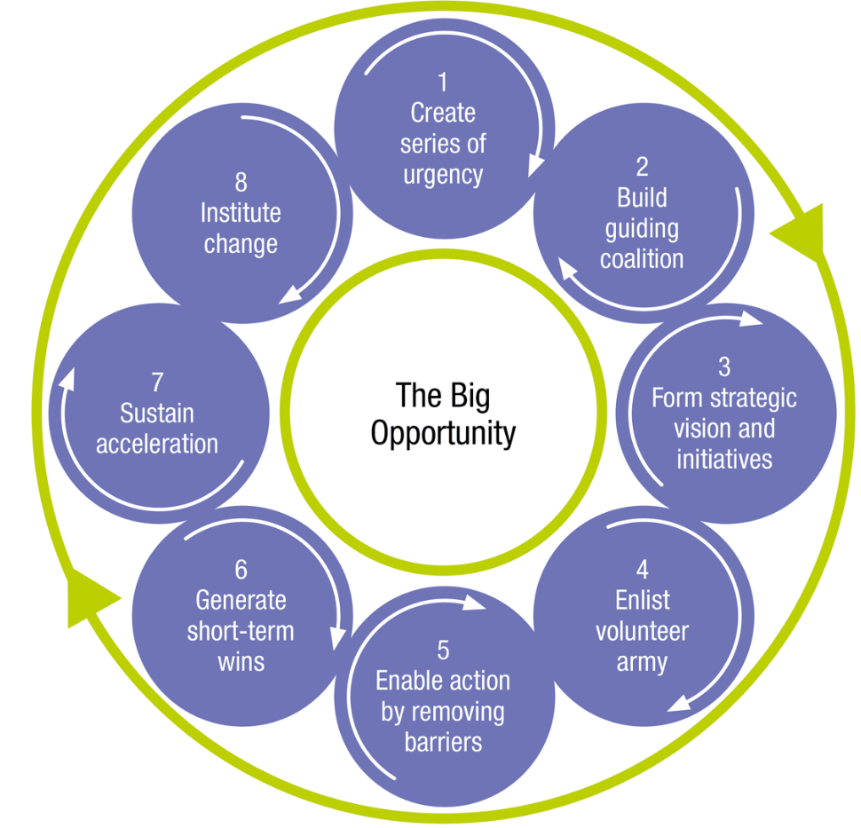
WCL aim to utilise this research to amend the current induction process, with Kotter’s 8 Step Process for Leading Change helping to introduce necessary changes. (Kotter, 2014).
Engagement with Kotter’s 8 Step Process could engage employees and build trust in the new process, with Table 1 (Appendix 6.4), providing a framework for WCL to follow.
Figure 2 : Kotter’s 8-Step Model
(Kotter Inc, 2022)

2.2 Benefits of a standardised and thorough induction programme
Organisations with a strong induction process can improve their retention by 82% and productivity by 70% (Cezanne HR, 2020). A effective and engaging experience is key to making a positive first impression (CIPD, 2021).

2.2.1 Structured induction

A good induction programme does not have to be extensive but needs to be structured, it can allow new starters to settle and become productive faster by introducing them to organisational procedures, processes and values (Fowler, 1999, p.4).
Alongside a comprehensive new starter induction programme, consideration needs to be paid to ‘inboarding’. This process will focus on retaining valuable employees during an internal move (Bauer, 2022).
2.2.2 ROI and Turnover
Structured induction programmes are a natural extension of the recruitment process, they are key to new starters success (O’Neill, 2018). An ineffective induction may affect employee turnover, absenteeism and employer branding (CIPD, 2021).
High employee turnover can be problematic due to disruption and expense of replacing employees (Indeed, 2022), ACAS and CIPD agree that the approximate direct cost of recruiting a new employee is £5,000 (Lawson, 2018), with this figure rising to more than £30,000 based on the lost output and the logistical cost of recruitment – agency fees, interviewing and advertising (Cezanne HR, 2020). Filling a vacancy is time consuming, so it is worth ensuring new starters want to stay (ACAS, 2015).
Induction expenditure is only 17% of overall recruitment spend but is key to higher ROI and lower employee turnover (O’Neill, 2018).

2.3 Pitfalls of a poor induction
Howlett (2020) warns that a poor induction programme could be detrimental to an organisation. If an organisation leaves induction to ‘chance’, employees can take longer to learn processes and adapt (Fowler, 1999, p.2). The CIPD (2021) note that an ineffective induction can also lower morale for the remaining staff and could increase turnover of existing staff. Bauer (2022) states that 12% of HR managers believed a poor induction process leads to higher employee turnover.
Early leavers or ‘non-starter syndrome’, occurs when new starters are not integrated effectively, leading to new starter’s deciding to either not join an organisation or stay long-term (Fowler, 1999, p.2; Bauer, 2022).
New starters should also have interaction with their manager prior to and on the morning of their first day (Lawson, 2018) - It is essential new starters are met by their manager (Fowler, 1996, p.27). This is not standard at WCL.

2.4 Example of a structured and extensive Induction Plan

Planning is critical to ensure standardisation, consistency and ownership. It is imperative that all stakeholders are aligned as without clear ownership a disjoined employee experience ensues (Howlett, 2020).
Induction is about steps an employer can take to help new starters and internal employees transition quickly, happily and effectively (Fowler, 1996, p.5). The induction process does not stop after the first day and can last up to 6 months (Fowler, 1999, p.51). Figure 1 is an example of a structured induction plan.
Figure 1: An amalgamated 3-6 month induction plan from Fowler (1999, p17-32); Howlett (2020); Roberts (2015).
The length and nature of the induction depends on the job role and organisational size and type (CIPD, 2021).
Larkins (2022) states inductions should be three phases:
- Phase 1 - The welcome, general administration and introduction to critical policies and procedures.
- Phase 2 – Departmental inductions, introductions to the role, the team, departmental goals, Key Performance Indicators and relevant policies and procedures.
- Phase 3 – Wider learning of the organisation’s history, culture, products and people.
WCL undertake Phase 1 well but are deficient in Phase 2 and 3, with the resources created for Phase 3 but no time allocated for roll-out.
3. Methodology
In order to achieve the overall aim of this report, data collection and primary data is critical to understand trends and shortcomings in WCL’s induction process.
Newby (2014, p.10-11) stated that research is conducted to improve a process from the way it is currently run. The outcome of this research needs to improve behaviours, effectiveness and performance at WCL.
A interpretivism research paradigm focuses on the study of a specific topic in great depth in order to fully understand it (BRM, 2022). The qualitative nature of this research lent to a interpretivist approach which focused on data collection through interviews and an interactive and participative approach (BRM, 2022).

3.1 Research group: Sample selection

It would be impracticable to collect data from everyone associated or impacted by WCL’s induction process, so sampling was required (Saunders et al, 2019, p315).
Saunders et al (2019, p.317) offers a sample size norm of 30, where participants are from a single organisation or will be analysed as a single group. Sample size in this research was 28.
The following employees would be the research group:
• Employees who have 1 year or less service at Wall Colmonoy
• Employees who have changed roles in the last 12 months
• Managers

3.1.1 Cluster Sampling

Cluster sampling was the appropriate option for this research, as the target population was already divided into three distinct groups: new starters, managers and change of role employees (Saunders et al, 2019, p313).
Engagement with managers allowed them the opportunity to critique the current process which could be invaluable when introducing a new standardised process.

3.2. Data Collection

Employees in the identified research groups were identified, approached and an opportunity to not engage given.
The method of collection was determined using a Pro and Con table (Appendix 6.5). Questionnaires via interview would provide the best outcomes and feedback in this instance, as some employees did not have access to a work phone or email. Newby (2014, p.264) also highlights that face-to-face contact would generate a higher response rate than phone or email and qualitative research allowed employees to give answers in their own way (Fink 2016). The research questionnaires can be found in Appendices (Appendix 6.1, 6.2 and 6.3).

3.3. Validity, reliability and limitations of research

Every research has limitations which need to be minimised. The sample size of the study was 28, 14.4% of WCL’s total head count. Sample size needs to be a consideration when questioning limitations of the research and in this instance 8 individuals left WCL prior to research starting.
Qualitative data generated via an Interpretivism research can be associated with a high level of validity as people tend to be honest and reliable (BRM, 2022), crucial is the acknowledgement that people will have differing perspectives of events, with some events being unverifiable (Saunders et al, 2019).
Time was a limitation with this research, as a fixed deadline meant some individuals were missed due to annual leave and work schedules. Undertaking research throughout the summer was challenging and resulted in less employees interviewed.

3.4 Thematic analysis of data collected

Thematic analysis was used to analysis the qualitative data collected. Braun and Clarke (2006) 6-step Guide to Good Thematic Analysis model was used to analysis the data, as it allowed flexibility to interpret and identify common themes, patterns and opinions (Caulfield, 2022).
Figure 3: Braun and Clarke (2006) 6-step Guide to Good Thematic Analysis

4. Results and Findings

28 employees were interviewed about WCL’s current induction process and the findings are resultant from those structured interviews. Appendix 6.6 is the primary data collected.
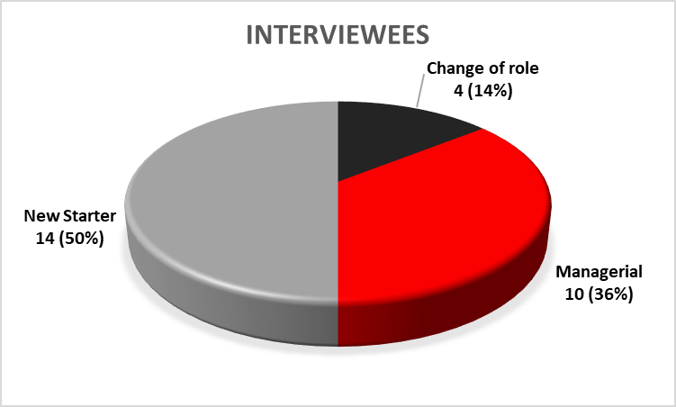
Type of Questionnaire/ Interview Type | Change of Role | Managerial | New Starter
No. Interviewed | 4  14% | 10  36% | 14  50%
Table 2 + Figure 4: The breakdown of employees interviewed
The research shows that mandatory areas of an induction are covered, e.g. New starter medicals, H&S Induction, HR Paperwork and system fingerprints. However, in the words of both a new starter and a manager, WCL’s induction process is “Good but improvements can be made”.
Three distinct themes become apparent.

4.1 Lack of Ownership

Howlett (2020) stated that inductions go wrong because of poor communication between departments and a question over ownership and who has responsibility. This is the case at WCL.
Currently there is assumptions on what has been done and who has covered what. A manager stated that there was a “Lack of ownership and responsibility (No one sees what each other does / what is covered”. how can activities be planned, if there is uncertainty what has already been achieved. Lack of ownership has been reiterated with “No ownership and communication mismatch”, continually being mentioned.
Whilst originally an assumption, it is now clear that WCL’s induction process is happening in a haphazard manner. No ownership or planning from line managers has resulted in employees taking ownership for their development “I visited new department off own back. There was no formal introductions”. This shows the lack of ‘Inboarding’ taking place at WCL, with employees being ‘throw into’ their new internal roles, with little support from Line managers (CIPD,2021).

4.2 Lack of structure

WCL’s induction process lacks structure once new starters are ‘handed over’ to their departments on their first day.
Whilst some new starters interviewed started they had a “Rough 1 week plan”, this isn’t the case for others who felt their induction was “Disjointed at times and they were left waiting between planned events”.
A lack of consistency was clear for in-depth departmental inductions, while Machine Shop undertakes a “Localised inductions with information on First aiders and SWI’s”, it doesn’t in others, with new starters in Alloy Products shown “SWI’s after 2 weeks”. A number of employees said that a “Further in depth departmental inductions would be helpful”, illustrating the benefit of replicating Machine Shop’s localised induction in other departments to ensure consistency with content and style. This is also emphasised through research and Larkins (2022) 'Phase 2’.
Howlett (2020) underlines how organisations “Finally have a resource but people treat them like an inconvenience”, many employees interviewed said that they were ‘Buddied up with a Team leader’, with one noting that it was “Monkey see, monkey do” and a number emphasising they’d have liked “More structure”.
Starting an employee when existing staff are too busy to support and train a new starter, can make that person feel like an inconvenience (CIPD, 2021).

4.3 Poor Communication

The final distinct theme was poor communication, one support manager noted that there were “No introductions to new key members of staff”. WCL are missing something fundamental not introducing ‘people’, with a new starter noting that they’d received “No introductions of people and areas, only to processes and procedures”.
Some managers acknowledged that “Communication between departments is abysmal”, with this inter-departmental communication breakdown resulting in IT issues, PPE and locker miscommunications and ad hoc introductions. Managers were more critical about poor communication than new starters.
Regular meetings between a new starter and their manager do not occur at present, while majority of managers said they undertake follow-up meetings, majority of employees said that they had just had a “brief catch up” with their managers. During an employee’s probationary period there needs to be time assigned to provide two-way feedback, no longer can the first review meeting be the probation meeting (Howlett, 2020).
Clear is the need for change. However, any recommendations need to fall within the ‘best fit’ school model, so they will be implemented efficiently and effectively (Boxall & Purcell, 2003. P47-51).

Conclusion

The aim of this report was to identify trends and shortcomings in the Induction process at WCL, to help inform and standardise the process for increased engagement and retention.
The UK’s tight labour market has emphasised the need for the adjustment of recruitment strategies (CIPD, 2020) and has been a catalyst for Wall Colmonoy to evaluate its current induction process.
Every research project has its limitations, with time and sample size being a consideration in this instance.
Thematic analysis of the 28 interviews with managers, new starter and change of role employees illustrated three distinct themes: A lack of ownership, lack of structure and poor communication. The focus post research now needs to be how the data can be used and what can be achieved. WCL’s current induction process lacks ownership, structure and coordination.
Using Kotter’s 8 Step Process for Leading Change as the framework for driving change, Wall Colmonoy need to standardise and enhance the induction process for all levels of employees to increase engagement and retention.

6. Appendices

6.1 Change of role employee questionnaire on Wall Colmonoy’s current induction process
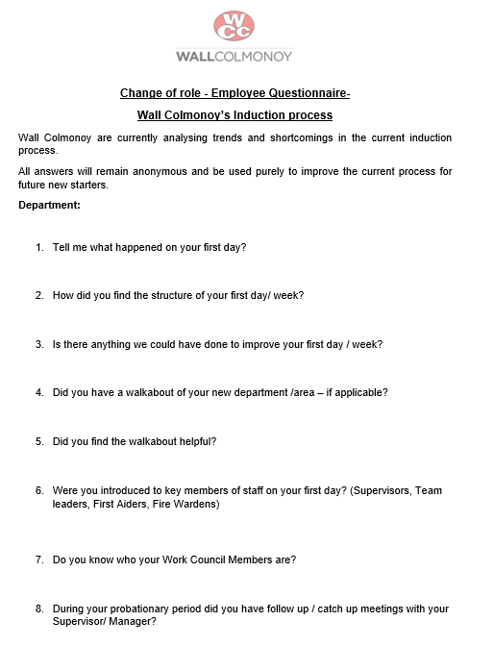

6.2 Managerial questionnaire on Wall Colmonoy’s current induction process
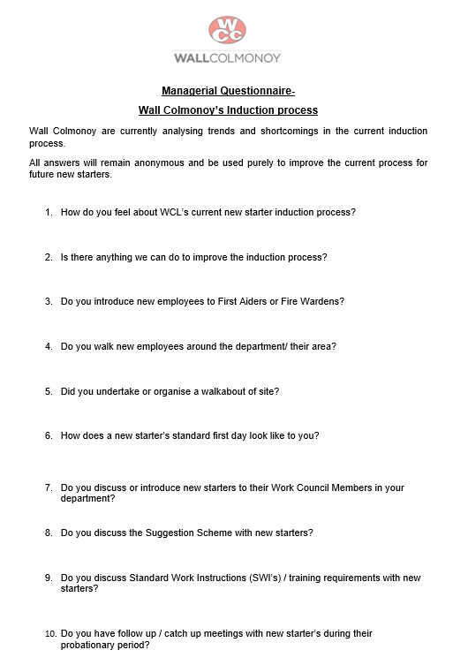

6.3 New Starter questionnaire on Wall Colmonoy’s current induction process
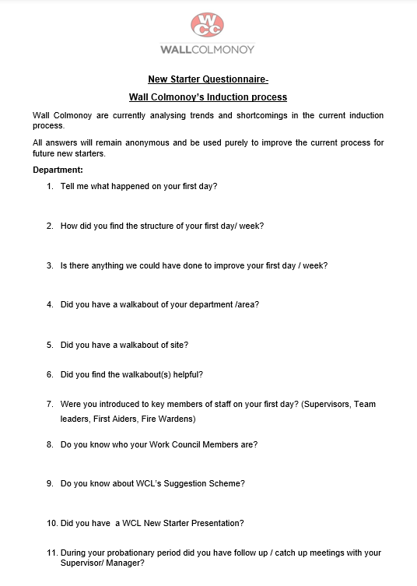

6.4 Kotter’s 8 Step process for Leading Change
Steps |  | Kotter’s ‘Step’ explanation
1) | Create a sense of urgency | - Communicate the need for change and the importance of acting immediately  - Start honest discussions, and give dynamic and convincing reasons to get people talking and thinking.  - Kotter suggests that 75% of a company's management needs to "buy into" the change for it to be successful.
2) | Build a guiding coalition | - Key people to help lead, coordinate, guide and communicate activities.  - Key people will convince people change is necessary and shows support.
3) | Form a strategic vision and initiatives | - Clarify how the future will be different and how this future can be made a realty.  - Create a strategy to execute that vision.  - A clear vision can help everyone understand why you're asking them to do something.
4) | Enlist a volunteer army | - People drive change and the larger the numbers involved the more effective change.  - Communicate it frequently and powerfully, and embed it within everything that you do. Create a movement and not a project.
5) | Enable action by removing barriers | - Removing inefficient processes and hierarchies  - Remove obstacles so people can execute the vision/ change
6) | Generate short-term wins | - Create short-term targets, not just one long-term goal.  - You want each smaller target to be achievable, with little room for failure  - Wins are molecules of results and must be collected, recognised and communicated, so progress can be tracked and volunteers re-energised.
7) | Sustain acceleration | - Be relentless with initiating change until the final outcome / vision is a reality – Many change projects fail because victory is declared too early.  - Real change runs deep. Quick wins are only the beginning of what needs to be done to achieve long-term change
8) | Institute change | - Make connections between new behaviours and successes until old habits are replaced.  - Existing staff and new leaders need to continue supporting the change
Table 1: Kotter’s 8 Step process for Leading Change (Kotter, 2014; Inc, 2022)

6.5 Pro and Cons of different data collection methods

Type of Data Collection | Pro’s | Con’s
Questionnaire  Online | - Individuals can carry out the research in their own time/ availability  - More private and higher level of anonymity. Survey could be answered anonymously | - Need access to online survey  - Lower response rates  - Cannot probe for further information or elaboration  - Cannot analyse body language
Questionnaire  face-to-face (1:1) | - Body Language can be analysed and can be a form of communication  - Wording can be clarified or individuals can be probed for more information  - Higher response rates  - Can access employees that phone or online questionnaires might not be able to reach | - Can take longer than other methods.  - Greater time investments and organisation  - Both parties need to be available in person at the same time.  - Participants may have concerns about privacy and anonymity
Questionnaire over the phone | - More flexibility, does not need to be in person.  - More private and higher level of anonymity, | - Both parties need to be available  - Lower response rates  - Cannot analyse body language

Table 3: Pro and Con table of data collection method (Macfarlan, 2022)

6.6 Primary Data from Questionnaires
 | New Starter Questionnaire
 | Tell me what happened on your first day? | How did you find the structure of your first day/ week? | Is there anything we could have done to improve your first day / week? | Did you have a walkabout of your department /area? | Did you have a walkabout of site? | Did you find the walkabout(s) helpful?
1 | Enjoyed 1st day - Time flew. Enjoyed going straight into role / production after H&S / Inductions | Good - Straight into work, enjoyed pace & structure | No | Yes | Yes | Yes
2 | H&S induction, paperwork, shopfloor but was left in canteen for extended break due to meetings - 2/3 hours | Buddy system, training, induction - found it ok | More structure/ fluidity | Yes | No | Yes of department but would have liked site walk
3 | H&S induction, paperwork, introductions, walk through site | Tricky - software/ computer wasn’t ready, so no access to system / PC | Have all items in place - mobile, computer, software | Yes | Yes | Found it very interesting
4 | Confusing - felt a little lost as no one was explaining anything, including breaks | No structure to help adjustment. No explanations on how breaks work/ ops | More explanation/ structure. Buddying would have helped | Yes | Yes | Found both helpful
5 | Some structure, met key players -crucial but needed more | Spend time in business unit for every support function | Systems/ processes and explanation of where documents are kept There is nowhere which states where to pull data from. No documented 'rule book' | Yes | Yes - Initiated by himself | Yes helped with engagement
6 | Told to turn up at 7am then turned away until 8am | First day was awkward due to confusion with time | People be structured and organised for new starters | Yes showed around by manager | Yes | Interesting to know what is going on and where
7 | H&S induction, paperwork, introductions to team, systems weren't set up in time | Little disjointed- more structure needed. 'Plonked on a PC' waiting for something to happen | More structure - knowledge of systems, so could get on with work between planned activities | Yes but too much information on some days. Better if they were spaced out. | Yes but too much information, better if spaced out or have a few smaller sessions | Yes but overloaded with different information =Too much
8 | H&S, Intro to the team | No set structure, little chaotic - Everyone tried their best but sat at desk a lot | More structure & knowledge of basic IT systems, could have felt more productive then | Yes | Yes | Yes but too much information- Broken up on different days would be best
9 | Mandatory training, fingerprints | Ok. IT was down which caused issues | Systems weren't set up or working, made first week difficult. Like more information about USA/ how WCC works | Yes | Yes | Yes found it helpful
10 | H&S induction, run throughwith supervisor of area / medical | Buddy system initially, then 'left to get on with it' | More structure but know there's been sickness. Be nice to know where parts are made go | Yes - Quick intro of department | Yes - Very basic but did have it | Yes but further indepth department would be helpful
11 | Walk through of section when in department, after H&S inductions | Not much structure. Start training learning off others - 'Monkey see, monkey do' | Maybe more structure but department is very busy | Yes | Yes during interview - briefly | Yes of area
12 | H&S induction, department/ section walk through, discussion of role | External training straight away, which took up a lot of time during 1st week | Nothing - Enjoyed going into training, being/ feeling productive | Yes of area | No but irrelevant for role. Might be nice after 1st week to see other areas | Yes of area
13 | H&S induction, HR, meet team, walk site | Good, learned site by shadowing and buddy system | No straight forward and relevant | Yes | Yes | Yes - Good to work out where to go/ where things are
14 | HR/ H&S Induction, meet team, thrown into role | Good, worked straight away. Enjoyed getting straight into role. | Adhoc but always is. Not sure where to go after H&S. Waited in canteen for extended lunch | Yes | No | Yes of area

Were you introduced to key members of staff on your first day? (Supervisors, Team leaders, First Aiders-FA, Fire Wardens-FW) | Do you know who your Work Council Members are? | Do you know about WCL’s Suggestion Scheme? | Did you have a WCL New Starter Presentation? | During your probationary period did you have follow up / catch up meetings with your Supervisor/ Manager?
Yes | Yes | Yes | No | Yes
Just people on shift/ working at time | Yes now I do | No | No | Yes informal meetings
No just line manager | Not at the start | No | No | Yes informal meetings/ catch ups
No aside from shift personnel | Not at the start | No | No | Yes had catch up meetings
No | Yes | Yes | No | Yes
Yes | Yes | No | No | Asked informally if any issues and how things are going
No to FA/FW- Introduced to key members of the team. Org chart would be helpful. | Yes but not on first day | Yes | No | Yes, no set timeframe but did have catch ups
No to FA/FW- Introduced to key members of the team on walkabout but a lot to take in. | Yes but not on first day | Yes | No | Yes but fluid, no set agenda
Yes team members not FA/FW. Org chart would be helpful | No found out in last 2 months - Been in post for over 1 year | Yes | No | No
Met team, buddy and supervisor + manager | No | No | No | No formal meetings 'How are you'
Everyone on site/ within team. No one singled out as first aiders | Yes now but not at start | Yes | No | No just a very brief catch up in passng
People on shift. Not told who FA/ FW are | Yes now but not during first weeks | Yes | Yes | No real meetings, a quick hellp/ how are you
Yes but not FA/ FW | No | No | No | Yes
Person buddied with , not FA/ FW | Not at start, do now | No | No | Informally/ How are you doing etc
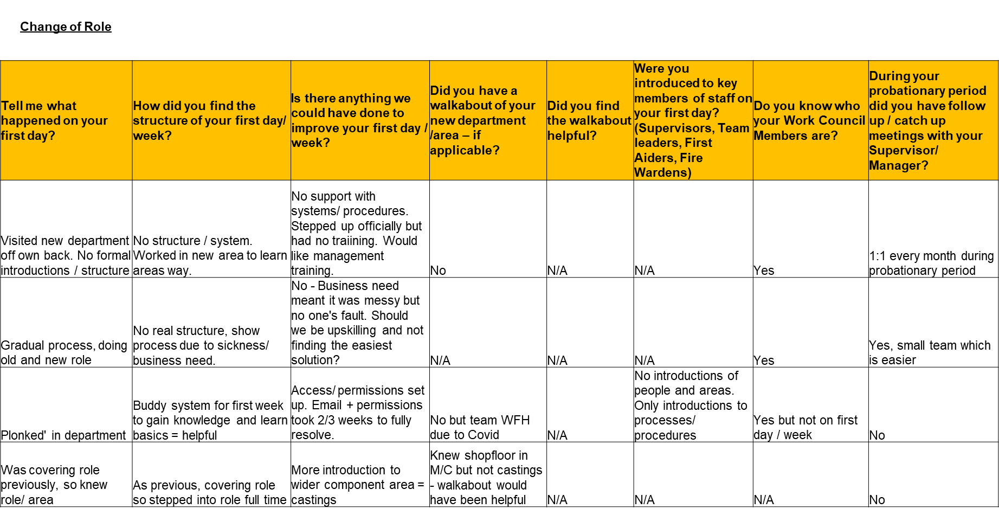

 | Managerial Questionnaire
 | How do you feel about WCL’s current new starter induction process? | Is there anything we can do to improve the induction process? | Do you introduce new employees to First Aiders - FA or Fire Wardens- FW? | Do you walk new employees around the department/ their area? | Did you undertake or organise a walkabout of site? | How does a new starter’s standard first day look like to you?
1 | More introductions needed not just paperwork. A lot of other introductions missing from day - HR / IT/ Quality (Dependent on role) | More face-to-face time with departments. Managers / Supervisors there to greet new starters - No ownership/ communication mismatch | No briefly addressed but not shown. Should there be a localised induction which includes FA/ FW | Try to if can, doesn’t always happen | Try to if can, doesn’t always happen | H&S Induction then onto processes as quick as possible
2 | Good but improvements can be made | Availability an issue. Need a formalized onboarding process = fixed itinerary for new starters. | No | Yes - Time with different areas of factory | Yes - Relevant tours/ inductions take place | H&S Induction, HR Paperwork, introductions, training
3 | Not too bad, but some improvements, Induction ok but set ups an issue | Locker set up / PPE set up needs to be quicker. Communication between departments abysmal | Shown board where first aiders listed | Yes | No - Thought this took place during H&S Induction - People should know where things are | H&S Induction, buddy up new starter with same person for first 4 weeks (Shadowing)
4 | Rushed too much emphasis on external training too early | Fixed plan in place. Training on first 2 days a problem if candidate withdraws. | No | Yes | Yes | H&S Induction, HR Paperwork, introductions to team, PPE and maybe training
5 | Good process, allows feedback. | No | No | Yes | Yes | H&S Induction, department introductions, rough 1 week plan
6 | Ok | Handbook would be helpful, more involvement from area/ department. No consistency across departments | Yes - Introduce them and have board to show them. | Yes | No - Unless problem, the encouraged to visit department. | H&S Induction, H&S/ SWI Induction to M/C, buddied up with intro to TL
7 | Ok - Mentions what it should | Refresher process, some H&S information re-iterated later - A lot of info to take in) | No - Clarification needed | Yes | Not relevant for shop floor operatives | H&S Induction, PPE kit out, risk assessments for department and training on first day if possible
8 | Lack of PPE for new starters - Sizes slow to come through, then process and need them tomorrow | No introductions to new key members of staff. Informally bump into people | Inconsistencies within department induction and everything else - including PPE | Yes | Yes | Some pitfalls, mostly PPE seen
9 | Disjointed at times - Waiting in between planned events but pretty good. | IT needs more warning of new starters and equipment needs. IT Policy needs changing | Not sure in office who they are. Should have similar system to shop floor - who they are and where. Notice board upstairs? | Yes quickly during 2nd interview and then in depth once joined | Yes in depth site tour on first day | Mandatory training, run through of processes, equipment, SOP's, walkabouts and then have a Q+A Session.
10 | Could be improvements | Not shown what's involved in H&S Induction. Lack of ownership and responsibility (No one sees what each other does / what’s been covered). | No, not part of induction | Yes, buddy training. TL Intro | Usually during interview and not when started. | H&S Induction, HR Paperwork, introductions to team, buddied up with TL

Do you discuss or introduce new starters to their Work Council Members in your department? | Do you discuss the Suggestion Scheme with new starters? | Do you discuss Standard Work Instructions (SWI’s) / training requirements with new starters? | Do you have follow up / catch up meetings with new starter’s during their probationary period? | Other comments
Yes | Yes | Yes - Not specifies but go through requirements | No formal set up | No organisation with new starter training, bring someone in weekly and want training - no coordination, so 3 sessions instead of 1. PPE isnt ordered. No ownership.
No but email sent to all people in department | No | 1:1 training. Manual completed for new starters to follow. | Yes, informal but on daily basis. Have 2 weekly meetings for updates.
No | No | Shown SWI's after 2 weeks, leave new starter settle and do role first. Once given SWI's given time to read and understand | Yes informally. Sit down and ask how it's going. 2 way feedback, positives and negatives. Give them an opportunity to say how they feel.
No | No | Yes | Yes
No | No | Yes | Yes
No | No | Yes | Yes - Informally | Job share a option? Currently no understanding of different areas.
Introduce to everyone / roles | No | Yes | Yes- End of week, ask if they're doing ok / if help is needed
No | No | Yes | Yes
No | No | Yes | Yes, usually every Monday
Talk about it during induction. No introductions though | Yes | Yes when start to do work and had training to do some work | Yes have meetings outside environment. Departmental meetings too, so opportunity to share | Companywide planned review meetings? Standardisation of monthly reviews/ feedback. PPE / Locker ownership and checklist of each part completed?

7. Reference List

- ACAS. (2015) Starting Staff: Induction. Available at: https://www.acas.org.uk/acas-guide-to-staff-induction (Accessed 20 September 2022).
- Bauer, P. (2022) ‘Effective onboarding: fundamental dos and don’ts for HR’, Cezanne HR. Available at: https://cezannehr.com/hr-blog/2022/04/effective-onboarding-for-hr/ (Accessed 20 August 2022).
- Blake, G. (2022) ‘Attracting and retaining professionals in a post-pandemic world’, Hays plc. Available at: https://www.hays.co.uk/blog/insights/attracting-and-retaining-professionals-in-a-post-pandemic-world (Accessed: 14 July 2022).
- Boxall, P & Purcell, J. (2003) Strategy and Human Resource Management. Basingstoke: Palgrave Macmillan, p47-51.
- Braun, V. and Clarke, V. (2006) ‘Using thematic analysis in psychology’, Qualitative Research in Psychology, 3(2), p 77-101.
- Biltgen, N. (2020) ‘ People- centred change’, Journal of sales transformation. Available at: https://www.journalofsalestransformation.com/people-centred-change/ (Accessed: 20 August 2022).
- BRM. (2022) Interpretivism (interpretivist) Research Philosophy, Business Research Methodology. Available at: https://research-methodology.net/research-philosophy/interpretivism/ (Accessed: 20 September 2022).
- Caulfield, J. (2022) ‘How to Do Thematic Analysis | Step-by-Step Guide & Examples, Scribbr. Available at: https://www.scribbr.com/methodology/thematic-analysis/#:~:text=Thematic%20analysis%20is%20a%20method%20of%20analyzing%20qualitative,and%20patterns%20of%20meaning%20that%20come%20up%20repeatedly. (Accessed: 20 August 2022).
- Cezanne HR. (2020) Onboarding 2020. London: Cezanne HR.
- Cezanne HR. (2022) Onboarding new employees: The facts HR needs to know. London: Cezanne HR.
- Churchill, F. (2022) ‘Employers warned to expect challenges as vacancies reach another record high’, People Management. Available at: https://www.peoplemanagement.co.uk/news/articles/employers-warned-expect-challenges-vacancies-reach-another-record-high (Accessed: 20 July 2022).
- Cheese, P (2022) ‘Is there a ‘new normal’?’, People Management, June 2022, p.5.
- CIPD. (2019) Proving the value of induction. Available at: https://www.cipd.co.uk/news-views/nutshell/issue-85/induction (Accessed: 20 September 2022).
- CIPD. (2020) Resourcing and talent planning survey 2020. London: Chartered Institute of Personnel and Development.
- CIPD. (2021) Induction. Available at: https://www.cipd.co.uk/knowledge/fundamentals/people/recruitment/induction-factsheet (Accessed: 20 July 2022).
- CIPD. (2022) Labour Market Outlook. London: Chartered Institute of Personnel and Development.
- Faragher, J. (2021) ‘What caused the talent crisis – and how can HR solve it?’, People Management. Available at: https://www.peoplemanagement.co.uk/long-reads/articles/what-caused-talent-crisis-how-hr-solve-labour-market (Accessed: 20 July 2022).
- Faragher, J (2022) ‘Which is the odd one out? Great Resignation, People Management, July/ August 2022, p.35-37.
- Fink, A. (2016) How to Conduct Surveys (6th edn). Thousand Oaks, California: Sage.
- Fowler, A. (1996) Employee Induction. 3rd Edition. London: Chartered Institute of Personnel and Development. P5-80.
- Fowler, A. (1999) Induction. London: Chartered Institute of Personnel and Development. P2-51.
- Hill, G. (2018) How to create your new starter induction, LinkedIn. Available at: https://www.linkedin.com/pulse/how-create-your-new-starter-induction-part-4-gareth-hill?trk=pulse-article (Accessed: 23 June 2022).
- Howlett, E. (2020) How to get onboarding right, People Management. Available at: https://www.peoplemanagement.co.uk/article/1742140/how-get-onboarding-right#_ (Accessed: 11 July 2022).
- Indeed. (2022) What is turnover (its importance and how to calculate it)?. Available at: https://ie.indeed.com/career (Accessed: 11 July 2022).
- Kotter J (2014), Accelerate. Boston: Harvard Business Review Press.
- Kotter Inc. (2022) The 8-Step Process for Leading Change. Available at: https://www.kotterinc.com/8-step-process-for-leading-change/ (Accessed: 11 July 2022).
- Larkins, K. (2022) Staff Induction Training Guide, KSL Training. Available at: https://www.ksl-training.co.uk/free-resources/staff-induction/staff-induction-training-guide/ (Accessed: 11 August 2022).
- Lawson, C. (2018) Welcome aboard: A guide to the perfect induction for new starters, Hiscox. Available at: https://www.hiscox.co.uk/business-blog/welcome-aboard-guide-perfect-induction-new-starters (Accessed: 11 June 2022).
- Monster. (2021) What is the ideal employee turnover rate? Available at: https://www.monster.co.uk/advertise-a-job/hr-resources/workforce-management-and-planning/staff-retention/what-is-the-ideal-employee-turnover-rate/ (Accessed: 02 July 2022).
- Macfarlan, A. (2022) Face-to-Face Questionnaires, Better Evaluation Organisation. Available at: https://www.betterevaluation.org/en/evaluation-options/face_to_face_questionnaires (Accessed: 23 August 2022).
- Newby, P. (2014) Research Methods for Education. Second Edition, New York: Routledge. P9-264.
- Office for National Statistics. (2019) Employee turnover levels and rates by industry section, UK, January 2017 to December 2018. Available at: https://www.ons.gov.uk/employmentandlabourmarket/peopleinwork/employmentandemployeetypes/adhocs/10685employeeturnoverlevelsandratesbyindustrysectionukjanuary2017todecember2018 (Accessed: 02 July 2022).
- O’Neill, O. (2018) The Importance of Inducting New Employees to Your Workplace, LinkedIn. Available at: https://www.linkedin.com/pulse/importance-inducting-new-employees-your-workplace-olivia-o-neill (Accessed: 11 June 2022).
- Saunders, M.N.K, Lewis, P, Thornhill, A. (2019) Research methods for business Students. 8th edition. London: Pearson. P300- 520.
- Strack, R. (2014) The workforce crisis of 2030 – and how to start solving it now [Video]. Available at: https://www.ted.com/talks/rainer_strack_the_workforce_crisis_of_2030_and_how_to_start_solving_it_now?referrer=playlist-talks_on_human_resources#t-21880 (Accessed: 10 July 2022).
- Thacker, M. (2021) After The Pandemic Comes The New Business As Usual Model, Forbes. Available at: https://www.forbes.com/sites/forbesbusinessdevelopmentcouncil/2021/07/30/after-the-pandemic-comes-the-new-business-as-usual-model/?sh=785f10db50bc (Accessed: 20 September 2022).
- Wall Colmonoy Ltd. (2022a) Who are we. Available at: https://www.wallcolmonoy.com/company-profile/who-we-are/ (Accessed:25 July 2022)..
- Wall Colmonoy Ltd. (2022b) Employee Turnover. Internal Wall Colmonoy Report. Unpublished.
Poster link:
https://wallcolmonoylimited-my.sharepoint.com/:p:/g/personal/nicolesmith_wallcolmonoy_co_uk/ETRRBMlQjXhKqRdXFGcSusIBI4G-cq3fg8CyWgFXO5QBzQ?e=kezFwT

