Assignment -1
Learning in Digital Era
Name- Iftekhar Rashid
E portfolio
Link: https://sway.office.com/d4GKvBP9ctHQBDFF

Video Link:
https://uowtsd-my.sharepoint.com/:v:/r/personal/2215602_student_uwtsd_ac_uk/Documents/UWTSD/Learning%20in%20digital%20era/Screen%20Record.mp4?csf=1&web=1&e=vgxRmJ

Task - 1
Essential Skills for study and employment


I must stick to getting constant knowledge which will help me adapt to the current quick shifting progress of in business & academic world.

Adjustment with time management is very remarkable. To earn the liability & trustworthy to my employer & also for catching up with every bit of university class topic, this time management keep us on aim.Communication ability similar to pay attention or telling informationclearly, when you talk or write. [4].

In the workplace you need to hit the sense of balance of being sure of yourself but not arrogant, but also have confidence in your work mate and the organization you represent. [5].

We adapt to the teamwork, modern thinking and latest digital equipment or software for surviving with current world of digital arena which must have skills to work or academic world. [1].

To modify swiftly myself when something does not go with the plan of action, we have accommodated even it does go out of our habitual task. [2].

Inventive & decisive view with imagination & logical thought for any problem solving prioritize on any field to get the wanted result. [3].

Resilience quality is vital in workplace to keep your colleague or client cool afterwards with well treat or sense of humour. [4].

Seeking Assistance When Needed is a great function of supporting for yourself is meaningful when to request for help. In search of help when you need it is a symbol of sincerity, not an admittance of malfunction. [6].
Similarity Score: 27%

Screen Shot 50
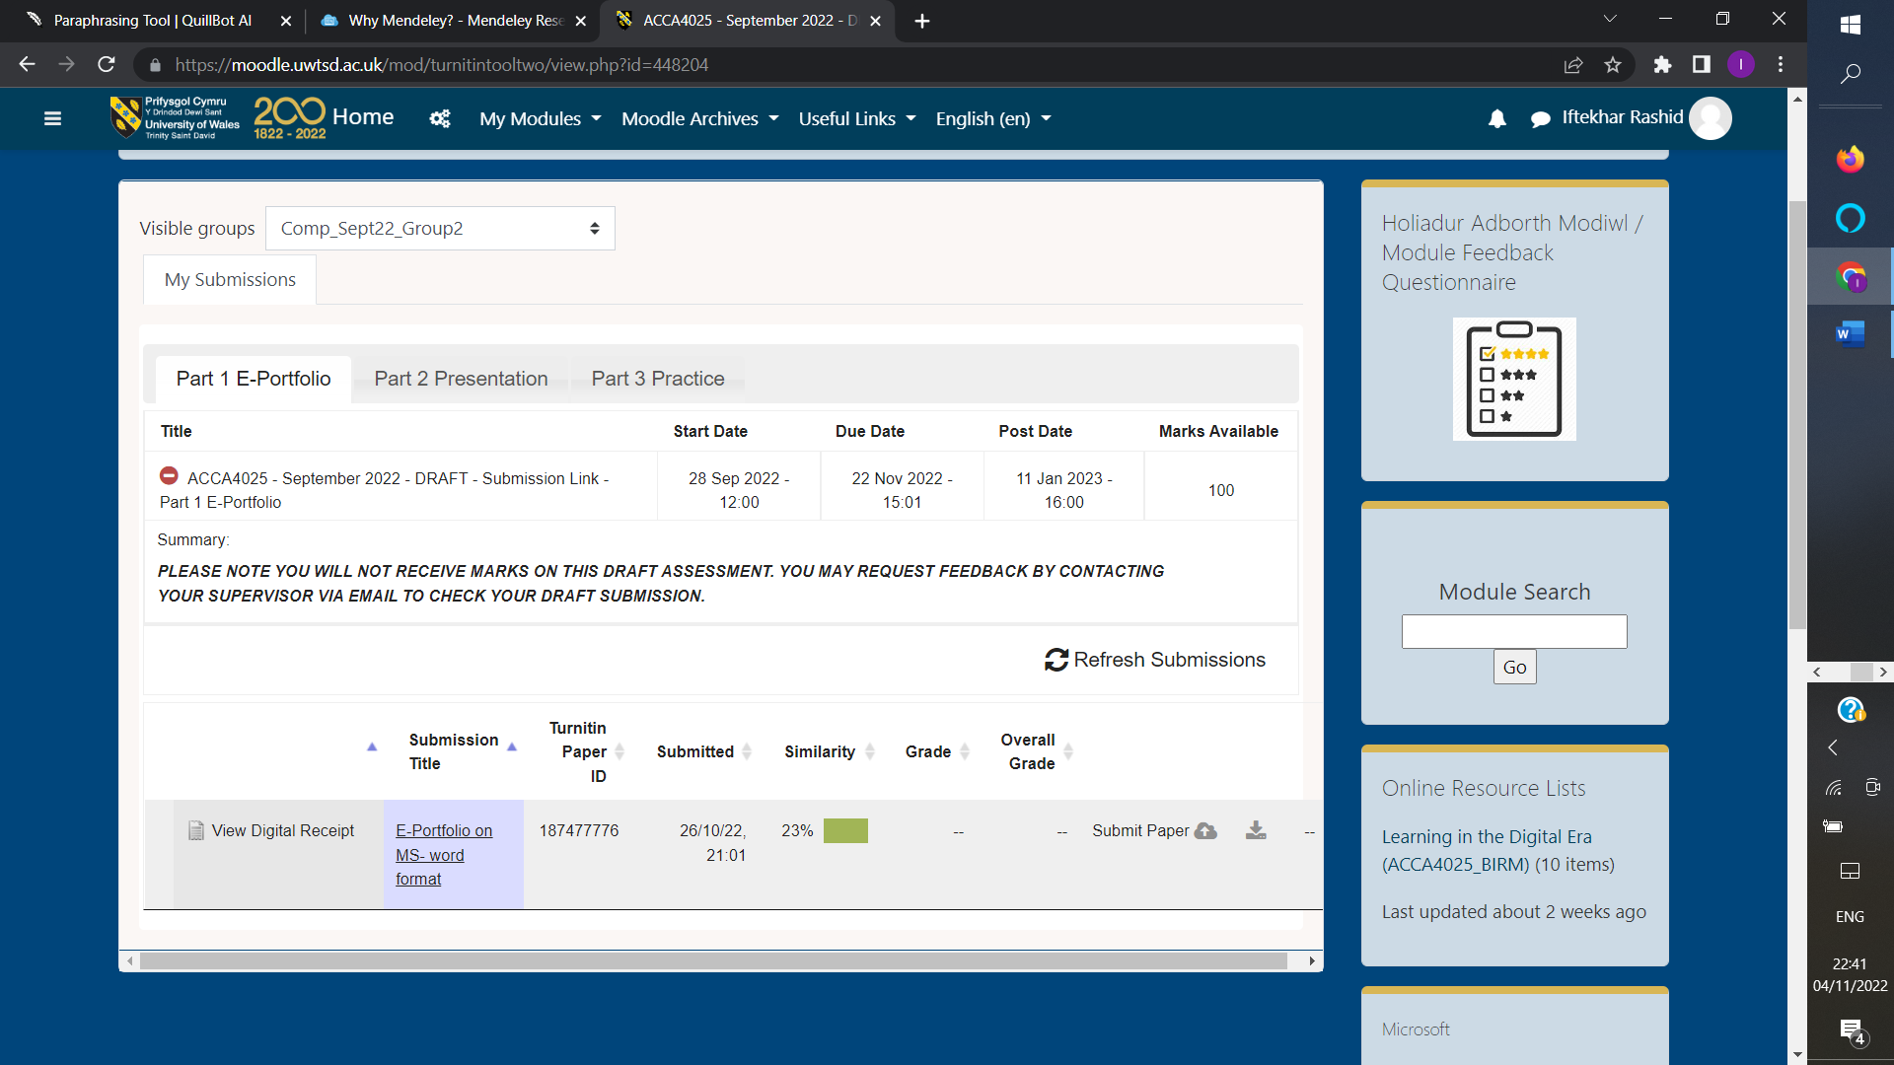

Comment- It was necessity to develop the rephrase still, It was required to Get my writing checked through further to make sure it is well-defined with more accuracy. At the same time to Prepare additional study to get support and bases to promote the ideas in writing. Compose a summary to arrange the concept to prepare the essay also was wanted. When using the article’s Main Body, must have been involved solid and related statements. At Each time it was essential for improve the systemized Reference side at the close of the writing.

Score : 70

.
.Reference:

[1] Tyler Omoth , Top resume, (2021), “The Top 13 Jobs Skills Employers Want in 2021”, available at https://www.topresume.com/career-advice/top-professional-skills-for-resume, accessed on 21st October 2022
[2] Sheila Kloefkorn, E skill, (22nd November 2016), “12 essential skills every employee should have” available at https://eskill.com/blog/essential-skills-employees/
[3] San Diego Workforce Partnership , (30th April 2020), “6 essential skills you can start building today”- https://workforce.org/news/essential-skills/
[4] Careers.govt.nz, n.d, “Skill employer are looking for” https://www.careers.govt.nz/plan-your-career/get-ideas-for-your-career/skills-employers-are-looking-for/
[5] Target Jobs, n.d, “10 key job skills graduate recruiters look out for” https://targetjobs.co.uk/careers-advice/skills-for-getting-a-job/what-are-top-10-skills-thatll-get-you-job-when-you-graduate
[6] Clarke University, “Essential Skills for College Students” https://www.clarke.edu/campus-life/health-wellness/counseling/articles-advice/essential-skills-for-college-students/

Task – 2

https://sway.office.com/d4GKvBP9ctHQBDFF

Screenshot of Microsoft Sway project

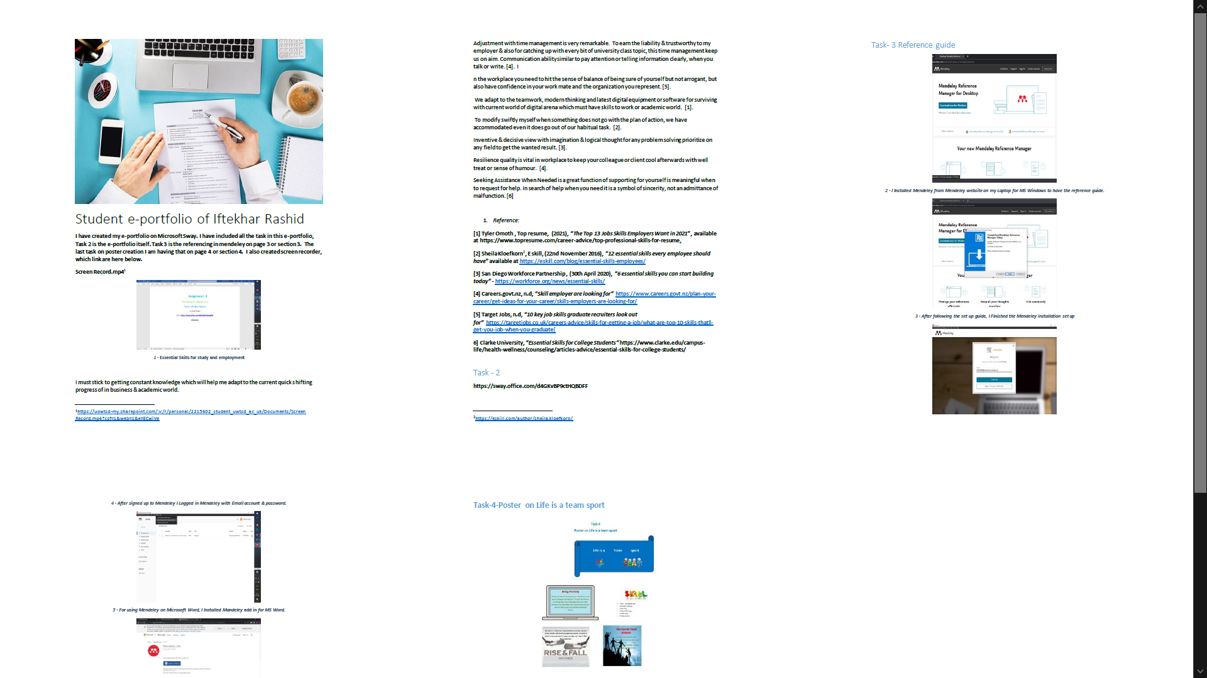

Task- 3 Reference guide

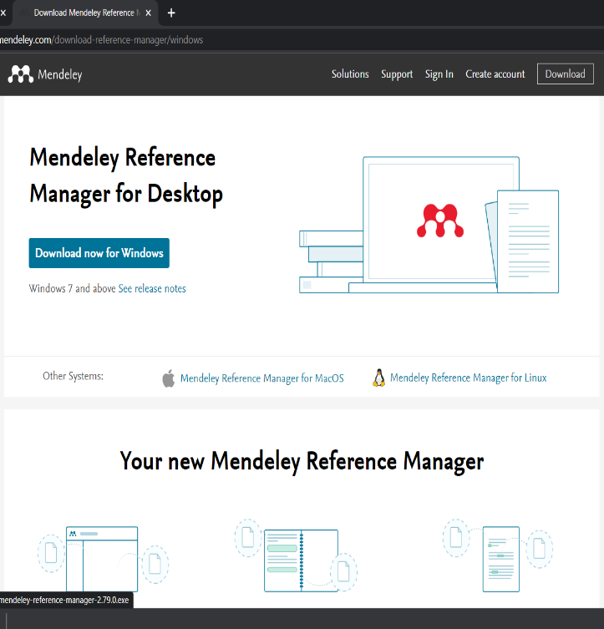
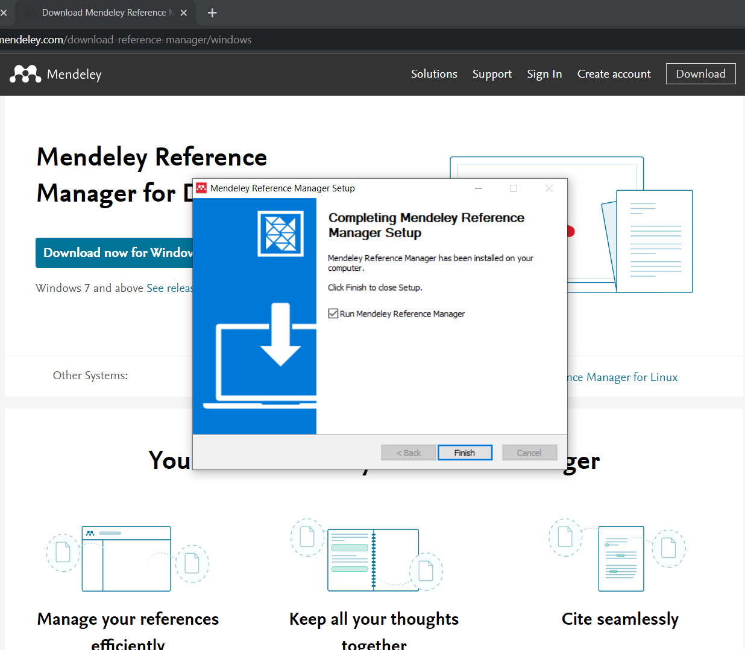

It costs nothing to download and set up this computer programme. This bibliography generating programme was compatible with my device.
After following the set up guide, I Finished the Mendeley installation. set up

Installed Mendeley from Mendeley website on my Laptop for MS Windows to have the reference guide. Mendeley is a free reference manager that may assist me with citation management, bibliography creation, and reference gathering.

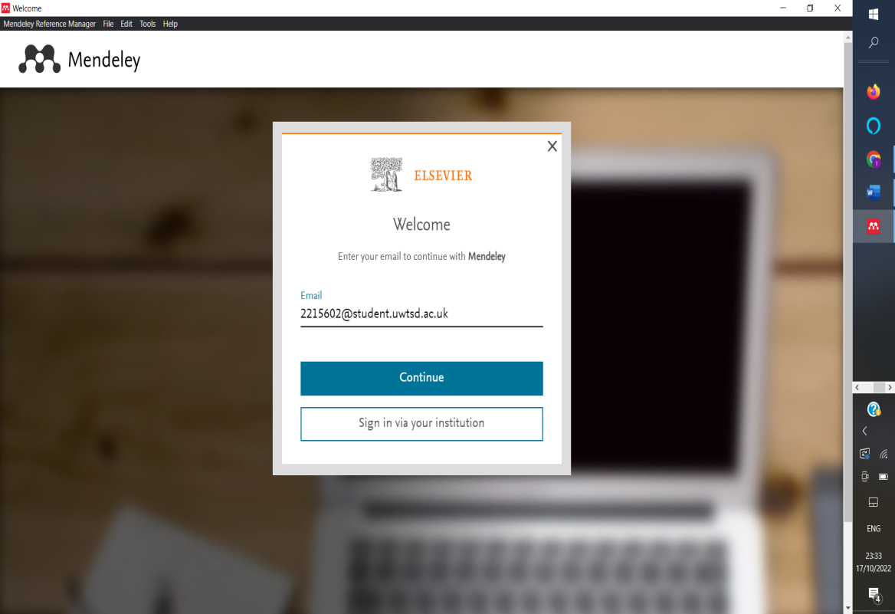
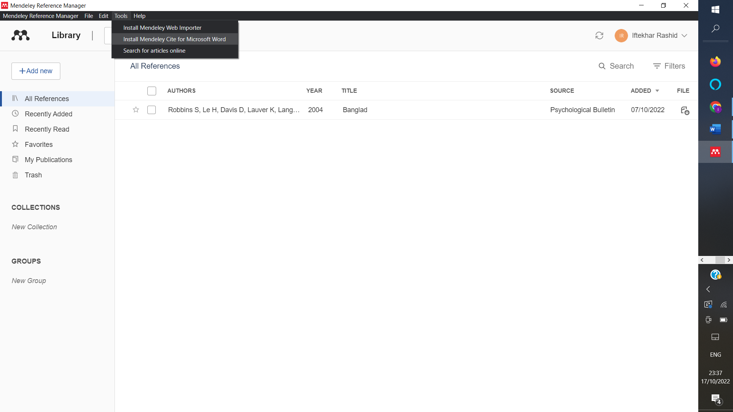
After signed up to Mendeley I Logged in Mendeley with Email account & password. after creating an account there using my email address and password I was able to start using it.

For using Mendeley on Microsoft Word, I Installed Mandeley add in for MS Word. I choose the appropriate choice from the Tools Menu after opening it. Mendeley identified the word processor I have installed, giving me the alternatives I need.

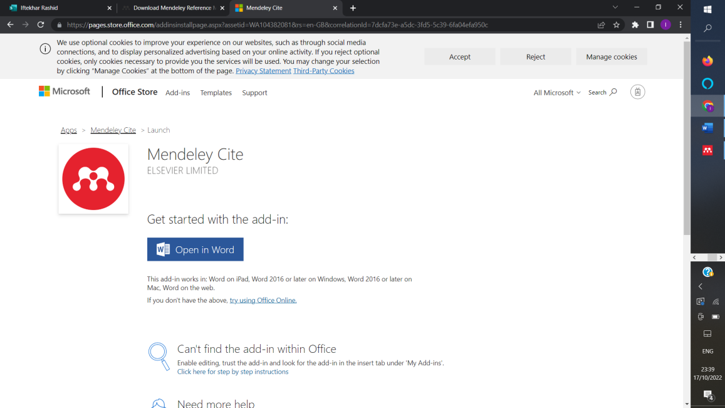
I'm now making an effort to install the plugin for Ms Word. Then Clicked the button for Opening Mendeley Cite in MS Word. The citation generator was rapidly installed, and after it was done, it was confirmed.

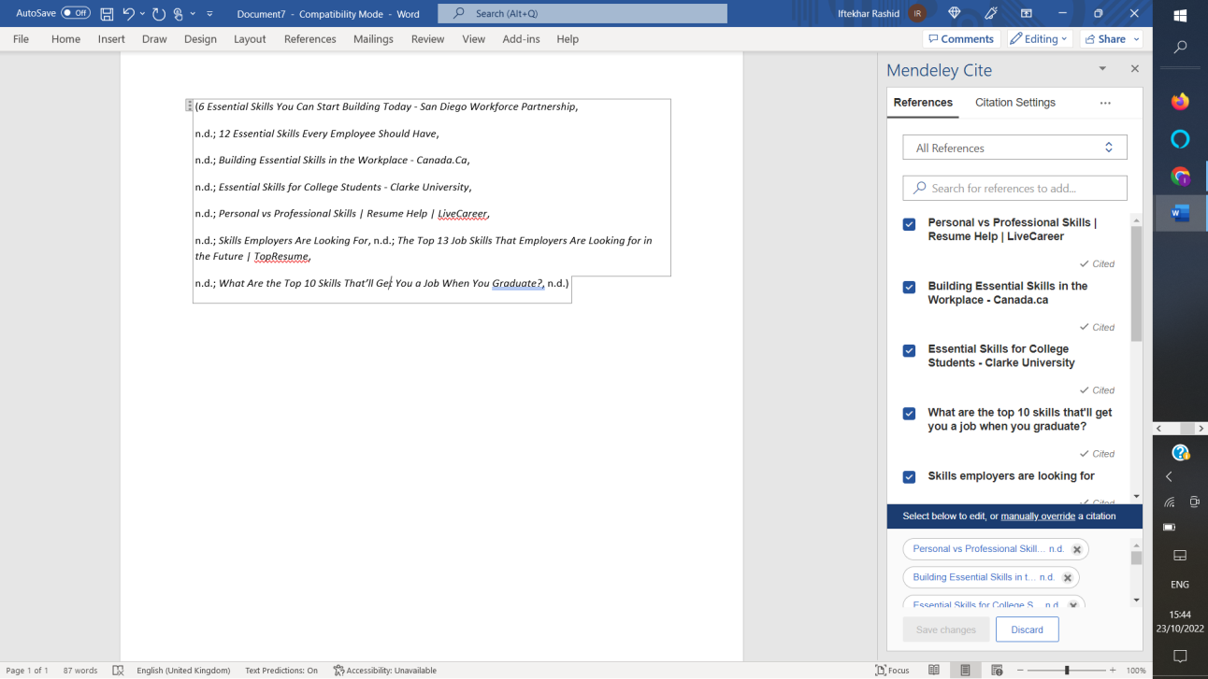
Now Mendeley cite button added under reference menu on MS Word. If you press Mendeley Cite button. In-text citations can be added to my Word document by choosing references from the desktop Mendeley.

Task – 4 A3 Poster
A3 Poster’s Link: https://uowtsd-my.sharepoint.com/:w:/g/personal/2215602_student_uwtsd_ac_uk/EaFfbOC3uM9Gov0poXffeOgB6NUu1MPPCYncIDBfWvK-gA?e=USON6c
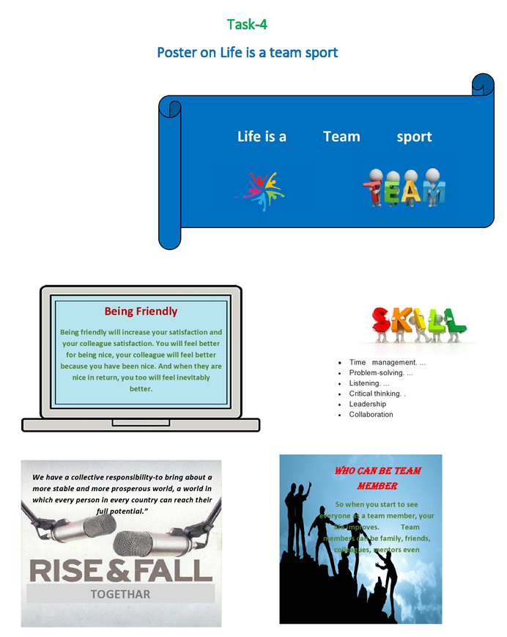Screenshot of A3 Poster

