PATHWAY PROJECT-1
Submitted By: Mahmuder Rahaman
Student ID : 1605850
Submission Date: 03-05-2018

Table of Contents
Introduction 2
Sustainability and Globalization 2
Global Citizen 3
Two examples of sustainable project 4
Two examples of environmental sustainability 4
Leadership and Entrepreneurship 5
Relationships between Entrepreneurship and Leadership 6
Community Participation 6
Benefits of community participation 7
Three skills which I have developed and applied in the project 7
Time management Skill 7
Communication Skill 8
Networking Skill 8
Conclusion 8
References 9
Appendix 10

Introduction
Today’s business world is very competitive and is becoming more competitive due to Sustainability and Globalization. It is becoming increasingly difficult to maintain existence and successful operation in this competitive market. In the world of globalization, It is very important for the organization to have sustainable development which involves the marinating long term existence in the market. Employability is also an influential factor in the organization which involves the essential qualities of the job candidates that will feet the needs of the organization (Hindsworth and Lang, 2009). Every job candidate must have adequate quality to get their expected job. Besides these, success of the business organization needs the quality of leadership and entrepreneurship among the top level employees of the business organization and it is not adequate in the market.

Sustainability and Globalization
In this globalization world, it is very important for the organization to have sustainable development which involves the marinating long term existence in the market. By working in the group, many important things about the globalization and sustainability have been learned. All the members of the team were very collaborative to each other (Doytch, 2013). In other words, sustainability is the smooth development of generation after generation to link between the present and future condition and it will also ensure the safety of future generation. It is process of increasing the live standards of the member of the society including the future generation development to provide the optimum benefits for the society and the member of the society. Three important pillars to ensure the sustainable development are:
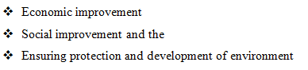
Ensuring the sustainable development refers to the activities for the overall development of the economy and it will be done by the people of the society. People of the society and organization should work together in hand for the development of the economy and work to ensure optimum benefits and welfare for the society. Besides the rules and regulations, organizations and people should follow the guidelines of the sustainability for the economic development.
Social development is another important pillar of the development which involves the responsibility of the organization to the development of the society. Besides achieving the corporate objectives, a business organization has to perform several faction as CSR function of the company for the development of the society and provide betterment of the people of the society. They also always ensure that their business activities will not pollute or disturb the welfare of the society (Chew and Sarabia, 2016). People and the organization should not do those activities which pollute the right and benefits of the next generation for the sustainable development. For the protection and sustainable development of the environment of the society organization and people should work together. They should not do any tasks which pollute their environment and refrain pothers from doing pollute activities. In using the environmental resources of the betterment of the society organization as well as the people of the society should be aware enough to use the environmental resources for the betterment of the resources so that their uses do not harm the betterment of the future generation. Any environmental pollution causes the climatic changes which is dangerous for the next generation (Kagan, 2007). So, it can said that we should not be involves in such activities that will harm the future generation interest and their benefits.

Global Citizen
Basically, globalization is a process which is combined of different types of activities like economic development activities, political activities, social activities and cultural development activities across the world. Local organization has become the international organization by crossing the national border and it is providing different opportunities to the international community to share and integrate their values, opinions, culture and other social and economical sharing to other international communities. All over the world has become a global village as a result of globalization and it has made the global people the citizen of the global village `(Kuratko, 2013). Global citizen is the result of the globalization which is an important in the globalization process and it provides the international citizen in other word the global citizen to use and take the benefits of the international assets and resources for their benefits and betterment. In other words, global citizen is the process of consuming the international resources for their betterment and for the international development. As a member of the global community, every global citizen can take the benefits of lower cost of production setting at home and has to contribute to the development of the international community.

Two examples of sustainable project
Sustainability is the smooth development of generation after generation to link between the present and future condition and it will also ensure the safety of future generation. It is process of increasing the live standards of the member of the society including the future generation development to provide the optimum benefits for the society and the member of the society. There are different examples of sustainable project around the world community and they working for the economic and social development of the world community and protecting the world environment. One of the famous projects is the providing micro credit finance by the Gramen bank, Bangladesh. This project is working for the economic development of the lower lass people by reducing their poverty (Doytch, 2013). This project provides financial benefits to the community member of the society to solve their financial problems. This project is sustainable from the perspective of economic and social development and also from environmental perspective. Viladamat Town Hall in Spain is another example of the sustainable development project and its contribution is very significant to the development of the economic development and for the social and environmental development of the internal; community. It is contributing to the development of the community from different perspective by providing clean energy and working for the economic, social and environmental development of the world community.

Two examples of environmental sustainability
For the protection and sustainable development of the environment of the society organization and people should work together. They should not do any tasks which pollute their environment and refrain pothers from doing pollute activities. In using the environmental resources of the betterment of the society organization as well as the people of the society should be aware enough to use the environmental resources for the betterment of the resources so that their uses do not harm the betterment of the future generation. In using the environmental resources of the betterment of the society, the people and the organization should keep in mind the benefits of their future generation. Swindon Chapel Farm Solar in UK is a famous environmental sustainable project and working for the development and protection of the global environment by providing clean energy at lower carbon (Raymond, Grenier and Hanley, 2014). Viladamat Town Hall in Spain is another example of the environmentally sustainable project and it is contributing to the internati0nal community environment by providing the clean energy to the society and also contributing to the development of the economic development, social and environmental development.

Leadership and Entrepreneurship
Most important concern for the business organization and main element of the success of the business organization is the effective leadership and entrepreneurship. Any organization needs effective and efficient leadership from the manager and the authority for the success and gets the tasks done effectively and timely from the employees and the organization also needs skilled, and efficient and experienced entrepreneurship (Kuratko, 2013). Leadership is the quality of a person that enable to lead others and get tasks done by others bi giving the employees motivation and encourage them to works better and achieve their target to achieve the goals and objectives of the leader. Leadership is the unique quality that make a leader different and unique from others and they are very passionate and uncourageous to achieve their goals and objectives and they achieve their objectives by encouraging and motivating others rather by coercion. They may be entrepreneurs or not. They manage their activities efficiently and effectively through their qualities and abilities. On the other hand entrepreneurship is the quality which starts or brings something new and works in systematic manner and initiates for doing something. An entrepreneur works by initiating for doing something, make planning for the starting and organize different element like the capital, land, labor and other factors for completing the tasks in a systematic way to achieve his goals and objectives. Entrepreneur is objectives oriented and he is committed to achieve the goals and objectives.

Relationships between Entrepreneurship and Leadership

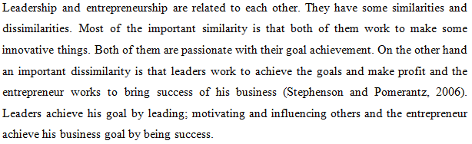

Community Participation
As a member of the global community, every global citizen can take the benefits of lower cost of production setting at home and has to contribute to the development of the international community. An international community member may communicate in the international events and program arranged by an internal community and can also contribute to the arrangement to the events. Participation in the international community program or events, increase the relationship among the different international community. International community member can participate in the cultural and other program.

(Dalati, 2015). Coca-Cola Company takes different programs in different times for the community participation. It is always working to build a sustainable and developed community from the perspective of economic development and from the perspective of social and environment.

Benefits of community participation
There are different benefits of community participation and they are:
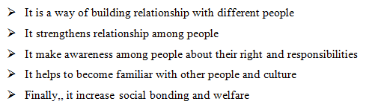
During working hours, I have learned many things about the sector I have worked and all the issues are discussed above of this assignment. Although I have faced different problems and limitations, I have gathered and developed different knowledge and experience from completing this tasks.

Three skills which I have developed and applied in the project
Followings are the skills are developed and their applications are shown below:

Time management Skill
In completing the task I have face time management problem and from this problem I have learned time management skill (Kagan, 2007). Time management is an important skill and all the members of the group have to maintain certain schedule and meet the appointment. All the members have to prepare their presentation and other necessary documents in the given time. Besides the group working, I had to do different personal things which have to done in the given time. So, time management is important in sphere of life.

Communication Skill
I have also developed communication skill through working in the group. The entire group members were very collaborative and they were very helpful to each other. For working with them, I have to maintain continuous communication with them using different communication media (Stephenson and Pomerantz, 2006). By communicating person to person, person to group, I have developed communication skill and knowledge about the communication moods and media which helped me a lot.

Networking Skill
By working in the group I have also developed networking skill and it refers to the developing relationship among different person of the society and around society. It is basically a networking system in which many people are building up in a contact by sharing and exchanging their ideas, thoughts, information to each other (Furtner, 2010). By establishing strong network in the society one can easily get helps and cooperation from other people in solving the problem. Networking may develop from person to person or person tp institution or institution to institution and it help develop social relationship.

Conclusion
During working hours, I have learned many things about the sector I have worked and all the issues are discussed above of this assignment. Although I have faced different problems and limitations, I have gathered and developed different knowledge and experience from completing this tasks like the efficient uses of time, skill of effective communication and effective networking ability have been developed from this working. Besides these , I have learned many things about the sustainability and the globalization.

References
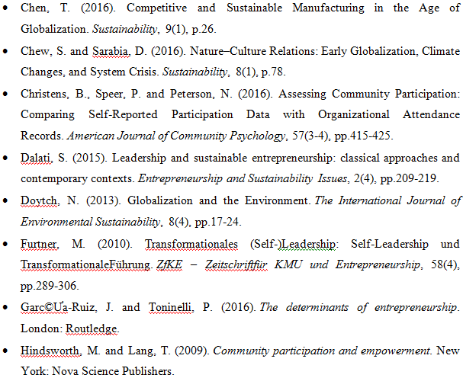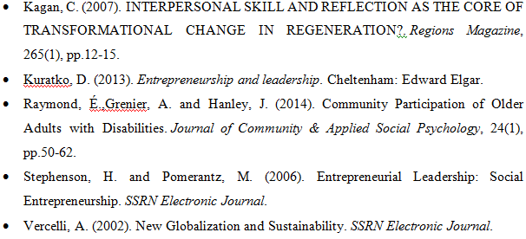

Appendix
Presentation plan
The entire group members were very collaborative and they were very helpful to each other. For working with them, I have to maintain continuous communication with them using different communication media. I have to communicate from person to person, person to group to complete the task. I have prepared necessary documents and presentation slide by discussing with the group members physically and using different social media. I have included all the content in the document in the slides after discussion with the members for presenting before the audience.
Learning log


