Student Learning Log

Student ID Name: Andreea Cristina Mirica
Student ID Number: 2211629
Managing Guest Service Operations BMIH6003
Lecturer’s Name: Jessica Newport
Date of Submission: 07/03/2025

Acknowledgement
I hereby declare that this report was completed without the assistance of any artificial intelligence tools or platforms. All research, analysis, and writing were conducted independently, adhering to academic integrity and originality standards.
This report reflects my understanding based on thorough research and critical analysis of credible sources.
Table of Contents
INTRODUCTION 3
Section 1: Reflection on Experience and Personal Development 3
Section 2 Critical Analysis of Work-Based Skills and Technical Knowledge 5
Section 3: Reflection on Organisational Issues 6
CONCLUSION 7
REFERENCES 8

List of Figure
Figure 1 Kolb reflective cycle 3

INTRODUCTION
This reflective report is designed to capture my work experience over the course of ten weeks within several departments of a hotel. Based on my experience in Food and Beverage, Front Desk, Housekeeping, Maintenance, and Meetings and Events Departments, I emphasize some elements connected with guest experience management and work-based skills. I will use reflection to understand and learn from my experience (Brown et al., 2020). The reflection model employed in this reflection exercise is called Kolb’s Experiential Learning Cycle.

Section 1: Reflection on Experience and Personal Development
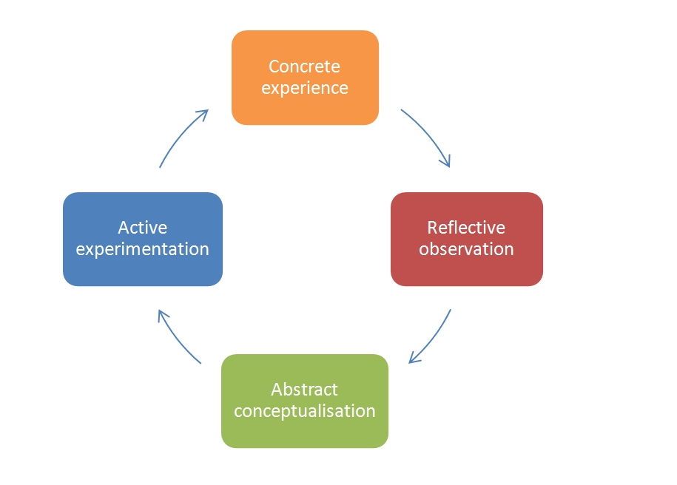
Figure 1 Kolb’s Reflective cycle
Source- Brown (2022)
Concrete Experience:
Through my hotel placement, I was privileged to work in various sectors in the reception, housekeeping, maintenance, F&B, and M&E. The most enlightening exercise was helping in taking guests through check-ins and checking them out of the hotel. As an assistant of the supervisor, I followed front line team and see how they deal with guest request, room distribution and their interaction with other operational teams. I equally assisted in handling special guest concerns, for instance complaints on room cleanliness or repair, through providing the information to the right department they require. Also, I was assigned to help with preparations of the rooms and the corresponding fulfilment of the guests’ requirements promptly.
Reflective Observation:
This made me appreciate the importance of communication and organization in delivering quality service to a guest. I noticed that the lack of proper correspondence between departments including the Front Desk, Housekeeping, and Maintenance is a tactical mistake since it will be hard to satisfy the guests. In some cases, if there was a misunderstanding /lack of communication this led to some delay in such service and hence would have been deemed to have affected the guest in one way or the other. It was observed also that I had to multitask in handling the guests’ needs since at times there were different guests’ requests at the same time such as checking in, while conversing with the housekeeping department about clients’ requests for different rooms. According to Tuckman (1965), the clear assignment of roles always enhances group performance, which was evident during the events when they were divided into teams, which had different tasks to perform (Woods, 2020).
Abstract Conceptualization:
This prompted me to realize that to successfully manage guests’ needs it is not enough to attend to each of them individually but there has to be a structured manner of completing different tasks at the same time and also being able to assess the needs of the guests before they are voiced. Further, I realized that courtesy is very important especially when dealing with a complaint to offer value to the guests. It also gave me an appreciation of how useful teamwork and leadership were in an environment that consisted of a hospitality organization because employees from various departments needed to work together to improve the experience of their clients (Hsu and Huang, 2018).
Active Experimentation:
In the future, I shall enhance my ability to manage time and respond to guests’ requests systematically and effectively, especially in multitasking and communicating with other departments. I will discuss the guest needs that should be considered for proactive service and the ways of serving those.

Section 2 Critical Analysis of Work-Based Skills and Technical Knowledge
Communication and Teamwork:
Effective verbal and written communication, as well as teamwork with people from diverse departments, is crucial when working in a hotel environment. Effective communication is also important in ensuring that all the teams are on the same track to work towards the achievement of the intended goal particularly when dealing with large events (Woods, 2002). I was impressed to see the system used by the hotel to keep everyone informed about the guests needs. They had a system that informed the front desk and the housekeeping department of the individual needs of each room. This helped employees save time on checking rooms that perhaps did not need to be checked and use that time to focus on other tasks. This system increased efficiency and cooperation between departments. In my opinion, it also facilitates teamwork, because everyone knows what needs to be done, where, and when. Teamwork is very important in the hospitality sector because leads to improved operational effectiveness, and enhanced guest experience and it can also motivate employees (Bronotte, 2023).
Task Management and Technology Utilization:
While working at the front desk, I noticed that I needed to improve my digital skills. The front desk was working with many systems simultaneously and at a very fast-paced rate. It took me a while to understand what they were doing and what systems they were using for each task. I also noticed that the staff pays great attention to data protection and guest security. At the beginning of my shift in the front-desk department they did not allow me to act, but only to observe because of security reasons. I appreciated that as it reminded me how important is to follow this principle in a place that handles sometimes hundreds or thousands of people daily.
Adaptability and Problem-Solving:
I noticed that theory applies to practice when it comes to solving problems in the hotel, as the guest is the main priority of all the staff. Using digital tools to communicate with each other helps the staff to keep problems very low (Duarte, 2024). The supervisor also double checks on a daily basis the work of others to ensure the data in the system matches with the real status of rooms, guests, kitchen, resources, and any other elements that can impact guest satisfaction. When a situation arises, the staff communicates with each other or other departments before making a decision to ensure disruption of service or disappointment of customers (Duarte, 2024).

Section 3: Reflection on Organisational Issues
Organizational Issue Encountered:
In my placement, I came across a major organizational issue of miscommunication that was between the front office and the food and service section. The problem arose when a guest bought a package that entailed accommodation services together with food services. However, there was a lack of integration of what was included in the package whereby there was poor communication between the departments of the hotel and especially in this case between the guest, the front desk staff the external restaurant provider. The guest had a misinformation that all his meal costs would be catered for in form of the package he was offered. This made the outside restaurant provider demand for extra charges to cater for the ordered food items as they were not included in the arranged food package. This caused uneasiness, because the guest was not told earlier about the restrictions concerning the catering menu.
Impact on Operations:
This breakdown of communication has a great effect on the hotel business as it will be seen later. The implication of this was poor customer experience since the guest was frustrated as a result felt cheated thus reducing customer satisfaction. Other employees such as the front desk staff were also burdened with additional work in the shift, owing to the random occurrence that was not expected to happen. This created confusion because the guests anticipated seamless services since they booked for a fancy package from the hotel. The problem arose from the website itself, as since the selling point the client should have been made aware of what the package includes in terms of food (Lewis, 2016).
Proposed Solutions:
In my opinion, this problem should be avoided by marketing a clear food and accommodation package where the client is informed of what he can and cannot receive. The package the client bought was expensive, created high expectations for the customer, and in place led to great disappointment. It is more efficient to maintain honesty with the client and to ensure that the packages offered provide value for money (Sayin, 2019).

CONCLUSION
Reflecting on my overall experience, I can see how this placement helped me to understand the theories and knowledge that I have acquired during my years of study. This placement has prepared me to become a manager in this industry and acknowledge the skills that I need to develop to ensure I can raise up to guest expectations in the hospitality sector.

REFERENCES

Bronotte, M. (2023) Why is teamwork so important in hospitality? | torrens university. Available at: https://www.torrens.edu.au/stories/blog/hospitality/why-is-teamwork-so-important-in-hospitality (Accessed: 02 March 2025).
Brown, K., Matthews, J., & Lyle, S. (2020). Enhancing departmental communication in hospitality settings. Journal of Hospitality and Tourism Management.
Brown, N. (2022) 'Reflective model according to Kolb', Nicole Brown. Available at: https://www.nicole-brown.co.uk/reflective-model-according-to-kolb/ (Accessed: 02 March 2025).
Duarte, J. (2024) 🌟 mastering problem-solving in the hospitality industry: Effective strategies for success 🛎️, jdchospitality. Available at: https://www.jdchospitality.com/post/mastering-problem-solving-in-the-hospitality-industry-effective-strategies-for-success (Accessed: 07 March 2025).
Hsu, C. H. C., & Huang, S. (2018). The importance of team communication and coordination in the hospitality industry. International Journal of Hospitality Management, 75, 156-168.
Kolb, D.A. (1984). Experiential Learning: Experience as the Source of Learning and Development. Prentice Hall.
Lewis, J. (2016). Communication and teamwork in the hospitality industry. Journal of Hospitality & Tourism Research, 40(3), 348-365.
Sayin, K. (2019) ‘The effect of communication problems on productivity in hotel operations: A qualitative application’, Mednarodno inovativno poslovanje = Journal of Innovative Business and Management, 11(2), pp. 51–58. doi:10.32015/jibm/2019-11-2-6.
Tuckman, B.W. (1965). Developmental sequence in small groups. Psychological Bulletin.
Woods, A. (2020). Communication and teamwork in hospitality settings. International Journal of Hospitality Management.

