BMSW4005: PROFESSIONAL CAREER DEVELOPMENT

NAME: Syed Mustafizur Rahman
Student NUMBER: 1818484

Contents
Introduction 2
Self-Evaluation 2
Self-Evaluation through reflection 4
Career goals 7
Conclusion 8
References 10
Appendix 11
Roleplay feedback 11

Introduction
Professional Career Development (PCD) refers to participating well-designated employment related activities and learnings which help an employee to develop in professional life (Seward, 1999). According to a survey by Ons.gov.uk (2019), more than 47% of employee in the UK wants to change their career every year. I have started my academic life to pursue a better career in the future. I studied HSC in Bangladesh which is equivalent to A-levels now I am doing ‘HE cert in Skills for the Workplace’ besides I am working in Indian takeout. In this report, I will try to portray a brief reflection on my role-play session as part of this course, showing the impacts, findings of my interview experience. I will also evaluate my strength and weakness to develop a career plan and action plan to achieve my objective.

Self-Evaluation
Learning style refers to the way of learning that varies from man to man. There are a number of competing and contested theories that claim learning styles vary depending on the individuals’ preferences regarding information absorption, processing, comprehension and retention (Pashleret al, 2008). Learning styles are often considered importantly because most people have their own but differentiated way of learning. While some people learn through listening, some others through observing the facts in detail, some others require to do it practically to learn it.
The VAK stands for Visual, Auditory and Kinesthetic, a learning styles model that exhibits a simple way of explaining & understanding learning styles. Using these three elements, one can diagnose a person’s preferred learning style.
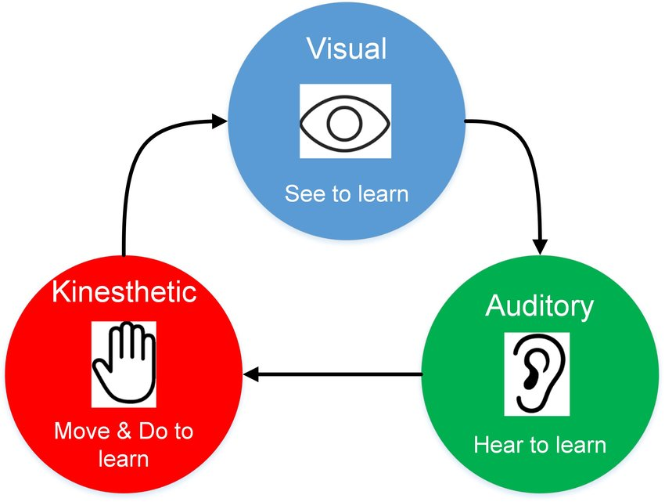
Figure: VAK learning styles (Gholami, and Bagheri, 2013)
Although no one has exclusively one single style to learn rather use all three sensory receivers to receive information, one (or more than one) receiving method dominates over others. Analyzing all the relevant questions given in the questionnaire, I have found that I have kinesthetic learning style that is I prefer touching and doing to learn anything. I learn things quickly through touch and movement; it gives me bright memories to recount what been done but not talked or seen clearly.
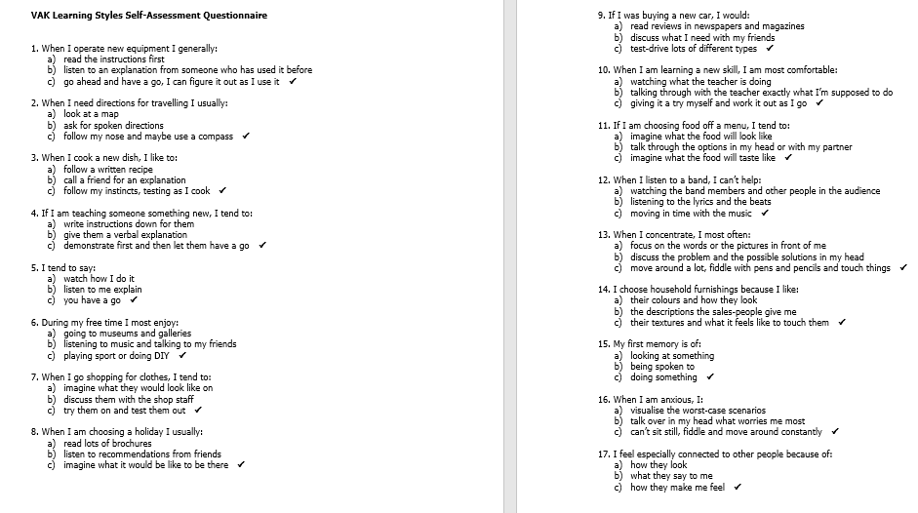
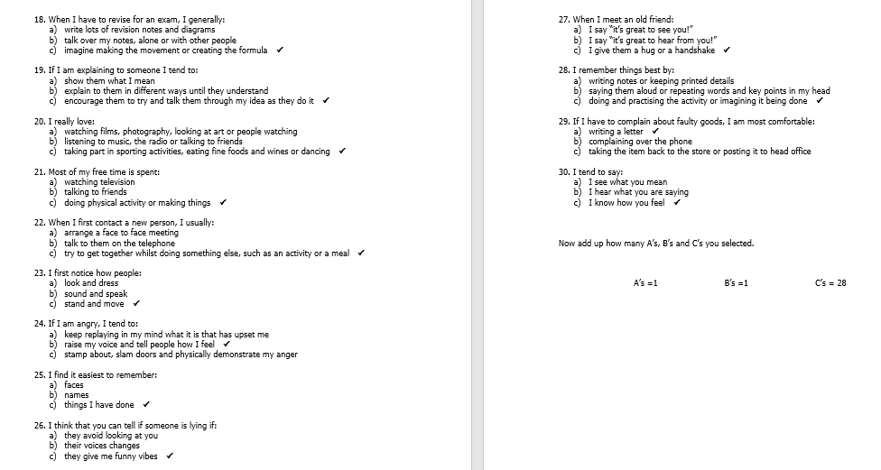
I always feel better to have a go with the things to have a physical experience through touching, doing, feeling, playing, holding practically. as I have chosen a and b too, I can conclude that I have mixed blend of these three preferential way of learning where kinesthetic plays dominating role.

Self-Evaluation through reflection
As I have performed in a role-play session as part of HE cert in Skills for the Workplace’, here, I go to have a reflective writing using Gibbs reflective cycle to evaluate the whole things I have undergone.
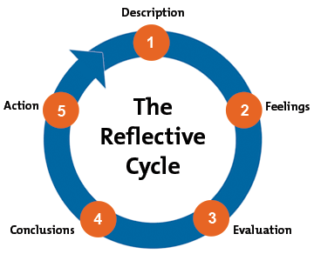
Figure: Gibb’s reflective cycle (Potter, 2015)
Description
In this role-play session, I was interviewee, applied for a job position for supervisor in Greggs. I took preparation to answer the questions would be asked in the session.
Feelings
Before participating in this interview session, I thought participating in an interview is always a matter of maintaining rough and tough etiquette, undergoing a harrowing question-answer session, and a moment full of anxiety, tensions and nervousness. While I was preparing for this session I was so tensed about do’s and don’ts of an interview session. When it was my turn to start with the session, though in the beginning I felt a bit nervous, I felt more easy going moment there. I feel comfortable to answer questions with due confidence and if not known to me, just leave the questions implying a grateful consideration from them.

Evaluation
The feedback shows I was good at maintaining eye contact with smiling face, started with a warm greeting to everyone. Throughout the interview I tried to show enthusiasm and politeness. I have answered well why the company needs an enthusiastic and agreeable employee to have a smooth operation as it goes now. However, in some instances, I failed to show confidence to the top that exposed my lack of preparation to that part- I found my lacking in relevant subject they ask for.
Analysis
I think that had pivotal role in making our session expected one was our earnest feel to go with the session. From my part, I can assure that I was longing for having such session practically as I feel I have kinesthetic learning style – I feel better to learn things practically. Here we both were so interactive before the session going on. I felt more driven to prepare myself for then session and all these things, made the session to be well-go one, I think.
I was so brave and bold while replying to the questions that later on I wondered how I became so courageous suddenly, forgetting my nervousness. I found it was the guidance I took from YouTube while practicing home. I watched videos on YouTube and looked for tips on Google regarding how to approach in interview sessions. I think that things worked well. But in the middle of the question-answering sessions why I failed to hold my confidence – I found my lack of knowledge is the only reason for this. As I failed to answer questions relevant to the subject I felt losing at that time.
Conclusion
I learnt that when one wants to approach for an interview, s/he should study some relevant literature precisely as questions may be asked from the subject he studied. However, I have found my lacking in relevant literature; I feel more study and practice will give me a perfection to proceed to participate any interview session. and so, I will try to overcome it following a proper action plan.
Action Plan
When I will go for any further interview session, I will try to ensure that I have adequate knowledge about the relevant literature. For this I will have to study required materials thoroughly. I have to go for more and more practices with my friends, even singly when I am staying home. I am confident following these two specific things I will be able to heck any more interview successfully.

Understanding world of employment
It is highly important to have a clear glimpse over the frequently changing world of work. Employment law comes in place to protect employees’ rights and qualify employers power exercising so that they are not to do any wrongdoing over the employees (Flynn et al, 2017). Workers, before introducing laws related to the employment, were highly vulnerable to a number of threats. Here are some areas that are especially considered under employment laws till date.
In the UK, there is no single Act that governs recruitment and selection but there are a number Acts that helps to determine the employment relationship relating to the stipulations fixed by the consents of both employer-employee, thus, play significant role on pre-employment issues (Employment Law | The Independent, 2021). Employers need to comply with the main principles of recruitment laws to ensure that they are not breaking the rules and regulations.
Data protection in employment contract refers to a clause that sets out the employer’s right to use or process data complying with the privacy notice agreed upon by the employees as of the employers’ data protection policy.
Employers must be aware of national minimum wage and national living wage which are the minimum wage levels need to be paid to the employees requiring to the employment laws, otherwise employers will be penalized for not to comply with the laws ((Employment tribunal decisions, 2021).
Employees are to have statutory annual leave of 5.6 weeks or 28 days if working five-day per week under the working Time regulations 1988, and this holiday entitlement is almost as of EU countries where employees are entitled to receive allowance for holidays too. An employee having normal working hours are entitled to receive at a rate of one week’s pay at which rate they been contacted, irrespective of the period of annual leave (The Working Time Regulations 1998, 2021). They will also be paid any other allowances that are not related to the work performance.
The Equality Act 2010 exhorts that if an employer discriminates job applicants or any existing employee in terms of his/her protective characteristics including age, gender reassignment, disability, sex, race, sexual orientation, religious belief, pregnancy and materiality, marriage and civil partnership etc. if does so, it will be unlawful and thus, punishable under criminal act.
The Health and Safety at work act 1974 describes legislation regarding health and safety issues in occupation and workplace in the UK. This law covers the general duties of the employers to the employees. A key area under employment laws is the freedom of (or lack of freedom) dismiss an employee. An employee can be laid-off at any time but if it’s for any unfair reason, the employer will be guilty of unfair dismissal under Employment Tribunal (Health and Safety at Work etc Act 1974 – legislation explained, 2021). In November 2011, for any unfair dismissal, the qualifying period enhanced to two year-continuous services. Having no capacity or capability to do the job and behaving inappropriately have been considered as the ground for dismissal.
Personal Strength and Weakness
Knowing personal strength and weakness gives one a better picturesque of how one functions and a better understanding of his capabilities and drawbacks (Stone et al, 2012). Based on one’s things, one can narrow down his choices while to look for a job in this competitive business world.
My strength is giving attention to every detail. I am an outgoing person, so I am approachable to people. But I have no educational knowledge, which is a major weakness as a candidate for any job in the current market, especially for my desire jobs in management levels in multinationals.

Career goals
I have been working in hospitality industry- in a restaurant; there was limited scope to have career growth but I did aspire to have a more dynamic career. Now I am aspiring to pursue my career as a manager in any multinational company salary over 40k.

Personal Development Plan
 | Short-term Time frame | Mid-term Time frame | Long-term Time frame
My Goals | - To improve management skills;  - To be accustomated to critical analyst  - To be a good presenter. | - To have educational degree in leadership and management  - To have work placement  - To be critical thinker | - To have my MBA in marketing  - To work in a multinational company where I can make minimum 40k
Skills and Knowledge to be learned | Management skills, analytical thinking, presentation skills | Getting a degree in leadership and management, Work placement, critical thinking | - Depth knowledge and application of theory in Marketing sector.  - Work placement, Driving license, managerial experience.
Next steps | Participating in team work and play team leader role;  Solving business cases and participating in case competition;  Practice more to overcome my problems in fluency. | - Progress into leadership and management degree program.  - Solving different complex business cases to think critically- beyond the box. | - Taking admission into a university in Marketing for MBA program.  - Applying for jobs as a manager in different multinational company.
Resources | Enthusiasm, time | Time, SLC and enthusiasm | Time, funding and aspiration
Time Schedule | 6 months | 2 years | 5 years
Starting time | 1st June, 2021 | 1st January, 2022 | 1st January, 2024
Finishing time | 31st December, 2021 | 31st December, 2023 | 31st December, 2024
Completion | - 30th July, 2021  - 31st October, 2021  - 31st December, 2021 | - 31st December, 2022  - 30st June, 2023  - 31st December, 2023 | - 31st December, 2023  - 31st December, 2024

Conclusion
Employee development and organizational development are closely related and in the same way, employee career development is necessary to ensure a smooth and desire growth in career of a person – either in existing job or in a new job for an aspirant (Jonathan, 2008). Here in this report, I have made reflective writing base on the role-play session I have as part of ‘HE cert in Skills for the Workplace’. I have found my strength as having interest in details but weakness in lacking in educational qualifications. So, I have outline a personal development plan with definite goals and time frame to ensure that I will have my aspired career accomplishing my goals.

References
Flynn, J., Dance, S. and Schaefer, D., 2017. Industry 4.0 and its Potential Impact on Employment Demographics in the UK. Advances in Transdisciplinary Engineering, 6, pp.239-244.
Gholami, S. and Bagheri, M.S., 2013. Relationship between VAK learning styles and problem solving styles regarding gender and students' fields of study. Journal of Language Teaching and Research, 4(4), p.700.
GOV.UK. 2021. Employment Tribunal Decisions. [online] Available at: <https://www.gov.uk/employment-tribunal-decisions> [Accessed 2 January 2021].
Hse.gov.uk. 2021. Health And Safety At Work Etc Act 1974 – Legislation Explained. [online] Available at: <https://www.hse.gov.uk/legislation/hswa.htm> [Accessed 2 January 2021].
Jonathan, P. ed., 2008. Local Economic and Employment Development (LEED) Entrepreneurship and Higher Education (No. 18). OECD Publishing.
Legislation.gov.uk. 2021. The Working Time Regulations 1998. [online] Available at: <https://www.legislation.gov.uk/uksi/1998/1833/contents/made> [Accessed 2 January 2021].
Lockwood, G., Henderson, C. and Thornicroft, G., 2012. The Equality Act 2010 and mental health. The British Journal of Psychiatry, 200(3), pp.182-183.
Parkinson, L. and Doyle, A.K., 2018. Gibbs’ Reflective Cycle.
Pashler, H., McDaniel, M., Rohrer, D. and Bjork, R., 2008. Learning styles: Concepts and evidence. Psychological science in the public interest, 9(3), pp.105-119.
Potter, C., 2015. Leadership development: an applied comparison of Gibbs’ Reflective Cycle and Scharmer’s Theory U. Industrial and Commercial Training.
Seward, D.M., 1999. PCD-what's in a name?. British dental journal, 187(1), pp.1-1.
Stone, W.F., Lederer, G. and Christie, R. eds., 2012. Strength and weakness: The authoritarian personality today. Springer Science & Business Media.
The Independent. 2021. Employment Law | The Independent. [online] Available at: <https://www.independent.co.uk/topic/employment-law> [Accessed 2 January 2021].
Vassie, L.H. and Lucas, W.R., 2001. An assessment of health and safety management within working groups in the UK manufacturing sector. Journal of Safety Research, 32(4), pp.479-490.

Appendix

Roleplay feedback
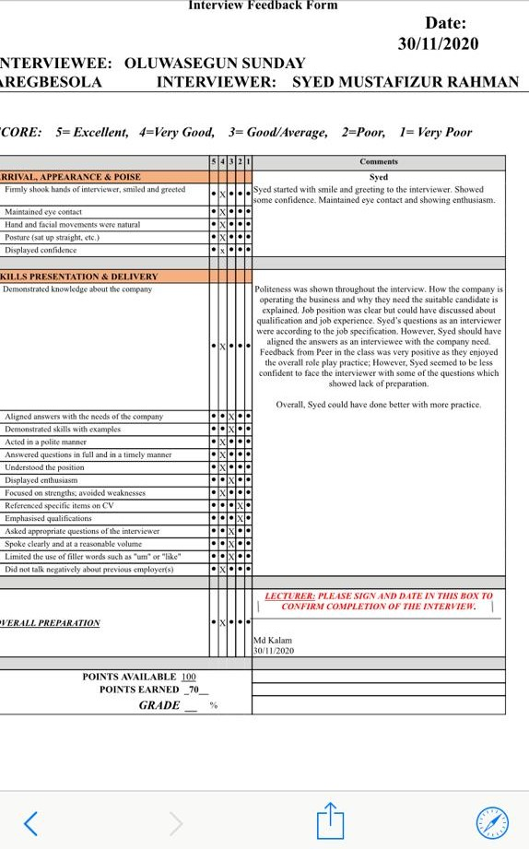

VAK Learning Style:


