Materials and Structures Course Notes
Materials are arrangements of atoms; structures are arrangements of materials.
There are some texts that may be helpful on-line via books24x7 (skillport):
“Fundamentals of Materials Science and Engineering: An Integrated Approach, 4th Edition” William D. Callister, Jr.,David G. Rethwisch
Dynamic Plasticity, N. D. Cristescu World Scientific Publishing Co © 2007
Terminal Ballistics, Zvi Rosenberg and Erez Dekel Springer © 2012
The Science of Armour Materials Ian G. Crouch (ed) Woodhead Publishing © 2017
Mechanics of Solid Polymers: Theory and Computational Modeling, Jörgen Bergström William Andrew © 2015
Standard Handbook for Civil Engineers, Fifth Edition, Jonathan T. Ricketts, M. Kent Loftin and Frederick S. Merritt (eds), McGraw-Hill Engineering © 2004
Mechanical Vibrations: Theory and Application to Structural Dynamics, Third Edition, Michel Géradin and Daniel J. Rixen John Wiley & Sons © 2015
Adiabatic Shear Localization: Frontiers and Advances, Second Edition, Bradley Dodd and Yilong Bai Elsevier Science and Technology Books, Inc. © 2012
Guided Waves in Structures for SHM: The Time-Domain Spectral Element Method, Wieslaw Ostachowicz, Pawel Kudela, Marek Krawczuk and Arkadiusz Zak John Wiley & Sons © 2012
Structural Components: Mechanical Tests and Behavioral Laws, Dominique Francois (ed) International Scientific and Technical Encyclopedia © 2008

Newton’s Laws
Understanding how materials interact mechanically requires understanding of Newton’s Laws. https://en.wikipedia.org/wiki/Newton%27s_laws_of_motion
This is because you only get to see the response of a material when you try to make it do something that it doesn’t want to do: compress, stretch, move, stop, change direction. In all the processes that we do there are three quantities that don’t change: total mass, momentum and energy. Things may break apart but the sum of all of the bits should add up to the same throughout the process. In military scenarios concerning materials and structures the most important of these is the conservation of momentum and its link to Newton’s Second Law: the force acting on a piece of material is equal to the rate of change of momentum in that material. If you want to stop a fragment or blast wave then you have a lot of momentum to change and this leads to high forces. This makes density very important because volume is determined by the wave speed.
Elasticity
Materials are made from assemblies of atoms. They can exist in everyday situations in various forms: solids, liquids and gases. For the most part we shall be considering solids because the complexity that is attached to the mechanical behaviour of materials is through their strength and only solids have strength. Atoms will always interact with other atoms, though, and this is due to electron interactions. For gases the type of atoms within the gas generally does not matter because they behave like rigid spheres bouncing off each other and the forces between them are very small. Liquids are not gases because the forces between the atoms are large enough to keep them together – water will stay in an open cup but nitrogen will not. Liquids do not have strength because the forces between the atoms are not large enough to resist any sort of tension. Solids have strong enough forces that they hold their shape – the weight of the material is not a large enough force to allow the atoms to move apart.
Elasticity is the ability of a material to return to its original shape after its shape or size has been changed – after it has been deformed. For gases and liquids this needs to be qualified because they take on the shape of the container they are in and this container can be provided by the inertia of the surrounding gas or liquid. Anything that causes the material to take on a different shape permanently is inelastic. Elasticity comes from the forces between the atoms in the material and the way that the electrons interact. If forces exist between atoms it is because the shared electron interactions reduce the total energy of the system; you have to do work on the atoms to move them from their normal positions. For gases and liquids this work can be done in compression – to move the atoms closer together – by decreasing the size of the container. Work can only be done on gases and liquids in tension – to move the atoms apart – by giving the atoms different relative momentum.
The standard way of discussing the forces and energy of electron interaction is via the potential function. For all materials you can consider how much energy it takes to compress or expand the volume of the material; for solids you can also ask the question: how much energy does it take to change shape without changing volume? Potential functions all have similar appearances with common features, Figure 1:
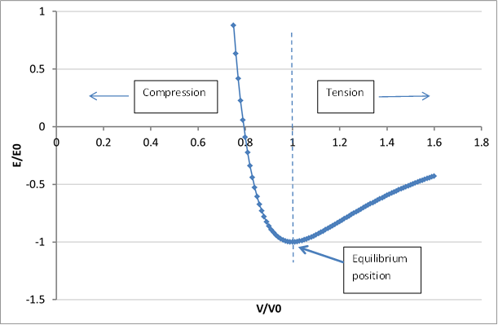
Figure 1: typical potential function shape
The material potential function in Figure 1 has been normalised to the equilibrium values to emphasise its generality. On the compression side of the equilibrium position you can push atoms together as much as you want it just gets more difficult. On the tension side the amount of work you can do to pull atoms apart is limited. The curve is asymptotic to the volume axis to indicate that the neutral energy position (E=0) is when the atoms are infinitely far apart. The gradient of the curve on the tension side goes through a maximum – this is important and will be discussed later. If you do some work to the atoms and then let them relax then they will go back to their desired equilibrium position; this is the essence of elasticity. The rapidity with which this will happen depends upon the curvature of the potential well around the equilibrium position. This curvature is the elastic modulus. Mathematical functions can be fitted to this curve to allow analysis.
Pascal Vinet, James H Rose, John Ferrante and John R Smith, “Universal features of the equation of state of solids”, J. Phys.: Condens. Matter 1 (1989) 1941-1963.
One useful aspect of this general behaviour is that the same mathematical function can be used for a particular material at different temperatures – the only change is the equilibrium point (E0, V0). This allows the effect of thermal expansion to be seen, Figure 2. The equilibrium point is at a higher V0 for the higher temperature T2 because the energy is also higher; thermal energy has caused the material to expand. It can be seen that the modulus has also dropped (the curvature around the equilibrium position is smaller) with the higher temperature.
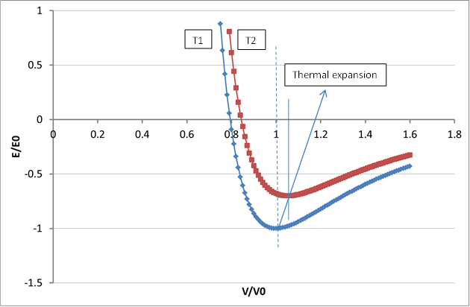
Figure 2: comparison between potential functions for the same material at different temperatures showing thermal expansion
The shape of the potential function and the way it responds to energy is down to the electron interactions between the atoms. These electrons have energy and any extra energy either through additional thermal (raising temperature) or mechanical (doing work) energy is stored in these electron interactions as vibrations of increased amplitude. The amplitude of the vibrations determines the equilibrium spacing of the atoms. This energy storage is reflected in the units used for modulus: 1 Pa = 1 J m⁻³; modulus and stress are energy densities.
Most discussions of atomic bonding split up the electron distributions into types of bond: ionic, covalent, metallic, etc. This is convenient for discussions of general properties and the differences between materials based on the strength of the interaction but materials rarely conform to pure types of bonding – the electron distributions are often mixtures of different types. One of the main discriminators between materials is the curvature of the potential well around its equilibrium position because of the way this drives a lot of material properties. For a particular material, though, the electron distributions and potential functions can be calculated accurately using Quantum Mechanics. Numerical simulation codes exist that can calculate all the elastic properties for any material and significant resource has been put into making the results of these calculations open to all:
https://materialsproject.org/wiki/index.php/Main_Page
http://exciting-code.org/elastic
The way that atoms in solids are arranged relative to each other is also an outcome of the electron distributions and this can lead to different elastic properties in different orientations of the material. Different elastic moduli can be described by a stiffness matrix and the material is called anisotropic. Isotropic materials do not have a direction-dependence to their stiffnesses and the maths is simpler. In military scenarios it is found beneficial to use materials that are isotropic or to process anisotropic materials so they respond in an isotropic way. Often it is found that under conditions of high stress anisotropic materials will respond isotropically.
Discussions of material stiffness often discuss moduli associated with specific modes of deformation: bulk modulus in hydrostatic compression, Young’s modulus in uniaxial tension, shear modulus in pure shear. These are only valid for small deformations but are useful in that region. They are linked by Poisson’s ratio which is also a measure of volume change in elastic deformation.
https://en.wikipedia.org/wiki/Hooke%27s_law#Matrix_representation_.28stiffness_tensor.29
https://en.wikipedia.org/wiki/Poisson%27s_ratio
In general, though, it is safer to think in terms of the derivatives of the potential function because this is how the materials actually respond:
$$stress=\frac{dE}{dV}\begin{matrix} & \end{matrix}Stiffness=\frac{1}{V}\frac{d^{2}E}{dV^{2}}$$
Potential functions exist for all modes of deformation and the gradients used should agree with the mode of deformation. The Shear (no volume change) potential function is very different to the volume potential function shown in Figure 1.
Stress
It is worth reiterating that elasticity is all about a material regaining its original shape. Hooke’s Law is about the force required to deform a material. The properties of materials tend to lead them to be used in different quantities for the same purpose – concrete vs steel in construction is a good example of this. In order properly to compare material response the size of the lump needs to be included in the information. Stress (= force/area) does this although the area often has to be inferred. For elastic materials this quantity is the gradient of the relevant potential function and comes under the general theme of hyperelasticity.
https://en.wikipedia.org/wiki/Hyperelastic_material
Thermodynamics
One other important area of physics associated with electron interactions, the potential function and the rate at which processes can occur is the vibrations that store the electron energy. These can be described by the Debye model:
https://en.wikipedia.org/wiki/Debye_model
This links the mechanical work to the thermal energy via statistical mechanics. The main result is that if you do work to a material the temperature of the material will rise. The Debye temperature can be linked to the curvature of the potential function. Polymers have a different form of the Debye model because of the large difference in stiffness normal to and parallel to the backbone atoms. There is another way of looking at atomic vibrations due to Einstein.
https://en.wikipedia.org/wiki/Einstein_solid
Timescales
When a stimulus is applied to a material it takes time to respond. This time is governed by the frequencies of vibration of the atoms and molecules and related to temperature via the Debye or Einstein frequency and Boltzmann’s constant. For crystals this is often fast because the period of oscillation is of the order 10⁻¹³ s. For polymers the period of oscillation can be longer than the application of the stimulus which leads to the classic relaxation behaviour.
https://en.wikipedia.org/wiki/Phonon
https://en.wikipedia.org/wiki/Stress_relaxation
The other aspect to time-dependent response is inertia. Force causes material to accelerate but this requires time to give rise to displacement – that is: the material moving out of the way. Materials can appear stronger in some testing configurations because inertia dominates the forces.
Elastic waves
If a time-dependent load is applied to a material then waves will propagate through the material. They travel at a characteristic speed which is pressure-dependent.
https://en.wikipedia.org/wiki/Linear_elasticity#Elastodynamics_.E2.80.93_the_wave_equation
https://en.wikipedia.org/wiki/Speed_of_sound
When waves encounter interfaces then some fraction of the energy in the wave will be transmitted and some will be reflected. The amount is given by the relative acoustic impedances of the materials.
https://en.wikipedia.org/wiki/Acoustic_impedance
If a material is surrounded by other material with substantially higher acoustic impedance then any energy generated within the lower impedance material will not escape and stresses will rise. This material is highly confined.

Shock Waves
Under conditions of continued high stress loading elastic waves in the high pressure region can overtake the initial wave due to the onset of loading. This leads to a very rapid transition in the material between low and high stresses and that transition is called a shock wave (or shock). An example of the shape of a shock pulse is given in Figure 3; the material stress rises in about half a microsecond from zero to 0.5 GPa.
There is substantial analytic work on shock waves and their associated thermodynamics. This is possible because they are treated as sharp transitions and no account is taken of the rise time. For a particular shock wave the condition of the material in front of and behind the shock are linked by the Rankine-Hugoniot conditions:
https://en.wikipedia.org/wiki/Rankine%E2%80%93Hugoniot_conditions
This links the stress, density and energy to the shock speed (the speed of the shock as it travels through the material) and the particle velocity (speed of the atoms; velocity because direction is implicit). It allows measurements of two of those five quantities to give the other three by calculation. These measurements are generally made using the plate impact test: a plate of a material is launched from a gas gun and undergoes plane impact on a stationary plate sending a shock into both plates. Stress and velocity gauges are used as well as time-of-arrival measurements. It is good practice to measure three of the five quantities to get a check on the calculations. Each impact follows the same course: the material shocks up the Raleigh line to a particular shock state. If multiple tests are carried out then the points associated with each shock state can be plotted on a graph; the locus of these points is called the principal Hugoniot.
clifton.mech.northwestern.edu/~espinosa/publications/papers/06i.pdf
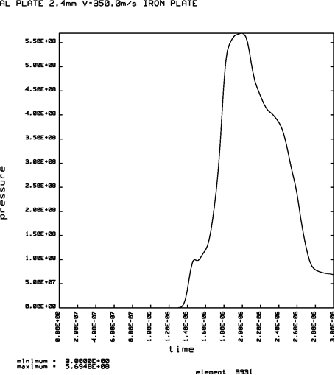
Figure 3: an example of a shock wave
The data can be fitted by equations that generally are described as Equations of State; for the most part these are pressure vs density or pressure vs volume equations. If the volumetric potential function for a material is available then the Hugoniot can be predicted from the pressure vs volume that comes from the derivative of the energy variation with volume. If the principal Hugoniot is plotted as shock speed vs particle velocity it is often noted that the locus is well described by a straight line; this is highly misleading. There is no direct equation linking shock speed to particle speed and a straight line through the Hugoniot points usually does not predict the zero pressure sound speed (zero particle velocity). If the equations also include energy and temperature then they are referred to as “complete” or “thermodynamically complete”. A significant amount of progress towards understanding material response in military scenarios can be made using just the equation of state – that is neglecting strength – and this effort comes under the label “Hydrodynamics”.
A shock wave can still be treated as an acoustic wave and acoustic impedance is still an important way of understanding how materials will behave. Of significant importance is the behaviour at free surfaces – that is surfaces that can move freely at which it can be assumed that the acoustic impedance is essentially zero on one side. In this case the stored energy in a compressive wave becomes kinetic energy and the acceleration of the surface generates tensile states that move back away from the surface increasing in magnitude as more volume of material accelerates. These are called “release waves” and are generally the only mechanism whereby failure can initiate.
Deviation from elasticity
As mechanical work is done to an elastic material it stores energy but there is a thermodynamic driver for energy minimisation that favours energy dissipation. There are several processes that dissipate energy and they have energy barriers that need to be overcome. The differing heights of these barriers depend upon material microstructure and atomic configurations and lead to the other main driver of material behaviour.
The potential function in Figure 1 has a point of inflection on its tensile arm. This is the point at which the force between the atoms reaches a maximum and there is no preferred direction in which the atoms will move. This allows significant structural change. The point of inflection can be reached by thermal energy at which it is associated with crystal melting or the amorphous glass transition. It can also be reached by mechanical energy and this plays a part in energy dissipation.
There are various dissipation mechanisms:
Atomic diffusion – the atoms can move relative to each other so there is a general bulk movement of material to a shape that minimises stored elastic energy. This is known as “creep” and normally takes place over long periods; it is only relevant where the ambient temperature is close to the material melting temperature.
Dislocation motion – the relaxation of atomic forces allows small volumes of amorphous material to be generated in a crystal lattice. This in turn makes bulk material movement to minimise stored elastic energy significantly easier. This is the primary deformation mechanism in metals but the energy barrier is dependent on the size of the unit cell.
https://en.wikipedia.org/wiki/Ductility
https://www.nde-ed.org/EducationResources/CommunityCollege/Materials/Structure/deformation.htm
Structural change – local crystalline changes from one crystal lattice to another can change the local volume or shape and thus reduce stored elastic energy. These are known as martensitic transformations or twinning.
Fracture – if other dissipation mechanisms have energy barriers that are too high then the generation of free surfaces can also dissipate energy by conversion of stored elastic energy into surface free energy and kinetic energy of the crack surfaces. This is generally true for glass, ceramic and rock.
Molecular vibrations – Another method of reducing stored elastic energy is by spreading it out amongst more vibrational modes. This is what occurs in polymer glass transitions – the molecular chains become able to move relative to each other and this activation of more vibrations absorbs energy.
Deviation from elasticity goes under various names depending on the material in question and confusion arising from these names is common. Yield is one such name. In metals the yield point is normally found by constructing a line slightly offset from the elastic stress vs strain line and choosing the point at which this intersects the stress vs strain line – this point is formally called the 0.2% proof stress and is useful because the initiation of dislocation motion can be gradual and the yield point not obvious. For metals, though, flow is usually more obvious and the change in gradient significant but this is the difference between yield and a flow stress. Yield is also used in glassy polymers to indicate the mechanical activation of the glass transition and this is largely a shape analogy with metal flow. The significant change in slope in compression for a material like concrete is referred to as failure rather than yield despite the material still being continuous and whole at this point.
In the majority of cases this deviation from elasticity defines strength. This is because, in the presence of any tensile stress, deviation from elasticity inevitably leads to an inability to withstand forces without major shape change.
An associated concept is hardness.
https://en.wikipedia.org/wiki/Hardness
This is easy to measure but very difficult to define because it does not directly interrogate a single material property. Types of material have different mechanisms for resisting penetration and this renders the test only useful for limited relative comparisons between the same types of material.

Fracture
Fracture is the generation of a crack or multiple cracks as a way of dissipating stored elastic energy. It requires the existence of tensile strains to move the surfaces apart. Load cannot be supported across the crack and, if the crack extends across the material, then it becomes failure. Failure implies the inability of the material to support load as a whole. There is at least one other relevant mechanism other than cracking that can be called failure.
Fracture mechanics is the method whereby criteria for determing failure via cracking are determined.
https://en.wikipedia.org/wiki/Fracture_mechanics
The major advance in the field was made by Griffiths who determined that the probability of cracking in a brittle material was determined by the surface free energy of the material and the volume of the material. Essentially the surface energy of the crack is compared to the stored elastic energy in the volume. Once formed, the crack will propagate unless initiation of cracking also allows other dissipation mechanisms to occur which take precedence in reducing stored elastic energy. If no other dissipation mechanisms do occur then fracture mechanics allows the calculation of the smallest crack size which will not propagate (critical flaw). In military scenarios fracture mechanics is generally not relevant because the stresses are overwhelming when failure occurs.
If dissipation mechanisms are activated by the initiation and propagation of a crack then it becomes more difficult to cause the crack to grow. This is toughness.
https://en.wikipedia.org/wiki/Fracture_toughness
Release waves can lead to tensile failure in a process called spall. Spall strength can be measured by the plate impact test but the value may be affected by effects other than material properties. It is observed that under conditions of high rate loading there is a time element to fracture initiation. It is generally considered that cracks travel at or below the shear wave speed; this can define a volume of deformation in a particular time which can lead to higher stresses via Griffiths criterion.
Strength of brittle materials is found to increase with imposed hydrostatic pressure. This is due to two effects:
- Increased strain needed to generate tensile strains
- Pressure hardening due to friction
Stress, for example in an impact, can cause widespread cracking within a brittle material but reduced strength comes from that material flowing away from the impact site. Fractured material will only flow if the relative frictional forces between the broken chunks can be overcome and the frictional force is proportional to the normal force and thus to hydrostatic pressure. This is the root of the phenomenon known as “dwell” where a non-pressure-hardening projectile cannot penetrate a pressure-hardening material because it flows more easily than the target. In this context hardening means increasing resistance to flow.
Ductile Failure
There are two types of failure that occur in ductile materials such as metals: adiabatic shear banding and ductile void growth. There are some metals – such as tungsten, as well as metallic glasses – in which the two are combined in such a way as to make the fracture appear to be brittle.
Adiabatic shear banding is most often seen in two military scenarios: fragmentation and plugging. It is critically dependent upon material parameters in a way that is not obvious or fully understood. In essence the process is:
- shear stress does work on a material but the heat generated cannot dissipate sufficiently quickly;
- increased temperature locally causes softening allowing larger local strains which generate more heat;
- this leads to a localisation of the strain in a positive feedback cycle and the material will eventually melt in a thin band;
- melting means that the material cannot sustain loads in the direction of the adiabatic shear band and tensile loads normal to the band

Metals that are prone to this generally contain large amounts of martensite (or martensitic phases) such as high strength steel and titanium.
Ductile void growth requires the presence of hydrostatic tension. The material is dissipating the stored elastic energy associated with volumetric expansion by dislocation motion around the surface of the growing void. The constraint associated with the void shape allows it to resist collapse if the stress is reversed. Strain is not a good measure of progress to failure because compressive strain states generally do not lead to void growth. This is discussed further in the section on metal deformation.
Damage
Damage is a very loose term. Continuum damage mechanics exemplifies this approach by considering damage as a degradation of strength without either considering directly what is meant by strength or why it is being degraded.
https://en.wikipedia.org/wiki/Damage_mechanics
Take the case of ductile void growth: this could be described as damage but does not affect the true flow stress prior to failure. This can also be extended to other damage forms where the damage function is just a proxy for the difference between engineering stress and true stress.
One scenario where damage is a real concept is in composite materials where microcracking starts to prevent homogeneity of stress or strain across the microstructure. This leads to a degradation of stiffness.
Ceramics
Ceramics and glass will behave as hyperelastic materials until they fail in a brittle manner. In a minority of cases compressive stress can be sufficiently high that, if cracking is suppressed, they will flow via dislocation motion, twinning, or creep. Silica has several high pressure phases (quartz – stishovite transformation) that can dissipate energy and are accessible in military scenarios; this can be highly energy absorbing. When they fail in military scenarios it is generally by crushing and they behave like sand.
Metals
See the associated document.
Geological materials
This includes rock, sand, soil, clay and composite materials made from them such as concrete. This is a very important area in force protection and cannot be covered here in any depth.
https://en.wikipedia.org/wiki/Geotechnical_engineering
Granular materials such as sand are generally considered to be elastic but, at some stress state, will flow without further resistance. This flow stress is dependent on pressure and water content; pressure raises the flow stress and moisture significantly decreases the flow stress. Figure 4 shows the effect of moisture on flow stress. The GREAC cell is a triaxial testing cell with passive confinement: essentially a massive steel tube which confines a cylindrical sample that is then loaded axially; the MAC2T rig is an active triaxial loading rig where cubes of material can be loaded independently on all three principal axes. These tests are designed to be uniaxial deformation – that is there is no lateral expansion on axial compression. It can be seen that saturated sand flows at a significantly lower shear stress (maximum principal stress minus minimum principal stress) than dry. If one is trying to absorb energy by doing work then a high stress will absorb more energy in a shorter distance (energy = force x distance). The mechanism for this is clear: the presence of moisture reduces the frictional forces between the sand grains. Organic matter will have a very similar effect.
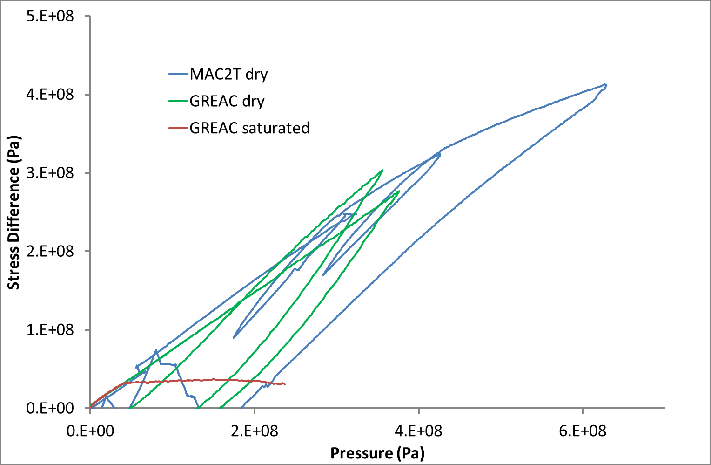
Figure 4: comparison between shear response for the same sand in different states
The same data are presented in Figure 5 to show the difference in volumetric behaviour. Here the difference between the two loading apparatus is clear. In the GREAC cell there is actually a lateral expansion of about 100 x 10⁻⁶ strain compared to the 1 x 10⁻⁶ strain in the MAC2T rig. The lateral release afforded by this extra expansion significantly reduces the pressure that can be achieved in the sand. So if the force to absorb energy is to be maximised then care needs to be taken to minimise lateral expansion.
Rock and concrete behave in the same way but have the ability to sustain higher tensile forces. This leads to further behaviour that needs to be described.

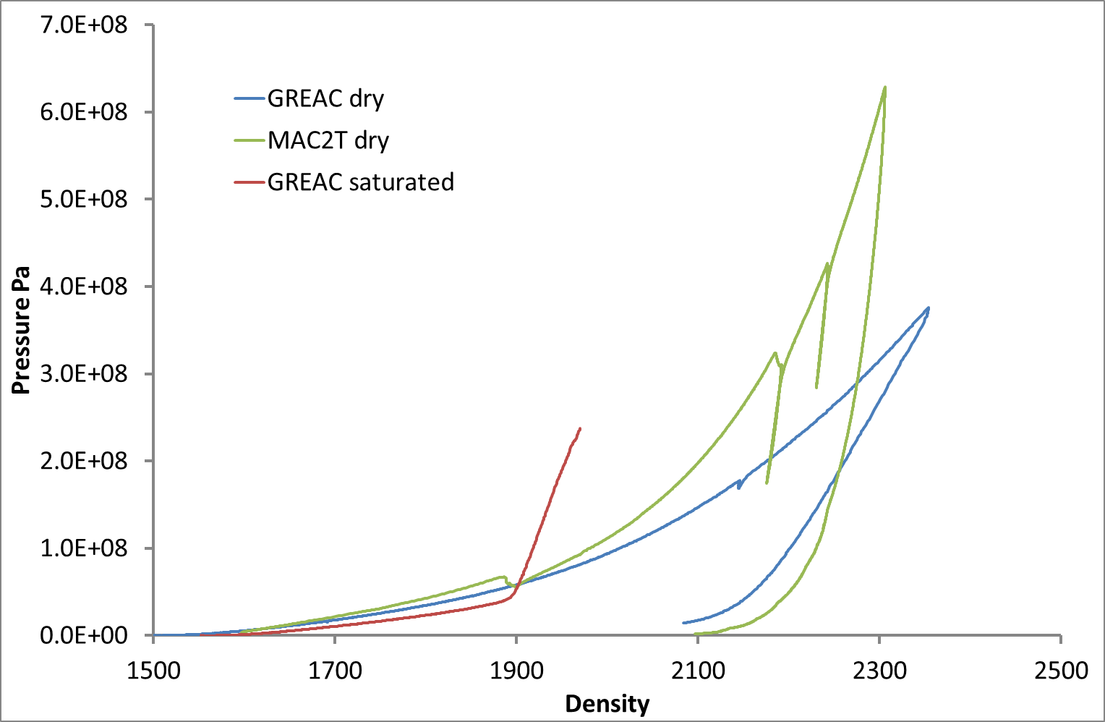
Figure 5: comparison between volumetric response for the same sand in different states
Figure 6 shows the general shape of a uniaxial compressive stress test on a cube of concrete. This was carried out in the MAC2T rig which allowed a slight lateral confinement to suppress surface spall.
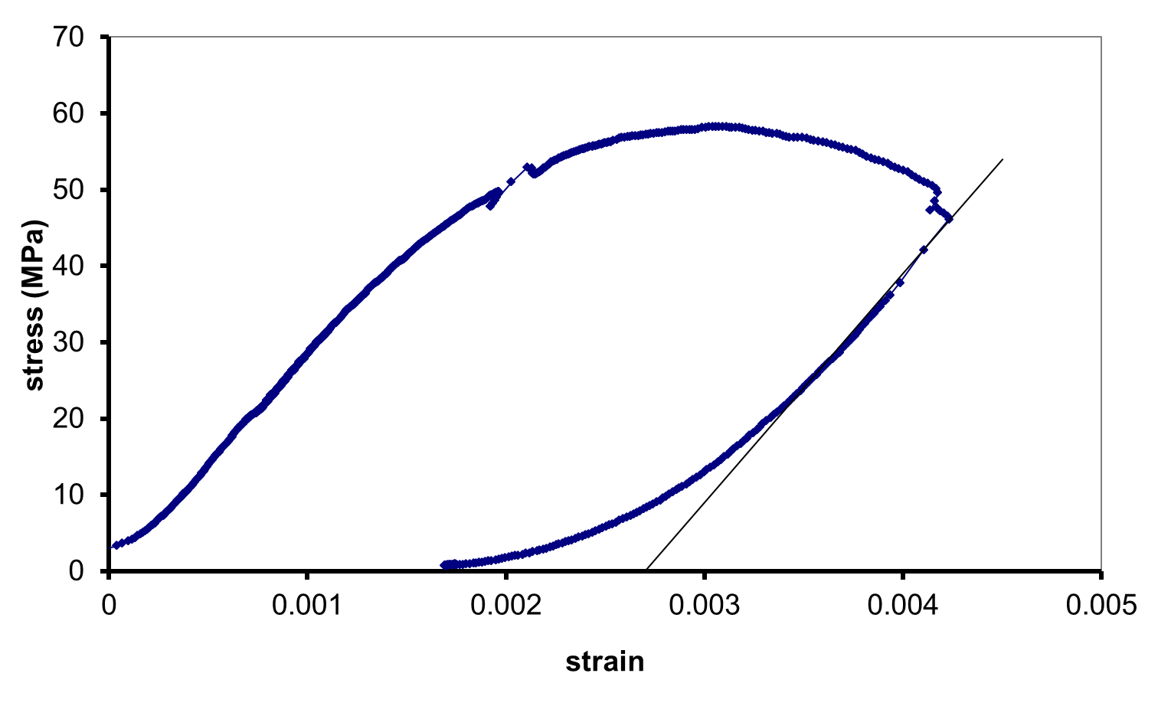
Figure 6: uniaxial compressive stress of concrete
If the test had been completely unconfined as is normal in concrete cube crushing then the surface spalling would have led to premature catastrophic brittle failure. This would have had a similar shape because the failed concrete takes time to move out of the way of the loading platens so appears able to still maintain load. The peak is therefore taken to be failure. However in the test shown in Figure 6 the cube remained fully intact and could be reloaded. It was damaged – that is its elastic stiffness was reduced because microcracking had separated the stiffer aggregate from the mortar – but it had not failed. Many different stress states can be imposed on concrete and the shape is generally always that in Figure 6 with more or less of a sharp peak and the stress at peak can be plotted as a function of stress state. Civil engineering has a useful way of describing the various accessible stress states – Lode Coordinates.
https://en.wikipedia.org/wiki/Lode_Coordinates
This leads to three distinct stress states: compression, extension and shear which each have their own meridian and variation with hydrostatic compression. When the “failure” (peak stress) points are plotted in this way a limit surface is found: that is for a particular concrete you cannot carry out a test that will move outside this surface. The two primary ways of plotting these data are shown in Figure 7 and Figure 8.
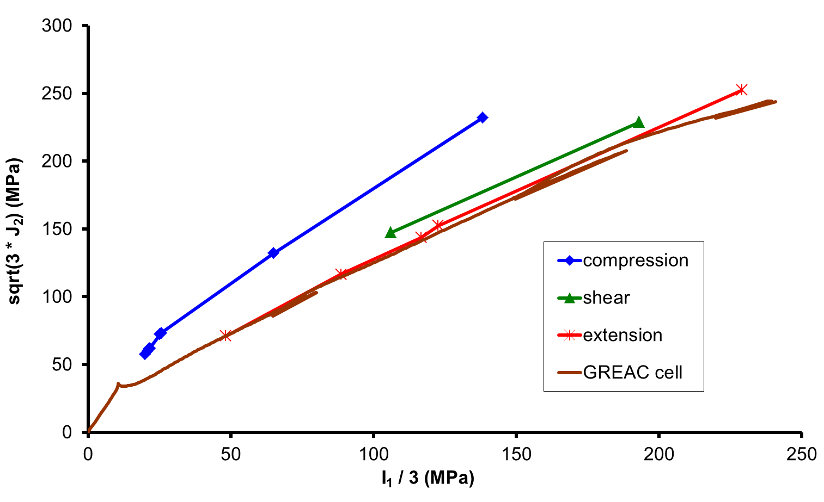
Figure 7: measured stress meridians for concrete

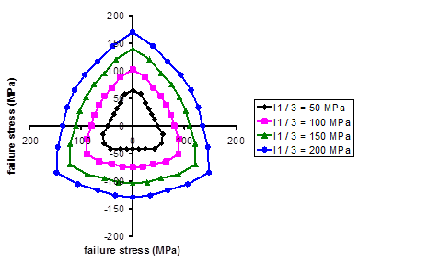
Figure 8: peak stresses in the octahedral plane
Ironically, despite these limit surfaces being seen as failure surfaces (which they are not), numerical simulation codes describe them via metal plasticity (which is completely different). This causes significant problems.
Tension is a significant problem for geological materials. Sand obviously bears no load. Clay is an example of a cohesive soil which can bear some tensile load and this is most generally seen in the response of buried charges. It is, in theory, possible to test rocks and concrete in uniaxial tension using the most popular methods but gripping the samples causes significant problems. Tensile spall is studied using Kolsky bar apparatus. The other main tensile testing method is the Brazilian disc which uses compression to stimulate uniaxial tensile stress states in a more convenient fashion. This test is usable over a wide range of test rates. The other test generally used, as with ceramics, is the 3- and 4-point bend test.
Composite Materials
There are two classes of composite material: continuous fibre-reinforced and particulate-reinforced. The latter also includes short fibres in its definition of particulate. The former predominantly use polymeric binders and there is substantial effort made to describe their behaviour. They behave as structures in normal use and the majority of design effort is put towards modifying the woven structures to give enhanced properties. Their military response depends entirely upon the rate of loading: for bullet impacts they display all the complexity that they are designed for; for more severe loads they behave as simple elastic/brittle isotropic solids.
https://en.wikipedia.org/wiki/Fibre-reinforced_plastic
Concrete is one example of a particulate-reinforced composite material and is discussed above. Polymer-bonded explosives (PBX) and composite propellants are the other main military use of this material class. Techniques used in the study of concrete can equally well be used for PBX and vice-versa – with acknowledgement being given to the safety requirements needed in explosive testing. Gripping of PBX is less of a concern and there are standard sample sizes that ensure a representative volume is tested. PBX are generally described using analogies with polymeric materials.
There are a variety of models that seek to predict the properties of composite materials from the properties of their constituents. These are more or less successful but are generally only good for fitting and to give bounds to the properties.
http://silver.neep.wisc.edu/~lakes/VECmp.html
Most PBX and propellants are cast-cured and so, whilst trying to maximise the volume fraction of energetic filler, viscosity for filling containers means that they can be described by models that treat the filler particles as stiffening agents for the elastomeric binders and damage models are appropriate. For applications such as shaped charges that require a higher energy density the material needs to be pressed and this leads to more complex behaviour. These behave more like moist sand because their binders are viscous rather than rubbery.
Polymers
The primary metric when discussing polymers is the glass transition. This is associated with significant loss in stiffness, a step change increase in heat capacity and thermal expansion coefficient high energy absorption, and a significant change in toughness. All polymers are brittle but the change in vibrational modes at the glass transition (and secondary transitions in some polymers) gives toughness. Properties of polymers can generally be related to the difference between ambient temperature and their glass transition temperature. The glass transition temperature is rate-dependent, changing by about 5K for every order of magnitude rate change. The loss properties of polymers are generally determined by dynamic mechanical analysis.
https://en.wikipedia.org/wiki/Dynamic_mechanical_analysis
The properties of polymers can be well predicted by group contribution methods but their representation in numerical simulation is unsatisfactory. Linear viscoelasticity is the primary means of describing these materials but the additives that are used for engineering reasons lead to significant non-linearity.
https://en.wikipedia.org/wiki/Group_contribution_method
Testing
There are standard tests to measure mechanical properties, some of which have been referred to above. They seek to provide a measure of strength at some temperature and strain rate; they will generate some measure of hydrostatic stress but rarely is this imposed actively on the test. Those normally carried out are:
- Uniaxial tension
- Uniaxial compression
- Biaxial tension
- 3pt/4pt Bending
- Split Hopkinson Pressure Bar (SHPB) also known as Kolsky bar
- SHPB in tension or torsion or end spall
- Brazilian disc
- Triaxial compression
- Flyer plate impact
- Diamond Anvil compression
Charpy or other fracture toughness tests can be used although they may not be relevant. Hardness testing can be useful to discriminate between similar materials but hardness is not a well-defined material property. The SHPB test will only generate valid true stress vs true strain for a metal; other materials violate the assumptions used in converting gauge outputs to stress vs strain and this test should only be used for validation of models for those materials. Using SHPB in tension, torsion or end spall requires other measurement techniques to be deployed to determine true stress vs true strain. Other validation tests include:
- Taylor test both classical and symmetric
- Dropweight impact
- Isentropic compression
Thermal tests that provide useful data include:
- Dynamic mechanical analysis
- Thermal expansion
- Differential scanning calorimetry

Numerical simulation
Material behaviour in complex scenarios is often described or predicted using numerical simulation. These different methods are often lumped under the heading “hydrocode” referring to the period where they were used without a description of material strength (hydrodynamic), Figure 9.
Hydrocodes solve the continuum equations for conservation of mass, momentum and energy. In situations where stress waves and shock waves are important in the analysis they use a time marching scheme where the solution is incremented in time by taking into account the maximum wave speed in the cell. This is referred to as an explicit scheme. There are many ways of doing this and one can refer to standard texts.
Structural FEA codes are implicit and do not account for wave propagation effects. They usually use a stiffness matrix to solve for the equilibrium stress state by iteration, although there are many other ways of doing this.
The method whereby the material is partitioned into smaller interacting elements or cells also takes many forms each with their own advantages and limitations. Lagrangian schemes make the elements move with the material whereas Eulerian schemes move the material through a fixed mesh.
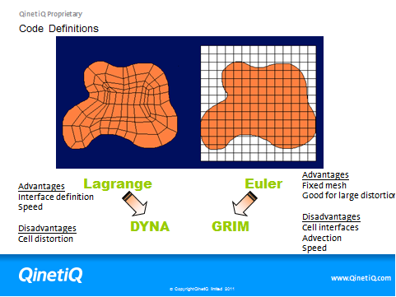
Figure 9: primary types of hydrocode
Other hydrocodes mix these two approaches or take radically different approaches.
https://en.wikipedia.org/wiki/Smoothed-particle_hydrodynamics
https://en.wikipedia.org/wiki/Peridynamics
When constructing material descriptions it is important to properly represent the physical material response. Numerical simulation can take materials into areas where normal testing cannot go and they need to be trusted to be correct. Part of this is knowing that all the relevant physics is represented in the material description and that the implementation properly deals with that physics. Then the outputs of the simulations need to be compared to reality in as much detail as possible to determine where it is inaccurate.
The normal way of constructing material models is to do a large amount of testing that covers all stress, rates and temperatures that are likely to be seen in the scenarios of interest and then fitting equation forms to this data. This is not only time-consuming and expensive but is often not possible due to material supply problems, testing supply problems or safety. It also ignores the influence of the equation forms chosen; the equations may describe the data but imply physical behaviour that is not real and thus leads to significant error outside the range of fitted data.
Validation therefore requires some very strong constraints from the material model. In order properly to compare simulation output with reality the parameters in the model should be real. That is you should be able to make a direct comparison between a model parameter and its real value rather than depending upon comparison of two sets of integrated properties. It is also essential that the model has a unique self-consistent set of parameters so that validation by coincidence can be avoided. Another issue that arises with complex materials such as concrete is that all of the testing is used for characterisation leaving no independent data for validation.

Table of properties
 | Density  (kg m⁻³) | Bulk modulus  GPa | Bulk sound speed (m/s) | Acoustic impedence  10⁶ kgm⁻²s⁻¹ | Quoted strength (MPa)
Hypalon | 1200 | 2.5 | 1450 | 1.8 | 25
Polycarbonate | 1200 | 4.8 | 2000 | 2.4 | 70
PBXN109 | 1670 | 7.5 | 2150 | 3.6 | 1
concrete | 2400 | 24 | 3300 | 7.9 | 50
aluminium | 2700 | 75 | 5250 | 14 | 75
Steel (EN24) | 8050 | 150 | 6100 | 49 | 1000
diamond | 3500 | 540 | 12000 | 42 | 10000

