Entry 1:

Individuality

Individuality refers to the possession of some specific character which helps in making an individual unique and distinguish form other people (Jetten, 2016). It can also be said as the capability to act alone line and consider it to be precise for oneself (Jetten, 2016). It is also considered crucial in developing and shaping the entire world as its continuous presence can offer blessing for people (Carmichael, 1919, pp 465-468). The improvement of the society will be central if the researchers will be determined by the deep individuality.

Positionality

Positionality can be referred as a researcher outlining their own position in relation to study along with the implication that their position might influence the overall outcome or study like the way of collecting the data or interpreting it in some specific way (Qin, 2016). Being aware about the positionality can be beneficial to the research and analysis process because it can facilitate researcher to critically analyse and consider about inclusion by collaboration (Nicholls, 2009). Every researcher must adhere to some specific position and at the same time they need to intentionally and reflectively modify across other different position according to purpose and context (Hopkins, et al., 2016 pp 20-25). Positionality can be manipulated by some factors like religion, gender and even some other aspects such as contextual and subjective (individual life background, spiritual belief and experiences) (Mortensen, 1996) and I will make sure not to manipulate and influence my final research in any way.

Importance of Positionality

Positionality is considered to be very crucial factor in terms of research because it can not only manipulate the way of carrying out research but also can influence the final outcome or result (Bourke, 2014). It is unsophisticated to accomplish absolute objectivism because it is not possible to separate our self from subjectivity (Bourke, 2014) and (Atkinson, 1995). To solve this confusion, positionality can play a crucial role as it can provide an opportunity where both objectivism and subjectivism can come together (Holmes, 2014). Reflectivity is also considered as the crucial process in determining the shape of positionality (Holmes, 2014).

Researcher being a female (positionality), feminist viewpoint or any bias should be avoided.

Insider and outsider

Insider and outsider represents an important guideline for researcher to deal with cultures apart from their own and insider versus outsider debate can also be explained as the subjective versus objective understanding of the world (Kusow, 2003). The debate on insider and outsider also concentres on influencing the researchers’ role and identity by traditional sociological and anthropological ethnography (Peshkin, 1984), (McLaren, 1991) and (Joshi, 2002). According to the classification done by Merton (1972), where structural concept has been applied, outsiders are considered to be non-members whereas insiders are specific members of certain clusters or occupants of some specific social status (Merton, 1972). The perspective of insider/outsider or the prospective of emic and etic, both of the have their own strengths and negative points depending on the situation (Kusow, 2003).

The issue of bias and positionality is important in both qualitative and quantitative data, cross-cultural studies and also to evaluate to which extent the approach of reflective-reflexive could be complementary in order to enhance the overall quality of research and to get the truth. Elements like cultural background, belief of researcher, gender, race, etc may affect research process (Jones, 2001) so researcher (I) should keep it in mind to establish truth without bias.

Appendix 1:

Bibliography
Atkinson, M. H. a. P., (1995). Ethnography: Principles in practice. London: Routledge.
Bourke, B., 2014. Positionality: Reflecting on the Research Process. Qualitative Report, 19(33), pp. 1-9.

Carmichael, R. D., (1919). Beauty and the Science Beast Author. American Association for the Advancement of Science Stable, 34(5), pp. 465-468.

Holmes, A. G. D., (2014). Researcher Positionality - A Consideration of Its Influence and Place in Research. s.l.:s.n.

Jetten, T. P. a. J., (2016). Individuality and the Group: Advances in Social Identity. London: Sage Publications.

Jones, M., (2001). The issue of bias and positionality in cross-cultural, educational studies - enhancing the validity of data through a reflective-reflexive approach. [Online]
Available at: http://www.leeds.ac.uk/educol/documents/00001733.htm
[Accessed 21 3 2020].

Joshi, P., (2002). Fieldwork experience: Relived and reconsidered. The Agrarian society of Uttar Pradesh. 2 ed. New Delhi: Oxford University Press.

Kusow, A. M., (2003). Beyond Indigenous Authenticity: Reflections on the Insider/Outsider Debate in Immigration Research. Society for the Study of Symbolic Interaction, 26(4), pp. 591-599.

McLaren, P., (1991). Experiencing Fieldwork: an inside view of qualitative research. London: Sage.

Merton, R. K., (1972). Insiders and Outsiders: A Chapter in the Sociology of Knowledge. American Journal of Sociology, 78(1).

Mortensen, K. G. E. a. P., (1996). Ethics and Representation in Qualitative Studies of Literacy. National Council of Teachers of English, Urbana, IL, pp. 115-133.

Nicholls, R., (2009). Research and Indigenous participation: critical reflexive methods. International Journal of Social Research Methodology, 12(2), pp. 117-126.

Peshkin, A., (1984). Odd Man Out: The Participant Observer in an Absolutist Setting. Sociology of Education, 57(4), pp. 254-264.

Robin M. Hopkins, G. R. &. D. D. P., (2016). A framework for negotiating positionality in phenomenological research. Medical Teacher, 39(1), pp. 20-25.

Sharan B. Merriam, J. J.-B. M.-Y. L. Y. K. G. N. &. M. M., (2001). Power and positionality: negotiating insider/outsider status within and across cultures. International Journal of Lifelong Education, 20(5), pp. 405-416.

Appendix 2:

- Qin, D., 2016. Wiley Online Library. [Online]
Available at: https://onlinelibrary.wiley.com/doi/epdf/10.1002/9781118663219.wbegss619
[Accessed 1 3 2020].

- What is your Research Positionality?
Available at: https://decolonizingresearch.wordpress.com/2016/02/25/what-is-your-researcher-positionality/

- Just Tell Me What I need to know: Reflexivity and Positionality statements
Available at: https://www.marvettelacy.com/blog/just-tell-me-what-i-need-to-know-reflexivity-and-positionality-statements

- The elite delusion: reflexivity, identity and positionality in qualitative research
Available at: http://sro.sussex.ac.uk/id/eprint/76090/3/elitedelusionacceptedversionmarch2018.pdf

- Positionalities
Available at: https://e-space.mmu.ac.uk/617498/1/draft%20proof%20of%20chapter%207th%20July.pdf

Appendix 3:

- Oxford Dictionaries , 2020. Oxford Dictionaries. [Online]
Available at: https://www.oxfordlearnersdictionaries.com/definition/english/individuality?q=Individuality+
[Accessed 1 3 2020].

- Writing Strategies: What’s Your Positionality?
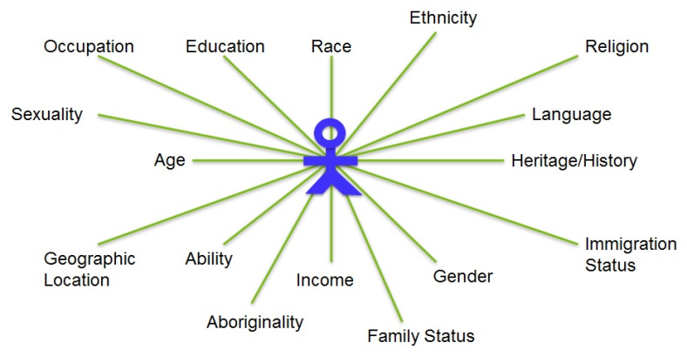
https://weingartenlrc.wordpress.com/2017/01/09/research-writing-whats-your-positionality/

Entry 2:

Knowledge

What is knowledge and what are the requirements on knowledge? Knowledge is based on agreement and the basic requirement of knowledge is truth and belief (Pritchard, 2014). It is almost impossible to have knowledge and idea about everything just by our personal experience so we also need to believe on what other people tell us. So, in this situation, it can be trusted on two sources of knowing: authority and traditional source (Babbie, 2010).

Effective reading

It becomes more challenging as we start to develop our reading skills as it plays a crucial role in knowledge inheritance. Academic reading should be taken as an active process rather than passive activity because it can lead reader to the development of learning (Nardi, 2017). Reader should read for learning and this process involves very conscious effort in order to make links, understanding the opinions, doing extensive research and applying it to our own learning process as a starting point in order to develop more knowledge and ideas (Plummer, 2019).

Knowledge are of three types and they are experiential knowledge, skills and knowledge claims (Dombrowski, et al., 2013, p 35). Experiential knowledge is about what can we acquire form direct connection with surroundings, by the help our sensory system and finally those information would be processed by our brain. Skills are knowledge all about how to do something which is based on experiential knowledge but in a very structured form which can be achieved by repeatedly doing the task. Knowledge claims means what is known to us or we think that it is known to us (Dombrowski, et al., 2013). Knowing all types of knowledge can help to become a better researcher and complete thesis in better way.

Thinking critically and its importance

Thinking critically means examining the ideas, evaluating them and making a decision by maintaining ‘objective’ position. When thinking in critical way, researcher should be able to weigh up every sides of an arguments as at the same time evaluate their weakness and strength (UWTSD, 2020). Academic writing is must to complete thesis and writing academically means researcher must have that ability to defend an argument against other charges for instance, biasness or lack of supporting evidence. As a reader or researcher, critical thinking can facilitate to get access to the evidence of what is being read and any illogical reasoning (Berlet, 2014). Critical thinking can help to make strong arguments and researcher can present and justify all claims on the basis of evidence provided which can ultimately make final thesis strong.

There are few steps to think critically. They are: i) to identify thrust of information ii) analysing materials and finally iii) comparing and applying information (Bratianu, 2018). In the first step: reader need to be aware of main argument points, every claims which are being made, evidence and conclusion. While analysing materials, if materials are relevant or not (old, sensible information, original material)? Finally, when comparing and applying, researcher need to see the implications, if there is any lack of coverage. Information always should be taken from valid source (peer-reviewed journals and articles, recent data, original articles) and for effective reading, preview, summarise, analyse, compare, contrast is crucial to make strong thesis (Harvard Library, 2020).

Appendix 1:

Bibliography
Babbie, E. R., (2010). The practice of social research. 12 ed. London: Cengage Learning .

Berlet, G. C., (2014). Critical Thinking. Sage Journals , 7(2), p. 94.

Bratianu, E. B. a. C., (2018). Emergent Knowledge Strategies: Strategic Thinking in Knowledge Management. New York: Springer International Publishing.

Eileen Dombrowski, L. R. a. M. B., (2013). Theory of Knowledge. Oxford: Oxford University Press.

Harvard Library, (2020). Thinking-Intensive Reading. [Online]
Available at: https://guides.library.harvard.edu/sixreadinghabits?gid=4877
[Accessed 22 3 2020].

Nardi, P. M., (2017). Critical Thinking: Tools for Evaluating Research. California: University of California Press.

Plummer, M., (2019). A Short Guide to Building Your Team’s Critical Thinking Skills. [Online]
Available at: https://hbr.org/2019/10/a-short-guide-to-building-your-teams-critical-thinking-skills
[Accessed 21 3 2020].

Pritchard, D., (2014). What is this thing called knowledge. 3 ed. London: Routledge.
UWTSD, 2020. Identity and Approaches to Applied Business Research. Swansea: UWTSD.

Appendix 2:

- Thinking Critically
Available at: http://www.openuniversity.edu/sites/www.openuniversity.edu/files/brochures/Critical-thinking-Open-University.pdf

- Literature review: Finding the resources
Available at: https://libguides.library.cityu.edu.hk/litreview/evaluating-sources#s-lg-box-8889331
- What is reading?
Available at: https://www.tesol.org/docs/books/bk_ELTD_Reading_998

- Effective reading
Available at: https://www.skillsyouneed.com/learn/effective-reading.html

- Evaluating information checklist
Available at: https://library.leeds.ac.uk/downloads/download/38/evaluating_information_%20checklist

Appendix 3:

Fig 1: Intellectual skill level (Adapted from Bloom, 1956)

Fig 2: Enquiry cycle
Source: http://www.openuniversity.edu/sites/www.openuniversity.edu/files/brochures/Critical-thinking-Open-University.pdf

Fig 3: Literature review process (Saunders, et al., 2016)

Appendix 4:

When I attended my first session with Dr David, I was traumatize because I felt like I know nothing about critical reading, argument structure and overall reading style. I almost felt like I should quit but later, I was feeling more confident after attending his lecture. He was a source of motivation for me and then I started focusing on Toulmin argument style, critical eye, critical thinking and changed my reading style and habit. Now, I am more confident and almost ready for my part 2 research.

Entry 3:

According to Grant, 1996 knowledge is considered to be crucial for economic performance, competitiveness and wealth. Knowledge production could be measured and conceptualised in different way and dimensions (Grant, 1996). There is a theory called Mode 1 and Mode 2 in relation to knowledge production developed by Gibbons. Mode 1 theory is about the production of scientific knowledge and is highly driven by academic interest highlighting on fundamental more than on applied nature. Mode 2 theory highlights on research that are practice oriented with the combination of both demand and supply side of knowledge (Gibbons, et al., 1994). According to Saunders, 2016 business research require not only knowledge but also should have potential to solve business related issues and it might threaten the creation of knowledge. For instance, researchers who are not given value and appreciation now could turn out to be a great significance in the days to come (Saunders, et al., 2016).

According to Saunders (2011), the gaps can be from various orientations like interest, methodological imperative, final outcome (Saunders, 2011). According to the purpose and context of research, management and business research could be considered as a continuous process from foundation research to applied research (Saunders, et al., 2016).

Research is a process that researcher need to undertake in order to expand their know-how or knowledge so that new things could be discovered in an organised way (Saunders, et al., 2016). Being a doctoral student, I (researcher) must demonstrate that dissertation would be an original study which would provide a significant contribution in the academic field and researcher (me) also need to make sure that the research is being driven by gaps how would I address that gap (Birkinshaw, et al., 2016)? Further, I also should be aware that if my research would be driven by some specific theoretical framework or current policy debates (Güttel, 2005), on which point do I need to focus on?

It is believed that the main motto of business and management research solve the problems via description, explanation and even predictions by developing the practical knowledge (Aken, 2005) where others argue that research must be a balance between application and explanation (Rousseau, 2009).

Appendix 1:

Bibliography
Aken, J. E. V., (2005). Management Research as a Design Science: Articulating the Research Products of Mode 2 Knowledge Production in Management. British Journal of Management, 16(1), pp. 19-35.

Güttel, D. F. C. a. W. H., (2005). Knowledge production of firms: research networks and the ‘scientification’ of business R&D. Int. J. Technology Management, 31(1), pp. 152-172.

Grant, R. M., (1996). Toward a knowledge‐based theory of the firm. Strategic Management Journal, 17(52).

Julian Birkinshaw, R. L. a. P. B., (2016). The Relevance Gap in Business School Research: Which Academic Papers Are Cited in Managerial Bridge Journals?. Academy of Management Learning & Education, 15(4).

Mark Saunders, P. L. a. A. T., (2016). Research Methods for Business Students. 7 ed. Essex: Pearson.

Michael Gibbons, C. L. H. N. S. S. P. S. &. M. T., (1994). The New Production of Knowledge: The Dynamics of Science and Research in Contemporary Societies. London: Sage.

Rousseau, G. P. H. D. M., (2009). Bridging the Rigour–Relevance Gap in Management Research: It's Already Happening!. Journal of Management Studies, 46(3), pp. 534-545.

Saunders, M. N., (2011). The management researcher as practitioner. In: Challenges and Controversies in Management Research. New York: Routledge, pp. 243-257.

Appendix 2:

- Types of the Contributions in a Research Paper
Available at: https://www.linkedin.com/pulse/types-contributions-research-paper-ali-asgari

- A Study on organisational Development
Available at: https://onthinktanks.org/wp-content/uploads/2016/03/14577361801LKR96.pdf

- How to demonstrate significant contribution and original study in your PhD thesis
Available at: https://writepass.com/journal/2013/05/how-to-demonstrate-significant-contribution-original-study-in-your-phd-thesis/

- Research in organizational change and development
Available at: https://www.emeraldgrouppublishing.com/products/books/series.htm?id=0897-3016

Appendix 3:

Fig 1: Relevance gap (https://slideplayer.com/slide/16310327/)

Basic and applied research
Fig 2: Basic and applied research (https://relivingmbadays.wordpress.com/2012/10/14/basic-versus-applied-research/)

Contribution table

Fig 3: contribution and outcome (Jill, PPT)

Appendix 4:
Researcher (yourself)  - Be more critical thinker  - Find connection between real world and practical world  - Become more cultural sensitive  - Information on employee retention  - Has become more practical and confident  - Developed skills and knowledge about intercultural competencies  - Understood the value of time and money | Academic knowledge  - Apply theory into practice
Organisation  - Help organisation to determine factors influencing employee retention | Individual  - Help individual to identify motivating factors in their job

Entry 4:
Research question is the representation of an attempt to tame curiosity (Lewins 1992, p. 8) and researcher could correlate and compare existing theories and previous findings during the process of formulation, development and refining the research questions (Lewins, 1992). It should be clear, concise and arguable which can the research (Duke Writing Studio , 2014). The development of research question is a first crucial step to do any research project (Mosavel, Simon, van Stade, & Buchbinder, 2005). Well-formulated research question is even more important than trying to find out the outcome because it totally depends upon the research studies which were initiated by research question (Grove, 2011). Researchers can develop research questions from the theoretical knowledge they have, from experience or previously conducted research or even from a practical need at workplace (Parahoo, 2014).
Importance of defining research question
Defining the research question is significant process which conducting research because it can narrow down the aim and objective of the research to that specific area where researcher wants to address (Creswell, 2014). Research questions are considered to be fundamental because they can guide in order to choose the methodology, sampling method, sample size, instruments to collect data and even techniques to analyse those data (Lipowski, 2008). Those researchers who has been engaging in exploratory research type and focusing on open-ended research approach find research question to be less essential or even finalise their research question in the halfway of their research process (Bell, 2015). On the other hand, Saunders (2016) strongly recommend to start the research with the clear and concise research question (Saunders, et al., 2016).
Types of research questions
According to Saunders (2016), there are three kinds of research questions and they are explanatory questions (causal relationship among the variables and also asks “why” (Ness, 2015)), descriptive questions (describes what exist or what’s going on) and exploratory questions (to produce new knowledge) (Saunders, et al., 2016).
Good research questions
Good research questions are not statements but a specific question which are researchable and can directly be addressed to the research that has been identified by the researcher (Simon, et al., 2017). According to (Guly, 2002), a good research question should have specific characteristics like every hypothesis should be formulated and tested; research need to be feasible in terms of money, time, proficiency and resources; overall outcome might change existing viewpoints and practice; research question should have that potential which could develop further research with a parallel concept (Guly, 2002).
However, (Pine, 2009) has acknowledged few ways where research question is considered to be not good. For instance: research questions which can be answered in one word with Yes or No; questions whose answer is already known to researcher and those question which is full of educational jargon (Pine, 2009).
It is not straightforward to generate any research question which has been sufficiently involved in order to develop a good quality research question (Saunders, et al., 2016). The first step is to choose a research topic and then convert research ideas into a clearly defined research question (Saunders, et al., 2016). Overall, it is crucial to understand the theory and develop it to contribute and formulate the research question (Neil, et al., 2014).
Appendix 1

Bibliography

Bell, A. B. a. E., (2015). Business Research Methods. 4 ed. Oxford: Oxford University Press.

Creswell, J. W., (2014). Educational Research: Planning, Conducting, and Evaluating Quantitative and Qualitative Research. 5 ed. Upper Saddle River NJ: Pearson Educatio.

Duke Writing Studio , (2014). What Makes a Good Research Question?. [Online]
Available at: https://sites.duke.edu/urgws/files/2014/02/Research-Questions_WS-handout.pdf
[Accessed 3 3 2020].

Grove, N. B. a. S. k., (2011). Understanding nursing research: building an evidence-based practice. 5 ed. St. Louis: Saunders Elsevier.

Guly, J. W. a. H., (2002). Identifying the research question and planning the project. Emergency Medicine Journal , Volume 19, pp. 318-321.

Hamza, S. K. A. a. K., (2015). Qualitative and Quantitative Research Paradigms in Business Research: A Philosophical Reflection. European Journal of Business and Management, 7(3), pp. 217-224.

Lewins, F., (1992). Social science methodology : a brief but critical introduction. South Melbourne: Macmillan.

Lipowski, E., (2008). Developing great research questions. American Journal of Health-System Pharmacy, 65(17), pp. 1667-1670.

M Mosavel, C. S. ,. D. v. S. ,. M. B., (2005). Community-based participatory research (CBPR) in South Africa: engaging multiple constituents to shape the research question. Social Science and Medicine, 61(12), pp. 2577-2587.

Mark Saunders, P. L. a. A. T., (2016). Research Methods for Business Students. 7 ed. Essex: Pearson.

Neil Burton, M. B. a. M. J., (2014). Doing Your Education Research Project. 2 ed. Los Angeles : Sage.

Ness, P. I. F. a. L. R., (2015). Are We There Yet? Data Saturation in Qualitative Research. The Qualitative Report 2015 , 20(9), pp. 1409-1413.

Parahoo, K., (2014). Nursing Research: Principles, Process and Issues. 3 ed. Basingstok: Palgrave MacMillan.

Pine, G. J., (2009). Teacher Action Research: Building Knowledge Democracies. Thousand Oaks: Sage.

Simon Brownhill, T. U. A. B., (2017). 'Jumping the first hurdle’: Framing action research questions using the Ice Cream Cone Model. Sage Journals, 10(3).

Appendix 2:
- Formulating the Evidence Based Practice Question: A Review of the Frameworks
Available at: https://journals.library.ualberta.ca/eblip/index.php/EBLIP/article/view/9741/8144

How to Write a Research Question

Available at:

https://writingcenter.gmu.edu/guides/how-to-write-a-research-question
- On The Importance Of Good Questions And Empirically Grounded Theorizing
Available at: https://search-proquest-com.ezproxy.uwtsd.ac.uk/docview/1021131121?accountid=130472&rfr_id=info%3Axri%2Fsid%3Aprimo
- Who’s afraid of research questions?
Available at: https://www.birmingham.ac.uk/Documents/college-social-sciences/education/projects/rdi-paper.pdf

Appendix 3: Fig 1: Ice cream cone model (Simon Brownhill, 2017)

Appendix 4:
When I was planning to join DBA, I knew that Identity and Approaches to Applied Business Research would be one of my modules where I could get intense knowledge and approaches to do research. After joining the module, it actually helped a lot. Before this module, I got opportunity to do quantitative method module with Dr Jill where I was exposed to numerous research tools, techniques, sampling, hypothesis and also developing the research questions and setting questionnaire and it actually helped me a lot to have better understanding this module.

Entry 5:
According to (Saunders, et al., 2016), philosophical assumptions and beliefs not only can influence our decisions that we make in our everyday life but also the overall research process without being consciously aware about it or not. This kinds of beliefs and assumptions are installed in our mind by various ways like educational background, by reading some books, articles and journals or even from the advice given to us by advisors. One of the crucial process while choosing methodology is positionality and philosophical assumptions like values, ontology, beliefs, epistemology (Sikes, 2004).

Importance of Philosophical Framework

Philosophical framework can help to shape to formulate the problem and research questions and helps to analyse the answer of the question. Understanding the theoretical assumptions can play a vital role in recognizing which techniques can work well and which techniques does not work. Similarly, it can also help to design the research so that researcher can take full advantages of strengths and compensate the weakness at the same time (Markič, 2013). Researchers create frameworks that include a philosophical and methodological model to help design their work and believe that it is the structure of the house according to Grant and Osanloo (2014).

Beliefs and assumptions

Everybody has some kind of assumptions and beliefs even if they are aware about it or not but it does not mean that everyone has systems. There are different categories of assumptions and everybody has assumptions within every categories like epistemology, axiology or ontology however it is not necessary that everyone has to fit together in a systematic way (Guba, 1990) and my research will be based on epistemology (from literature review).

- Ontology
Ontology is about the philosophical study which is concerned with the world and also nature of the reality. It can determine the way how researcher sees their research object. The prospective of ontological researcher also can link to their epistemological perspective as ontology is about pertaining to the world’s reality whereas epistemological perspective is about pertaining to the knowledge of that world (Jackson, 2013).

- Epistemology
Epistemological perspective is more concerned about the philosophical study of the knowledge and that ground due to which it is believed something to be true. It has strong link to the claim of new knowledge (Pritchard, 2014) because the way knowledge is being developed and perceived depends upon methodology and also on rigour of methodology (Irene, 2014).

- Axiology
Every researcher brings value to their study however qualitative researcher try to make their own value known in the research (Saunders, et al., 2016) and this is known as axiological assumption which can characterise qualitative research.

Major Research Philosophies

According to research onion by (Saunders, et al., 2016), there are five main research philosophies and they are positivism, critical realism, interpretivism, post-modernism and pragmatism. To develop any research philosophy, there are three steps They are beliefs and assumptions, research philosophies and research design (Saunders, et al., 2016).

Reviewing the literature is considered to be key aspect as it can provide information to researcher about existing theories, gaps in that theories, other background information which can ultimately help researcher to formulate an argument and research questions. That argument can help to build a theoretical framework for the research (Jackson, 2013). Overall, it has given deep ideas to researcher (me) to conduct research for final thesis.

Appendix 1:

Bibliography
Cynthia Grant, A. O., (2014). Understanding, Selecting, and Integrating a Theoretical Framework in Dissertation Research: Creating the Blueprint for Your "House". Administrative Issues Journal, 4(2), pp. 12-26.

Guba, E., (1990). The Paradigm Dialog. London: Sage.

Irene, D., (2014). The Ontological and Epistemological Foundations of Qualitative and Quantitative Approaches to Research. International Journal of Economics, Commerce and Management, 2(10), pp. 2-15.

Jackson, E., (2013). Choosing a Methodology: Philosophical Underpinning. Practitioner Research In Higher Education, 7(1), pp. 49-62.

Mark Saunders, P. L. a. A. T., (2016). Research Methods for Business Students. 7 ed. Essex: Pearson.

Markič, O., (2013). The Philosophical Framework for Understanding Neuroscientific Research. Interdisciplinary Description of Complex Systems, 11(4), pp. 351-362.

Pritchard, D., (2014). What is This Thing Called Knowledge?. 3 ed. London: Routledge.

Sikes, P., (2004). Doing Educational Research: A Guide to First-Time Researchers. London: Sage.

Appendix 2:

- A Philosophical Framework for Enhancing the Understanding of Artefacts in the Technology Classroom

Available at: https://www.tandfonline.com/doi/abs/10.1080/18117295.2016.1215959

- Call for mixed analysis: A philosophical framework for combining qualitative and quantitative approaches
Available at: https://www.tandfonline.com/doi/abs/10.5172/mra.3.2.114?journalCode=rmra20

What is the term philosophical framework in relation to social research?
Available at: https://www.quora.com/What-is-the-term-philosophical-framework-in-relation-to-social-research

Appendix 3 :
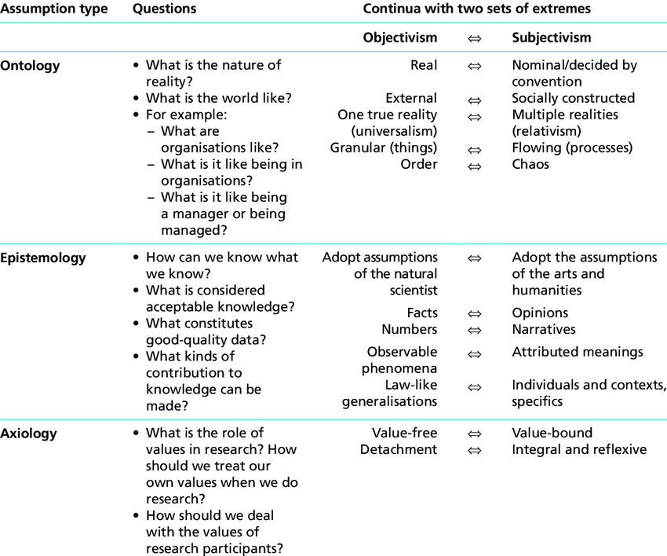
Table 1: Philosophical assumptions by (Saunders, et al., 2016).
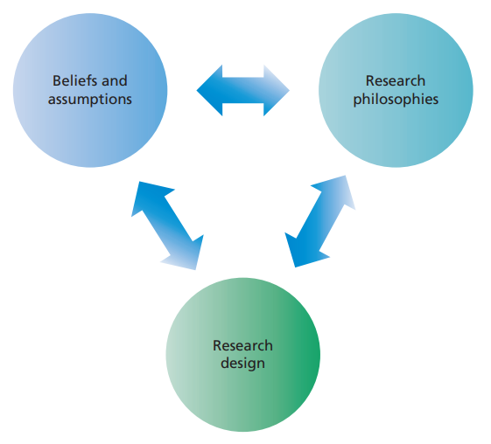
Fig1 : Developing your research philosophy: a reflexive process (Saunders, et al., 2016)

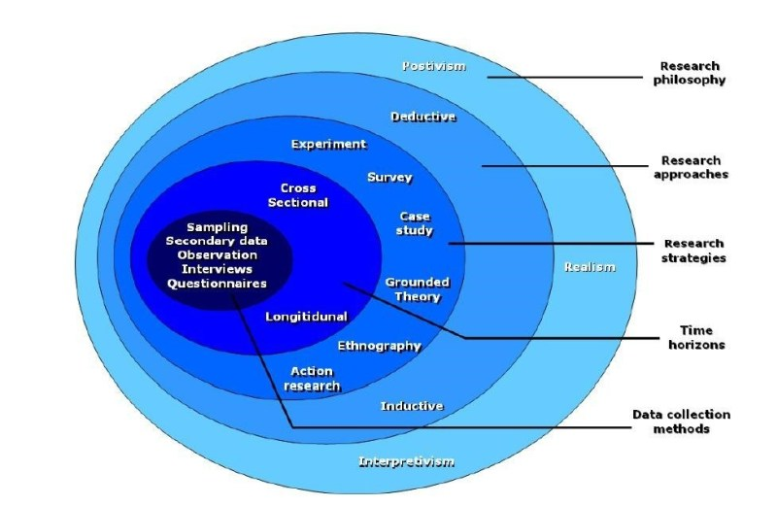
Fig 2: Research onion (Saunders, et al., 2016)

Figure 3: 4 Paradigms (Burrell and Morgan, 1979) adopted from (Saunders, et al., 2016)

Fig 4: Implications of research philosophy: PPT by Dr. Caroline Jawed (2020)

Appendix 4:

After finishing class, I along with my classmates used to have some deep and detailed discussion on importance of philosophical frameworks and which type of philosophy would fit on for my individual research. By the end of the session, I can say that Epistemological perspective would fit for my final part 2 research because it is more concerned about the philosophical study of the knowledge and that ground due to which it is believed something to be true. It has strong link to the claim of new knowledge.

Entry 6:

Research design is the structure of the overall research which can hold together every elements of research together (Lincoln, 2011). According to Saunders, there are stages of research design and they are to specify the problem or the topic, to frame the research design, planning the sampling (whether to conduct probability or non-probability sampling or mixed sampling), collecting and analysing the data and finally to prepare the report (Saunders, et al., 2016).

Importance of research design

Research design is important because it can help in advance planning to adopt the research methods in order to collect the data and which technique to be used to analyse the data along with considering the money, time of the researcher (Akhtar, 2016).

Types of research

According to (Saunders, et al., 2016), there are five types of research and they are descriptive, evaluative, exploratory, mixed and explanatory research and being a researcher, we must analyse the purpose of doing research and choose the research type accordingly. Descriptive research is used to obtain and identify the information on feature of particular things like specific group of people, or community etc and aims to portray the accurate information from specific criteria like age group, gender, education level and so on. The main motto of evaluative research is to explore how well the research is working in order to contribute the new understanding of the theory. Exploratory research is crucial to ask open questions in order to produce new knowledge (Hamza, 2015). Mixed or combine research can be conducted when the purpose of research tends to be more than one in order to facilitate data collection and to strengthen the overall quality of research. Explanatory research deals with the causal relationship among the variables and also asks “why” (Ness, 2015). It ultimately will help me to choose the best research type that can fit into my final thesis.

Qualitative research:
It is in-depth research which tests the relationship between variables via interviews, questionnaires, observations (attitudes, opinion or belief) (UWTSD, 2020). It follows exploratory scientific method as it describes what is seen locally and even come up with new hypothesis or theory and operates under assumption of “reality is socially constructed” (Guba, 1990). It uses interpretivism/ idealism as a paradigm. It has inductive approach and focus on generation of theory and it uses strategies like case studies, ethnographies, interviews, focus group, recordings and filming (Hamza, 2015).

Quantitative research:
This approach follows the confirmatory scientific method as it concentrates on hypothesis testing as well as testing of theory (Holosko, 2010). Overall outcome from quantitative research can be summarised by numbers and it clearly focus on one or more research questions and uses strategies like measurement, structured protocols, questionnaires, empirical examination (Hamza, 2015). It operates under assumption of objectivity. It uses positivism/ realism as a paradigm and is deductive in approach and focus on testing of theory (Hamza, 2015).

Mixed research:
It is a combination of both research positions (Hamza, 2015) and I will be using mixed method in my final report.
While conducting research, researchers mainly use deductive and inductive reasoning and after considering all the elements and factors, researcher must critically evaluate the research design along with ethical consideration (Saunders, et al., 2016).

Appendix 1:

Bibliography
Akhtar, M. I., (2016). Research in Social Science: Interdisciplinary Perspectives. 1 ed. India: s.n.

Guba, E., (1990). The Paradigm Dialog. London: Sage.

Hamza, S. K. A. a. K., (2015). Qualitative and Quantitative Research Paradigms in Business Research: A Philosophical Reflection. European Journal of Business and Management, 7(3), pp. 217-224.

Holosko, M. J., (2010). What Types of Designs are We Using in Social Work Research and Evaluation?. Research on Social Work Practice, 20(6), pp. 665-673.

Lincoln, N. D. a. Y. S., (2011). Introduction: The discipline and practice of qualitative research. In: The Sage Handbook of Qualitative Research . London: Sage, pp. 1-20.

Mark Saunders, P. L. a. A. T., (2016). Research Methods for Business Students. 7 ed. Essex: Pearson.

Ness, P. I. F. a. L. R., (2015). Are We There Yet? Data Saturation in Qualitative Research. The Qualitative Report 2015 , 20(9), pp. 1409-1413.

UWTSD, (2020). Identity and Approaches to Applied Business Research. Swansea: UWTSD.

Appendix 2:

Research design and methodology
Available at: https://www.researchgate.net/publication/328543118_Research_design_and_methodology

- Research Methods Handbook
Available at: https://www.cles.org.uk/wp-content/uploads/2011/01/Research-Methods-Handbook.pdf

Appendix 3:

Fig 1: Research onion (Saunders, et al., 2016)

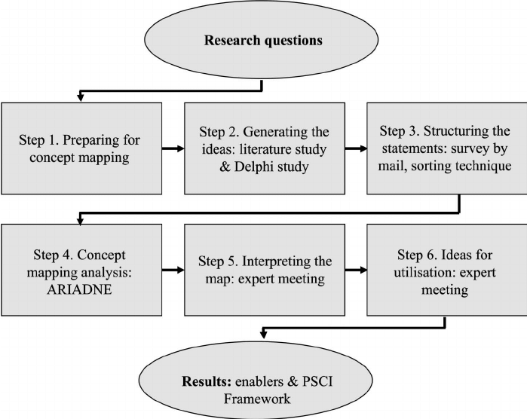
Fig 2: Research design
Available at: https://www.researchgate.net/figure/Concept-mapping-research-design_fig1_263611910

Fig 3: Research questionnaires (Saunders, et al., 2016)

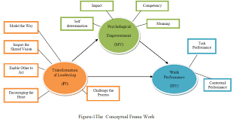
Figure 4: Advanced research
Available at: http://www.journalijar.com/uploads/755_IJAR-8565.pdf

Appendix 4:

I got opportunity to learn so much about research design from both class and self-reading outside class. Thinking about my final research, I was feeling nervous and some kind of anxiety because the topic was so huge in itself. I was also stressed if I would be able to get all the data or not while conducting research and also if I would be able to get access to my potential participants. However, I could definitely link all the learning to my final projects like which research method, design to adopt and I will be using mixed method.

Entry 7:

According to the philosophy of Milton Friedman, in context of every business, their social responsibility is just to increase the profit (Friedman, 1970). But what about ethics? It is important for every research to meet key ethical criteria because any research should not harm anybody in any way.

Ethics is considered to be a systematic approach in order to analyse, understand and distinguish between right and wrong, good and bad. Ethics and morality involves decision about wright and wrong (UWTSD, 2020). Ethics is that moral principles which can govern a behaviour of a person. Research ethics means doing those things which are morally and legally right while doing research. It is also considered as the code of conduct which distinguish acceptable and unacceptable behaviour and researcher must be careful about numerous ethical issues during this process.

Researcher should be solely responsible of their own research for ethical code of conduct like safety, data security, well-being, privacy of their respondents. Researcher must be ensure about the confidentiality and privacy of the collected information and make sure that those information and data are stored safely by maintaining anonymity of participants. Further, researcher need to provide complete information about data collection and make sure that participants are aware about the fact that they can terminate their participation at any time. However, both participants and researchers have crucial role to pay as one’s right is considered to be other’s obligation in research process.

Ethical principles should be set during research process like honesty, open communication with high transparency of data, rigour and respect and care (human, animals, environment, culture) (UWTSD, 2020).

To maintain research ethics and integrity, researcher must ensure that no harm occurs while during research process that might harm in some way. There are possibilities of harm like psychological harm, financial harm or social harm while doing interactions with participants and this should be avoided (Muir, 2011). So it is important to carefully analyse the potential harm and ensure to behave in appropriate ethical standard and consider how that specific research could affect the respondents in negative way (Saunders, et al., 2016).

Ethical code of conduct

There are numerous code of ethical conduct which regulates the behaviour of the researcher. This issues might arise while conducting research or even other issues correlated with professional practice (Israel, 2014).

Ethical philosophies

Two kinds of ethical philosophies are very much related to student research ethics that leads to completion and conflict of ethical position and they are: deontology philosophy and teleology philosophy where deontology says that participants should not be harmed in any way even if there would be potential benefit and teleology is about consequences of result from action (Thomas, 1996).

Human intervention

Human intervention means range of activities that includes interviews, experiment, survey, review from corporate records, information from websites by which researcher can have assess to those information readily and widely available (Thomas, 2013). If theses types of information are being used then it is unlikely that most of the information could be applied in every research.

The commonly believed ethical agreements in social research are voluntary participation and no harm to participants in any way and as a researcher, we always must analyse research ethics and integrity while conducting research and any type of plagiarism is illegal (UWTSD, 2020).

Appendix 1:

Bibliography
Friedman, M., (1970). The Social Responsibility of Business is to Increase its Profits. [Online]
Available at: https://moodle.uwtsd.ac.uk/pluginfile.php/320364/mod_resource/content/1/Milton%20Friedman.pdf
[Accessed 20 3 2020].

Israel, M., (2014). Research Ethics and Integrity for Social Scientists. 2 ed. New York: Sage.

Mark Saunders, P. L. a. A. T., (2016). Research Methods for Business Students. 7 ed. Essex: Pearson.

Muir, R. M. a. J., (2011). Research ethics committees: values and power in higher education. International Journal of Social Research Methodology, 14(5), pp. 391-405.

Thomas, J., (1996). Introduction: A Debate about the Ethics of Fair Practices for Collecting Social Science Data in Cyberspace. The Information Society, 12(2), pp. 107-118.

Thomas, J. R. a. E. J., (2013). Intervention Research Design and Development for Human Service. New York: Routledge.

UWTSD, 2020. 21st Century Business and Societal Ethics. Swansea: UWTSD.

Appendix 2:

- An Introduction To Ethics Issues And Principles In Research Involving Human And Animal Participants
Available at: https://www.canterbury.ac.uk/research-and-consultancy/documents/introduction-to-ethics.pdf

- Research Ethics
Available at: https://moodle.uwtsd.ac.uk/pluginfile.php/358359/mod_resource/content/1/Research%20Ethics%20Script.pdf

- Research Ethics & Integrity Code of Practice
Available at: https://www.uwtsd.ac.uk/media/uwtsd-website/content-assets/documents/research/research-ethics-integrity-code-practice.pdf

Appendix 3:
Fig 1: Ethics, morality and law (Caroline Jawed, PPT, Ethics)

2. what is research integrity?
Available at: https://www.bath.ac.uk/corporate-information/definition-of-research-integrity/

- Ethical principles
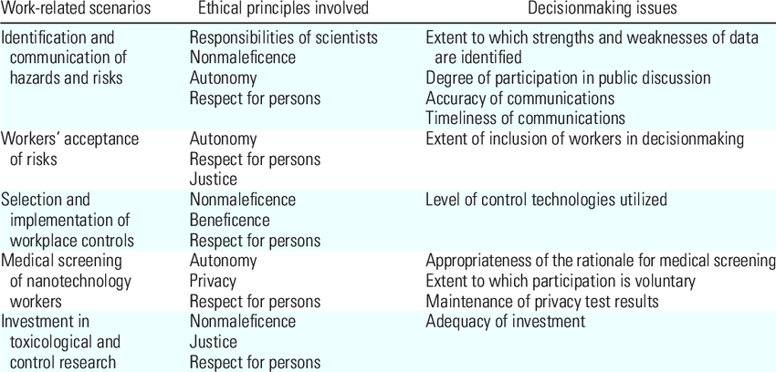
Fig 2: Ethical principles
Available at: https://www.researchgate.net/figure/Ethical-issues-pertaining-to-workplace-situations-involving-nanomaterials_tbl1_23279409

- Moral humility: In life and at work
Available at: https://www.sciencedirect.com/science/article/abs/pii/S019130851830011X

Appendix 4:
Due to pandemic Covid-19, we had to do online class and during online session, I was divided into group to work with my classmates. We discussed about the importance of research ethics and integrity and did group work together. Our work was to identify the potential ethical problems and compensation available.

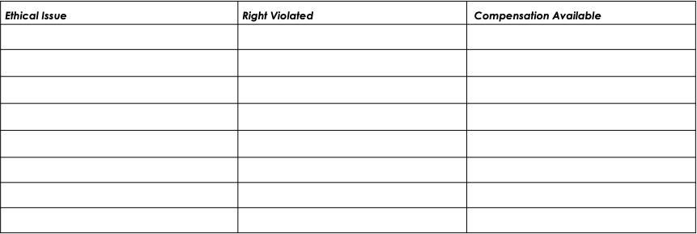
Table 1: Potential Ethical Problems Relating to Researching Consumers

While conducting my research, I will make sure to follow all the guidelines set by ethical committee and no harm will be done to anyone (human, animals).

