University of Wales Trinity Saint David
LONDON CAMPUS
Individual Report
Module Name : Digital Skills and Research Methods
Module Code : LCHS 4007
Student name : Andrei Niqoule Gabriel Dimayuga
Student ID : 2515167
Lecturer’s Name : Md Sadeque Imam Shaikh

Table of Contents
Research Topic: 1
Access to Health Care Services among the Disadvantaged People in the United Kingdom 1
Introduction 1
Problem Statement 1
Information Sources and Justification 2
Problem Statement 2
Information Sources and Justification 2
Problem Statement 3
Information Sources and Justification 3
Task 2: Research Methodologies 3
What research methodology was used for your research and why? 4
Task 3: Data Collection 4
Overview of primary and secondary data collection 4
What form of data will be used to address your research problem, and why? 5
Conclusion 5
References 6

Research Topic:

Access to Health Care Services among the Disadvantaged People in the United Kingdom

Introduction
The United Kingdom ensures the provision of healthcare services to all residents, prioritising the health and well-being of individuals through the National Health Service (NHS). This publicly funded system delivers healthcare free of charge. In accordance with the UK Constitution, these services are available to everyone, regardless of gender, ethnicity, age, disability, religion, or residency status. Consequently, access to healthcare is determined by clinical need rather than financial capacity.
This study aims to enhance the health and well-being of disadvantaged populations in the United Kingdom, reduce health inequalities within the community, and protect public health, which are among its primary objectives.

Problem Statement
Providing appropriate attention to the Special Education Needs and Disability (SEND) children will have a significant impact on the family receiving the support they need and will have a profound effect on the children's education and well-being (Healthwatch 2024). This has been a problem for several years within the community of children with special needs in the United Kingdom. For instance, A parent living in Sheffield with an Attention Deficit Hyperactivity Disorder ADHD child has had a difficult time trying to get assessed and diagnosed. It is a long wait for the family, estimated to be five to eight years, just to get an appointment. The child's progression will be delayed due to missing school and not receiving the appropriate health and educational treatment. Subsequently, these delays in accessing mental health services for children will have a long-term outcome, such as aggravated physical and mental health problems, low educational attainment and limitations on life opportunities.

Information Sources and Justification
This shows that accessing health services like diagnosis, referral and treatment is affecting the education, social care and individual well-being of children with special needs, making them more vulnerable. Furthermore, Delays and failure to impose the structured system in the healthcare services, the issue of being left behind by the disadvantaged children is significantly highlighted. This demonstrates that access to is not only about income and location, but also the disability, developmental and complexity needs of children.

Problem Statement
Longer waiting times for care are a major issue, particularly for patients with cancer treatments. Obtaining GP appointments, as well as dental appointments, is a struggle, and even emergency services have long wait times. According to the State of Care, this situation is worst in NHS low-performing areas, where there is a more than two-month wait from a General Practitioner Urgent referral to a patient's initial treatment of cancer. In 2023, the NHS performed a survey about GP satisfaction rates with appointments. 750,000 people took the survey, and 43% responded that they were not offered an appointment, an increase from previous years. 32% responded that there are no appointments available for the requested date and time, and 11% responded that appointments would take a long time (Care Quality Commission,2025). People are queuing and waiting times are longer nowadays to access treatments for major health issues. These waiting times are a risk to people’s physical and mental health. In addition, 2,524 people responded to the Office for National Statistics office survey of waiting GP appointments making a negative impact to their lives, which was conducted last December 2022, saying that 59% had their well-being affected, 36% their condition is worse, 34% their ability to exercise is affected and 33% said their mobility is reduced. In these difficult situations, patients face a long and unacceptable waiting time for appointments. Especially in areas with a low quality of life and a high ratio of GPs to patients, contributing to increased morbidity and reduced life expectancy.
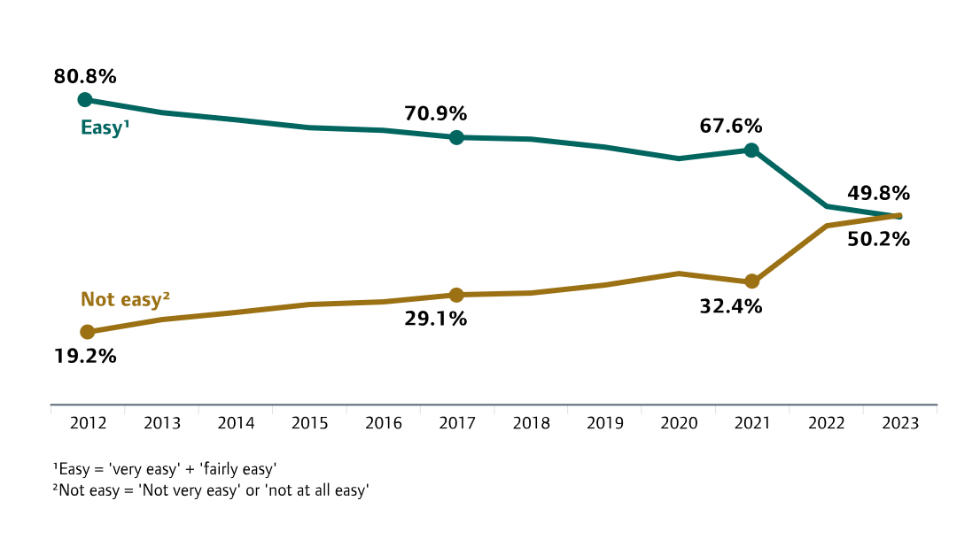
Figure 1: 2023 General Practice patient survey on how to get to an appointment.

Information Sources and Justification
The report highlights the challenges in accessing health and social care services, involving General Practitioners, Dental, and Hospital treatments. It illustrates the significant demand and pressure on primary care for the country's population. This leads to a long waiting list, delayed treatment, and inequality in the services available. In addition, it summarises the impact of the issues on patients and services, including negative outcomes and additional problems that may occur.

Problem Statement
Persistent inequalities in healthcare access among disadvantaged groups remain a serious national concern. Those living in deprived communities, ethnic minority populations, and socially marginalised groups are disproportionately affected. It is mentioned that 20% living in the most underprivileged areas have difficulties in securing primary care, including challenges in booking GP appointments, limited-service availability, transport barriers, language difficulties, and low levels of trust in healthcare organisations, which are central issues (UK Health Security Agency 2025). These barriers contribute to higher disease rates, poorer mental health outcomes, and shorter life expectancy. Accident and Emergency admissions are double the rate compared to less deprived areas within the country. In addition, limited access to preventive measures such as vaccinations and early detection further worsens health outcomes. The strain created by these inequalities also places significant pressure on healthcare professionals, increasing the risk of burnout and reducing job satisfaction.

Information Sources and Justification
The Health Inequalities Report 2025 by the UK Health Security Agency is very relevant and reliable in describing access to Healthcare services among disadvantaged people in England. This shows national-level information that deprived areas of the country are highly affected in accessing the healthcare system. Those experiencing the worst health issues, according to the study, are ethnic minority groups, with higher rates of admission with infectious diseases compared to the white groups.

Task 2: Research Methodologies
Quantitative research focuses on numeric data, statistical analysis and large sample data (Dehalwar, et al. 2023). It uses structured methods to measure relationships, patterns, and trends, making it especially valued in fields like psychology, economics and public health where objective, evidence-based conclusions are essential.
Qualitative research emphasises in-depth exploration, subjective interpretation, and more focused samples (Dehalwar, et al. 2023). Using methods such as interviews, case studies, document analysis, focus groups, and observations. For understanding human experiences, motivations, and social dynamics, and making it central to disciplines like sociology, anthropology, and specific areas of psychology.
These two kinds of approaches may differ in their goals, methods, and types of data, yet both contribute essential insights to research and knowledge building.

What research methodology was used for your research and why?
In this research, mixed-methods approach is being used. Which is more suited for analysing the inequalities in accessing health and care among the disadvantaged groups in the United Kingdom. A mixed-methods approach is appropriate, as it enables a more comprehensive understanding of the issue by integrating quantitative data, which illustrates the scale and distribution of inequalities, with qualitative evidence that captures the lived experiences of affected individuals and their families. Such experimental perception provides a depth and context that cannot be obtained from numerical measures alone.
Quantitative methods are important. The national data clearly state the scope of healthcare inequalities. Examples of this are that 20% of deprived people have a problem accessing care, which, according to the Health Security Agency, is reflected in the Emergency admission rate being twice the national average, as well as GP waiting times and referral times. These reports only show that the discrepancy helps to illustrate the extent, severity and location of inequalities across the country.
Qualitative reports are also essential and significant. Thus, demonstrates that children with SEND experience how long delays in diagnosis, referrals and treatments affect their education, mental health and overall wellbeing. This cannot be shown by numerical data alone.

Task 3: Data Collection

Overview of primary and secondary data collection
Collecting data is a crucial step in the research process, both before and after the study is designed. It involves gathering essential information for developing the entire research. It comprises two types: primary and secondary data collection. Primary data collection is firsthand information, which is directly from the source, obtained from a direct communication between the researcher and the participants. This is in various direct forms (Mazhar, et al. 2023). While Secondary data collection involves information that has been collected and stored for a different purpose.

What form of data will be used to address your research problem, and why?
Secondary data is used in this research. The subject concerns the accessibility and current issues faced by disadvantaged groups living in the United Kingdom regarding Healthcare Services. This is primarily documented and gathered by national organisations such as Healthwatch UK, Care Quality Commission (CQC), and the UK Health Security Agency. These information providers are accurate and reliable sources of evidence.
Gathered Secondary data is appropriate for several reasons. Firstly, it analyses the patterns, inequalities and barriers rather than collecting individual experiences, which makes the research efficient and reliable. The gathered data has a large scale, including surveys, reports, and national statistics, thereby ensuring the information is accurate and credible. Secondly, the data is suitable for both descriptive and analytical strategies, which differentiate the data collected from different sources, helping to evaluate the issues in the healthcare sector that affect disadvantaged communities. Finally, the secondary data used are deliberately accurate and authoritative, providing a more complete picture of the national context.
Overall, Secondary data collection is appropriate for research because it provides extensive, relevant, and reliable information that supports and serves as a valuable resource for future research.

Conclusion
In Conclusion, the accessibility of health and social Care in the United Kingdom remains an apparent failure due to the constant and ongoing inequalities, particularly among disadvantaged populations. Despite the National Health Service's principle that treatment should depend on need, not on what the individual can afford. Structural barriers continue to isolate specific groups. Likewise, these Individuals who are in deprived areas, ethnic groups and families with children who have complex needs such as Special Education Needs and Disability, are encountering disheartening challenges in securing diagnosis, treatment and social support. This includes longer waiting times for booking and securing an appointment, as well as limitations on healthcare services and their availability, which vary depending on the area where you live. Additionally, there are barriers related to transportation, language, and trust in the healthcare institution.
By adopting a mixed-methods approach, the research reveals the severity of inequalities through quantitative methods and highlights the sensitive lived experiences of individuals through qualitative data. This collected data can serve as a helpful tool to resolve issues in the healthcare service. This involves strengthening the workforce with a structured, systematic, and social approach that is universal and improving service coordination between different public sectors to ensure everyone can access timely, appropriate, and unbiased care.

References

The King’s Fund (2025) Tackling health inequalities on NHS waiting lists.
Available at: https://www.kingsfund.org.uk/insight-and-analysis/reports/health-inequalities-nhs-waiting-lists (Accessed 7 December 2025)

National Health Service NHS UK (2025). What are healthcare inequalities? Available at: https://www.england.nhs.uk/about/equality/equality-hub/national-healthcare-inequalities-improvement-programme/what-are-healthcare-inequalities/ (Accessed 1 December 2025)

National Institute of Health and Care Research (2024) What are things that make it difficult for families on low incomes to attend healthcare appointments? Available at: https://arc-nenc.nihr.ac.uk/evidence/poverty-proofing-healthcare/ (Accessed 7 December 2025

The Health Foundation (2025) A framework for NHS action on social determinants of health. Available at: https://www.health.org.uk/reports-and-analysis/briefings/a-framework-for-nhs-action-on-social-determinants-of-health (Accessed: 4 December 2025)

Care Quality Commission (2024) Access to care. Available at: https://www.cqc.org.uk/publications/major-report/state-care/2022-2023/access-to-care (Accessed: 5 December 2025)

UK Health Security Agency (2025) Health inequalities in health protection report 2025. Available at: https://www.gov.uk/government/publications/health-inequalities-in-health-protection-report/health-inequalities-in-health-protection-report-2025 (Accessed 7 December 2025)
British Medical Association (2025) Reducing health inequalities in your local area: a toolkit for clinicians. Available at: https://www.bma.org.uk/what-we-do/population-health/addressing-social-determinants-that-influence-health/reducing-health-inequalities-in-your-local-area-a-toolkit-for-clinicians (Assessed 7 December 2025)

Oxford University Press (2024) Socio-economic inequalities on the distribution of health care in the UK. Available at: https://academic.oup.com/ooec/article/3/Supplement_1/i577/7708105 (Assessed 3 December 2025)

Dehalwar, et al. (2023) Exploring the distinction between Quantitative and Qualitative Research Methods. Available at: https://www.researchgate.net/profile/Kavita-Dehalwar/publication/377624694_Exploring_the_Distinctions_between_Quantitative_and_Qualitative_Research_Methods/links/65afbac57fe0d83cb561ee80/Exploring-the-Distinctions-between-Quantitative-and-Qualitative-Research-Methods.pdf (Accessed 11 December 2025)

Mazhar, et al. (2023) Methods of data collection: A fundamental Tool of Research.
Available at: https://www.researchgate.net/profile/Syeda-Ayeman Mazhar/publication/356269289_Methods_of_Data_Collection_A_Fundamental_Tool_of_Research/links/61fe7e23870587329e943cd1/Methods-of-Data-Collection-A-Fundamental-Tool-of-Research.pdf (Accessed 11/12/2025)

