12/15/2025
Assessment 1
BSc/HND Computing Portfolio

Module NaMe: Databases and Application Development
Module Code: ACCA5026
Student NAME: Malinson Gonzalez Mendez
Student ID: 2313686
Lecturer: Dr. Suresh
Shanmugasundaram
Trinity saint david University of Wales (London Campus)

Name:
Student ID: 2313686
Table of Contents
Introduction: 2
Task A 3
Database Design 3
2.1 Entities and Relationships 3
2.2 Logical Model and 3NF Normalisation 5
SQL Implementation 5
Table Creation & Constraints 5
Sample Data Insertion 7
Stored Procedures, Transactions and Triggers 10
Stored Procedure 10
Transaction Scenario 11
Trigger – Membership Status Audit 11
Indexing & Performance Optimization 12
PART B — SQL Injection Vulnerabilities and Defences 13
Overview of SQL Injection 13
SQL Injection (SQLi) 13
Vulnerability Analysis of the "Retro Games" Website 13
How the Défense Works: 14
Weaknesses and Future Improvements 17
Validation Test: 18
References 20

Introduction:
The Students' Union at the university manages various student clubs/societies, each of which performs the tasks of membership management, event organization, and student communication. The existing practices of storing information about the above-mentioned tasks through paper forms, emails, and spreadsheets create duplications of work in addition to the complications involved in generating meaningful reports. This becomes an even larger problem when the Union has increasing tasks to attend to.
This report presents the development of the Campus Club Management System relational database, which aims to properly and efficiently store data regarding the activities of the clubs. The paper answers the requirements of the assessment brief regarding entity relationship modelling, normalisation to the Third Normal Form (3NF), the creation of SQL tables, constraints, stored procedures, transactions, triggers, and indexing. [1]
The aim of the database solution described in this project is to allow the Students' Union to efficiently manage student profiles, groups, memberships, and event attendances. The concepts applied in this project are derived from known relational database theory and practices. This has been applied in line with known best practices from the relevant literature. [1]

Task A

Database Design

2.1 Entities and Relationships
The case study presents many crucial points that must be represented in the database. These points include students, clubs, memberships, events, and event participation. All the above are real-world concepts that are directly mapped to the database.
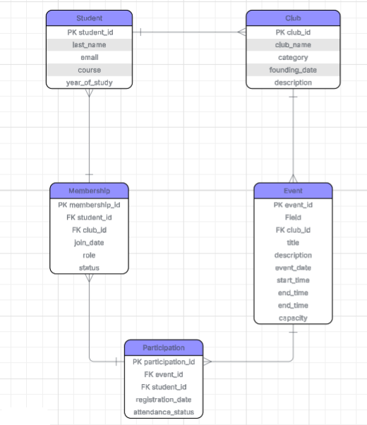

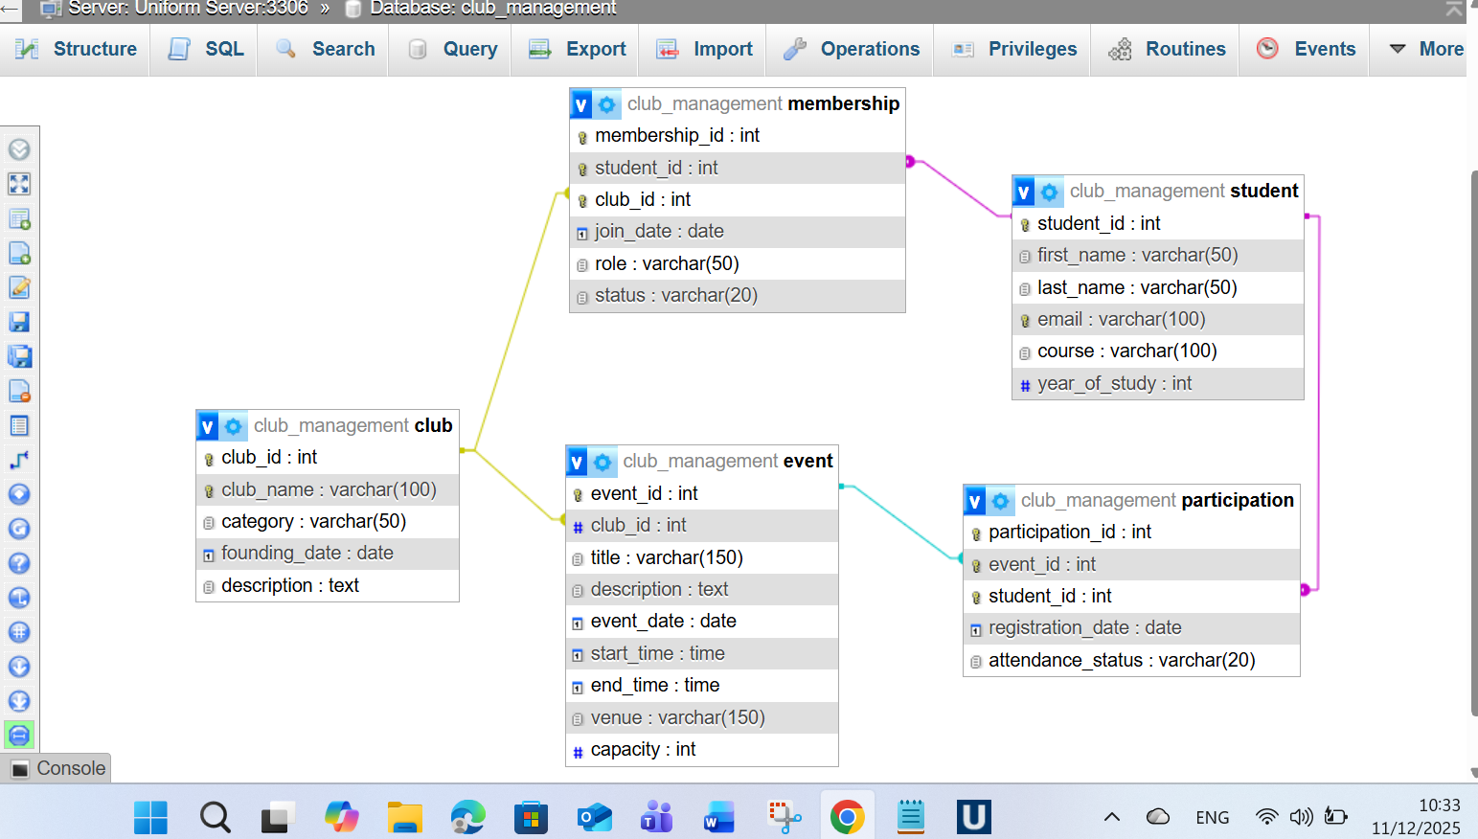
- Student information: This comprises information about the student’s personal and educational background.

- The information about the clubs will comprise the name of the club/group and the description.

- The number of members indicates the relationship existing between the students and the clubs. A student can belong to various clubs, and each of these may contain many members.

- The information regarding each event comprises title, description, date of the event, time of the event, location of the event, and the event capacity. All the events are organized by different clubs.

- The participation information captures the student’s engagement in the club event through attendance or registration.

The following relationships exist:
- Student (1) – (M) Membership (M) – (1) Club
Many-to-many relationship resolved with Membership.
- Club (1) – (M) Event
One club can organise multiple events.
- Student (1) – (M) Participation (M) – (1) Event
Many – to many relationship resolved with Participation.

This structure develops a versatile yet robust paradigm for depicting student participation in clubs and event [3] [4]

2.2 Logical Model and 3NF Normalisation
Normalisation enhances database structure by removing redundancies and irregularities. The design adheres to the concepts of First, Second, and Third Normal Forms:
- 1NF: All tables have atomic values and primary keys.
- 2NF: There are no partial dependencies; characteristics depend on the entire key.
- 3NF: No transitive dependencies; non-key attributes rely entirely on the primary key.

For instance, a student's email address is only stored in the student database and is never used in Membership or Participation. Club qualities are only displayed in the Club table. Event information is not duplicated across participation records. This provides consistency while reducing storage redundancy. [5]

SQL Implementation

Table Creation & Constraints
Each table was implemented using SQL CREATE TABLE statements, which included:
- Primary keys include student_id, club_id, membership_id, event_id, and participation_id.
- Foreign keys reinforce ties.
- UNIQUE restrictions (e.g., student email or club name)
- CHECK restrictions (e.g., event capacity > zero)
- Not NULL constraints for needed attributes
This ensures data accuracy and structural integrity.
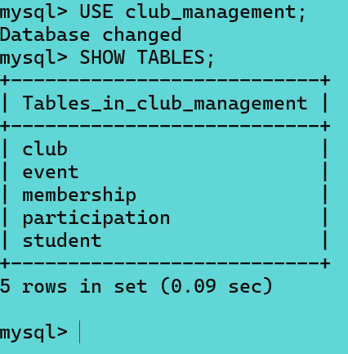
Student Table
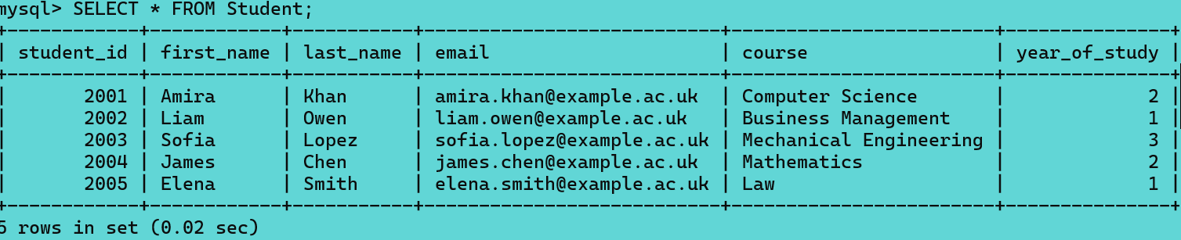

Club Table
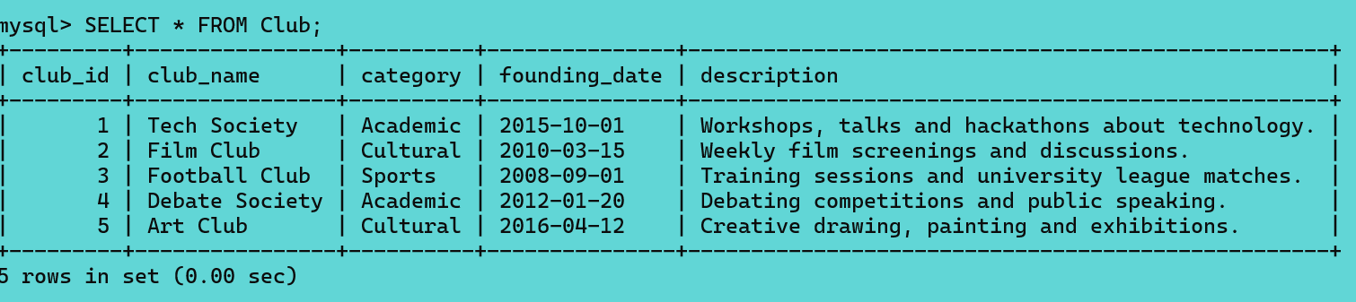
Membership Table
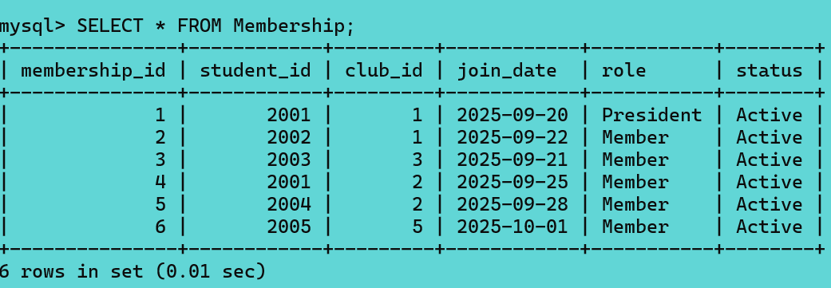
Event Table
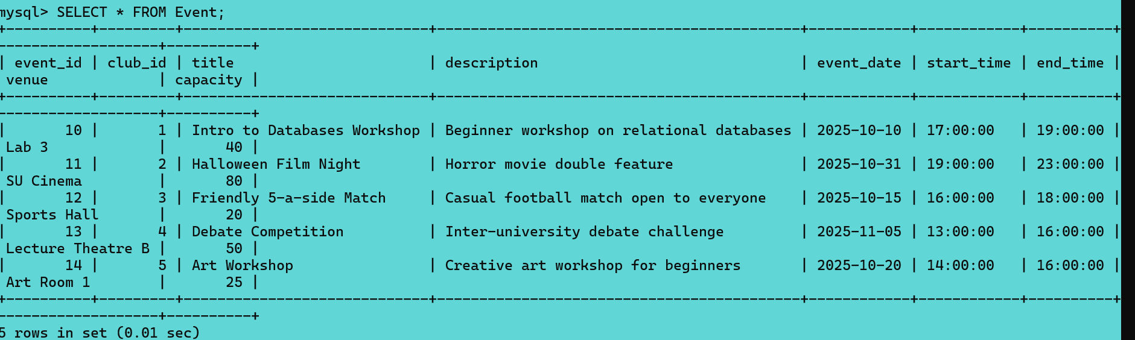

Participation Table
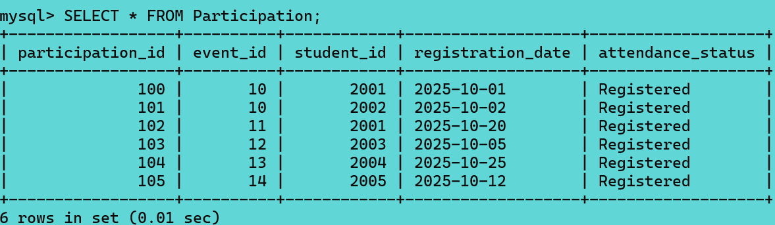

Sample Data Insertion

To demonstrate the functionality, sample data was created.

- Students in different courses and year groups
- Clubs in many categories (academic, sport, cultural)
- Memberships link students to clubs.
- Clubcreated events
- Records of participation in events

It confirms that the database can adequately fulfil the requirements of the system.
Students
INSERT INTO Student (student_id, first_name, last_name, email, course, year_of_study) VALUES
(2001, 'Amira', 'Khan', 'amira.khan@example.ac.uk', 'Computer Science', 2),
(2002, 'Liam', 'Owen', 'liam.owen@example.ac.uk', 'Business Management', 1),
(2003, 'Sofia', 'Lopez', 'sofia.lopez@example.ac.uk', 'Mechanical Engineering', 3),
(2004, 'James', 'Chen', 'james.chen@example.ac.uk', 'Mathematics', 2),
(2005, 'Elena', 'Smith', 'elena.smith@example.ac.uk', 'Law', 1);

Clubs
INSERT INTO Club (club_id, club_name, category, founding_date, description) VALUES
(1, 'Tech Society', 'Academic', '2015-10-01', 'Workshops, talks and hackathons about technology.'),
(2, 'Film Club', 'Cultural', '2010-03-15', 'Weekly film screenings and discussions.'),
(3, 'Football Club', 'Sports', '2008-09-01', 'Training sessions and university league matches.'),
(4, 'Debate Society', 'Academic', '2012-01-20', 'Debating competitions and public speaking.'),
(5, 'Art Club', 'Cultural', '2016-04-12', 'Creative drawing, painting and exhibitions.');

Memberships
INSERT INTO Membership (membership_id, student_id, club_id, join_date, role, status) VALUES
(1, 2001, 1, '2025-09-20', 'President', 'Active'),
(2, 2002, 1, '2025-09-22', 'Member', 'Active'),
(3, 2003, 3, '2025-09-21', 'Member', 'Active'),
(4, 2001, 2, '2025-09-25', 'Member', 'Active'),
(5, 2004, 2, '2025-09-28', 'Member', 'Active'),
(6, 2005, 5, '2025-10-01', 'Member', 'Active');

Events
INSERT INTO Event (event_id, club_id, title, description, event_date, start_time, end_time, venue, capacity) VALUES
(10, 1, 'Intro to Databases Workshop', 'Beginner workshop', '2025-10-10', '17:00', '19:00', 'Lab 3', 40),
(11, 2, 'Halloween Film Night', 'Horror movie screening', '2025-10-31', '19:00', '23:00', 'SU Cinema', 80),
(12, 3, 'Friendly 5-a-side Match', 'Casual football match', '2025-10-15', '16:00', '18:00', 'Sports Hall', 20),
(13, 4, 'Debate Competition', 'Inter-university challenge', '2025-11-05', '13:00', '16:00', 'Lecture Theatre B', 50),
(14, 5, 'Art Workshop', 'Beginner art session', '2025-10-20', '14:00', '16:00', 'Art Room 1', 25);

Participation
INSERT INTO Participation (participation_id, event_id, student_id, registration_date, attendance_status) VALUES
(100, 10, 2001, '2025-10-01', 'Registered'),
(101, 10, 2002, '2025-10-02', 'Registered'),
(102, 11, 2001, '2025-10-20', 'Registered'),
(103, 12, 2003, '2025-10-05', 'Registered'),
(104, 13, 2004, '2025-10-25', 'Registered'),
(105, 14, 2005, '2025-10-12', 'Registered');

Stored Procedures, Transactions and Triggers

Stored Procedure
A saved procedure was written to manage event registration and check event capacity: [6]

DELIMITER $$

CREATE PROCEDURE register_participation(
IN p_student_id INT,
IN p_event_id INT
)
BEGIN
DECLARE event_capacity INT;
DECLARE current_count INT;

SELECT capacity INTO event_capacity
FROM Event WHERE event_id = p_event_id;

SELECT COUNT(*) INTO current_count
FROM Participation WHERE event_id = p_event_id;

IF current_count >= event_capacity THEN
SIGNAL SQLSTATE '45000'
SET MESSAGE_TEXT = 'Event is full';
ELSE
INSERT INTO Participation (event_id, student_id, registration_date)
VALUES (p_event_id, p_student_id, CURDATE());
END IF;
END $$

DELIMITER ;

Transaction Scenario
A transaction ensures that participation is added only when all conditions are satisfied: [7]
START TRANSACTION;

-- Check for duplicates or capacity here

INSERT INTO Participation (event_id, student_id, registration_date)
VALUES (10, 2001, CURDATE());

COMMIT;
If an error occurred, a ROLLBACK would be executed.

Trigger – Membership Status Audit

A trigger logs every change in a membership's state.
Audit Table
CREATE TABLE MembershipAudit (
audit_id INT PRIMARY KEY AUTO_INCREMENT,
membership_id INT,
old_status VARCHAR(20),
new_status VARCHAR(20),
changed_at TIMESTAMP DEFAULT CURRENT_TIMESTAMP
);
Trigger
DELIMITER $$

CREATE TRIGGER log_membership_status_change
BEFORE UPDATE ON Membership
FOR EACH ROW
BEGIN
IF OLD.status <> NEW.status THEN
INSERT INTO MembershipAudit (membership_id, old_status, new_status)
VALUES (OLD.membership_id, OLD.status, NEW.status);
END IF;
END $$

DELIMITER ;

Indexing & Performance Optimization
Indexes were added to improve the performance of common queries:
CREATE INDEX idx_membership_student ON Membership(student_id);
CREATE INDEX idx_membership_club ON Membership(club_id);
CREATE INDEX idx_event_club_date ON Event(club_id, event_date);
CREATE INDEX idx_participation_event ON Participation(event_id);
CREATE INDEX idx_participation_student ON Participation(student_id);

PART B — SQL Injection Vulnerabilities and Defences

Overview of SQL Injection

SQL Injection (SQLi)
SQL Injection (SQLi) is a web application vulnerability. SQLi takes place when user input, such as input provided to a search box or a log-in page, is improperly validated and concatenated to form a SQL database query. In such a circumstance, the interpreter, which is the SQL database system, is left to recognize and interpret the input provided by the attacker. [8]

This is a major issue for websites because it allows attackers to modify the SQL statements specified by developers. Successful SQLi attacks can have serious consequences:
- Unauthorised Access: Attackers can circumvent authentication methods by logging in without a password.
- Data Exfiltration: Passwords, emails, and credit card numbers can be retrieved.
- Data Loss: Attackers can erase entire datasets using commands such as DROP TABLE.
A classic example of a vulnerability is a login query written like this:
$sql = "SELECT * FROM users WHERE username = '" . $username . "'";

If an attacker enters admin' -- as the username, the resulting query becomes:
SELECT * FROM users WHERE username = 'admin' --'

The -- sequence blanks out the rest of the query (ignoring the password check), giving the attacker immediate administrative access . [9]

Vulnerability Analysis of the "Retro Games" Website
Within the scope of the Retro Games Library, I found specific examples of where the app interacts with the database based on user input. These areas are liable to SQL Injection without adequate protection.

Identified Susceptible Areas:

- The Search Facility (index.php): The search bar accepts a string from the user ($_GET['search']) and filters game titles. If raw SQL concatenation was used here, a user might utilise UNION SELECT operations to view data from other tables (such as the users table).
- The Authentication System (login.php): The login form accepts a username and password. This is the most common target for SQLi to bypass security checks.

- Record Management (edit.php / admin.php): The edit page relies on an ID in the URL (id=5). A malicious user could manipulate this ID to access records they are not supposed to see or inject commands.

- Implementation of Anti-SQL Injection Defences
To secure the application, I only used PDO (PHP Data Objects) Prepared Statements. This is the industry-standard approach to avoiding SQL injection in PHP applications. [10]

How the Défense Works:
In prepared statements, the structure and the data are separated. When you call the prepare(), the database parses, compiles, and optimizes the query plan. The input is then sent independently by execute(). SQL injection is not possible because the input is treated only as data and not SQL code, regardless of what has been input by the user.
Evidence of Implementation:

Image 1: Defence Implementation in Search (index.php)
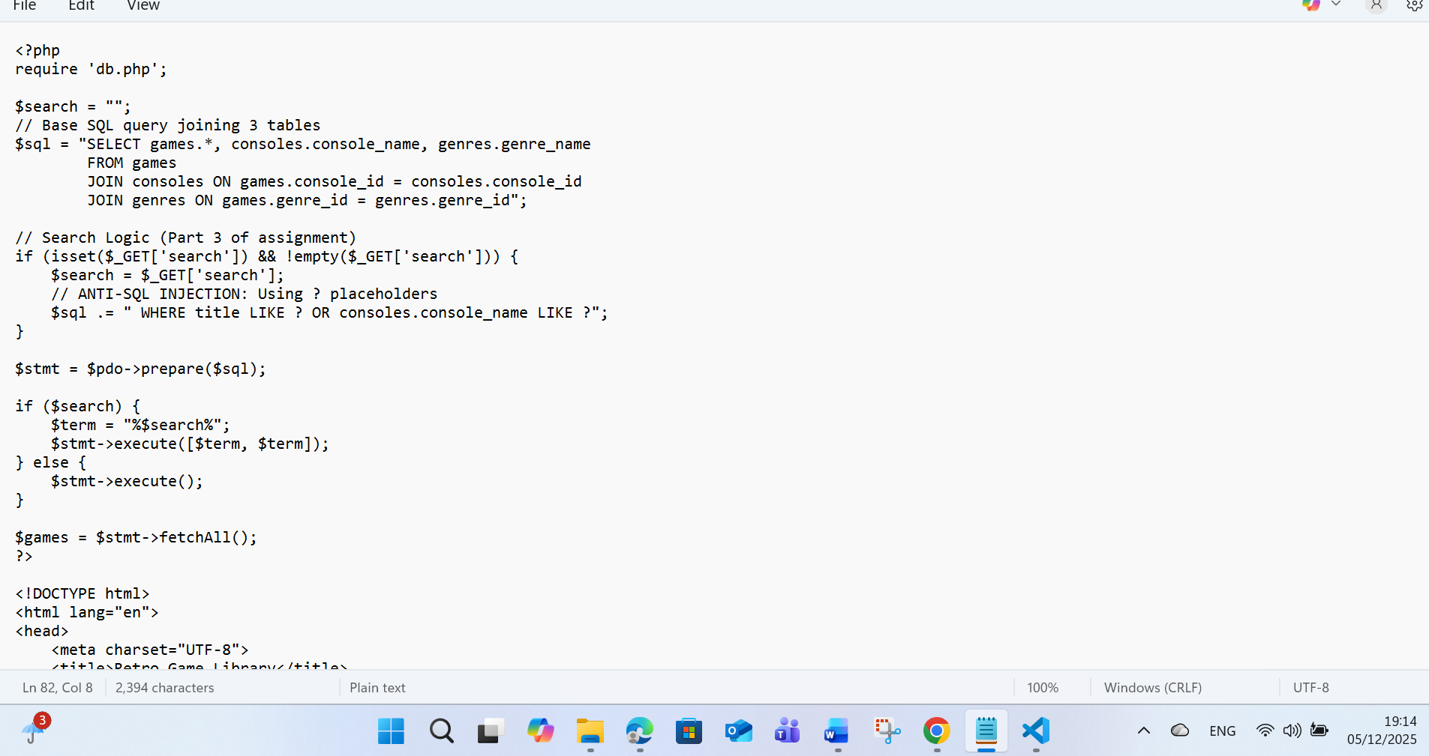
Discussion: As illustrated in Figure 1, I utilised the? placeholder in the SQL string. The variable $search is never inserted straight into the string. It is securely provided through the execute() array.

Image 2: Defence Implementation in Login (login.php)
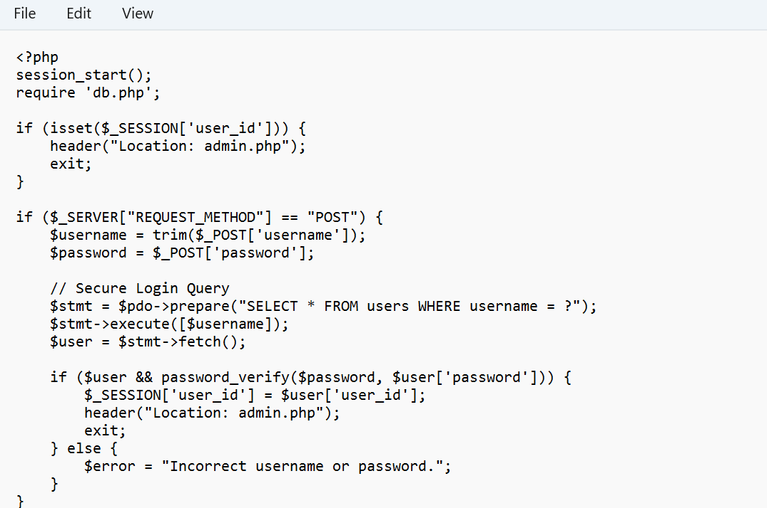
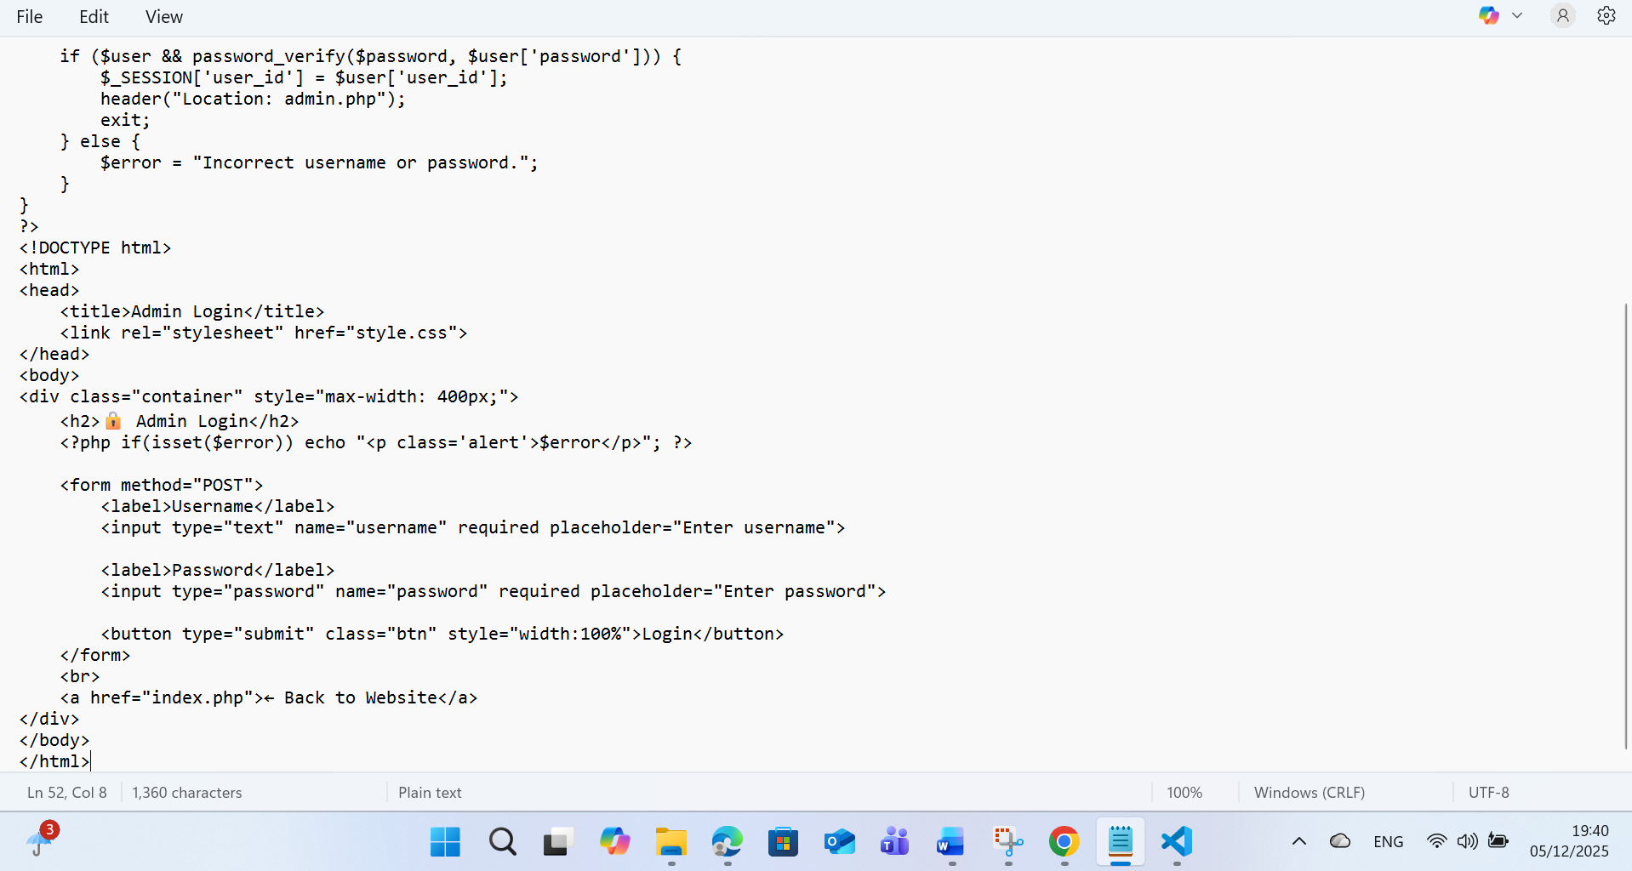
Discussion: In the login system, I looked up the user using a prepared statement. Furthermore, passwords are validated using password_verify(), which means that plain-text passwords are never saved or queried, providing a second layer of protection.

Weaknesses and Future Improvements
While the current method adequately eliminates SQL Injection using PDO, there are some small issues with Data Validation.

Currently, the system is dependent on the database to categorize and save information. In add.php, if a person chooses to insert information into the "Release Year" field, the database is most likely to result in an error message and assign the default value, which is (0). Nevertheless, the programming is not doing any verification prior to submitting information to the database.

Image 3: Code needing improvement (add.php)
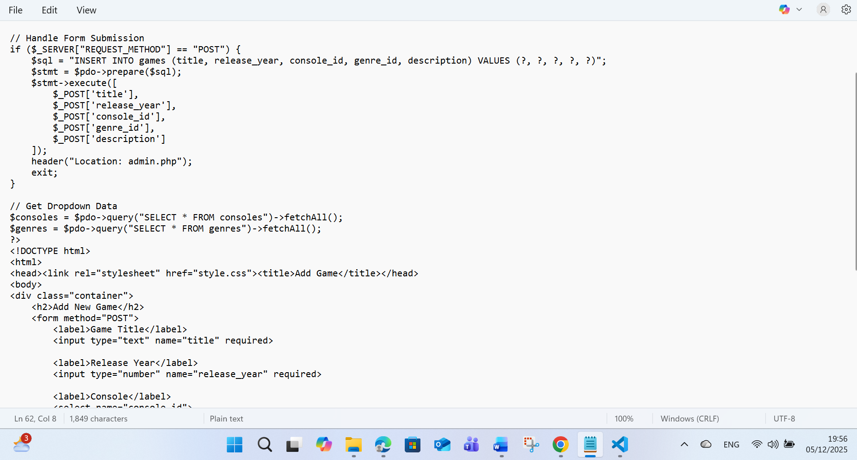

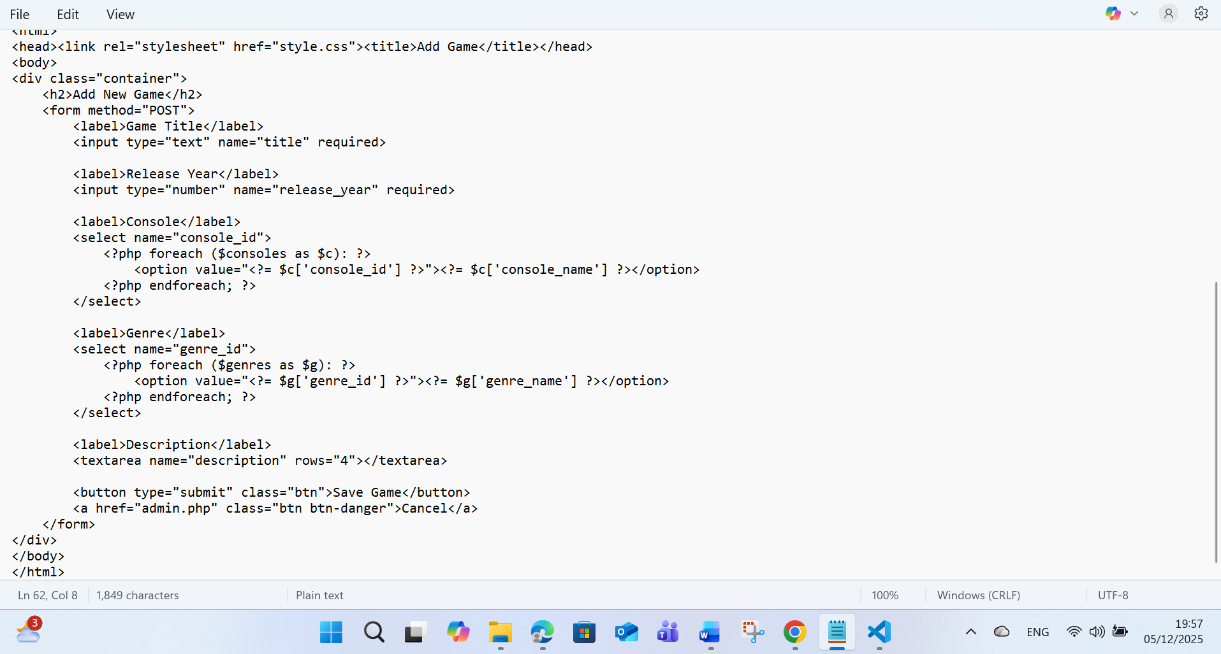

To enhance this in the future, I would use PHP's filter_var() function to ensure that the year is a valid integer and falls within a respectable range (for example, 1970-2025) before trying the database connection. This would eliminate excessive database load and give more accurate user feedback. [11]

Validation Test:
Retro game database from phpmyAdmin
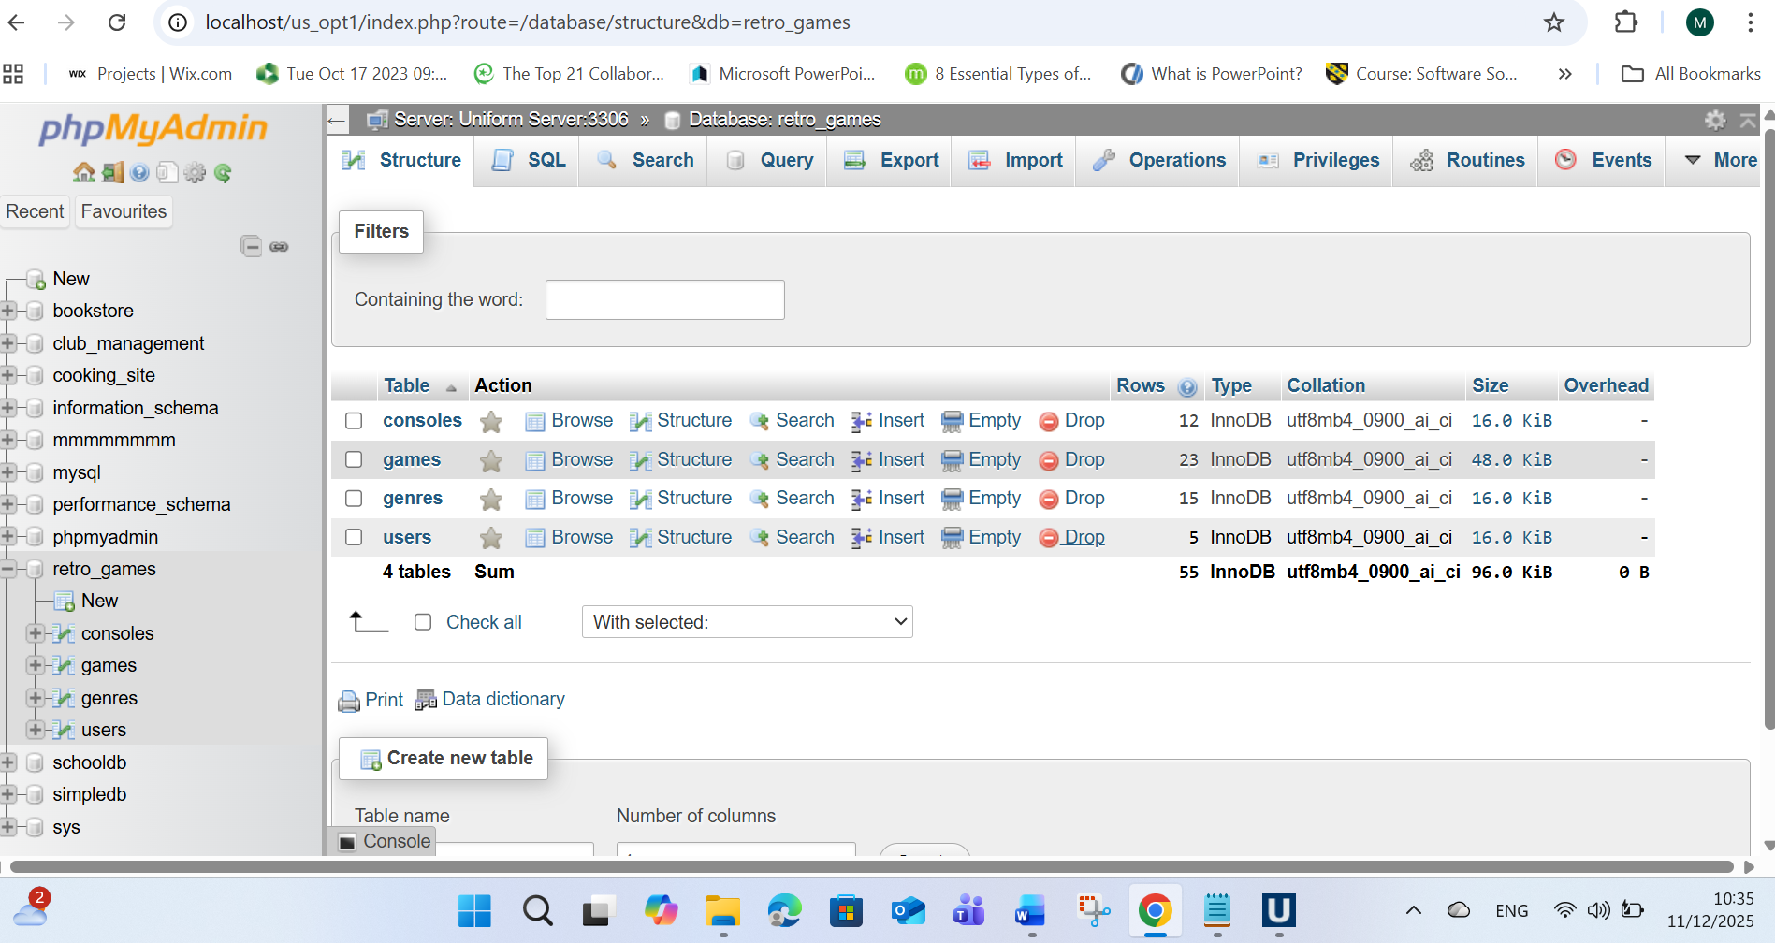

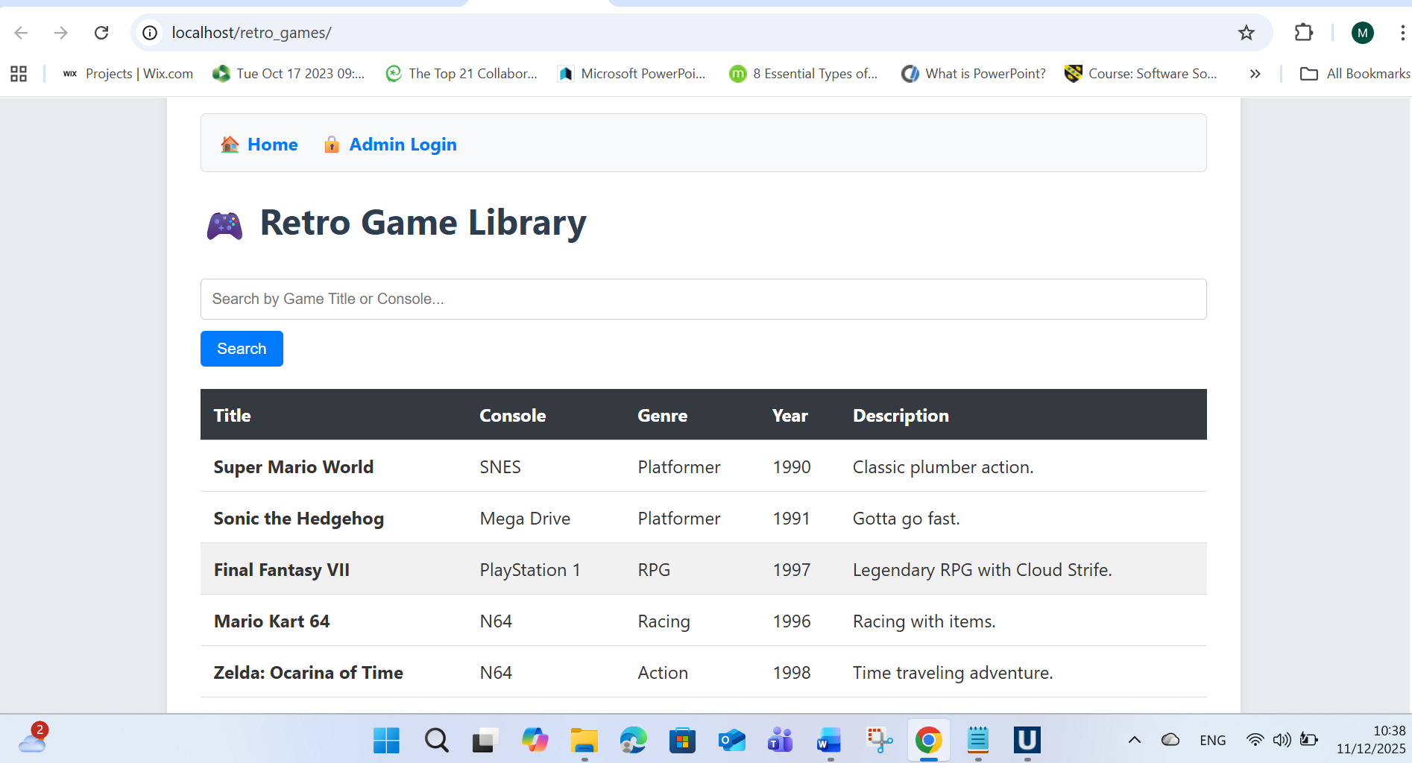
I made manual test on retro game website page to confirm is all alright. The result it will be show bellow.
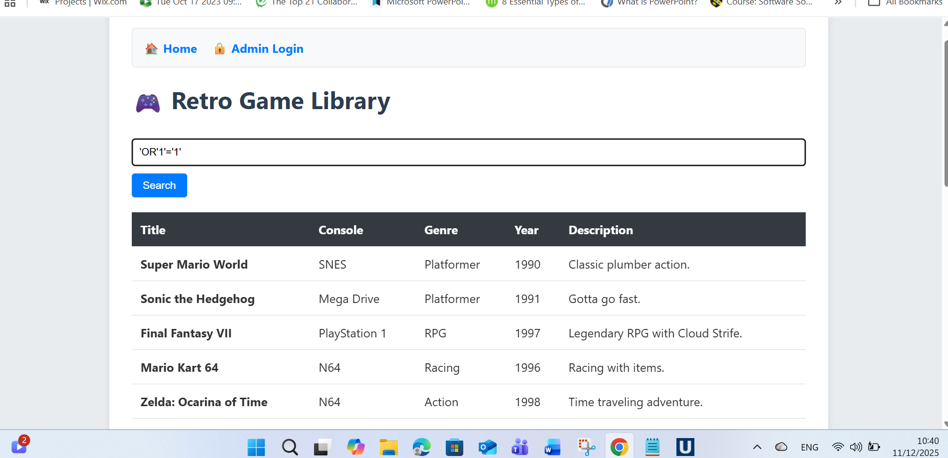

Here is the result of the manual test, it will be demonstrating bellow with the screenshot
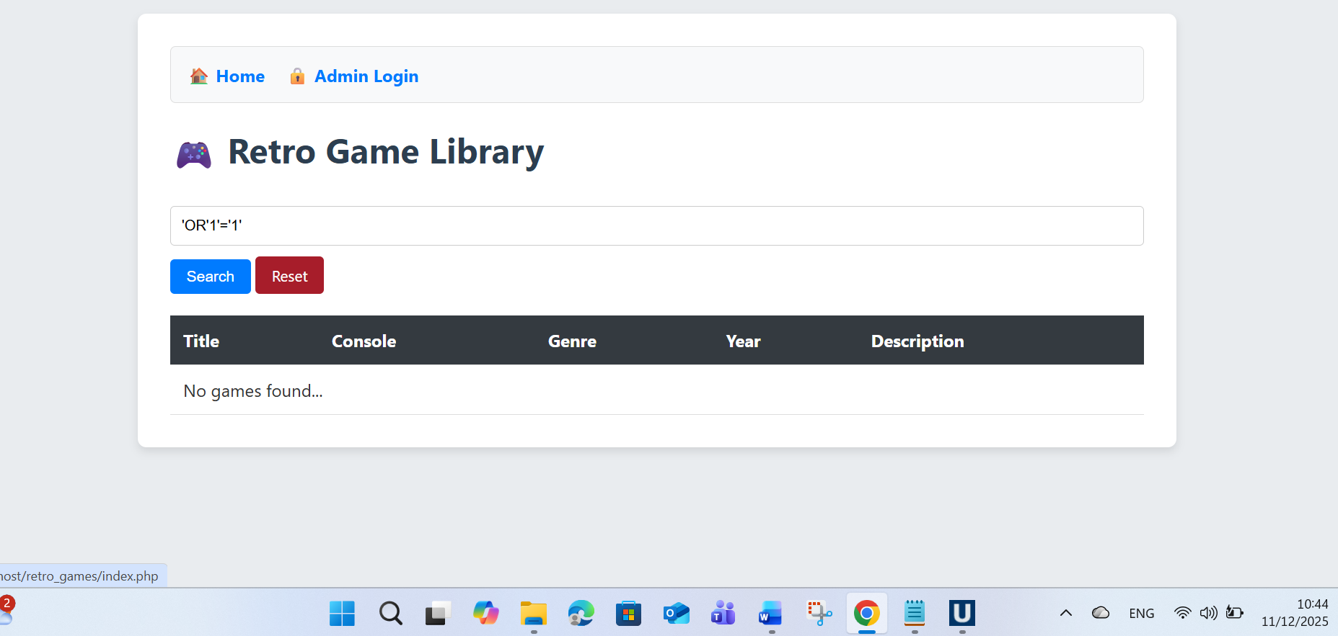

References

[1] | André Ribeiro, Afonso Silva, Alberto Rodrigues da Silva, “Data Modeling and Data Analytics: A Survey from a Big Data Perspective,” Journal of Software Engineering and Applications,, vol. Vol.8, p. No.12, December 30, 2015.
[2] | Mario Soflano, , Thomas M. Connolly, Thomas Hainey, “sciencedirect.com,” August 2015. [Online]. Available: https://www.sciencedirect.com/science/article/abs/pii/S0360131515000937. [Accessed 04 Dec 2025].
[3] | 2. b. V. Paradigm, “Visual Paradigm,” Visual Paradigm, 2025 . [Online]. Available: https://www.visual-paradigm.com/guide/data-modeling/what-is-entity-relationship-diagram/. [Accessed 04 Dec 2025].
[4] | Ivan Belcic, Cole Stryker, “ibm,” ibm, 2025. [Online]. Available: https://www.ibm.com/think/topics/entity-relationship-diagram. [Accessed 04 Dec 2025].
[5] | geeksforgeek, “geeksforgeek,” geeksforgeek, 25 Jul 2025. [Online]. Available: https://www.geeksforgeeks.org/dbms/third-normal-form-3nf/. [Accessed 04 Dec 2025].
[6] | A. Ouko, “.datacamp.com,” datacamp, 8 Jan 2025. [Online]. Available: https://www.datacamp.com/tutorial/sql-stored-procedure?dc_referrer=https%3A%2F%2Fwww.google.com%2F. [Accessed 04 Dec 2025].
[7] | S. Varma, “scaler,” 22 Dec 2023. [Online]. Available: https://www.scaler.com/topics/dbms/transaction-in-dbms/. [Accessed 05 Dec 2025].
[8] | kingthorin, zbraiterman, “The OWASP® Foundation,” 2025. [Online]. Available: https://owasp.org/www-community/attacks/SQL_Injection. [Accessed 05 Dec 2025].
[9] | R. Nixon, “oreilly,” July 2021. [Online]. Available: https://www.oreilly.com/library/view/learning-php-mysql/9781492093817/. [Accessed 05 Dec 2025].
[10] | php, “php,” 2001-2025. [Online]. Available: https://www.php.net/manual/en/pdo.prepare.php. [Accessed 05 Dec 2025].
[11] | S. R. Sharma, “educba.com,” 25 May 2023. [Online]. Available: https://www.educba.com/php-filters/. [Accessed 05 Dec 2025].
[12] | kingthorin, zbraiterman, “owasp,” owasp, 2025. [Online]. Available: https://owasp.org/www-community/attacks/SQL_Injection. [Accessed 05 Dec 2025].
[13] | Fortine, “Fortine,” 2025. [Online]. Available: https://www.fortinet.com/uk/resources/cyberglossary/sql-injection#:~:text=An%20SQL%20injection%20(SQLi)%20is,the%20application's%20underlying%20SQL%20database.. [Accessed 05 Dec 2025].
[14] | Jibran Rasheed Khan, Sehan Ahmed Farooqui, Adnan Ahmed Siddiqui, “Journal of Independent Studies and Research Computing (JISR-C)ISSN (P):2412-0448, ISSN (E):1998-4154,” Journal of Independent Studies and Research Computing (JISR-C)ISSN (P):2412-0448, ISSN (E):1998-4154, vol. 21, no. 2, Dec 2023.
[15] | geeksforgeeks, “geeksforgeeks,” geeksforgeeks, 06 Aug, 2025. [Online]. Available: https://www.geeksforgeeks.org/ethical-hacking/error-based-sql-injections/. [Accessed 05 Dec 2025].
[16] | B. Hofesh, “brightsec.co,” 8 Apr Apr 8th, 2022 . [Online]. Available: https://brightsec.com/blog/sql-injection-attack/#prevention-cheat-sheet. [Accessed 05 Dec 2025].

