


Emerging Network Technologies (ENT)

Tutorial 4

Faculty of Architecture, Computing & Engineering
School of Applied Computing
I.Q Building, Room 205
Swansea
SA1 8EW

- INTRODUCTION AND OBJECTIVES OF THE Exercises
In the lecture, you learnt about the Cellular networks and LTE, which is an essential factor in successfully operating the network. Apply your understanding and knowledge from what you learnt in the lecture about the topic by answering the following:

Please read the following and then answer the questions as best as you can, your lecture notes, text book, library databases and/or the Internet can be used to answer the questions. – 30 mins
Once you have done that, discuss your answers with other members on your table – 10 mins
Be prepared to discuss and even present your findings to the rest of the class, upon the lecturer’s choice

Questions:
- Explain two types of cellular networks interference.

- Describe the cellular hierarchy.

- Describe the typical hardware and software architectural elements of a cellular network.

- What do you understand by channel reuse in cellular networks?

- What are some advantages and challenges of cellular networks?

- A newly form Internet Provider company, employed you as their Network specialist. You are asked by the company Manager to explain LTE and LTE advanced. Than Manager need to know if there are any major differences between both and also if LTE technologies are better for Broadband Mobile Internet compare to that of WiMAX. Write a report explaining to the Manager about these technologies and giving your views about LTE technologies and WiMAX.

- Problem solving of operation of cellular networks

  - Consider a single high-power transmitter (see diagram below) that can support 35 voice channels over an area of 100 km² with the available spectrum. If seven lower power transmitters are used so that they support 30% of the channels over an area of 14.3 km² each, then a total of ~80 voice channels are now available in this area instead of 35. In reality, channels will have to be allocated to BSs in such a way as to prevent interference between one BS and another.

    - Provide a radio communication service to a city with total bandwidth available is 25MHz and each user requires 30 KHz of bandwidth for voice communication. If one antenna is use to cover the entire town,
      - How many users can be supported simultaneously?

    - If the city is split into hexagonal cells with seven cells per cluster
      - How much allocated spectrum each cell has?
      - Hence, how many users can each cell supported?

    - If a cellular topology was employed where 20 lower power antennas are opportunistically located to minimize both kinds of interference:
      - Now, what is the total number of simultaneous users?

Note that the number of users supported simultaneously (capacity) can be calculated using the formula:
$n= \frac{k(\frac{S}{N})}{W}$ Where S is the total spectrum, W is the bandwidth needed per user, N is the cluster size, and k is the number of cells required to cover a given area.

Frequency Reuse

Consider figure (a) and (b) below, Frequency Reuse example:
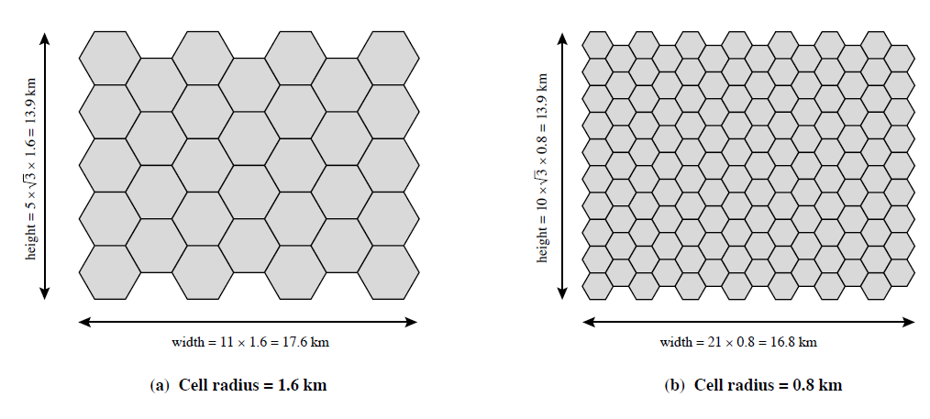
Assume a system of 31 cells with a cell radius of 1.6km, a total of 32 cells, a total frequency bandwidth that supports 336 traffic channels and a reuse factor of N = 7.

The area of a hexagon of radius R is 1.5R² $\sqrt{3 }$

If there are 32 total cells,
- What is the area of the hexagon?
- What geographic area is covered (the total area covered)?
- How many channels are there per cell (the number of channels per cell)?
- What is the total number of concurrent cells that can be handled (the total channel capacity)?
- Repeat for a cell radius 0.8km and 128 cells.

Signal Strength
In designing a cellular layout, the communications engineer must take account of these various propagation effects, the desired maximum transmit power level at the base station and the mobile units, the typical height of the mobile unit antenna, and the available height of the BS antenna. These factors will determine the size of the individual cell. Unfortunately, as just described, the propagation effects are dynamic and difficult to predict. The best that can be done is to come up with a model based on empirical data and to apply that model to a given environment to develop guidelines for cell size.

For an urban environment, predicted path loss is:
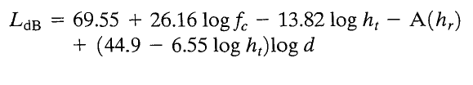
Where
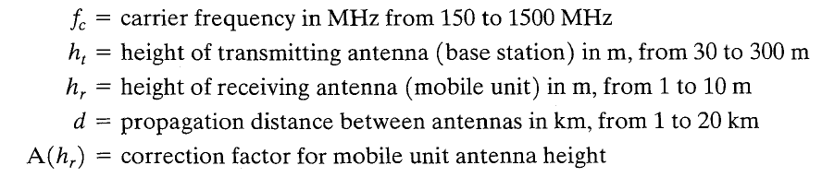

For a small or medium size city, the correction factor is given by:

For a large city it is given by:
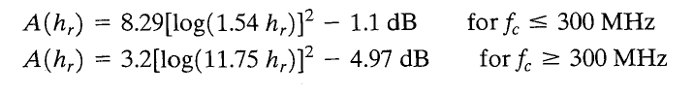

To estimate the path loss in a suburban area, the formula for urban path loss above is modifies as:
And for the path loss in open areas, the formula is modified as:

- Let f_{c} = 900MHz, h_{t} = 40m, h_{r} = 5m and d = 10km. Estimate the path loss for a medium-size city. Show your working.

Traffic Engineering

Traffic engineering concepts were developed in the design of telephone switches and circuit-switching telephone networks, but the concepts equally apply to cellular networks. Consider a cell that has L potential subscribers (L mobile units) and that is able to handle N simultaneous users (capacity of N channels). If L ≤ N, the system is referred to as nonblocking; all calls can be handled all the time. If L > N, the system is blocking; a subscriber may attempt a call and find the capacity fully in use and therefore be blocked.

Two parameters determine the amount of load presented to a system:
λ = the mean rate of calls (connection requests) attempted per unit time
h = the mean holding time per successful call

The basic measure of traffic is the traffic intensity, expressed in a dimensionless unit, the erlang:
A = λh
Where A equals the average number of calls arriving during the average holding period or one could view A as the mean number of calls in progress.

Consider the figure below, an example distribution of Traffic in a Cell with Capacity 10 channels over a period of 1 hour (60 minutes):
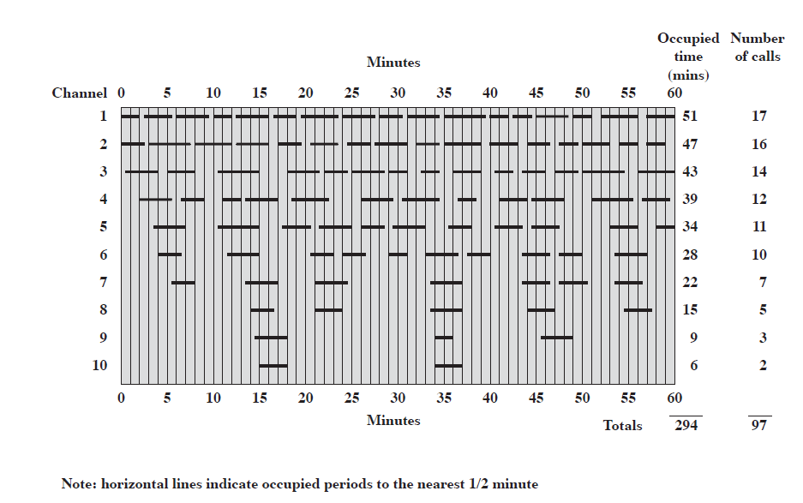
What is?
- The rate of calls per minute?
- The average holding time per call, in minutes
- The mean/average number of calls in progress

