Assessment 1 – November 5th, 2021
What is climate change?
Climate change is a challenge the whole world faces, it poses an existential threat to humanity if we leave it go unchecked, The United Nations defines climate change as; “long-term shifts in temperatures and weather patterns. These shifts may be natural, but since the 1800s, human activities have been the main driver of climate change, primarily due to the burning of fossil fuels (like coal, oil and gas), which produces heat-trapping gases”. (1) So, what are we doing about climate change? and how are businesses adapting to solve this crisis? Read more to find out!

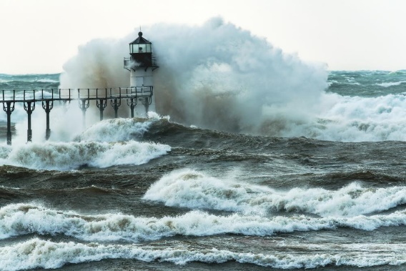
How does climate change affect business?
Changes in climate can affect business in numerous ways depending on where a business is geographically located. The adverse effects of unpredictable weather can have very severe consequences on a business directly. In countries where it is hot you may have increased risk with droughts and wildfires. If a business is located near the sea or major river then it may be vulnerable to flooding and abrupt cutting off from vital utilities. The weather can impact businesses in many potentially catastrophic ways, and as climatological science has shown through years of collecting research and data. Increases in temperature may be increasing the frequency and severity of droughts and storms.

- Tom Gill – Waves Pounding The Outer Light

Global trends in temperature change
Ever since the dawn of the Industrial Revolution, mankind has been burning fossil fuels like coal oil and gas at a very literal unprecedented level, while this revolution did spark a never-before-seen age of prosperity and technological innovation, it has also presented us with an only right now realised existential problem. With all the new levels of CO2 being put in our atmosphere, how are we going to deal with this enormous global increase of greenhouse gasses, heating up our atmosphere? How are we going to reverse the effects of two hundred years of burning these fossil fuels? According to NOAA's 2020 Annual Climate Report “the combined land and ocean temperature has increased with an average rate of 0.13 degrees Fahrenheit (0.08 °C) per decade since the 1880’s” (2) How will the global community solve this problem?

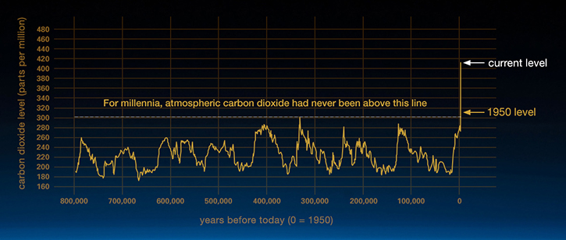

(2) Robust CO2 data from ice cores covering the last 800,000 years. From climate.nasa.gov
Which nations are most impacted?
Changes in climate don’t have a neat uniform effect on all nations in the world, some nations will inevitably suffer more from temperature rises, while some others will almost certainly prosper. Here we will look at two nations and how their economies each will be affected by global warming.
The case for Russia
Russia is a very cold country. It’s also very large, the largest in the world in fact. With its borders spanning 17.13 million km² of land. Today, only about 27% of Russia's total population lives in the very cold and inhospitable region of its northern territories, but in the future the rising of global temperatures will almost certainly make this massive, 13 million square-kilometre region, much more habitable than it currently is today. A great transformation will come over Russia, for centuries most of its land has been inhospitable to human habitation and farming, (3) It is estimated that Russia is warming 2.5 times faster than the rest of the world, meaning that this will lead to a considerable reduction in snow cover in most areas of Russia. The projected increase in winter precipitation in most parts of the country will be mainly due to rain, reducing the snow mass and increasing winter runoff (4), and soon Russia will see the benefit of more arable land to grow crops and graze cattle, Improving the health of the nation, Improving the nations GDP as there will be less spent on importing food. As well as opening many opportunities for business ventures and foreign investment for Russia’s soon to be thriving economy.
The case for Africa
The continent of Africa however seeks to be hurt the most by the changing climate. Especially in countries like Mozambique. Africa is underdeveloped, the people there rely on old farming techniques and fossil fuels heavily. Slight disruptions to this can shake Mozambique very hard. The Global Climate index ranks Mozambique as the country most affected by climate change after it took a 12.6% GDP knock on its economy in 2019 and suffered $4.9 billion losses in monetary terms from the impacts of climate change that resulted in the deaths of 700 Mozambicans. (5)



- Angolan President Joao Lourenco and Russian President Vladimir Putin in Johannesburg in 2018. EPA-EFE/Alexei Nikolsky/Kremlin Pool
Extreme weather events like Cyclone Idai in 2019 wiped out 2.2% of Mozambique’s GDP as well as the lives of 347 people. If weather events like Idai are to be more frequent, Thousands of businesses will be forced to shutter and whole communities would be thrust into poverty. With very little economic incentive for businesses to stay, African nations will surely be the worst affected places on Earth when the climate starts changing more rapidly.

The case for Amazon

Amazon is the 4th largest company on the planet, and in 2020 the online retail platform reported a net income of 21.33 billion US dollars. Which is nearly double of what it made the year prior in 2019. Amazon is owned by the world’s richest man, Jeff Bezos, who founded it in 1994 out of the garage of his rented home. Amazon operates all over the globe, powering an almighty global fleet of trucks and cargo planes, with thousands of warehouses and enrichment centres, supplying customers with goods 24 hours a day, 7 days a week, 365 days a year. Of course, running this mighty economic powerhouse has a very drastic impact on the environment, according to the e-commerce firm's latest sustainability report, Amazon's absolute global carbon footprint during 2020 was 60 million metric tonnes – almost one-fifth higher than 2019 levels. This means that the business is now emitting more than Ireland annually. (6)
So, what is Amazon doing to curb their carbon emissions? Firstly, Amazon has a plan to be net-zero by 2040, That means that overall Amazon will have zero impact on the environment, they hope to achieve this monumental goal by powering their operations on 100% renewable energy, they also plan to make 50% of their shipments net-zero carbon by 2030 which can be achieved with their deployment of 100,000 custom electric delivery vehicles by 2030. Amazon is also investing two billion dollars to support decarbonising technologies and services as well as investing 100 million dollars into reforestation projects and climate mitigation solutions. (7)

(4) Amazon’s vision of sustainability

What is sustainability?
To understand how sustainability works in business it’s important to first understand its definition. National Geographic defines sustainability as “The practice of using natural resources responsibly today, so they are available for future generations tomorrow. “(8) Sustainability has three main components or pillars: Economic, Environmental and Social, or more commonly, Profits, Planet, People. The Environmental element means to preserve and protect the environment around us. By reducing pollution and our carbon footprint as well as transitioning to renewable energy The Social element of sustainability aims to improve the health and lives of those most effected by climate change. This is achieved through market regulations and innovations i.e., Providing people with more clean air and water. The Economic element refers to people being able to afford more luxuries such as fuel as the costs will be lowered due to conservation. More sustainable development impacts would mean that people are more able to invest in their own futures.
So how can businesses be sustainable? There are many ways a business can become sustainable: reducing waste, preventing pollution, adopting clean energy, conserving water, greening the planet by planting trees, using sustainable materials, making their products sustainable, and by adopting
sustainable business travel policies. (9) A great example of this would be Patagonia who make jeans for outdoor exploration. Patagonia has been striving to be an environmentally friendly business for more than twenty years. 1% of their revenue goes to environmental organisations, and they organise workshops where consumers learn how to repair their own clothing and belongings - or Patagonia fixes it for them. The clothing doesn't have to be Patagonia’s. They also encourage sustainable travel by organising a yearly event in June. (9)
The case for Apple
Some businesses however can be antithetical to sustainable development, Take Apple for instance, the largest company in the world, Apple reported net income of 57.41 billion U.S. dollars in its 2020 fiscal year, the second highest net income to date. Apple's global revenue rose to 274.52 billion U.S. dollars in that same year. (10) While Apple said last year, it wants to eliminate its contributions to climate change and become carbon neutral by 2030. The company says it will directly eliminate 75% of emissions from its supply chain and products by 2030, and the Restore Fund will help address the other 25% of its emissions. (11) However, Apple are contradicting their pro-environment message by severely limiting the repairability of their smartphones and laptops. Apple is hyper focused on selling new phones, with new models every year, encouraging their customers to keep buying the new model of smartphone every time they release one, which at the current rate is about once annually. This marketing scheme is very costly to the environment. Producing inordinate amounts of e-waste and carbon emissions, 79% of Apple’s carbon emissions are in production, and production takes place in poorer countries with very few or no emission regulation laws. Apple is also rapidly advancing their smartphone designs to be as difficult to repair as possible for the average consumer, with proprietary screw heads, unibody enclosures, glued in lithium batteries and meticulously written software hard coded into all their devices ensuring that aftermarket replacement parts aren’t made compatible with the rest of the device, all this to ensure that Apple holds a monopoly on repair, and can push for increased sales. On average an Apple iPhone XS takes about 70kg of CO2 to produce, its much worse with their MacBook’s which on average cost 212kg of CO2 to manufacture. Limiting the lifecycle of their products is contradictory to their supposed pro-environmentalist stances. This all just goes to show that you must always question companies about their true intentions behind their emission limitation plans.
Renewable Energy
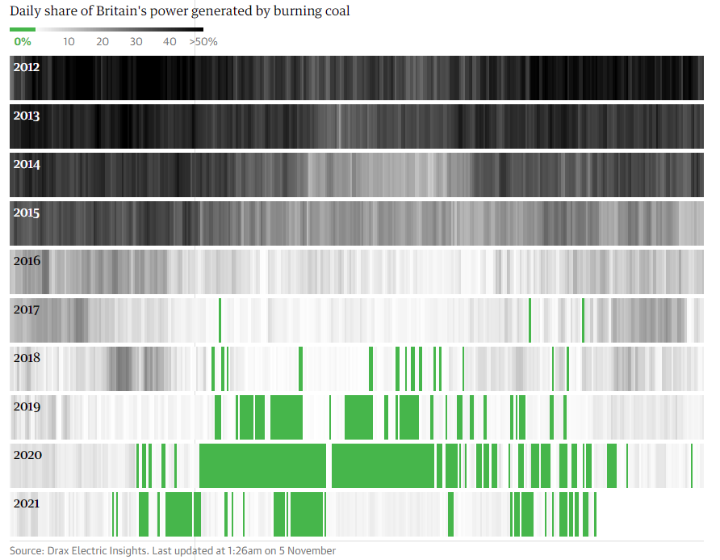
Sustainable technology is the most important component to being environmentally conscious and sustainable. Renewable energy is a very popular example, these include wind, hydroelectric, solar, geothermal, and tidal. Renewable energy technologies are also dependent on entirely weather-related factors such as wind speed and sunlight exposure, meaning that the size and location of a business will help determine which type of renewable source is most suitable.
Almost all the world’s major economies have implemented emission trading programs, or in layman’s terms, carbon taxes, where businesses are made to pay large fines to governments for the right to pollute, which means that businesses will cut down emissions in order to pay less tax. In fact, most investments made into the renewable energy transition are coming from private investments, because green energy truly is the future, soon enough fossil fuels will be too economically viable, while renewable sources will become just like untapped goldmines of profit for these massive energy firms.

(5) daily share of Britain’s power generated by burning coal
The return on investment for green energy is over 422% compared to just 59% in fossil fuels. This can be seen in Britain’s power generation statistics. Last year in 2020, coal fired power plants were barely switched on to meet our massive power demands. (12)

How technology has evolved
In the year 2000, Scientists believed that in the year 2020 the Global National Grid could only generate 20 gigawatts per hour using wind turbines. Fortunately, these predictions were totally wrong. Because today we generate 651 gigawatts per hour, we were wrong by 3,155%. It’s the same story for solar power, we thought we would only increase solar power output by 1 gigawatt every year until 2020, But again, we were wrong, only off by 15,300%, Now we install 154 gigawatts of solar per year and it only grows exponentially (13) ) This is because of the unpredictability of the private sectors ability to adapt and invent groundbreaking technology, no one predicted the internet or smartphones, and no one 20 years ago believed we could be dependent on renewable energy. IN fact, we are almost there, In Scotland 97% of the grid is supplied with renewables. (14)
Emissions in the Transport Sector
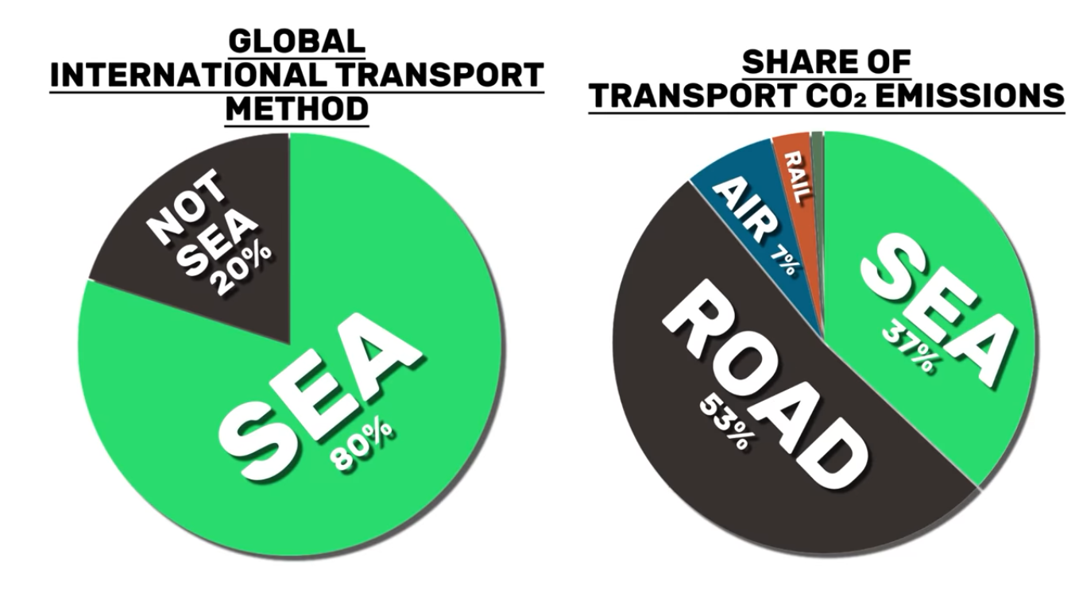
To power a global economic engine you need transport, and lots and lots of it. It is estimated that in 2019, 11 billion tonnes of cargo was moved on ships all around the globe, to put that into perspective that’s almost like moving the entire weight of the Three Gorges Dam in China around the world on a boat. Ships, however, pose a serious global problem when it comes to greenhouse gas emissions. 80% of international transport of goods are done over the sea. And container ships aren’t well known to be green and efficient. Large commercial vessels primarily burn what's called Heavy Fuel Oil when out at sea. This fuel is not heavily refined, has high sulphur content and produces a lot of sulphur oxide and nitrogen oxide. These emissions contribute to the greenhouse effect far more than plain carbon dioxide, they even pose more of a risk to human health. Yet trucks and cars that occupy the road are responsible for more than half of transport CO2 emissions
(6) Percentages of Global International Transport and share of CO2 Emissions

Breakthroughs are being made with road transport, however. More and more consumers are choosing to buy hybrid cars, which are cars that use both electricity as well as petrol, Recent tech start-ups like Tesla are seriously pushing the electric vehicle industry forward, bringing more sustainable development for road users.
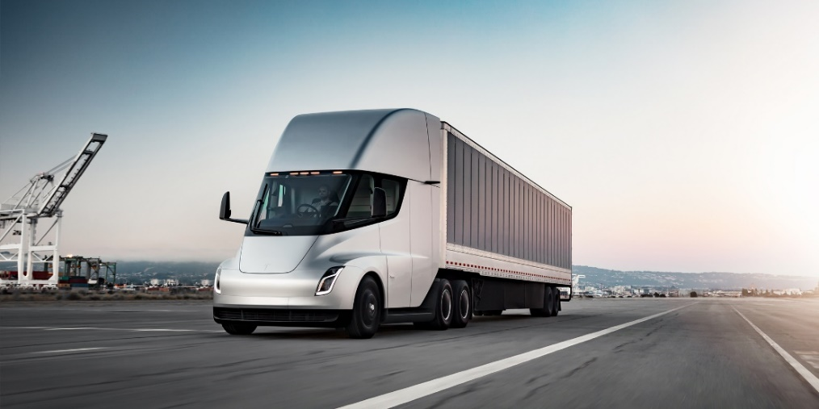
Breakthroughs are being made with road transport, however. More and more consumers are choosing to buy hybrid cars, which are cars that use both electricity as well as petrol, Recent tech start-ups like Tesla are seriously pushing the electric vehicle industry forward, bringing more sustainable development for road users. Tesla is even designing and testing all electric semi-trucks, since most road CO2 emissions come from trucks, Tesla’s breakthrough will seriously help to stop the climate change crisis. If Tesla sticks to its specs and price point for the Tesla Semi, it’s hard to overstate the impact that it could have on the trucking industry. “Electrifying the trucking industry would have a massive impact on emissions, but in a highly competitive industry where every cent per mile is crucial, the decisions are often made with a spreadsheet. That’s where Tesla Semi comes in with a capacity capable of covering most US trucking routes while delivering a lower cost of operations thanks to fuel and maintenance savings. They already attracted the attention of major fleet owners, like Walmart, PepsiCo, and trucking companies.” (15)
(7) Tesla’s new all electric semi-truck concept art

So, what’s the conclusion?


Overall, there are many ways that businesses are threatened by climate change, and as we have seen for hundreds of years the market has learned to adapt, along with this adaptation. There will also soon be a new dawn of prosperity for mankind, with cleaner air and water improving the health of everyone, Soon the whole planet will be powered by renewable energy, and businesses will be using all sustainable resources to develop their new products.
(9) A future vision of a sustainable city
(8) A smog shrouded mega city

References
- United Nations (2021). What Is Climate Change? https://www.un.org/en/climatechange/what-is-climate-change - Accessed on 29/10/2021)

- Climate.gov (2021). Climate Change: Global Temperature: https://www.climate.gov/news-features/understanding-climate/climate-change-global-temperature - Accessed on 29/10/2021)

- NYTimes. (2020). HOW RUSSIA WINS THE CLIMATE CRISIS : https://www.nytimes.com/interactive/2020/12/16/magazine/russia-climate-migration-crisis.html - Accessed on 29/10/2021)

- Wikipedia (2021) Climate Change In Russia / Projected precipitation changes: https://en.wikipedia.org/wiki/Climate_change_in_Russia - Accessed on 29/10/2021)

- Quartz Africa (2021) These African countries are among the world’s worst hit by climate change: https://qz.com/africa/1965013/mozambique-zimbabwe-malawi-worlds-worst-hit-by-climate-change/ - Accessed on 29/10/2021)

- Edie.net (2021) Amazon's carbon footprint grew 19% in 2020 amid pandemic parcel boom : https://www.edie.net/news/6/Amazon-s-carbon-footprint-grew-19--in-2020-amid-pandemic-parcel-boom/ - Accessed on 29/10/2021)
- Amazon (2020) Amazon sustainability: https://sustainability.aboutamazon.com/ - Accessed on 29/10/2021)
- National Geographic Society (2019) Sustainability: https://www.nationalgeographic.org/encyclopedia/sustainability/ - Accessed on 30/10/2021)
- FlyGreen (2020) 5 Sustainable Businesses in 2021 & Their Best Practices : https://flygrn.com/blog/sustainable-businesses-best-practices- Accessed on 30/10/2021)
- Statista (2021) Apple’s net income 2005 – 2020 : https://www.statista.com/statistics/267728/apples-net-income-since-2005/#:~:text=Apple%20reported%20net%20income%20of,dollars%20in%20that%20same%20year. - Accessed on 31/10/2021)

- The Verge (2021) Apple launches $200 million fund for climate change: https://www.theverge.com/2021/4/15/22385552/apple-200-million-fund-climate-change-environment - Accessed on 31/10/2021)
- Vox (2015) The International Energy Agency consistently underestimates wind and solar power, Why? :https://www.vox.com/2015/10/12/9510879/iea-underestimate-renewables - Accessed on 31/10/2021)
- The Guardian (2020) Britain breaks record for coal-free power generation: https://www.theguardian.com/business/2020/apr/28/britain-breaks-record-for-coal-free-power-generation - Accessed on 31/10/2021)
- BBC (2021) Renewables met 97% of Scotland’s electricity demand in 2020: https://www.bbc.co.uk/news/uk-scotland-56530424 - Accessed on 01/11/2021)
- Electrek (2021) Tesla Semi electric truck is finally nearing production: https://electrek.co/2021/07/20/tesla-semi-electric-truck-finally-go-into-production/ - Accessed on 01/11/2021)

Images
- https://www.flickr.com/photos/lapstrake/32272107047/in/photolist-RaLZ5K-29mNy1o-ZgZB7d-rA8u5-2fN8kiz-22CJWfM-J9FFN2-CoNkyy-9uW71e-NJeWK7-p1e7XD-29nV3Tj-2e9kAF3-NVK4VE-2aUJAT9-DoTQiT-PZq5zc-QcWiXL-skGZNL-cRUZVY-d5f7gw-3BiNAj-

- https://earth.org/data_visualization/a-brief-history-of-co2/

- https://theconversation.com/how-russia-is-growing-its-strategic-influence-in-africa-110930

- https://sustainability.aboutamazon.com/

- https://www.theguardian.com/business/2020/apr/28/britain-breaks-record-for-coal-free-power-generation

- https://unctad.org/topic/transport-and-trade-logistics/review-of-maritime-transport

- https://electrek.co/2021/07/20/tesla-semi-electric-truck-finally-go-into-production/

- https://cityzenith.com/clean-cities-clean-future

- https://cityzenith.com/clean-cities-clean-future

