Running Head: REFLECTIVE REPORT

Leadership and Management Skills for the Workplace
[Alexandru Munteanu]
[University of Wales Trinity Saint Davit London]
[Anita Nan (BMS6105)]
Table of Contents
Reflection of My Coaching Session 4
Description 5
Feelings 5
Evaluations 5
Conclusions 6
Action 6
SMART Actions 7
Critical Evaluation of Coaching and Mentoring 9
Grow Model 9
Reflection on the coaching Session- Goal 9
Reality 10
Options 11
Way Forward 12
An analysis of skills, behaviors, attitudes and beliefs of coaches 13
Conclusion 15
Reference 17

Leadership and Management Skills for the Workplace

Introduction
Through coaching and mentoring, which are crucial components of professional growth and promote organisational success, people may reach their full potential (Cornelius et al., 2020). With the goals of fostering self-discovery, goal-setting, and skill development, coaching is a collaborative interaction between an experienced coach and a client. Mentoring, in contrast, is a more seasoned professional—the mentor—guiding and teaching a less seasoned individual—the mentee—to encourage their professional development (Garvey et al., 2018). By serving as catalysts for both professional and personal advancement, coaching and mentoring both support a culture of continuing learning and achievement.
Coaching provides a plethora of advantages for people seeking to improve both professionally and personally (Bachkirova et al., 2020). It basically provides a personalised professional growth path, allowing users to pinpoint their strengths, development needs, and objectives. This self-awareness encourages greater self-confidence and a more distinct sense of purpose. Coaching also promotes goal orientation by aiding individuals in formulating specific, attainable objectives and making strategies to achieve them (Garvey et al., 2021). This process fosters accountability for one's growth whilst also boosting motivation. Additionally, coaching fosters the growth of crucial skills like effective leadership, problem-solving, and communication, which enhances an individual's total competency (Cornelius et al., 2020). Coaching also encourages adaptability and resilience, providing people with the tools they need to face challenges.
Employers find that incorporating coaching within their organisational structure has several advantages. The first benefit of coaching is that it raises engagement and job happiness (Al Hilali et al., 2020). Individualised attention and guidance make people feel valued by the organisation, which boosts engagement and creates a positive work environment. Second, coaching enhances individual performance, which contributes to the business's success. When employees grow in their skills and work toward clearly defined objectives, their contributions are more important and consistent with corporate objectives. Thirdly, coaching fosters the leadership potential of a workforce. By investing in coaching programs for prospective leaders, employers may create a pool of skilled workers who are ready to take on additional responsibility (Cornelius et al., 2020). Additionally, coaching encourages improved communication and interpersonal dynamics amongst staff employees, which enhances cooperation and collaboration.

Reflection of My Coaching Session
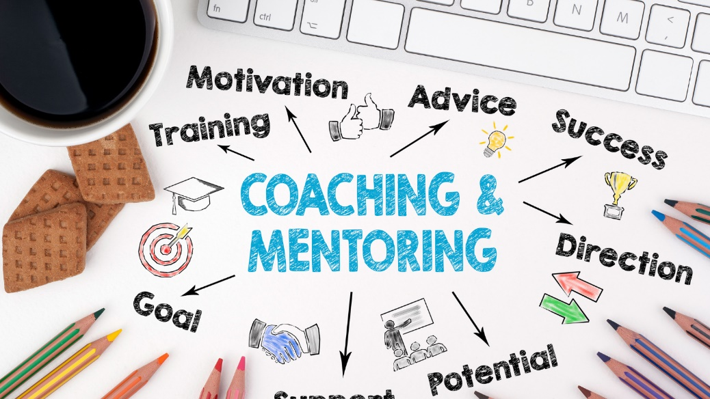
Figure 1: Coaching and Mentoring
source 1: https://www.mentoringcomplete.com/coaching-and-mentoring-whats-the-difference/

Description
I took the role of Philippa and took part in a coaching session with Maria Cook that included an introduction. Maria's ambition to further her career in the fast-paced international healthcare industry was the session's main topic. Maria was searching for guidance on setting and achieving her objectives, so I chose coaching as the approach. I utilised the GROW paradigm (Goal, Reality, Options, Way Forward) to structure the conversation.

Feelings
I was thrilled to have the opportunity to help Maria before the session navigate her career aspirations. As the session progressed, I felt engaged and focused on her needs. Before the coaching session, I felt a mix of duty and excitement. As a coach, I saw the need of giving Maria a safe and supportive environment in which to share her thoughts and concerns. I was also eager to use my coaching skills and the GROW approach to assist Maria in overcoming her career challenges. The coaching session left me feeling attentive and sympathetic. As Maria opened up about her difficulties and desire for advancement, I felt a connection to her emotions and was there throughout the conversation. I wanted to provide her a space where she could be herself without worrying about getting in trouble. However, I could see Maria was tight in her responses, maybe as a result of her prior failures and professional challenges.

Evaluations
The coaching session had several benefits. Maria participated actively, demonstrating her commitment to developing her career. The concise structure of the GROW model allowed us to cover goal setting, challenges, options, and an action plan effectively. Maria was able to express herself in a safe and unrestricted environment, in my opinion. However, several things might have been done more effectively. Because of her former employment in the department, Maria occasionally came off as being reticent. In retrospect, I should have spent more time building a relationship and a safe space before launching into the GROW model. I could have also looked a bit further to see if any underlying problems were affecting her attitude and aversion.

Conclusions
In the future, I have learned the importance of creating a friendly and trustworthy environment at the start of coaching sessions, especially when working with those who could be reticent or frustrated. I may have opened the session by asking Maria open-ended questions to encourage her to divulge additional information during the conversation. If her concerns about the team chemistry and her earlier experiences had been taken care of, she could have been less aggressive.

Action
In following encounters, I will place more focus on establishing a rapport and a friendly atmosphere conducive to open communication before introducing the coaching paradigm. As a result, trust will increase and sharing will become more honest. I will attempt to improve my active listening skills so that I can see cues that indicate underlying fears or emotions. By posing probing questions, you may be able to identify deeper issues that might have an impact on the coaching process. I will make an effort to be more sympathetic and understanding, especially when speaking with employees who might have different opinions or complaints. They will find it simpler to feel heard and valued if I do this.

SMART Actions
Objective | Specific | Measurable | Achievable | Relevant | Time-Bounded
Improve questioning methods to assist coachees in personal development by seeking tools and training for insightful questions | Improve questioning techniques | Use feedback to evaluate progress | Seek appropriate resources | Relevant to coaching improvement | Within the next 3 months
Enhance ability to aid coachees in setting precise, attainable goals by incorporating goal-setting techniques into sessions | Improve goal-setting proficiency | Track successful goal outcomes | Implement learned techniques | Relevant to effective coaching | Within the next 6 months
Master empathetic questioning to understand coachees' emotions, offer supportive feedback, and insights | Develop empathetic questioning | Observe improved client rapport | Practice empathetic questioning | Relevant to effective coaching | Within the next 12 months

Ultimately, the coaching session with Maria helped us get fresh views on the dynamics of the department at Healthcare International and the challenges that employees face. Even though the session was productive, I still believe there is potential for improvement, which I will address in future coaching sessions. My goal in developing my coaching methods and personalising my approach to meet the needs of each individual is to improve the department's performance and morale.

Critical Evaluation of Coaching and Mentoring
The different needs of team members are considered in the coaching and mentoring plan (Bachkirova et al., 2020). Coaching focuses on enabling people to analyse their thoughts, feelings, and potential solutions, as opposed to mentoring, which offers advice based on the mentor's expertise (Garvey et al., 2018). Providing a specialised path to job success is one of the main objectives of mentoring and coaching. When their unique objectives, challenges, and possibilities for progress are addressed, employees are more likely to feel appreciated and involved in their professions. Understanding and teamwork are enhanced through the coaching and mentoring process, which promotes open communication between managers and employees. This is especially helpful in situations when employees could feel overlooked or undervalued. The importance of the coacher’s or mentee's active involvement in choosing their goals and course of action is strongly emphasised in both coaching and mentoring (Al Hilali et al., 2020). This sense of ownership might encourage more motivation and commitment.

Grow Model
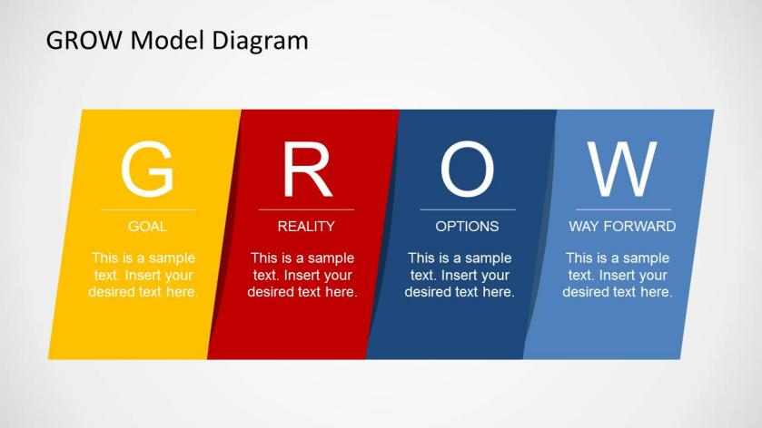
Figure 2: GROW Reflective Model
source 2: https://slidemodel.com/templates/grow-model-template-powerpoint/

Reflection on the Coaching Session- Goal
Maria showed a strong desire for promotion within the organisation and was open to discussing her professional goals. She was open about her concerns and objectives, which facilitated a fruitful exchange of ideas. Maria had a certain goal in mind, but I needed to have done more to find out what her dream job would entail after earning the promotion. This would have given me a clearer objective to work towards.
Setting and outlining a specific goal is a crucial step in the coaching process (Garvey et al., 2021). By aiding Maria in identifying her professional goal, the coaching session can have a positive impact on her performance and morale. Having a clearly stated objective might improve her feeling of direction, drive, and a new sense of purpose in her current employment. A top-notch coach or mentor can ask probing questions that help the coaches articulate their goals in detail. They create a safe space for the coaches to openly discuss their objectives. A competent coach also assists in making goals that are more SMART—specific, measurable, realistic, applicable, and time-bounded (Al Hilali et al., 2020). It was essential to establish Maria's career goal as the first stage in my coaching approach since it needed to be made apparent. Although the goal was made clear, I should have done a better job of understanding the specifics of the desired promotion. But as a result of the coaching session, Maria was able to create a worthwhile objective, which might help her to improve her confidence and performance.

Reality
I listened intently as Maria discussed her challenges and setbacks whilst participating in the seminar as a basic-grade microbiologist. She was pushed by me to be open about her emotions and concerns. She was able to discuss candidly her interactions with coworkers, how she felt trapped in her current role, and how she hoped to grow as a result. To delve further into Maria's ideas and feelings, I would consider asking more in-depth questions in later sessions. This could provide a clearer understanding of her perspective and point out any underlying issues that might be affecting her output and morale.
Acknowledging Maria's feelings and concerns throughout the coaching session's "Reality" section can improve her performance. She could feel more understood and validated if she is allowed to express herself, which might boost her motivation and enjoyment at work. Taking care of her issues can also cause her attitude toward her colleagues and the team to shift. Active listening abilities are displayed by a capable coach or mentor throughout the "Reality" phase of coaching. They create a setting of openness and trust where the coachee may freely express their emotions. Underlying issues and challenges may have an impact on a coachee's performance and welfare; these issues and challenges may be made clear through good questioning techniques. During the "Reality" portion of the coaching session, Maria had the opportunity to talk about her feelings and challenges. By genuinely listening and acknowledging her sentiments, the conversation set the stage for resolving her concerns and maybe improving her overall performance and morale within the team.

Options
The focus of the "Options" section of the coaching session with Maria Cook was on developing a wide range of viable solutions and methods to handle her problems and goals within the team and organisation. I helped Maria come up with ideas when we got to the "Options" stage to help her break out of her rut and increase her chances of getting promoted. I challenged her to think creatively and consider both short-term and long-term solutions. In the following sessions, I would encourage Maria to extend her outlook and challenge any self-limiting beliefs that would keep her from considering bold and novel ideas. Additionally, I would make certain that she evaluates each option in terms of feasibility and fit with her goals.
Maria may be given the tools she needs to take charge of her career by participating in the creation of workable solutions during the "Options" stage. She may reclaim her sense of agency and passion for her career path by attempting other approaches, which can improve her morale and level of job satisfaction. An outstanding coach or mentor may help you through the "Options" phase by fostering your creativity, critical thinking, and open-mindedness. They provide a nonjudgmental environment where the coaches may question assumptions and feel free to explore other paths. The coach's belief in the student’s potential and value drives the process. During the "Options" part of the coaching session with Maria, she had the chance to think about a variety of plans for getting over her current challenges and achieving her objectives. I encouraged her to think critically and imaginatively about a range of choices because I wanted to give her the tools, she needed to enhance both the morale of the team and her performance.

Way Forward
The section of Maria Cook's coaching session focused on encouraging commitment and outlining specific actions she might take to address her issues and achieve her professional objectives. I helped Maria come up with concrete measures she might do during the "Will" stage to overcome her sensation of being trapped and enhance her chances of advancement. I advised her to set specific goals and commit to managing the development of her career. In the following sessions, I would concentrate on working with Maria to establish a precise timeline for her action steps and make sure they were realistic and attainable in light of her current circumstances. I would also help her come up with strategies to overcome any obstacles.
The "way forward" stage can help Maria create a particular action plan, which will enable her to take on actual activities to improve her performance and morale. Her commitment to her goals can foster a sense of empowerment and purpose, which could increase her drive and attitude. This stage is aided by a great coach or mentor who motivates the coaches to translate insights and potential into actionable steps. They instil a sense of accountability and commitment whilst demonstrating confidence in the coachee’s ability to achieve. The coach's unwavering support and encouragement inspire the students to persevere. During the "way forward" part of the coaching session with Maria, she had the option to translate her insights and alternatives into precise action plans. I intended to help her adopt a proactive mindset, support improvement in her work output, and promote overall job satisfaction. I counselled her to set realistic goals and commit to taking concrete steps to achieve them.

An analysis of skills, behaviours, attitudes and beliefs of coaches

Figure 3: Characteristics of Coaching
source 3: https://startuptalky.com/coaching-vs-mentoring/
As Maria's coach, using active listening techniques will enable me to fully comprehend her frustrations, goals, and worries. This ability will allow me to inquire deeply and give specific advice. The effectiveness of the coaching session will increase as a result of developing empathy since it will establish a secure and encouraging environment where Maria feels appreciated and understood. Adroit questioning will nudge Maria to consider her career objectives, pinpoint her skills, and look into potential areas for improvement. Moreover, giving Maria frank useful comments will enable her to understand her behaviour and mental processes, promoting her self-awareness and development. By Bringing an open mind to the coaching session and no prejudices I will be better able to comprehend Maria's unique perspective and modify my recommendations as a result of this action. I will need to create an environment where Maria can express herself, set goals, and take control of her career. Develop patience as Maria mulls over her challenges and objectives and gives her the time and space she needs to reflect and feel. Furthermore, by keeping the coaching sessions private, I will be able to respect Maria's privacy whilst promoting openness and trust.
Adopting a growth attitude, believing that with the correct help and direction, people like Maria can develop, learn, and overcome obstacles. Showing respect to Maria will foster a welcoming environment that motivates her to actively participate in the coaching process. fostering a cooperative relationship with Maria is extremely important, stressing that both the coach and the student are equally responsible for their development and success. Moreover, I will need to stress the importance of lifelong learning and development and exhort Maria to seize chances to broaden her knowledge and skill base. I have great confidence in Maria’s abilities to overcome challenges and achieve their goals. An honest and open coaching relationship is encouraged by the coaches' belief in the coaches’ intentions and choices. Coaches view the coaching relationship as a collaboration when working with students to find solutions and create action plans.
Keeping empathy as a core principle and showing genuine concern for Maria's wellness and professional advancement. I can gain Maria's trust by upholding high ethical standards throughout the coaching relationship and acting with honesty and integrity. Furthermore, I intend to provide additional help to Maria in making sensible decisions and achieving her objectives to positively impact her career path. Effective coaching and mentoring might significantly affect performance and morale within Healthcare International. By addressing the concerns and aspirations of team members like Maria, coaching may enhance work satisfaction, career progression, and overall engagement. Additionally, an environment of open communication and understanding between workers and management may be fostered via a helpful coaching relationship.

Conclusion
The utilisation of coaching and mentoring by Healthcare International's Quality Assurance department has a lot of potential to assist its members with their issues. The personality of Maria Cook makes it obvious that specialised coaching and mentoring can boost group morale and individual performance. By putting into practice, a properly defined coaching or mentoring model and including the requisite skills, attitudes, behaviours, and values of an effective coach or mentor, Philippa can promote an environment of development, support, and cooperation.
The working environment at Healthcare International is shifting, and coaching and mentoring give employees the tools they need to adapt, define their career goals, and successfully contribute to the department's success. The report further reflects the importance of Philippa's empathy, attentive listening, perceptive questioning, and constructive criticism. By promoting openness and trust, Phillipa may help her team member “Maria Cook” achieve her goals whilst improving their output and morale. Furthermore, the critical analysis also draws attention to the benefits of coaching and mentoring, including increased engagement, increased job satisfaction, and enhanced skills. It is crucial to understand that whilst coaching and mentoring can boost performance and morale, they cannot serve as the organisation's only means of addressing underlying issues. Therefore, it is important to consider corporate demands, automation initiatives, and changing work dynamics all at once.

Reference
Al Hilali, K.S., Al Mughairi, B.M., Kian, M.W. and Karim, A.M., 2020. Coaching and mentoring. Concepts and practices in development of competencies: A theoretical perspective. International Journal of Academic Research in Accounting, Finance and Management Sciences, 10(1), pp.41-54.
Bachkirova, T., Arthur, L. and Reading, E., 2020. Evaluating a coaching and mentoring program: Challenges and solutions. Coaching Researched: A Coaching Psychology Reader, pp.361-378.
Cornelius, K.E., Rosenberg, M.S. and Sandmel, K.N., 2020. Examining the impact of professional development and coaching on mentoring of novice special educators. Action in Teacher Education, 42(3), pp.253-270.
Garvey, B., Garvey, R. and Stokes, P., 2021. Coaching and mentoring: Theory and practice. Sage.
Garvey, B., Stokes, P., and Megginson, D., (2018). ☐ Coaching and Mentoring: Theory and Practice. London: SAGE.

