Module: Leading and Implementing Workplace Change
Module Code: BMSW6103
Student Name: Alexandra Avadani
Student ID: 2111890
Lecturer Name: Nadeem Mirza
Assignment Title: Individual Report on Change Management Plan
Report on Tesla Motors

Executive Summary
This research deeply examines how Tesla Motors deals with change. Both the electricity and car industries owe a lot to Tesla Motors. The company is famous for being essential to today's EV (electric vehicle) business. This story talks about Tesla's new plan to make all its plants crank more cars and use more sophisticated robotic technologies. As the need for electric cars (EVs) grows, Tesla needs to make this critical strategy move to stay on top of the competition and keep up with the demand. The market is becoming less stable as technology changes quickly and the economy is unsure. Currently, Tesla is at the forefront of new business and technology growth. Dealing with significant shifts in the company and growing operations are two problems that come with this job. Getting around these issues is possible thanks to Tesla's unique working culture, which is defined by a high change rate, burdensome work requirements, and a high willingness to take risks. Different theories and frameworks are used to examine Tesla's ways of managing change. The study finds that transformational and flexible leadership styles are used a lot. People with these styles can make quick choices and develop new ideas. They can also see where they can be more involved at work and where they should communicate more clearly. The report's plan for managing change advocates for a more forthcoming way of handling policy changes. Set up organised staff training courses which concentrate on being adaptable and fluid. Make sure every individual is on a similar page with a communication plan. Keep track of how modifications change things and how sound schemes work with a review plan. This investigation aims to help the board of directors and leadership team of the Tesla Corporation get better at dealing with change. This will help the company meet its primary objective of expanding and becoming more assertive.

Table of Contents
Executive Summary 2
1.0 Introduction 4
1.1 Tesla Motors’ Overview 4
1.2 Aim of the Research 5
2.0 Current State of Tesla Motors 6
2.1 Tesla’s Current Operational, Financial, Strategic Status 6
2.2 Tesla’s Market Position, Technological Advances, and Business Challenges 7
3.0 Relationship with Tesla Motors 9
4.0 Outline of Current Change Initiatives 10
4.1 Ongoing Change Initiatives at Tesla Motors 10
4.2 Purpose, Scope, and Objectives of the Change Initiatives 11
5.0 Analysis of Recent History and External Impacts 12
5.1 Examination of Recent Historical Events of Tesla 12
5.2 Economic Uncertainty and Digital Disruption 13
5.3 Impact of the Factors on Tesla’s Operational Strategy 13
6.0 Evaluation of Change Management Models 15
6.1 Change Management Models Applicable to Tesla 15
6.2 Leadership Styles Observed During the Change Process 16
6.3 Analysis of the Models and Styles by Tesla 17
7.0 Organisational Culture and its Impact on Change Management 19
7.1 Tesla’s Role in Hindering the Changes 19
7.2 Evaluation of the Impact of the Culture 20
8.0 Conclusion 21
References 22

1.0 Introduction

1.1 Tesla Motors' Overview
Elon Musk was one of the experts who started Tesla Motors in 2003. Its one-of-a-kind electric vehicles (EVs) and alternative energy products have changed how cars are made. This business has become a major player in the renewable and automobile industries because its primary goal is accelerating the global move to clean energy (Ali, 2024). As of 2023, Tesla is one of the most opulent car companies in the world based on its market value. This shows how much it may affect the money and car business.
Tesla makes various fast electric cars, including the Model S, Model 3, Model X, and Model Y. It also uses solar energy, like solar roofs and powerwalls. The Tesla Model 3 truly revolutionised the market. It is now the world's best-selling electric car, and by the end of 2022, it will have sold more than 800,000 pieces (Ali, 2024). The company is dedicated to new ideas that go beyond cars. It has made green energy sources, self-driving features, and batteries with much power. In many ways, this qualifies it as a leader in technology.
Musk's company, Tesla, will always be significant if it develops and makes electric cars first. With goals to make additional cars and an annual output of more than a million cars per year by 2022, Tesla has been at the forefront of finding environmentally friendly ways to get around that can help solve the problems caused by climate change (Ali, 2024). People often talk about the company's prospects of transportation, energy, and technological progress because it is constantly proliferating and generating technological gains.

1.2 Aim of the Research
The primary purpose of this research is to look closely at how Tesla Motors deals with change. Tesla is known for quickly growing and bringing in new ideas. It is essential to cope well with organisational change if it wants to keep growing and be competitive (Jin and Sriram, 2024). With a focus on how they have brought new technologies and raised their output, the main point of the research is to examine how Tesla has worked with different attempts to change. Change management theories and models are used in the study to offer Tesla's key initiatives new ideas and tips that might improve them.
Because of how the study is set up, it is feasible to give an in-depth examination of Tesla's ways of dealing with change. The first part looks at the company's current state, including its operations, plan, and the market (Jin and Sriram, 2024). Then, it discusses how the data was gathered and related to Tesla. A particular attempt to change is examined to discover what it implies and how Tesla's plan fits it.
The next part discusses how economic and technological changes have changed business from the outside. They then look closely at Tesla's methods for managing change and how company culture affects these processes (Jin and Sriram, 2024). They then devised a change leadership strategy for the future based on what they found. In the study's conclusion, Tesla can find knowledge that helps them keep developing and evolving in the world market, which moves quickly.

2.0 Current State of Tesla Motors

2.1 Tesla's Current Operational, Financial, and Strategic Status
Between 2022 and 2024, Tesla, Inc., the most prominent company that makes electric cars (EVs), had a range of income. The company's net income and operating margins went down in 2023, which was a bad year for money. Tesla made $21.6 billion in sales in Q4 2023, less than the $25.6 billion that folks thought it would make (Ali, 2024). On the other hand, its net income went up to $7.9 billion because of a one-time credit of $5.7 billion. Nevertheless, in Q4 2023, the operating profit dropped significantly—from 16% in the previous quarter to 8.2%.
This was because the company planned to lower the prices of its current models. In 2023, Tesla's sales of cars went up by 15% to $82.4 billion. However, their gross profit went down by 15%, to $17.6 billion, and their net income went down by 19%, to $15 billion (Ali, 2024). The operating margin for the year was 9.2 percent, less than the 16.8 percent seen in 2022, and shows that the company is making less money. It is likely to be hard for Tesla to do business in 2024.
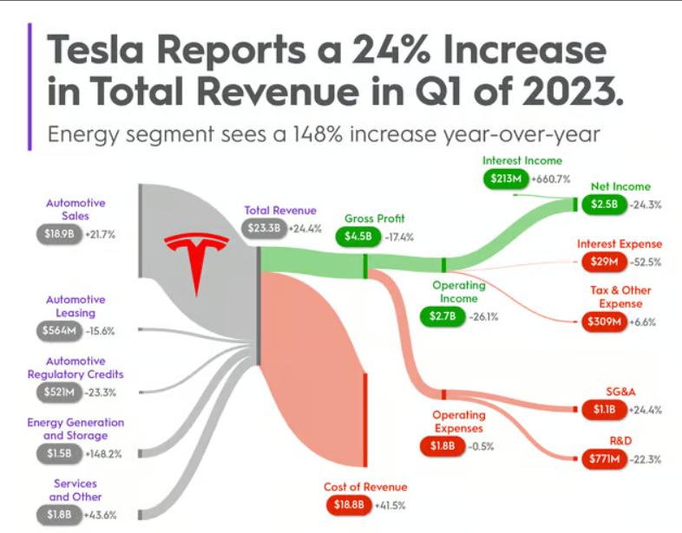
Fig 02: Tesla's Current Financial Status (Ali, 2024)
The company has said that slower car growth is likely because of things like the economy, problems in the supply chain, and more companies entering the EV market. Experts and investors fear that Tesla will not set a clear output goal for 2024 and will keep quiet about its production and income predictions for the brand-new Cybertruck model (Smith, 2023). People are paying close attention to how Tesla manages its money after its stock price dropped significantly in 2022. This made people wonder about the company's general money management. However, Tesla has been praised for how well it handles its cash. Some experts believe that the business's plan to buy back shares and give payouts could make its stock more valuable and attract more investors. Tesla's production and delivery lines plan is still geared toward increasing sales and output (Smith, 2023).
The company made $23.3 billion in Q1 2023, which is 24% more than the same time the previous year. However, its net income dropped 24%. The cost of some Tesla cars has decreased to get a more significant market share. This makes it hard for other car companies to keep up with how they set their prices. This company has also been spending money on making new things (Smith, 2023). They are soon going to show off a new type of car. A few people have said that Tesla's manufacturing and supply chain strategy relies too much on its CEO, Elon Musk and that the company cannot find and keep the top leaders it needs to grow. Along with established and growing businesses with more money, the business has to deal with new and growing businesses that can proliferate.

2.2 Tesla's Market Position, Technological Advances, and Business Challenges
From 2022 to 2024, the company had many business problems, and new technology changed how it did business. This company does much business with electric cars (EVs). They possessed about 58% of the nation's EV market in the fourth quarter of 2022 (Sukhanova, 2023). Tesla has stayed ahead of other manufacturers by focusing on luxurious electric vehicles (EVs). However, GM, Ford, Nissan, Nio, and Hyundai are also entering high-end EV and self-driving car markets. Tesla's progress in technology is a big part of its success.
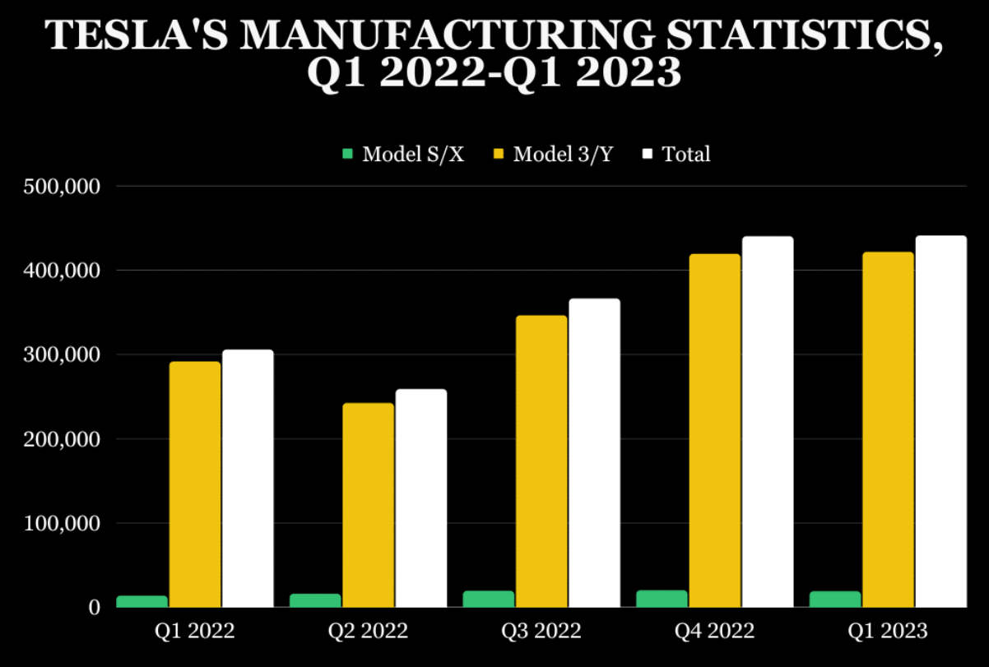
Fig 03: Tesla Motor's Manufacturing Statistics (Jin and Sriram, 2024)
Making things, battery technology and cars that power themselves have all come a long way for the company. The company's Full autonomous driving (FSD) plan began a new round of trial testing in October 2020. However, it became clear that a driver would still need to interact with the software. It had been almost a year before the full beta emerged. All Tesla owners with an FSD-enabled system could use the test version with FSD features (Sukhanova, 2023). However, Tesla's business additionally encountered a great deal of trouble. The company has had issues with its supply chain, increasing rivalry, and rules and laws. In August 2022, California's Department of Motor Vehicles indicated Tesla lied to its consumers when it said the company's Autopilot and driverless technology would enable cars to drive themselves (Jin and Sriram, 2024).

3.0 Relationship with Tesla Motors
Massive secondary research was used to investigate Tesla Motors and how it handles change. Much information was open to the public and could be gleaned without directly communicating with the business (Hundal, 2024). The approach was chosen because of this, which we needed to know came from other sources, like research studies, reputable business news sources, stories from the field, and Tesla's public comments, such as annual reports and press releases.
Reading about other companies' strategies, technological breakthroughs, and market positions was needed to understand Tesla fully (Hundal, 2024). This method makes it simpler to do an independent study despite the flaws associated with working for the company. It also shows how Tesla functions and its issues in a broad sense.
This information from various sources was carefully examined to learn more about how well Tesla handles progress and how its business culture impacts these processes (Hundal, 2024). This method gives everyone a fair chance to speak, and the test is thorough and well-informed. It can be used for both schoolwork and planning strategies.

4.0 Outline of Current Change Initiatives

4.1 Ongoing Change Initiatives at Tesla Motors
Tesla recently changed its staff and business plans to keep up with the burgeoning electric vehicle (EV) market through 2024 and adapt to market alterations. Tesla is changing its working focus on purpose to protect its funds and keep bringing fresh goods to market (Westbrook, 2023). This is because sales were lower than expected in 2023, and production of cars is expected to drop in 2024. People working for the company are being carefully examined to find important jobs, reduce expenses, and deal with decreased demand, expense cuts, and the financial effects of the current projects.

Fig 04: Tesla Motor's New Model Launch (Armstrong, 2023)
This anticipated modification to Tesla's workforce will make things run more smoothly and help the company stay operational as the market changes. Social networking sites are also being used by Tesla for the initial time as a component of a full-blown advertising campaign to get more people to know about the brand and bust some common EV myths (Westbrook, 2023). Tesla needs to keep old customers and get new ones. They also want to be strong and committed to environmentally friendly transportation. To do this, they plan to lower prices, give current owners more reasons to buy, and look for fresh opportunities to sell the automobiles they own.

4.2 Purpose, Scope, and Objectives of the Change Initiatives
Tesla's plan for change from 2023 to 2024 is meant to adapt to alterations in the market, increase productivity, and narrow the effectiveness gap in the production process. The plan will alter the attitude by pushing the work area to consistently grow and develop new ideas (Abbas, 2023). The change effort's goals from March 2023 are to make a full change administration plan to improve production processes, close the effectiveness gap, and conserve as much revenue as possible. The goal of the plan is that the manufacturing department is always a place where people work together, try to get better, and come up with new ideas.
For 2023, Tesla's numbers were lower than expected, according to Bloomberg. The company is in the latter stages of two waves of growth. Tesla is intently looking at its workers to find essential positions and cut costs because customer demand is falling, costs are going down, and current projects are costing much money (Abbas, 2023). Because of the problems in the economy right now, like falling profit margins and a slower expansion expected in sales of automobiles in 2024, this anticipated adjustment to the workforce is a response.
Tesla is still the best at making and storing energy. They make significant changes every year; in 2024, they will make even bigger ones. It shows that the company wants to be new by putting money into artificial intelligence (AI) like the DoJo machine (Abbas, 2023). These projects could make Tesla a lot more valuable and keep its goods on the vanguard of technological progress.

5.0 Analysis of Recent History and External Impacts

5.1 Examination of Recent Historical Events of Tesla
Many important things that happened recently at Tesla that will affect the company in 2023 and 2024 are the company's plan to adjust its staff to keep up with the evolving EV (electric vehicle) business (Damodaran, 2023). Tesla is amid two growth peaks; its 2023 numbers were lower than expected. In response, Tesla is hiring new people, improving its goods, and initially using social networks to get more people to know about its brand.
The business looks closely at its workers to find key jobs and cut costs. Some staff members are being changed because demand and costs are decreasing, and current initiatives are costing a lot of money (Damodaran, 2023). Bloomberg reports that the modification will affect more than 140,000 jobs.
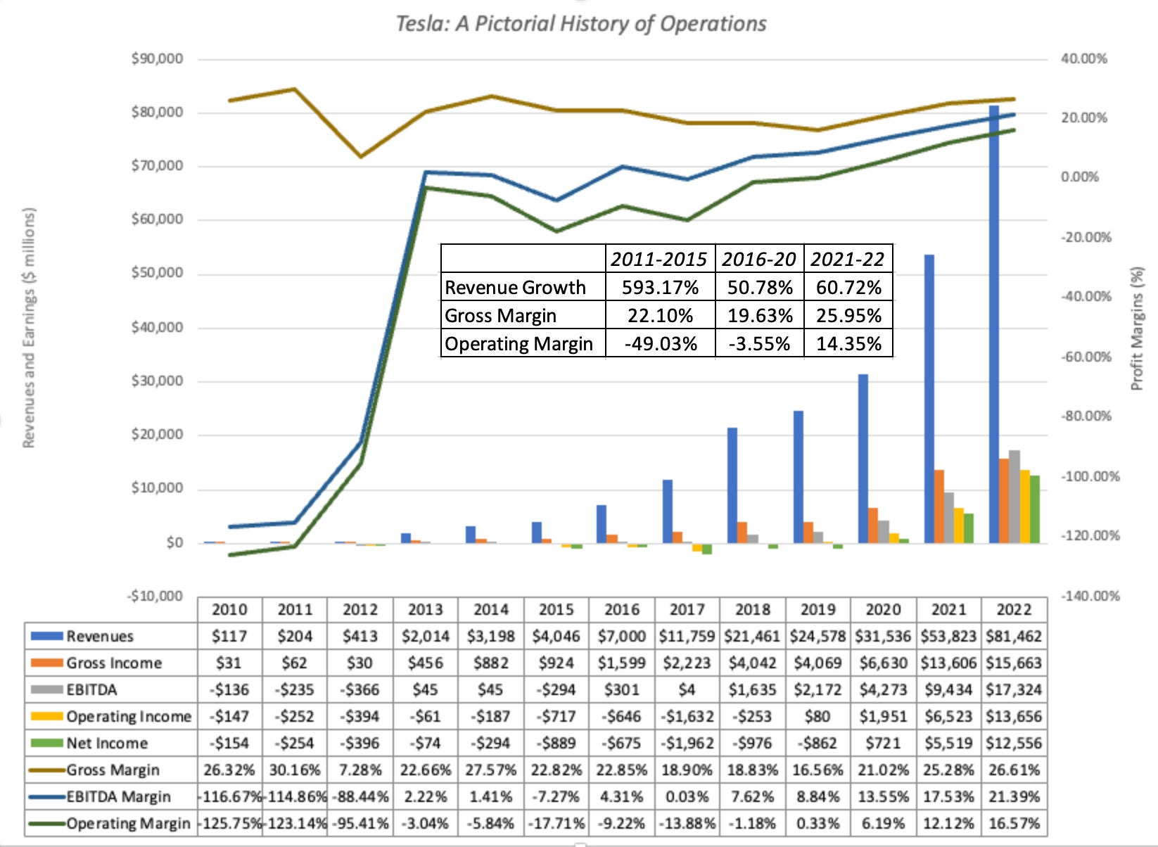
Fig 05: Tesla Motor's Operation History (Damodaran, 2023)
Along with these significant steps, Tesla is also dealing with the present economic situation's challenges, like smaller profit margins and slower growth in car sales anticipated in 2024 (Kolodny, 2024). The company still makes and stores energy better than anyone else. Every year, they get bigger, and by 2024, they will be even more significant.
There is growth in technology. Tesla is investing in AI and making the DoJo technology, demonstrating that it is open to new ideas (Kolodny, 2024). These projects could make Tesla much more valuable and keep its products on the leading edge of technological progress.
Tesla has also begun its first full-scale campaign to advertise on social media. Many people have the wrong idea about electric cars (EVs), which is an important move for the business to clear that up (Kolodny, 2024). Tesla additionally gives people who already own cars reasons to improve their rides. Some perks, like fully driverless packages and supercharging, will be added to new cars, and costs will go down in some parts of the world for some models.

5.2 Economic Uncertainty and Digital Disruption
Tesla's business is affected by things outside the company, mainly economic and technological changes (Hundal, 2024). Tesla failed to sell as many cars as planned in 2023 and 2024. Moreover, the number of cars delivered was expected to wind down in 2024. To adapt, Tesla has made innovative changes, like putting money into AI technologies and making the most of its employees.
Not knowing what will happen with the business is a big problem for Tesla. The company is going through two waves of growth, and its earnings margins have grown smaller (Hundal, 2024). In order to find essential positions and cut costs, Tesla is paying close attention to its workers. The company also invests in AI technologies, such as the DoJo device, to keep its products cutting-edge and valuable.
For Tesla, technological advancement is another external influence that works on it. Tesla has begun its first full-scale campaign to advertise on social media. With this big move, the company hopes to make its name more well-known and clear up some common misconceptions about electric cars (Hundal, 2024). The fact that Tesla is now working with electronic media reveals that the organisation is serious about finding new ways to promote its goods and change how people travel in the future.

5.3 Impact of the Factors on Tesla's Operational Strategy
Factor | Impact Description | Statistics
Workforce Adjustment | As a result of lower demand, some workers are being let go in order to save money. When the plan changes, it changes how the business is set up. | Nearly 140,000 jobs will be lost (Damodaran, 2023)
Economic Uncertainty | It is becoming harder to make a profit, and sales of cars are likely to slow down. This changes plans and strategies for money. | The main problems are lower earnings margins and a decrease in the supply of cars (Kolodny, 2024).
Technological Investment | The company is trying to stay ahead of the competition by investing in AI and the DoJo machine. | Much growth every year in the renewable energy field, pioneering technological advances (Kolodny, 2024).
Social Media Campaign | Commencement of Tesla's primary full-scale social media campaign to educate more people about the business and dispel common EV deception. | Updates for current users; price changes for versions worldwide (Kolodny, 2024).

6.0 Evaluation of Change Management Models

6.1 Change Management Models Applicable to Tesla
Tesla's strategies for managing change from 2023 to 2024 can be broken down into different models to help the company work better. Lewin's Change Management Model has three phases: unfreezing, changing, and refreezing (Iliff, 2022). The company is now in the "unfreezing" phase, knowing it must adjust. This is clear because it has changed its strategy, worked to improve its staff, and put money into AI technologies. Tesla is managing its workers well and trying to cut costs to deal with the unstable economy and technological changes (Iliff, 2022). This shows that the landscape is shifting. The last step is "refreezing," which makes these changes public so they become a standard procedure in the company.
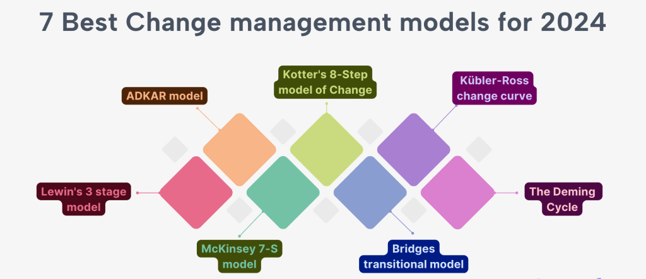
Fig 06: Use of Change Management Model by Tesla Motors (Chohan, 2023)
Another one that might help is Kotter's 8-Step Change Framework. Its primary goals are to make people understand that they must move quickly, form a strong union, and clear the change goal (Chohan, 2023). Tesla's improvements to its team and plan are all about making things more important and building a union to speed things up. The altered strategy is getting through to stakeholders because the business focuses on AI and social media ads.
Check if Tesla's strategy, structure, methods, staff, skills, style, and shared values align with its goals to make changes using the McKinsey 7-S Structure. Tesla is focused on making its employees, AI tools, and digital advertising efforts work better (Chohan, 2023). This shows the corporation has adjusted its approach, structure, and methods to adapt to the market.

6.2 Leadership Styles Observed During the Change Process
Leadership methods at Tesla throughout the changeover in 2023–2024 were based on new ideas, adaptability, and working together as a team. Elon Musk is the CEO of Tesla. He is known for being a forward-thinking leader committed to clean energy. This has helped the company do very well. A big part of Musk's way of leading is being open to new ideas and ready to take risks.
Within the fast-changing car business, this has assisted Tesla in staying ahead of the curve of its rivals. This is because the market and economy are changing all the time. To keep the market for electric cars going forward, Tesla has changed its approach and staff (St. John, 2023). This means investing much energy into artificial intelligence (AI), such as developing the DoJo technology, to make its products more valuable in the market and keep them at the forefront of technology.
Musk and Elon Musk's commitment to artificial intelligence (AI) technologies shows they value new ideas and the flexibility to adapt to changing marketplace circumstances. Working collectively and continually improving is also very important to Tesla when facing change (St. John, 2023). The company has pushed for a mindset of steady improvement and novel concepts in the production area. Workers are taught how to do their jobs in a dynamic, profitable industrial process. This shows that the boss cares about what the workers say and wants them and the tools to work collectively to get the most done.
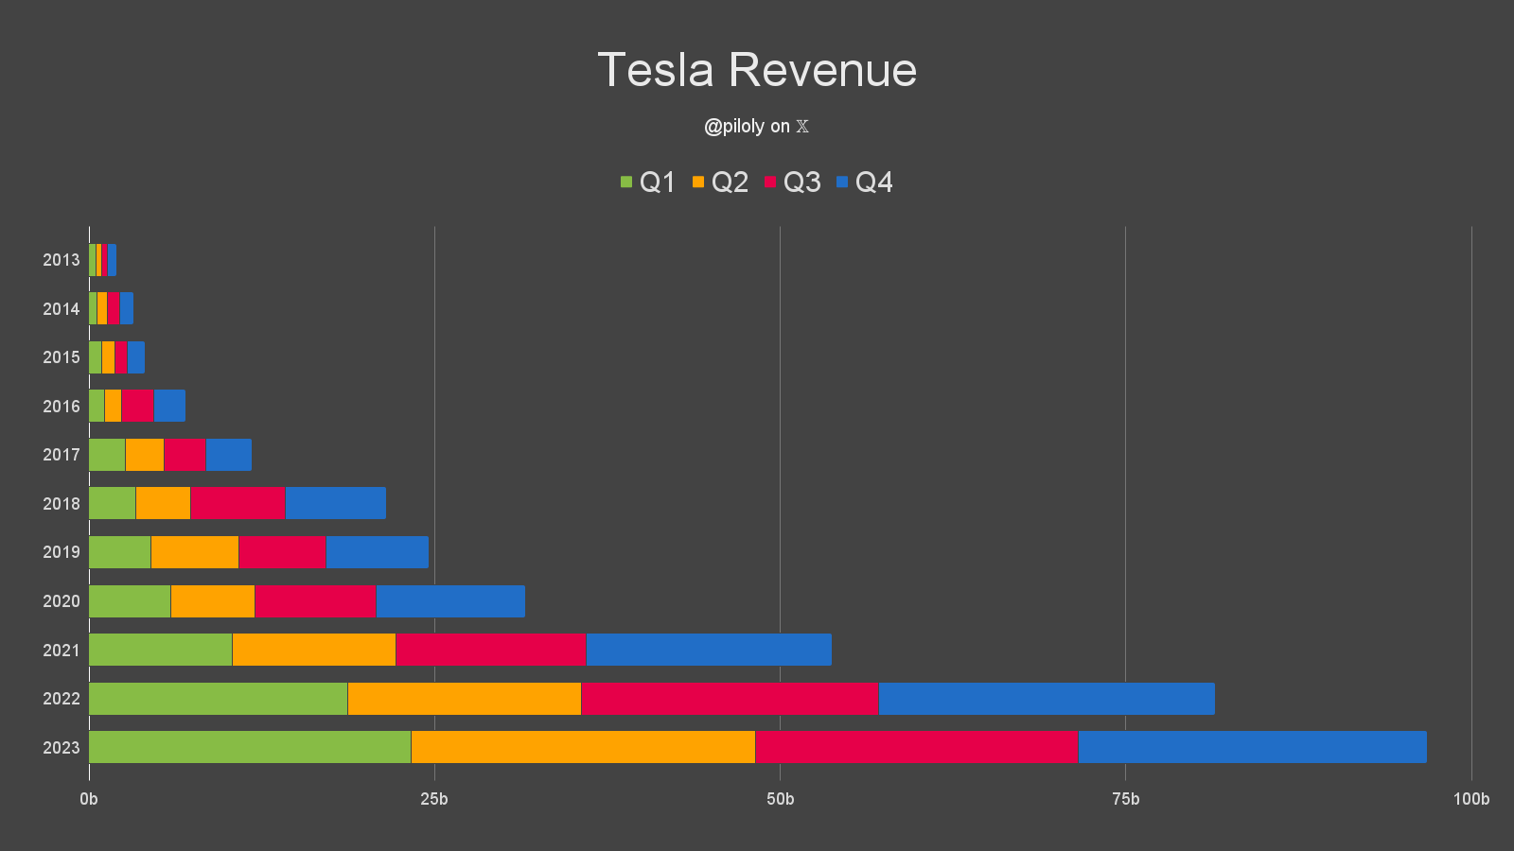
Fig 07: Tesla's Revenue during the Leadership Changes (St. John, 2023)
Tesla additionally began its first full-blown social media marketing campaign and started giving current users benefits to improve their cars. This proves that the business leaders know about customer wants and market changes (St. John, 2023). Tesla is looking for novel approaches to sell its goods and improve the value for customers who stick with them. It also demonstrates that its way of leading is customer-oriented and focused on giving partners value.
The way Tesla led during the shift in 2023–24 was based on new ideas, being flexible, working as a team, and putting customers first (Lexchart, 2022). In addition, they have ensured that the company's modifications are carried out well and in a manner that will last. This way, growth, and new ideas remain possible in the frantic auto industry.

6.3 Analysis of the Models and Styles by Tesla
Lewin's Management of Change Approach, especially the "unfreezing" part, benefited Tesla as it began to make strategic changes and technological progress from 2023 to 2024. Tesla's adjustments to its workforce and use of artificial intelligence (AI) show that this business plan works (Lexchart, 2022). These modifications demonstrate that Tesla is poised to make them, but they have not yet hit the "refreezing" stage. That is when they require to be thoroughly reviewed because they must become normal for Tesla.
Kotter's 8-Step Change Framework has been very helpful, especially for making things move faster and getting a group of people together to help Tesla make decisions. Putting AI and digital marketing approaches at the forefront of Tesla's list of goals makes it clear that the company is focused on the long-term success of its technology (Lexchart, 2022). Innovative relationships and making individuals feel obligated to act quickly help companies change quickly. However, what will show how well these modifications work is how they impact Tesla's business and finances over the coming years. Close monitoring will be performed on revenue margins and the number of cars supplied.
Tesla needs to stay ahead of the competition, and Elon Musk's management has helped people be willing to take risks and develop new ideas. The fact that Musk wants to improve AI and digital marketing shows that his forward-thinking and artistic style has rendered work environments more open to change (Lexchart, 2022). These leadership traits are helpful, as shown by Tesla's ongoing efforts to change the market. However, they should be checked regularly to ensure they are relevant to shifting customer requirements and internal capabilities.

7.0 Organisational Culture and its Impact on Change Management

7.1 Tesla's Role in Hindering the Changes
Innovation, taking risks, and focusing on good performance are all critical parts of Tesla's work culture. This company culture is a big part of what helps and slows change. People at the company are always looking for ways to improve technology so things run more smoothly. Elon Musk, the CEO, leads this attitude (Tesla, 2024). This is necessary to stay ahead in the electric car (EV) business, which is very competitive. For instance, Tesla's quick use of artificially intelligent (AI) tools and its strong drive toward autonomous vehicles are good instances of how an innovative culture speeds up change.
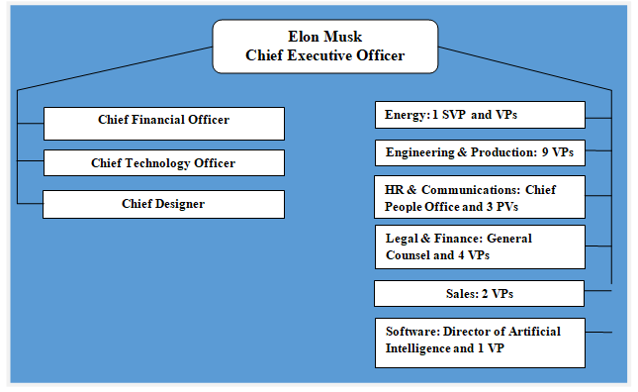
Fig 08: Organisational Chart of Tesla (Tesla, 2024)
This way of life has helped Tesla stay ahead in electric vehicles (EVs). Tesla had more than 16 percent of the world's electric vehicle (EV) market by the end of 2023. However, this very demanding way of thinking about organisations may render it hard for institutions to shift, which has been connected to a substantial turnover rate (Westbrook, 2023). Reports say Tesla's rate of change is higher than the norm for the business world.
Sticking to long-term goals and keeping things stable might be more challenging. It may also be hard to assess and implement novel procedures fully because of how fast and energetic the culture is. This is because fast innovation may eclipse the change management part of stability (Westbrook, 2023). Tesla's culture helps with making quick changes and coming up with imaginative concepts, but it also has issues that could stop long-term progress if they are not dealt with the right mix of speed alongside integration.

7.2 Evaluation of the Impact of the Culture
Tesla's company culture is very different from other companies, and this affects its change management in many essential ways, such as:

- Tesla's focus on fast innovation helps the company adapt quickly to new technologies and market needs. Being able to bend and stretch is strong and weak (Sukhanova, 2023). It helps Tesla make cutting-edge products like the DoJo machine but may also give rise to quick ideas that do not work well in the long run.
- Jobs with much pressure, like those at Tesla, can cause workers to burn out and quit the business in large numbers. This is good for a high-performance mindset, but it could make it harder to attain the in-depth understanding and stability required for long-term change in the company (Sukhanova, 2023). Too many staff moves can slow down business work and make it more challenging for people to share what they know and remember things for the company.
- Tesla is ready to take significant risks, which helps the organisation make risky decisions. This is important for making advancements in a challenging industry (Sukhanova, 2023). However, this can sometimes mean that risk evaluations and prevention plans are not being done well, which can hurt the long-term viability of new projects.
- Tesla wants to be the leader in electric car technology and environmentally friendly business practices (Sukhanova, 2023). This fits well with the company's mindset of focusing on new ideas. Because all parties in the company contribute towards the same goals, this teamwork makes it easier to handle change.

At Tesla, the way the company is run generally promotes a lively and innovative work environment that helps people achieve quick changes. However, for these changes to last, there must be a balance between new ideas, workers' health and safety, and attentive risk management.

8.0 Conclusion
This study looked closely into how Tesla Motors deals with change across every one of its products and focused on how the company's changing work culture impacts things. Some significant findings show that Tesla starts and completes strategy changes using frameworks like Lewin's and Kotter's (White and Lienert, 2023). This is especially true when introducing new technologies and expanding its market reach through AI and social networking sites. However, the rapid rate of technology change and the demanding job atmosphere complicate things, mainly when it involves keeping workers and controlling risks.
These issues might make changes last less long. At Tesla, handling change is essential because the company has to deal with fast business changes and tough competition. One should start to change projects, see them through to the end, and ensure they fit into the organisation's system for long-term success (White and Lienert, 2023). If Tesla can handle these changes well, it will stay at the forefront of the electric car marketplace for a long time and significantly affect the development of green transportation.
Researchers should inquire into Tesla's ways of managing change in the decades to come, mainly as they affect the business's long-term safety and market performance (White and Lienert, 2023). Change management methods could be mixed with plans to keep employees happy and healthy. This could assist Tesla in staying unique and making it a desirable place to work.

References
Abbas, T. (2023) Tesla change management case study, CMI. Umar Tahir. Available at: https://changemanagementinsight.com/tesla-change-management-case-study/ (Accessed: April 19, 2024).
Ali, I. (2024) Tesla financials deep dive — massive growth, CleanTechnica. Available at: https://cleantechnica.com/2024/01/29/tesla-financials-deep-dive-massive-growth/ (Accessed: April 19, 2024).
Armstrong, K. (2023) Tesla's new video unveils the magic behind model Y engineering, Not a Tesla App. Available at: https://www.notateslaapp.com/news/1503/tesla-s-new-video-unveils-the-magic-behind-model-y-engineering (Accessed: April 19, 2024).
Chohan, S. (2023) 7 best change management models for 2024, Lemon Learning. Available at: https://lemonlearning.com/blog/7-best-change-management-models-2024 (Accessed: April 19, 2024).
Damodaran, A. (2023) Tesla in 2023: A return to reality, the beginning of the end or time to buy, Musings on Markets. Available at: https://aswathdamodaran.substack.com/p/tesla-in-2023-a-return-to-reality (Accessed: April 19, 2024).
Dudovskiy, J. (2021) Tesla Organizational Structure: divisional and flexible, Research-Methodology. Available at: https://research-methodology.net/tesla-organizational-structure-divisional-and-flexible/ (Accessed: April 19, 2024).
Hundal, T. (2024) The next new Tesla model might come sooner than we thought, The Autopian. Available at: https://www.theautopian.com/the-next-new-tesla-model-might-come-sooner-than-we-thought/ (Accessed: April 19, 2024).
Iliff, L. (2022) Tesla: 2023 kicks off next big cycle, Autonews.com. Available at: https://www.autonews.com/future-product/tesla-future-product-2023-kicks-next-big-cycle (Accessed: April 19, 2024).
Jin, H. and Sriram, A. (2024) Tesla warns of slowing growth before new model launch next year, Reuters.com. Available at: https://www.reuters.com/business/autos-transportation/tesla-gross-margin-falls-fourth-quarter-2024-01-24/ (Accessed: April 19, 2024).
Kolodny, L. (2024) Tesla shares drop 6% on weak auto revenue, warning of slower growth in 2024, CNBC. Available at: https://www.cnbc.com/2024/01/24/tesla-tsla-earnings-q4-2023.html (Accessed: April 19, 2024).
Lexchart (2022) Elon musk ownership chart of Telsa & Twitter [free download], Lexchart. Available at: https://lexchart.com/org-charts/elon-musk-tesla-twitter-ownership-chart/ (Accessed: April 19, 2024).
Norton, K. (2022) "Tesla stock 2023: EV giant faces big challenges in its two megamarkets," Investor's Business Daily, 27 December. Available at: https://www.investors.com/news/tesla-stock-2023-forecast-reveals-a-tale-of-two-challenging-ev-megamarkets/ (Accessed: April 19, 2024).
Smith, H. (2023) Is now a good time to buy Tesla?, The Motley Fool. Available at: https://www.fool.com/investing/2023/04/20/is-now-a-good-time-to-buy-tesla/ (Accessed: April 19, 2024).
St. John, A. (2023) "Tesla is outselling the competition by miles. This chart shows how much catching up other automakers need to do," Business Insider, 11 July. Available at: https://www.businessinsider.com/tesla-sales-numbers-easily-top-american-competition-one-simple-chart-2023-7 (Accessed: April 19, 2024).
Sukhanova, K. (2023) Electrifying Tesla statistics for 2023, The Tech Report. Available at: https://techreport.com/statistics/tesla-statistics/ (Accessed: April 19, 2024).
Tesla (2024) UNITED STATES SECURITIES AND EXCHANGE COMMISSION OF TESLA, Tesla.com. Available at: https://ir.tesla.com/_flysystem/s3/sec/000162828024002390/tsla-20231231-gen.pdf (Accessed: April 19, 2024).
Westbrook, J. (2023) 2025 Tesla Model S: Everything You Should Know About the Electric Sedan, Motortrend.com. Available at: https://www.motortrend.com/news/2025-tesla-model-s-update-electric-sedan-future-cars/ (Accessed: April 19, 2024).
White, J. and Lienert, P. (2023) Focus: Elon Musk's challenge: Stay ahead of the competition, Reuters.com. Available at: https://www.reuters.com/technology/elon-musks-challenge-stay-ahead-competition-2023-02-24/ (Accessed: April 19, 2024).

