Introduction

During the late Eighteenth Dynasty of Egypt—especially in the fourteenth century BCE— contacts between New Kingdom Egypt and the Aegean world became much more prominent. The contacts created, are some of the clearest examples of long-distance interaction in the Late Bronze Age, in the Mediterranean area. The contacts formed part of a complex international system, which linked Egypt to the Levant, Anatolia, Mesopotamia and the Aegean basin.
Egyptian textual, artistic, and archaeological evidence refers to Aegean peoples as “Keftiu” and “islands in the midst of the Great Green”. This is a strong indication of Egypts awareness and connection to the Aegean. The reigns of Amenhotep III and Akhenaten marked a peak in the interactions between these areas, through trade, gift exchange, and cultural mixing.
During the fourteenth century BCE, Egypt was a dominant imperial power with strong diplomatic ties across the Near East. Scholars like Cline (2014) put Egypt into “Great Powers Club” which also included, the Hittites, Mitanni, and Babylonia. Within this system, rulers were equals, and the Aegean world was not a centralized entity, but participated culturally and economically

Archaeological Evidence

The Amarna Letters
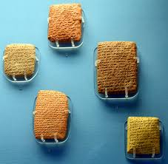
The Amarna Period, during the latter half of the 18th dynasty, provides crucial contextual evidence to Egypts flourishing during this period. They are a corpus of diplomatic texts revealing extensive Egyptian interaction with foreign states, though direct references to the Aegean are limited. The letters vary from economical accounts, material invetories, gift demands (often of future wives and daughters!), and general diplomatic interaction. The interaction between the Aegean was clear in a few of these letters, though they cover a wider area too like central Africa.
BRITISH MUSEAM: LONDON

Aegean-style frescoes in Tell el-Dab’a
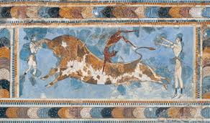
Among the strongest evidence for direct contact are the Aegean-style frescoes discovered at Tell el-Dab'a. These paintings are dated to the early Eighteenth Dynasty, and depict bull-leaping and other clear motifs characteristic of Minoan iconography, who viewed the Bull as a sacred symbol of the power of the ruling class.
Scholars like Manfred Bietak argue that these frescoes were produced either by Minoan artists working in Egypt, or by locally trained artisans adopting Aegean techniques (Bietak 1995). Their presence suggests overseas trade, and the movement of skilled artisans and artistic knowledge, suggesting a deeper level of interaction.
(Anna Keneally, 2023)

Aegean Pottery in Egypt
Mycenaean pottery has been found at numerous Egyptian sites, including Amarna, Thebes, and Memphis. These ceramics, especially from Late Helladic IIIA–B phases, are classed by some as key chronological markers of Aegean-Egyptian exchange (Cline 1994).
As their presence was in elite and administrative contexts, like palaces and temples, it is suggested that such imports were not random but part of organized exchange systems, possibly involving diplomatic gift-giving or high-status trade.

Egyptian Objects in the Aegean
Scarabs, faience vessels, and hieroglyphic inscribed objects, and other Egyptian artifacts have been discovered in Mycenaean landmarks and cities, like Mycenae and Tiryns. Some bear the cartouches of rulers, for instance like Amenhotep III, indicating connections which are relevant to the fourteenth century BC. 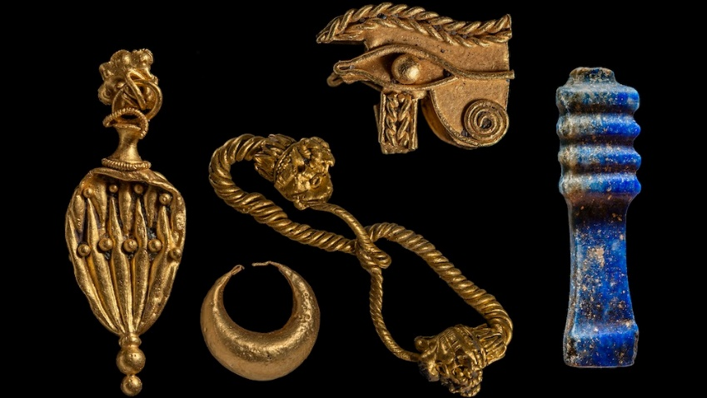
Live Science, Jennefer Nalewicki (2023)
These objects likely functioned as “prestige goods”, valued not only for their material but also for their association with Egyptian royal power (Phillips 2008).

Iconographic and Textual Evidence
Tombs at Thebes depict Aegean emissaries paying tribute. These figures are labelled as Keftiu (Aegean peoples) and are shown to be wearing distinct clothing and offering objects consistent with Aegean material culture like bridge-spouted jars, conical rhyta, ewers and jugs with long spouts and handled cups and goblets
As argued again by Eric Cline, these scenes likely represent gift exchange rather than tribute in a strict political sense, reflecting diplomatic or symbolic relationships (Cline 1994).

Evidence of Topographical Lists

Topographical lists from the reign of Amenhotep III include place names that some scholars associate with Aegean locations, possibly including Knossos and Mycenae. The lists suggest that Egyptian scribes possessed some knowledge of Aegean geography (Cline 2014).
Gift Exchange

Trade and Exchange Systems
Trade between Egypt and the Aegean involved both luxury and utilitarian goods: Aegean exports like pottery, olive oil, perfumed oils, textiles, and possibly metals, and Egyptian exports like gold, faience, glass, linen, and manufactured luxury goods. Interestingly, Gold was a very common mineral in Egypt, so Silver was valued higher, and exported from overseas only for the extremely rich.
The exchange of such goods reflects what scholars describe as a “prestige-goods economy”, in which elite consumption drove long-distance trade (Sherratt and Sherratt 1991).

Maritime Networks
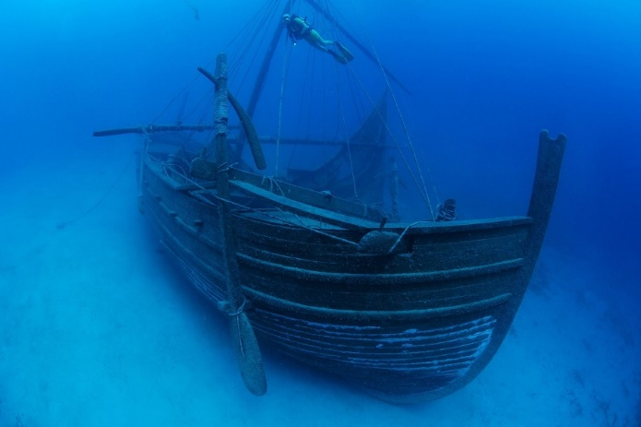
Shipwrecks like the Uluburun provides an insight into Late Bronze Age trade. Its cargo included goods from across the eastern Mediterranean, such as Copper ingots shaped as oxhide ingots (rec tangular in form with handles”, Tin Ingots used for Bronze, and other luxury raw materials likely from Cyprus.
Although no single route linked Egypt directly to the Aegean, trade likely moved through Levantine ports such as Ugarit, forming a multi-stage exchange system (Wachsmann 1998).
Peterborough Archeology, 2022

Movement of Peoples

Craftsmen and Artists
The Aegean frescoes at Tell el-Dab'a strongly imply the presence of foreign artisans in Egypt. This aligns with broader patterns in the Late Bronze Age, where skilled craftsmen traveled between courts (Bietak 1995).

Warriors and Seafarers
Some evidence suggests that Aegean individuals may have served in Egypt as mercenaries or sailors. While clearer evidence appears later with the Sea Peoples, earlier interactions may have laid the groundwork for such movements (Cline 2014). There is also the conquests of Amenhotep to consider, which though was conducted by foot into the Hittite empire, likely would have required foreign material export, and also potentially bought over other mercenaries from the Aegean.

Cultural Interaction

Artistic Exchange
Aegean influence is visible in Egyptian art primarily through fresco techniques, like wet lime plaster, which as it dries produces matte surfaces, and motifs consisting of singular scenes of animals, with symbolic significance, ie. Dolphins, Leaping Bulls, Waves and Sea life (The Maritime identity of the Aegean world and ritual or elite sport of the Minoan culture) . Conversely, Egyptian symbols and materials appear in Aegean contexts, indicating bidirectional influence rather than one-sided borrowing.

Technological Exchange
The exchange of raw materials—especially metals like copper and tin—was crucial. The Aegean’s access to metal resources complemented Egypt’s wealth in gold and manufactured goods, creating a mutually beneficial economic relationship. This would have influenced armies, craftsman, and merchants heavily, creating a new economy that spanned beyond local boarders.

Decline of Contacts
By the end of the Late Bronze Age (c. 1200 BCE), this interconnected system collapsed due to a combination of factors, including political instability, economic disruption, and population movements.
The decline of Mycenaean palatial centres and the weakening of Egyptian power during the later New Kingdom reduced direct contact. However, these earlier interactions laid the foundation for later connections between Egypt and the Greek world in the first millennium BCE.

Conclusion
Contacts between Egypt and the Aegean during the late Eighteenth Dynasty were sustained, multidimensional, and embedded within a wider international system. Archaeological evidence, artistic representations, and textual sources collectively demonstrate that these interactions included trade, diplomacy, and cultural exchange.
Rather than peripheral, the Aegean world was an active participant in the Late Bronze Age Mediterranean network. The study of these contacts provides essential insight into early globalization processes and the movement of goods, ideas, and people across ancient societies.

Works Cited
“The Uluburun Shipwreck.” Peterborough Archaeology, 30 May 2022, Available: peterborougharchaeology.org/event/uluburun-shipwreck/. (Accessed 10 Apr. 2026.)
Bietak, Manfred. Avaris: The Capital of the Hyksos. British Museum Press, 1995.
Cline, Eric H. 1177 B.C.: The Year Civilization Collapsed. Princeton UP, 2014.
https://press.princeton.edu/books/paperback/9780691168388/1177-bc (Accessed 08 April 2026)
Cline, Eric H. Sailing the Wine-Dark Sea: International Trade and the Late Bronze Age Aegean. BAR International Series 591, 1994.
Keneally, Anna. “Bull and Bull-Leaping Iconography: Knossos, Tell el-Dab’a, and beyond” Penn’s classical Studies, 2023.Available: https://web.sas.upenn.edu/discentes/2023/12/24/bull-and-bull-leaping-iconography-knossos-tell-el-daba-and-beyond/ (Accessed 08 April 2026)
Knappett, Carl. An Archaeology of Interaction: Network Perspectives on Material Culture and Society. Oxford UP, 2011.
Liverani, Mario. International Relations in the Ancient Near East, 1600–1100 BC. Palgrave Macmillan, 2001.
https://link.springer.com/book/10.1057/9780230287648 (Accessed 08 April 2026)
Nalewicki, Jennifer. “Sunken Temple and Sanctuary from Ancient Egypt Found Brimming with ‘Treasures and Secrets.’” LiveScience, Purch, 20 Sept. 2023, Available: www.livescience.com/archaeology/ancient-egyptians/sunken-temple-and-sanctuary-from-ancient-egypt-found-brimming-with-treasures-and-secrets. (Accessed 10 Apr. 2026.)
Phillips, Jacke. Aegyptiaca on the Island of Crete in Their Chronological Context. Austrian Academy of Sciences Press, 2008.
Sherratt, Andrew, and Susan Sherratt. “From Luxuries to Commodities: The Nature of Mediterranean Bronze Age Trading Systems.” Bronze Age Trade in the Mediterranean, edited by N. H. Gale, Åström, 1991, pp. 351–386.
Wachsmann, Shelley. Seagoing Ships and Seamanship in the Bronze Age Levant. Texas A&M UP, 1998.

