UWTSD – SCHOOL FOR SCIENCE AND ARTS
Ryan Williams
2023 -Beng Manufacturing systems
the desktop de-spooler
Contents
Declaration of Authenticity. 3
Table of figures. 4
61.Introduction 6
1.1 Contract Manufacturing 6
2.Background 8
3.Requirements capture. 9
4.Research 10
5.Work carried out 12
5.1 Introduction to machine. 12
5.2 Introduction to the control system. 22
5.2 Payoff Shaft Size 32
5.3 Motors Over-heating 38
5.4 Label printer 43
5.5 Lowering tension. 49
5.6 Pulley design 51
5.6 HMI and Loadcell enclose and position. 56
5.7 Machine enclosure and storage. 58
Enclosure Idea 1 58
Enclosure Idea 2 59
Enclosure idea 4 61
Machine storage 63
5.8 Better suited encoder. 64
6.0 Final design 65
7.0 Conclusion 69
8.0 Further Work 69
References 71

Declaration of Authenticity.

This thesis is the result of the author’s original research. It has been composed by the author and has not been previously submitted for examination which has led to the award of a degree.

Signed: R J Williams. Date: 18/05/2023

Table of figures.
Figure 1 A picture of the machine in its current state. 14
Figure 2 Dimensional representation of a DIN 160 spool 15
Figure 3 A dimensional representation of a 1/2 cat and a DIN 100 spool. 15
Figure 4 Operational flow chart for the machine. 16
Figure 5 CAD model of the current machine with wire path depicted in minimum tension. 17
Figure 6 CAD model of current machine with wire path depicted in maxiumum tension. 18
Figure 7 2-dimensional drawing or reverse engineered machine. 19
Figure 8 2-dimensional exploded drawing of reverse engineered machine 20
Figure 9 Mechanical Bill of Materials with estimated cost applied. 0
Figure 10 Electrical Bill of materials with estimated cost applied. 0
Figure 11 HMI screen 1 22
Figure 12 Encoder position inputs and outputs. 22
Figure 13 Encoder position reset button. 23
Figure 14 Dancer position potentiometer on machine electrical schematics 24
Figure 15 Dancer position PLC output 24
Figure 16 0-10v Analogue converter from PLC ladder program. 25
Figure 17 PLC output from loadcell and Wheatstone bridge diagram from machine schematics. 25
Figure 18 Motor 1 status. 26
Figure 19 Traverse motor status. 26
Figure 20 Take up motor status 27
Figure 21 Manual commands screen 28
Figure 22 Settings screen. 29
Figure 23 Motor parameters within technology object. 30
Figure 24 Diagram to shows pulse frequency and direction output. 31
Figure 25 Pulses per revolution set in technology object. 31
Figure 26 Motor velocity settings 32
Figure 27 Dimensional drawing of proposed payoff shaft 33
Figure 28 FEA mesh settings 34
Figure 29 FEA material override properties. 34
Figure 30 Picture of load direction 35
Figure 31 Picture to showing the constrained highlighted face 35
Figure 32 Table of FEA results. 36
Figure 33 Picture showing the new constrained face. 36
Figure 34 comparison table for both FEA analysis. 37
Figure 35 Picture to show first principal stress in assembly FEA 37
Figure 36 PIcture to show 3rd principal stress in assembly FEA 37
Figure 37 Picture to show displacement in assembly FEA 38
Figure 38 Picture to show Von MIses stress in assembly FEA 38
Figure 39 Picture to show construction of stepper motor. 39
Figure 40 Diagram demonstrating step pulse and direction pulse to operate stepper motor. 40
Figure 41 Schematic diagram of leadshine stepper drives. 41
Figure 42 Recorded temperatures from experiment. 42
Figure 43 Graph to show temperature vs time. 42
Figure 44 Example a passive cooling heatsink. 43
Figure 45 Example of an active cooling heatsink. 43
Figure 46 Picture of a jumper block and circuit representation 44
Figure 47 Jumper block configuration from zebra technologies 45
Figure 48 Table to show the configuration of the 15 pin connector 46
Figure 49 Schematic diagram for 15 pin connector dependant of power supply from zebra technologies 47
Figure 50 ZE511 printer sizes and costs. 48
Figure 51 ZT610 printer sizes and costs. 48
Figure 52 Comparison of proposed printers including sizes and costs. 49
Figure 53 Picture showing weight of small bought pulley. 51
Figure 54 Picture showing weight of designed small 3d printed pulley. 52
Figure 55 Dimensional drawing for weight reduction of encoder. 52
Figure 56 Picture of weight before, encoder in drill and weight after. 53
Figure 57 picture of weight of bought large pulleys. 53
Figure 58 Picture of weight of designed 3d printed pulleys. 54
Figure 59 Exploded diagram showing proposed light weight pulleys. 55
Figure 60 Exploded image of loadcell enclosure. 56
Figure 61 Siemens HMI axis directions. 57
Figure 62 Siemens HMI max angle and temperature. 57
Figure 63 Dimensional drawing of HMI mount bracket. 58
Figure 64 Enclosure idea 1 mock-up 59
Figure 65 Enclosure idea 2 mock-up 60
Figure 66 Enclosure idea 3 mock-up. 61
Figure 67 Enclosure idea 4 mock-up. 62
Figure 68 Dimensional drawing of machine and drawer. 63
Figure 69 Dimensional drawing of drawer 64
Figure 70 Table of upgrades including estimated costs. 65
Figure 71 Exploded drawing of proposed upgrade machine. 66
Figure 72 Dimensional outline drawing of proposed upgrade machine. 67
Figure 73 Render of proposed upgrade machine with lid open. 68
Figure 74 Render of proposed upgrade machine with lid closed. 68
Figure 75 Render of proposed upgrade machine front view. 69

61.Introduction

Laser Wire Solutions is a small to medium size business, founded just over 10 years ago by its managing director Dr Paul Taylor. Laser Wire Solutions is a relatively new company but has vast experience in ablation of diverse range of wires, using different lasers and techniques. Using that experience and utilising the latest laser and robot technology, they can manufacture precision laser wire stripping and connection machines and provide turnkey solutions to aid the manufacture and processing of current and future generations of high value and precision cable assemblies.
Laser wire stripping is superior to conventional mechanical methods and in many cases is the only viable option, as it intrinsically gives high precision and unrivalled quality.
Turnkey solutions consist of laser wire stripping and laser micro soldering machinery.
Laser wire stripping machinery is used to remove sections of insulation from delicate, high value wire and cables that are used in medical devices, by applying precision laser light to ablate the coating, without contacting the conductor material.
Laser micro soldering machinery is used to selectively solder extremely high gauge, high value wires, using precise and controlled laser beams to form a bond to the circuit board or other areas.
The company has received some notable awards and accreditations such as the Queen’s Award for Enterprise, featured in the Financial Times fastest growing companies and this year was awarded ‘International Business of the Year’ at the Wales STEM awards.
As well as producing machinery for customers, they also offer a contract manufacturing service. This report is based on this service and provides the basis of this project.

1.1 Contract Manufacturing
Laser Wire Solutions contract manufacturing department consists of a suite of automated manufacturing solutions, produced by the production department, and optimised and operated by the skilled laser and wire experts. The contract manufacturing department can offer a full production service to meet customers ablated wire requirements. These can be shipped and ready to use in various medical devices.
Working with some of the world’s top catheter manufactures, the department have completed some increasingly challenging requests and recognise the importance of high quality, consistent and repeatable results.
The contract manufacturing service features many benefits to its customers, such as a fast turnaround, quality assurance and is suited to several key applications:
Catheter Wiring: Assembly of interventional catheters, neuro-stimulation electrodes and precision thermocouples require very precisely stripped insulation whilst preserving a good surface for attaching sensing rings.
Advanced Sensors: Single and multi-filar ribbons in wire gauges from 36-52 AWG, can be delivered with high precision strips ready for point of assembly, to sensors.
Mechanical actuation wires: High strength micro wires used for steering or actuation applications where surface quality is vital to preserving integral strength.
The equipment used at Laser Wire Solutions for contract wire products allows wires and coating materials to be processed at high velocity, whilst having no impact on the integrity of the wire. These wires require gentle handling, typically 1 to 100 grams maximum tension force. The contract manufacturing department will be referred to as “the customer” for the remainder of this report.

2.Background
The suite of contract manufacturing machines at Laser Wire Solutions requires wire on two different industry standard size spools, at defined lengths, dependant on the customer’s requirements.
The wire is bought in large quantities on a master spool prior to processing. An automated closed loop system machine is then used to load smaller spools, with a set amount of wire, from a larger master spool. The machine operator can define the length and tension with which the wire is de-spooled.
The machine is known within the company as the ‘desktop de-spooler machine’. I will refer to the machine as the ‘de-spooler’ within this project. As the quality of the re-spooled wire is critical to the ablation process, the de-spooler automatically decants the fine wire from the master spool to the new spool in a controlled manner. It does this whilst monitoring the tension within the wire and measuring the amount of wire given to the new spool. The basis of the control system used within the de-spooler machine, utilises a dancing arm tension control system.
The de-spooler at Laser Wire Solutions was made from excess components from production machines, as well as machines from various other projects and constructed within a short timeframe, to meet a production demand. No CAD or complete bill of materials was ever recorded, and the software was produced by sub-contract software engineers. Therefore, unlike all the other machines produced for the contract manufacturing department, the company are not able to reproduce and sell this particular product if they wish too. The equipment is adequate and serves its purpose but doesn’t meet the high standards of machine’s produced at Laser Wire Solutions, which the department and company have grown to expect.
The company is now in a position that they require a new and improved de-spooling machine, and, on that basis, this project aims to provide the reader and company with a deeper understanding of the machine and a rationale of the system used within the equipment. It will also provide the company with the opportunity to reproduce the machine as it stands but also produce a new and improved version.

3.Requirements capture.
A significant part of this report will be detailing and understanding the current machine and the parameters used within the system with the potential for this report to be used as an operating or fault-finding manual. Not only will this help the company and machine operators to better understand the equipment but will also aid in the design improvements required.
The following have been defined by the customer as requirements for the new machine and can be categorised in to needs and wants, as follows:
Number | Issues/Requirements | Targets/Limits | Want | Need
1 | New machine must be based on current machine – current machine layout works. | - Must fit desktop.  - Same user interface  - Same method for controlling tension |  | ×
2 | Current payoff shaft size unsuitable, makes loading the master-spool difficult. | - New payoff shaft needs to be long and strong enough to support master-spool unaided. |  | ×
3 | Current motors run very hot, potentially overheating | - New motors need to be able to run at processing speeds for 5-24 hours. |  | ×
4 | Current machine doesn’t feature a label printer that’s required for new spools produced. | - New printer should be located on the machine.  - Printer should obtain the required information from the control system, where possible. |  | ×
5 | Current machine runs at its tension limit for processing fine wires. | - New machine must be able to process fine wire, at a lower tension. |  | ×
6 | Current machine doesn’t have a location or enclosure for the HMI. | - New HMI must have a suitable enclosure.  - Must have a suitable location or mounting position. |  | ×
7 | Current machine doesn’t feature enclosures | - New machine will have an enclosure.  - Load cell will have an enclosure. |  | ×
8 | Current machine doesn’t have any storage for associated equipment/tools | - New machine to have suitable storage facilities or reduce the amount of equipment needed. | ×
9 | Current encoder uses a resolution that’s too fine for the required production lengths. | - New machine should have a better suited encoder. | ×

4.Research
Tension control is an essential process in manufacturing, especially in web handling applications, such as paper, film, and textile production. (Gu, 2020) states “Tension control techniques have enormous applications in not only civil industry but also national defence, where precise tension regulation is highly essential to guarantee both quality and productivity.” Tension control systems have been developed and improved over the years and are essential to meet the demands of modern manufacturing processes. This chapter aims to briefly describe the different types of tension control systems used in manufacturing, their principles of operation, and their advantages and disadvantages.
Types of Tension Control Systems:
- Open Loop Tension Control Systems: Open-loop tension control systems are the simplest type of tension control systems, and they do not use any direct feedback mechanism. They are mainly used in applications where the material's properties remain constant, such as paper production. Open-loop systems rely on mathematical models to calculate the required torque or brake pressure to maintain the desired tension. Open loop systems typically rely on roll diameter as indirect feedback. (Martinez, 2023) states “Open-loop systems are relatively inexpensive and simple and can be effective at constant unwind tension during a process. As there is no feedback the accuracy of an open loop system is only as accurate as the calculations and the linearity of the torque device attached to the roll of material”.
- Closed Loop Tension Control Systems: Closed-loop tension control systems use feedback mechanisms to adjust the tension in real-time. They are used in applications where the material's properties change over time, such as textile production or metal forming. Closed-loop systems use load cells to measure the actual tension and compare it to the desired tension. The control system then adjusts the torque or brake pressure to maintain the desired tension. Closed-loop systems are more accurate than open-loop systems and can produce better quality output. (J.M. Allwood, 2016) states “Metal forming processes operate in conditions of uncertainty due to parameter variation and imperfect understanding. This uncertainty leads to degradation of product properties from customer specifications, which can be reduced by the use of closed loop control”.
- Dancer Control Systems: Dancer control systems are a type of closed-loop tension control system that uses a dancer roller to maintain tension. The tension in the material causes the dancer roller to move up or down, which in turn adjusts the torque or brake pressure to maintain the desired tension. Dancer control systems are commonly used in textile production and can handle a wide range of materials.
Each type of tension control system has its advantages and disadvantages. Research shows that open-loop systems are inexpensive but are not very accurate. Closed-loop systems are more accurate but can be more expensive. Dancer control systems are highly versatile and can handle a wide range of materials. Tension control is an essential process in manufacturing, and different types of tension control systems are used depending on the application's requirements: Open-loop, closed-loop, dancer. The choice of tension control system depends on the material being produced, the required accuracy, and the budget available. Research has shown how important tension control is in the production of composite materials, metals, fibre’s and paper and many articles can be found on these applications. However, articles on tension control for fine wire appear to be uncommon and this is backed up by (Gu, 2020) who states “it is found that the existing research on wire tension control techniques are surprisingly few, even though enamelled wire are a kind of important material that is used widely electromagnetic windings, household appliances and electronic equipment”

5.Work carried out

5.1 Introduction to machine.
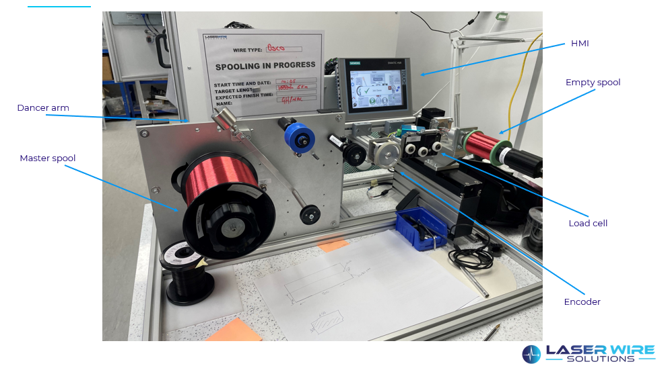
Figure 1 A picture of the machine in its current state.
The machine consists of the following:
A frame/base, dancer arm with counterbalance, potentiometer, tension load cell, Rotary encoder, three stepper motors, leadscrew, system pulleys, spool drive adaptors and control panel. The control systems comprises of a siemens s7-1200 CPU PLC system coupled with a siemens cinematic TP700 seven inch, touch screen human machine interface.
The company purchase many different fine wires dependant on the customers specification however all the master spools are purchased and supplied on an industry standard DIN 160 spool, the dimensions for a DIN 160 spool can be seen below. The weight of new master spool is approximately 6-7kg.
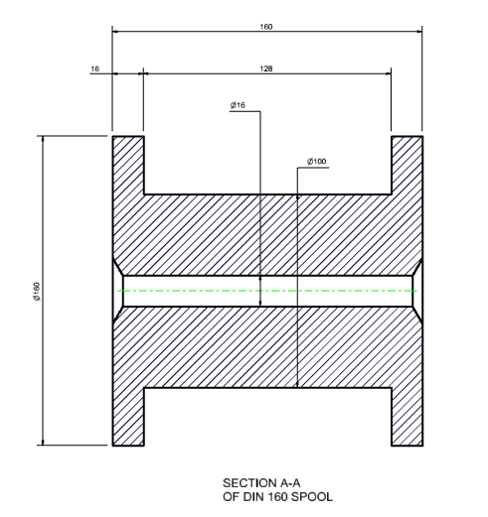
Figure 2 Dimensional representation of a DIN 160 spool
The laser wire stripping machines require the wire on the following industry standard size spools DIN 100 and ½ cat:

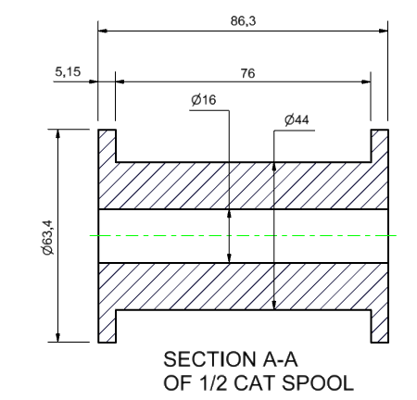
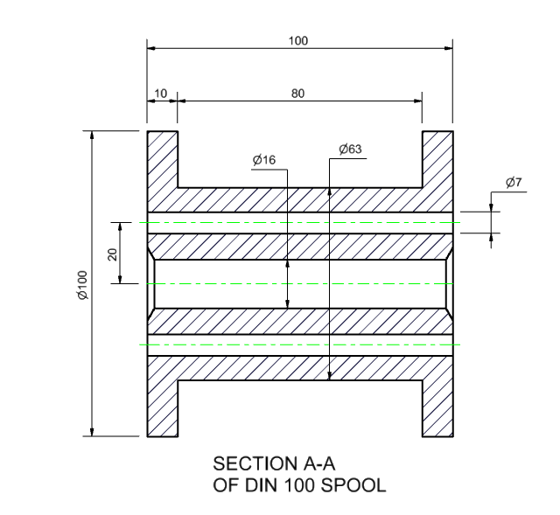
Figure 3 A dimensional representation of a 1/2 cat and a DIN 100 spool.

The following flow chart describes the process with which the operator uses to obtain a spool of wire in preparation to be used on the laser stripping machine.
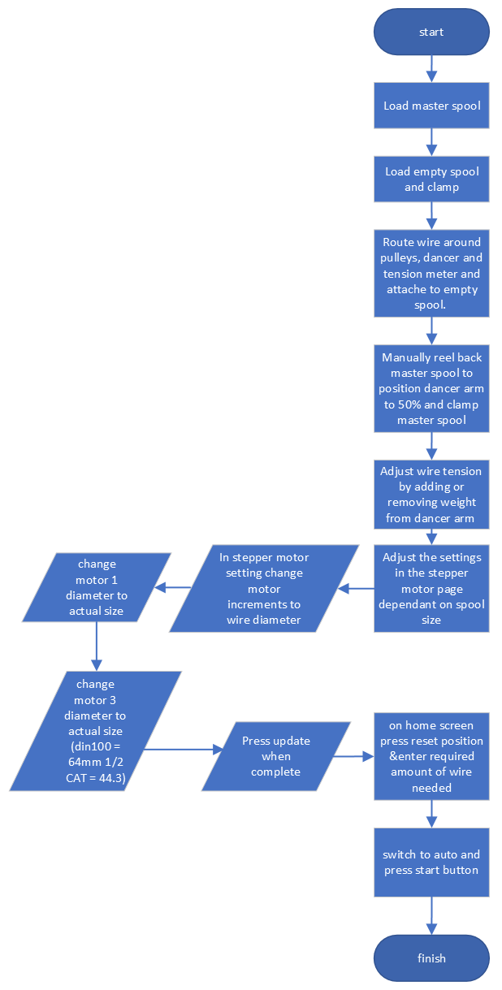
Figure 4 Operational flow chart for the machine.
The wire is fed from the master spool through the system pulleys and around the pulleys of the dancer arm and through the tension load cell making contact with the encoder wheel and attached to the new spool. The dashed green line in Figure 5 demonstrates the wire path and the system running with the maximum amount of wire and the minimum amount of tension.
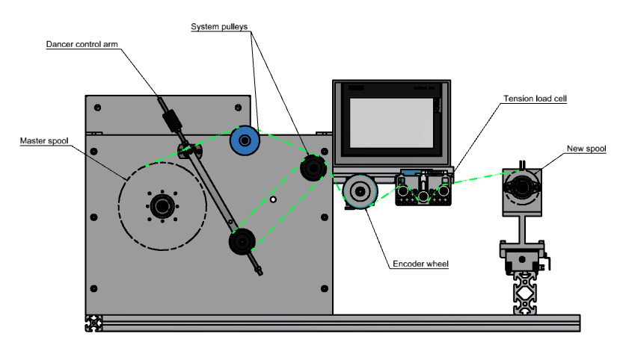
Figure 5 CAD model of the current machine with wire path depicted in minimum tension.
The dancer arm can travel up to 30 degrees to compensate for any fluctuations in tension while the system is running, figure 6 shows the system running with minimum amount of wire and maximum tension.
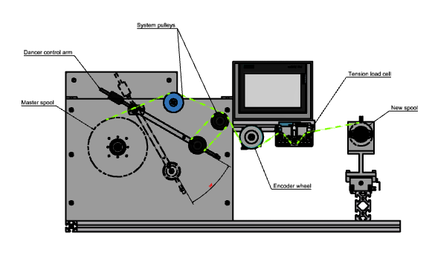
Figure 6 CAD model of current machine with wire path depicted in maxiumum tension.
To help with the design process and to be able to perform a cost analysis, the current machine was reverse engineered to provide a mechanical bill of materials and provide a design starting point. The bill of materials or BOM is a list of the components within the engineered product. The BOM is frequently created using a tree structure of components and sub-assembly names. The bill of materials can be broken down into fixed and variable costs (Karl T Ulrich, 1995) Not only will this help with the design process but it will also aid the company in the future, as the machine was designed using company engineering standards and processes. All manufacturing components were assigned a manufacturing number, designed in 3D and a 2D engineering drawing was produced. All purchased parts were assigned a purchased part number and added to the materials requirements planning system. The 3D models were attained from supplier websites, where possible, or modeled from supplier data sheets and all sub assemblies were assigned sub assembly numbers and exploded view diagrams or build instructions produced. By completing the aforementioned, if in the future, should the company decide to make another machine of this specification, this could be used to provide complete bill of materials to the purchasing department and complete assembly instructions to the production department. The following drawing is an outline of the machine as it currently stands, outlining the General assembly (GA) number and some basic dimensions.
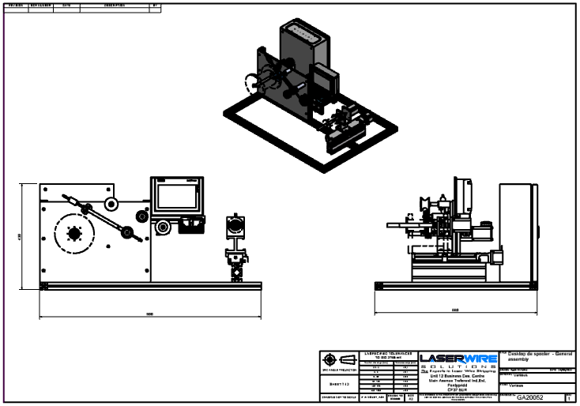
Figure 7 2-dimensional drawing or reverse engineered machine.
Note the lack of enclosure, storage and unsuitable position for the HMI. The following drawing features an exploded assembly view with a comprehensive parts list that will form the mechanical bill of materials.

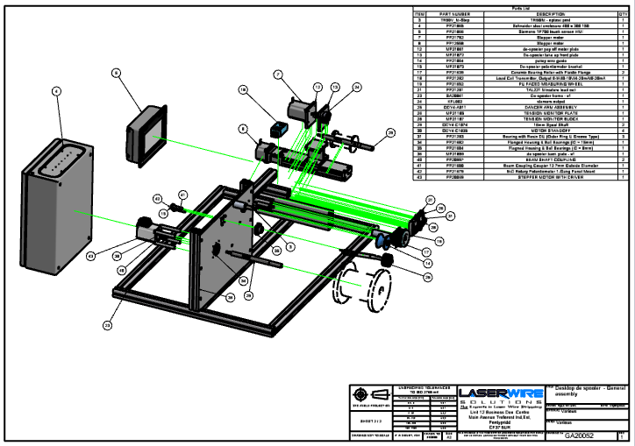
Figure 8 2-dimensional exploded drawing of reverse engineered machine
The following electrical and mechanical bill of materials were constructed and costings applied. Because the equipment was constructed from excess stock and no official project or records were performed, it was my belief from initial discussions with the customer that the customer had completely undervalued the machine. It was the customer’s estimate that the machine had cost in the region of £2000 in materials. However, it is clear to see by performing the reverse engineering and completing a cost exercise with the data that, in fact, the total cost of materials alone is £5213.81. This estimate doesn’t include any fasteners or non-recurring engineering (NRE). NRE refers to the one-time costs associated with the design, development, and testing of a new product or system. NRE expenses typically include activities such as research, design, prototyping, tooling, testing, and verification. These costs are not incurred on an ongoing basis but are necessary to bring a product from concept to production. (Karl T Ulrich, 1995). To be able to truly appreciate the cost as a business or to be able to price this equipment from a selling perspective, these would also have to be considered.

Figure 9 Mechanical Bill of Materials with estimated cost applied.
Figure 10 Electrical Bill of materials with estimated cost applied.

5.2 Introduction to the control system.
The HMI is made of three separate pages. Below is a layout of the home screen.
Status of the Machine Position
Wire Tension Position
Previous Page
Motor 3 – Take Up Tension Position
Encoder Position
Dancer’s Position
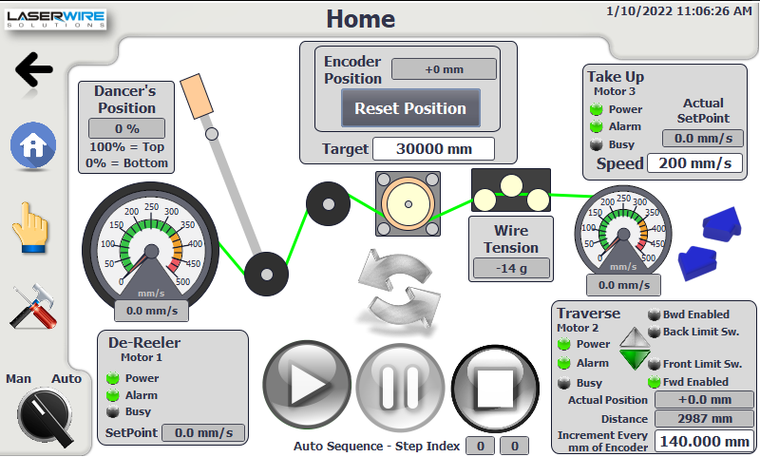
Motor 1 – De-spooler Tension Position
Manual
Manual-Auto Selector
Figure 11 HMI screen 1
Motor 2 – Traverse Tension Position
Start/Stop/Pause Buttons
Loading Button

Throughout all three pages, if a box is greyed out it could only be visualized as it set as an output only from the PLC software. However, if it is has a white background, it can be modified and, therefore, it is set as input & output within the PLC software.
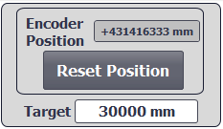
Editable
Read Only
Figure 12 Encoder position inputs and outputs.

Manual-Auto Selector: This selector is used to switch between the auto and manual mode. When auto-mode is selected, it is possible to start the loading sequence and the de-spooler sequence. In manual mode it is possible to manually jog all three motors independently.
Start/Stop/Pause Buttons: These three buttons are used to start, stop, and pause the de-spooler sequence and can only be used in auto mode; in Manual mode they will be greyed out and nonresponsive.


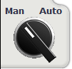


If the De-spooler sequence has been activated, the buttons Pause and Stop will be enabled:

Encoder Position
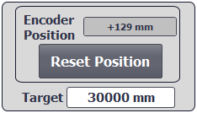
Figure 13 Encoder position reset button.
A rotary encoder is used to convert the angle traveled through, into a linear dimension. The encoder position is calculated according to the parameter set on the Settings page and the target field below is used to specify the length of the wire to be de-spooled. The reset Position button will reset the Encoder Position to 0 and is to be used during the loading sequence.

Dancer Arm Position
Dancer control systems are typically equipment used for attenuation of tension disturbances and generally categorised into three different systems: active dancer, passive dancer, and hybrid dancer systems. In an active dancer system, the position of dancer arm/pulley is measured and the arm is forced by an external actuator to regulate the tension. The passive dancer system is composed of a spring and damper but has no external actuator to regulate tension. The current machine uses a hybrid system, which is a mixture of passive and active and, therefore, regulates the tension in a manner of keeping constant position of the dancer arm by changing velocity of the payoff or master spool (K Kang, 2010). This position is calculated through the analogue reading coming from a potentiometer mechanically connected to the dancer arm. A rotary potentiometer consists of three electrical contacts and of a wire-wound track over which a rotatable electrical contact or slider can be rotated. A constant input voltage is applied to contact 1 and 3 and the output voltage $V0$ between the slider terminal 2 and 1 is dependent on the position the slider has rotated around the track. It is said that if the track has a constant resistance per unit length, then the output is proportional to the angle θ.
$$V0=kθ (where k is a constant)$$
And, therefore, the angular displacement can be converted into potential difference (Bolton, 1991).
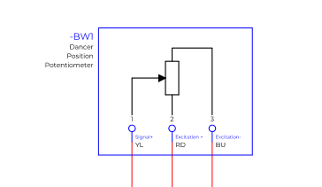
Figure 14 Dancer position potentiometer on machine electrical schematics
When the position is reading 0% the dancer arm is at the lowest position and 100% when at the top position. During the loading sequence, the operator will set the position to 50% by manually taking up the slack with the new spool before locking into position on the shaft coupled to the motor. This is the reference position where the system will automatically move the arm during the de-spooler sequence.
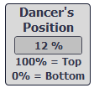
Figure 15 Dancer position PLC output
The parameters of the scaling are fixed and defined by 0-10v analogue convertor data block within the plc program and can only be changed through the PLC code.
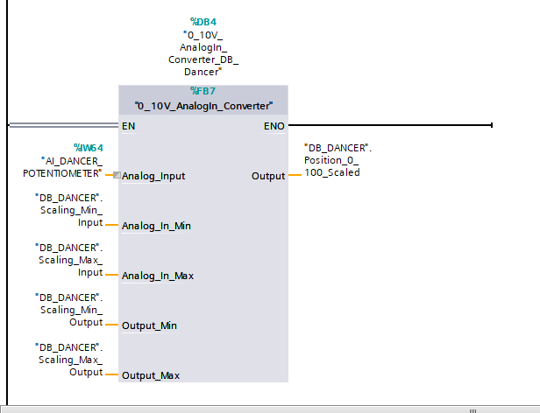
Figure 16 0-10v Analogue converter from PLC ladder program.

Wire Tension
The wire tension is calculated reading the voltage coming from the wheat stone bridge within the load cell and has a range of -20 grams up to 100 grams.
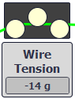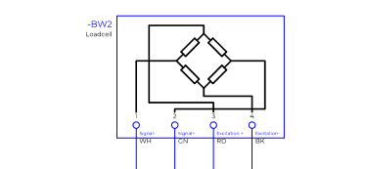
Figure 17 PLC output from loadcell and Wheatstone bridge diagram from machine schematics.
A Wheatstone bridge is a form of electrical circuit used to measure unknown resistance by comparing it with a known resistance. Invented by Samuel Hunter Christie in 1833 it was later popularized by Sir Charles Wheatstone in 1843. The circuit consists of four resistors arranged in a diamond shape, with the unknown resistance placed in one of the arms. The other three arms are made up of two resistors with a known resistance, and a third resistor, which is used to balance the bridge.
When an electrical current is applied to the Wheatstone bridge, a voltage is produced across the unknown resistance. By adjusting the third resistor, the voltage across the bridge can be balanced to zero, indicating that the unknown resistance is equal to the known resistance in the other arm of the circuit. This allows for accurate measurement of the unknown resistance. (Paul Horowitz, 2015, pp. 62-68)
Wheatstone bridges are commonly used in electrical and electronic applications, including strain gauges, temperature sensors, and pressure transducers.
The parameters of the scaling are fixed and can only be changed through the PLC code. If the tension is -14g, like in the picture above, the wire is missing or has been snapped. During a review of the PLC program this parameter is not being used in the code to stop the process or for anything else, therefore, there is the potential to improve the code and implement a form of monitor or control within the system.
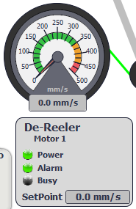
Motor 1 – De-spooler
Actual Speed
Setpoint Calculated by the PLC
Figure 18 Motor 1 status.

The de-spooler motor is used to adjust/control the position of the dancer’s arm reference point of 50% during automatic sequence. This is achieved by speeding up or slowing down the motor 1 velocity. The Setpoint is a parameter calculated by the PLC and the actual speed may be different to the setpoint because it is in relation to the acceleration/deceleration parameters set on the Settings page.
Motor 2 – Traverse motor
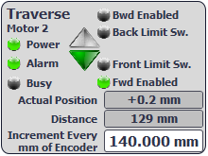
Figure 19 Traverse motor status.
The traverse motor is used to move the new spool transversally against the master spool to achieve equal layers of wire. The increment is dictated by the length recorded by the encoder. In this case, every 140mm of wire re-spooled the motor will be activated for a certain number of steps in the forward or back direction.
Motor 3 – Take Up

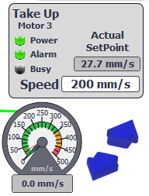
Figure 20 Take up motor status
The Motor 3 is used to wind the wire at a constant speed on to the new spool. The maximum speed that the motor can be set is 500mm/s.
Status of the Machine: this text is used to show the operator the status of the machine. The different statuses we could have are: Manual, Auto, De-spooler Sequence – Running, De-spooler Sequence – Pausing, De-spooler Sequence – Stopping, Loading Sequence - Traverse Homing, Loading Sequence - Traverse Homing Completed.
Manual Commands page.
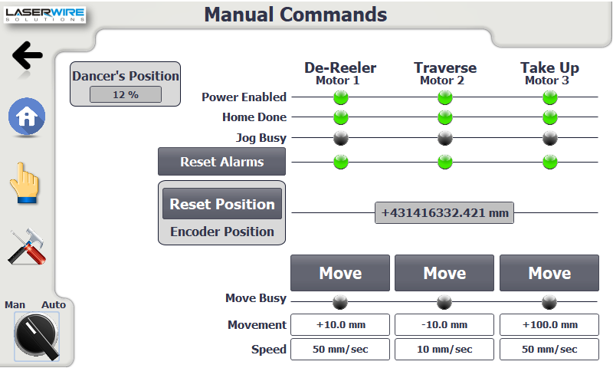
Figure 21 Manual commands screen

The move buttons are used to test the movements of the motors using the field boxes below. Movement is the distance to move and speed is the rate at which that distance is carried out. Reset position is to reset set the accumulative count of the encoder and reset alarms is to reset any alarm codes within the PLC program.
Settings page.
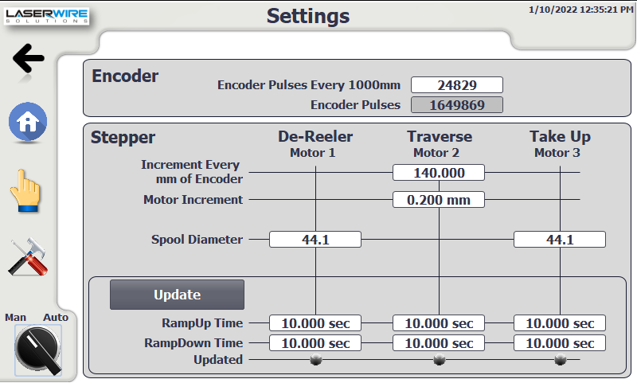
Pulses Every 1000mm
Figure 22 Settings screen.
Pulses Every 1000 mm.
The pulses Every 1000mm is a parameter used to calculate the wire length in millimetre.
Motor 2 - Increment Every mm of encoder.
This parameter is used to activate the movement of the Traverse motor once the wire length specified has been reached (140 mm in that case).
Motor 2 – Increment
This parameter is used as a relative movement for Motor 2 once activated.
Motor 1/3 - Spool Diameter
This parameter is used to convert the speed of the motors from pulses/s into mm/s
Ramp Up/Down Time
This is the time (in seconds) to accelerate/decelerate the motor from the configured maximum velocity to standstill.
It is necessary to press the button “Update” to load the new parameters modified.

All the motor drive parameters are stored within the PLC program within a siemens TIA technology object. The Siemens s7-1200 PLC uses these technology objects to control the outputs that control the motors. The following is a description for the parameters that control the payoff motor. The other motors will use the same base settings with possibly slightly different parameters.
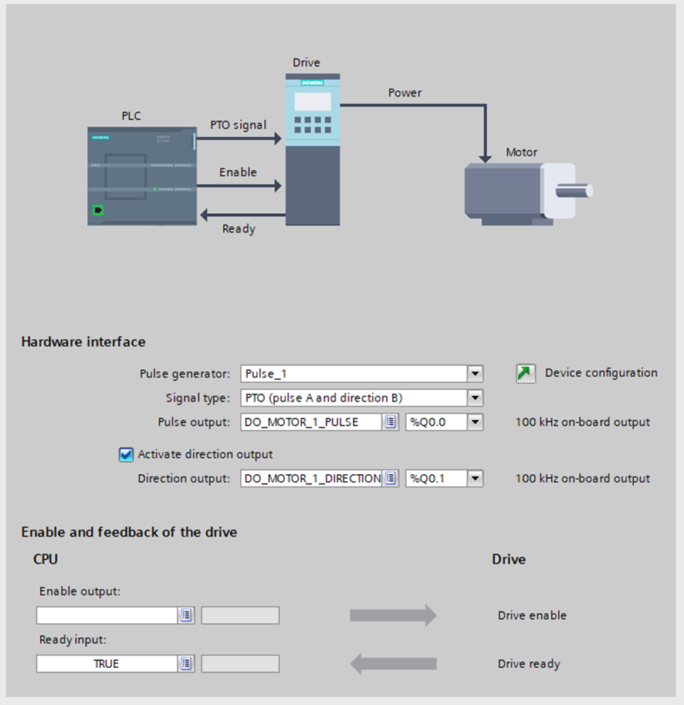
Figure 23 Motor parameters within technology object.
As you can see the CPU signal type is set to pulse generator outputs or Pulse Train Output. There are four separate configurations of pulse train output:
- Pulse A and direction B.
- Count up A, Count down B.
- A/B phase shifted.
- A/B phase shifted – fourfold.
All three technology objects are configured for Pulse A and direction B which equates to following: The CPU outputs the velocity and direction of travel via two separate outputs. This instance Q0.0 is used for velocity and Q0.1 is used for the direction. Therefore, for every pulse output at Q0.0 the motor shaft will rotate through a set degree and if a positive voltage is detected at Q0.1 the shaft will rotate clockwise. However, if there is no voltage detected the shaft will rotate anti clockwise.
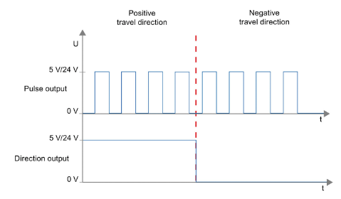
Figure 24 Diagram to shows pulse frequency and direction output.
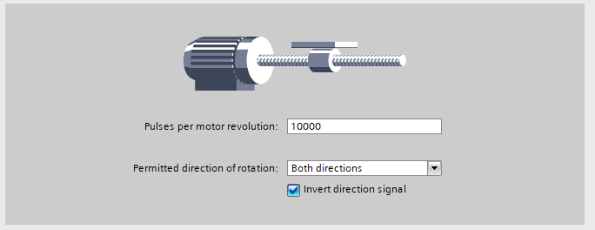
Figure 25 Pulses per revolution set in technology object.

Pulses per motor revolution is set to 10000, therefore, for every pulse the motor shaft will rotate through an angle of 0.04.
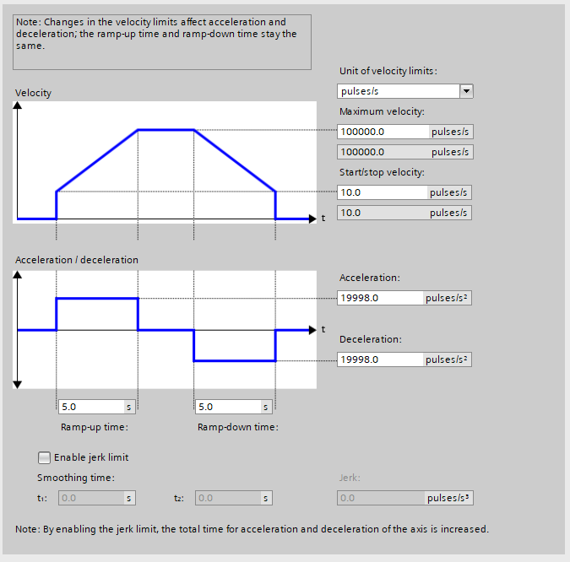
Figure 26 Motor velocity settings

5.2 Payoff Shaft Size
To be able to design a suitable shaft for the payoff spool we must first understand some of the design requirements.
- The shaft should be long enough to fit both master spool and the fixed and driving pintle used to connect the master spool to the driven shaft.
- The maximum diameter of the shaft must not exceed the internal diameter of master spool.
- The shaft should be long enough to support both master spool and the fixed and driving pintle used unaided.
- The shaft must be able to support the master spool and pintles.
The shaft is supported in a cantilever arrangement, with a bearing housing assembly. The bearing housing assembly consisting of two bearings 11mm wide spaced 20.5mm apart. The assembled shaft protrudes 228.75mm from the supporting bearing housing.
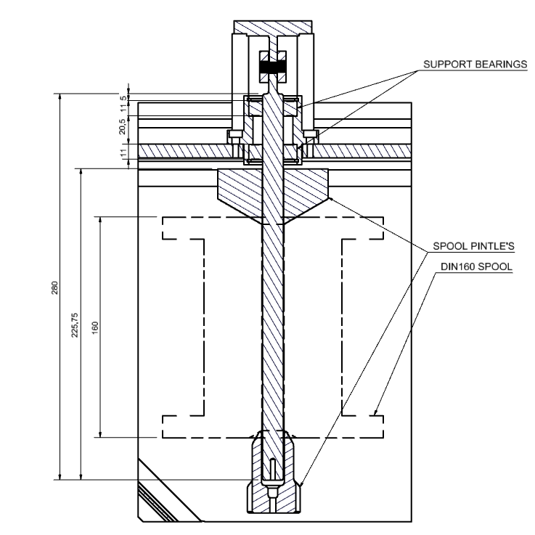
Figure 27 Dimensional drawing of proposed payoff shaft
An FEA static analysis was constructed with Autodesk Inventor software to analyse the stress upon the fully laden shaft. Autodesk FEA analysis will provide results for Von mises stress, 1st and 3rd principal stress as well as the displacement. Von Mises stress is described as a widely used measure of the maximum equivalent stress in materials under complex loading conditions. It is used mostly for ductile materials. It was originally proposed by Von Mises in 1913. The Von Mises stress is based on the distortion energy theory, which states that failure occurs when the total energy due to distortion reaches a critical value (Simscale, 2023). The following settings were constructed to perform the analysis:
Mesh size was set to 0.1
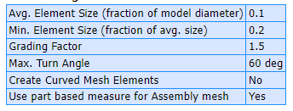
Figure 28 FEA mesh settings
The material override were set to steel for the bearing housing and aluminium for the shaft.
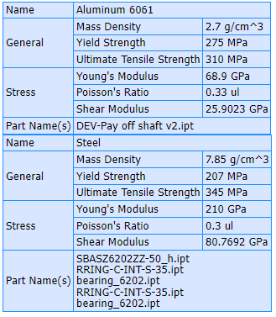
Figure 29 FEA material override properties.
The bearings and bearing housing were set as the supporting constraints and a load of 10kg (98.1 newtons) was set on the protruding shaft.
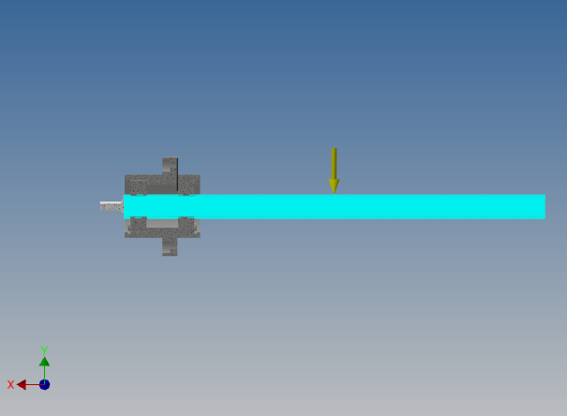
Figure 30 Picture of load direction
The bearing housing is bolted the backplate of the machine, therefore, the face of housing was set as the supporting\constrained face.
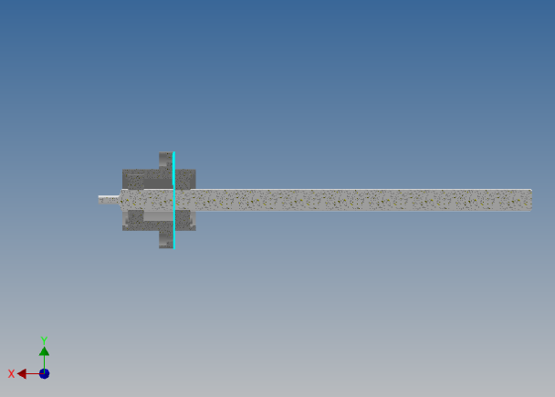
Figure 31 Picture to showing the constrained highlighted face
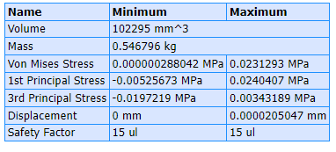
Figure 32 Table of FEA results.
The result of the FEA analysis fell well within the mechanical boundaries for the material specified and the results produced were not as expected, based on previous experience of performing a similar analysis. Providing doubt to the method/process used. Therefore, it was decided to remove some of the complexity of the analysis and conduct a FEA on the part only and not within an assembly environment. The mesh settings were again set at 0.1. The direction and amplitude of the force remained the same. However, for the second analysis the face of the shaft was set as the constrained face, effectively creating a simply supported beam/cantilever scenario, creating an “extreme case” scenario.

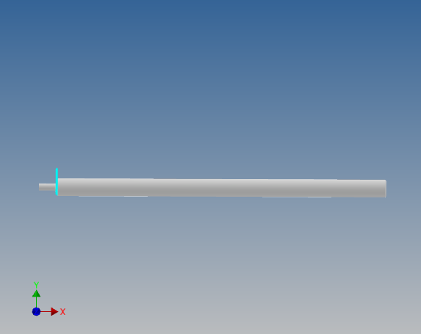
Figure 33 Picture showing the new constrained face.
This analysis produced similar results and, therefore, provided further confidence that the material and length chosen for the design meets the requirements. A comparison of both analysis can be found in the table below:
name | minimum | maximum
Assembly Von Misses stress (Mpa) | 2.88042E-07 | 0.0231293
Part Von Misses stress (Mpa) | 4.6102E-08 | 0.0170453
Assembly 1st principal stress (Mpa) | -0.00525673 | 0.0240407
Part 1st principal stress (Mpa) | -0.00566239 | 0.00818041
Assembly 3rd principal stress (Mpa) | -0.0197219 | 0.00343189
Part 3rd principal stress (Mpa) | -0.0219099 | 0.000649012
Assembly displacement (mm) | 0 | 2.05047E-05
Part displacement (mm) | 0 | 2.01104E-05
Figure 34 comparison table for both FEA analysis.
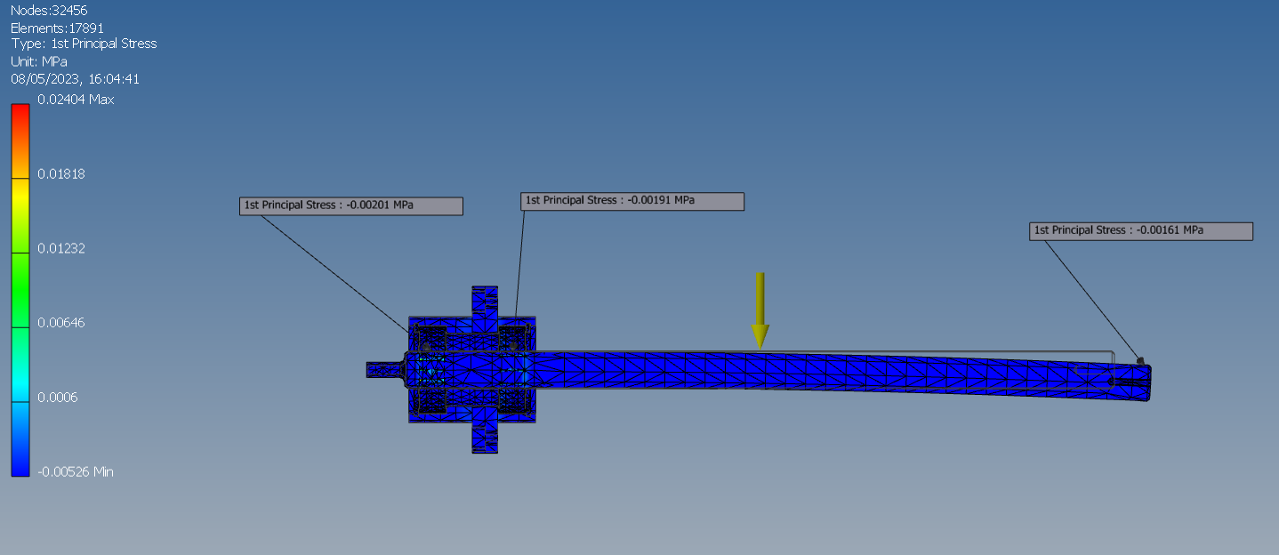
Figure 35 Picture to show first principal stress in assembly FEA
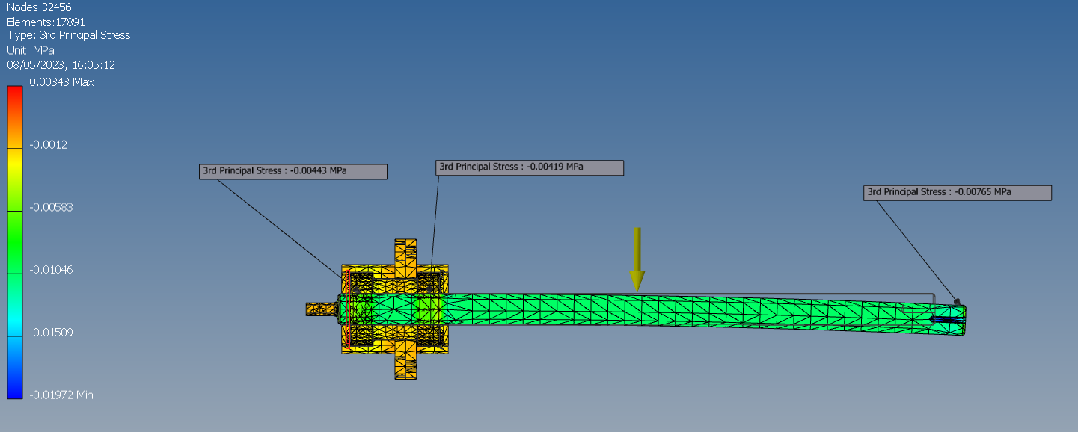
Figure 36 PIcture to show 3rd principal stress in assembly FEA
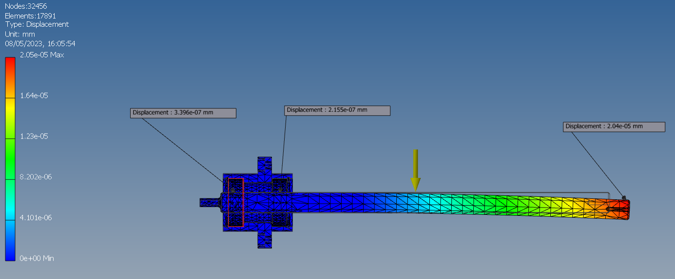
Figure 37 Picture to show displacement in assembly FEA
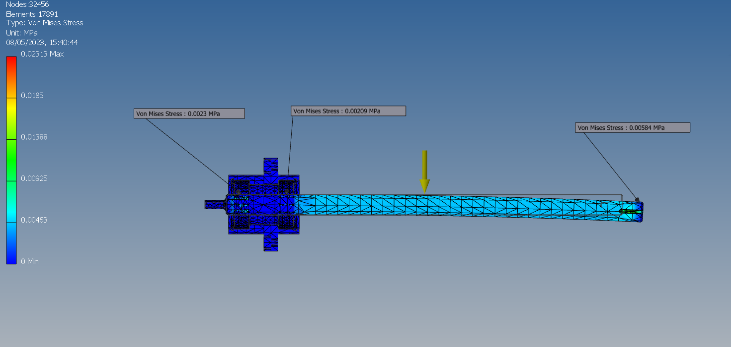
Figure 38 Picture to show Von MIses stress in assembly FEA

5.3 Motors Over-heating
All three motors used in the system are stepper motors. At the start of the project, the customer explained that the motors are extremely hot during a production run and questioned their suitability. To be able to answer this, some research was required.
A stepper motor is a precise electromechanical device that converts electrical pulses into mechanical movements. It is commonly used in applications such as robotics, CNC machines, and 3D printers. The operation of a stepper motor is based on the principle of electromagnetic induction, where the interaction between the magnetic field and current flowing through the coil creates a rotational force on the shaft. A stepper motor consists of a rotor (shaft) and a stator (stationary part), which contains multiple coils of wire. The rotor has several magnetic poles, which are attracted or repelled by the magnetic fields created by the stator coils. The stator coils are energized in a specific sequence, causing the rotor to rotate step by step.
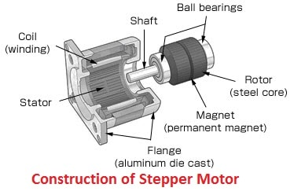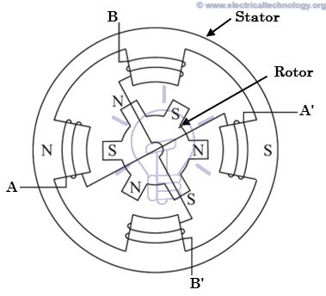
Figure 39 Picture to show construction of stepper motor.
(Technology, 2023)
There are several types of stepper motors, including:
- Permanent Magnet Stepper Motor: The rotor has a permanent magnet, and the stator has two or more coils that are energized in a specific sequence to produce the desired movement.
- Variable Reluctance Stepper Motor: The rotor has several teeth that are attracted to the stator poles when energized. This type of motor is simpler in construction and is often used in low-cost applications.
- Hybrid Stepper Motor: This type of motor combines the features of permanent magnet and variable reluctance stepper motors. It has a rotor with both permanent magnets and teeth, and the stator has multiple coils that are energized in a specific sequence (Krishnan, 2001).
Stepping motor systems are generally suited to open loop control and contain both motor and controller/driver. The output is the angular position of the motor shaft, and the input consists of two low power digital signals. Steps/pulses on the step input line determine the angular position of the shaft and the digital state of the input on the direction line: High for one direction, low for the opposite direction.
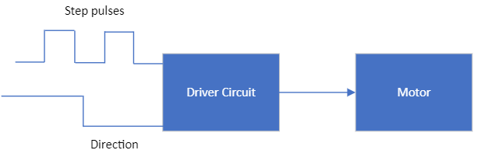
Figure 40 Diagram demonstrating step pulse and direction pulse to operate stepper motor.
A stepper motor may run very hot due to several reasons, including:
- Overloading or exceeding the rated capacity can cause it to run hot. This is due to excessive torque or speed demands on the motor, which can cause the coils to overheat and the motor to run hot.
- Incorrect Wiring: If the wiring of the stepper motor is not correct or damaged, it can cause the motor to run hot. Incorrect wiring can cause the coils to receive too little or too much power, resulting in overheating.
- Insufficient Cooling: If the stepper motor is not properly cooled, it can run hot. This can be due to inadequate ventilation or improper heat dissipation from the motor, which can cause the temperature to rise.
- High Duty Cycle: A stepper motor may run hot if it is used for extended periods or if it is operated at high duty cycles. This can be due to the continuous flow of current through the coils, which can cause them to overheat.
- Driver Circuitry: The driver circuitry of the stepper motor can also cause it to run hot. If the driver is not designed to handle the current demands of the motor or if it is not properly calibrated, it can cause the motor to overheat.
(Hughes, 1993, p. 276) states that the running performance of a stepper motor depends heavily on the type of drive circuit and it is important to emphasise, that to meet a specification, it is necessary to consider motor and drive together as a package.
The machine uses Leadshine DM542T digital stepper motor drivers.
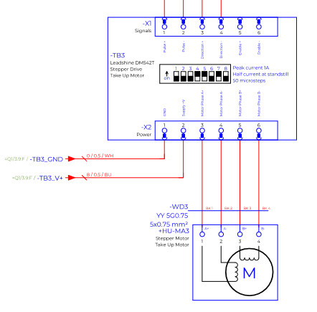
Figure 41 Schematic diagram of leadshine stepper drives.
The DM542 drivers are advertised as suited to driving hybrid stepping motors and feature cost-effective, good high-speed performance with Automatic idle-current reduction, Pure-sinusoidal current control technology, DIP switch current setting with 8 different values and use current chopping technique for its driving circuit.
The machine uses Adam power stepper motors model number 23hs40a76, with the following specification: Step Accuracy:±5%,Resistance Accuracy:±10%,Inductance Accuracy:±20%,Temperature Rise:80°C ,Max Ambient Temperature Range: -20°C~ +50°C,Storage Temperature Range: -30°C~ +60°C,Insulation Resistance:100M Ω MIN. 500V, DC Dielectric Strength:500V AC ,1minRadial Play:0.02mm MAX. (450g Load), End Play:0.08mm MAX. (450g Load)
As the temperature rise is rated for 80°c, an experiment was performed with the machine to record the temperature at certain elapsed time periods. The machine was loaded with a scrap spool of wire and set the run for 100 metres at 10mm/s. The temperature of the motor driving the master spool was recorded at timed intervals throughout the day with a digital thermometer and the results were recorded as follows:
Figure 42 Recorded temperatures from experiment.
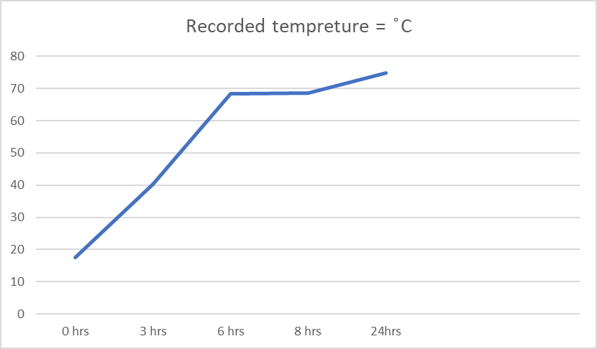
Figure 43 Graph to show temperature vs time.
The experiment is limited and doesn’t represent real life conditions, as the machine would typically run a little faster with a higher load. It is recommended that the experiment be repeated during a suitable production run and the results compared. However, based on data obtained and the research conducted it is recommended that stepper motors are suitable for this application, as the temperature didn’t exceed 80°c and are operating within the specified boundaries. There are methods readily available and are relatively inexpensive for additional cooling of stepper motors and these could be fitted as a precautionary measure. The first method for additional cooling is described as passive cooling and consists of mounting a heatsink with a conductive tape made from aluminium foil known as thermal tape. A heatsink is made from metal and acts as a radiator drawing heat via conduction from the component it is attached too and allowing the heat to rise from the source through its metal fins, where it will move across the thermal gradient from high temperature to low temperature. As a heatsink relies on thermal gradient, no convection will occur if the surrounding temperature is not cooler. A heatsink alone is described as passive cooling, as there are no moving parts and are often used with computer CPU’s as they are prone to overheating.
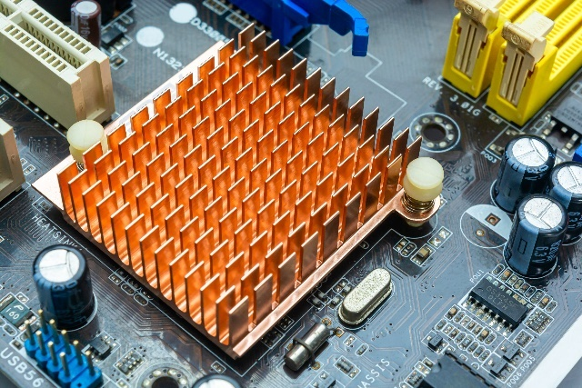
Figure 44 Example a passive cooling heatsink.
Active cooling or active heatsinks utilize forced air, created by a fan. This forced air ultimately increases the thermal gradient across the heatsink, which in turn allows more heat to be dissipated
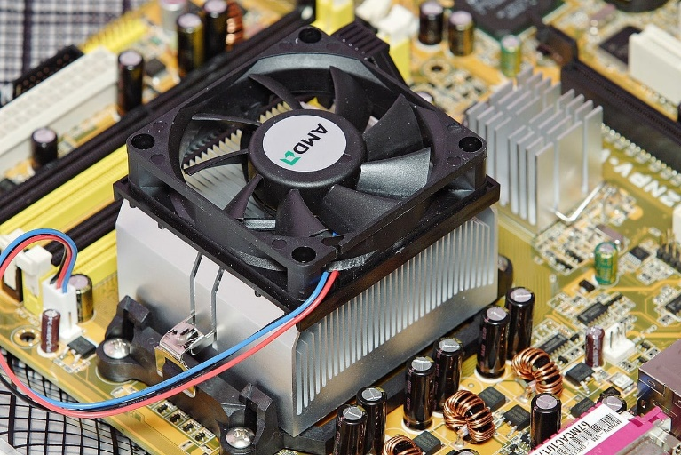
Figure 45 Example of an active cooling heatsink.
(Trick, 2022)
A passive 40mm x 40mm heatsink with thermal adhesive foil can be purchased for as little as £2.32. An active heat sink in a similar size can be purchased for £77.52.

5.4 Label printer
The company requires the newly spooled wire to have a label attached for company record purposes and the label must include the following: Master wire part number, re-spooled length, re-spooled speed, re-spooled tension, date spool was created and the initials of the operator who spooled the wire.
The company has used the Zebra brand of label printers for other applications in the past and expressed that would be a preference for the brand on the newly designed machine. After initial research on the website, it wasn’t clear what printers where suitable to receive information from a PLC, therefore, it was decided to contact the manufacturers.
The manufacturers state that to be able to use one of their printers with a PLC it needs to be a printer that feature the applicator interface option. The applicator interface is a method of integrating zebra printers into custom applications and the interface allows printer control from a programmable logic control or a personal computer via a cable attached to a 15-pin connector. This provides the capability of placing the printers on a production line in loose loop or print and apply configuration or allow the printer to be controlled by a machine. The print engine communicates with the customer application through a series of signals on the pins in DB-15 connector. When the printers are configured in this way, the applicator input signals allow an external device to control when the printer prints and the output signals provide handshaking and status information to the external host.
The PAX4 and ZE500 model printers feature the Application interface port installed from the factory and XI3 Plus, XI4 and ZT600 have the option to purchase and add the application port (Zebra Technologies Corporated , 2021).
To be ensure the PLC is properly interfaced and to be able set the print mode and applicator port settings on the printer the following information must utilized. Each pin causes different things to happen when a signal is active or not active. Firstly, the application port must be set for the power supply that will be used. The communication port ships in a default +5v internal power mode. If the interface is to be used with external power supply of +5v to 28v the jumpers on the circuit board need to set up.
Circuit board jumpers provide a reversable and convenient way of reconfiguring the circuitry on a printed circuit board. Circuit board jumpers are made of two or more conductive pins and a jumper box. The pins are soldered to the circuit board but are separated from each other by nonconductive material. The jumper box or cap is made up of an electrically conductive material covered with a nonconductive material to prevent accidental short circuits. The pins mounted to the circuit board are closed using the jumper box. When at least two pins are covered with a jumper box it is said to be a closed jumper and an electrical connection is made. However, when the pins are uncovered it is referred to as an open jumper and, therefore, the pins are in an open circuit state. (Shaik, n.d.)

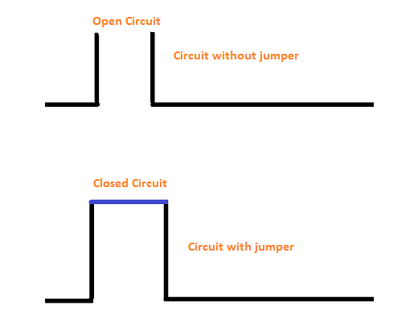
Figure 46 Picture of a jumper block and circuit representation
The printer’s application port circuit board must be configured with the following jumper placement dependant on power supply used:
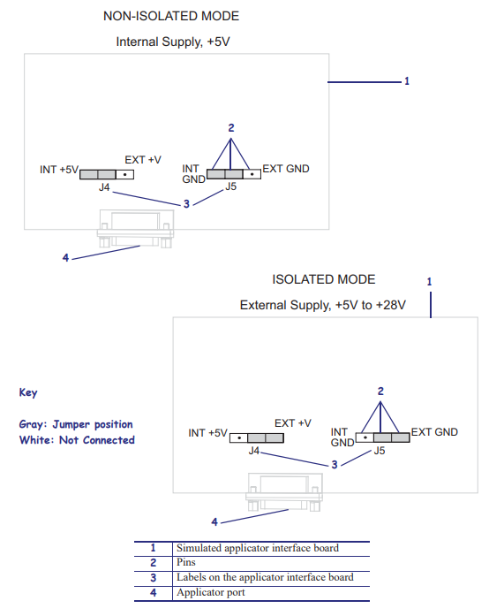
Figure 47 Jumper block configuration from zebra technologies
And the 15-pin configuration will be needed by the control engineers within the company and is defined as the following:
Figure 48 Table to show the configuration of the 15 pin connector
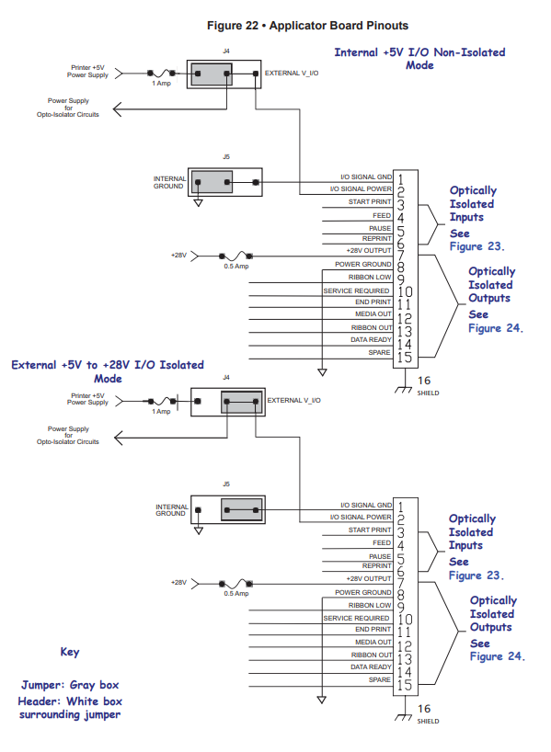
Figure 49 Schematic diagram for 15 pin connector dependant of power supply from zebra technologies
(Zebra Technologies Corporated , 2012)

Further research finds that the X13 plus and PAX4 has been discontinued and, therefore, the company now offers no support or service. PAX4 was replaced with ZE500 model printer comes in two variations the ZE511 capable of printing labels 4” wide and ZE521 capable of printing labels 6” wide and are designed to be integrated onto line side machinery or equipment.
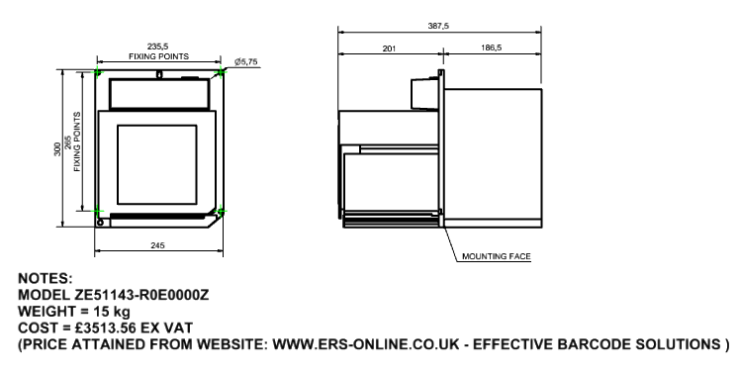
Figure 50 ZE511 printer sizes and costs.
The zebra xi4 has also been discontinued but is still available to purchase from zebra printer vendors. The xi4 was replaced with ZT600 series of printers and is available in four models ZT610, ZT610 RFID, ZT620 and ZT620 RFID. The ZT610 prints labels up to 4” wide and the ZT620 prints labels up to 6” wide. The RFID model adds RFID encoding. Unlike the ZE range the ZT model of printers are designed to be standalone.
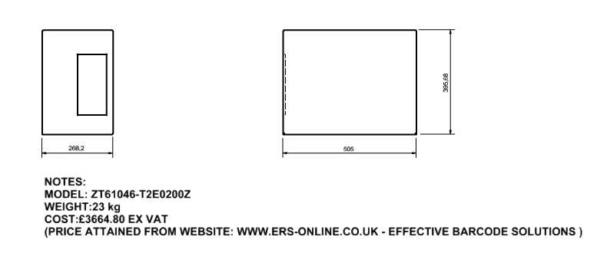
Figure 51 ZT610 printer sizes and costs.
Both options are generally classed as high-volume industrial label printers and at over £3500 are considered a large investment and feature a big footprint for what is to be a desktop size machine.
Zebra printers also offer a series of desktop printers. ZD200, ZD400 ZD600. The ZD range are advertised as compact, easy to use, low to mid volume printers. Feature a smaller footprint and are priced from £200 - £400. The drawback to using this type of printer is a separate computer system and manual input of data is required. There is potentially a method of the PLC saving the information required into a file and that file could be saved to USB stick or emailed and used with a separate computer and, therefore, could lower the risk of the wrong data being entered. However, this would require further research.
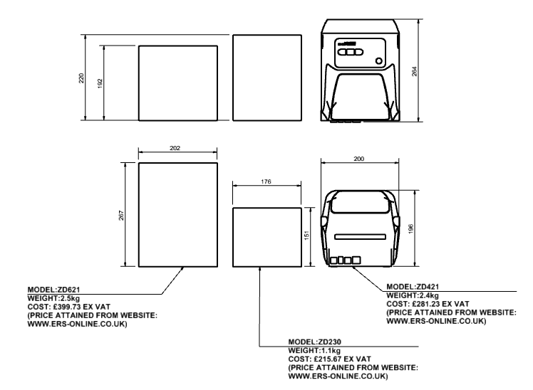
Figure 52 Comparison of proposed printers including sizes and costs.

5.5 Lowering tension.
Before we can aim to reduce tension in the system there are some considerations and underpinning knowledge that need to be taken into consideration.
Those considerations start with “Newtons second law of motion”. The acceleration of an object acted upon by an external force is proportional to the force and is in the same direction as the force.
Equation (1) newtons second law of motion is Force = Mass x Acceleration
$$\vec{F}=m\vec{a} (1)$$
Another consideration is the principle of pulley momentum theory, which is commonly used in mechanics to analyse the motion of objects connected by a pulley system. According to this theory, when a rope or cable is passed over a pulley, the tension in the rope on either side of the pulley is the same, and the pulley itself does not contribute any force to the system.
When an object is attached to one end of the rope and allowed to fall, it gains kinetic energy and momentum. As the object falls, the rope on the other side of the pulley is pulled upward, causing the pulley to rotate. The rotational speed of the pulley is directly proportional to the speed of the falling object and the rotational momentum of the pulley is equal and opposite to the linear momentum of the object. Pulley momentum theory is commonly used in mechanical systems involving pulleys and cables, such as lifts, cranes, and other lifting mechanisms. It allows for accurate calculation of the forces and motion involved in these systems, helping to ensure safe and efficient operation (Hugh D Young, 1999).
This can be defined in equation (2) Torque equals inertia, multiplied by angular acceleration.
$$(2) T=Iα$$
The angular acceleration in the pulleys is equal to the acceleration of the moving mass divided by the pulley radius and can be defined by equation (3).
$$(3) ∝ =\frac{a}{r}$$
Pulley inertia is a term used to describe the resistance of a pulley to changes in its motion. It is a measure of the pulley's mass distribution, which effects how quickly it can accelerate or decelerate. When a pulley is used in a mechanical system, it can contribute to the system's total inertia. This means that the pulley has an effect how much force is required to move the system and how quickly it can accelerate or decelerate.
The amount of pulley inertia depends on several factors, including: the mass of the pulley, the distribution of that mass, and the shape and size of the pulley. A pulley with a large mass and a concentrated mass distribution will have a higher inertia than a pulley with a lower mass and more evenly distributed mass. Pulley inertia is important to consider in the design and operation of mechanical systems, as it can affect the performance and efficiency of the system. A system with a high pulley inertia may require more force or energy to start/stop and will take longer to reach a desired speed (Ferdinand Beer, 2014). The moment of inertia of the pulley is equal to the mass times the radius of gyration and is defined by equation (4).
$$\left(4\right) I=m x k$$
The radius of gyration is a physical property of an object that describes the distribution of its mass around an axis of rotation. It is defined as the distance from the axis of rotation to a point where the object's entire mass can be concentrated, resulting in the same moment of inertia as the object's actual distribution of mass. Alternatively, the radius of gyration is the equivalent distance that would give the same rotational inertia as the object's actual mass distribution. The value of the radius of gyration depends on the mass distribution of the object, as well as the axis of rotation around which the object is rotating.
The radius of gyration is an important parameter in the study of rotational motion, as it allows for the calculation of the moment of inertia of an object around a particular axis of rotation. It is commonly used in engineering and physics applications, such as in the design of rotating machinery (Hugh D Young, 1999).
The radius of gyration for a uniform disc can be expressed as equation (5):
$$\left(5\right) k=d^{2}/8$$

5.6 Pulley design
The pulley assemblies used in the system consist of a ceramic roller, the contact point for the wire 30mm in diameter, plastic flanges with a diameter of 45mm , a 626z bearing and 6 screws. The company purchase these from a company called Ascotex and the details can be found at:

https://www.ascotex.com/product-category/ceramic-parts/ceramic-rollers/bearing-rollers/ceramic-bearing-rollers-with-plastic-flanges/ceramic-bearing-rollers-with-plastic-flanges/
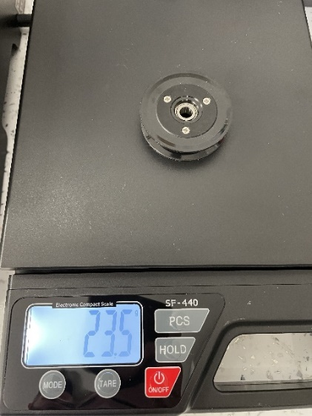
Figure 53 Picture showing weight of small bought pulley.
The pulleys, as bought, weigh 23.5g. It was decided to try and lower the mass in the pulley and a 3D printed flange was created to house the ceramic roller and bearing supplied but also to decrease the amount of fixings used.
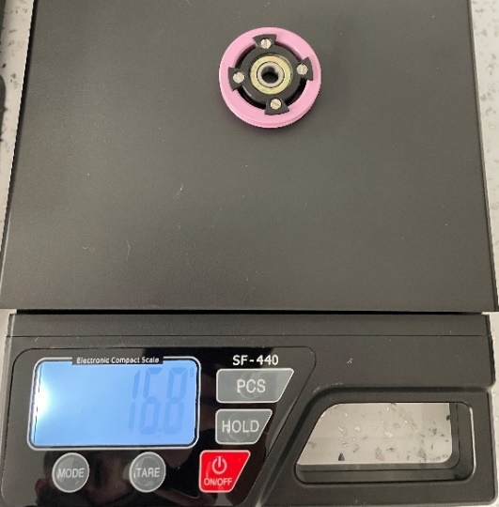
Figure 54 Picture showing weight of designed small 3d printed pulley.
By reducing the diameter of the flange but still using the same diameter roller and 3D printing, the flange in ABS with a 20% infill and reducing the amount fixings from six to four the mass of the pulley was reduced to 16.8g. The system features three of these pulleys, therefore, the total mass for these pulleys alone were:
$$total mass of three purchased pulleys=3 x 23.5g=70.5 g$$
By creating the three new lighter pulleys, the total mass was reduced to 50.4g. which equates to a 28.55% reduction in mass.
$total mass for three printed pulleys 3 x 16.8=50.4$g
$\left(\frac{(50.4-70.5)}{70.5}\right)x100= -28.55$ %
There were also the opportunities to decrease the mass of the encoder wheel. This was achieved by 3D printing a jig to clamp the encoder to a pillar drill in the production workshop and drilling a series of holes as follows:
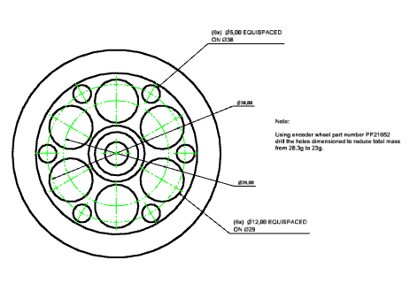
Figure 55 Dimensional drawing for weight reduction of encoder.
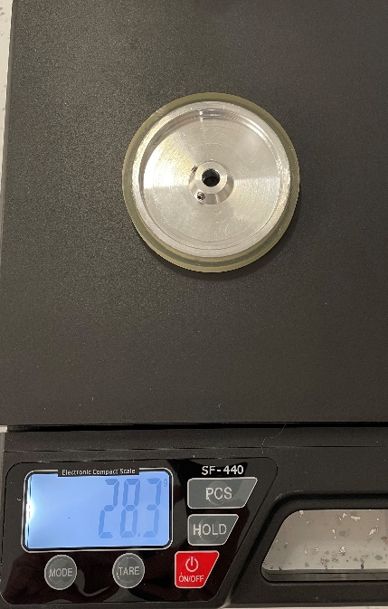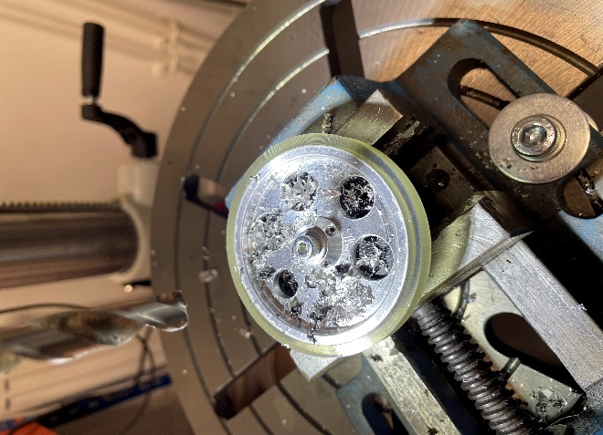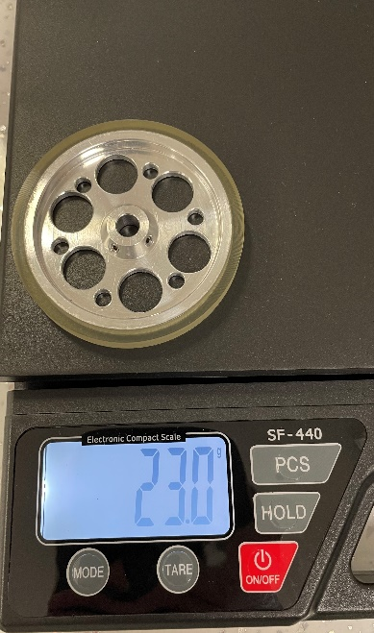
Figure 56 Picture of weight before, encoder in drill and weight after.
By completing this activity, it was possible to reduce the mass of the encoder wheel by almost 19% from 28.3g to 23g.
Therefore, by incorporating these new components on the new machine it will reduce the mass in the system from 93.8g to 52.4g, which equates to a mass reduction of 44% which is significant in a process of this nature and may be the answer to being able to process the finest wires. The pulley company also make a ceramic roller with a diameter of 50mm, plastic flanges with a diameter of 70mm using 6800z bearings. This pulley weighted at 36.9g. Out of curiosity, the same method was used to see how much mass could be reduced with these.
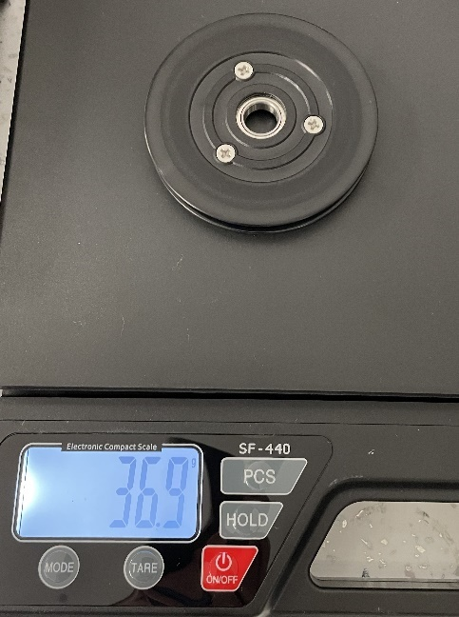
Figure 57 picture of weight of bought large pulleys.
A 3D printed flange was created to accommodate the increased diameter roller and bearing. As the machine was built for bearings with an internal inner diameter, a bush would also be required to retrofit this new type of pulleys.
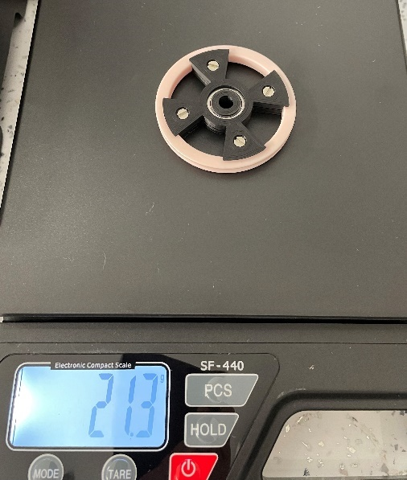
Figure 58 Picture of weight of designed 3d printed pulleys.
It was possible to achieve a pulley with an increased diameter for less weight than the original pulleys, however, based upon the research this will increase the moment of inertia for the system. This will also increase the kinetic energy within the system and could be trialled on the old machine and compared.
When you’re working with a system that is dealing with less than 10g of force mechanical losses or force generated by frictional losses, this cannot be ignored. Friction resistance is generated in bearings as they rotate, which in turn cause tension. Bearing manufacturer SKF uses the following model to calculate bearing friction and starting torque and is defined in equation (6)
$$\left(6\right) M=Mrr+Msl+Mseal+Mdrag$$
Where:
Mrr = The rolling frictional moment and includes effects of lubricant starvation and inlet shear heating.
Msl = The sliding frictional moment and includes the effects of the quality of lubrication conditions.
Mseal = the frictional moment from integral seals. Where bearings are fitted with seal, the frictional losses from the seals may exceed those generated in the bearings.
Mdrag = the frictional moment from drag losses, churning, splashing etc oil bath.
$$\left(7\right) Mstart=Msl+Mseal$$
Equation (7):
Mstart = starting frictional moment
Msl = sliding frictional moment
Mseal = frictional moment of seals.
(Bearing friction, power loss and starting torque, n.d.)
The bearings currently used feature two metal shield seals and are, therefore, adding to the frictional losses. On the new machine with an enclosure and clean environment, these shields aren’t needed and could be removed. Ceramic bearings could also be used. Ceramic bearings are made from silicon nitride/Si3n4 or Zirconia material and are generally considerably lighter than steel bearings and have a very low coefficient of friction and are often used in applications when very low turning resistance is needed. Ceramic bearings come in two types, hybrid, and full ceramic. As the name suggests the hybrid bearings use two types of material, steel rings and ceramic balls and this combination creates a bearing that can run at higher speeds due to the lower centrifugal force of the lightweight balls and the forgiving nature of the steel rings. Full ceramic bearings can cope with extreme temperatures and have excellent corrosion resistance, however, are more brittle and cannot be rotated at the same speed as the steel or hybrid equivalents. Both types would be suitable for this application (full ceramic vs hybrid bearings, n.d.).
Ceramic bearings cost considerably more than steel bearings. A 626-steel bearing with rubber seals from SKF can be purchased online for £4.37. However, a hybrid bearing from the same company can be purchased online for £56.55.

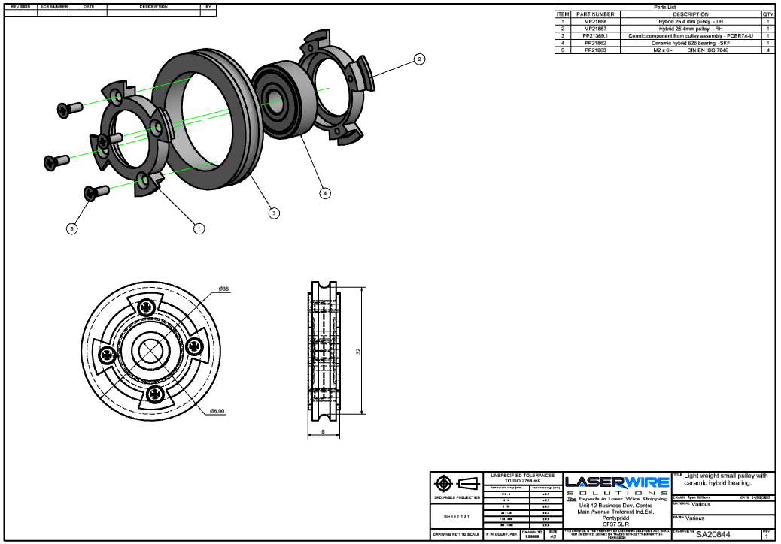
Figure 59 Exploded diagram showing proposed light weight pulleys.

5.6 HMI and Loadcell enclose and position.
The load cell enclosure features two components that are connected together with standard fasteners, and it also has the facility for the connectors to be applied when the load cell is enclosed. The load cell case features ventilation slots and can be printed with the companies 3D printers in ABS.
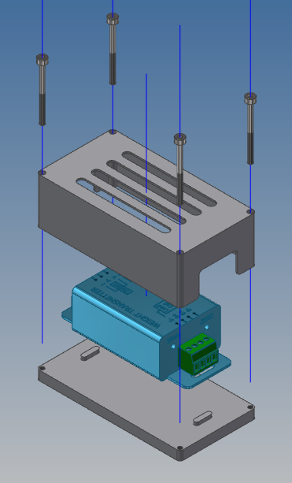
Figure 60 Exploded image of loadcell enclosure.

According to the Siemens TP700 HMI manual the requirements for fitting are as follows: the HMI can be loaded into sheet metal between 2-6mm in thickness and the size of the cut-out for a TP700 HMI is 197 mm wide x 141 mm high. The minimum clearance should be 15mm to the right and left (x axis) 50mm above and below (y axis) (technology).
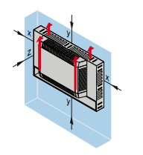
Figure 61 Siemens HMI axis directions.
The HMI must also not sit and an angle less than 35 degrees below the vertical.

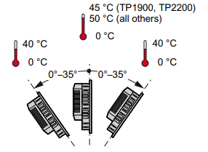
Figure 62 Siemens HMI max angle and temperature.
The other consideration is the connections to the HMI are at the bottom and, therefore, space will be required below for the cable entry. The mounting can be produced to the following dimensional drawing to suit and assembled to the base plate of the machine.
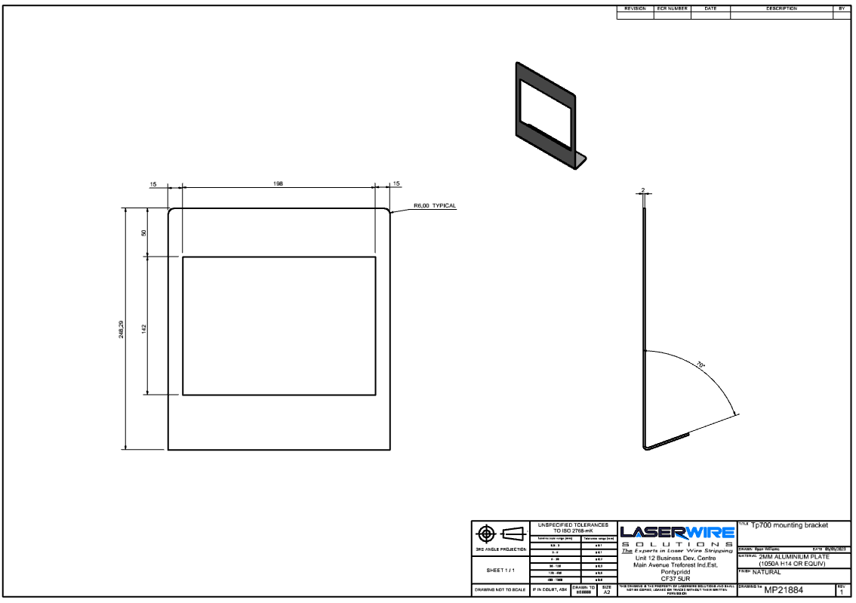
Figure 63 Dimensional drawing of HMI mount bracket.

5.7 Machine enclosure and storage.
Enclosure Idea 1: Consists of two guards made entirely, or mostly, from clear Perspex. The guards will be mounted onto some linear bearings that slide open to the left and the right of the machine.
Pros:
- Fairly easy to construct.
- Great visibility.
Cons:
- With both doors open the length of the machine doubles and would, therefore, overhang the desktop.
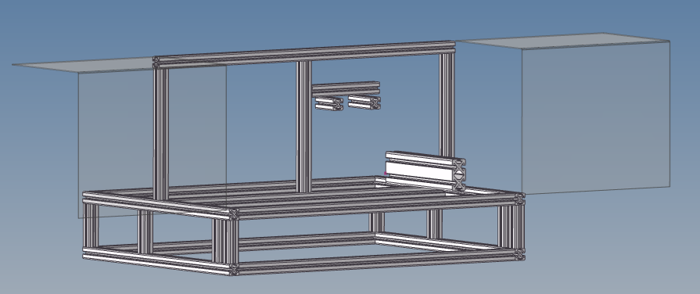
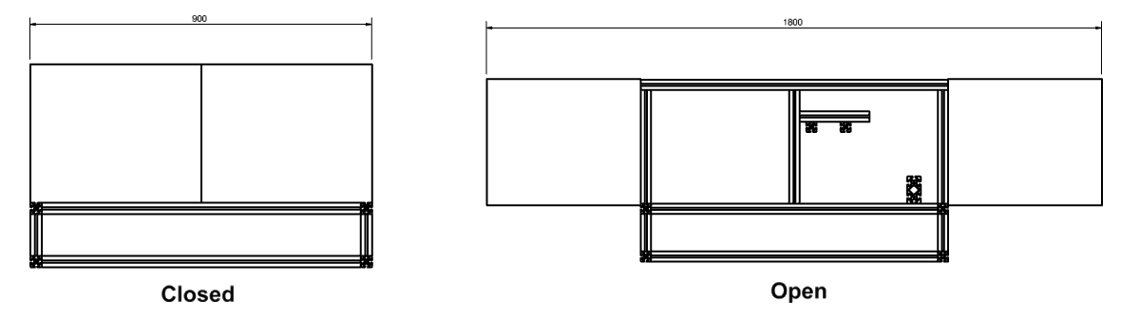
Figure 64 Enclosure idea 1 mock-up
Enclosure Idea 2 consists of two guards, one mounted to top of machine and one to the front of the machine. The top lid opens upwards and the front guard opens out towards the operator. Both guards will be mounted by hinges and are made from extruded aluminium and clear Perspex.
Pros:
- Easily mounted.
- Solid structure – minimum chance of deforming or flexing.
Cons:
- The front guard that opens out has the potential to get in the way of the machine operator.
- The front guard has potential to get lent on and broken.

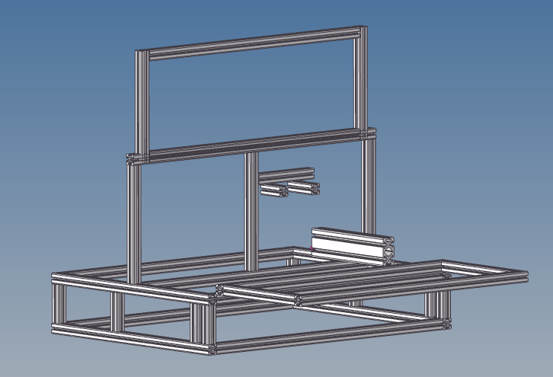
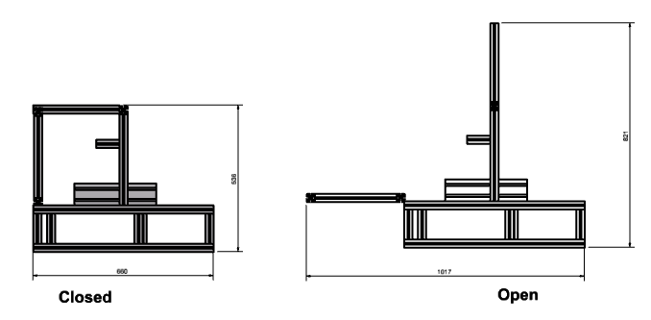
Figure 65 Enclosure idea 2 mock-up
Enclosure idea 3 consisting of lid type guard made from an extruded aluminium frame with three Perspex viewing panes. Mounted by hinges at the top of the machine frame that opens into the air.
Pros:
- Doesn’t add any length to the machine.
- Good visibility
Cons:
- Will need additional support when in the open position.
- Will need to open a lot, so as not to inhibit machine operator.
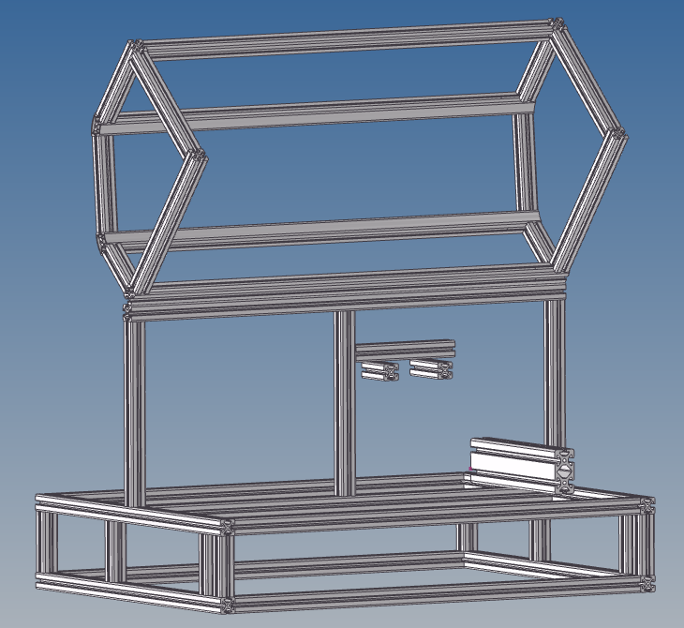
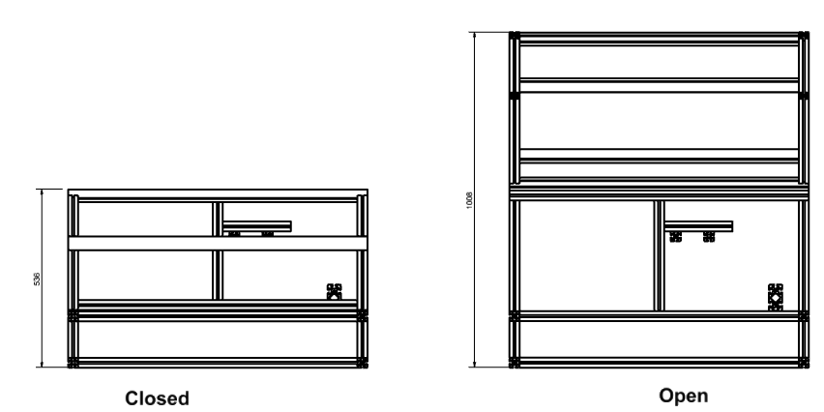
Figure 66 Enclosure idea 3 mock-up.
Enclosure idea 4 consists of Perspex guards the same as idea 1, however, these guards will be offset to allow them to open in the same direction and, therefore, limit the distance required for the open position.
Pros:
- Great visibility
- Small increase in open length than idea 1
Cons:
- Still increases length of machine.
- Increased complexity in mounting to allow both guards to overlap in the open position.
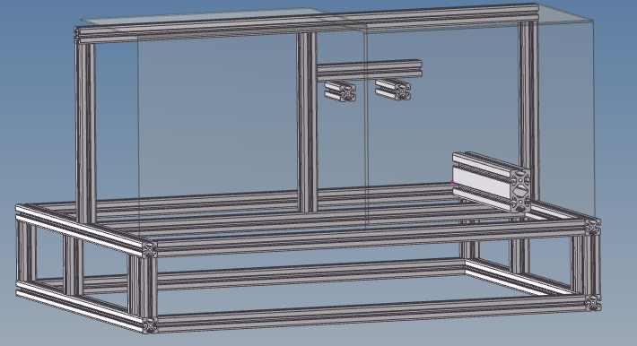

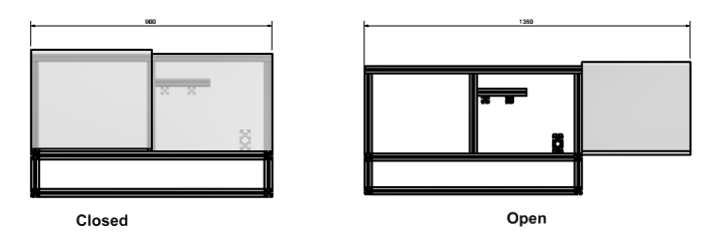
Figure 67 Enclosure idea 4 mock-up.
When designing a machine of this nature, the following British Standards Institution (BSI) safety standards should be met. The following standards provide guidelines for the design, construction, and operation of machinery to minimize risks associated with rotating components. By following these standards, along with performing suitable routine risk assessments and failure mode effect analysis during the design phase, can help ensure the safety of operators and other personnel who may need to use the machine.
- BS EN ISO 12100:2010: This standard provides general principles for the design and risk assessment of machinery, including requirements for the identification, elimination, or control of hazards associated with machinery.
- BS EN 60204-1:2018: This standard provides safety requirements for electrical equipment used in machines and specifies the requirements for the design, construction, and installation of electrical equipment.
- BS EN 1088:1995: This standard specifies the requirements for interlocking devices associated with guards on machinery.
- BS EN 953:1997: This standard specifies general requirements for the design and construction of guards provided primarily to protect persons from mechanical hazards.
- BS EN 349:1993: This standard specifies the minimum gaps to avoid crushing of body parts by machinery.
- BS EN ISO 13857:2008: This standard specifies safety distances to prevent hazard zones being reached by upper and lower limbs.

Machine storage
The best method for item storage is to utilize the space below the base of the frame for a drawer. Of all the associated tools and equipment used with the machine the biggest component that needs storing is a DIN 100 spool, therefore, it is safe to assume that the drawer should have a minimum height of 100mm. The drawer can be mounted to the frame using some good quality ball bearing toolbox drawer slides. The runners chosen will allow the drawer to open up to 278mm.
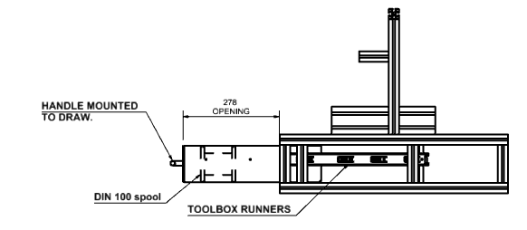
Figure 68 Dimensional drawing of machine and drawer.
The drawer should be manufactured by laser cutting and CNC folding 2mm thick aluminium. The corners will need welding before being powder coated for protection. The following annotated drawing can be used to allow the manufacturer to construct the drawer.
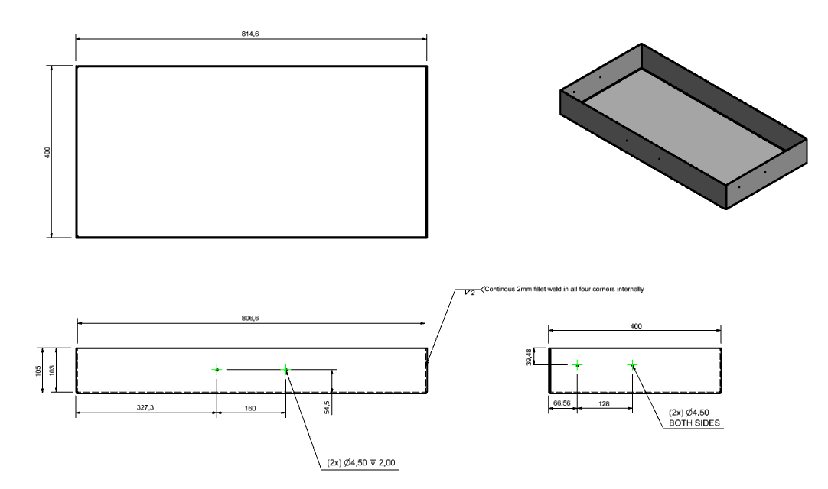
Figure 69 Dimensional drawing of drawer
The drawer is 900mm wide and, therefore, might bow or flex in the middle if there was considerable weight in the middle. There is little risk of this as most the tools are light, however, to reduce the risk of this happening the drawer could feature some dividers fitted to it to strengthen it, or the machine could feature two drawers instead of one, as a drawer half the length is less likely to flex.

5.8 Better suited encoder.
This machine uses a rotary encoder to track the length of wire. Rotary or shaft encoders are described as a device used to output a digital form related to the angular position of a shaft and come in two different configurations: incremental and digital. In this instance an optical incremental rotary encoder is used and it works by providing on-off signals as the shaft rotates. The position of the shaft is determined by counting the pulses that have transpired since the shaft was last at a particular position. This is achieved via a disc attached to the shaft of the encoder. The type of disc depends on the transducer used within. In the case of an optical encoder, the disc is made up of a series of windows in which light is allowed to pass through and the light pulses are recorded with a light sensitive transducer. For every pulse of light, an electrical output is produced and the counting of these series of outputs determines the angular position of the encoder shaft and whatever the encoder shaft is attached to. When the rate of rotation is required, it is necessary to determine the rate of pulses per second (Bolton, 1991).
Optical incremental encoders are available in different resolutions. Encoder resolution is defined by the number of pulses per revolution (PPR) or bit outputs by the encoder during one 360-degree revolution. Insufficient resolution will create ineffective feedback. There is also a maximum resolution and this is dependent on the maximum frequency response of the encoder electronics combined with the RPM of the application. Exceeding this could result in degraded signal and cumulative error (Ferbert, unknown ).
Minimum encoder resolution can be calculated by:
$$Resolution \left(PPR\right)=360°/Smallest increment of measurement required.$$
Maximum Encoder resolution can be calculated by:
$$Max resolution=operating frequency x60/ max⁡RPM$$
The machine currently uses an encoder with a PPR resolution of 5000 with a standard frequency response 125kHZ. The encoder wheel has a circumference of 200mm, therefore, if the machine is set to run at 200mm/s the encoder shaft will rotate 60 RPM, using the maximum resolution calculation above for 200mm/s:
$$125000*\frac{60}{60}=125000 PPR$$
By using the formula for calculating suitable encoder resolutions, the current encoder should be suitable and further investigation would be required into why the customer believes the current encoder is not suitable.

6.0 Final design
The additional features add further £1160 cost, bringing the total cost of the upgraded machine to £6373.81.
Item | Part Number | Description | QTY | Estimated Cost
1 | SA20842 | De-spooler frame assembly - v2 | 1 | £97.82
2 | MP21879 | de-spooler draw | 1 | £115.00
7 | SA20845 | De-spooler lid | 1 | £458.60
25 | MP21865 | de-spooler Pulley shaft | 1 | £78.00
51 | MP21883 | de-spooler top panel | 1 | £67.00
52 | MP21884 | Tp700 mounting bracket | 1 | £87.00
53 | MP21881 | de-spooler side panel | 2 | £56.00
54 | MP21878 | de spooler top back panel | 1 | £56.00
55 | MP21862 | de-spooler back panel | 1 | £48.00
56 | MP21880 | de spooler payoff shaft | 1 | £86.00
 | PP21862 | Ceramic hybrid bearing - SKF | 4 | £46.60
 |  |  | total | £1160
Figure 70 Table of upgrades including estimated costs.
An exploded view of the updated version of the machine with the upgraded parts identified with balloons. 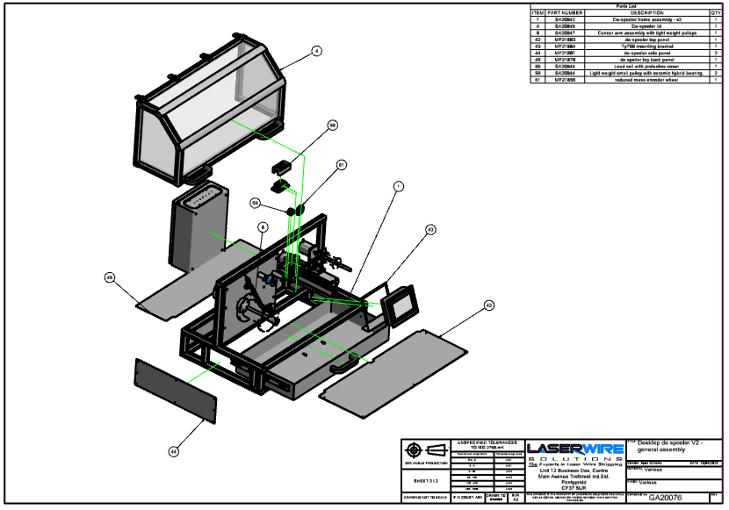
Figure 71 Exploded drawing of proposed upgrade machine.
The following drawing is a typical outline drawing of the upgraded machine, showing the dimensions of the drawer in a fully opened state.

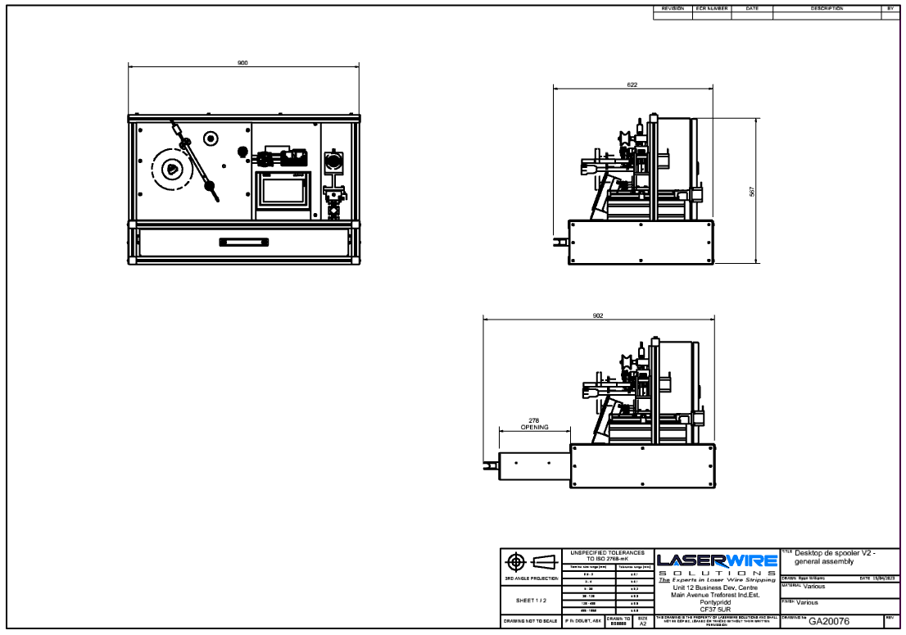
Figure 72 Dimensional outline drawing of proposed upgrade machine.

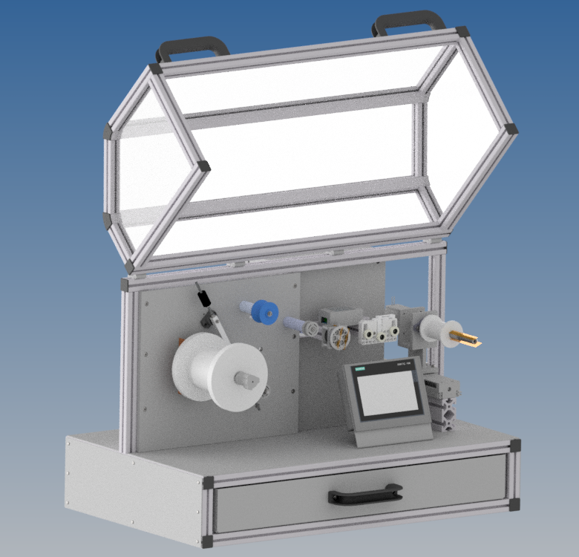
Figure 73 Render of proposed upgrade machine with lid open.

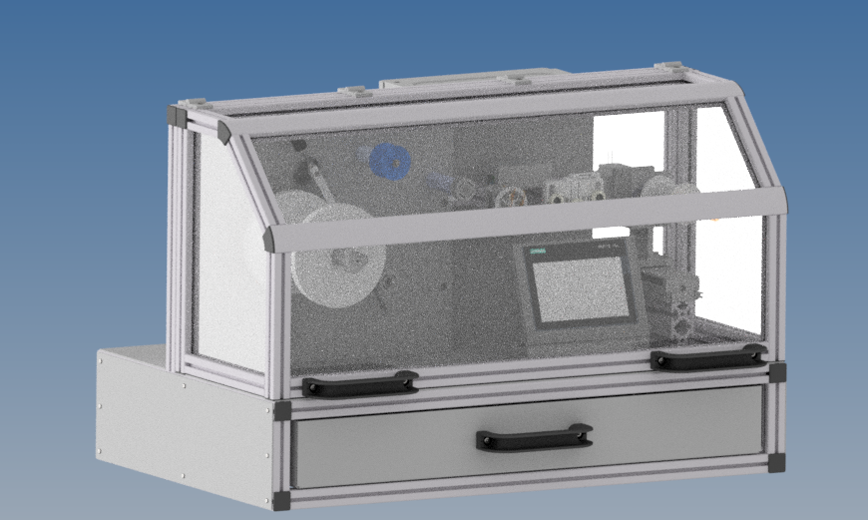
Figure 74 Render of proposed upgrade machine with lid closed.
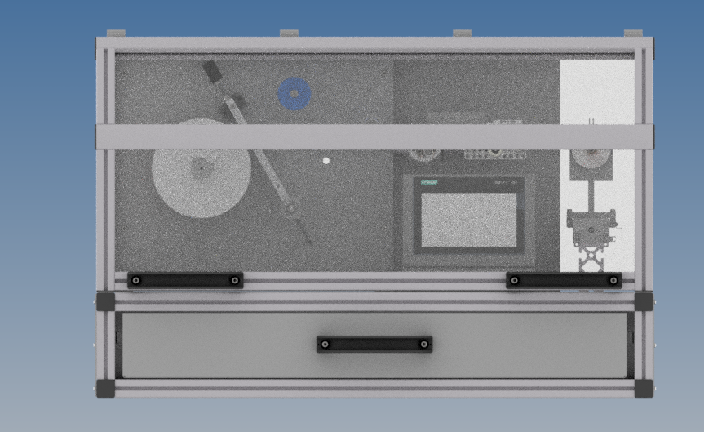
Figure 75 Render of proposed upgrade machine front view.

7.0 Conclusion
By constructing this report, it has allowed for a better understanding of the control system featured in this machine and the complexity within what was initially perceived as a simple piece of equipment. There is also now the capacity to build an upgraded machine that will better suit the contract manufacturing compartment and, hopefully, allow them to process the finest wires used by some of the biggest medical companies in the world, should they get the chance. Research into similar machines shows that there are at two other companies making similar machines.

8.0 Further Work
All the extra features designed within this project will allow for them to be retrospectively fitted to the existing machine, therefore, it is possible that should the customer so wish they could upgrade the current machine and test the proposals. During research into similar equipment there is one common difference between them and the machine used to at Laser Wire Solutions and that is the facility to measure the increased diameter of the newly spooled wire to be able to allow for greater accuracy in the layering process, which is also critical to the laser machines used. It appears that the control system uses the diameter of an empty spool to control the traverse of spool to apply defined layers, however, that isn’t efficient, as the new spool diameter increases with the amount of wire being built up. It also appears that what the customer believed to be an unsuitable encoder resolution doesn’t appear to the case and it is suspected that the error in measured spooled wire is due to something else within the system. It is suspected that the encoder isn’t revolving with every mm of re-spooled wire. That will need further investigation.
It is my belief that if the company were to produce this machine as a sellable product there are some cost reductions that could be made to increase profit and make them competitive. The frame uses the standard variant and the manufacturer of that particular extruded aluminium makes a lighter cheaper version. Also, the Siemens s7-1200 PLC and 7” touch screen makes up 27.56% of the cost. The interface is outstanding, and it makes sense with some of the more intricate machine produced, however, I believe that it would create little value in this machine as a sellable product and a cheaper, simpler PLC and interface would be able to provide the same level of control for a smaller price tag.

References
Bearing friction, power loss and starting torque. (n.d.). Retrieved from SKF: https://www.skf.com/uk/products/rolling-bearings/principles-of-rolling-bearing-selection/bearing-selection-process/operating-temperature-and-speed/bearing-friction-power-loss-and-starting-torque
Bolton, W. (1991). Industrial Control and Automation (1st ed.). Harlow: Longman Scientific and Technical .
Effective barcode solutions. (n.d.). Retrieved from ERS: https://www.ers-online.co.uk/p10617/zebra-zd421d-advanced-direct-thermal-desktop-printers
Ferbert, D. (unknown ). Dynapar. Retrieved Febuary 23, 2023, from https://www.dynapar.com/knowledge/how-to-calculate-encoder-resolution
Ferdinand Beer, E. J. (2014). Mechcanics of mtaerials. New york: McGraw-Hill Education.
full ceramic vs hybrid bearings. (n.d.). Retrieved from SMB bearings .
Gu, Z. (2020). Fully digital tension control sytem with PID algorithm for winding ultr fine enameled wires. Material science and engineering.
Hugh D Young, R. A. (1999). Sears and Zemanskys Unervisity Physics. London: Pearson.
Hughes, A. (1993). Electrical Motors and Drives (2nd ed.). Oxford: B H Newnes.
J.M. Allwood, S. D. (2016). Closed-loop control of product properties in metal forming. CIRP Annals, 573-596.
K Kang, W. L. (2010). Modelling and Matching Design of a Tension Controller. 1-8.
Karl T Ulrich, S. D. (1995). Product Design and Development. singapore: Mcgraw-hill.
Krishnan, R. (2001). Electric Motor Drives Modeling Analysis and Control. New Jersey: Prentice Hall .
Martinez, H. (2023). open loop web tension control. Retrieved from Montalvo: https://www.montalvo.com/article-library/open-loop-web-tension-control-overview-benefits-latest-technology/
Paul Horowitz, W. H. (2015). The art of electronics. Cambridge University press.
Shaik, A. (n.d.). Electronic Jumpers. Retrieved from Physics and radio electronics: https://www.physics-and-radio-electronics.com/blog/electronic-jumpers/
Simscale. (2023, March 9). What is von mises stress. Retrieved from Simscale: https://www.simscale.com/docs/simwiki/fea-finite-element-analysis/what-is-von-mises-stress/
Technology, E. (2023). Retrieved febuary 24, 2023, from https://www.electricaltechnology.org/2016/12/stepper-motor-construction-types-and-modes-of-operation.html
technology, S. (n.d.). Comfort panel operating instructions. . Retrieved from https://cache.industry.siemens.com/dl/files/233/49313233/att_59649/v1/hmi_comfort_panels_operating_instructions_en-US_en-US.pdf
Trick, C. (2022, may 16th). Blogs by trenton systems. Retrieved from Trenton systems: https://www.trentonsystems.com/blog/what-is-a-heat-sink
Zebra Technologies Corporated . (2012, 11 20). Print Engines Maintenance Manual . Retrieved from https://support.zebra.com/cpws/docs/inquira/attachments/SO8455.pdf
Zebra Technologies Corporated . (2021, February 24). What is the applicator port option.

