DS 1 Assignment

My Screenshots/Photos
- Please add 4–6 screenshots or photos of your digital life.
- You can use your phone or laptop.
- For each screenshot, write one or two sentences explaining what it shows.

Screenshot/my laptop
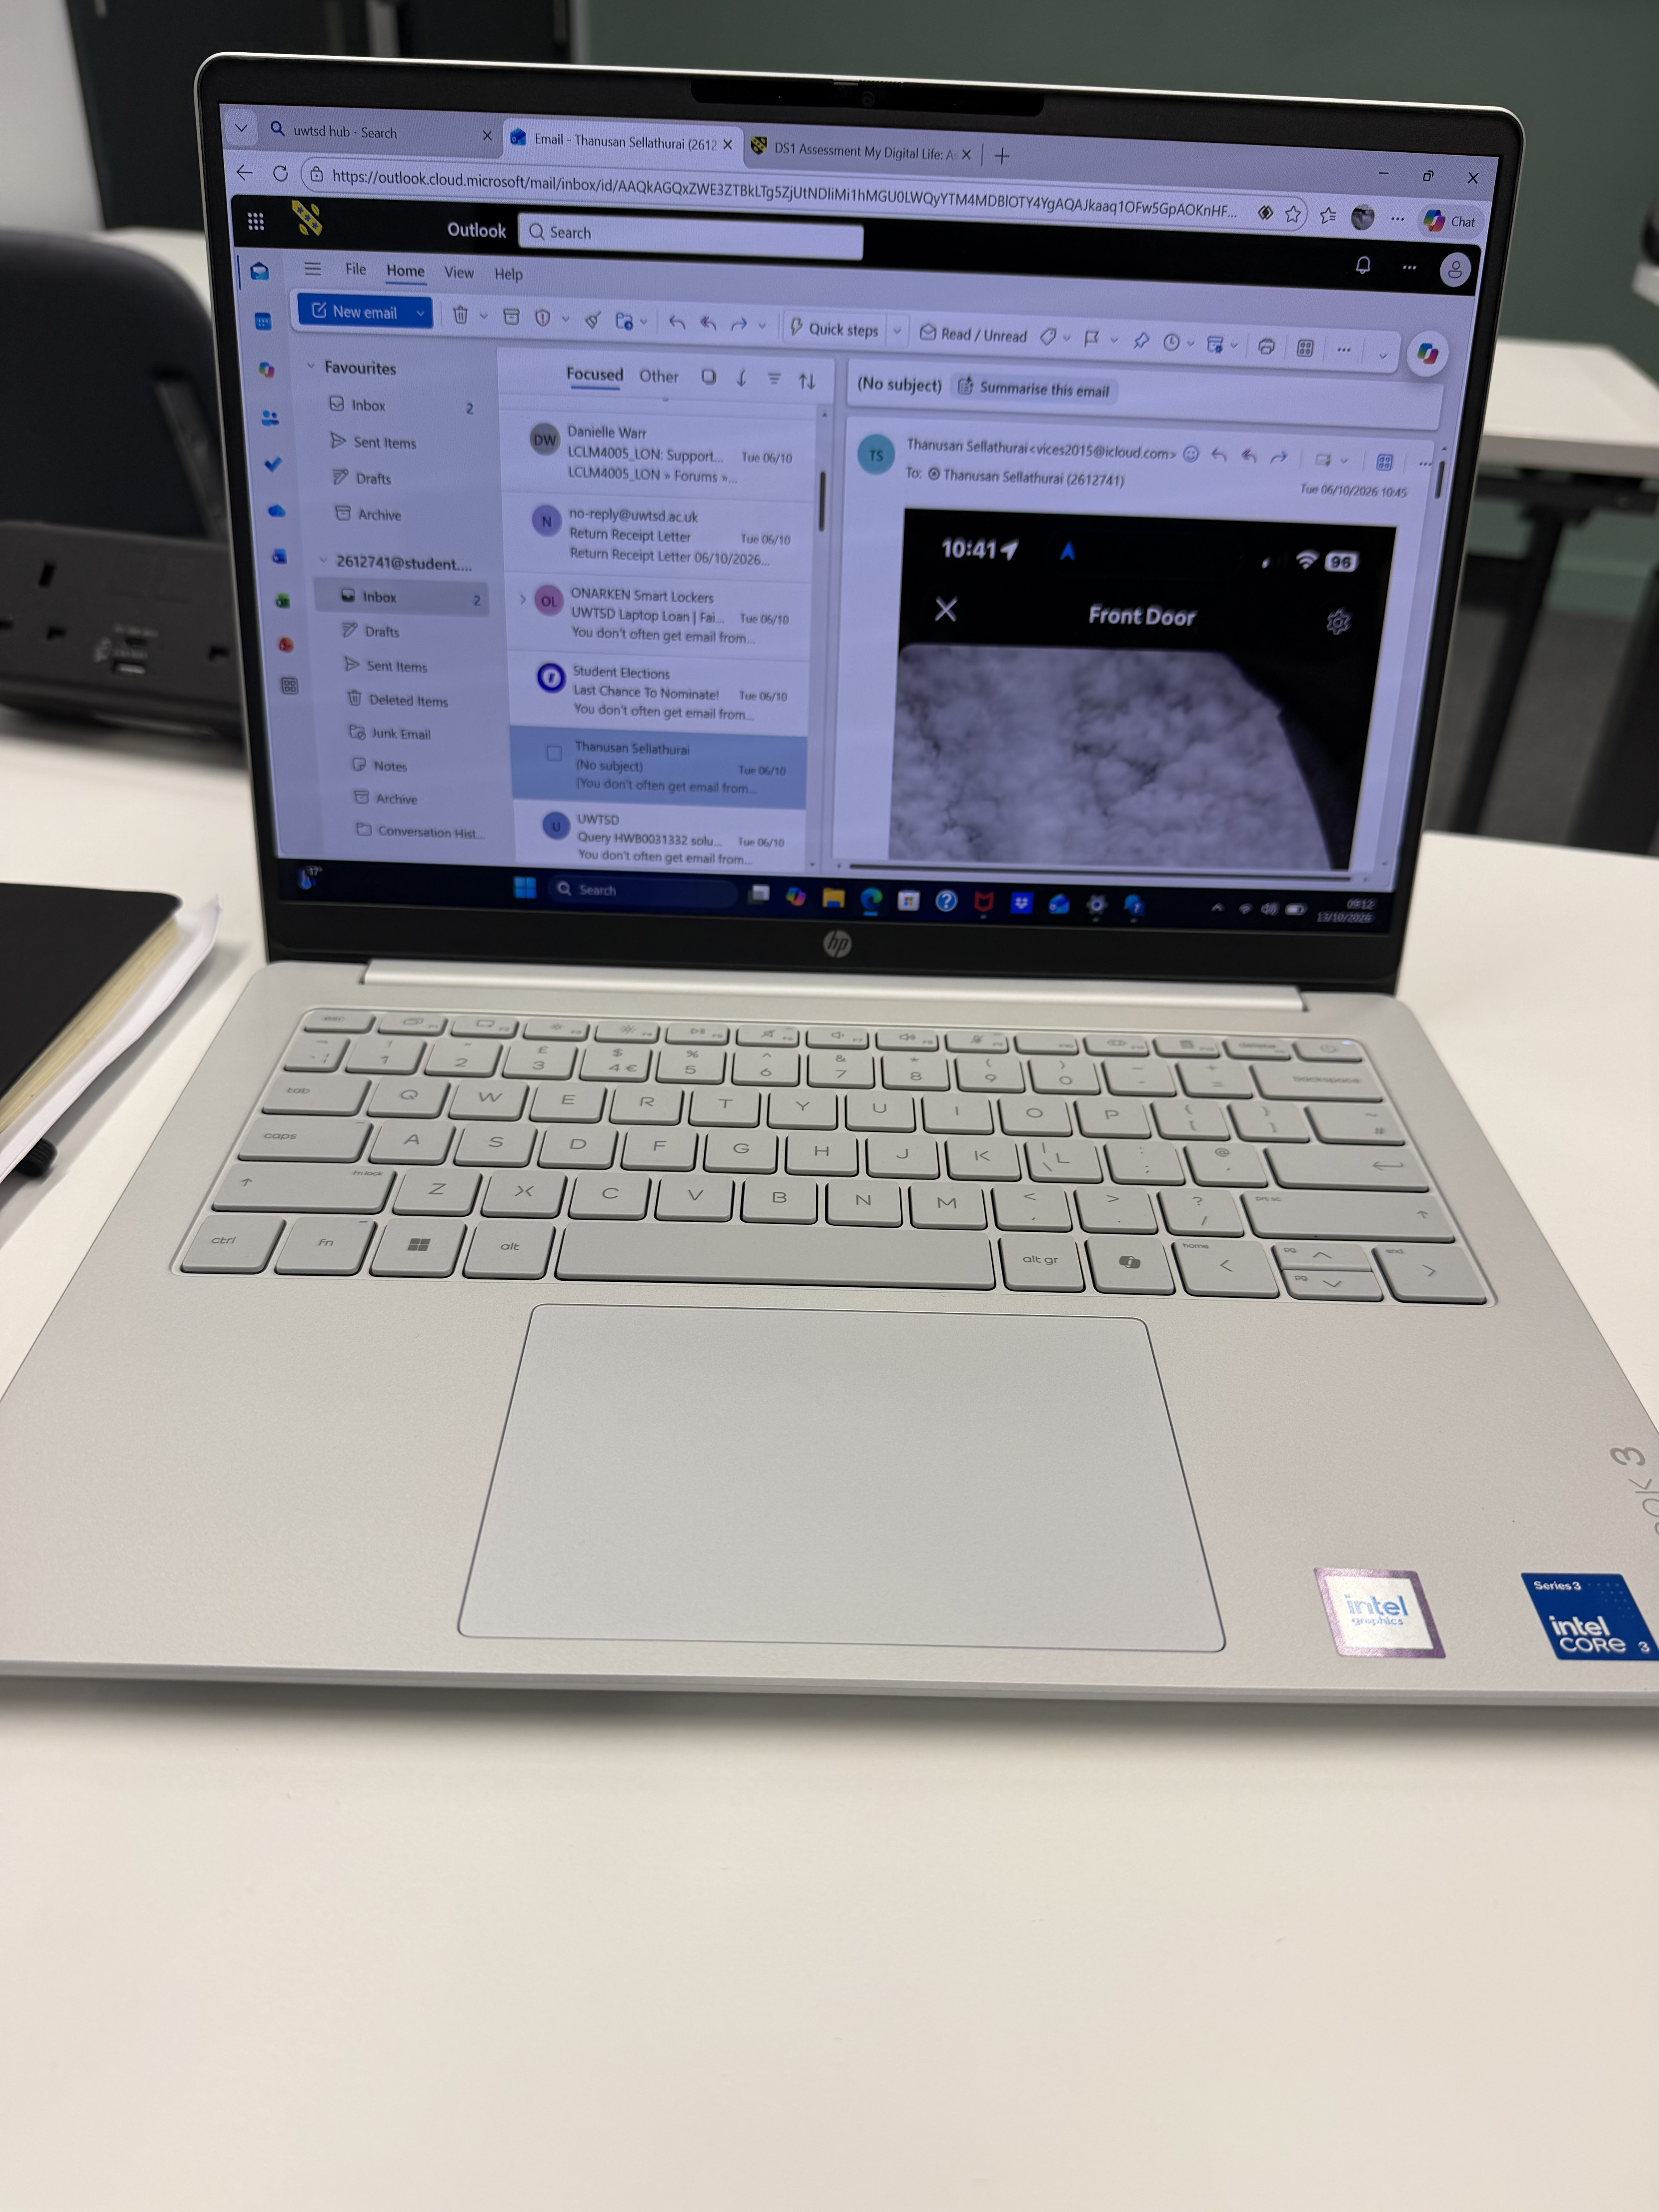
A laptop is a portable personal computer that integrates a display screen, keyboard, this is lightweight easy to take anywhere with me. That make my life easy.

Screenshot/navigation
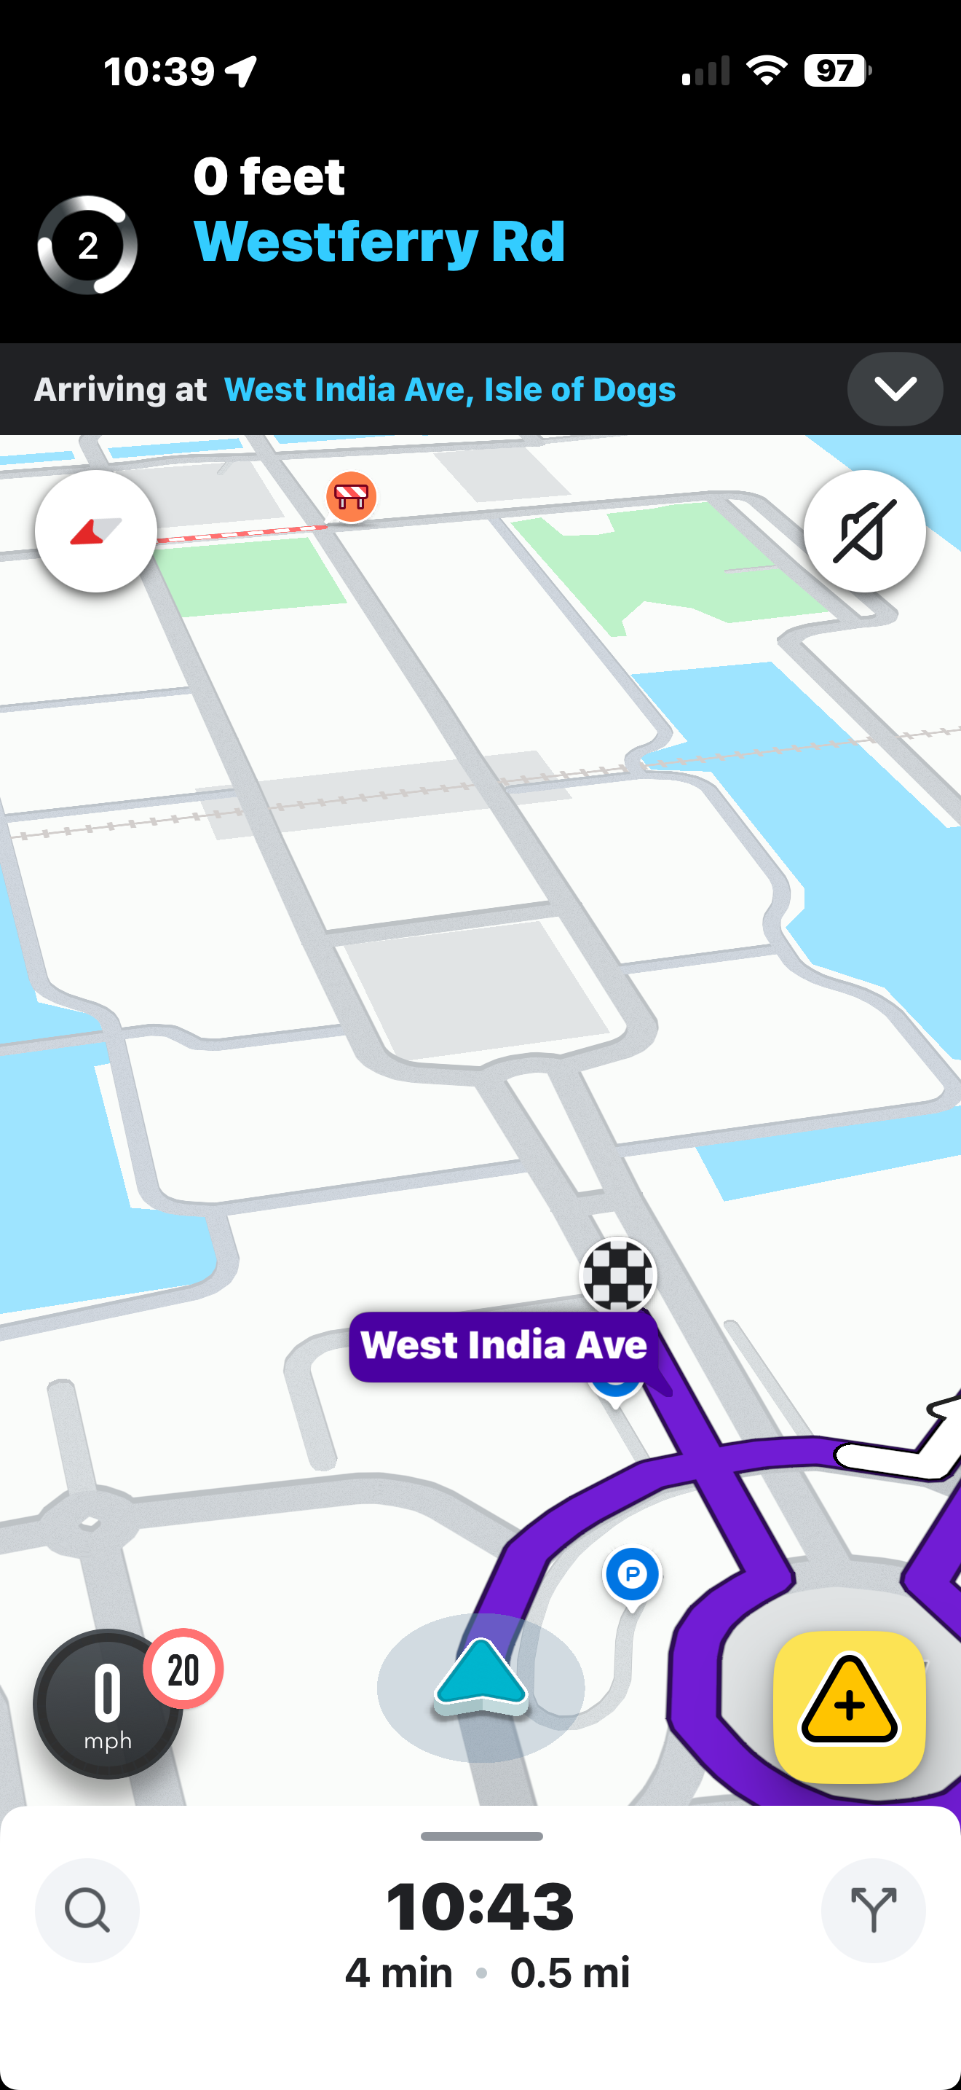
Navigation is the art and science of determining a position, course, and direction. This is very helpful who don’t know how to reach destination.

Screenshot/digital thermostat
[Insert Photo/Screenshot below]
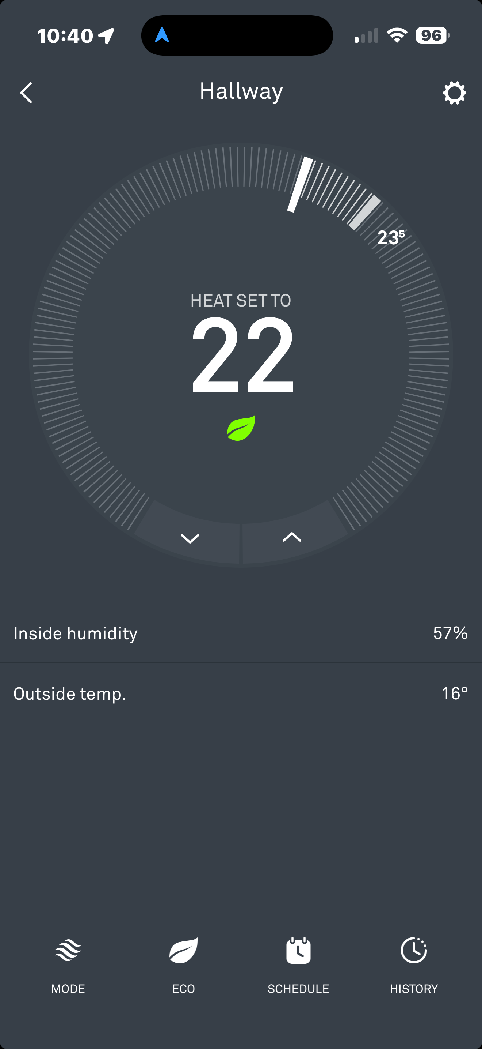
A digital thermostat is an electronic temperature controller that measures room or system temperature, compares it to a set point, and automatically adjusts heating or cooling to maintain comfort. I can control from any where in the world to warm up my house.

Screenshot/Digital doorbell
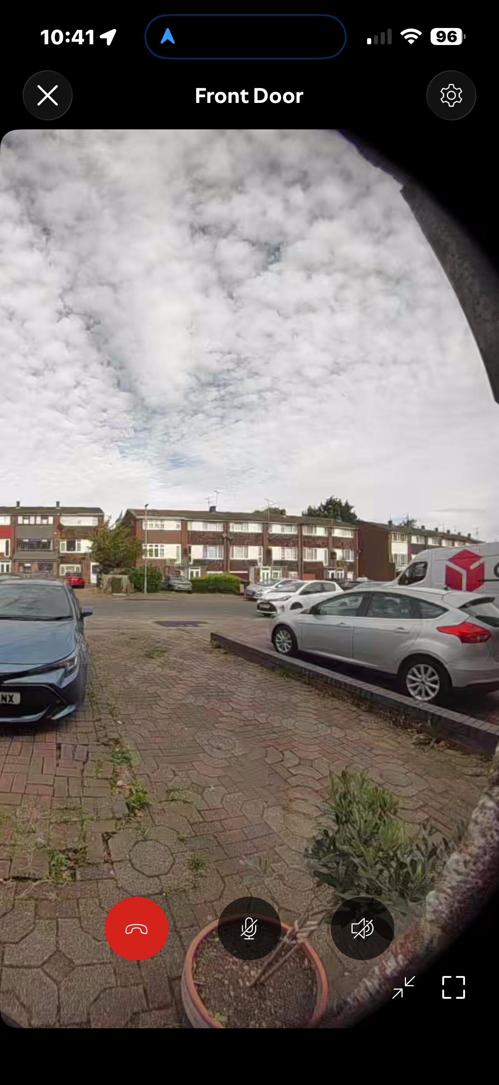
A digital video doorbell camera is a smart, internet-connected doorbell with a built-in camera and microphone, letting you see and speak to visitors from anywhere via your visitor. there is an option to alert me if any anonyms person reaches my house. That make me feel safe.

Screenshot/Photo 5
[Insert Photo/Screenshot below]

[Write what this shows of your digital life]

Screenshot/Photo 6
[Insert Photo/Screenshot below]
[Write what this shows of your digital life]

My Short Reflection
- Write 5–8 simple sentences about your digital life.
- You can use the sentence starters below if helpful.
I use digital tools to use my everyday life make life easy.

I feel confident when I go anywhere and control my digital life via apps
I want to improve my knowledge more to use all the devices
I sometimes feel nervous about when I lost internet connection without internet cant use those devices
I hope this module will help me learning about digital life and those help me how to use computer more.
Digital skills are important for me because my life rely on digital divices

Sentence starters
- I use digital tools to …
- I feel confident when I …
- I want to improve …
- I often use these tools: …
- I sometimes feel nervous about …
- I hope this module will help me …
- Digital skills are important for me because …
You can write more if you want.

Submission Checklist
Before you submit, please check:
​​​ ☐ I added 4–6 screenshots
☐ I wrote short sentences for each screenshot
☐ I wrote my short reflection
☐ My work is my own
☐ My file opens correctly
​​☐ My file opens correctly

