Katherine Fischer-Jenkins 2507285 BMDS7007 CW2

A Critical Reflection on Stakeholder Management in Implementing the Digital Strategy of Cardiff and Vale University Health Board.

Introduction
Reflection on practice is a process increasingly used in healthcare professions to improve personal practice and deepen understanding by learning from experiences (Rolfe, Jasper and Freshwater, 2011). This is especially true in midwifery where reflection has long been an established part of practice, both for student midwives and as part of continuing professional development and revalidation processes mandated by the Nursing and Midwifery Council (NMC) (Wain, 2017). In this piece I will reflect on my experience of working in Cardiff and Vale University Health Board (CAVUHB) and implementing digital transformation within the time period of the organisation’s digital strategy entitled “Delivering Digital. Building a learning health and care system. A Five Year Strategy” (CAVUHB, 2020).
I will reflect on my experiences of multi-disciplinary working and consider methods of stakeholder management and decision-making to identify future improvements based on my experience. This reflection will be structured using the Integrated Reflective Cycle developed by Bassot (2024) which has four stages and contains several questions (Figure 1) which can be used to prompt reflection, analysis and consideration of how lessons learned can be applied.
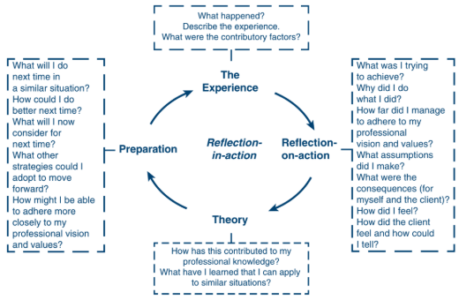
Figure 1: The Integrated Reflective Cycle (Bassot, 2024).

The Experience
I have worked for CAVUHB as a midwife since 2011 and moved into the role of digital transformation within the maternity department in 2023. As such, I was a member of staff during the preparation and publication of the five-year digital strategy for 2020 to 2025 (CAVUHB, 2020). I also led a large digital transformation project within the maternity service to implement the Badgernet digital maternity record in 2025, as part of the national Digital Maternity Cymru (DMC) programme (Digital Health and Care Wales, 2023). Despite this, I was not previously aware of the organisation’s digital strategy and have not experienced it being used or referred to by teams undertaking digital transformation in the health board. Furthermore, I do not recall staff engagement or consultation whilst the strategy was being created or any communication with staff around its launch.
My experience of implementing digital transformation in CAVUHB has been challenging. Despite Badgernet Maternity being a stated high priority project both nationally and locally (James, 2024), I frequently encountered barriers in the project stemming from other digital projects competing for limited financial and technical resources. There was also a failure by the health board structures to fully understand the scale and scope of the Badgernet Maternity project and basic project management methodologies were not in place for digital projects in the health board when it commenced. Much of the project was led by me as a clinician with an interest in digital transformation but no formal training or experience, which inevitably led to challenges along the way.
In particular, I encountered resistance from some staff groups which was expressed in unprofessional ways and directed towards me as an individual. This occurred most often in discussions where I was attempting to challenge long-established ways of working and question negative assumptions that were made about digital transformation. For example, some consultant obstetricians objected to the idea of completing consultation notes in the Badgernet system which contain tailored questions and tick-box answers as they felt that their existing method of free-text documentation should be exactly duplicated in the digital system. This unfortunately led to derogatory comments being made to me about the differing roles of midwives and obstetricians and assertions that I should not propose any changes to their ways of working as I am ‘only’ a midwife.

Reflection – on – action
Reflecting on the Badgernet Maternity project since its completion, I recognise that I frequently felt alone in my efforts to progress the project due to a lack of guidance and support from wider health board structures. My subsequent analysis of the CAVUHB digital strategy showed that it lacked evidence of stakeholder engagement and was written in a way that is not accessible or useable for wider staff groups beyond the digital teams (Fischer-Jenkins, 2026). This potentially reflects a lack of integration between digital teams and the wider organisation’s strategy and operations (NHS Providers, 2024) which would explain my experience. In addition, I found there to be a disconnect between the ambitious stated aims of the strategy and the reality of a low level of digital maturity and poor technical infrastructure in the health board (Fischer-Jenkins, 2026). I see this reflected in the ambitious decision to implement a fully-digital maternity record contrasted with my experience of significant barriers in basic technical aspects of the project and a lack of established project management processes in the organisation.
I also now reflect that my experience of feeling alone, and in some ways solely responsible for large parts of the project, likely contributed to the challenging interactions I experienced with colleagues from other professions within maternity services. Some staff expressed that they did not believe I, as a midwife, should be involved in digital transformation affecting their more senior professions, as they saw it. I felt that I was being held personally responsible for the decision to implement Badgernet and was the target of behaviour which impacted me emotionally, without a formal project structure for me to escalate any issues for support. Whilst this was difficult to deal with at the time, I recognise that it was brought about by my desire to make the project a success and resulting willingness to engage in those challenging discussions for the ultimate benefit of the transformation work.

Theory
Consideration of stakeholders is key for a successful digital strategy, both to ensure that the strategy meets the needs of the organisation and to embed stakeholder management practices into the strategy itself (NHS Providers, 2024). The CAVUHB digital strategy does not evidence any significant stakeholder engagement in its production, and it makes no mention of stakeholder management within digital transformation or any measurable objectives to determine if the needs of stakeholders have been met (CAVUHB, 2020). Stakeholder analysis can be used to identify and classify stakeholders according to their levels of power over a project and the level of impact that it will have on them (Figure 2), in order to plan the appropriate methods of engagement with them (Government Communication Service, 2025).
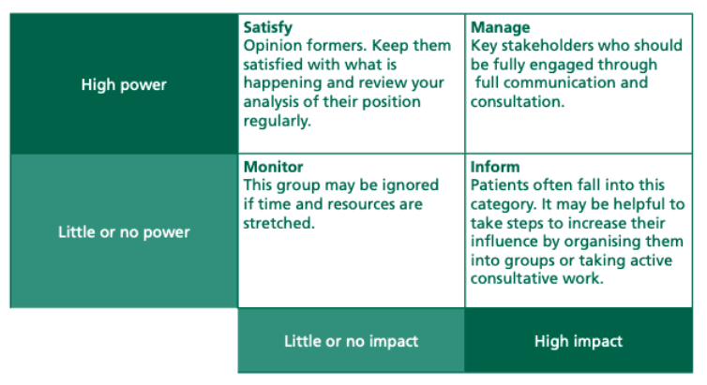
Figure 2: Prioritising stakeholders (NHS Institute for Innovation and Improvement, 2009)

Use of a framework such as this could have contributed to a more effective digital strategy for CAVUHB and clearer principles for those undertaking digital transformation in the health board to embed this practice. As well as stakeholder management, effective project management processes are essential in digital transformation to co-ordinate technical work with the change processes and governance structures necessary for success (Chen et al., 2025). Had this been in place in CAVUHB from the outset of the Badgernet project, it would have provided explicit channels for decision making and escalation of issues causing conflict as well as guidance and support for me as an individual.
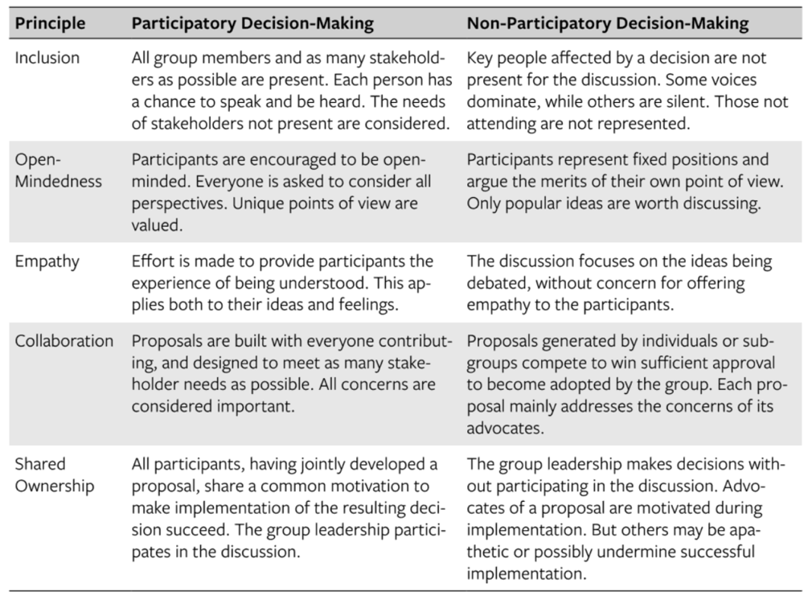
Whilst challenging widely accepted ideas can cause conflict as I experienced, it is an essential part of avoiding the pitfalls of ‘groupthink’. This theory, developed by Irving Janis in 1972, describes how groups of people can make extremely bad decisions when the cohesion of the group is unwittingly prioritised over proper appraisal of the decision being made (Rose, 2011). Techniques to avoid ‘groupthink’ include leaders who remain impartial, encouraging critical evaluation from all group members, and bringing in outside expertise to challenge and question (Rose, 2011). Similarly, Hartnett (2011) described a model for consensus-orientated decision-making (CODM) which aims for maximum participation of all members of a group and efficiency in reaching a collaborative decision. Embedding the guiding principles of this model (Figure 3) into the leadership of digital transformation projects could ensure that the best possible decisions are made and inter-personal conflicts minimised.
Figure 3: Participatory decision-making principles (Hartnett, 2011).

Preparation
A future digital strategy for CAVUHB should be produced with much greater input from stakeholders across the organisation. It should also include consideration of how stakeholders will be managed within programmes and projects covered by the strategy and how feedback and evaluation will be handled to determine how successful the strategy has been. My analysis of stakeholders for digital transformation in CAVUHB are shown in Table 1 with proposed engagement channels and frequency.

Table 1: Stakeholder analysis and communication plan for implementation of a future CAVUHB digital strategy.
Stakeholder role | Engagement | Content | Channel
Digital Health and Care Wales (DHCW) | Manage | Alignment with DHCW national strategy, national interoperability, technical capabilities. | Regular meetings.
Executive directors and board members | Satisfy | Alignment with organisational strategy, reassurance on cost and timescales. | Reports to board meetings.
Digital teams | Manage | Awareness across all digital teams of current project priorities, barriers and status. | Regular meetings and updates disseminated by team leaders.
Corporate teams (e.g. finance, governance, legal) | Inform | Reassurance on cost and consideration of legal and governance frameworks. | Updates to senior team members.
Clinical Professionals | Manage | In depth involvement for those affected directly by a change. | Regular meetings with representatives and progress updates disseminated to all.
Support and administrative staff | Manage | In depth involvement for those affected directly by a change. | Regular meetings with representatives and progress updates disseminated to all.
Primary care providers (e.g. GPs, pharmacists) | Inform | Awareness of planned changes and anticipated impacts on processes and pathways. | Progress updates by email.
Patients / Service Users and their representative groups. | Inform | Awareness of planned changes and anticipated impacts on processes and pathways. | Progress updates by email.

A digital strategy should not set out to detail every change to be made but rather to provide guiding principles to support teams to make the right decisions (NHS Providers, 2024). In view of this, I believe a future digital strategy for CAVUHB should outline the principles of project management within the organisation and advocate for evidence-based approaches to decision making and team leadership.
For my personal development, this reflection has highlighted the importance of considering how groups function to make decisions and how this can be optimised with the use of evidence-based approaches. I have also gained insight into the extent to which the Badgernet project lacked support and guidance that should have come from the organisational structures in CAVUHB to ensure that digital transformation projects are successful and positive. This has helped me to see that the inter-personal conflicts I experienced were a product of many situational factors for myself and the other professionals involved, rather than a failure on my part. My improved understanding of stakeholder analysis will help me in approaching future projects with collaborative working embedded from the beginning.

References
I confirm this essay is my own original work and does not include text created by a generative artificial intelligence tool.
Bassot, Barbara. (2024) The reflective journal. Bloomsbury Academic.
CAVUHB (2020) Delivering Digital. Building a learning health and care system. A Five Year Strategy. Cardiff and Vale University Health Board. Available at: https://cavuhb.nhs.wales/files/publications/cardiff-and-vale-uhb-digital-strategy/ (Accessed: February 22, 2026).
Chen, M. et al. (2025) “Digital Transformation in Project Management: A Systematic Review and Research Agenda,” Systems 2025, Vol. 13, Page 625, 13(8), p. 625. Available at: https://doi.org/10.3390/SYSTEMS13080625.
Digital Health and Care Wales (2023) Women in Wales to benefit from new digital maternity system - Digital Health and Care Wales. Available at: https://dhcw.nhs.wales/news/latest-news/women-in-wales-to-benefit-from-new-digital-maternity-system/ (Accessed: January 17, 2026).
Fischer-Jenkins, K. (2026) “A Critical Evaluation of the Digital Strategy of Cardiff and Vale University Health Board. ,” Unpublished [Preprint].
Government Communication Service (2025) Ensuring Effective Stakeholder Engagement. Available at: https://www.communications.gov.uk/publications/ensuring-effective-stakeholder-engagement/#How-are-you-going-to-engage-with-them (Accessed: February 22, 2026).
Hartnett, Tim. (2011) Consensus-Oriented Decision-Making : the CODM Model for Facilitating Groups to Widespread Agreement. New Society Publishers.
James, D. (2024) “Cardiff and Vale University Health Board Business Case - Digital Maternity Health Record – System Replacement Project ,” Unpublished [Preprint].
NHS Institute for Innovation and Improvement (2009) The Organising for Quality and Value: Delivering Improvement programme. Engaging, Involving and Understanding Others’ Perspectives. Available at: https://www.england.nhs.uk/improvement-hub/wp-content/uploads/sites/44/2018/06/Engaging-Involving-Understanding-Others-Perspectives.pdf (Accessed: February 22, 2026).
NHS Providers (2024) Building a digital strategy (2024). Available at: https://nhsproviders.org/resources/building-a-digital-strategy-2024 (Accessed: March 2, 2026).
Rolfe, Gary., Jasper, Melanie. and Freshwater, Dawn. (2011) Critical reflection in practice : generating knowledge for care. 2nd ed. Red Globe Press.
Rose, J.D. (2011) Diverse Perspectives on the Groupthink Theory – A Literary Review.
Wain, A. (2017) “Learning through reflection,” British Journal of Midwifery, 25(10).

