Student No.: 2120527
BMIH4006
Operating Hotel Facilities
(Component 1)
Lecturer: Lola Villard

Table of Contents
Key skills for working in a housekeeping team 1
Personal reflection 2
Reference list 4

Key skills for working in a housekeeping team
Members of a housekeeping team must be scrupulous in their work since they take care of the cleaning part and customers are generally sensitive in cleaning aspects. They must work painstakingly to ensure proper customer satisfaction. A survey of 4362 housekeepers in the hospitality industry showed that 84% of them think that they do not get considered for a housekeeping team if they are not meticulous enough (Scanlon, 2022). I developed this skill when I was employed in a restaurant. I was trained by the restaurant manager and also got feedback from my managers regarding my performance. Thus I developed this skill.
Since housekeepers contact customers directly for knowing their service demands, communication skill is required for working in a housekeeping team. The more amicably housekeepers can interact and the more languages they know, the more edge they get to work in a team. The Premier Inn arranged a language learning course for housekeepers and found a 20% improvement in their performance (Robinson, 2020). I used this skill in the restaurant job. Given that there used to be many customers during the rush hours. I had to manage them with to-the-point conversations and sometimes even non-verbal communication.
Some hard skills such as cleaning, dusting, polishing, mopping, sweeping, vacuuming, and so on are a must for working in a housekeeping team given that housekeepers are responsible for performing these duties. With these skills, housekeepers can distribute their tasks to their team members and ensure customer service (Brigham, 2021). To illustrate, Hotel InterContinental provides traditional and on-the-job training to its housekeepers for increasing their hard skills because research showed that customer satisfaction can enhance by 15% in this way. I improved my hard skills like cleaning, table arrangement, customer service, and so on when I took the restaurant job. For instance, I cleaned up tables after customers used them during breakfast and dinner time. I came to know how to clean them in the best possible way so that no complaints come from the customers.
Given that a housekeeper performs different tasks at different times, he or she must be adroit at time management. Punctuality is a key skill for working in a housekeeping team because housekeepers cannot cope with their peers if they lack this skill. Trinity Hotel teaches the application of the Pomodoro model to its employees because it has observed that this strategy increased its employee productivity by 18% in 2021 (Scanlon, 2022). Restaurant job creates a lot of pressure, especially during rush hours. Therefore, I had to develop my time management skills. I worked on fast task completion and also avoided wasting time between tasks. Thus I develop this skill exquisitely.

Personal reflection
From the student journal, I have learned different skills that are required for housekeepers. I can use these skills when I will be employed in a hotel for leading a team or appointing the right housekeepers to my team. I have improved my communication and teamwork skills as well since I had to often interact with my teachers and peers while working in a team as well for completing the journal. My data analysis skill has got a boost as well given that I had to collect data relevant to the housekeeping skills in the hospitality industry. I learned how to gather data from diverse and credible sources. Last but not least, I improved my academic writing skill splendidly by developing this student journal. I developed my hard skills, time management skill, and communication skill after my placement at the restaurant. For instance, I cleaned up tables after customers used them during breakfast and dinner time. I came to know how to clean them in the best possible way and thus I developed my hard skills. I had to manage customers with to-the-point conversations and sometimes even non-verbal communication and thus I developed my communication skill. I worked on fast task completion and also avoided wasting time between tasks so that I could develop my time management skill as well. The development of these skills was an effective experience for me because I could become a better employee with the use of this knowledge.
I will be able to use my learned skills and theoretical knowledge whilst working for any company because communication, data analysis, writing, and teamwork are crucial skills for the current job market. I will be preferred to get appointed to a job if I can showcase my skills perfectly. I will also get promotions easily in my job for these skills and knowledge.

Reference list
Brigham, G.H. (2021). What’s Ahead for the Hotel Housekeeper? Cornell Hotel and Restaurant Administration Quarterly, 3(1), pp.95–100.
Mohamad, A.M., Yusof, F.Mohd. and Aris, B. (2014). Online Cooperative Learning for Communication and Team Working Skills Enhancement. Jurnal Teknologi, 69(1).
Raghubalan, G. and Raghubalan, S. (2016) Hotel Housekeeping - Operations And Management. 3rd ed. India: Oxford University Press.
Robinson, M. (2020). Housekeeping..
Scanlon, J. (2022). Old Housekeeping, New Housekeeping, or No Housekeeping? Journalism History, 30(1), pp.2–10.

BMIH4006
Operating Hotel Facilities
(Component 2)
Lecturer: Lola Villard
Assignment Title: Assessment of Practical Tasks

Table of Contents
Why did it happen? 1
What are you going to do? 1
How will you prevent this from happening in the future? 1
What measures would you introduce to improve team effectiveness? 2
Reference 3

I work in Hotel Trinity as a team leader for a floor. Recently, I have got some customer complaints regarding room cleaning. As a team leader, my action plan is as follows.

Why did it happen?
I received a complaint from a customer as his room was not properly cleaned. Although the complaints are not frequent, the problem is not novel either. There are some reasons behind this problem which let it happen frequently (Pratiwi and Agustina, 2021). To illustrate, there is a shortage of the number of housekeepers in Hotel Trinity as the company terminated a number of employees during the Covid-19 pandemic to reduce its operating cost. For instance, in 2020, Hotel Trinity fired 20% of its employees, to be precise. Another reason is that Hotel Trinity does not arrange training sessions much for its employees as it conducts a cost leadership approach. Therefore, the work of employees in this company is not meticulous enough. These are some reasons why a customer did not get proper cleaning service and complained to the hotel for better service (Cahill, 2021).

What are you going to do?
As a team leader of an entire floor in Hotel Trinity, I am responsible for dealing with any kind of customer complaint. Given that I have received a complaint from a customer of the hotel, I have to take some actions for solving the issue fast. To illustrate, I can contact the HR department of Hotel Trinity for getting more employees in my team and improving the overall customer service (Watson and Wright, 2019). For instance, the HR department in my office can publish a circular after taking the employee requirement data from my team. Then it can recruit some employees by following the proper channel of recruitment. I can help the HR department in the screening process given that I know what skills are required for working in my team and being a good housekeeper. I, moreover, can arrange training sessions for my team members. I am going to ensure that no employee starts their duty without proper training on the allocated job (Laxmi, 2022).

How will you prevent this from happening in the future?
Given that I am responsible for managing customer service on my floor, I have to take some necessary actions so that similar cases do not take place in the future. For instance, I will enlarge my team significantly. It is not unknown that without an adequate number of employees, it is not an easy task to conduct the activities of a team (Pratiwi and Agustina, 2021). Therefore, I will take help from the HR department of my company to provide better services to the customers of the hotel and avoid such complaints in the future. Again, I will arrange training sessions for my team members. I will arrange some conventional training sessions for improving the hard skills of my team members. On the other hand, on-the-job training sessions will also be available in my team so that members can learn about their roles in detail and in practice.

What measures would you introduce to improve team effectiveness?
Improving the team's effectiveness is of utmost importance because team members deliver customer service ultimately (Cahill, 2021). To illustrate, if members of my team perform their tasks with utmost meticulousness, customers will not get any chance to make any complaints, so customer service in my company will improve. I can take some initiatives to improve the team's effectiveness since I am the leader of the floor. For instance, I can choose who will perform what task based on the employees’ interests and experience in a task. If employees get tasks as per their preference, their enthusiasm to work will be top-notch (Pratiwi and Agustina, 2021). Another action I can take will be to encourage employees to engage in workshops related to housekeeping. Given that employees will get pragmatic knowledge from the sessions, their learning will be perfect and thus the overall performance of my team will get a fast boost.

Reference
Cahill, D.J. (2021). What’s Wrong with Service Providers? Journal of Customer Service in Marketing & Management, 3(2), pp.71–79.
Laxmi, Y.S. (2022). Customer Complaint Analysis Using Hadoop (Consumer Analysis). International Journal Of Engineering And Computer Science.
Mullins, L. and Dossor, P. (2013) Hospitality Management and Organisational Behaviour. 5th ed. Harlow: Pearson.
Pratiwi, W.A. and Agustina, I.F. (2021). Implementation of Cleaning Service Retribution Policy in Sidoarjo Regency. Academia Open, 6.
Watson, L.L. and Wright, L.G. (2019). Housekeeping. Harlow: Prentice Hall.

BMIH4006
Operating Hotel Facilities
(Component 3)
Lecturer: Lola Villard
Assignment Title: Presentation

Slide 1
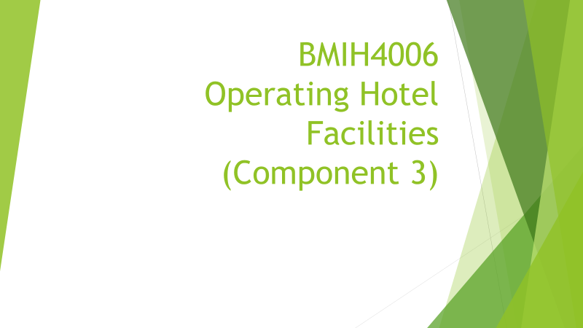
Slide 2
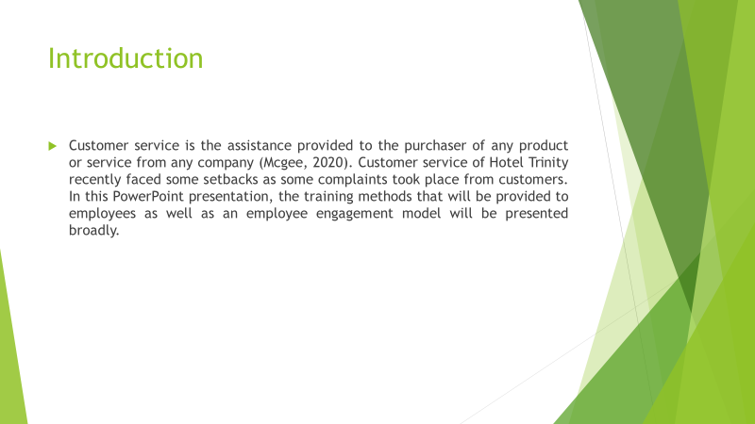
Slide 3
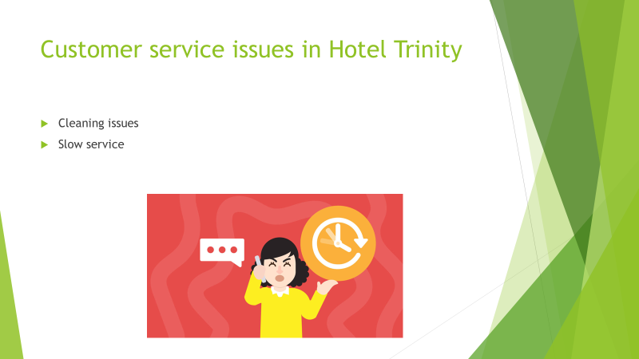
Cleaning issues: In Hotel Trinity, customers have complained that they did not get the proper cleaning service or at least they expected a better service. Customers of Hotel Trinity found dust on the bedsheet of the hotel rooms and also the washroom of the hotel was stinky (Baquero, 2022).
Slow service: Slow service is another problem in the company. To illustrate, the housekeeping team in the hotel took almost 3-4 hours to clean a room, which is extremely slow compared to the services of other hotels.
Slide 4
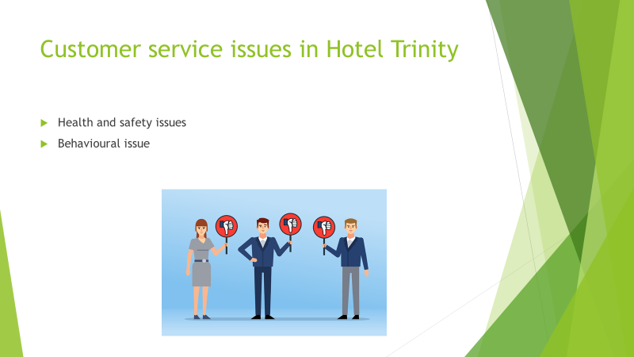
Health and safety issues: Some customers in Hotel Trinity complained that the housekeepers in the hotel do not maintain safety protocols (Fugate, 2022). They do not wear masks and personal protection equipment during cleaning a room, so customers’ health and safety are jeopardized.
Behavioural issue: Some housekeepers are not adept at communicating with employees while some show arrogance as well. So, customers in the hotel have complained about the behavioural issues of customers.
Slide 5
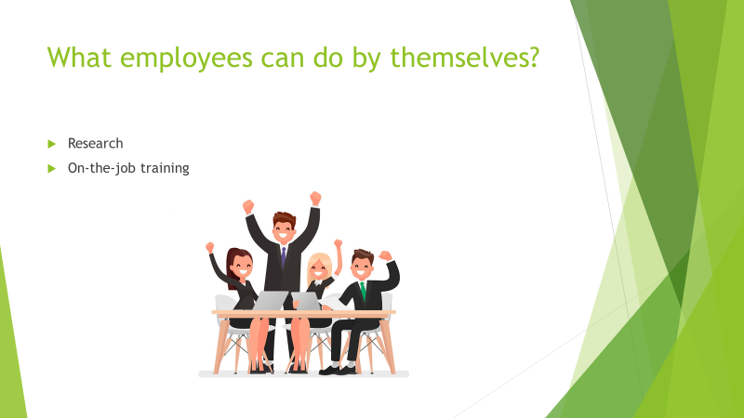
Research: Housekeepers must understand what flaws they are making during their work and thus they will understand what amendments they must make. To illustrate, employees can seek customer opinions during their work and thus they will be able to conduct their research.
On-the-job training: When housekeepers perform their job, they can ask for feedback from employees because feedback will improve their work significantly (Stuart, 2021). Employees can learn from their supervisors practically during their work.
Slide 6
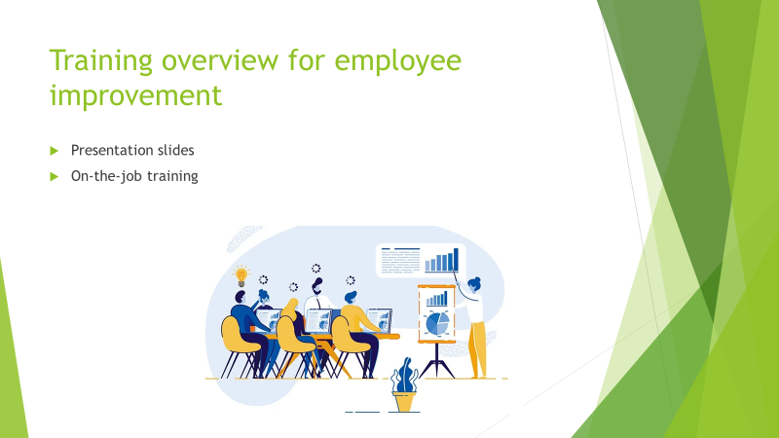
Presentation slides: Employees of Hotel Trinity can be trained using the presentation slide method. In this method, employees’ hard skills will be improved by increasing their theoretical knowledge on them. For instance, if an employee does not know the proper way of cleaning, presentation slides will be presented to delineate some photos and videos on the topic and teach them properly.
On-the-job training: On-the-job training is the training process which is delivered during the performance of any task. Hotel Trinity can deliver this training to employees by assigning some adept and prudent trainers (Yadav, 2020). Managers of the company can play this role perfectly.
Slide 7
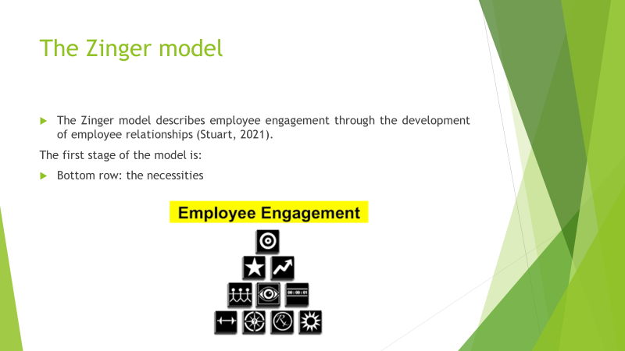
The Zinger model describes employee engagement through the development of employee relationships.
The three stages of the model are:
Bottom row: the necessities: Employee engagement in any company can increase if the basic human needs of employees are fulfilled accordingly. The bottom row of the model, therefore, takes care of the fulfilment of the fundamental needs of humans. For instance, employees must be offered a competitive salary and enough leaves to ensure their engagement (Baquero, 2022). Again, their work needs to be meaningful to them, or they must be assigned tasks as per their experience and interest, to be precise. For instance, the Premier Inn noticed a 10% increase in employee engagement when it started collecting employee opinions before assigning tasks to them.
Slide 8
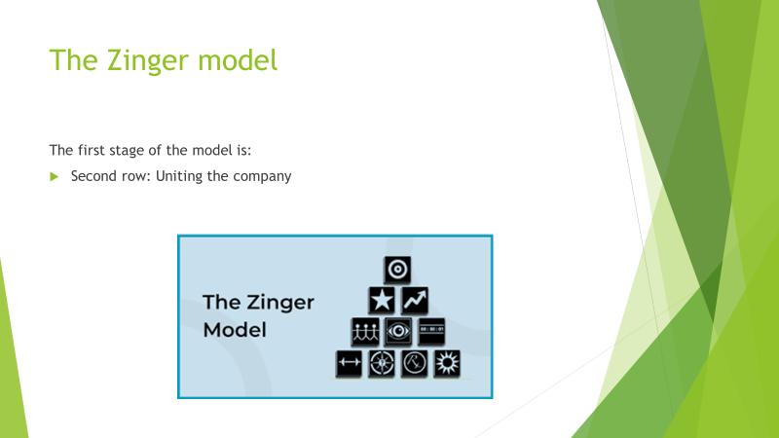
The first stage of the model is:
Second row: uniting the company: This stage of the model cares about the development of employee relationships. Zinger’s model states that employee engagement cannot be increased sufficiently if employees do not have an amicable relationship among themselves. Teamwork is a good way to develop affable and friendly relationships among employees. Again, companies should try recognizing employees’ hard work to develop their relationships and engagement. For instance, Hotel Marriott keeps 40% of its projects team-based because it helps to increase its employee engagement by 20% (Byrne, 2020).
Slide 9
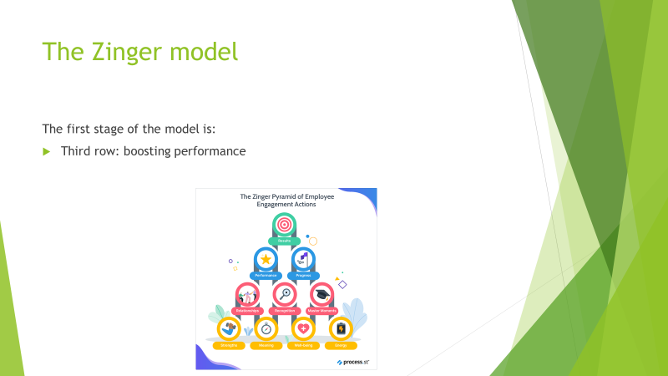
The first stage of the model is:
Third row: boosting performance: This stage of the model cares about reaching the result of employee effort. The Zinger model states that employees will not stay motivated to work or stay engaged in the company if they are not appreciated for their performance. Therefore, regular feedback, performance monitoring, reward providing, and so on are the processes for employee engagement (Yadav, 2020). Hotel InterContinental has a supervising team for work monitoring and allocates 5% of its budget for rewarding employees each year for increasing their engagement effectively.
Slide 10
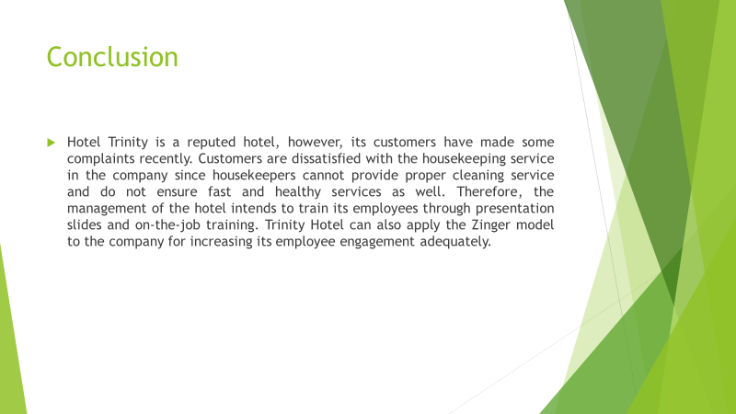
Slide 11


